STEPS TO CREATE AN ACCOUNT ON GITKRAKEN
- Consult git platforms and choose one to create an account
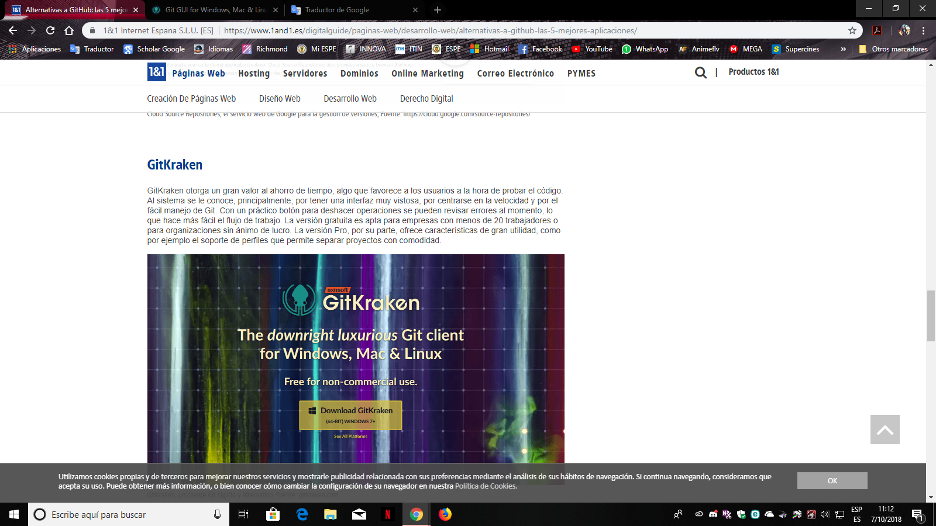
- Go to the official website and create an account
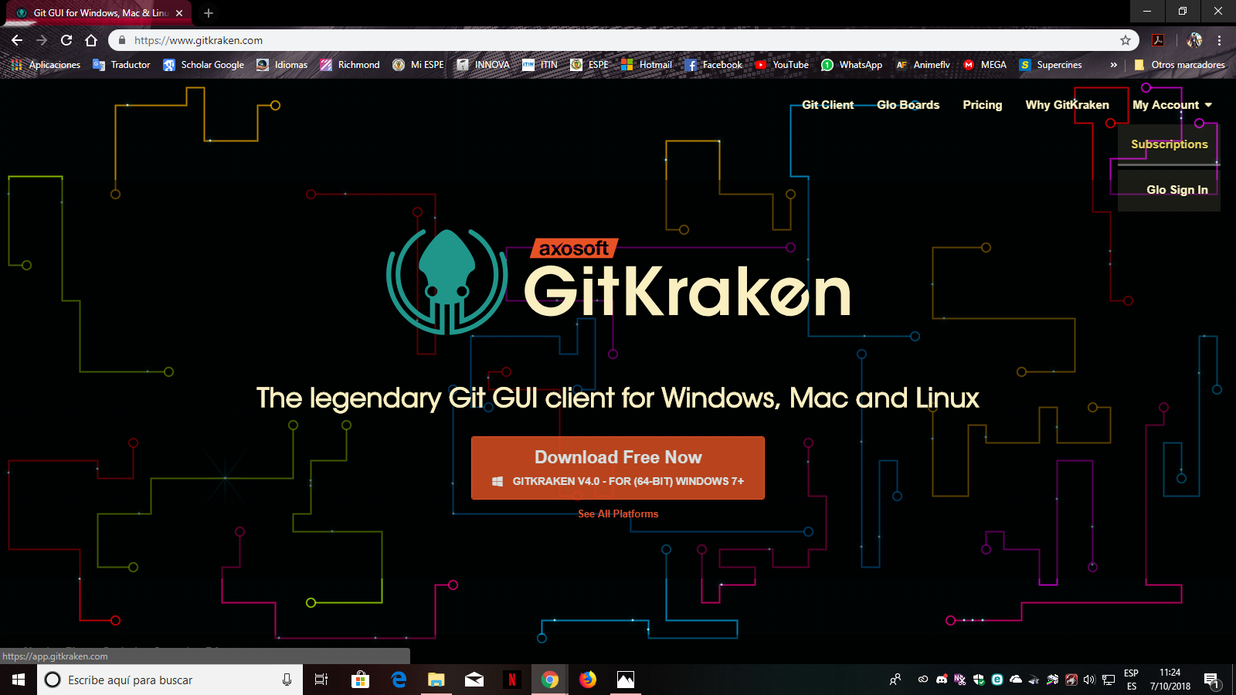
- Select the option I want to create an account
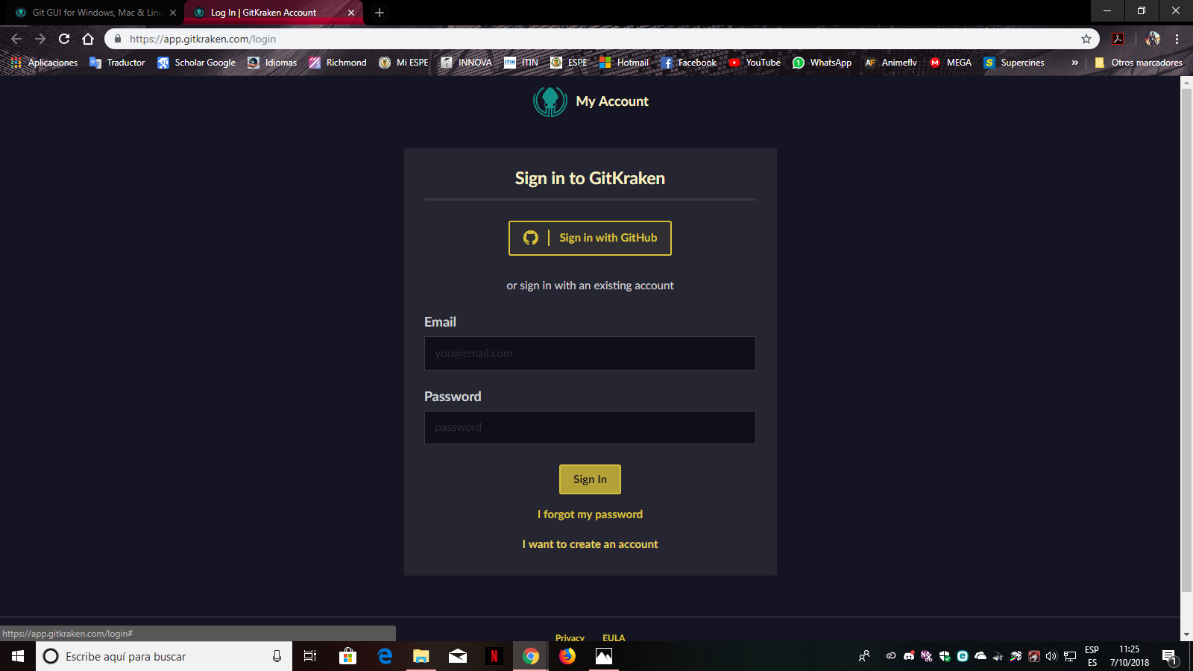
- Fill in your personal information needed to create your account and press create account
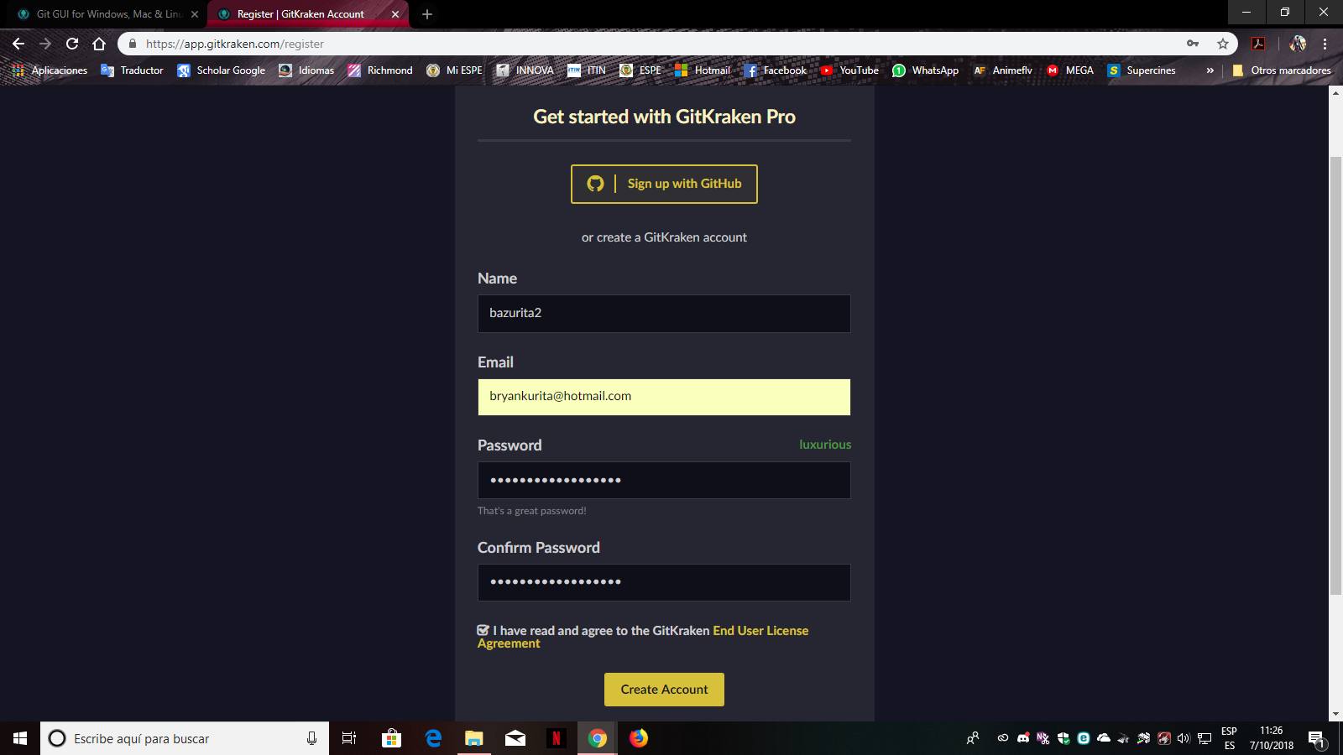
- If you want to create a payment account fill your data otherwise press cancel to start a free account
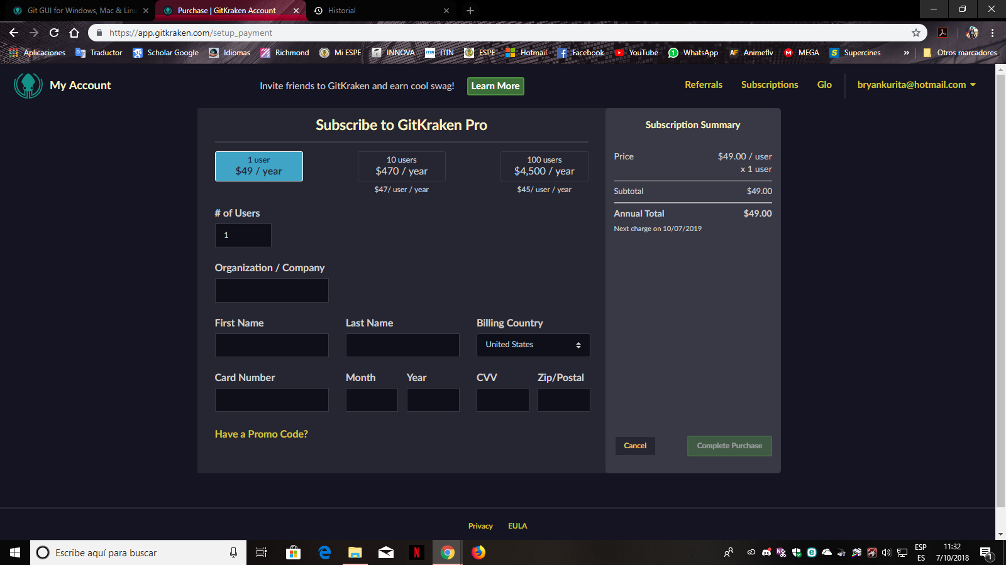
- Now the account is created you need to download the client for your computer, pressing download free now
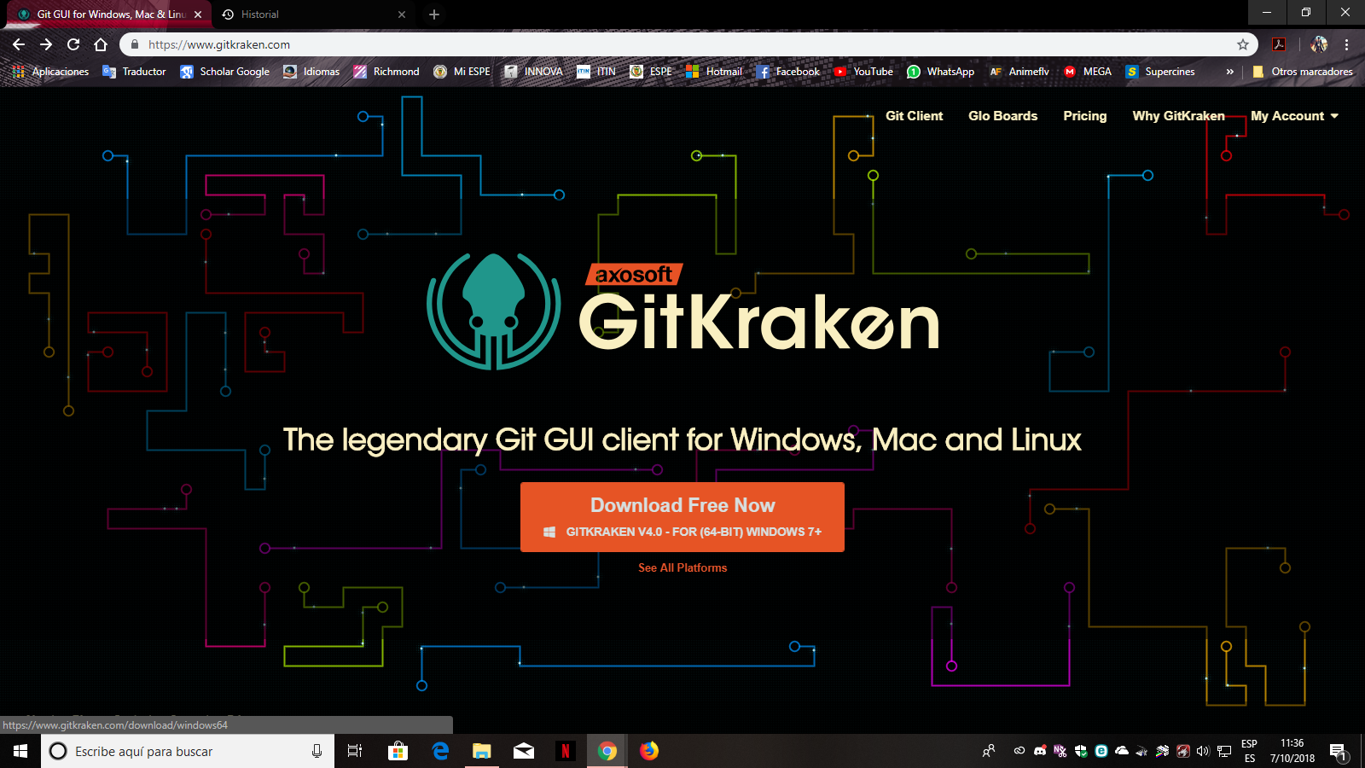
- Select your operating system and press download, the download will start immediately
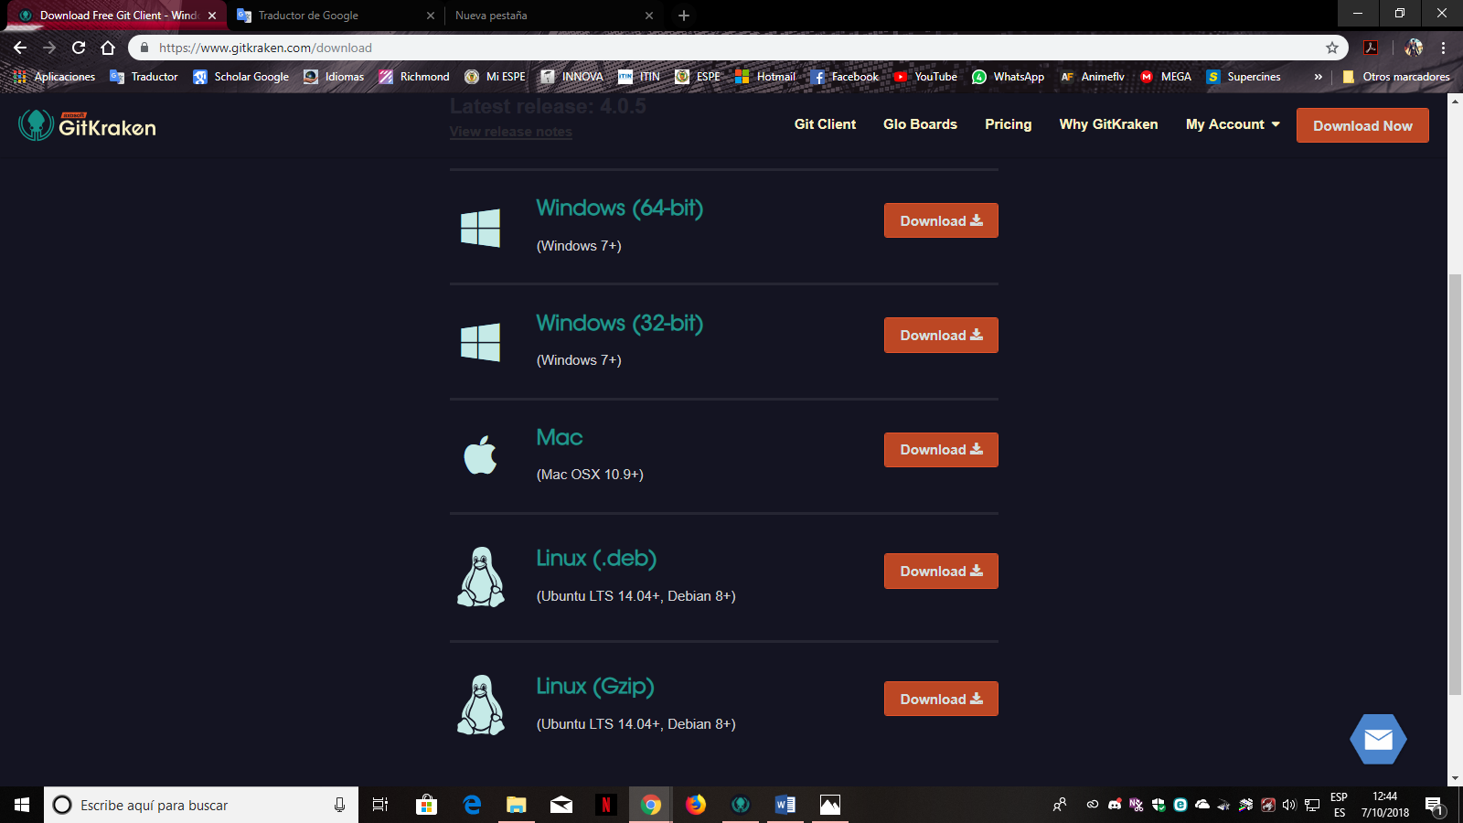
- Once downloaded the application presses on the download to proceed with the installation
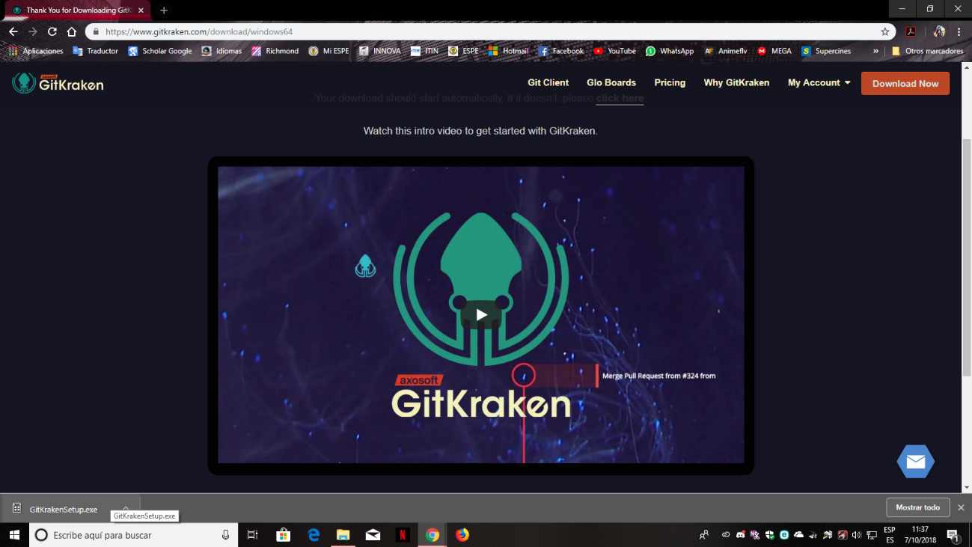
- After that press on execute
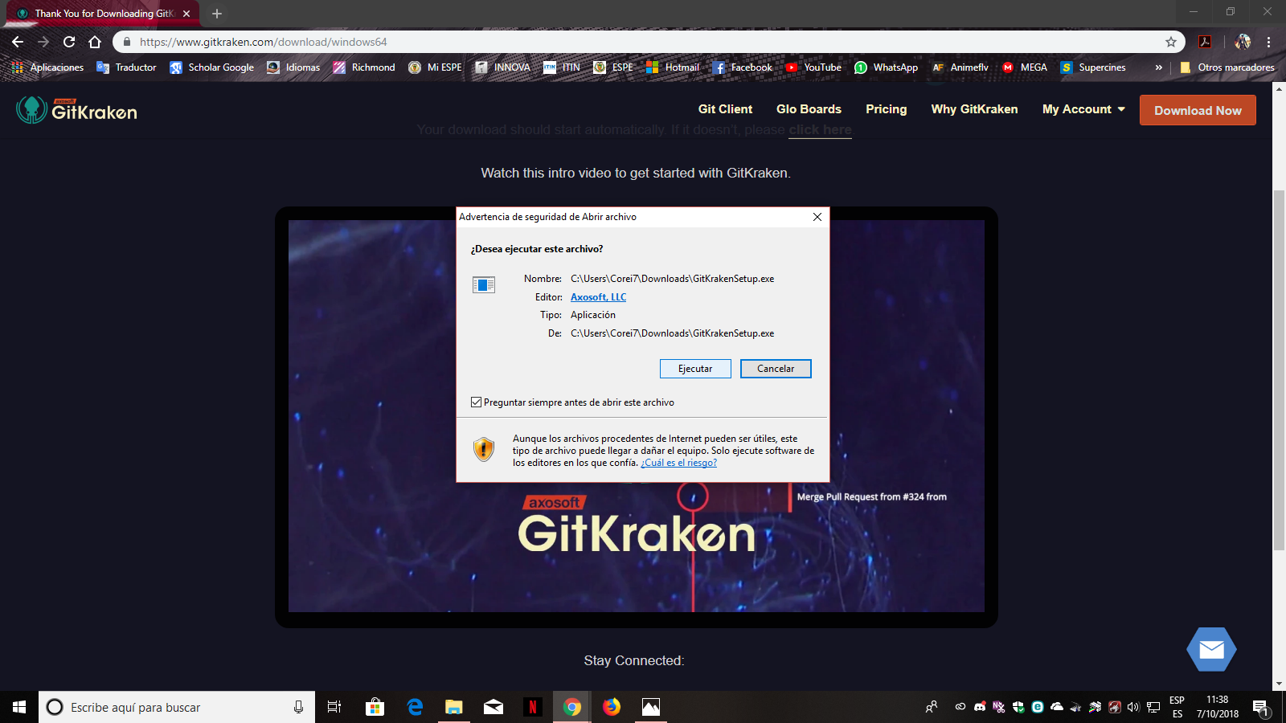
- Once the application is already open, fill your data from your account
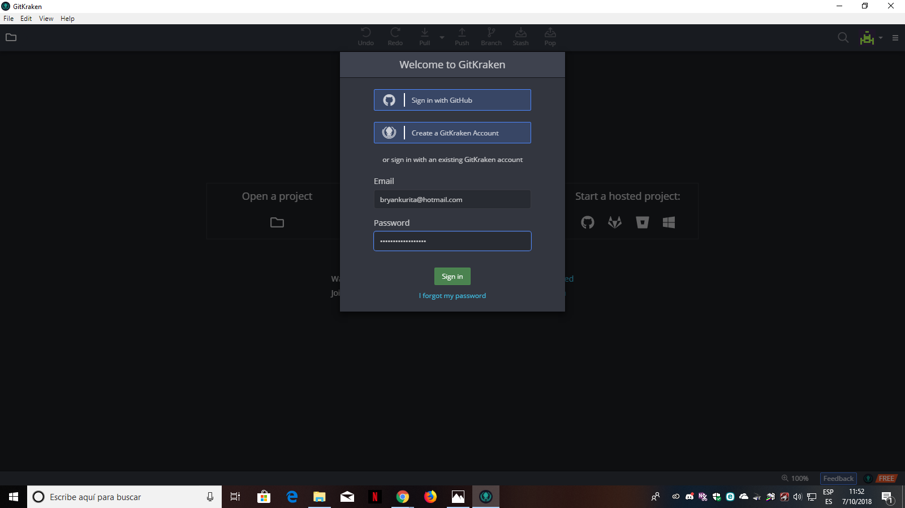
- Almost completed, fill in the details of your account profile
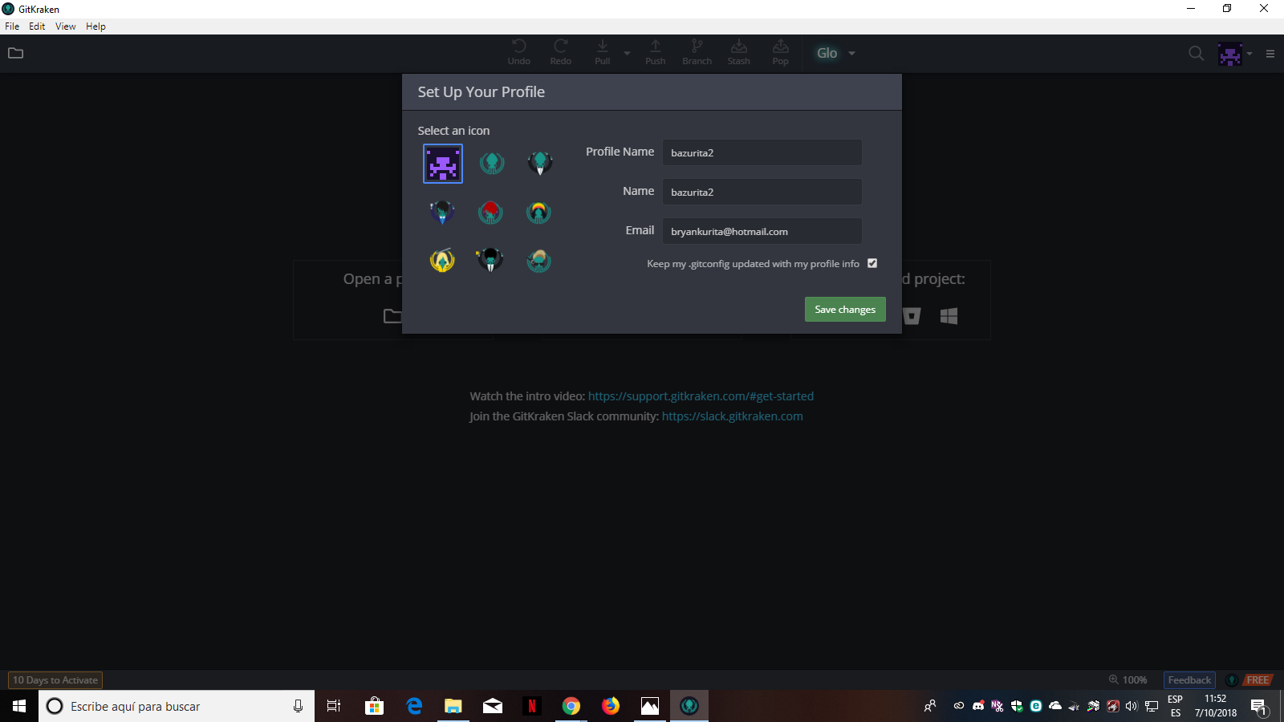
- Finally, your account will be completely created ready to upload files.
