PFNA 1 compartment Plots (v8)

Weihsueh Chiu, Claire Lay, Parker Malek

2022-01-23

library(coda)  
library(bayesplot)

## This is bayesplot version 1.8.0

## - Online documentation and vignettes at mc-stan.org/bayesplot

## - bayesplot theme set to bayesplot::theme_default()

## * Does _not_ affect other ggplot2 plots

## * See ?bayesplot_theme_set for details on theme setting

library(ggplot2)  
library(ggsci)  
library(khroma)  
library(tidyverse)

## ── Attaching packages ─────────────────────────────────────── tidyverse 1.3.0 ──

## ✓ tibble 3.1.0 ✓ dplyr 1.0.5  
## ✓ tidyr 1.1.3 ✓ stringr 1.4.0  
## ✓ readr 1.4.0 ✓ forcats 0.5.1  
## ✓ purrr 0.3.4

## ── Conflicts ────────────────────────────────────────── tidyverse_conflicts() ──  
## x dplyr::filter() masks stats::filter()  
## x dplyr::lag() masks stats::lag()

library(reshape2)

##   
## Attaching package: 'reshape2'

## The following object is masked from 'package:tidyr':  
##   
## smiths

library(yardstick)

## For binary classification, the first factor level is assumed to be the event.  
## Use the argument `event_level = "second"` to alter this as needed.

##   
## Attaching package: 'yardstick'

## The following object is masked from 'package:readr':  
##   
## spec

library(here)

## here() starts at /media/projects/projects/PFAS_PBPK/user/weihsueh_2021/PFAS_1cpt_v8-main/PFNA_1cpt_v8

knitr::opts_chunk$set(echo = TRUE, dpi = 300 )

Set up MCSim file

# this markdown file must be saved in top level directory for the following to work; the mcsim code depends on getwd results.  
mdir <- "MCSim"  
source(here::here(mdir,"setup_MCSim.R"))  
# Make mod.exe (used to create mcsim executable from model file)  
makemod()

## The mod.exe had been created.

## Set filenames and load data

## Set up dataset

id_lut <- multicheck$df_check %>% select(Level) %>% unique () %>%  
 mutate(dataset = c(   
 rep("Decatur M Train", 9),  
 rep("Decatur F Train", 9),  
 rep("Decatur M Test", 9),  
 rep("Decatur F Test", 10),  
 'Paulsboro-Train','Horsham-Train',  
 'Warminster-Test'),   
 Sex = c(   
 rep("M", 9),  
 rep("F", 9),  
 rep("M", 9),  
 rep("F", 10),  
 'Mixed', 'Mixed', 'Mixed'),  
 City = c(   
 rep("Decatur", 18),  
 rep("Decatur", 19),  
 'Paulsboro','Horsham','Warminster'),   
 Train_Test = c(   
 rep("Train", 9),  
 rep("Train", 9),  
 rep("Test", 9),  
 rep("Test", 10),  
 'Train', 'Train', 'Test'),  
 datatype = c(  
 rep("Individual",9+9+9+10),  
 rep("Summary",3)),  
 Simulation = row_number(),  
 variable = paste0(dataset, " ",Simulation))  
  
id_lut$dataset <- factor(id_lut$dataset,levels=  
 c("Decatur M Train","Decatur F Train","Arnsberg M Train",  
 "Arnsberg F Train","Decatur M Test","Decatur F Test","Arnsberg M Test",  
 "Arnsberg F Test","Minnesota Train","Minnesota Test",  
 'Lubeck-Bartell-Train', 'Lubeck-Bartell-Test',  
 'Little Hocking-Bartell-Train', 'Little Hocking-Bartell-Test',  
 'Little Hocking-Emmett-Test','Paulsboro-Train','Horsham-Train',  
 'Warminster-Test','Warrington-Train'))  
id_lut$City <- factor(id_lut$City,levels =   
 c("Decatur","Arnsberg","Minnesota",'Lubeck-Bartell',  
 'Little Hocking-Bartell','Little Hocking-Emmett',  
 'Paulsboro','Horsham','Warminster','Warrington'))  
   
indiv_lut <- id_lut %>%   
 filter(City %in% c("Decatur")) %>%  
 mutate( dataset = as.factor(dataset))  
  
nv <- data.frame(dataset =unique(indiv_lut$dataset),   
 variable= rep("Pop GM", 4),  
 type= rep("Pop GM", 4), stringsAsFactors = FALSE)

## Individual parameters

set.seed(314159)  
  
indiv_parms <- indiv_lut  
lnkparmnames <- paste("ln_k.",gsub("_",".",indiv_parms$Level),".",sep="")  
lnVdparmnames <- paste("ln_Vd.",gsub("_",".",indiv_parms$Level),".",sep="")  
  
parmsamp <- apply(multicheck$parms.samp,2,sample,1)  
  
## Random z-score estimate of each parameter  
indiv_parms$ln_k.z.samp <- parmsamp[lnkparmnames]  
indiv_parms$ln_Vd.z.samp <- parmsamp[lnVdparmnames]  
  
normd <- data.frame(x=qnorm(ppoints(200)))  
normd$y <- dnorm(normd$x)  
  
iplotk<-  
 ggplot(subset(indiv_parms,Train_Test=="Train"))+  
 geom_histogram(aes(x=ln_k.z.samp,after_stat(density)),bins=10)+facet_wrap(~City,ncol=1)+  
 geom_line(aes(x=x,y=y),data=normd)+  
 xlab("Individual z-scores for k") + theme_bw()  
  
iplotVd<-  
 ggplot(subset(indiv_parms,Train_Test=="Train"))+  
 geom_histogram(aes(x=ln_Vd.z.samp,after_stat(density)),bins=10)+facet_wrap(~City,ncol=1)+  
 geom_line(aes(x=x,y=y),data=normd)+  
 xlab("Individual z-scores for Vd") + theme_bw()  
  
print(iplotk)

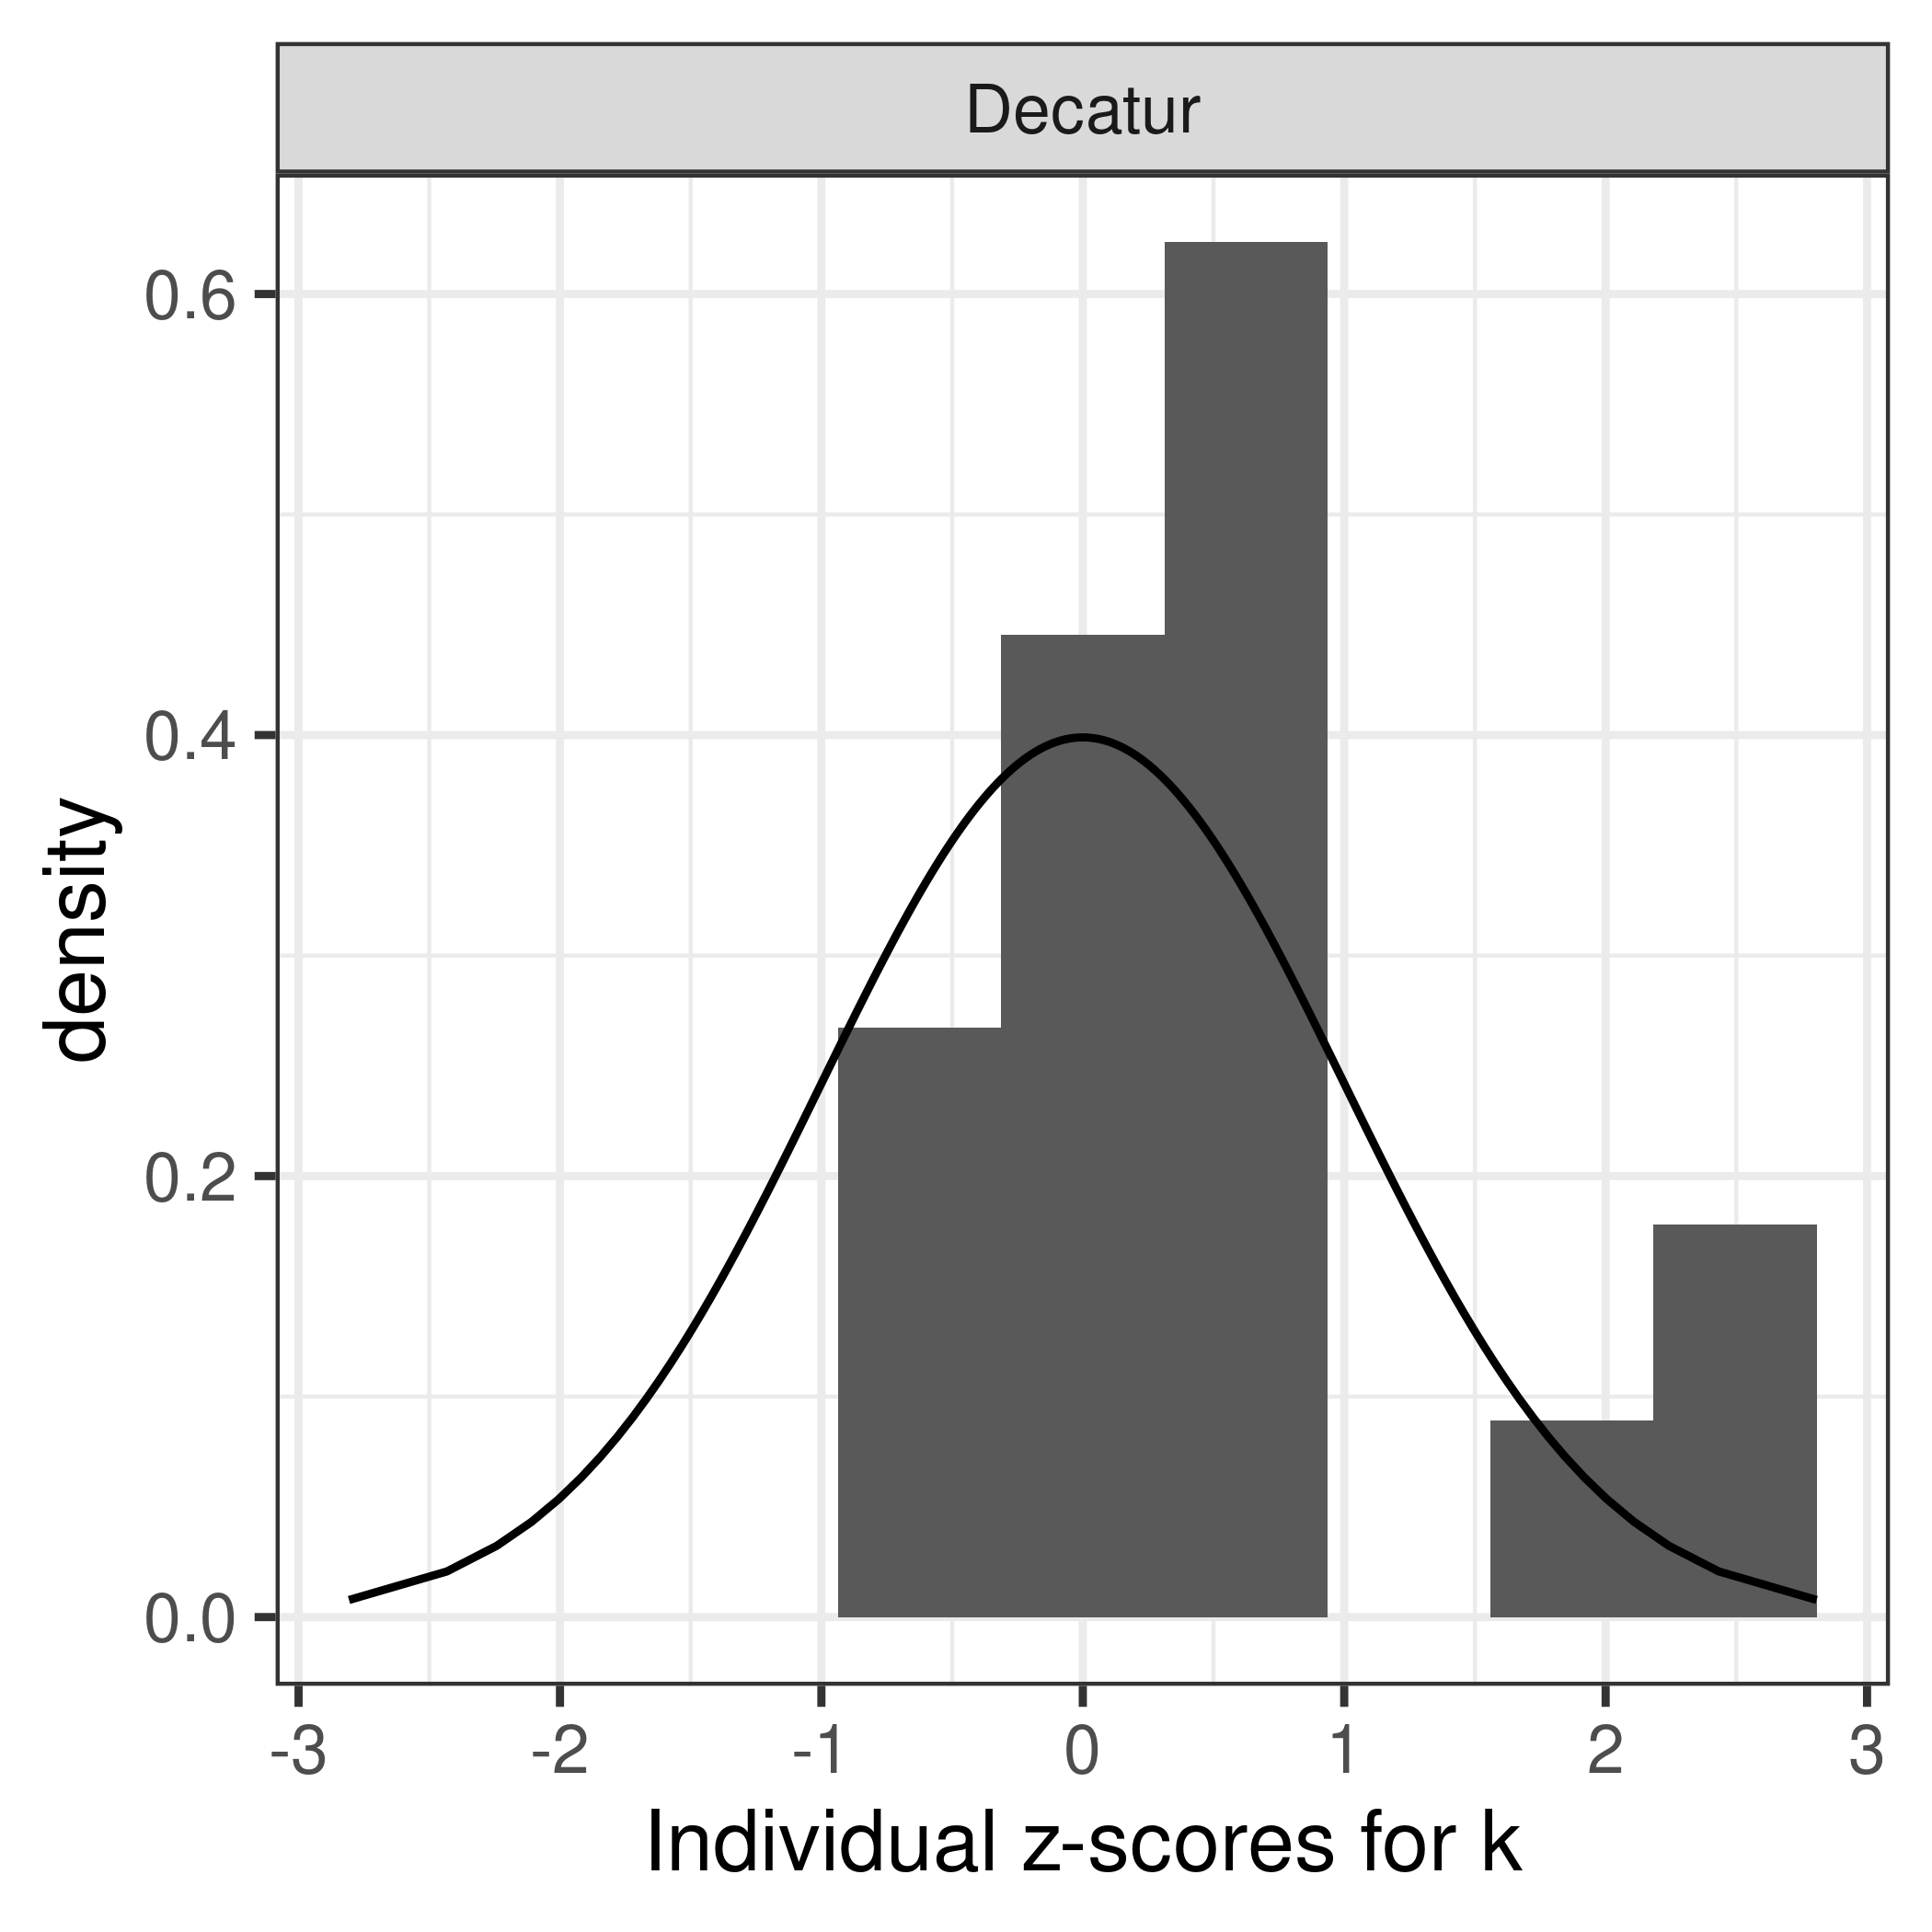

print(iplotVd)

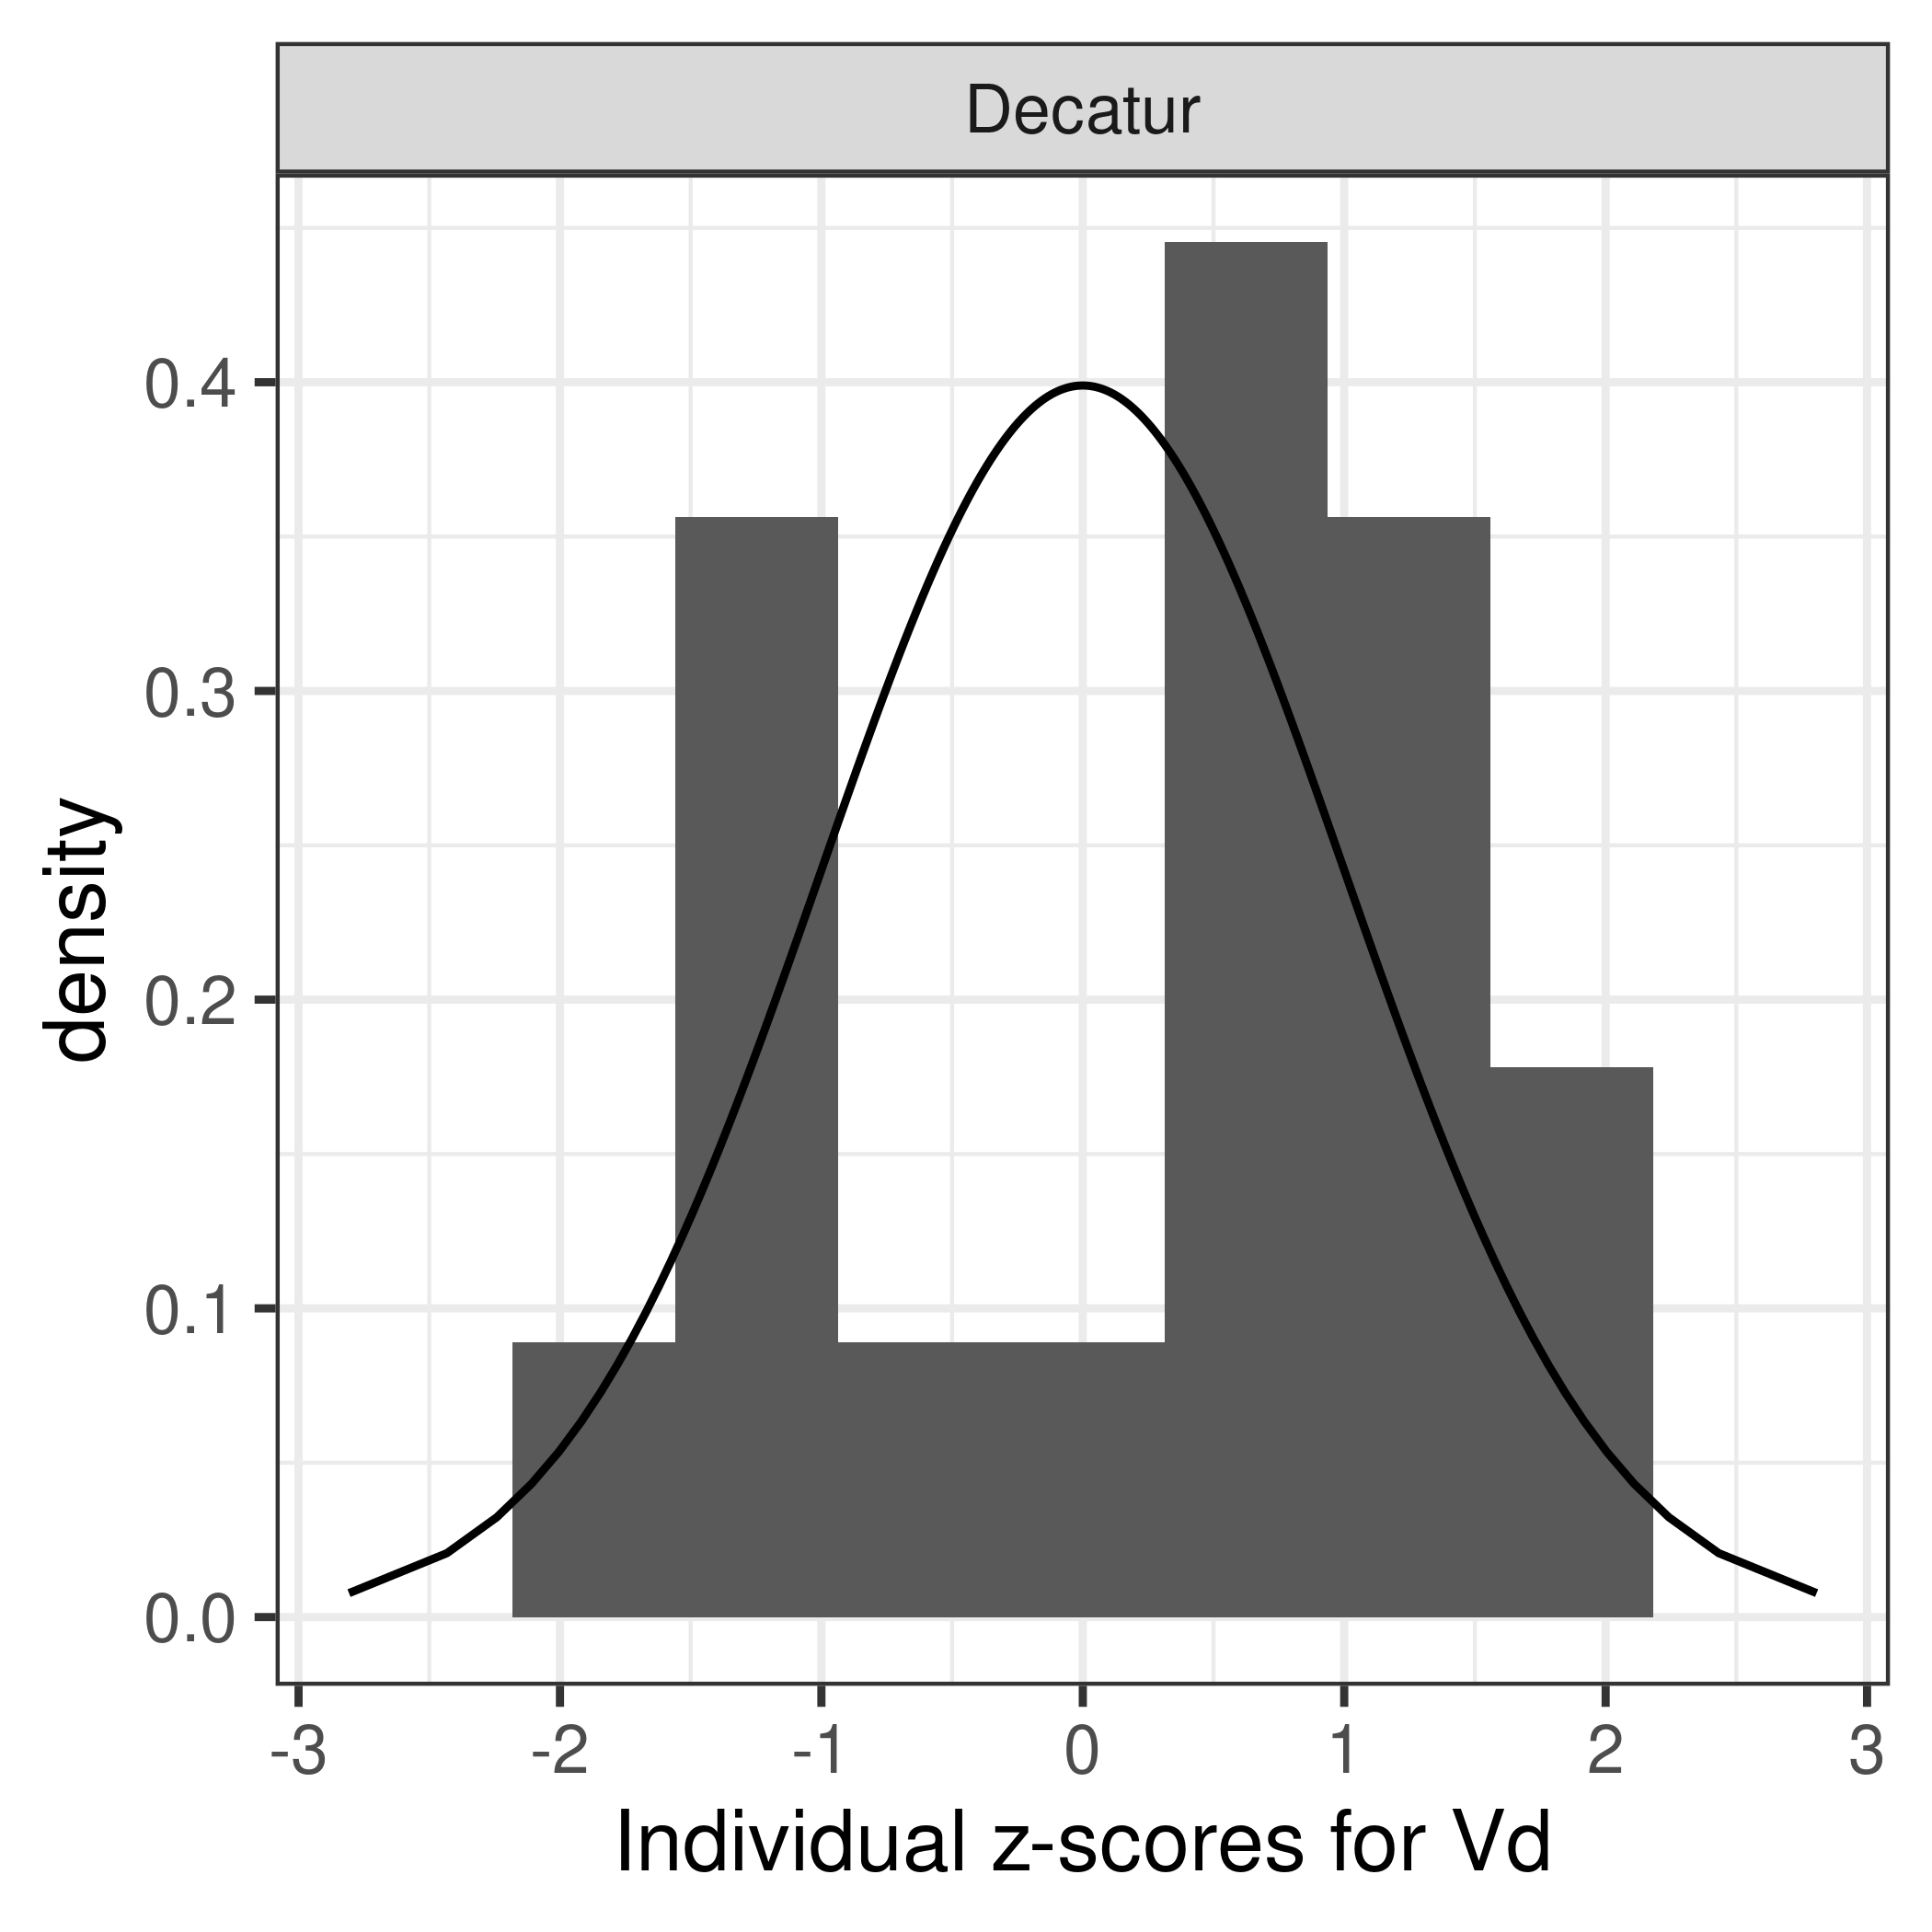

ggsave(file.path("output-plots",  
 paste0( sa,"Indiv_zscores_k_PFNA.pdf")),iplotk,dpi=600)

## Saving 3.5 x 3.5 in image

ggsave(file.path("output-plots",  
 paste0( sa,"Indiv_zscores_Vd_PFNA.pdf")),iplotVd,dpi=600)

## Saving 3.5 x 3.5 in image

ggsave(file.path("output-plots",  
 paste0( sa,"Indiv_zscores_k_PFNA.png")),iplotk,dpi=600)

## Saving 3.5 x 3.5 in image

ggsave(file.path("output-plots",  
 paste0( sa,"Indiv_zscores_Vd_PFNA.png")),iplotVd,dpi=600)

## Saving 3.5 x 3.5 in image

## Scatter plot of predictions (median of multicheck samples) versus data.

This is a Figure 2 panel. Needed to use “scale=1.1” in ggsave to match PFOA.

nrow(multicheck$df_check)

## [1] 38500

nrow(id_lut)

## [1] 40

multicheck$df_check %>% left_join(id_lut) %>% nrow()

## Joining, by = c("Level", "Simulation")

## [1] 38500

names(multicheck$df_check)

## [1] "Level" "Simulation" "Output_Var" "Time" "Data"   
## [6] "Prediction"

multicheck2 <- multicheck$df_check %>% left_join(id_lut)%>%   
 group_by_at ( vars(-Prediction)) %>%   
 summarise(Prediction = median(Prediction)) %>%  
 ungroup() %>%  
 group_by(City) %>%   
 mutate(Train_Test = factor(Train_Test, levels = c("Train", "Test")),  
 `City (datatype)` = factor (paste0("\n" , City, "\n(", datatype, ")\n") ),  
 label = case_when(Train_Test=="Train" ~ "E: PFNA Train",  
 Train_Test=="Test" ~ "F: PFNA Test",  
 TRUE ~ ""))

## Joining, by = c("Level", "Simulation")

## `summarise()` has grouped output by 'Level', 'Simulation', 'Output_Var', 'Time', 'Data', 'dataset', 'Sex', 'City', 'Train_Test', 'datatype'. You can override using the `.groups` argument.

#define color for testing boxplots  
bp_cols <- c (as.character (khroma::colour("muted")(9)) , "#191919")   
bp_cols <-bp_cols[c(1, 7, 9:8)]# plot_scheme_colourblind(bp_cols)   
  
### Create aesthetics lookup  
aes_lut <- multicheck2 %>% ungroup() %>%   
 group_by(City, datatype, `City (datatype)` ) %>% summarise () %>% ungroup() %>%  
 mutate( cols = bp_cols, city_fills = bp_cols ,   
 # for individual level on point plot (multicheck2), darken outlines for visibility, use standard colors otherwise  
 city_outlines = if_else(datatype == "Individual" , colorspace::darken(city_fills, 0.3), city_fills) ,   
 shapes = case_when(datatype == "Individual" & `City` %in% c('Decatur', 'Arnsberg', 'Minnesota') ~ 23,  
 datatype == "Summary" &`City` %in% c("Horsham", "Warminster", "Warrington") ~ 2,  
 datatype == "Summary" & `City` == "Paulsboro" ~ 1,  
 TRUE ~ 18 ),   
 size = if_else(datatype =="Individual", 1.75, 2.5 ) )

## `summarise()` has grouped output by 'City', 'datatype'. You can override using the `.groups` argument.

source( paste0(gsub(basename(here()), 'shared_functions', here()), '/plot_scatter_mcheck.r'))  
  
p2 <- plot_scatter_mcheck(dframe = multicheck2, pfas_nom = pfas_name, aes_lut_fn = aes_lut )

## Joining, by = "facet_label"

print(p2)

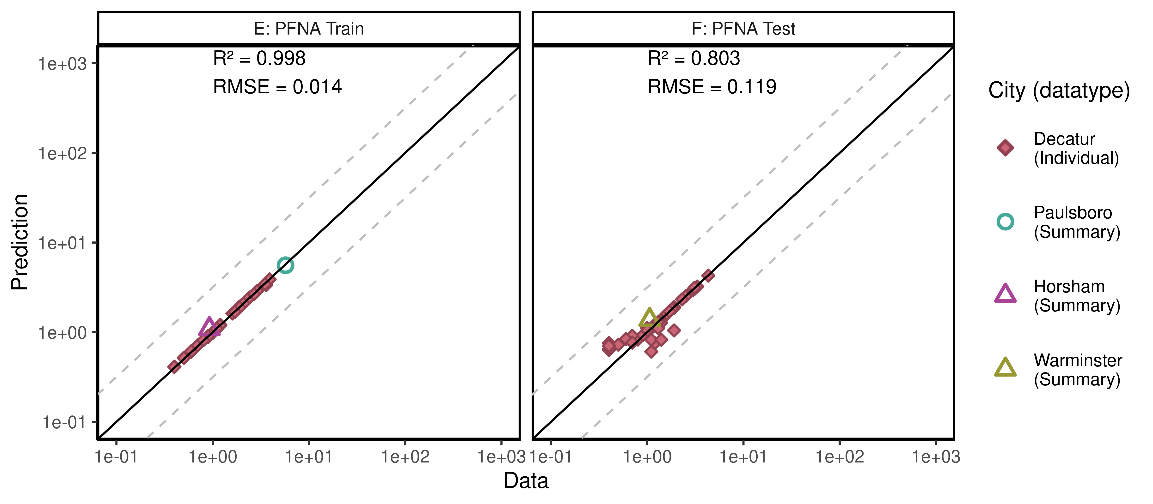

ggsave(here ("output-plots", paste0( sa,"multicheckplot_", pfas_name,  
 ".pdf")),p2,dpi=600, scale=1.1)

## Saving 8.8 x 3.85 in image

ggsave(here ("output-plots", paste0( sa,"multicheckplot_", pfas_name,  
 ".png")),p2,dpi=600, scale=1.1) # doesn't properly handle '\n' unicode for line feed. Not sure why; possibly device opens from windows working environment.

## Saving 8.8 x 3.85 in image

multicheck2$PFAS <- "PFNA"  
multiplot_scatter_dat <- list(aes_lut = aes_lut, multicheck2 = multicheck2) # save out for use in commbined plot  
save(multiplot_scatter_dat, file= "pfna_multiplot_scatter.Rdata")

## Parse multicheck

df_check <- multicheck$df_check  
df_check <- subset(df_check,Data > 0)   
  
n1 <- nrow(df_check)  
id_chks <- df_check %>% select(Level) %>% unique() %>% bind_cols(id_lut) %>%  
 mutate(dataset = as.factor(dataset), Sex = as.factor(Sex), City = as.factor(City),   
 Train_Test = as.factor(Train_Test))

## New names:  
## * Level -> Level...1  
## * Level -> Level...2

df_check <- df_check %>% left_join(id_chks, by = "Simulation")%>%  
 mutate(Dataset = paste(as.character(dataset), Simulation),  
 Sex = ordered(Sex, levels = c("M", "F", "Mixed"),   
 labels = c("Male", "Female", "Mixed (all sexes)")))  
n2 <- nrow(df_check)  
if(n1 != n2)print("duplicates created in id-lut join")

df_check$Time.desc <- as.character(paste0("T=",df_check$Time))  
df_check$Time.desc[df_check$Time.desc == "T=1e-06"] <- "SteadyState"  
df_check$Dataset.Time <- interaction(df_check$Dataset,  
 df_check$Time.desc,lex.order=TRUE)  
df_check$Dataset.Time <- factor(df_check$Dataset.Time,  
 levels=levels(df_check$Dataset.Time))  
calibdata <- df_check[,names(df_check) != "Prediction"]  
calibdata <- calibdata[!duplicated(calibdata),]  
print(calibdata)

## Level Simulation Output_Var Time Data Level...1 Level...2  
## 1 1_1_1_1_1 1 Cserum 0.000 1.900 1_1_1_1_1 1_1_1_1_1  
## 2 1_1_1_1_1 1 Cserum 5.802 1.100 1_1_1_1_1 1_1_1_1_1  
## 3 1_1_1_1_2 2 Cserum 0.000 1.100 1_1_1_1_2 1_1_1_1_2  
## 4 1_1_1_1_2 2 Cserum 5.802 0.900 1_1_1_1_2 1_1_1_1_2  
## 5 1_1_1_1_3 3 Cserum 0.000 2.100 1_1_1_1_3 1_1_1_1_3  
## 6 1_1_1_1_3 3 Cserum 5.802 0.700 1_1_1_1_3 1_1_1_1_3  
## 7 1_1_1_1_4 4 Cserum 0.000 1.900 1_1_1_1_4 1_1_1_1_4  
## 8 1_1_1_1_4 4 Cserum 5.802 0.500 1_1_1_1_4 1_1_1_1_4  
## 9 1_1_1_1_5 5 Cserum 0.000 3.500 1_1_1_1_5 1_1_1_1_5  
## 10 1_1_1_1_5 5 Cserum 5.802 0.900 1_1_1_1_5 1_1_1_1_5  
## 11 1_1_1_1_6 6 Cserum 0.000 1.200 1_1_1_1_6 1_1_1_1_6  
## 12 1_1_1_1_6 6 Cserum 5.802 0.600 1_1_1_1_6 1_1_1_1_6  
## 13 1_1_1_1_7 7 Cserum 0.000 2.700 1_1_1_1_7 1_1_1_1_7  
## 14 1_1_1_1_7 7 Cserum 5.802 0.800 1_1_1_1_7 1_1_1_1_7  
## 15 1_1_1_1_8 8 Cserum 0.000 1.700 1_1_1_1_8 1_1_1_1_8  
## 16 1_1_1_1_8 8 Cserum 5.802 0.500 1_1_1_1_8 1_1_1_1_8  
## 17 1_1_1_1_9 9 Cserum 0.000 1.100 1_1_1_1_9 1_1_1_1_9  
## 18 1_1_1_1_9 9 Cserum 5.802 0.600 1_1_1_1_9 1_1_1_1_9  
## 19 1_1_1_1_10 10 Cserum 0.000 1.600 1_1_1_1_10 1_1_1_1_10  
## 20 1_1_1_1_10 10 Cserum 5.802 1.000 1_1_1_1_10 1_1_1_1_10  
## 21 1_1_1_1_11 11 Cserum 0.000 2.000 1_1_1_1_11 1_1_1_1_11  
## 22 1_1_1_1_11 11 Cserum 5.802 1.100 1_1_1_1_11 1_1_1_1_11  
## 23 1_1_1_1_12 12 Cserum 0.000 1.000 1_1_1_1_12 1_1_1_1_12  
## 24 1_1_1_1_12 12 Cserum 5.802 0.400 1_1_1_1_12 1_1_1_1_12  
## 25 1_1_1_1_13 13 Cserum 0.000 1.700 1_1_1_1_13 1_1_1_1_13  
## 26 1_1_1_1_13 13 Cserum 5.802 0.400 1_1_1_1_13 1_1_1_1_13  
## 27 1_1_1_1_14 14 Cserum 0.000 3.900 1_1_1_1_14 1_1_1_1_14  
## 28 1_1_1_1_14 14 Cserum 5.802 1.200 1_1_1_1_14 1_1_1_1_14  
## 29 1_1_1_1_15 15 Cserum 0.000 2.400 1_1_1_1_15 1_1_1_1_15  
## 30 1_1_1_1_15 15 Cserum 5.802 3.600 1_1_1_1_15 1_1_1_1_15  
## 31 1_1_1_1_16 16 Cserum 0.000 1.200 1_1_1_1_16 1_1_1_1_16  
## 32 1_1_1_1_16 16 Cserum 5.802 0.600 1_1_1_1_16 1_1_1_1_16  
## 33 1_1_1_1_17 17 Cserum 0.000 2.900 1_1_1_1_17 1_1_1_1_17  
## 34 1_1_1_1_17 17 Cserum 5.802 0.900 1_1_1_1_17 1_1_1_1_17  
## 35 1_1_1_1_18 18 Cserum 0.000 1.200 1_1_1_1_18 1_1_1_1_18  
## 36 1_1_1_1_18 18 Cserum 5.802 0.400 1_1_1_1_18 1_1_1_1_18  
## 37 1_1_1_2_1 19 Cserum 0.000 1.500 1_1_1_2_1 1_1_1_2_1  
## 38 1_1_1_2_1 19 Cserum 5.802 0.400 1_1_1_2_1 1_1_1_2_1  
## 39 1_1_1_2_2 20 Cserum 0.000 3.300 1_1_1_2_2 1_1_1_2_2  
## 40 1_1_1_2_2 20 Cserum 5.802 1.000 1_1_1_2_2 1_1_1_2_2  
## 41 1_1_1_2_3 21 Cserum 0.000 1.800 1_1_1_2_3 1_1_1_2_3  
## 42 1_1_1_2_3 21 Cserum 5.802 0.600 1_1_1_2_3 1_1_1_2_3  
## 43 1_1_1_2_4 22 Cserum 0.000 1.600 1_1_1_2_4 1_1_1_2_4  
## 44 1_1_1_2_4 22 Cserum 5.802 0.700 1_1_1_2_4 1_1_1_2_4  
## 45 1_1_1_2_5 23 Cserum 0.000 4.300 1_1_1_2_5 1_1_1_2_5  
## 46 1_1_1_2_5 23 Cserum 5.802 1.400 1_1_1_2_5 1_1_1_2_5  
## 47 1_1_1_2_6 24 Cserum 0.000 1.700 1_1_1_2_6 1_1_1_2_6  
## 48 1_1_1_2_6 24 Cserum 5.802 1.400 1_1_1_2_6 1_1_1_2_6  
## 49 1_1_1_2_7 25 Cserum 0.000 1.300 1_1_1_2_7 1_1_1_2_7  
## 50 1_1_1_2_7 25 Cserum 5.802 0.400 1_1_1_2_7 1_1_1_2_7  
## 51 1_1_1_2_8 26 Cserum 0.000 3.000 1_1_1_2_8 1_1_1_2_8  
## 52 1_1_1_2_8 26 Cserum 5.802 1.000 1_1_1_2_8 1_1_1_2_8  
## 53 1_1_1_2_9 27 Cserum 0.000 3.100 1_1_1_2_9 1_1_1_2_9  
## 54 1_1_1_2_9 27 Cserum 5.802 1.300 1_1_1_2_9 1_1_1_2_9  
## 55 1_1_1_2_10 28 Cserum 0.000 1.500 1_1_1_2_10 1_1_1_2_10  
## 56 1_1_1_2_10 28 Cserum 5.802 1.200 1_1_1_2_10 1_1_1_2_10  
## 57 1_1_1_2_11 29 Cserum 0.000 3.100 1_1_1_2_11 1_1_1_2_11  
## 58 1_1_1_2_11 29 Cserum 5.802 1.900 1_1_1_2_11 1_1_1_2_11  
## 59 1_1_1_2_12 30 Cserum 0.000 1.900 1_1_1_2_12 1_1_1_2_12  
## 60 1_1_1_2_12 30 Cserum 5.802 0.800 1_1_1_2_12 1_1_1_2_12  
## 61 1_1_1_2_13 31 Cserum 0.000 1.000 1_1_1_2_13 1_1_1_2_13  
## 62 1_1_1_2_13 31 Cserum 5.802 1.100 1_1_1_2_13 1_1_1_2_13  
## 63 1_1_1_2_14 32 Cserum 0.000 1.200 1_1_1_2_14 1_1_1_2_14  
## 64 1_1_1_2_14 32 Cserum 5.802 0.400 1_1_1_2_14 1_1_1_2_14  
## 65 1_1_1_2_15 33 Cserum 0.000 2.500 1_1_1_2_15 1_1_1_2_15  
## 66 1_1_1_2_15 33 Cserum 5.802 0.900 1_1_1_2_15 1_1_1_2_15  
## 67 1_1_1_2_16 34 Cserum 0.000 1.200 1_1_1_2_16 1_1_1_2_16  
## 68 1_1_1_2_16 34 Cserum 5.802 0.400 1_1_1_2_16 1_1_1_2_16  
## 69 1_1_1_2_17 35 Cserum 0.000 2.300 1_1_1_2_17 1_1_1_2_17  
## 70 1_1_1_2_17 35 Cserum 5.802 0.700 1_1_1_2_17 1_1_1_2_17  
## 71 1_1_1_2_18 36 Cserum 0.000 1.500 1_1_1_2_18 1_1_1_2_18  
## 72 1_1_1_2_18 36 Cserum 5.802 0.500 1_1_1_2_18 1_1_1_2_18  
## 73 1_1_1_2_19 37 Cserum 0.000 1.900 1_1_1_2_19 1_1_1_2_19  
## 74 1_1_1_2_19 37 Cserum 5.802 1.100 1_1_1_2_19 1_1_1_2_19  
## 75 1_2_1 38 M_Cbgd_Css 2.200 5.710 1_2_1 1_2_1  
## 76 1_3_1 39 M_Cbgd_Css 2.000 0.925 1_3_1 1_3_1  
## 77 1_4_1 40 M_Cbgd_Css 2.000 1.060 1_4_1 1_4_1  
## dataset Sex City Train_Test datatype  
## 1 Decatur M Train Male Decatur Train Individual  
## 2 Decatur M Train Male Decatur Train Individual  
## 3 Decatur M Train Male Decatur Train Individual  
## 4 Decatur M Train Male Decatur Train Individual  
## 5 Decatur M Train Male Decatur Train Individual  
## 6 Decatur M Train Male Decatur Train Individual  
## 7 Decatur M Train Male Decatur Train Individual  
## 8 Decatur M Train Male Decatur Train Individual  
## 9 Decatur M Train Male Decatur Train Individual  
## 10 Decatur M Train Male Decatur Train Individual  
## 11 Decatur M Train Male Decatur Train Individual  
## 12 Decatur M Train Male Decatur Train Individual  
## 13 Decatur M Train Male Decatur Train Individual  
## 14 Decatur M Train Male Decatur Train Individual  
## 15 Decatur M Train Male Decatur Train Individual  
## 16 Decatur M Train Male Decatur Train Individual  
## 17 Decatur M Train Male Decatur Train Individual  
## 18 Decatur M Train Male Decatur Train Individual  
## 19 Decatur F Train Female Decatur Train Individual  
## 20 Decatur F Train Female Decatur Train Individual  
## 21 Decatur F Train Female Decatur Train Individual  
## 22 Decatur F Train Female Decatur Train Individual  
## 23 Decatur F Train Female Decatur Train Individual  
## 24 Decatur F Train Female Decatur Train Individual  
## 25 Decatur F Train Female Decatur Train Individual  
## 26 Decatur F Train Female Decatur Train Individual  
## 27 Decatur F Train Female Decatur Train Individual  
## 28 Decatur F Train Female Decatur Train Individual  
## 29 Decatur F Train Female Decatur Train Individual  
## 30 Decatur F Train Female Decatur Train Individual  
## 31 Decatur F Train Female Decatur Train Individual  
## 32 Decatur F Train Female Decatur Train Individual  
## 33 Decatur F Train Female Decatur Train Individual  
## 34 Decatur F Train Female Decatur Train Individual  
## 35 Decatur F Train Female Decatur Train Individual  
## 36 Decatur F Train Female Decatur Train Individual  
## 37 Decatur M Test Male Decatur Test Individual  
## 38 Decatur M Test Male Decatur Test Individual  
## 39 Decatur M Test Male Decatur Test Individual  
## 40 Decatur M Test Male Decatur Test Individual  
## 41 Decatur M Test Male Decatur Test Individual  
## 42 Decatur M Test Male Decatur Test Individual  
## 43 Decatur M Test Male Decatur Test Individual  
## 44 Decatur M Test Male Decatur Test Individual  
## 45 Decatur M Test Male Decatur Test Individual  
## 46 Decatur M Test Male Decatur Test Individual  
## 47 Decatur M Test Male Decatur Test Individual  
## 48 Decatur M Test Male Decatur Test Individual  
## 49 Decatur M Test Male Decatur Test Individual  
## 50 Decatur M Test Male Decatur Test Individual  
## 51 Decatur M Test Male Decatur Test Individual  
## 52 Decatur M Test Male Decatur Test Individual  
## 53 Decatur M Test Male Decatur Test Individual  
## 54 Decatur M Test Male Decatur Test Individual  
## 55 Decatur F Test Female Decatur Test Individual  
## 56 Decatur F Test Female Decatur Test Individual  
## 57 Decatur F Test Female Decatur Test Individual  
## 58 Decatur F Test Female Decatur Test Individual  
## 59 Decatur F Test Female Decatur Test Individual  
## 60 Decatur F Test Female Decatur Test Individual  
## 61 Decatur F Test Female Decatur Test Individual  
## 62 Decatur F Test Female Decatur Test Individual  
## 63 Decatur F Test Female Decatur Test Individual  
## 64 Decatur F Test Female Decatur Test Individual  
## 65 Decatur F Test Female Decatur Test Individual  
## 66 Decatur F Test Female Decatur Test Individual  
## 67 Decatur F Test Female Decatur Test Individual  
## 68 Decatur F Test Female Decatur Test Individual  
## 69 Decatur F Test Female Decatur Test Individual  
## 70 Decatur F Test Female Decatur Test Individual  
## 71 Decatur F Test Female Decatur Test Individual  
## 72 Decatur F Test Female Decatur Test Individual  
## 73 Decatur F Test Female Decatur Test Individual  
## 74 Decatur F Test Female Decatur Test Individual  
## 75 Paulsboro-Train Mixed (all sexes) Paulsboro Train Summary  
## 76 Horsham-Train Mixed (all sexes) Horsham Train Summary  
## 77 Warminster-Test Mixed (all sexes) Warminster Test Summary  
## variable Dataset Time.desc Dataset.Time  
## 1 Decatur M Train 1 Decatur M Train 1 T=0 Decatur M Train 1.T=0  
## 2 Decatur M Train 1 Decatur M Train 1 T=5.802 Decatur M Train 1.T=5.802  
## 3 Decatur M Train 2 Decatur M Train 2 T=0 Decatur M Train 2.T=0  
## 4 Decatur M Train 2 Decatur M Train 2 T=5.802 Decatur M Train 2.T=5.802  
## 5 Decatur M Train 3 Decatur M Train 3 T=0 Decatur M Train 3.T=0  
## 6 Decatur M Train 3 Decatur M Train 3 T=5.802 Decatur M Train 3.T=5.802  
## 7 Decatur M Train 4 Decatur M Train 4 T=0 Decatur M Train 4.T=0  
## 8 Decatur M Train 4 Decatur M Train 4 T=5.802 Decatur M Train 4.T=5.802  
## 9 Decatur M Train 5 Decatur M Train 5 T=0 Decatur M Train 5.T=0  
## 10 Decatur M Train 5 Decatur M Train 5 T=5.802 Decatur M Train 5.T=5.802  
## 11 Decatur M Train 6 Decatur M Train 6 T=0 Decatur M Train 6.T=0  
## 12 Decatur M Train 6 Decatur M Train 6 T=5.802 Decatur M Train 6.T=5.802  
## 13 Decatur M Train 7 Decatur M Train 7 T=0 Decatur M Train 7.T=0  
## 14 Decatur M Train 7 Decatur M Train 7 T=5.802 Decatur M Train 7.T=5.802  
## 15 Decatur M Train 8 Decatur M Train 8 T=0 Decatur M Train 8.T=0  
## 16 Decatur M Train 8 Decatur M Train 8 T=5.802 Decatur M Train 8.T=5.802  
## 17 Decatur M Train 9 Decatur M Train 9 T=0 Decatur M Train 9.T=0  
## 18 Decatur M Train 9 Decatur M Train 9 T=5.802 Decatur M Train 9.T=5.802  
## 19 Decatur F Train 10 Decatur F Train 10 T=0 Decatur F Train 10.T=0  
## 20 Decatur F Train 10 Decatur F Train 10 T=5.802 Decatur F Train 10.T=5.802  
## 21 Decatur F Train 11 Decatur F Train 11 T=0 Decatur F Train 11.T=0  
## 22 Decatur F Train 11 Decatur F Train 11 T=5.802 Decatur F Train 11.T=5.802  
## 23 Decatur F Train 12 Decatur F Train 12 T=0 Decatur F Train 12.T=0  
## 24 Decatur F Train 12 Decatur F Train 12 T=5.802 Decatur F Train 12.T=5.802  
## 25 Decatur F Train 13 Decatur F Train 13 T=0 Decatur F Train 13.T=0  
## 26 Decatur F Train 13 Decatur F Train 13 T=5.802 Decatur F Train 13.T=5.802  
## 27 Decatur F Train 14 Decatur F Train 14 T=0 Decatur F Train 14.T=0  
## 28 Decatur F Train 14 Decatur F Train 14 T=5.802 Decatur F Train 14.T=5.802  
## 29 Decatur F Train 15 Decatur F Train 15 T=0 Decatur F Train 15.T=0  
## 30 Decatur F Train 15 Decatur F Train 15 T=5.802 Decatur F Train 15.T=5.802  
## 31 Decatur F Train 16 Decatur F Train 16 T=0 Decatur F Train 16.T=0  
## 32 Decatur F Train 16 Decatur F Train 16 T=5.802 Decatur F Train 16.T=5.802  
## 33 Decatur F Train 17 Decatur F Train 17 T=0 Decatur F Train 17.T=0  
## 34 Decatur F Train 17 Decatur F Train 17 T=5.802 Decatur F Train 17.T=5.802  
## 35 Decatur F Train 18 Decatur F Train 18 T=0 Decatur F Train 18.T=0  
## 36 Decatur F Train 18 Decatur F Train 18 T=5.802 Decatur F Train 18.T=5.802  
## 37 Decatur M Test 19 Decatur M Test 19 T=0 Decatur M Test 19.T=0  
## 38 Decatur M Test 19 Decatur M Test 19 T=5.802 Decatur M Test 19.T=5.802  
## 39 Decatur M Test 20 Decatur M Test 20 T=0 Decatur M Test 20.T=0  
## 40 Decatur M Test 20 Decatur M Test 20 T=5.802 Decatur M Test 20.T=5.802  
## 41 Decatur M Test 21 Decatur M Test 21 T=0 Decatur M Test 21.T=0  
## 42 Decatur M Test 21 Decatur M Test 21 T=5.802 Decatur M Test 21.T=5.802  
## 43 Decatur M Test 22 Decatur M Test 22 T=0 Decatur M Test 22.T=0  
## 44 Decatur M Test 22 Decatur M Test 22 T=5.802 Decatur M Test 22.T=5.802  
## 45 Decatur M Test 23 Decatur M Test 23 T=0 Decatur M Test 23.T=0  
## 46 Decatur M Test 23 Decatur M Test 23 T=5.802 Decatur M Test 23.T=5.802  
## 47 Decatur M Test 24 Decatur M Test 24 T=0 Decatur M Test 24.T=0  
## 48 Decatur M Test 24 Decatur M Test 24 T=5.802 Decatur M Test 24.T=5.802  
## 49 Decatur M Test 25 Decatur M Test 25 T=0 Decatur M Test 25.T=0  
## 50 Decatur M Test 25 Decatur M Test 25 T=5.802 Decatur M Test 25.T=5.802  
## 51 Decatur M Test 26 Decatur M Test 26 T=0 Decatur M Test 26.T=0  
## 52 Decatur M Test 26 Decatur M Test 26 T=5.802 Decatur M Test 26.T=5.802  
## 53 Decatur M Test 27 Decatur M Test 27 T=0 Decatur M Test 27.T=0  
## 54 Decatur M Test 27 Decatur M Test 27 T=5.802 Decatur M Test 27.T=5.802  
## 55 Decatur F Test 28 Decatur F Test 28 T=0 Decatur F Test 28.T=0  
## 56 Decatur F Test 28 Decatur F Test 28 T=5.802 Decatur F Test 28.T=5.802  
## 57 Decatur F Test 29 Decatur F Test 29 T=0 Decatur F Test 29.T=0  
## 58 Decatur F Test 29 Decatur F Test 29 T=5.802 Decatur F Test 29.T=5.802  
## 59 Decatur F Test 30 Decatur F Test 30 T=0 Decatur F Test 30.T=0  
## 60 Decatur F Test 30 Decatur F Test 30 T=5.802 Decatur F Test 30.T=5.802  
## 61 Decatur F Test 31 Decatur F Test 31 T=0 Decatur F Test 31.T=0  
## 62 Decatur F Test 31 Decatur F Test 31 T=5.802 Decatur F Test 31.T=5.802  
## 63 Decatur F Test 32 Decatur F Test 32 T=0 Decatur F Test 32.T=0  
## 64 Decatur F Test 32 Decatur F Test 32 T=5.802 Decatur F Test 32.T=5.802  
## 65 Decatur F Test 33 Decatur F Test 33 T=0 Decatur F Test 33.T=0  
## 66 Decatur F Test 33 Decatur F Test 33 T=5.802 Decatur F Test 33.T=5.802  
## 67 Decatur F Test 34 Decatur F Test 34 T=0 Decatur F Test 34.T=0  
## 68 Decatur F Test 34 Decatur F Test 34 T=5.802 Decatur F Test 34.T=5.802  
## 69 Decatur F Test 35 Decatur F Test 35 T=0 Decatur F Test 35.T=0  
## 70 Decatur F Test 35 Decatur F Test 35 T=5.802 Decatur F Test 35.T=5.802  
## 71 Decatur F Test 36 Decatur F Test 36 T=0 Decatur F Test 36.T=0  
## 72 Decatur F Test 36 Decatur F Test 36 T=5.802 Decatur F Test 36.T=5.802  
## 73 Decatur F Test 37 Decatur F Test 37 T=0 Decatur F Test 37.T=0  
## 74 Decatur F Test 37 Decatur F Test 37 T=5.802 Decatur F Test 37.T=5.802  
## 75 Paulsboro-Train 38 Paulsboro-Train 38 T=2.2 Paulsboro-Train 38.T=2.2  
## 76 Horsham-Train 39 Horsham-Train 39 T=2 Horsham-Train 39.T=2  
## 77 Warminster-Test 40 Warminster-Test 40 T=2 Warminster-Test 40.T=2

#Multicheck plot  
  
# Split Steady State Group into different populations for boxplot grouping  
#df_check[df_check$Time.desc == "SteadyState" & grepl("Lubeck",df_check$Dataset),]$Time.desc <- "Lubeck"  
#df_check[df_check$Time.desc == "SteadyState" & grepl("Little Hocking",df_check$Dataset),]$Time.desc <- "Little Hocking"

Modify aesthetics lookup table for boxplots

## additional source aesthetic lookup table for grey-scale time (years); merged legends save space on plotting output  
times <- df_check%>% select(Time.desc, Time) %>% unique () %>%   
 mutate(rank = rank(Time) , grey = grey.colors(start=1,end=0.4, n = n()),  
 alpha = (rank)/8) %>%   
 select(-Time)  
   
df_check <- df_check %>% mutate (legend_label = (paste0(City, "\n", Time.desc ) )) # add legend-labels  
aes_lut <- df_check %>%   
 select(City, Train_Test, datatype,Time, Time.desc, legend_label) %>% unique () %>%  
 left_join(aes_lut[, c("City", "cols")], by = "City") %>% ungroup () %>% unique ()%>%  
 left_join (times, by = "Time.desc") %>%   
 arrange(datatype, City, Train_Test, Time) %>%   
 mutate(alpha = if_else(City == "Horsham", alpha/2, alpha)) %>% # otherwise too dark with this color  
 mutate_if(is.factor, as.character)

## Decatur boxplots

Changed grey start to 1 instead of 0.8, end at 0.6 instead of 0.4. Changed shape of symbols so they are filled.

##EF  
  
df_decat <- df_check %>%   
 filter(City == "Decatur" & Train_Test %in% c ("Train", "Test")) %>%   
 mutate(panel = ordered (Train_Test, levels = c ("Train", "Test"),   
 labels = c("E: PFNA Decatur Train", "F: PFNA Decatur Test") ))  
  
aes_lut_df_df_decat <- aes_lut %>%   
 filter(City == "Decatur" & Train_Test %in% c ("Train", "Test")) %>%   
 mutate_if(is.factor, as.character)   
  
source( paste0(gsub(basename(here()), 'shared_functions', here()), '/plot_sum_boxplot.r'))  
  
  
plt_train <- plot_sum_boxplot (dframe = df_decat, aes_lut= aes_lut_df_df_decat, facets = TRUE , pfas_nom = pfas_name )   
print(plt_train)

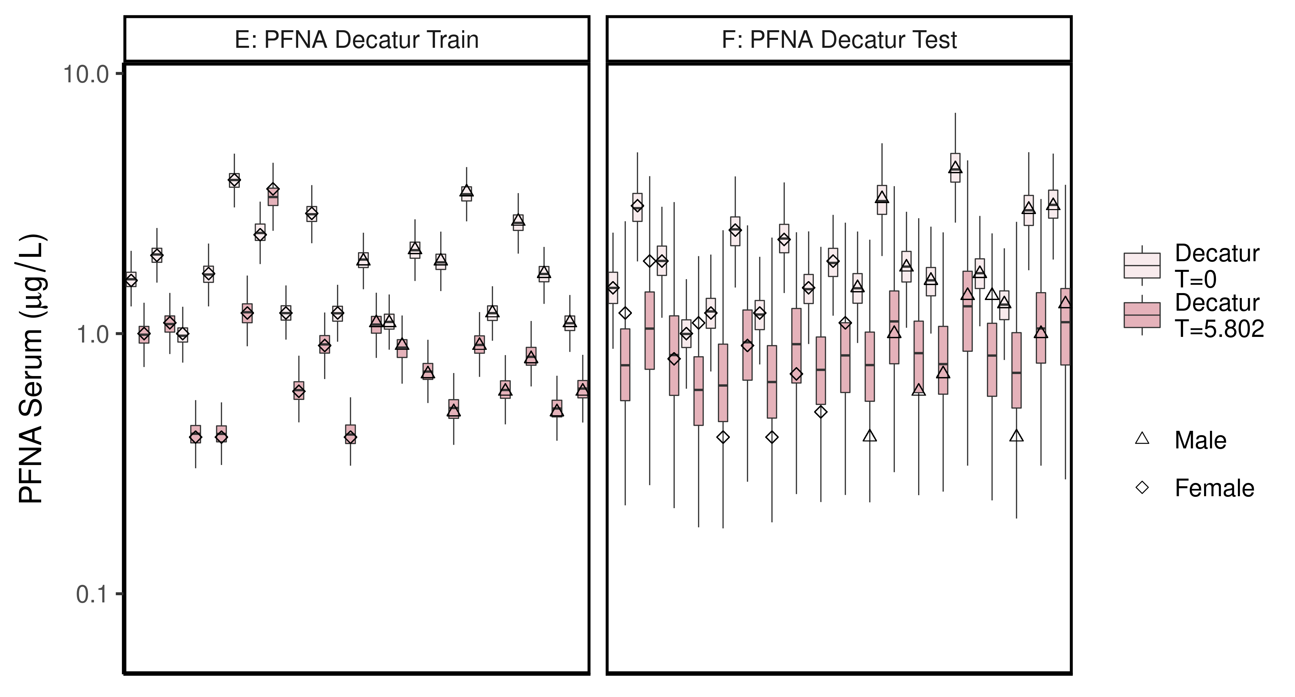

ggsave(here ("output-plots",paste0( sa,"DecaturTrainTestboxplot",pfas_name,".pdf")),plt_train,dpi=600)

## Saving 6.5 x 3.5 in image

ggsave(here ("output-plots",paste0( sa,"DecaturTrainTestboxplot",pfas_name,".png")),plt_train,dpi=600)

## Saving 6.5 x 3.5 in image

## All boxplots

Changed grey start to 1 instead of 0.8, end at 0.6 instead of 0.4. Added shapes and fills to data points.

lets <- LETTERS;  
names(lets)[1:(length(unique(df_check$dataset))-4)]<-as.character(unique(df_check$dataset))[5:length(unique(df_check$dataset))]  
  
for (d in unique(df_check$dataset)) { # d = unique(df_check$dataset)[11]  
 ddset <- df_check %>%   
 filter(dataset == d)   
   
 aes_lut_ddset <- ddset %>% select(legend_label, City,Train_Test,datatype, Time.desc ) %>% unique () %>% inner_join(aes_lut)  
   
 gt <- ifelse(is.na(lets[d]),d,paste0(lets[d],": ", d))  
 plt <- plot_sum_boxplot(dframe = ddset, aes_lut= aes_lut_ddset, gtitle= gt, facets = FALSE, pfas_nom = pfas_name)  
   
 print(plt)  
 ggsave(here ("output-plots",  
 paste0( sa, d,"-boxplot-",   
 pfas_name,".pdf")) ,  
 plt,dpi=600)  
 ggsave(here ("output-plots",  
 paste0( sa, d,"-boxplot-",   
 pfas_name,".png")) ,  
 plt,dpi=600)  
  
  
}

## Joining, by = c("legend_label", "City", "Train_Test", "datatype", "Time.desc")

## Saving 6.5 x 3.5 in image  
## Saving 6.5 x 3.5 in image

## Joining, by = c("legend_label", "City", "Train_Test", "datatype", "Time.desc")

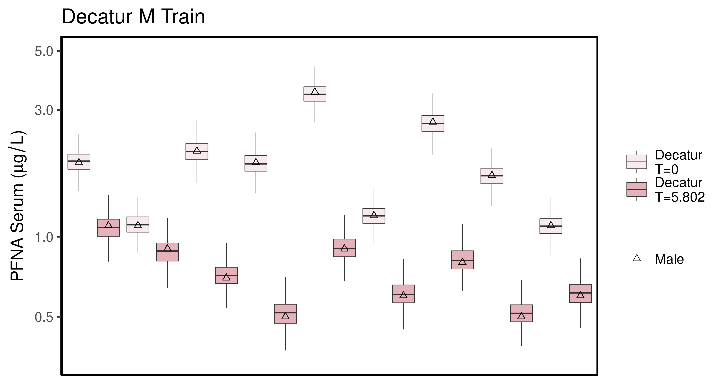

## Saving 6.5 x 3.5 in image

## Saving 6.5 x 3.5 in image

## Joining, by = c("legend_label", "City", "Train_Test", "datatype", "Time.desc")

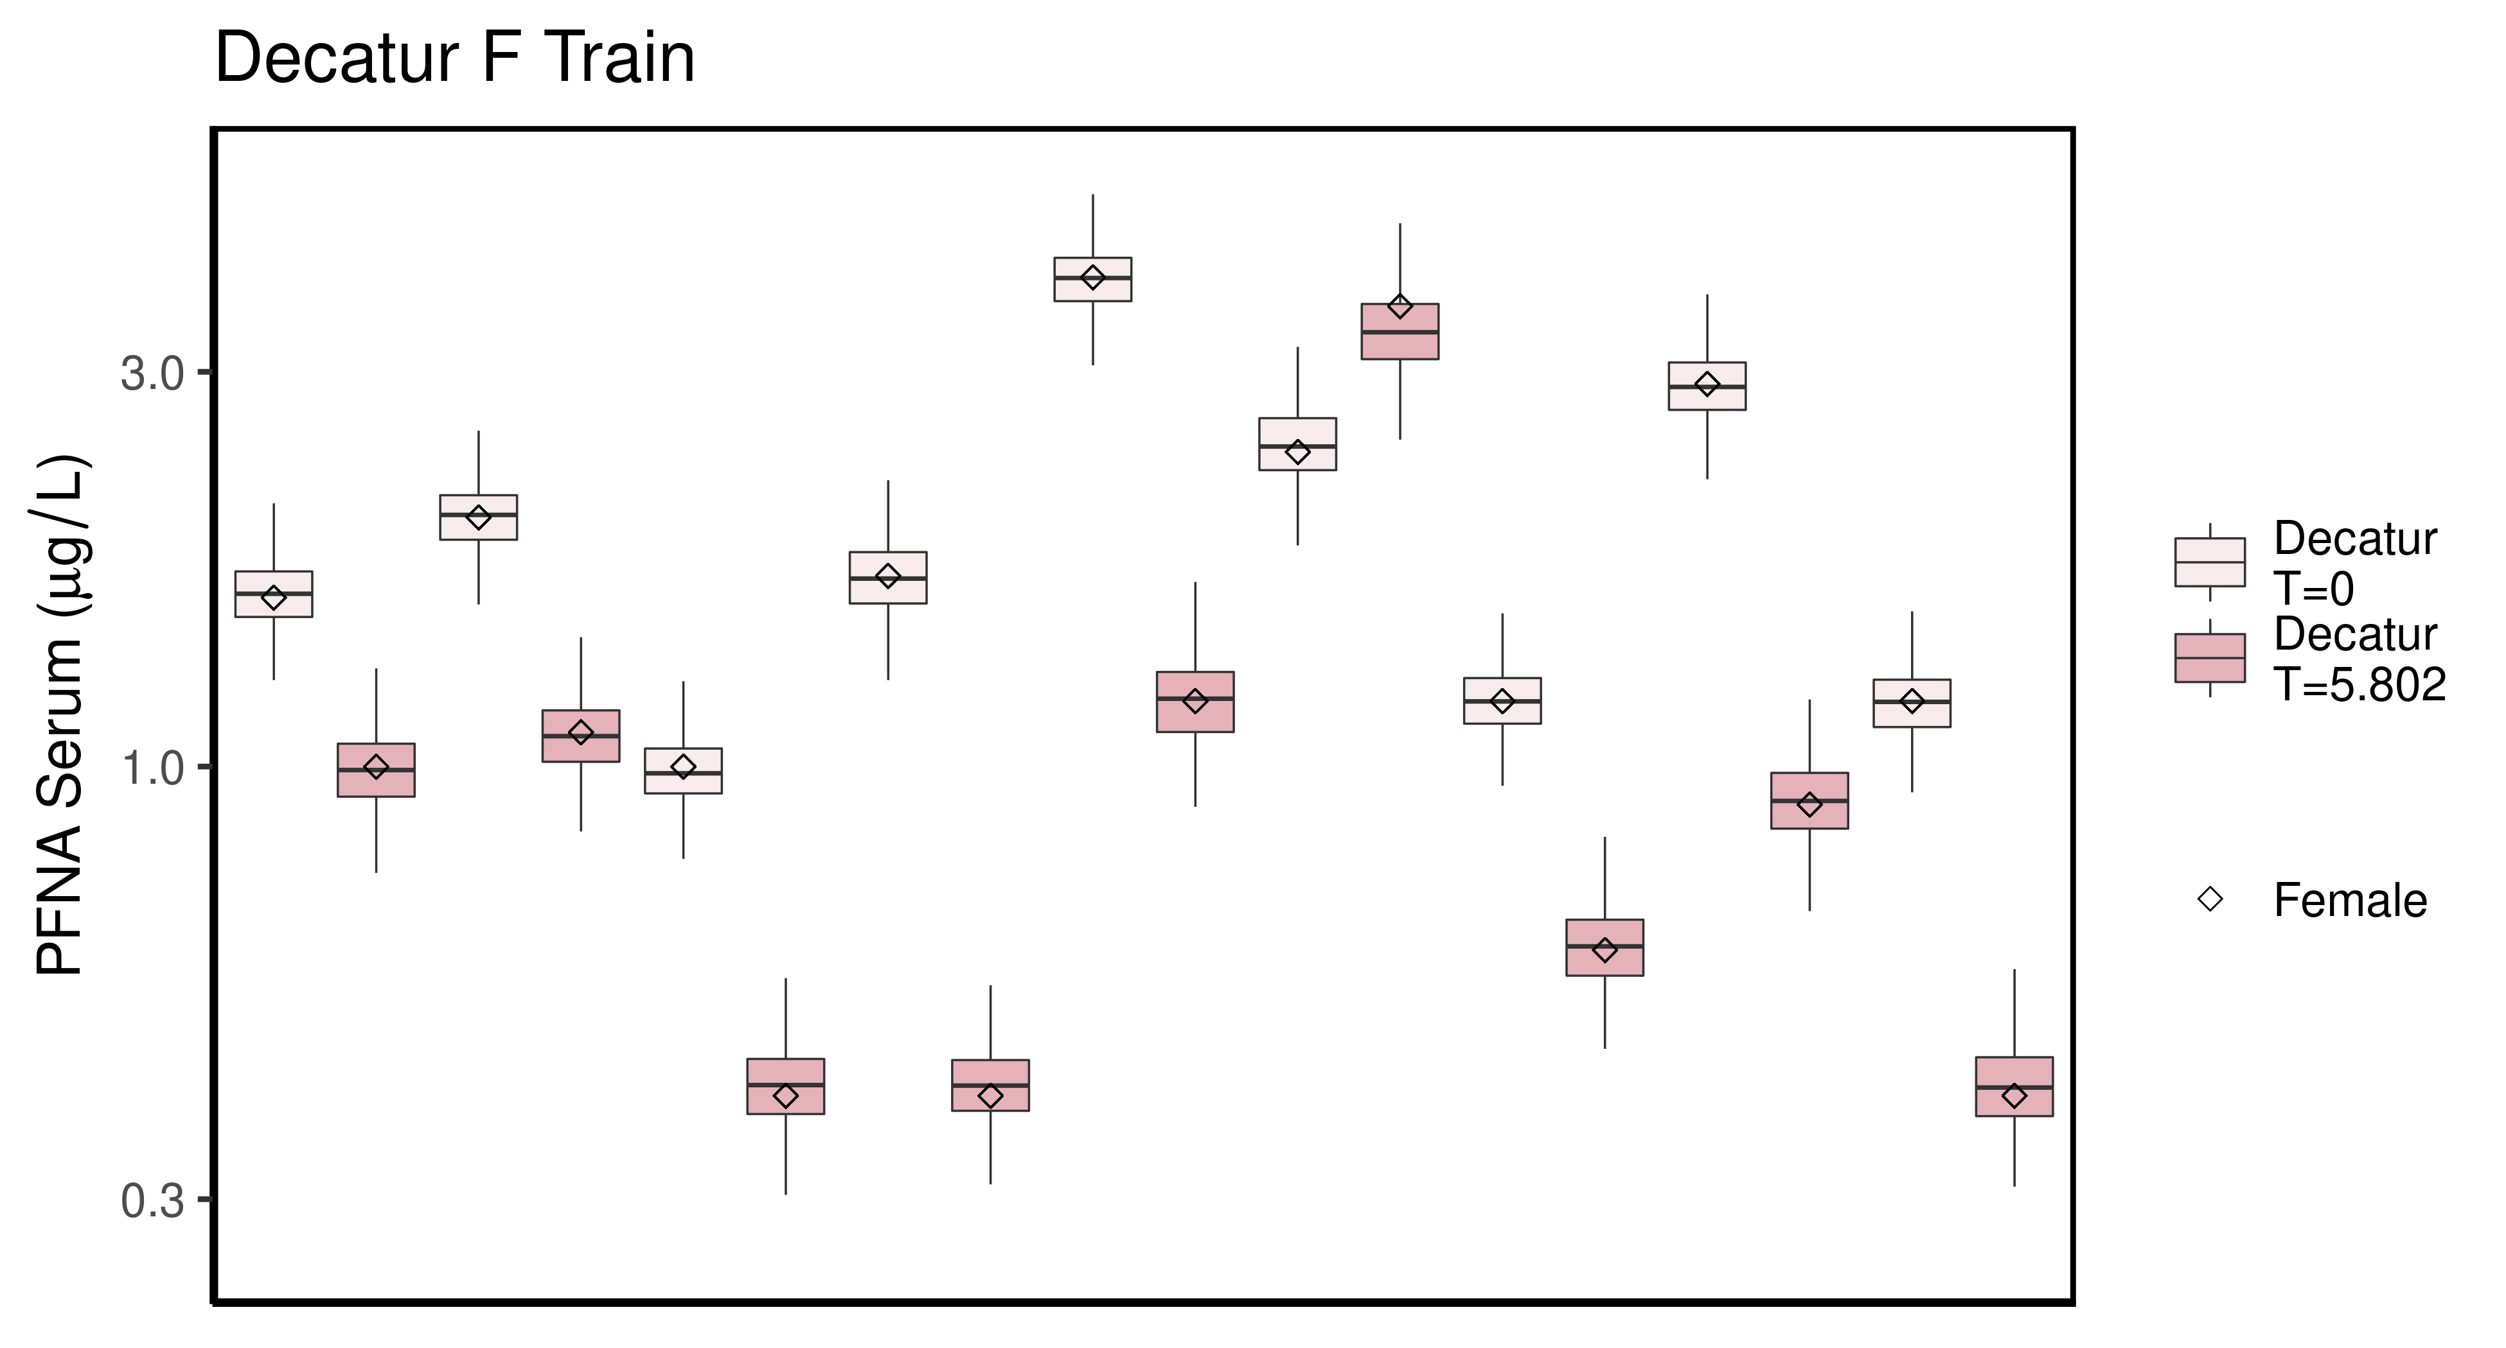

## Saving 6.5 x 3.5 in image

## Saving 6.5 x 3.5 in image

## Joining, by = c("legend_label", "City", "Train_Test", "datatype", "Time.desc")

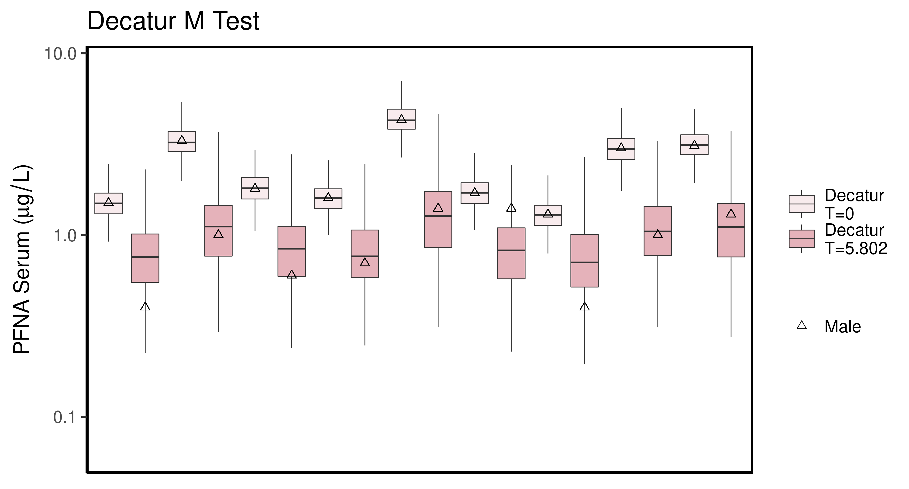

## Saving 6.5 x 3.5 in image

## Saving 6.5 x 3.5 in image

## Joining, by = c("legend_label", "City", "Train_Test", "datatype", "Time.desc")

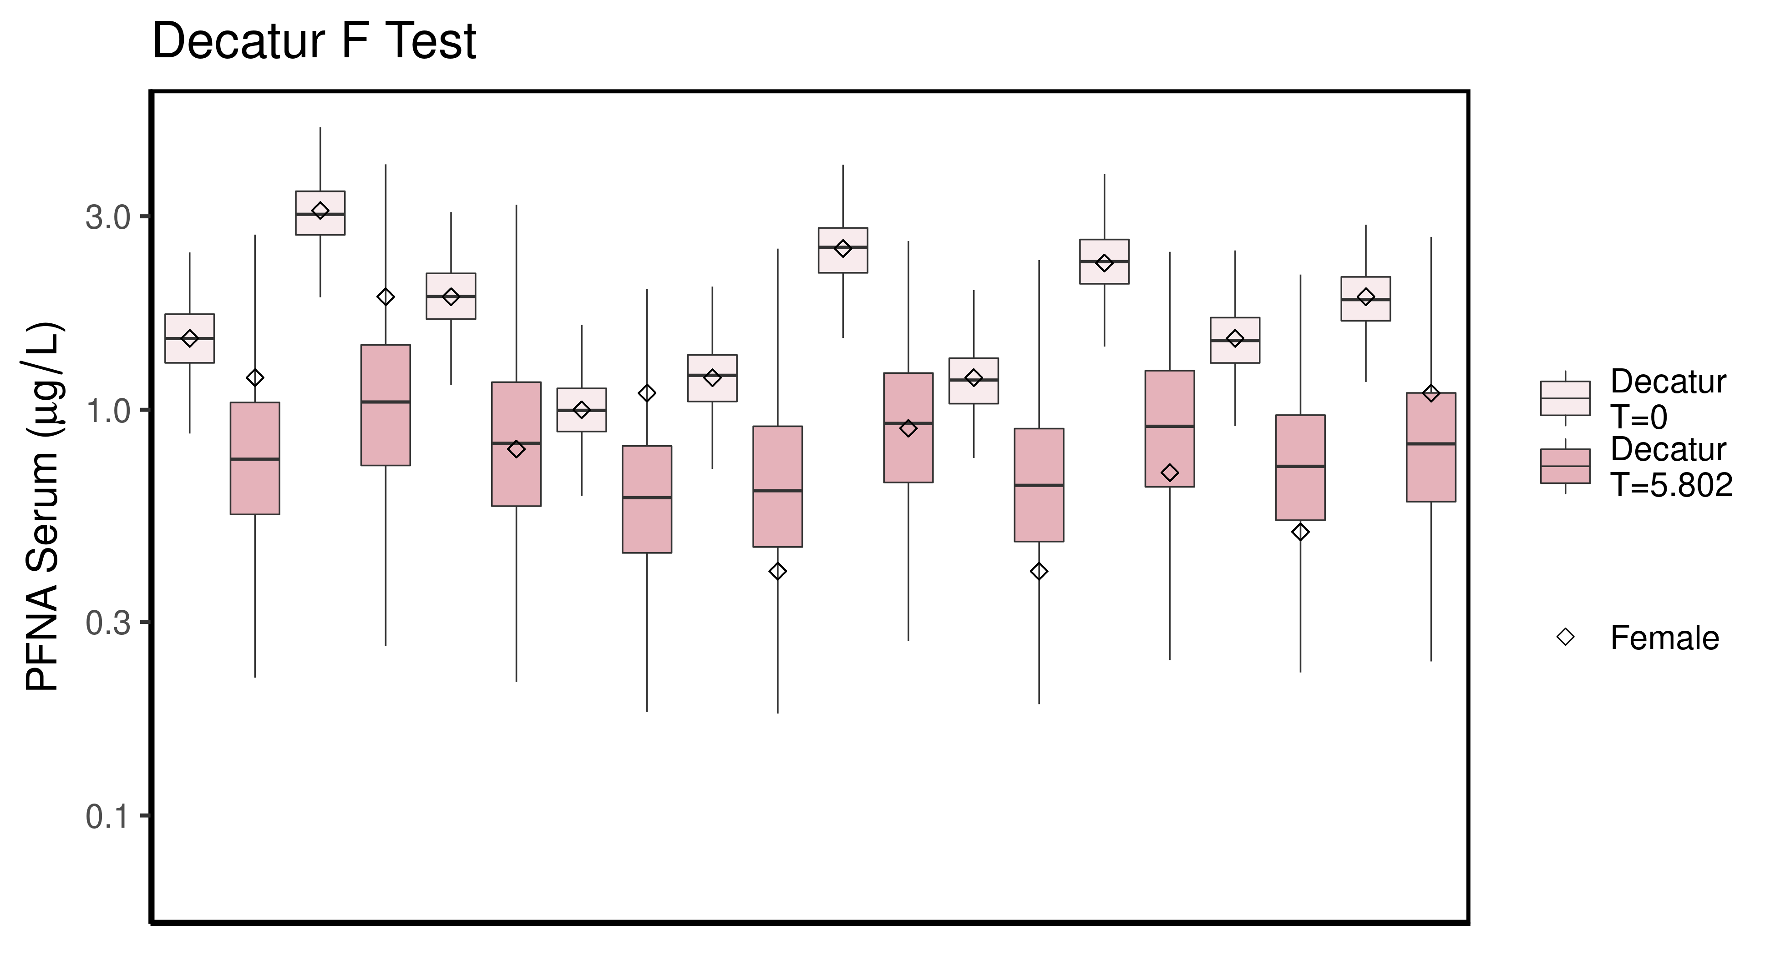

## Saving 6.5 x 3.5 in image

## Saving 6.5 x 3.5 in image

## Joining, by = c("legend_label", "City", "Train_Test", "datatype", "Time.desc")

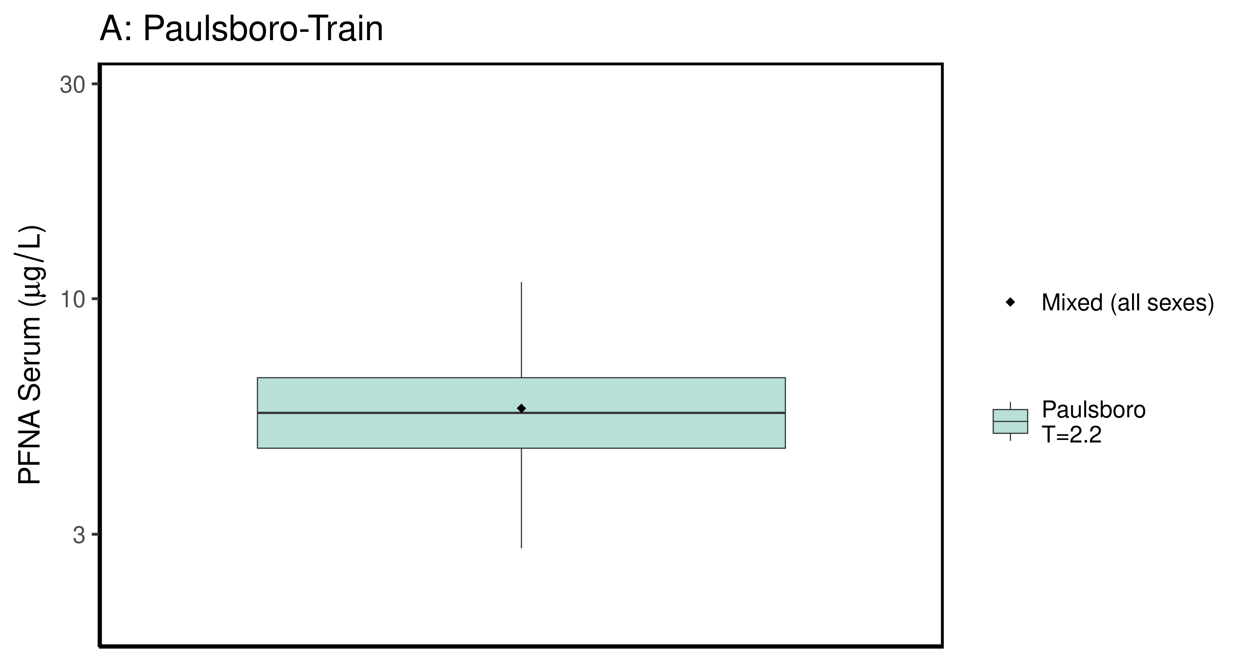

## Saving 6.5 x 3.5 in image

## Saving 6.5 x 3.5 in image

## Joining, by = c("legend_label", "City", "Train_Test", "datatype", "Time.desc")

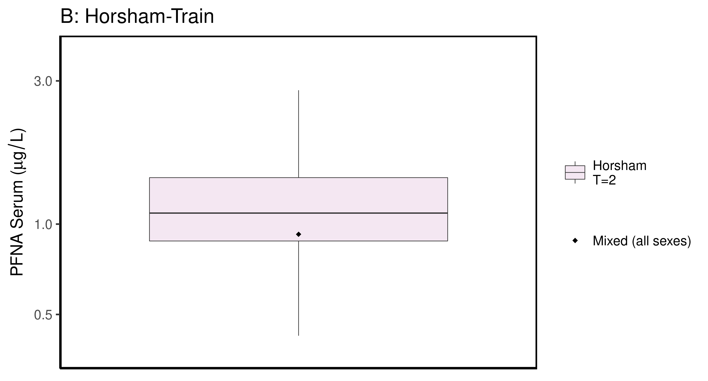

## Saving 6.5 x 3.5 in image

## Saving 6.5 x 3.5 in image

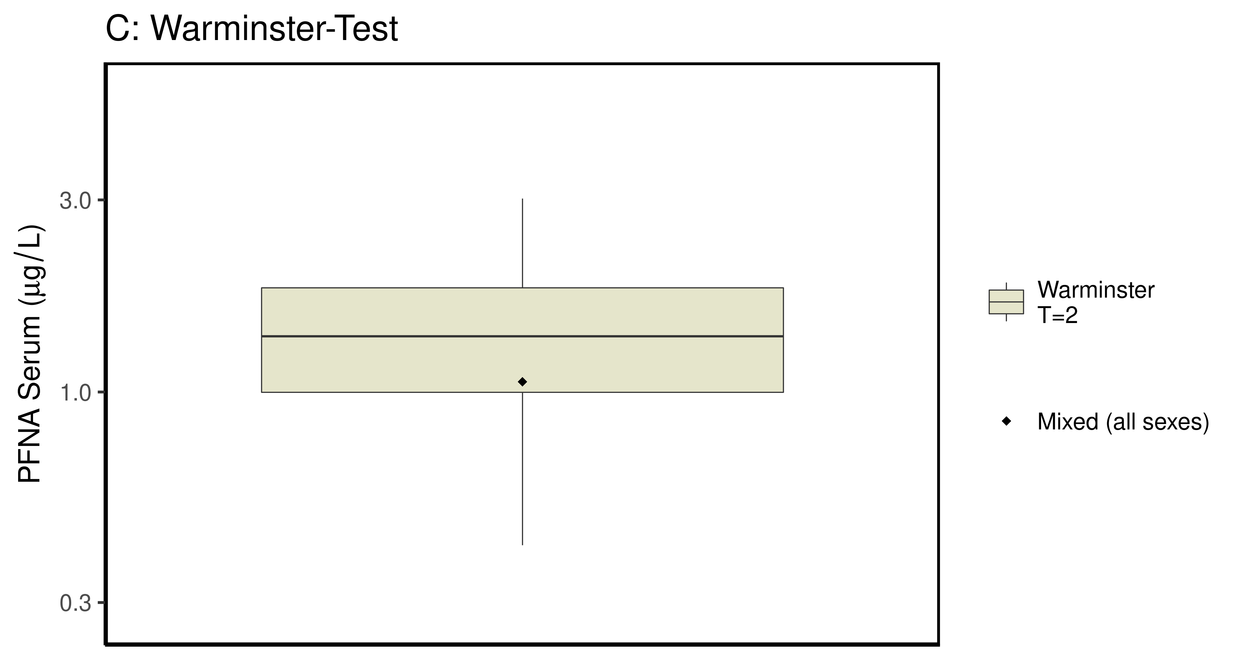

### make Training plot   
  
df_d_trt <- df_check %>%   
 filter( (Train_Test == "Train") & ((Output_Var == "M_Cbgd_Css") | (Output_Var == "M_Cserum"))) %>%  
 mutate_if(is.factor, as.character) %>% # drop factor levels unused  
 mutate(Dataset.Time = factor(Dataset.Time))   
   
  
 aes_lut_df_d_trt <- df_d_trt %>% select(City, datatype,Time, Time.desc, legend_label) %>%   
 inner_join(aes_lut ) %>%   
 select(-Train_Test) %>% ungroup () %>% unique ()

## Joining, by = c("City", "datatype", "Time", "Time.desc", "legend_label")

plt_train <- plot_sum_boxplot(dframe = df_d_trt, aes_lut= aes_lut_df_d_trt,   
 gtitle="A: Summary Data - Train" , facets = FALSE, pfas_nom = pfas_name )  
 print(plt_train)

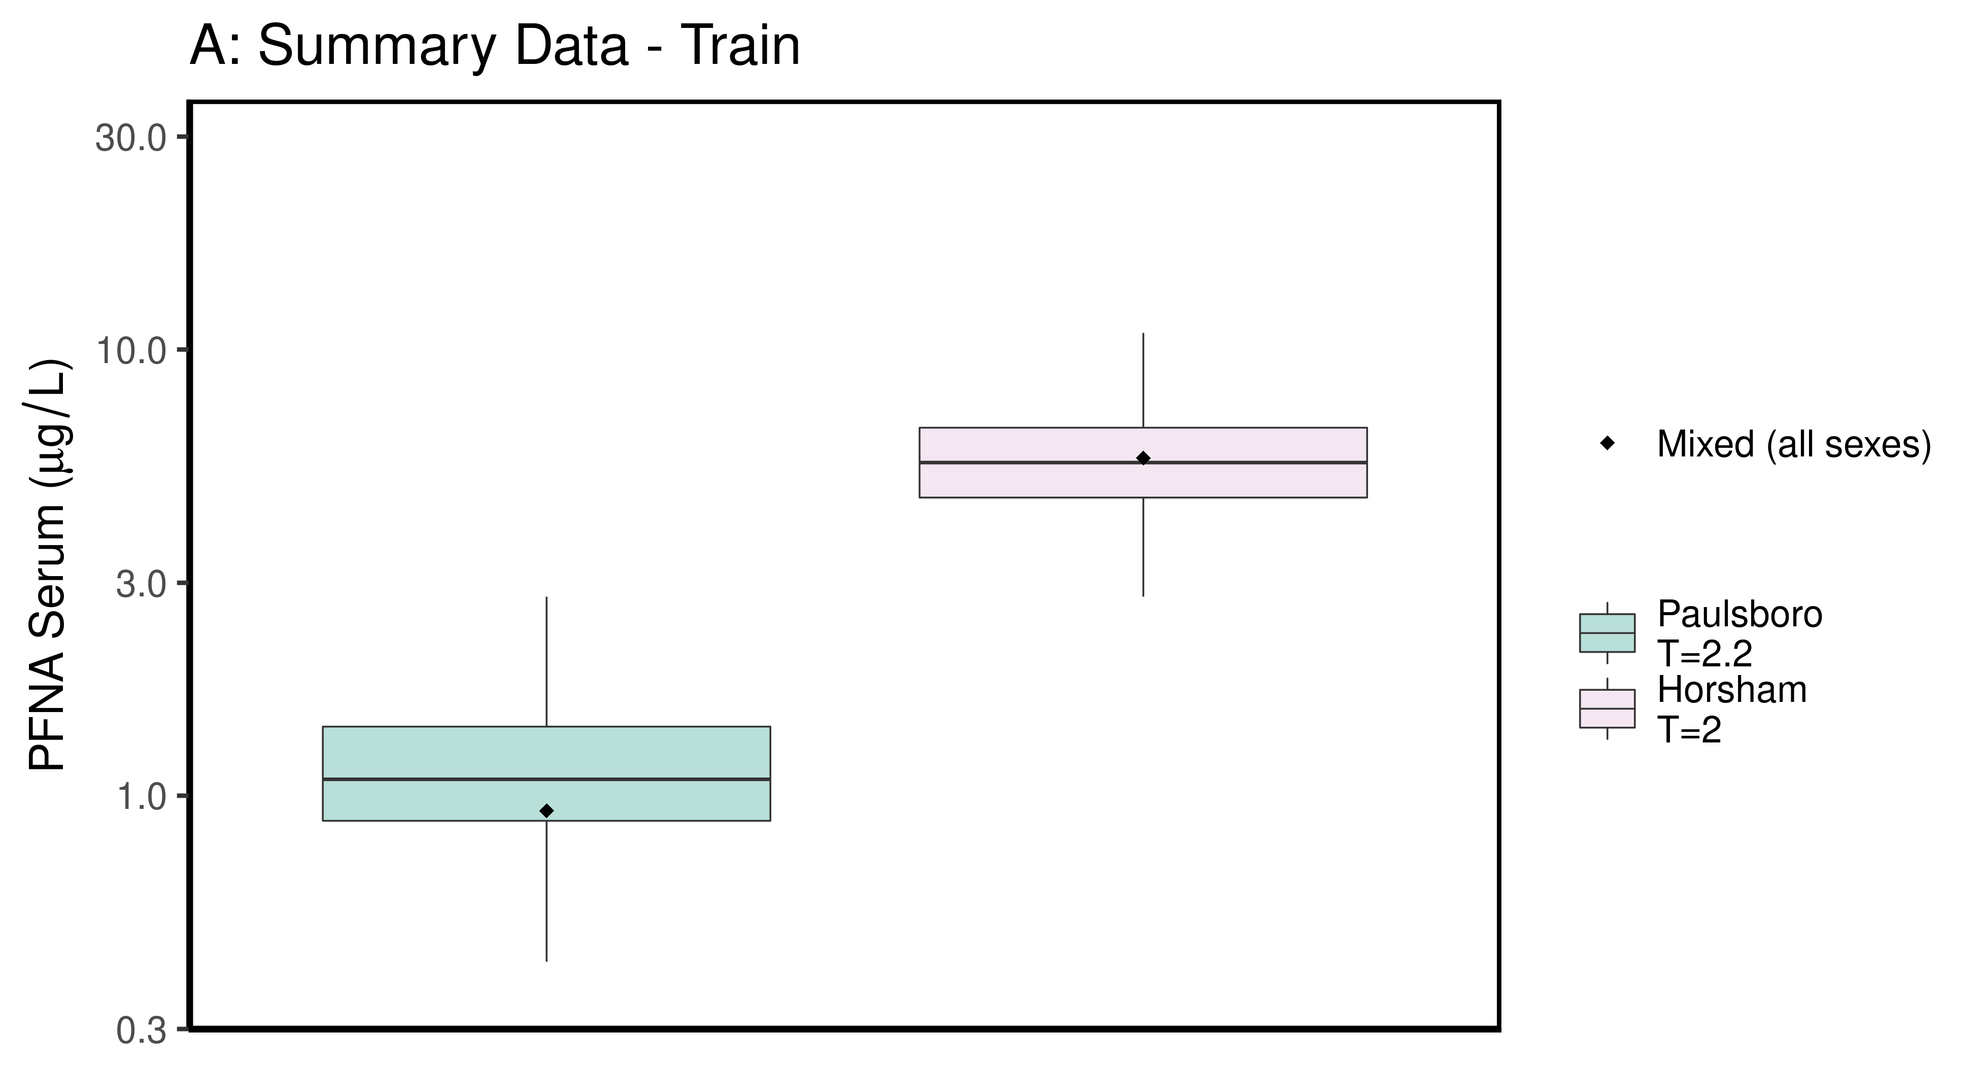

ggsave(here ("output-plots", paste0( sa, "SummaryTrainDataboxplot",pfas_name,".pdf")), plt_train,dpi=600)

## Saving 6.5 x 3.5 in image

ggsave(here ("output-plots", paste0( sa, "SummaryTrainDataboxplot",pfas_name,".png")), plt_train,dpi=600)

## Saving 6.5 x 3.5 in image

### make Test plot  
df_d_test <- df_check %>%   
 filter((Train_Test == "Test") &   
 ((Output_Var == "M_Cbgd_Css") | (Output_Var == "M_Cserum"))) %>%  
 mutate_if(is.factor, as.character) %>% # drop factor levels unused  
 mutate(Dataset.Time = factor(Dataset.Time))   
  
aes_lut_df_d_test <- df_d_test %>% select(City, datatype,Time, Time.desc, legend_label) %>%   
 inner_join(aes_lut ) %>%   
 select(-Train_Test) %>% ungroup () %>% unique ()

## Joining, by = c("City", "datatype", "Time", "Time.desc", "legend_label")

plt_test <- plot_sum_boxplot(dframe = df_d_test, aes_lut= aes_lut_df_d_test,   
 gtitle="B: Summary Data - Test", facets = FALSE, pfas_nom = pfas_name)  
 print(plt_test)

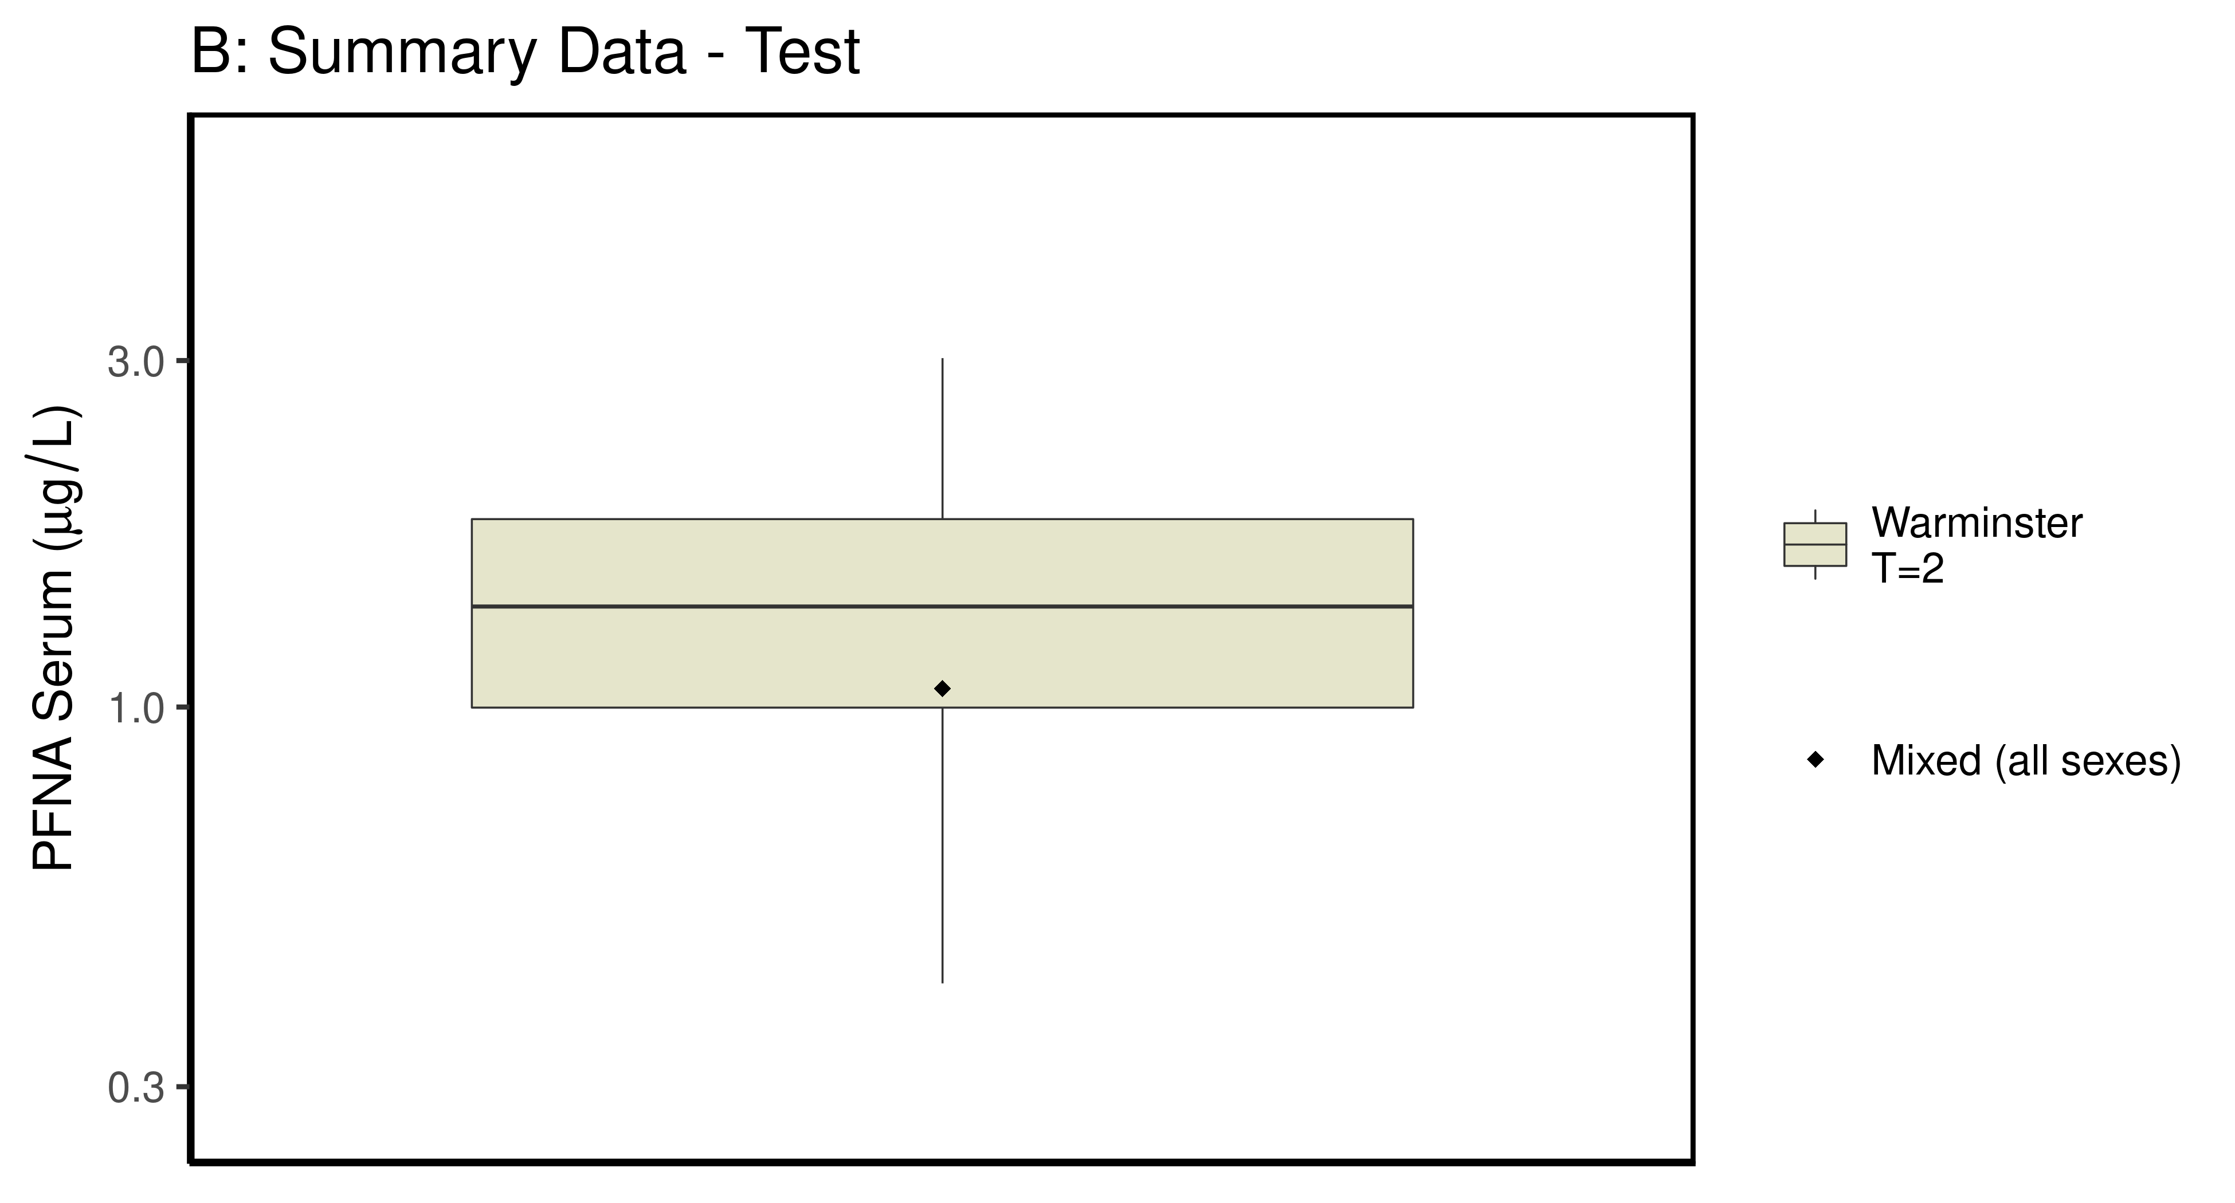

ggsave(here ("output-plots",paste0( sa, "SummaryTestDataboxplot",pfas_name,".pdf")), plt_test,dpi=600)

## Saving 6.5 x 3.5 in image

ggsave(here ("output-plots",paste0( sa, "SummaryTestDataboxplot",pfas_name,".png")), plt_test,dpi=600)

## Saving 6.5 x 3.5 in image

## PFNA

### Background posteriors

Shows shift in background estimate.

gmscale<-0.8  
  
dat <- multicheck$parms.samp[,grep("M_ln_Cbgd",names(multicheck$parms.samp))]  
datasetnames <- as.character(unique(calibdata$dataset))  
datasetnames <- gsub(" Train","-Train",datasetnames)  
datasetnames <- gsub(" Test","-Train",datasetnames)  
datasetnames <- gsub(" M","",datasetnames)  
datasetnames <- gsub(" F","",datasetnames)  
datasetnames<-datasetnames[!duplicated(datasetnames)]  
names(dat) <- datasetnames  
dat <- dat[,grep("Train",names(dat))]  
dat.df <- pivot_longer(dat,1:ncol(dat))  
dat.df <- rbind(dat.df,  
 data.frame(name="Prior",value=rnorm(5000,m=log(gmscale),sd=0.4055)))  
dat.df$name <- factor(dat.df$name,levels=rev(  
 c("Prior",datasetnames[grep("Train",datasetnames)])))  
dat.df$value <- exp(dat.df$value)  
  
p<-ggplot(dat.df)+  
 #geom_violin(aes(x=name,y=value,fill=name=="Prior"))+  
 geom_boxplot(aes(x=name,y=value,fill=name=="Prior"),outlier.shape=NA)+  
 scale_y_log10()+coord_flip()+  
 scale_fill_manual(name=NULL,   
 values=c("#009988", "#EE7733" ))+  
 theme_classic() +   
 geom_hline(yintercept = gmscale,color="grey")+  
 theme(legend.position="none",  
 panel.background = element_rect(color="black",size=1))+  
 ylab("Posterior shift in Background Concentration")  
  
print(p)

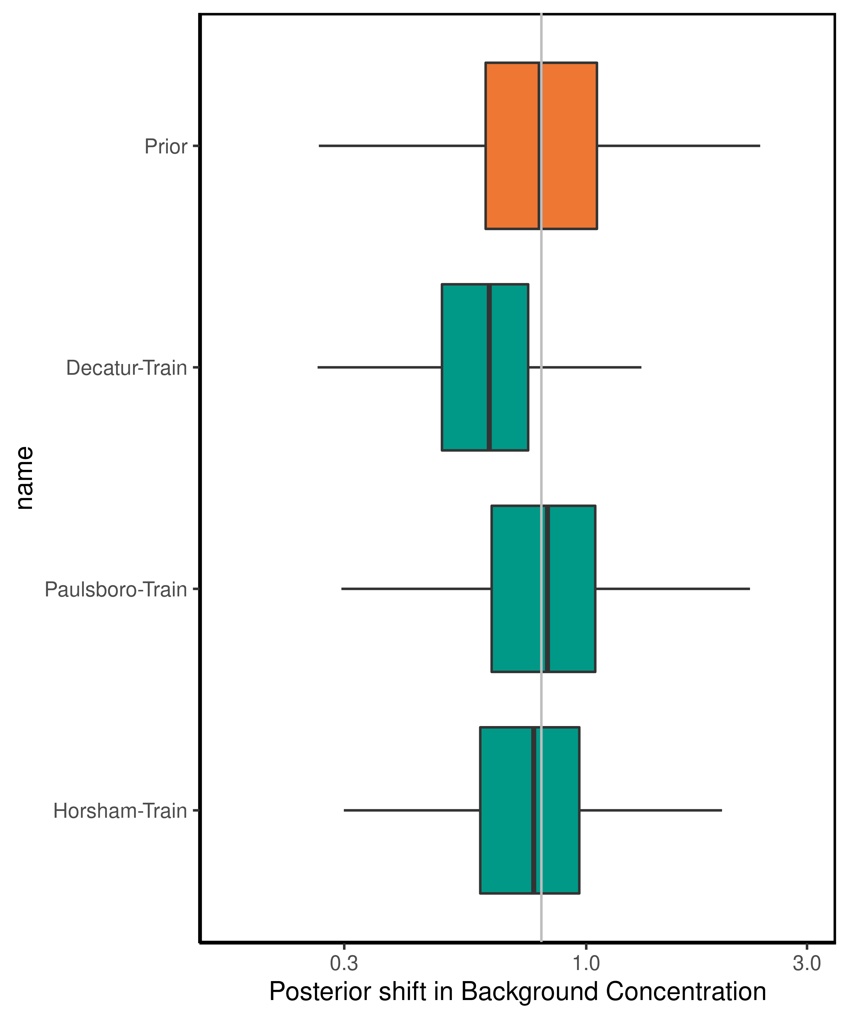

ggsave(here ("output-plots",paste0( sa, "PFNA_GM_Cbgd.pdf")) ,p,dpi=600)

## Saving 5 x 6 in image

ggsave(here ("output-plots",paste0( sa, "PFNA_GM_Cbgd.png")) ,p,dpi=600)

## Saving 5 x 6 in image

### Half-life

For PFNA, the population GM of the half-life has a posterior distribution that is narrower than the prior, with a posterior median (95% CI) estimate of 3.06 (2.16-4.37) years. The population GSD posterior is larger than the prior at 1.47(1.44-1.75).

dat <- multicheck$parms.samp[,c("M_ln_k.1.","V_ln_k.1.", "M_ln_Vd.1.", "SD_ln_Vd.1.")]  
names(dat) <- c("M_ln_k(1)","V_ln_k(1)", "M_ln_Vd(1)", "SD_ln_Vd(1)")  
   
set.seed(3.14159)  
dat$z_ln_k <- rnorm(nrow(dat))  
dat$z_ln_Vd <- rnorm(nrow(dat))  
dat %>% rename_()

## Warning: `rename_()` was deprecated in dplyr 0.7.0.  
## Please use `rename()` instead.

## M_ln_k(1) V_ln_k(1) M_ln_Vd(1) SD_ln_Vd(1) z_ln_k z_ln_Vd  
## 12503 -1.148890 0.1521450 -1.644860 0.033445100 -0.961933416 -2.139841913  
## 15901 -1.002320 0.2060560 -1.694370 0.034291900 -0.292525723 -1.263479244  
## 17543 -1.055780 0.2534080 -1.581000 0.119517000 0.258788216 0.083307969  
## 18721 -1.487880 0.1567170 -1.116290 0.090183900 -1.152131886 0.188325130  
## 11662 -1.292670 0.1257340 -1.729690 0.069338800 0.195782826 0.189814193  
## 13403 -1.270390 0.1332800 -1.571610 0.123823000 0.030123945 0.217615352  
## 13192 -1.322610 0.1972070 -1.570780 0.042810200 0.085417732 -0.648814142  
## 15663 -1.166540 0.2739130 -1.750370 0.204899000 1.116610213 0.254774383  
## 1246 -1.541050 0.1699320 -1.954920 0.307553000 -1.218857416 -0.468830015  
## 16132 -0.879350 0.1893850 -1.966390 0.056025200 1.267368722 -1.192510054  
## 10602 -1.249670 0.1313740 -1.544400 0.043984900 -0.744781596 0.121228235  
## 10563 -1.461480 0.2405850 -1.614720 0.047697700 -1.131218571 -1.035932658  
## 15932 -1.383280 0.1528040 -1.569850 0.164226000 -0.716358490 -0.191888295  
## 1114 -1.297140 0.1640490 -2.220420 0.154966000 0.252652370 -0.970546336  
## 1699 -1.152140 0.1985670 -1.444610 0.120178000 0.152045707 0.057771938  
## 1141 -1.178850 0.1854660 -1.256510 0.324982000 -0.307656430 -2.110692675  
## 13383 -1.275550 0.1117450 -1.408290 0.499785000 -0.953017331 0.978176274  
## 12832 -1.297250 0.1902310 -1.478650 0.206337000 -0.648242811 0.371021737  
## 19552 -1.006070 0.1985060 -1.986540 0.026646300 1.224313624 0.720910931  
## 14423 -1.176370 0.1173450 -2.178930 0.171581000 0.199811608 1.879594880  
## 12372 -1.235080 0.1808280 -1.577460 0.165649000 -0.578483722 -0.396316112  
## 12042 -1.350500 0.1844130 -2.019890 0.176727000 -0.942300733 0.110322947  
## 10473 -1.526280 0.1624130 -1.732740 0.216899000 -0.203728180 -0.593140881  
## 1509 -1.110140 0.1343630 -1.704000 0.004860840 -1.666474840 0.419621770  
## 1552 -1.092160 0.1715180 -1.190030 0.162174000 -0.484455109 -0.545738743  
## 19513 -1.203980 0.1737090 -1.507090 0.005604350 -0.741072661 1.160921499  
## 17471 -1.441230 0.1352880 -1.708930 0.004171310 1.160615779 0.639817834  
## 18092 -1.043930 0.1107730 -1.781350 0.198875000 1.012067125 -0.122020443  
## 1613 -0.908095 0.1933200 -1.782390 0.087617900 -0.072078474 0.184645026  
## 14383 -0.994470 0.1972190 -2.129090 0.044906900 -1.136782298 -0.517806023  
## 14263 -1.079830 0.2136990 -1.866520 0.140176000 0.900624729 0.067988352  
## 18291 -1.212370 0.2009270 -1.642030 0.040445900 0.851770447 -0.184797156  
## 1945 -1.210880 0.2226610 -1.862430 0.360906000 0.727715174 -1.403691615  
## 19613 -1.359880 0.1562270 -1.530230 0.037197400 0.736502146 0.229740706  
## 1842 -1.370210 0.1948250 -1.683180 0.110479000 -0.352129617 -0.889081301  
## 1873 -1.381120 0.1286330 -1.287650 0.075345400 0.705515513 -0.160401177  
## 19423 -1.337190 0.1232990 -1.551320 0.238411000 1.300357989 -0.242136794  
## 19352 -0.940684 0.1100470 -1.951660 0.070556600 0.038252014 -0.028837196  
## 11812 -1.002080 0.1239260 -1.628970 0.063945200 -0.979283770 -0.316215474  
## 14982 -1.007010 0.1489250 -1.947040 0.412745000 0.793761231 -0.416160087  
## 11263 -1.295550 0.1972890 -1.478610 0.015491400 0.786506872 -1.023895957  
## 1028 -1.100740 0.1689520 -1.745430 0.039382000 -0.310463131 1.099495275  
## 1051 -1.215460 0.1923220 -2.142890 0.010908300 1.698884846 0.817712470  
## 17222 -0.762399 0.2218630 -1.494810 0.054188700 -0.794593709 0.168875510  
## 1747 -0.970160 0.3950510 -1.662360 0.199804000 0.348437716 0.038665440  
## 1284 -1.293490 0.1351090 -1.591640 0.108788000 -2.265401074 1.078174892  
## 1564 -1.280160 0.2069320 -1.243720 0.192766000 -0.162205279 0.379427297  
## 18632 -1.272020 0.2242500 -1.746310 0.097674300 1.130864991 -1.078174559  
## 19142 -1.045890 0.2665000 -1.844500 0.041960400 -0.455545976 0.188763468  
## 15793 -1.198640 0.1910660 -1.324320 0.281682000 -0.899166316 1.583133508  
## 1126 -1.505250 0.1950870 -1.661810 0.325596000 0.726838902 -0.250112295  
## 16502 -0.900348 0.2037790 -1.795750 0.184344000 -0.809440902 0.342994219  
## 15103 -1.053320 0.1502970 -1.848110 0.210119000 0.267085116 -0.124701883  
## 11251 -0.924291 0.1440950 -1.648460 0.108575000 -1.737263711 -0.993314763  
## 11732 -1.228260 0.1761790 -1.693830 0.199828000 -1.411425136 -1.021439085  
## 18382 -1.256490 0.1606040 -1.896650 0.173900000 -0.453551227 0.840642928  
## 13433 -1.379720 0.1899890 -1.383700 0.138141000 -1.035491275 0.849573118  
## 16403 -1.169590 0.2128440 -1.896030 0.067505000 1.362142893 0.469618942  
## 11871 -0.936760 0.2042520 -1.687350 0.180522000 0.917456737 -1.269655261  
## 1988 -1.476260 0.1729090 -1.476030 0.057966700 -0.785142161 -1.105120219  
## 1589 -1.410330 0.2089860 -1.365140 0.383078000 0.573518173 -1.897945965  
## 1449 -1.203200 0.1592950 -1.586390 0.107711000 0.918196208 0.491787265  
## 1232 -1.218830 0.2001760 -1.440570 0.101240000 0.256287273 -0.704722317  
## 10171 -1.278840 0.1632960 -1.521600 0.121822000 0.351966556 1.777576130  
## 1259 -1.332300 0.2541450 -1.568980 0.084448300 1.174337357 -0.245389029  
## 18503 -1.007670 0.1988150 -1.350240 0.210202000 -0.480846375 -2.111252318  
## 10801 -1.400430 0.1727630 -1.351870 0.241283000 -0.418829722 -0.585314536  
## 15263 -1.239470 0.1444630 -1.740040 0.100783000 0.955112803 -0.517903726  
## 1042 -1.184560 0.1972290 -1.927030 0.170507000 -1.289006611 0.513919145  
## 18363 -1.370560 0.1351710 -1.526220 0.129331000 0.186197433 -0.626426919  
## 19072 -1.085680 0.2185060 -1.965330 0.126436000 -0.031325502 0.192142595  
## 16632 -1.282830 0.1827020 -1.659900 0.117019000 0.467097310 -1.427277992  
## 1401 -1.154940 0.1904120 -1.947120 0.408341000 1.024197674 0.400991028  
## 14691 -1.626850 0.2274930 -1.437450 0.101931000 0.267358452 1.161564956  
## 17041 -1.144550 0.1361590 -1.773940 0.105697000 0.231826103 0.326346805  
## 19822 -1.360900 0.2797010 -1.694260 0.018405400 0.747592465 -1.014982273  
## 13613 -1.293400 0.1557650 -1.803810 0.070306500 1.217068511 0.101258362  
## 11013 -1.613820 0.2659580 -1.652930 0.088322600 0.383358345 0.991893279  
## 15791 -1.004860 0.2111640 -1.675570 0.203652000 -0.988052822 1.102650759  
## 16531 -1.292270 0.1326060 -1.715860 0.159055000 -0.156852910 0.280375017  
## 1970 -1.425360 0.1907840 -2.008040 0.067129400 1.735535216 -0.406177410  
## 16331 -1.011370 0.2268860 -2.045700 0.187632000 -0.352298306 1.286412690  
## 1242 -1.334350 0.1512920 -1.527980 0.078351800 0.688640044 -0.254030579  
## 15251 -0.784662 0.2398560 -1.696470 0.159037000 1.224406096 -1.144448704  
## 1653 -1.158740 0.1682180 -1.761160 0.049367100 0.794296303 0.266410910  
## 1140 -1.226440 0.1550100 -1.153850 0.175458000 -0.006402398 0.636855748  
## 17771 -1.179000 0.1657370 -1.838840 0.025525200 0.219150635 -1.402115093  
## 18012 -1.246120 0.2095570 -1.508930 0.093316000 -0.886463751 -1.511824827  
## 14062 -1.117930 0.1747590 -1.636790 0.076441500 0.439760291 -0.301192859  
## 1964 -1.431390 0.2031620 -1.824300 0.073339100 -0.886389751 0.491361149  
## 18413 -1.478350 0.1771790 -1.821550 0.102423000 -0.853818454 -0.898156496  
## 13791 -1.372560 0.1357440 -1.954840 0.181136000 -0.989994331 -1.575054814  
## 15832 -1.319660 0.1248490 -1.928510 0.028714100 -0.650877737 -0.503256667  
## 1060 -0.973914 0.1617890 -1.574540 0.142654000 1.053946660 -0.622908441  
## 12073 -1.135350 0.3301920 -1.993710 0.238262000 -0.390878033 -0.684829990  
## 15683 -1.233130 0.2360550 -1.670320 0.058101800 -0.070586394 -0.221516764  
## 1693 -1.059430 0.2205020 -1.947280 0.111595000 -0.462050809 0.388050833  
## 17531 -1.433470 0.1676120 -1.939220 0.065488300 0.540908267 -0.806316456  
## 10311 -0.991806 0.1413050 -1.786720 0.137810000 0.931634971 -0.547213054  
## 18041 -0.917880 0.2563210 -1.985040 0.246913000 -0.209274345 1.213494144  
## 19672 -1.281640 0.2086190 -1.883840 0.178908000 0.617350048 -0.417013230  
## 18351 -1.444460 0.1757890 -1.424830 0.007889670 -0.405077513 0.164593185  
## 13741 -1.489430 0.1053760 -1.757690 0.089587100 1.053103763 -1.569627007  
## 11892 -1.343760 0.1639040 -1.774530 0.232614000 0.602284246 1.466675890  
## 18762 -1.610890 0.1782680 -1.140250 0.138270000 1.017461177 -1.496085449  
## 1808 -1.077740 0.1587670 -2.003060 0.032877300 0.608167318 -1.150289019  
## 15861 -1.234820 0.1225970 -1.660030 0.223637000 0.206735995 -2.023009144  
## 12312 -0.866548 0.1929490 -2.013320 0.077406400 -1.897727292 -0.681652395  
## 13473 -1.335980 0.2061710 -1.792220 0.064004400 -0.682582832 0.507010414  
## 1040 -1.108020 0.1666370 -2.060320 0.032093600 0.481338415 0.747111894  
## 17573 -1.121060 0.1564430 -1.519850 0.149839000 -0.463031038 0.175989014  
## 19872 -1.161140 0.2372220 -1.808170 0.428886000 -0.279741696 -0.437523579  
## 1953 -1.320800 0.1031930 -1.861780 0.095176900 -0.413690145 0.942726154  
## 15883 -1.420980 0.1604670 -1.680470 0.020340300 1.618766521 0.891044960  
## 1663 -1.112870 0.1443020 -1.757520 0.130221000 -0.721055711 -1.691785958  
## 18913 -1.438350 0.1938370 -1.684970 0.000622974 -0.453093157 -0.712147393  
## 1005 -1.245180 0.1125260 -1.637690 0.272433000 0.014257161 -0.332268892  
## 1878 -1.385100 0.1479570 -1.351570 0.150457000 0.215764621 0.983033453  
## 15553 -1.080680 0.1308870 -1.784470 0.098865600 0.188870195 -0.988041784  
## 19433 -1.365070 0.1355280 -1.690150 0.282425000 -0.050148494 0.265546446  
## 15642 -1.096520 0.2069020 -2.263360 0.057454500 -1.495419632 -0.728186155  
## 13873 -1.361820 0.1197010 -1.669030 0.072795400 0.367837753 1.375405013  
## 17882 -0.865875 0.2107470 -1.636070 0.146619000 0.517144022 -0.599264333  
## 1857 -1.267580 0.2760140 -1.727480 0.028811000 -0.484335465 -0.272173202  
## 1103 -1.309420 0.2021170 -1.262550 0.192267000 0.674855616 0.405324773  
## 12581 -0.997721 0.2357290 -1.526580 0.069789900 -0.762448605 0.846734123  
## 1974 -1.441960 0.1627870 -1.630060 0.055930800 0.386073791 0.518125984  
## 13822 -1.007520 0.1597030 -2.040110 0.107257000 -0.664003345 1.579413771  
## 1101 -1.320010 0.1363580 -1.350330 0.021601200 -1.724344195 -0.112951698  
## 1198 -1.056630 0.1544810 -1.350090 0.029961900 1.156319079 -0.484652932  
## 19762 -1.346910 0.1755560 -1.733380 0.104811000 0.693506590 -2.377853826  
## 18271 -1.358280 0.1448260 -1.418110 0.101130000 0.143156356 -0.636048007  
## 18911 -1.501290 0.1514200 -1.394290 0.232582000 1.492813560 0.035663770  
## 19111 -1.192130 0.1276320 -2.186760 0.021864500 -1.632153479 -0.109166877  
## 1374 -1.227730 0.1689690 -1.335630 0.058564100 0.127846023 -1.871305162  
## 1920 -1.309430 0.1692400 -1.682160 0.014997200 -2.403663727 -0.079333090  
## 1504 -1.347320 0.3070670 -1.640040 0.280039000 1.443928256 -0.318596856  
## 16771 -1.314780 0.2045410 -1.271120 0.009669120 -0.878893050 0.118181119  
## 19693 -1.087260 0.1919930 -1.798210 0.301519000 -1.306438327 0.532403631  
## 13331 -1.362800 0.2170540 -1.333230 0.014238600 -0.877198993 -0.197683940  
## 18422 -1.315930 0.1188300 -1.031820 0.100300000 -1.164380459 1.664379027  
## 11663 -1.003400 0.1663040 -1.862830 0.021184100 -1.982347680 0.314495086  
## 13082 -1.365240 0.2792340 -1.692020 0.037004300 -0.989944235 0.601591759  
## 14941 -1.251280 0.2346260 -1.423070 0.322700000 -0.151684601 -1.429557536  
## 1073 -1.341940 0.1836450 -1.832510 0.163159000 0.912506791 -0.472999146  
## 1781 -1.218510 0.1519380 -1.395430 0.150065000 0.407669808 -0.487888829  
## 15091 -1.110730 0.2291230 -1.676570 0.153650000 -1.242184375 1.027388649  
## 13413 -1.337400 0.1981320 -1.820060 0.069875700 -0.642694412 -1.095763686  
## 12463 -1.345650 0.1679940 -1.780480 0.134881000 1.930243689 -0.916445608  
## 11261 -0.946974 0.1885450 -1.834250 0.118521000 0.410199364 1.054094779  
## 10231 -1.032070 0.1741980 -1.357530 0.040824600 -1.291349321 -1.439834035  
## 16911 -1.174190 0.1695050 -1.452290 0.126665000 2.635045375 0.532564109  
## 12011 -1.025760 0.1667010 -1.561410 0.029705900 0.487072288 -1.046928774  
## 14342 -1.043370 0.1443420 -1.879450 0.011780900 0.853892318 0.087385881  
## 1170 -0.884153 0.1976010 -1.930030 0.437463000 1.088442705 -0.174111691  
## 17372 -1.227720 0.2281010 -1.925090 0.080894200 0.226013957 -0.533826331  
## 1839 -1.378750 0.2009660 -1.148240 0.063103500 0.068198838 0.099317747  
## 11531 -0.968745 0.2022720 -1.933450 0.048726600 -0.984815533 -1.020107099  
## 16811 -1.322710 0.1482050 -1.759980 0.003431340 -1.310854422 0.430041832  
## 1825 -1.274930 0.2169080 -1.564140 0.158939000 2.464055335 1.502847759  
## 12443 -1.384290 0.2784940 -1.200830 0.377198000 -0.665428070 -0.270760795  
## 12893 -1.445750 0.1776920 -1.629900 0.054283000 0.912862648 0.871555415  
## 1694 -1.017180 0.1144040 -1.674850 0.100670000 0.964664226 -1.216293810  
## 11843 -1.374990 0.2285840 -2.198040 0.201657000 1.608002937 -1.892738669  
## 15731 -0.832782 0.1412720 -2.222260 0.238808000 1.835399525 -0.822382571  
## 15783 -1.144510 0.1910660 -1.593200 0.229606000 0.702462733 0.751782015  
## 11601 -1.166220 0.1843150 -1.728110 0.005883760 1.217854079 0.773574518  
## 17572 -0.951146 0.1573650 -1.833420 0.107279000 -1.123653829 -1.787532258  
## 1062 -1.230660 0.1988230 -1.426960 0.007114730 0.668330116 0.088817469  
## 12182 -1.340180 0.1795980 -1.535560 0.093265600 1.216411488 -0.180052904  
## 18073 -1.084380 0.2191640 -1.693980 0.006295450 0.234575354 -1.471714902  
## 1773 -1.129230 0.1723210 -0.799626 0.117478000 -0.418696588 0.490094947  
## 12412 -1.249360 0.1175330 -1.409480 0.064342300 0.238220090 -0.397833206  
## 14813 -1.220100 0.1979730 -1.731830 0.077305100 -0.550588192 -0.169679442  
## 19503 -1.223020 0.1567190 -1.442090 0.042691300 -0.500602769 -2.214982820  
## 1029 -1.024190 0.1073090 -1.643520 0.076987000 1.163897492 1.008145236  
## 1473 -0.989214 0.1404140 -1.834210 0.217112000 2.155536954 0.524260695  
## 1430 -1.226600 0.2230890 -1.753460 0.143741000 -1.709157009 0.264820635  
## 12303 -1.070430 0.1839170 -1.944150 0.104089000 -1.600822615 -0.388256354  
## 1738 -0.690318 0.1444160 -2.055060 0.193161000 -1.038553413 -0.399451920  
## 11051 -1.044050 0.2376210 -2.267710 0.022517400 0.323094221 0.227146190  
## 18882 -1.592190 0.1792820 -1.704610 0.090264800 -0.888847154 -0.611156980  
## 14953 -0.989546 0.1603090 -1.943670 0.017979400 0.393678982 0.540650478  
## 17223 -0.708453 0.2017440 -1.612360 0.204649000 0.236541468 0.909955002  
## 10543 -1.402440 0.1867690 -1.804730 0.011919900 -0.430496813 1.406622276  
## 19871 -1.090820 0.2197780 -1.894310 0.031795700 -0.547933126 -0.755587121  
## 15571 -0.903138 0.1724100 -2.144680 0.018893000 -1.322251659 -0.020592429  
## 19333 -1.514150 0.2271670 -1.516230 0.155948000 0.682126749 0.137858516  
## 1357 -1.049750 0.1969230 -1.635080 0.068976800 2.162789482 -0.921540392  
## 12813 -1.218110 0.2781850 -1.933040 0.002703670 -0.416669649 0.576523431  
## 1222 -1.220310 0.2093680 -1.639300 0.024055500 -1.357317897 0.298893720  
## 19032 -1.197850 0.1431660 -1.772900 0.024040300 -0.671226462 -0.862301037  
## 1190 -1.124210 0.2046220 -2.254940 0.258408000 0.649918243 -0.810138091  
## 17662 -1.298550 0.1210440 -1.795650 0.240844000 0.771291175 0.472555898  
## 1570 -1.494400 0.1719700 -1.279900 0.161876000 2.676631927 0.568499025  
## 12933 -1.321820 0.1561970 -1.805750 0.335370000 -1.370871421 1.413098269  
## 17162 -1.119330 0.1753060 -1.352560 0.312497000 0.057759145 0.058817380  
## 18321 -1.333310 0.2002800 -1.663300 0.113155000 -0.197067508 -0.583447921  
## 13532 -1.385060 0.3063740 -1.390300 0.068219900 -1.261517626 0.270123085  
## 14012 -1.051130 0.2324810 -1.564810 0.020006900 -0.662442562 1.078046441  
## 19571 -1.399900 0.1465390 -1.600770 0.071451500 -1.332352324 -0.146579622  
## 12991 -1.347580 0.2232500 -1.633150 0.236853000 0.277323621 -0.635253591  
## 17063 -0.905313 0.1491310 -1.510400 0.073610200 1.085533849 0.524084655  
## 19203 -0.728033 0.1971500 -1.843450 0.120553000 -1.642718489 1.105146081  
## 14513 -1.128790 0.1443260 -2.069700 0.279842000 -0.457180258 -0.501011903  
## 18052 -1.259250 0.1722180 -1.330430 0.244807000 1.461171845 0.424192601  
## 1957 -1.162700 0.2200050 -1.630210 0.094473500 -1.672532602 -1.077357662  
## 1965 -1.371090 0.1471960 -1.342920 0.270276000 1.561095996 -0.625837491  
## 13273 -1.407130 0.2058400 -1.618610 0.071951300 -1.493370648 0.840120571  
## 1789 -1.363030 0.1197840 -1.489070 0.155546000 -1.182449141 -0.059466609  
## 13492 -1.343010 0.1281520 -1.834160 0.066900100 -0.356586881 -0.077217546  
## 12513 -1.116440 0.2303910 -1.612660 0.276568000 -0.915640125 0.416709627  
## 14672 -1.188470 0.1771540 -1.544010 0.048563800 0.849485485 -1.379914328  
## 18373 -1.342850 0.1929340 -1.935890 0.092301900 -0.489607238 -1.482149933  
## 11793 -1.256660 0.2170420 -1.514850 0.529986000 0.727983210 0.122071411  
## 1361 -1.163670 0.2298620 -1.852380 0.250120000 -0.619313219 1.195887446  
## 15123 -1.057420 0.2037100 -1.812280 0.130866000 0.343735543 -0.254062405  
## 18791 -1.483970 0.1687700 -1.294580 0.034544800 1.813625401 -0.344407316  
## 10681 -1.027900 0.1991560 -1.678390 0.028718200 1.453226830 -1.809799151  
## 11143 -1.378440 0.2868030 -1.293460 0.116647000 0.412429443 -1.630895018  
## 1194 -1.033410 0.1803350 -1.416880 0.051829300 0.201975959 -0.271965872  
## 1330 -1.220790 0.1555770 -1.748800 0.054178400 1.684346898 -1.790901346  
## 18142 -1.109390 0.2477020 -1.735110 0.000671681 -0.964824478 -0.228499227  
## 1934 -1.391280 0.2033940 -1.748240 0.018285900 0.662155194 1.784240948  
## 1622 -1.085410 0.1893240 -1.617590 0.107330000 -0.553343994 -0.166313575  
## 14913 -0.938525 0.1810590 -1.598000 0.076677600 2.444205231 0.809087394  
## 14073 -1.062310 0.1416910 -1.418260 0.070152500 -0.304629836 -0.972329346  
## 19561 -1.481610 0.1912520 -1.592680 0.100759000 -0.117369869 -1.952502354  
## 1231 -1.379450 0.1705480 -1.605860 0.070227600 0.969428787 1.786422520  
## 1849 -1.358980 0.1941410 -1.484540 0.143197000 0.590939630 1.312987748  
## 15711 -1.111970 0.1412720 -1.950020 0.142709000 -1.208958402 1.108674735  
## 13711 -1.582210 0.1642930 -1.940700 0.132027000 -0.301928423 -0.993200725  
## 17031 -1.249410 0.1973630 -1.562670 0.006265290 0.401260475 0.526099803  
## 16543 -1.087180 0.2446780 -1.711180 0.039803900 -1.688368241 -0.768071012  
## 17671 -1.234870 0.1911590 -1.388400 0.360814000 -0.712992471 0.529000051  
## 19841 -1.156510 0.1752660 -1.926260 0.205988000 -0.254300337 0.142537992  
## 19063 -1.138980 0.1876230 -1.731590 0.138481000 -1.001566828 -1.540493313  
## 17851 -1.388170 0.2363560 -1.452500 0.242579000 -0.924100354 -0.776809099  
## 1478 -1.048230 0.1283280 -1.811660 0.349501000 0.440245569 -3.053299791  
## 18823 -1.279070 0.1521900 -1.710500 0.320247000 -0.326816611 0.871474290  
## 10932 -1.079950 0.2641970 -1.162880 0.209708000 -0.274475875 0.190962149  
## 12382 -1.144330 0.2060000 -1.867780 0.165178000 1.284142059 0.849572629  
## 11613 -1.117270 0.1992960 -1.733860 0.159419000 0.304211777 -0.563481733  
## 12701 -1.482020 0.1708840 -1.517360 0.176042000 1.273682656 1.204416928  
## 14801 -1.480020 0.2342140 -1.208260 0.128714000 1.033447932 1.704492687  
## 13023 -1.064060 0.2630790 -1.440390 0.101997000 0.665384156 -0.058008606  
## 12123 -1.031500 0.1838840 -1.793100 0.135974000 -0.313328109 0.770876717  
## 10272 -0.871530 0.2590890 -2.110940 0.179191000 0.464076685 -0.027690324  
## 18622 -1.155090 0.1669520 -1.869560 0.082454300 0.478605860 1.303131096  
## 15523 -0.836544 0.2055940 -1.998600 0.383326000 2.536235795 -0.711585886  
## 15201 -0.993963 0.1768980 -1.765960 0.313209000 -0.535063085 -0.771192049  
## 14391 -1.022770 0.1504400 -1.296780 0.038038000 1.368106222 -1.338907825  
## 1658 -1.171890 0.2439680 -1.581450 0.099087300 0.141844290 0.408160652  
## 17003 -0.892976 0.2183160 -0.942614 0.106430000 -0.782814969 0.206537589  
## 1316 -1.004970 0.2059010 -2.041100 0.020071200 1.881518733 -0.224476304  
## 15442 -1.455210 0.1726830 -1.449660 0.291275000 0.552922865 -1.504028164  
## 1008 -1.281710 0.2002580 -1.605880 0.057270300 -1.844856583 0.238798379  
## 18082 -1.086890 0.2033380 -1.718220 0.198875000 -0.550307914 -0.440094481  
## 1931 -1.322760 0.2041640 -1.456920 0.172862000 -0.026014759 1.085948334  
## 1192 -1.142640 0.1960460 -2.016400 0.041471200 -2.159250362 0.287937278  
## 16292 -0.933044 0.1467300 -1.881590 0.038093500 1.770600080 -0.592582238  
## 12013 -0.904780 0.1143590 -1.766870 0.098961700 0.760473482 -1.030482341  
## 1999 -1.449010 0.1395300 -1.406670 0.032171600 -0.484542846 0.722738858  
## 15621 -1.065370 0.2142300 -1.810130 0.164082000 -0.472763899 -0.814832560  
## 17171 -1.044380 0.1878560 -1.676390 0.050360000 0.331672075 0.414635154  
## 19781 -1.251100 0.1387520 -1.121740 0.057748500 -0.972300798 -0.192636529  
## 11202 -0.894562 0.1397710 -2.168100 0.148990000 -0.531244209 -0.410108658  
## 16253 -0.885080 0.1972280 -1.998230 0.251192000 0.062036740 0.206361537  
## 16722 -1.006750 0.1461540 -1.614340 0.257612000 0.103529988 0.284630186  
## 18962 -1.309550 0.1674100 -2.085540 0.360176000 1.169799329 -0.604884836  
## 1076 -1.316010 0.1601690 -1.513270 0.161122000 0.394189201 0.583220593  
## 1501 -1.372930 0.1816770 -1.967740 0.158797000 -0.134102361 0.280145010  
## 10951 -1.390080 0.1650250 -1.580560 0.110049000 -0.379875566 1.315610342  
## 15121 -0.904474 0.1819160 -2.013870 0.153212000 1.278666582 -1.452676821  
## 1006 -1.263150 0.0994442 -1.793560 0.014245700 -0.699332309 -1.158009146  
## 16093 -1.231880 0.2173800 -1.952100 0.170084000 0.564250526 -0.047178285  
## 18592 -1.250610 0.1483160 -2.077240 0.162631000 0.302941956 0.162912346  
## 16783 -1.186500 0.1579640 -1.504640 0.051769400 0.215441157 0.940933129  
## 17292 -1.130270 0.1552520 -1.683670 0.253131000 0.921002999 -0.392834083  
## 11801 -1.318560 0.2054960 -1.742520 0.240477000 -0.887551892 -0.562332042  
## 16312 -0.965966 0.2979790 -1.824290 0.048179000 -0.002893014 1.502073402  
## 1104 -1.321280 0.2419900 -1.361650 0.466520000 -0.195173624 -0.477261637  
## 13902 -1.084430 0.2256000 -1.833660 0.043073800 -2.234678901 -0.750163568  
## 1347 -1.279780 0.1958270 -1.814660 0.264313000 0.478322985 -1.018058650  
## 1769 -1.188180 0.1948700 -1.364430 0.282958000 1.622692015 -1.054689491  
## 11621 -1.212600 0.1499740 -1.740410 0.022264100 -1.196074086 -0.641345254  
## 18953 -1.302220 0.1818520 -1.828570 0.080026400 1.659509162 1.404537373  
## 10771 -1.374080 0.1806550 -1.012170 0.014701800 0.204545434 -0.065751336  
## 1117 -1.295100 0.2215060 -1.738680 0.220174000 1.385975853 -0.049392617  
## 10782 -1.361200 0.1893470 -1.669710 0.234155000 -0.857811795 0.510827457  
## 16763 -1.316860 0.1718660 -1.757330 0.364055000 0.685862076 0.285062593  
## 12292 -0.875579 0.2091570 -1.848950 0.531124000 -0.581662540 -0.044179742  
## 14191 -1.325330 0.1364300 -1.358960 0.069821200 -0.684552910 2.160619408  
## 15113 -1.080570 0.1566430 -1.936310 0.247751000 0.378472922 0.251437855  
## 19862 -1.231630 0.1085030 -1.423390 0.441210000 1.312957410 -0.757802743  
## 16053 -1.183550 0.1845640 -1.740440 0.327762000 0.314021521 2.029114324  
## 11031 -1.076740 0.1515290 -1.649930 0.108569000 -0.502185174 -0.759754169  
## 10963 -1.552260 0.1247010 -1.464100 0.026772400 1.252114604 0.540998808  
## 1755 -1.262980 0.2311340 -1.871720 0.204196000 -0.303155378 -2.266765003  
## 16961 -1.218750 0.2278710 -1.938380 0.191024000 0.811231864 -1.367218227  
## 1616 -1.068310 0.1574080 -1.933210 0.219389000 -1.259378794 1.046089176  
## 12221 -1.328880 0.1527610 -1.216990 0.170878000 0.762987289 0.345531150  
## 15873 -1.482520 0.1563130 -1.712860 0.193523000 -0.803453540 1.169703621  
## 1387 -1.163970 0.0951289 -2.023840 0.076257000 -0.379383917 1.622790746  
## 18883 -1.278600 0.2301930 -1.983520 0.114926000 -1.366494285 -0.277961194  
## 12152 -1.168760 0.1396840 -1.723200 0.034561400 3.519299065 -1.162967695  
## 1874 -1.306260 0.1868000 -1.765330 0.312487000 -1.213148497 0.875151132  
## 11321 -1.076930 0.1877270 -1.753900 0.033298100 0.194357317 0.244195278  
## 17601 -1.458940 0.1530430 -1.546260 0.115603000 0.094365637 -0.025469417  
## 16001 -1.059700 0.1855810 -1.981460 0.041429000 -0.878491419 -0.077051330  
## 15491 -1.069190 0.1192170 -1.604700 0.066860600 0.260435859 -2.050564466  
## 15013 -1.080030 0.1550670 -1.840370 0.078131900 0.657707063 0.061337130  
## 15821 -1.133470 0.2135980 -1.492530 0.071855700 0.765796530 -0.494998449  
## 15921 -0.996005 0.2173710 -2.115110 0.108040000 -2.235360626 0.479269669  
## 1852 -1.406030 0.1893300 -1.674470 0.029232200 -0.902826117 0.751390595  
## 10712 -1.129480 0.1505000 -1.924870 0.255580000 -0.166383835 0.172589245  
## 1394 -0.955668 0.1838480 -1.832860 0.387082000 -0.065499417 -0.060847194  
## 13771 -1.347300 0.1766270 -2.217780 0.076745900 -0.505638021 0.636966353  
## 11862 -1.172990 0.1325170 -1.828480 0.488491000 0.520286715 -1.463983320  
## 1966 -1.177350 0.1400410 -2.034300 0.052418800 0.035701483 -0.849069592  
## 11292 -1.189080 0.2154100 -1.458680 0.118323000 -0.910689564 0.508940075  
## 10831 -1.144770 0.1439010 -1.938670 0.096514200 0.914343124 0.632460951  
## 17903 -1.343100 0.1926700 -1.749370 0.335100000 -0.336709121 1.166244744  
## 1644 -1.255780 0.1257370 -1.448910 0.008080840 0.094762857 0.390579179  
## 1565 -1.193600 0.1377240 -1.688190 0.114761000 2.127220716 -0.136916556  
## 13241 -1.465910 0.3132930 -1.908230 0.199370000 0.196584478 -1.093804247  
## 16871 -1.310810 0.2362630 -1.471100 0.015107500 -0.967604740 -1.669799789  
## 1229 -1.333720 0.1711030 -1.686900 0.082005500 -0.284897245 1.131946555  
## 10372 -0.958463 0.1727500 -1.706950 0.171707000 0.164445997 0.569647807  
## 16003 -1.314570 0.1669740 -1.961170 0.131099000 -1.111870811 -0.629400068  
## 11721 -1.032480 0.2047130 -1.701770 0.143857000 -1.929364819 -0.917405418  
## 14731 -1.577730 0.2444210 -1.546260 0.051934200 -0.470260857 0.995658022  
## 14522 -1.171240 0.1692470 -1.835510 0.266650000 0.534387834 -0.889488176  
## 1525 -1.313920 0.2865040 -1.822710 0.041056700 -0.921049943 1.325976748  
## 16992 -0.919764 0.2279000 -1.582080 0.106645000 0.684374353 0.340950621  
## 16511 -1.280010 0.1384750 -1.368920 0.078865800 1.522078770 1.262076498  
## 14453 -1.230480 0.2510310 -2.192780 0.184543000 0.194613305 2.189657376  
## 11523 -1.183150 0.2005450 -1.645610 0.152787000 1.697224718 1.866736427  
## 13622 -1.351330 0.1412350 -1.641890 0.033978300 0.278068186 0.735091166  
## 15022 -1.162350 0.2303040 -1.235440 0.096571500 -0.571010463 -0.786304399  
## 1807 -0.958933 0.1667980 -2.232300 0.021342000 -0.157879440 -0.876974257  
## 13841 -1.392200 0.1492580 -1.212070 0.214476000 2.488339353 -1.220868128  
## 13602 -1.472950 0.1504320 -1.740750 0.080254700 1.071369094 1.616651857  
## 12461 -1.087510 0.1613350 -1.796670 0.128960000 0.342219077 0.498043756  
## 1135 -1.054820 0.2060450 -1.375390 0.111750000 0.221327427 1.602559271  
## 19683 -1.025260 0.2261120 -1.681040 0.172301000 0.068362742 0.635575578  
## 1320 -1.146240 0.1311660 -1.417270 0.013771900 0.307421602 -1.068431798  
## 12102 -1.206160 0.2718290 -1.711950 0.258805000 1.508633864 -1.707926964  
## 1567 -1.364770 0.2261010 -1.238620 0.258484000 0.615842239 -1.021218419  
## 19002 -1.219350 0.1399980 -1.868950 0.006890630 0.089812018 -0.227106122  
## 10362 -0.928310 0.1721030 -1.786270 0.002397150 -2.398452730 1.242464352  
## 15102 -1.100090 0.1997610 -1.555290 0.177860000 0.047807291 -0.578908578  
## 11942 -1.330100 0.1517600 -2.165690 0.086726000 0.336143355 1.032077158  
## 12732 -1.402280 0.1913470 -1.703990 0.096957000 0.434845736 -0.191477506  
## 1255 -1.154260 0.2061460 -1.707030 0.017867400 0.211023629 -0.424186098  
## 12453 -1.270750 0.1739750 -1.463350 0.032202500 0.110793489 -2.391613110  
## 13211 -1.446320 0.1947530 -1.013380 0.277264000 -1.993322911 1.646065343  
## 10972 -1.172680 0.1484530 -1.412190 0.110675000 1.505015705 -0.767060351  
## 16851 -1.273440 0.2025980 -2.013120 0.286376000 0.354157119 0.756270977  
## 1031 -1.036970 0.1795500 -2.054970 0.237846000 0.434837780 1.492709667  
## 10612 -1.299030 0.1185080 -1.569640 0.064955700 0.768243915 0.655936058  
## 16583 -1.076310 0.2099900 -1.670450 0.429324000 0.409688369 0.494717169  
## 14233 -1.160090 0.2085420 -1.440280 0.181314000 -1.976651601 -0.253101875  
## 10792 -1.379890 0.1843630 -1.722720 0.040486400 -1.087579363 -0.662941615  
## 1698 -1.147640 0.2052010 -1.900990 0.090031100 1.064863970 0.562125564  
## 1626 -1.013260 0.1683970 -1.589470 0.102806000 2.120202537 -0.779297892  
## 14002 -1.038370 0.1743420 -1.564810 0.220127000 -0.505837533 0.858962271  
## 1228 -1.452180 0.1996020 -1.412690 0.019119800 0.406987081 0.934961145  
## 1155 -1.081220 0.1347530 -1.535410 0.255635000 2.040025754 -0.791952504  
## 19331 -1.710840 0.2326290 -2.647000 0.247153000 -0.193935372 1.359486952  
## 1281 -1.309590 0.1755610 -1.597580 0.060850600 1.370222895 0.019649377  
## 17963 -1.291780 0.1999930 -1.579150 0.098650500 -0.515357348 -1.185940292  
## 17163 -0.615370 0.1816110 -1.583530 0.086820800 -0.718232806 0.343632123  
## 15473 -0.858576 0.1431530 -1.661980 0.216161000 -0.177242285 0.585487847  
## 16942 -1.196960 0.1803300 -1.424270 0.045777600 -0.401576463 -1.430200670  
## 13951 -0.987983 0.1984830 -1.478450 0.025281800 0.829883568 1.019029395  
## 17981 -1.309140 0.2113310 -2.090570 0.019637500 -0.785806614 0.320298932  
## 17043 -0.881887 0.1950440 -1.445160 0.181286000 -0.938501217 -0.501576176  
## 19892 -1.292540 0.1912850 -1.589400 0.371039000 0.417806768 -0.141376028  
## 16761 -1.149790 0.1930140 -1.723330 0.141690000 2.098097844 -1.430818217  
## 14713 -1.430190 0.1795460 -2.038250 0.091464900 -0.448862342 0.587857654  
## 12702 -1.447070 0.1968170 -1.517460 0.054050500 -1.095288092 0.868963574  
## 10551 -1.205060 0.1861150 -1.477560 0.033556400 -0.528972750 0.456654992  
## 10322 -0.775376 0.1053220 -2.008290 0.213690000 -0.484793938 -1.355959524  
## 18782 -1.522460 0.2112900 -1.493490 0.093002300 0.127757042 0.643807790  
## 10061 -1.167450 0.2472700 -1.840520 0.065974000 -0.074673107 0.070101188  
## 1083 -1.285290 0.1908670 -1.747140 0.154168000 -0.359162136 0.010391561  
## 14773 -1.566540 0.2178590 -1.463840 0.029226700 -2.048480559 0.721199978  
## 13932 -0.964007 0.1861260 -1.409340 0.016419000 -0.751180021 0.093814902  
## 14413 -1.344280 0.1491670 -2.091620 0.187438000 -1.581383000 -0.564257032  
## 15182 -1.234100 0.1891790 -1.780640 0.002961240 -0.289776058 0.007023682  
## 1371 -1.122260 0.1919080 -1.633650 0.257191000 -0.691954528 -0.561537486  
## 11582 -1.239160 0.2287080 -1.713670 0.156316000 -0.171987946 1.755959697  
## 11852 -1.036380 0.1094270 -1.771300 0.488491000 -0.222564010 0.170426604  
## 11001 -1.320350 0.1467060 -1.726880 0.081377100 0.919241279 1.065195204  
## 1943 -1.269630 0.2189100 -1.614020 0.043970100 -1.110065480 1.504156131  
## 15613 -0.927812 0.1598350 -1.855890 0.021033200 -0.660888997 0.659959697  
## 1793 -1.329770 0.1240690 -1.466980 0.044000800 -0.873774912 -0.838201076  
## 11502 -1.169860 0.1497970 -1.775160 0.046863000 -0.132809701 0.394689060  
## 16553 -1.017390 0.2748160 -2.045010 0.068947200 0.305489104 -0.379625994  
## 11162 -1.457870 0.2268120 -1.609450 0.153156000 2.163842485 2.066779896  
## 13412 -1.328540 0.2554440 -1.704010 0.124541000 0.880378505 -1.029749769  
## 14722 -1.135340 0.1546780 -1.785980 0.039749100 0.505116253 -0.123095504  
## 12323 -1.062370 0.1946740 -1.757170 0.294759000 0.110590205 0.173957707  
## 1722 -0.992483 0.1758780 -1.717860 0.193971000 -0.292858583 0.553190600  
## 1256 -1.508560 0.2942640 -1.561940 0.112191000 0.772319992 -0.759068678  
## 13092 -1.387480 0.2500860 -1.771400 0.213104000 2.128794229 0.035829594  
## 14762 -1.197360 0.1311250 -1.448840 0.078594300 0.547967970 -0.003495063  
## 18661 -1.467510 0.2836300 -1.846580 0.196842000 1.532129229 -0.220190416  
## 1032 -0.876705 0.1795500 -1.689650 0.132275000 1.666430854 -1.557680246  
## 12772 -1.419270 0.1668190 -1.397460 0.257099000 -0.478000049 -0.238045956  
## 1346 -1.435780 0.1840880 -1.793880 0.319896000 -0.368681625 0.424982482  
## 14222 -1.019400 0.1783760 -1.717310 0.153210000 -0.516166127 -0.446779715  
## 1432 -1.204910 0.1986230 -2.214190 0.258644000 0.396937689 -1.401854780  
## 1420 -1.471100 0.2164770 -1.672550 0.104933000 -0.314871760 -0.547414257  
## 15641 -1.188750 0.1328400 -1.987040 0.200518000 -0.684689801 0.247941769  
## 1591 -1.342180 0.1588430 -2.037950 0.008910940 1.632247789 -1.351702539  
## 10181 -1.333140 0.2110900 -1.618100 0.103016000 -0.684533761 1.285374670  
## 15213 -1.059280 0.1565030 -1.962360 0.147284000 -0.313076970 2.096632994  
## 18383 -1.363960 0.1809830 -2.080350 0.109559000 -0.640032652 -1.075716671  
## 17121 -1.213590 0.1987780 -1.708830 0.203067000 0.635304358 0.643818555  
## 11961 -0.942605 0.1677060 -1.568280 0.012490800 0.024848366 0.811107086  
## 1550 -1.271530 0.2492080 -1.602510 0.367388000 0.227622212 -0.373369162  
## 1021 -1.208220 0.2013520 -1.882580 0.006181030 -0.246068246 -0.117755702  
## 13783 -1.504950 0.2767930 -1.710070 0.005845430 0.024223829 0.939509301  
## 1472 -0.998248 0.1301630 -1.542690 0.217112000 -1.244582466 -0.223544486  
## 17673 -1.338640 0.1993270 -1.412470 0.001263940 -1.205974540 -1.188865752  
## 14023 -1.236650 0.2043240 -1.916250 0.152792000 0.273093950 0.599961163  
## 15453 -0.853049 0.1970220 -1.715700 0.015433100 1.729414034 -0.863306018  
## 16151 -1.249430 0.2050700 -1.839860 0.174695000 -1.064950869 -0.669136112  
## 14392 -0.989229 0.1316600 -1.880760 0.035701400 -0.113736688 0.758080913  
## 1606 -1.176450 0.1085420 -1.306680 0.057675600 -0.643751471 0.977212323  
## 14853 -1.199790 0.1800410 -1.755050 0.097832200 0.940648418 1.486960427  
## 16371 -1.201020 0.1475300 -1.541010 0.073559900 1.918810176 0.809182023  
## 14261 -0.943522 0.1691140 -1.906880 0.434825000 -1.006045550 1.049591298  
## 13171 -1.445530 0.1397700 -1.380650 0.072777100 0.547082630 -1.378317315  
## 10481 -1.183720 0.1711940 -1.603670 0.297181000 0.033847059 -1.166379732  
## 14142 -1.204510 0.2302830 -1.629050 0.139501000 -0.315828929 0.450531663  
## 15372 -1.262580 0.1670890 -1.547630 0.076518500 0.288544593 0.553986739  
## 13811 -1.452080 0.1714170 -1.562430 0.231370000 -0.344392202 0.171533785  
## 1300 -1.242750 0.1989870 -1.587450 0.058679600 0.116631435 -0.806881470  
## 1855 -1.185750 0.1758560 -1.609760 0.045351000 0.542965968 0.978852878  
## 18943 -1.301740 0.1192960 -1.673310 0.272330000 1.143947544 1.171035498  
## 18831 -1.340220 0.2619560 -1.658890 0.023431700 -1.284548845 -0.254750999  
## 1629 -1.307790 0.2020370 -1.794750 0.183690000 0.919811790 -0.261779474  
## 11953 -1.020480 0.0905709 -1.990220 0.096288700 -0.846090161 1.357008537  
## 13562 -1.512350 0.1185840 -1.719360 0.142946000 -1.419304273 1.048195428  
## 18421 -1.317890 0.3081440 -1.490250 0.011759000 -2.665697589 2.228898486  
## 20003 -1.084030 0.1362490 -1.942520 0.059576600 0.835106141 -1.470518812  
## 11401 -1.294360 0.1670040 -1.625950 0.242911000 2.377446549 -1.031250041  
## 1048 -1.260280 0.1715700 -1.924650 0.250562000 0.013969708 0.164813527  
## 12143 -1.162150 0.2929790 -2.196810 0.091211000 -1.633423995 -1.243838156  
## 1075 -1.348220 0.1911510 -1.615170 0.151644000 0.488932473 0.116308174  
## 18021 -1.159890 0.1569430 -1.858580 0.118455000 -1.019179409 1.197547370  
## 17623 -1.083010 0.1275620 -1.797920 0.153072000 1.090553483 -0.698130988  
## 1499 -1.420770 0.2530700 -1.669230 0.373396000 -1.139469805 0.293604948  
## 18673 -1.329800 0.2247650 -1.760590 0.213349000 -0.015725635 0.437297744  
## 1093 -1.344090 0.1470580 -1.706570 0.145846000 0.297491282 0.627762573  
## 13553 -1.258670 0.1705540 -1.560090 0.032589800 3.200590040 -1.160543514  
## 12592 -1.248530 0.1749740 -1.486560 0.139641000 0.089244244 -0.020788418  
## 12912 -1.259470 0.2055960 -1.342680 0.007414460 0.570972338 1.044724089  
## 1785 -1.278190 0.1704140 -1.319920 0.105045000 0.528685630 1.311594585  
## 14041 -1.030720 0.1339080 -1.287960 0.272206000 -0.440904798 -0.082439028  
## 1624 -1.150740 0.2430760 -1.594140 0.081809100 -0.672793368 0.919224762  
## 1841 -1.381060 0.2177520 -1.312610 0.117235000 2.154313365 -0.243269921  
## 19553 -1.173570 0.1542610 -1.352790 0.127490000 0.593852716 0.351094377  
## 12722 -1.481960 0.1339950 -1.282300 0.207273000 -0.384063768 -1.340384172  
## 15122 -1.100180 0.1947170 -1.284740 0.399640000 0.719783276 0.425846094  
## 1348 -1.327960 0.1973640 -1.898100 0.123360000 1.708173402 -0.814353733  
## 15183 -0.893438 0.2581560 -1.734980 0.030148900 1.075215667 0.693374081  
## 14432 -1.228600 0.1647800 -1.615580 0.116352000 0.777420367 0.705544556  
## 1468 -1.056130 0.3296350 -1.638600 0.287617000 0.052200047 0.278350539  
## 17953 -1.438420 0.1541050 -1.197040 0.086812100 -1.083698485 -1.202692142  
## 1557 -0.930346 0.1897400 -1.955180 0.206831000 -0.008856207 0.642761817  
## 19642 -1.016430 0.1904750 -1.482470 0.072050700 2.030643112 -0.605973945  
## 16191 -1.013930 0.2475180 -1.595300 0.229066000 -1.113328933 -1.377257613  
## 17011 -1.269110 0.1203700 -1.629310 0.142751000 1.138271925 -0.925992687  
## 1820 -1.291130 0.1052950 -1.535270 0.298035000 -0.614892642 0.567243857  
## 10851 -1.116600 0.1407670 -1.678320 0.143690000 -2.193536615 2.595481260  
## 13483 -1.270700 0.2077540 -1.772490 0.246260000 -1.215686372 -0.239984547  
## 13183 -0.955247 0.1587530 -1.484440 0.083875200 -0.045326362 0.687536401  
## 18462 -1.303210 0.2238330 -1.434190 0.465465000 1.598812624 -0.151788986  
## 15542 -1.296150 0.1732730 -1.616400 0.099121700 0.927542200 0.227544260  
## 18752 -1.552990 0.1604060 -1.462730 0.015831600 0.829284552 -0.668648038  
## 12081 -1.281540 0.1715570 -1.646070 0.070379800 1.024603876 0.030829067  
## 1014 -1.270060 0.1201080 -1.474480 0.117319000 -0.476238068 0.028429558  
## 15612 -1.198060 0.1873550 -1.855840 0.032189900 1.638868393 -0.365455074  
## 14833 -1.252720 0.2172760 -1.851060 0.056223400 -0.632050958 -2.208012195  
## 1639 -1.250320 0.1704420 -1.547500 0.100388000 -1.379618576 0.297039427  
## 10353 -1.235000 0.2323190 -1.338930 0.065478600 -0.257455748 2.129700659  
## 15011 -1.318120 0.2163190 -1.576520 0.239615000 1.679972711 1.325041143  
## 12253 -1.030050 0.2843570 -1.651820 0.050472600 -2.545858038 -0.116171447  
## 10793 -1.273770 0.1554400 -1.420120 0.279225000 0.012078784 -1.470146221  
## 10103 -1.214790 0.1801720 -1.892480 0.265947000 1.960925111 -0.379271835  
## 1903 -1.394550 0.1828180 -2.057140 0.012390100 -0.385905481 -1.465005931  
## 1679 -0.979064 0.1695630 -1.885510 0.067393900 0.910757548 1.075148263  
## 1795 -1.206960 0.2103120 -1.527350 0.229186000 -1.448130794 -1.226124877  
## 1489 -0.973331 0.1935460 -1.437530 0.353152000 -1.121614596 -3.056328234  
## 1881 -1.297160 0.1585240 -1.529640 0.246627000 -0.973617906 1.450657775  
## 15061 -1.149900 0.1908490 -1.656620 0.003690420 -0.067186922 0.717976859

dat$ln_k_i <- dat$`M_ln_k(1)` + sqrt(dat$`V_ln_k(1)`)*dat$z_ln_k  
dat$ln_Vd_i <- dat$`M_ln_Vd(1)`+ dat$`SD_ln_Vd(1)`*dat$z_ln_Vd  
linmod <- lm(ln_Vd_i ~ ln_k_i,data=dat)  
ggplot(dat) + geom_point(aes(ln_k_i,ln_Vd_i)) +   
 labs(subtitle=paste("Adj R2 =",signif(summary(linmod)$adj.r.squared,2)))

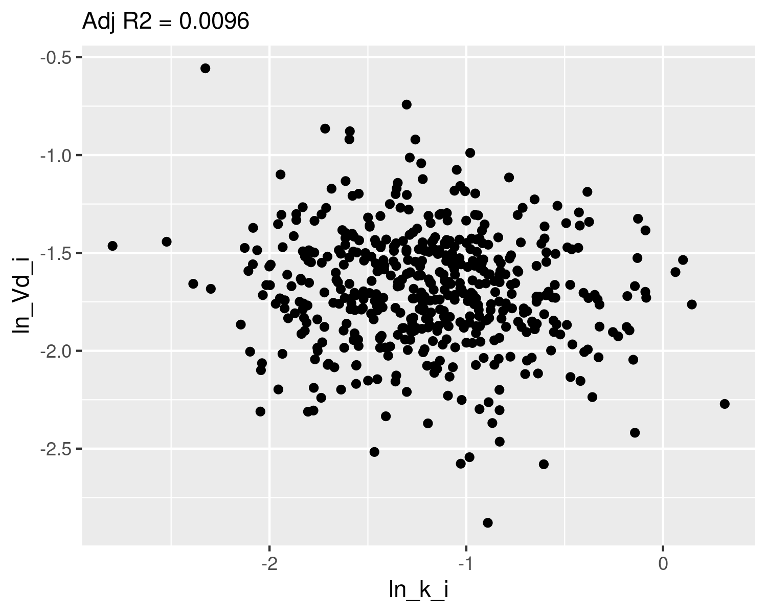

## Check normality

qqnorm(dat$ln_k_i,main="ln k Q-Q Normal")  
qqline(dat$ln_k_i,col="red")

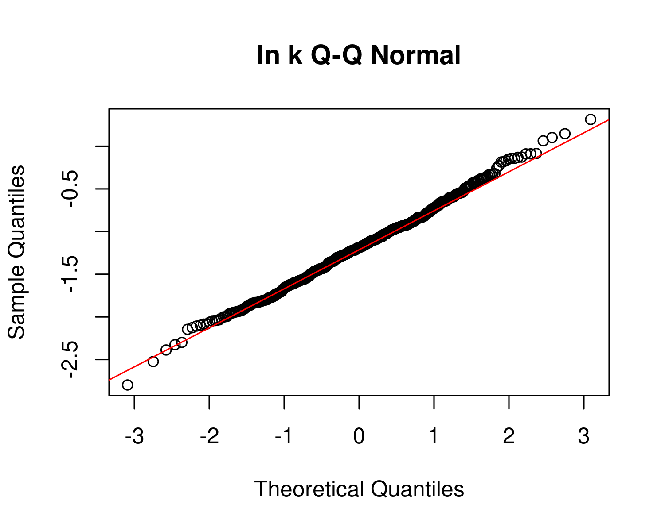

plot(ecdf(dat$ln_k_i))  
x <- seq(-3,1,0.01)  
m_ln_k_i <- mean(dat$ln_k_i)  
sd_ln_k_i <- sd(dat$ln_k_i)  
lines(x,pnorm(x,mean=m_ln_k_i,sd=sd_ln_k_i),col="red")  
text(m_ln_k_i-2*sd_ln_k_i,0.9,paste("m =",signif(m_ln_k_i,4),"\nsd =",signif(sd_ln_k_i,4)))

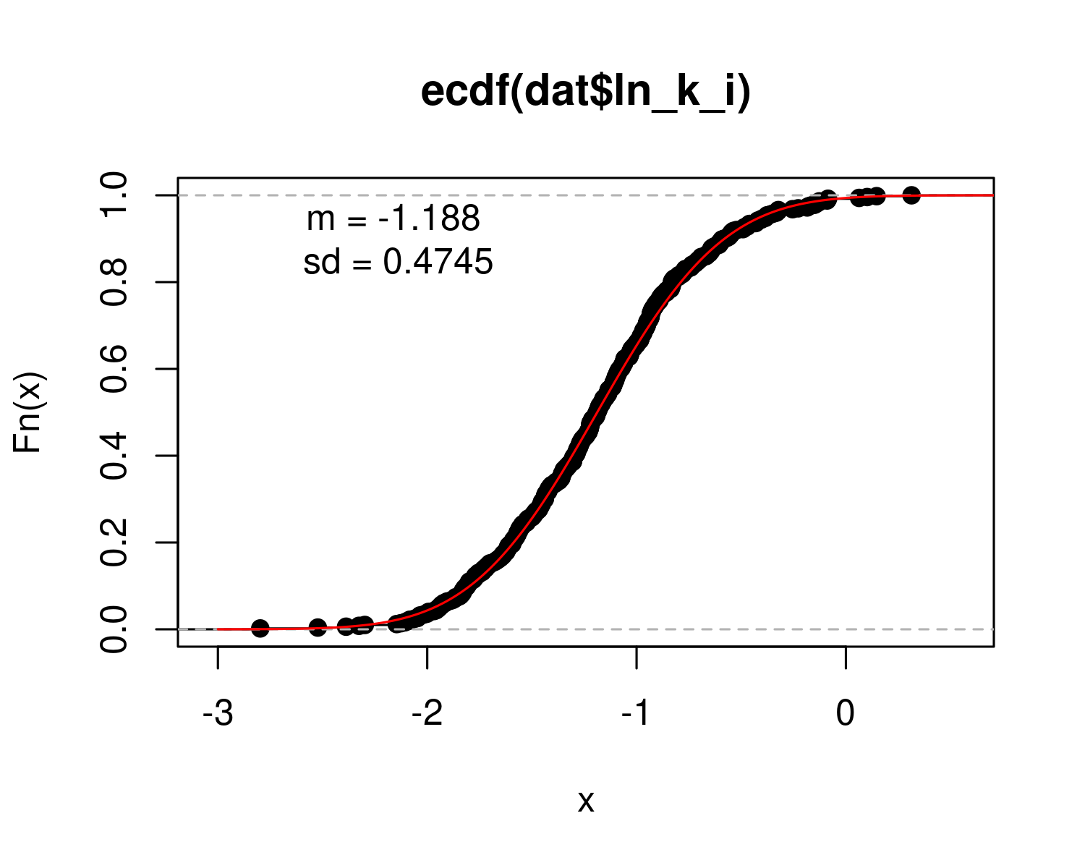

qqnorm(dat$ln_Vd_i,main="ln Vd Q-Q Normal")  
qqline(dat$ln_Vd_i,col="red")

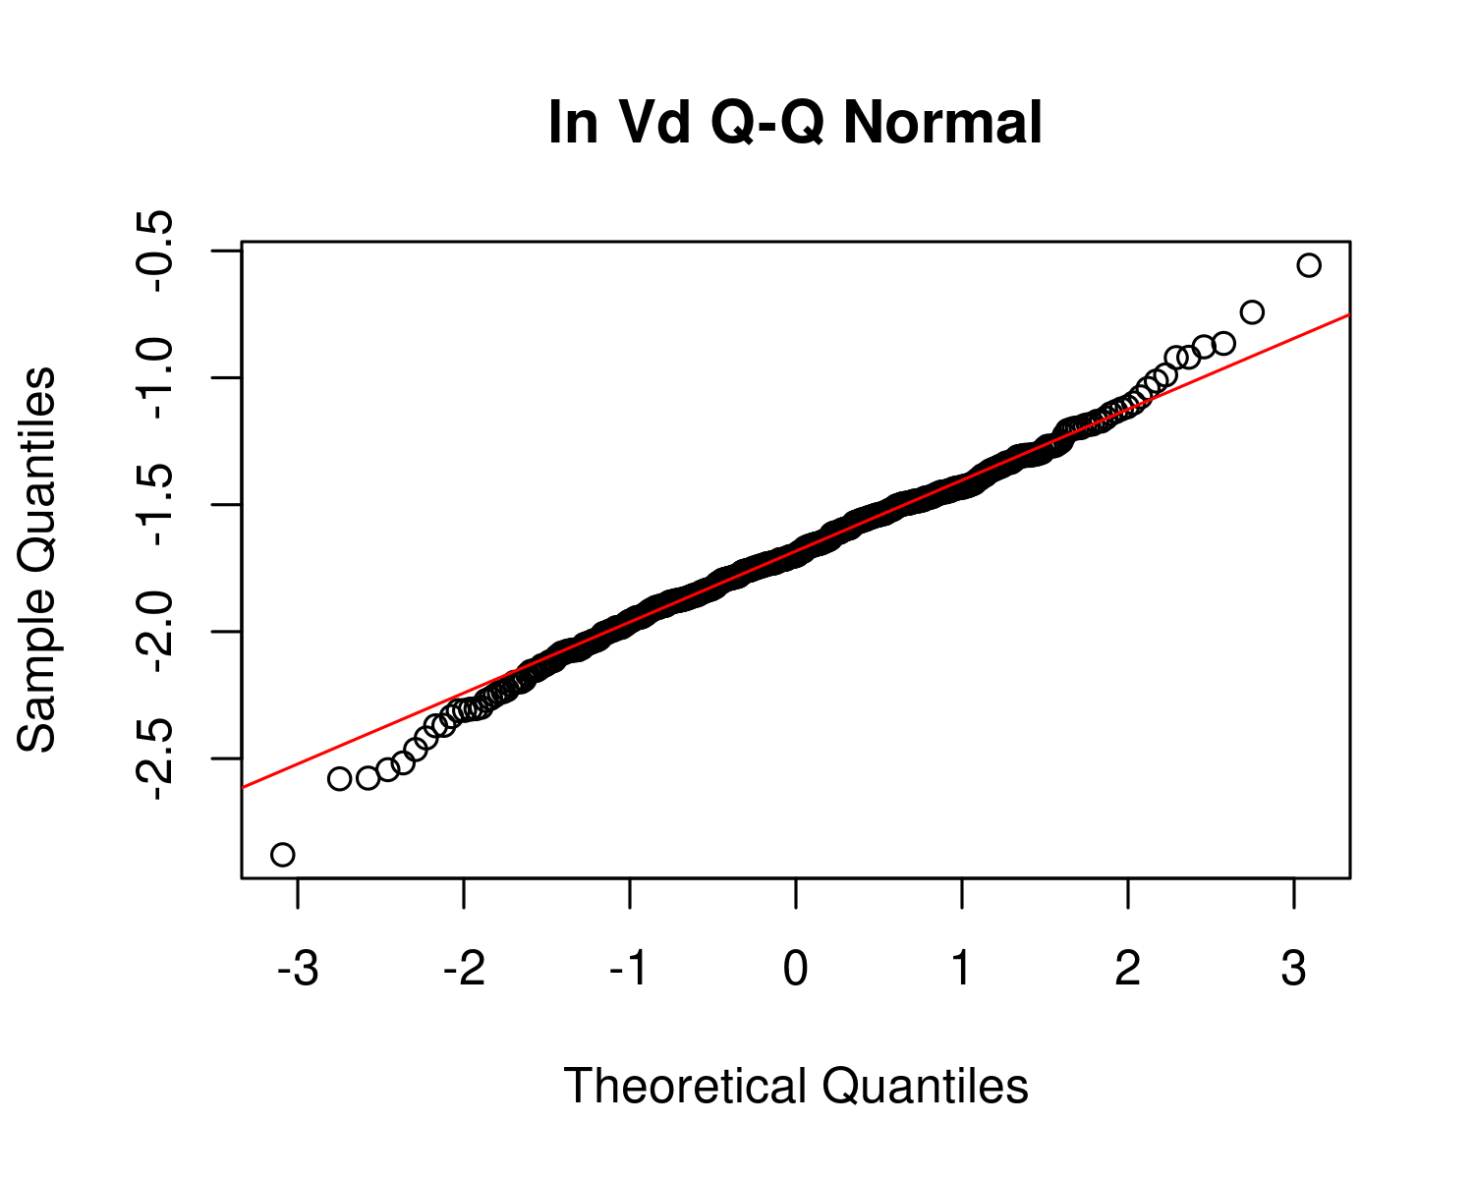

plot(ecdf(dat$ln_Vd_i))  
x <- seq(-3,1,0.01)  
m_ln_Vd_i <- mean(dat$ln_Vd_i)  
sd_ln_Vd_i <- sd(dat$ln_Vd_i)  
  
lines(x,pnorm(x,mean=m_ln_Vd_i,sd=sd_ln_Vd_i),col="red")  
text(m_ln_Vd_i-2*sd_ln_Vd_i,0.9,paste("m =",signif(m_ln_Vd_i,4),"\nsd =",signif(sd_ln_Vd_i,4)))

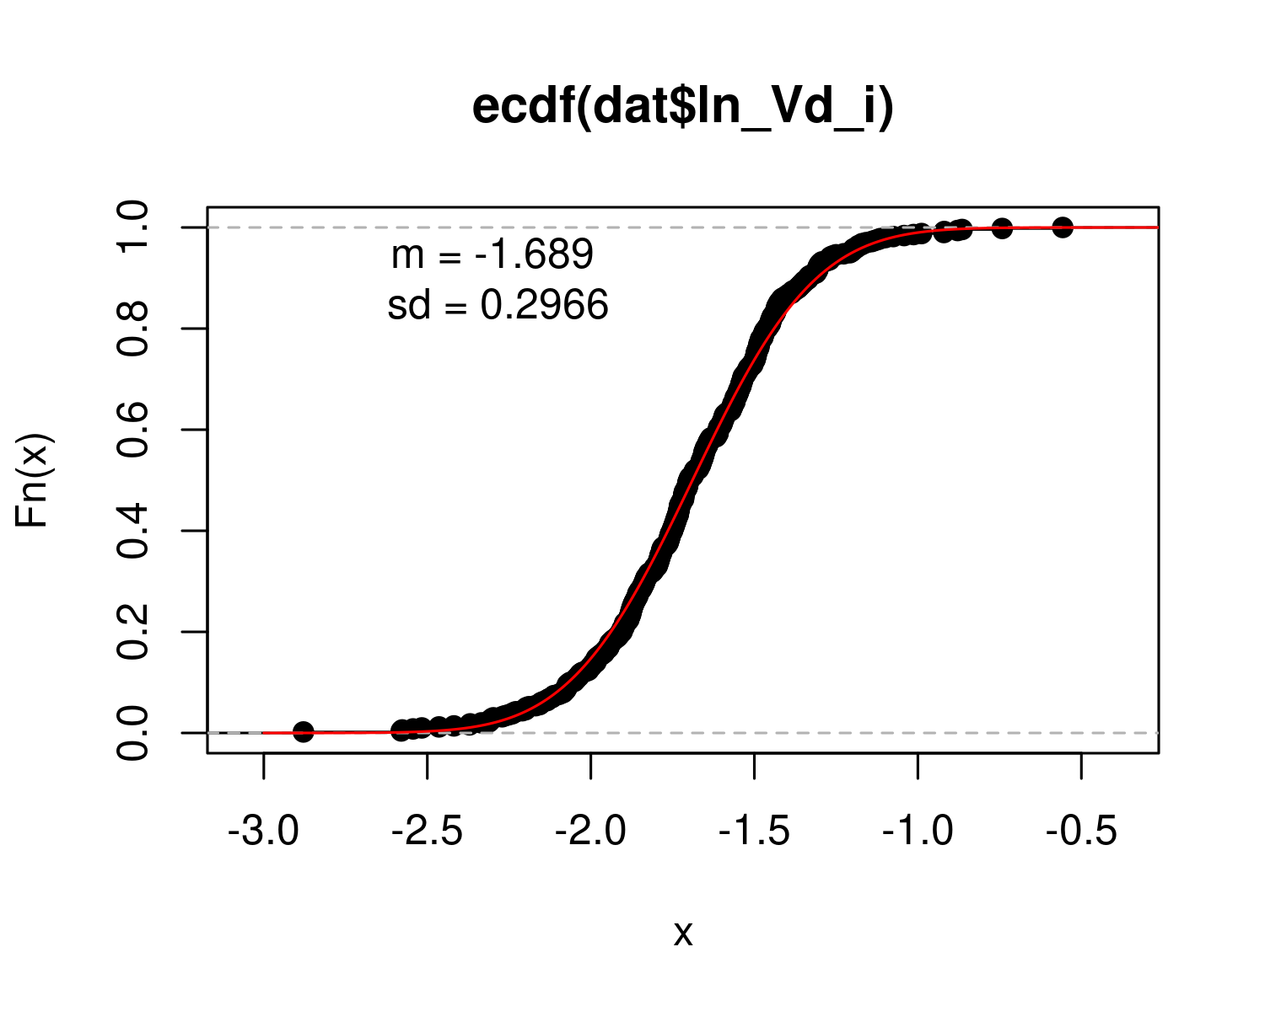

## Calculate table values for individual-level

hl_i <- log(2)/ exp(dat$ln_k_i) # individual half-life   
med_hl_i <- paste(signif (median (hl_i), 3)) # median of individual half-life  
ci_med_hl_i <- paste(signif (quantile(hl_i, prob=c(0.025,0.975)), 3),collapse="-") # 95ci med individual halflife  
ci98_med_hl_i <- paste(signif (quantile(hl_i, prob=c(0.01,0.99)), 3),collapse="-") # 98ci med individual halflife  
gm_hl_i <- paste(signif (exp(mean(log(hl_i))), 3)) # gm (which should be really close)  
gsd_hl_i <- paste(signif (exp(sd(log(hl_i))), 3)) # gsd individual  
  
med_Vd_i <- paste(signif (median(exp(dat$ln_Vd_i)), 3)) # median individual Vd  
ci_med_Vd_i <-paste(signif (quantile(exp(dat$ln_Vd_i), prob=c(0.025,0.975)), 3),collapse="-") # 95ci med individual Vd  
ci98_med_Vd_i <-paste(signif (quantile(exp(dat$ln_Vd_i), prob=c(0.01,0.99)), 3),collapse="-") # 98ci med individual Vd  
gm_vd_i <- paste(signif (exp(mean(dat$ln_Vd_i)), 3)) # gm (which should be really close)  
gsd_vd_i<- paste(signif (exp(sd(dat$ln_Vd_i)), 3)) # gsd indiv  
  
med_CL_i <- paste(signif (median(exp(dat$ln_Vd_i+dat$ln_k_i)), 3)) # median individual CL  
ci_med_CL_i <-paste(signif (quantile(exp(dat$ln_Vd_i+dat$ln_k_i), prob=c(0.025,0.975)), 3),collapse="-") # 95ci med individual CL  
ci98_med_CL_i <-paste(signif (quantile(exp(dat$ln_Vd_i+dat$ln_k_i), prob=c(0.01,0.99)), 3),collapse="-") # 98ci med individual CL  
gm_CL_i <- paste(signif (exp(mean(dat$ln_Vd_i+dat$ln_k_i)), 3)) # gm (which should be really close)  
gsd_CL_i<- paste(signif (exp(sd(dat$ln_Vd_i+dat$ln_k_i)), 3)) # gsd indiv

PFNA_priors <- data.frame(  
 halflife_GM= log(2)/rlnorm(50000,  
 meanlog=-1.80181,sdlog=0.4055))  
M_k <- exp(as.numeric(dat$`M_ln_k(1)`))  
PFNA_halflife_GM <- log(2)/M_k  
  
PFNA_hlgm_pr_med <- signif(median(PFNA_priors$halflife_GM,3))  
PFNA_hlgm_pr_med_95ci <-paste(signif(quantile(PFNA_priors$halflife_GM,  
 prob=c(0.025,0.975)),  
 3),  
 collapse="-")  
  
PFNA_hl_median_gm <- signif(median(PFNA_halflife_GM),3)  
PFNA_hl_median_gm_95ci <- paste(signif(quantile(PFNA_halflife_GM,  
 prob=c(0.025,0.975)),3),collapse="-")  
  
p<-ggplot()+  
 stat_density(aes(halflife_GM, color = "Prior"),data=PFNA_priors,geom="line",size=2)+  
 stat_density(aes(PFNA_halflife_GM,stat(density),color="Posterior"),geom="line",size=1.5)+  
 xlim(0,15)+  
 labs(title = bquote("E: PFNA"~T[1/2]~"Population GM") ,  
 subtitle=paste("Posterior Median (95% CI): ",  
 PFNA_hl_median_gm," (",  
 PFNA_hl_median_gm_95ci,  
 ")",sep=""))+  
 xlab(bquote("Population GM"~T[1/2]~"(yrs)")) +  
 scale_color_manual(name=NULL,   
 values=c(Prior="#009988", Posterior="#EE7733" )) +   
 theme_classic() +   
 theme(legend.title = element_blank(),legend.position=c(0.8,0.7),  
 panel.background = element_rect(color="black",size=1),  
 legend.background = element_rect(fill="transparent", color=NA))  
print(p)

## Warning: Removed 41 rows containing non-finite values (stat_density).

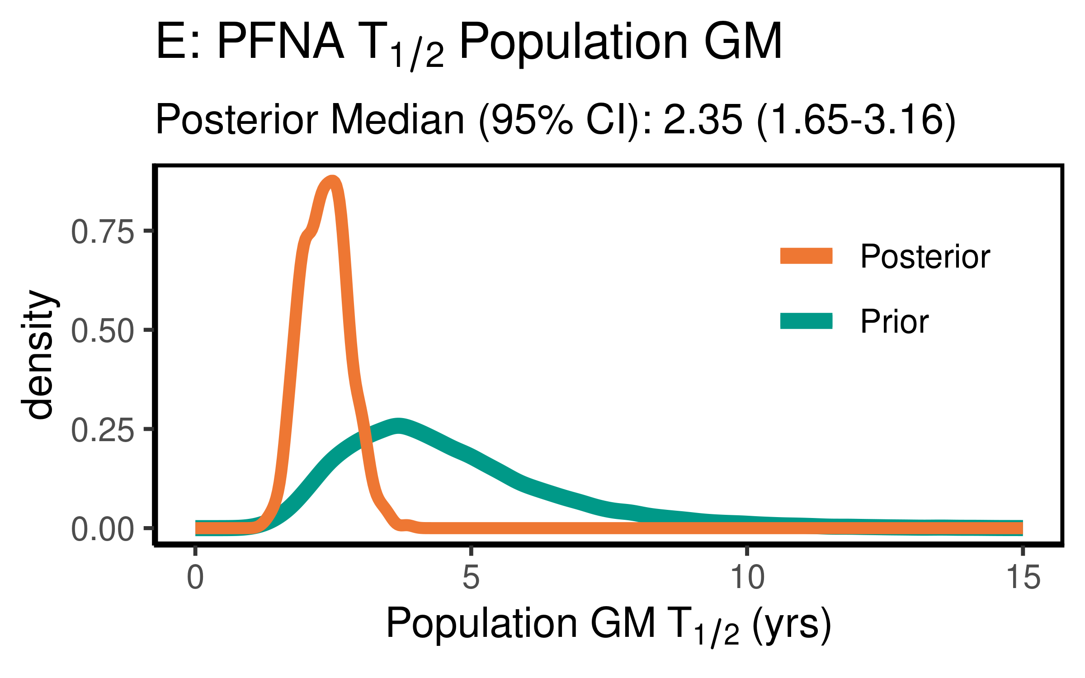

ggsave(here ("output-plots", paste0( sa, "PFNA_hl_gm.pdf")) ,p,dpi=600)

## Saving 4 x 2.5 in image

## Warning: Removed 41 rows containing non-finite values (stat_density).

ggsave(here ("output-plots", paste0( sa, "PFNA_hl_gm.png")) ,p,dpi=600)

## Saving 4 x 2.5 in image

## Warning: Removed 41 rows containing non-finite values (stat_density).

PFNA_priors$halflife_GSD = exp(sqrt(exp(rnorm(50000,m=log(0.2000),sd=log(1.275)))))   
PFNA_halflife_GSD <- exp(sqrt(dat$`V_ln_k(1)`))  
  
PFNA_hlgsd_pr_med <- signif(median(PFNA_priors$halflife_GSD,3))  
PFNA_hlgsd_pr_med_95ci <-paste(signif(quantile(PFNA_priors$halflife_GSD,  
 prob=c(0.025,0.975)),  
 3),  
 collapse="-")  
PFNA_hl_gsd_med <- signif(median(PFNA_halflife_GSD),3)  
PFNA_hl_gsd_med_95ci <- paste(signif(quantile(PFNA_halflife_GSD,  
 prob=c(0.025,0.975)),3),collapse="-")  
p<-ggplot()+  
 stat_density(aes(halflife_GSD, color = "Prior"),data=PFNA_priors,geom="line",size=2)+  
 stat_density(aes(PFNA_halflife_GSD,stat(density), color = "Posterior"),geom="line",size=1.5)+  
 xlim(1,3)+  
 labs(title = bquote("F: PFNA"~T[1/2]~"Population GSD"),   
 subtitle=paste("Posterior Median (95% CI): ",  
 PFNA_hl_gsd_med," (",  
 PFNA_hl_gsd_med_95ci,  
 ")",sep=""))+  
 xlab(bquote("Population GSD"~T[1/2]))+  
 scale_color_manual(name=NULL,   
 values=c(Prior="#009988", Posterior="#EE7733" )) +   
 theme_classic() +   
 theme(legend.title = element_blank(),legend.position=c(0.8,0.7),  
 panel.background = element_rect(color="black",size=1),  
 legend.background = element_rect(fill="transparent", color=NA))  
print(p)

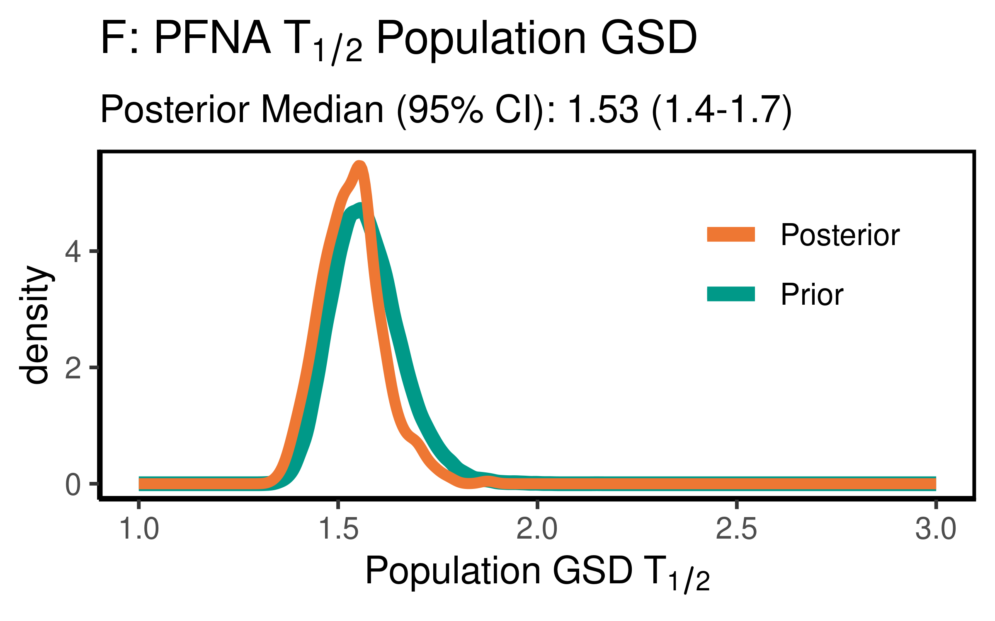

ggsave(here ("output-plots", paste0( sa, "PFNA_hl_gsd.pdf")), p,dpi=600)  
ggsave(here ("output-plots", paste0( sa, "PFNA_hl_gsd.png")), p,dpi=600)

### Distribution Volume

For PFNA, the data were not particularly informative, but slightly increased the estimate of the median to 0.308(0.223-0.548) slightly. They were not informative as to the population GSD, with the posterior distributions essentially unchanged from the priors.

PFNA_priors$Vd_GM <- rlnorm(50000,  
 meanlog=-1.77196,  
 sdlog=0.2624)  
PFNA_Vd_GM <- exp(dat$`M_ln_Vd(1)`)  
  
   
  
PFNA_vd_gm_pr_med <- signif(median(PFNA_priors$Vd_GM,3))  
PFNA_vd_gm_pr_med_95ci <- paste(signif(quantile(PFNA_priors$Vd_GM,  
 prob=c(0.025,0.975)), 3), collapse="-")  
PFNA_vd_gm_med <- signif(median(PFNA_Vd_GM),3)  
PFNA_vd_gm_med_95ci <- paste(signif(quantile(PFNA_Vd_GM,  
 prob=c(0.025,0.975)),3),collapse="-")  
  
p<-ggplot()+  
 stat_density(aes(Vd_GM, color = "Prior"),data=PFNA_priors,geom="line",size=2)+  
 stat_density(aes(PFNA_Vd_GM,stat(density), color = "Posterior"),geom="line",size=1.5)+  
 xlim(0,1)+labs(title = bquote("E: PFNA"~V[d]~"Population GM"),  
 subtitle=paste("Posterior Median (95% CI): ",  
 PFNA_vd_gm_med," (",   
 PFNA_vd_gm_med_95ci,")",sep=""))+  
 xlab(bquote("Population GM"~V[d]~"(l/kg)"))+  
 scale_color_manual(name=NULL,   
 values=c(Prior="#009988", Posterior="#EE7733" )) +   
 theme_classic() +   
 theme(legend.title = element_blank(),legend.position=c(0.8,0.7),  
 panel.background = element_rect(color="black",size=1),  
 legend.background = element_rect(fill="transparent", color=NA))  
print(p)

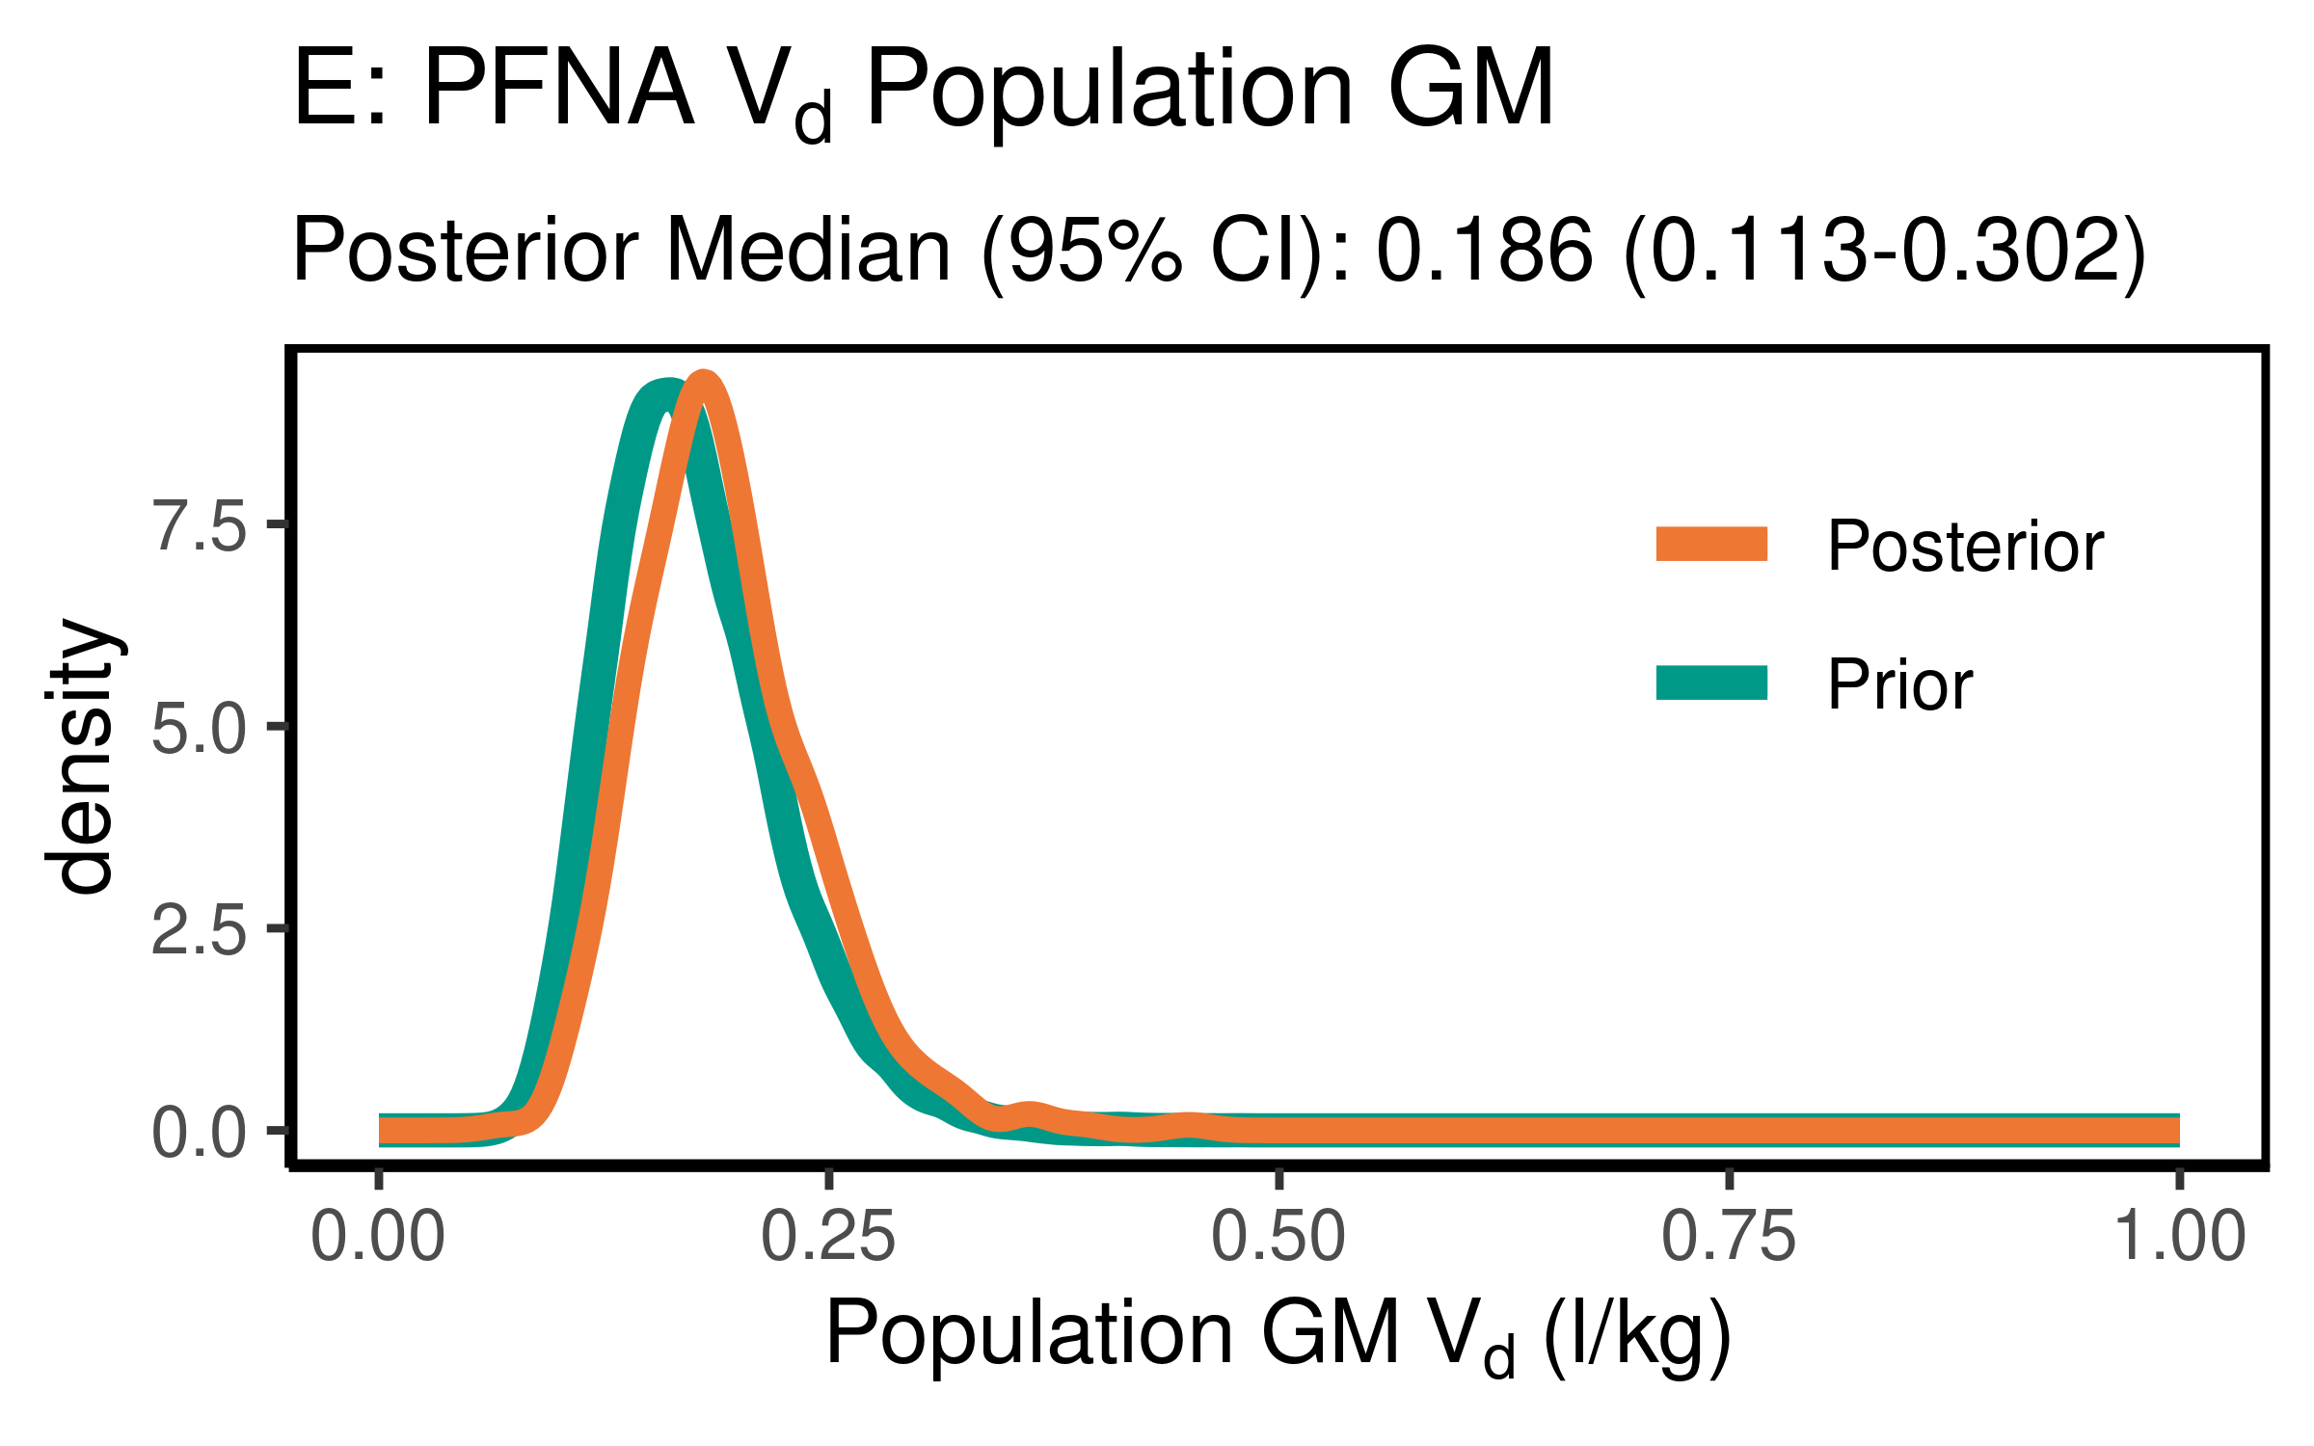

ggsave(here ("output-plots",paste0( sa, "PFNA_vd_gm.pdf")), p,dpi=600)  
ggsave(here ("output-plots",paste0( sa, "PFNA_vd_gm.png")), p,dpi=600)

PFNA_priors$Vd_GSD = exp(abs(rnorm(50000,sd=0.17)))  
PFNA_Vd_GSD <- exp(dat$`SD_ln_Vd(1)`)  
  
PFNA_vd_gsd_pr_med <- signif(median(PFNA_priors$Vd_GSD,3))  
PFNA_vd_gsd_pr_med_95ci <- paste(signif(quantile(PFNA_priors$Vd_GSD,  
 prob=c(0.025,0.975)), 3), collapse="-")  
  
PFNA_vd_gsd_med <- signif(median(PFNA_Vd_GSD),3)  
PFNA_vd_gsd_med_95ci <- paste(signif(quantile(PFNA_Vd_GSD,  
 prob=c(0.025,0.975)),3),collapse="-")  
  
p<-ggplot()+  
 stat_density(aes(Vd_GSD, color = "Prior"),data=PFNA_priors,geom="line",size=2)+  
 stat_density(aes(PFNA_Vd_GSD,stat(density), color = "Posterior"),geom="line",size=1.5)+  
 xlim(1,3)+  
 labs(title = bquote("F: PFNA"~V[d]~"Population GSD "),  
 subtitle=paste("Posterior Median (95% CI): ",  
 PFNA_vd_gsd_med," (",  
 PFNA_vd_gsd_med_95ci,  
 ")",sep=""))+  
 xlab(bquote("Population GSD"~V[d]))+  
 scale_color_manual(name=NULL,   
 values=c(Prior="#009988", Posterior="#EE7733" )) +   
 theme_classic() +   
 theme(legend.title = element_blank(),legend.position=c(0.8,0.7),  
 panel.background = element_rect(color="black",size=1),  
 legend.background = element_rect(fill="transparent", color=NA))  
print(p)

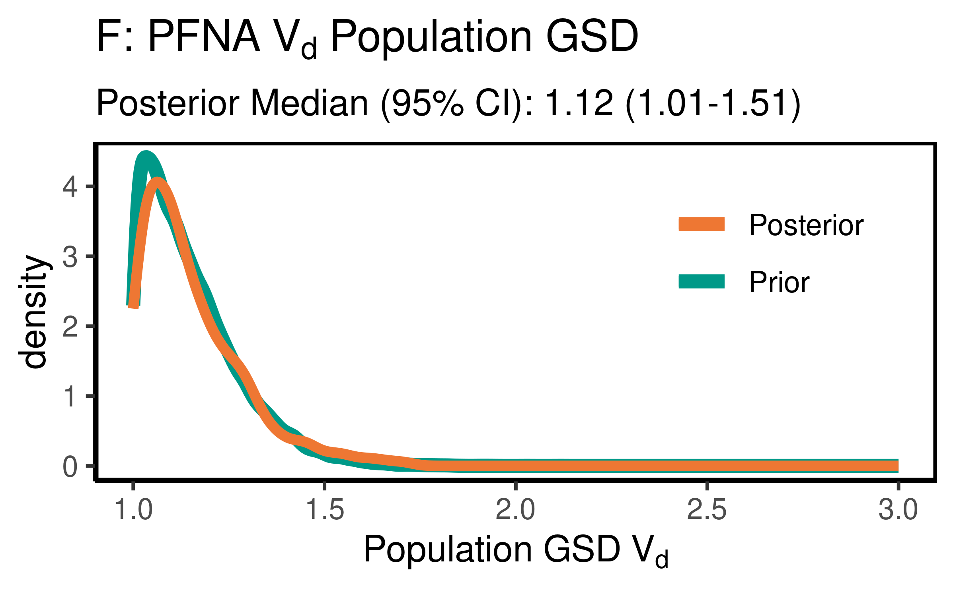

ggsave(here ("output-plots",paste0( sa, "PFNA_vd_gsd.pdf")), p,dpi=600)  
ggsave(here ("output-plots",paste0( sa, "PFNA_vd_gsd.png")), p,dpi=600)

### Clearance

Cl is k * Vd

PFNA_priors$CL_GM <- PFNA_priors$Vd_GM * (log(2)/PFNA_priors$halflife_GM)  
PFNA_CL_GM <- exp(dat$`M_ln_Vd(1)` + dat$`M_ln_k(1)`)  
  
PFNA_cl_gm_pr_med <- signif(median(PFNA_priors$CL_GM,3))  
PFNA_cl_gm_pr_med_95ci <- paste(signif(quantile(PFNA_priors$CL_GM,  
 prob=c(0.025,0.975)), 3), collapse="-")  
PFNA_cl_gm_med <- signif(median(PFNA_CL_GM),3)  
PFNA_cl_gm_med_95ci <- paste(signif(quantile(PFNA_CL_GM,  
 prob=c(0.025,0.975)),3),collapse="-")  
  
p<-ggplot()+  
 stat_density(aes(CL_GM, color = "Prior"),data=PFNA_priors,geom="line",size=2)+  
 stat_density(aes(PFNA_CL_GM,stat(density), color = "Posterior"),geom="line",size=1.5)+  
 xlim(0,0.25)+labs(title = "C: PFNA Clearance Pop. GM ",subtitle=paste("Posterior Median (95% CI): ",  
 PFNA_cl_gm_med," (",  
 PFNA_cl_gm_med_95ci,  
 ")",sep=""))+  
 xlab("Pop. GM CL (l/(kg-yr))")+  
 scale_color_manual(name=NULL,   
 values=c(Prior="#009988", Posterior="#EE7733" )) +   
 theme_classic() +   
 theme(legend.title = element_blank(),legend.position=c(0.8,0.7),  
 panel.background = element_rect(color="black",size=1),  
 legend.background = element_rect(fill="transparent", color=NA))  
print(p)

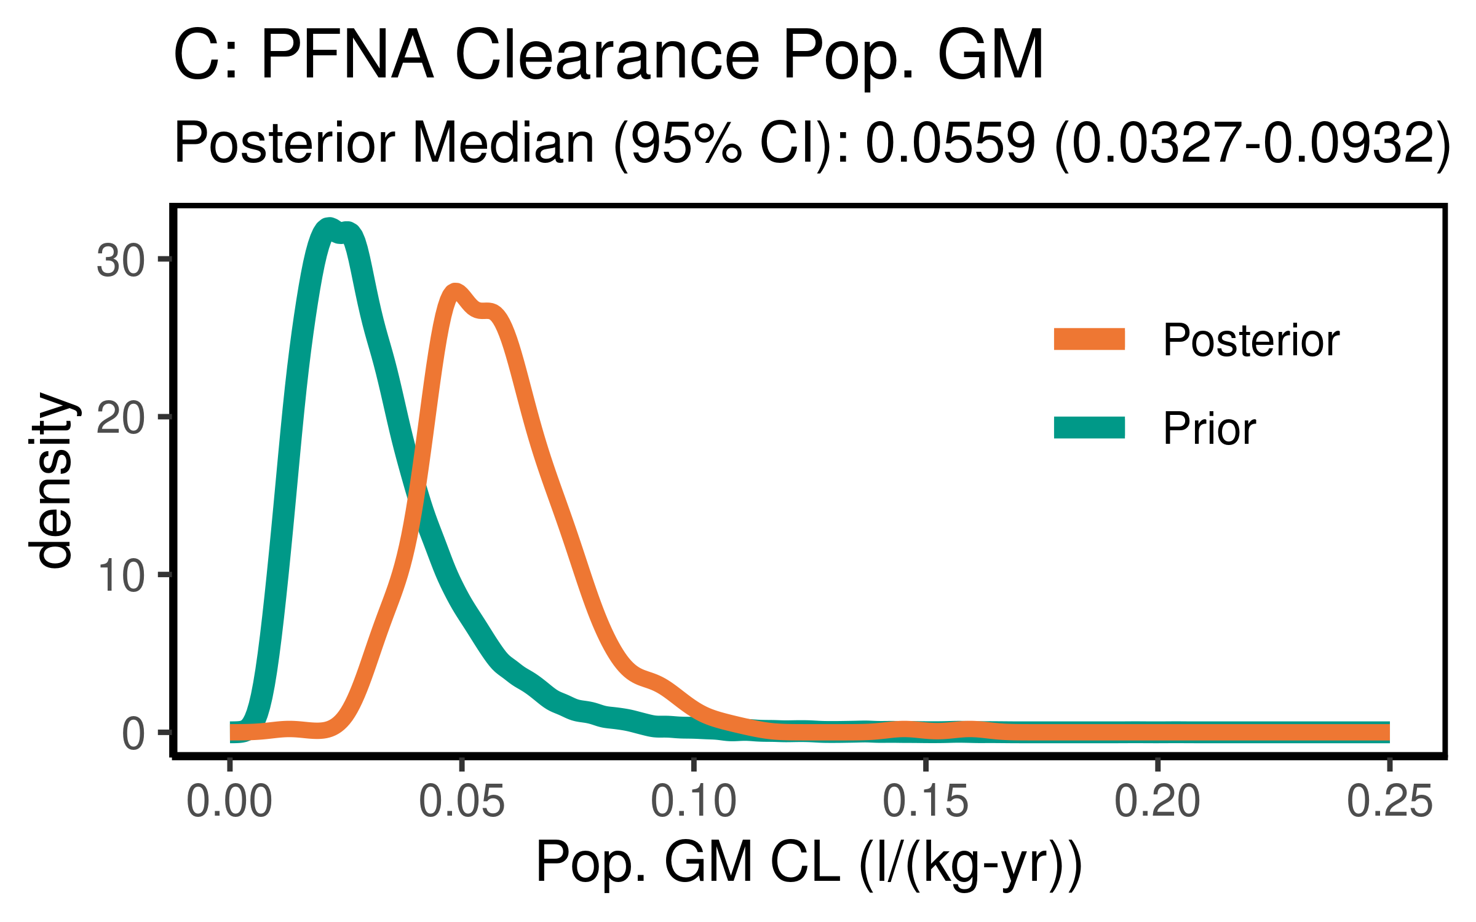

ggsave(here ("output-plots",paste0( sa, "PFNA_CL_gm.pdf")) ,p,dpi=600)  
ggsave(here ("output-plots",paste0( sa, "PFNA_CL_gm.png")) ,p,dpi=600)

PFNA_priors$CL_GSD = exp(sqrt(log(PFNA_priors$Vd_GSD)^2 +   
 log(PFNA_priors$halflife_GSD)^2))  
PFNA_CL_GSD <- exp(sqrt(log(PFNA_Vd_GSD)^2 +   
 log(PFNA_halflife_GSD)^2))  
  
PFNA_CL_gsd_pr_med <- signif(median(PFNA_priors$CL_GSD,3))  
PFNA_CL_gsd_pr_med_95ci <- paste(signif(quantile(PFNA_priors$CL_GSD,  
 prob=c(0.025,0.975)), 3), collapse="-")  
  
PFNA_CL_gsd_med <- signif(median(PFNA_CL_GSD),3)  
PFNA_CL_gsd_med_95ci <- paste(signif(quantile(PFNA_CL_GSD,  
 prob=c(0.025,0.975)),3),collapse="-")  
  
p<-ggplot()+  
 stat_density(aes(CL_GSD, color = "Prior"),data=PFNA_priors,geom="line",size=2)+  
 stat_density(aes(PFNA_CL_GSD,stat(density), color = "Posterior"),geom="line",size=1.5)+  
 xlim(1,3)+  
 labs(title = bquote("H: PFNA"~CL~"Population GSD "),  
 subtitle=paste("Posterior Median (95% CI): ",  
 PFNA_CL_gsd_med," (",  
 PFNA_CL_gsd_med_95ci,  
 ")",sep=""))+  
 xlab(bquote("Population GSD"~CL))+  
 scale_color_manual(name=NULL,   
 values=c(Prior="#009988", Posterior="#EE7733" )) +   
 theme_classic() +   
 theme(legend.title = element_blank(),legend.position=c(0.8,0.7),  
 panel.background = element_rect(color="black",size=1),  
 legend.background = element_rect(fill="transparent", color=NA))  
print(p)

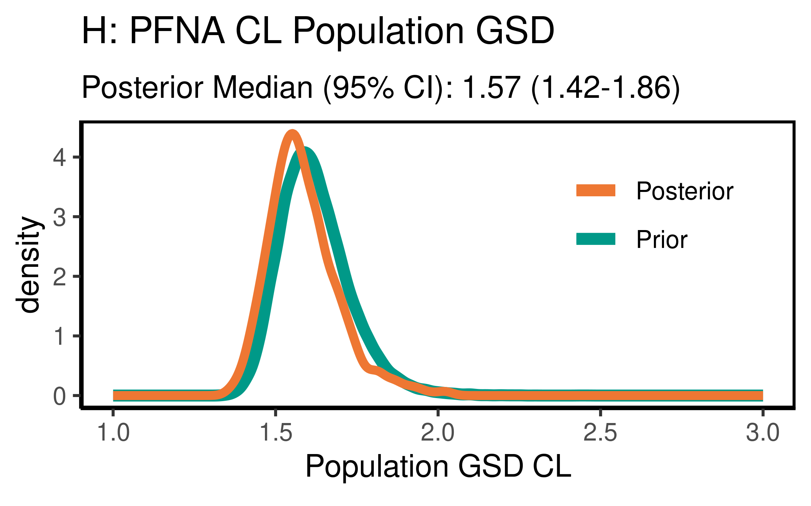

ggsave(here ("output-plots",paste0( sa,"PFNA_CL_gsd.pdf")) ,p,dpi=600)  
ggsave(here ("output-plots",paste0( sa,"PFNA_CL_gsd.png")) ,p,dpi=600)

## Table significant digit values

PFNA_hlgm_pr_med <- paste(signif(PFNA_hlgm_pr_med, 3))  
PFNA_hl_median_gm<- paste(signif(PFNA_hl_median_gm, 3))  
PFNA_hlgsd_pr_med<- paste(signif(PFNA_hlgsd_pr_med, 3))  
PFNA_hl_gsd_med<- paste(signif(PFNA_hl_gsd_med, 3))  
PFNA_vd_gm_pr_med<- paste(signif(PFNA_vd_gm_pr_med, 3))  
PFNA_vd_gm_med<- paste(signif(PFNA_vd_gm_med, 3))  
PFNA_vd_gsd_pr_med<- paste(signif(PFNA_vd_gsd_pr_med, 3))  
PFNA_vd_gsd_med<- paste(signif(PFNA_vd_gsd_med, 3))  
PFNA_cl_gm_pr_med<- paste(signif(PFNA_cl_gm_pr_med, 3))  
PFNA_cl_gm_med<- paste(signif(PFNA_cl_gm_med, 3))

### Population median estimates [95% CI]

|  |  |  |  |  |
| --- | --- | --- | --- | --- |
| Parameter | Prior GM | Posterior GM | Prior GSD | Posterior GSD |
| Half-life (years) | 4.2 | 2.35 | 1.56 | 1.53 |
| HL [95% CI] | [1.89-9.37] | [1.65-3.16] | [1.42-1.77] | [1.4-1.7] |
| Volume of distribution | 0.17 | 0.186 | 1.12 | 1.12 |
| [95% CI] | [0.102-0.284] | [0.113-0.302] | [1.01-1.46] | [1.01-1.51] |
| Clearance | 0.028 | 0.0559 |  |  |
| [95% CI] | [0.0108-0.0727] | [0.0327-0.0932] | [] | [] |

### Individual Posterior estimates

|  |  |  |  |
| --- | --- | --- | --- |
| Parameter | median GM [95% CI] [[98% CI]] | GM calculator input | GSD individual |
| Half-life (years) | 2.27 [ 0.826-5.36 ] [[ 0.758-5.94 ]] | 2.27 | 1.61 |
| Volume of distribution | 0.183 [ 0.0998-0.324 ] [[ 0.085-0.398 ]] | 0.185 | 1.35 |
| Clearance (L/kg-yr) | 0.0573 [ 0.0188-0.163 ] [[ 0.0165-0.199 ]] | 0.0563 | 1.7 |

## ─ Session info ───────────────────────────────────────────────────────────────  
## setting value   
## version R version 3.6.3 (2020-02-29)   
## os Red Hat Enterprise Linux Server 7.9 (Maipo)  
## system x86_64, linux-gnu   
## ui X11   
## language (EN)   
## collate en_US.UTF-8   
## ctype en_US.UTF-8   
## tz America/New_York   
## date 2022-01-23   
##   
## ─ Packages ───────────────────────────────────────────────────────────────────  
## package * version date lib source   
## assertthat 0.2.1 2019-03-21 [2] CRAN (R 3.6.3)  
## backports 1.2.1 2020-12-09 [2] CRAN (R 3.6.3)  
## bayesplot * 1.8.0 2021-01-10 [2] CRAN (R 3.6.3)  
## broom 0.7.5 2021-02-19 [2] CRAN (R 3.6.3)  
## cachem 1.0.4 2021-02-13 [2] CRAN (R 3.6.3)  
## callr 3.5.1 2020-10-13 [2] CRAN (R 3.6.3)  
## cellranger 1.1.0 2016-07-27 [2] CRAN (R 3.6.3)  
## cli 2.3.1 2021-02-23 [2] CRAN (R 3.6.3)  
## coda * 0.19-4 2020-09-30 [2] CRAN (R 3.6.3)  
## codetools 0.2-18 2020-11-04 [2] CRAN (R 3.6.3)  
## colorspace 2.0-0 2020-11-11 [2] CRAN (R 3.6.3)  
## crayon 1.4.1 2021-02-08 [2] CRAN (R 3.6.3)  
## DBI 1.1.1 2021-01-15 [2] CRAN (R 3.6.3)  
## dbplyr 2.1.0 2021-02-03 [2] CRAN (R 3.6.3)  
## debugme 1.1.0 2017-10-22 [2] CRAN (R 3.6.3)  
## desc 1.3.0 2021-03-05 [2] CRAN (R 3.6.3)  
## devtools 2.3.2 2020-09-18 [2] CRAN (R 3.6.3)  
## digest 0.6.27 2020-10-24 [2] CRAN (R 3.6.3)  
## dplyr * 1.0.5 2021-03-05 [2] CRAN (R 3.6.3)  
## ellipsis 0.3.1 2020-05-15 [2] CRAN (R 3.6.3)  
## evaluate 0.14 2019-05-28 [2] CRAN (R 3.6.3)  
## fansi 0.4.2 2021-01-15 [2] CRAN (R 3.6.3)  
## farver 2.1.0 2021-02-28 [2] CRAN (R 3.6.3)  
## fastmap 1.1.0 2021-01-25 [2] CRAN (R 3.6.3)  
## forcats * 0.5.1 2021-01-27 [2] CRAN (R 3.6.3)  
## fs 1.5.0 2020-07-31 [2] CRAN (R 3.6.3)  
## generics 0.1.0 2020-10-31 [2] CRAN (R 3.6.3)  
## ggplot2 * 3.3.3 2020-12-30 [2] CRAN (R 3.6.3)  
## ggridges 0.5.3 2021-01-08 [2] CRAN (R 3.6.3)  
## ggsci * 2.9 2018-05-14 [2] CRAN (R 3.6.3)  
## glue 1.4.2 2020-08-27 [2] CRAN (R 3.6.3)  
## gtable 0.3.0 2019-03-25 [2] CRAN (R 3.6.3)  
## haven 2.3.1 2020-06-01 [2] CRAN (R 3.6.3)  
## here * 1.0.1 2020-12-13 [2] CRAN (R 3.6.3)  
## highr 0.8 2019-03-20 [2] CRAN (R 3.6.3)  
## hms 1.0.0 2021-01-13 [2] CRAN (R 3.6.3)  
## htmltools 0.5.1.1 2021-01-22 [2] CRAN (R 3.6.3)  
## httr 1.4.2 2020-07-20 [2] CRAN (R 3.6.3)  
## jsonlite 1.7.2 2020-12-09 [2] CRAN (R 3.6.3)  
## khroma * 1.7.0 2021-09-02 [1] CRAN (R 3.6.3)  
## knitr 1.31 2021-01-27 [2] CRAN (R 3.6.3)  
## labeling 0.4.2 2020-10-20 [2] CRAN (R 3.6.3)  
## lattice 0.20-41 2020-04-02 [2] CRAN (R 3.6.3)  
## lifecycle 1.0.0 2021-02-15 [2] CRAN (R 3.6.3)  
## lubridate 1.7.10 2021-02-26 [2] CRAN (R 3.6.3)  
## magrittr 2.0.1 2020-11-17 [2] CRAN (R 3.6.3)  
## memoise 2.0.0 2021-01-26 [2] CRAN (R 3.6.3)  
## modelr 0.1.8 2020-05-19 [2] CRAN (R 3.6.3)  
## munsell 0.5.0 2018-06-12 [2] CRAN (R 3.6.3)  
## pillar 1.5.1 2021-03-05 [2] CRAN (R 3.6.3)  
## pkgbuild 1.2.0 2020-12-15 [2] CRAN (R 3.6.3)  
## pkgconfig 2.0.3 2019-09-22 [2] CRAN (R 3.6.3)  
## pkgload 1.2.0 2021-02-23 [2] CRAN (R 3.6.3)  
## plyr 1.8.6 2020-03-03 [2] CRAN (R 3.6.3)  
## prettyunits 1.1.1 2020-01-24 [2] CRAN (R 3.6.3)  
## pROC 1.17.0.1 2021-01-13 [2] CRAN (R 3.6.3)  
## processx 3.4.5 2020-11-30 [2] CRAN (R 3.6.3)  
## ps 1.6.0 2021-02-28 [2] CRAN (R 3.6.3)  
## purrr * 0.3.4 2020-04-17 [2] CRAN (R 3.6.3)  
## R6 2.5.0 2020-10-28 [2] CRAN (R 3.6.3)  
## Rcpp 1.0.6 2021-01-15 [2] CRAN (R 3.6.3)  
## readr * 1.4.0 2020-10-05 [2] CRAN (R 3.6.3)  
## readxl 1.3.1 2019-03-13 [2] CRAN (R 3.6.3)  
## remotes 2.2.0 2020-07-21 [2] CRAN (R 3.6.3)  
## reprex 1.0.0 2021-01-27 [2] CRAN (R 3.6.3)  
## reshape2 * 1.4.4 2020-04-09 [2] CRAN (R 3.6.3)  
## rlang 0.4.10 2020-12-30 [2] CRAN (R 3.6.3)  
## rmarkdown 2.7 2021-02-19 [2] CRAN (R 3.6.3)  
## rprojroot 2.0.2 2020-11-15 [2] CRAN (R 3.6.3)  
## rstudioapi 0.13 2020-11-12 [2] CRAN (R 3.6.3)  
## rvest 1.0.0 2021-03-09 [2] CRAN (R 3.6.3)  
## scales * 1.1.1 2020-05-11 [2] CRAN (R 3.6.3)  
## sessioninfo 1.1.1 2018-11-05 [2] CRAN (R 3.6.3)  
## stringi 1.5.3 2020-09-09 [2] CRAN (R 3.6.3)  
## stringr * 1.4.0 2019-02-10 [2] CRAN (R 3.6.3)  
## testthat 3.0.2 2021-02-14 [2] CRAN (R 3.6.3)  
## tibble * 3.1.0 2021-02-25 [2] CRAN (R 3.6.3)  
## tidyr * 1.1.3 2021-03-03 [2] CRAN (R 3.6.3)  
## tidyselect 1.1.0 2020-05-11 [2] CRAN (R 3.6.3)  
## tidyverse * 1.3.0 2019-11-21 [2] CRAN (R 3.6.3)  
## usethis 2.0.1 2021-02-10 [2] CRAN (R 3.6.3)  
## utf8 1.2.1 2021-03-12 [2] CRAN (R 3.6.3)  
## vctrs 0.3.6 2020-12-17 [2] CRAN (R 3.6.3)  
## withr 2.4.1 2021-01-26 [2] CRAN (R 3.6.3)  
## xfun 0.22 2021-03-11 [2] CRAN (R 3.6.3)  
## xml2 1.3.2 2020-04-23 [2] CRAN (R 3.6.3)  
## yaml 2.2.1 2020-02-01 [2] CRAN (R 3.6.3)  
## yardstick * 0.0.9 2021-11-22 [1] CRAN (R 3.6.3)  
##   
## [1] /home/ad.abt.local/layc/R/x86_64-pc-linux-gnu-library/3.6  
## [2] /opt/R/3.6.3/lib64/R/library