PFOS 1 compartment Plots (v8)

Weihsueh Chiu, Claire Lay, Parker Malek

2021-03-02

library(coda)  
library(bayesplot)

## This is bayesplot version 1.7.0

## - Online documentation and vignettes at mc-stan.org/bayesplot

## - bayesplot theme set to bayesplot::theme_default()

## * Does _not_ affect other ggplot2 plots

## * See ?bayesplot_theme_set for details on theme setting

library(ggplot2)  
library(ggsci)  
library(khroma)  
library(tidyverse)

## ── Attaching packages ─────────────────────────────────────── tidyverse 1.3.0 ──

## ✔ tibble 2.1.3 ✔ dplyr 0.8.3  
## ✔ tidyr 1.0.0 ✔ stringr 1.4.0  
## ✔ readr 1.3.1 ✔ forcats 0.4.0  
## ✔ purrr 0.3.3

## ── Conflicts ────────────────────────────────────────── tidyverse_conflicts() ──  
## ✖ dplyr::filter() masks stats::filter()  
## ✖ dplyr::lag() masks stats::lag()

library(reshape2)

##   
## Attaching package: 'reshape2'

## The following object is masked from 'package:tidyr':  
##   
## smiths

library(here)

## here() starts at /media/projects/Projects/PFAS_PBPK/user/weihsueh_2021/PFAS_1cpt_v8-main/PFOS_1cpt_v8

knitr::opts_chunk$set(echo = TRUE, dpi = 300 )

Set up MCSim file

# this markdown file must be saved in top level directory for the following to work; the mcsim code depends on getwd results.  
mdir <- "MCSim"  
source(here::here(mdir,"setup_MCSim.R"))  
# Make mod.exe (used to create mcsim executable from model file)  
makemod()

## The mod.exe had been created.

## Set filenames and load data

## Set up dataset

id_lut <- multicheck$df_check %>% select(Level) %>% unique () %>%  
 mutate(dataset = c(   
 rep("Decatur M Train", 9),  
 rep("Decatur F Train", 9),  
 rep("Decatur M Test", 9),  
 rep("Decatur F Test", 10),  
 rep("Minnesota Train", 49),  
 rep("Minnesota Test", 49),  
 'Paulsboro-Train','Horsham-Train',  
 'Warminster-Test','Warrington-Train'),   
 Sex = c(   
 rep("M", 9),  
 rep("F", 9),  
 rep("M", 9),  
 rep("F", 10),  
 rep("Mixed", 49),  
 rep("Mixed", 49),   
 rep("Mixed", 4)),  
 City = c(   
 rep("Decatur", 18),  
 rep("Decatur", 19),  
 rep("Minnesota", 98),  
 'Paulsboro','Horsham','Warminster','Warrington'),   
 Train_Test = c(   
 rep("Train", 9),  
 rep("Train", 9),  
 rep("Test", 9),  
 rep("Test", 10),  
 rep("Train", 49),  
 rep("Test", 49),  
 'Train','Train',  
 'Test','Test'),  
 datatype = c(  
 rep("Individual",9+9+9+10+49+49),  
 rep("Summary",4)),  
 Simulation = row_number(),  
 variable = paste0(dataset, " ",Simulation))  
  
id_lut$dataset <- factor(id_lut$dataset,levels=  
 c("Decatur M Train","Decatur F Train","Arnsberg M Train",  
 "Arnsberg F Train","Decatur M Test","Decatur F Test","Arnsberg M Test",  
 "Arnsberg F Test","Minnesota Train","Minnesota Test",  
 'Lubeck-Bartell-Train', 'Lubeck-Bartell-Test',  
 'Little Hocking-Bartell-Train', 'Little Hocking-Bartell-Test',  
 'Little Hocking-Emmett-Test','Paulsboro-Train','Horsham-Train',  
 'Warminster-Test','Warrington-Train'))  
id_lut$City <- factor(id_lut$City,levels =   
 c("Decatur","Arnsberg","Minnesota",'Lubeck-Bartell',  
 'Little Hocking-Bartell','Little Hocking-Emmett',  
 'Paulsboro','Horsham','Warminster','Warrington'))  
   
  
indiv_lut <- id_lut %>%   
 filter(City %in% c("Decatur", "Minnesota")) %>%  
 mutate( dataset = as.factor(dataset))  
  
nv <- data.frame(dataset =unique(indiv_lut$dataset),   
 variable= rep("Pop GM", 6),  
 type= rep("Pop GM", 6), stringsAsFactors = FALSE)

## Scatter plot of predictions (median of multicheck samples) versus data.

This is a Figure 2 panel. Needed to use “scale=1.1” in ggsave to match PFOA.

nrow(multicheck$df_check)

## [1] 88000

nrow(id_lut)

## [1] 139

multicheck$df_check %>% left_join(id_lut) %>% nrow()

## Joining, by = c("Level", "Simulation")

## [1] 88000

names(multicheck$df_check)

## [1] "Level" "Simulation" "Output_Var" "Time" "Data"   
## [6] "Prediction"

multicheck2 <- multicheck$df_check %>% left_join(id_lut)%>%   
 group_by_at ( vars(-Prediction)) %>%   
 summarise(Prediction = median(Prediction)) %>%  
 ungroup() %>%  
 group_by(City) %>%   
 mutate(Train_Test = factor(Train_Test, levels = c("Train", "Test")),  
 `City (datatype)` = factor (paste0(City, "\n(", datatype, ")\n") ),  
 label = case_when(Train_Test=="Train" ~ "C: PFOS Train",  
 Train_Test=="Test" ~"D: PFOS Test",  
 TRUE ~ ""))

## Joining, by = c("Level", "Simulation")

## Warning in mutate_impl(.data, dots, caller_env()): Unequal factor levels:  
## coercing to character

## Warning in mutate_impl(.data, dots, caller_env()): binding character and factor  
## vector, coercing into character vector  
  
## Warning in mutate_impl(.data, dots, caller_env()): binding character and factor  
## vector, coercing into character vector  
  
## Warning in mutate_impl(.data, dots, caller_env()): binding character and factor  
## vector, coercing into character vector  
  
## Warning in mutate_impl(.data, dots, caller_env()): binding character and factor  
## vector, coercing into character vector  
  
## Warning in mutate_impl(.data, dots, caller_env()): binding character and factor  
## vector, coercing into character vector  
  
## Warning in mutate_impl(.data, dots, caller_env()): binding character and factor  
## vector, coercing into character vector

#define color for testing boxplots  
bp_cols <- c (as.character (khroma::colour("muted")(9)) , "#191919")   
bp_cols <-bp_cols[c(1,3, 7, 10:8)]# plot_scheme_colourblind(bp_cols)   
  
### Create aesthetics lookup  
aes_lut <- multicheck2 %>% ungroup() %>%   
 group_by(City, datatype, `City (datatype)` ) %>% summarise () %>% ungroup() %>%  
 mutate( cols = bp_cols, city_fills = bp_cols ,   
 # for individual level on point plot (multicheck2), darken outlines for visibility, use standard colors otherwise  
 city_outlines = if_else(datatype == "Individual" , colorspace::darken(city_fills, 0.3), city_fills) ,   
 shapes = case_when(datatype == "Individual" & `City` %in% c('Decatur', 'Arnsberg', 'Minnesota') ~ 23,  
 datatype == "Summary" &`City` %in% c("Horsham", "Warminster", "Warrington") ~ 2,  
 datatype == "Summary" & `City` == "Paulsboro" ~ 1,  
 TRUE ~ 18 ),   
 size = if_else(datatype =="Individual", 1.75, 2.5 ) )   
  
  
  
source( paste0(gsub(basename(here()), 'shared_functions', here()), '/plot_scatter_mcheck.r'))  
  
p2 <- plot_scatter_mcheck(dframe = multicheck2, pfas_nom = pfas_name, aes_lut_fn = aes_lut )  
print(p2)

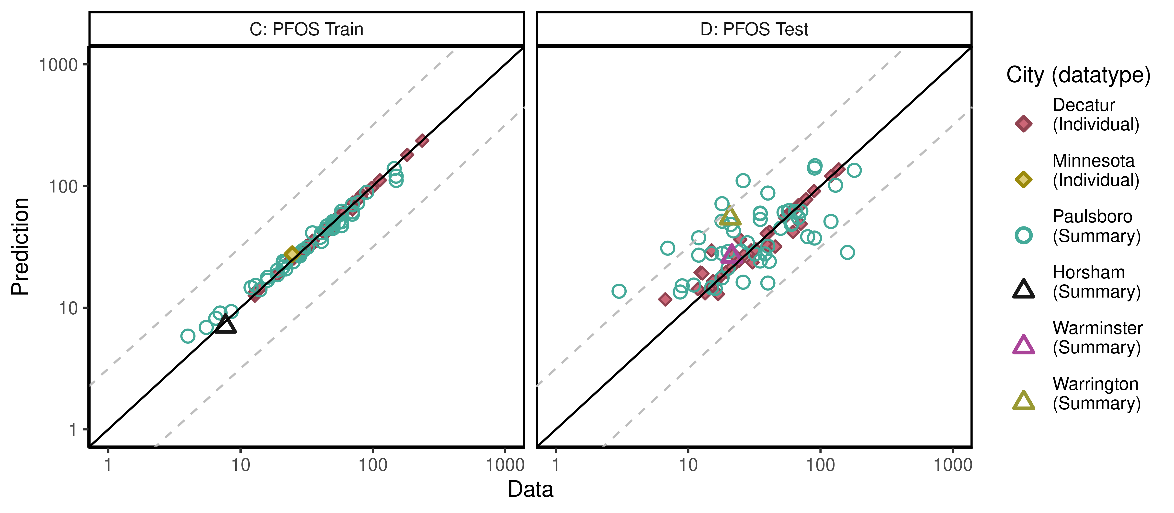

ggsave(here ("output-plots", paste0( sa,"multicheckplot_", pfas_name,  
 ".pdf")),p2,dpi=600, scale=1.1)

## Saving 8.8 x 3.85 in image

## Parse multicheck

df_check <- multicheck$df_check  
df_check <- subset(df_check,Data > 0)   
  
n1 <- nrow(df_check)  
id_chks <- df_check %>% select(Level) %>% unique() %>% bind_cols(id_lut) %>%  
 mutate(dataset = as.factor(dataset), Sex = as.factor(Sex), City = as.factor(City),   
 Train_Test = as.factor(Train_Test))  
  
df_check <- df_check %>% left_join(id_chks)%>%  
 mutate(Dataset = paste(as.character(dataset), Simulation),  
 Sex = ordered(Sex, levels = c("M", "F", "Mixed"),   
 labels = c("Male", "Female", "Mixed (all sexes)")))

## Joining, by = c("Level", "Simulation")

n2 <- nrow(df_check)  
if(n1 != n2)print("duplicates created in id-lut join")

df_check$Time.desc <- as.character(paste0("T=",df_check$Time))  
df_check$Time.desc[df_check$Time.desc == "T=1e-06"] <- "SteadyState"  
df_check$Dataset.Time <- interaction(df_check$Dataset,  
 df_check$Time.desc,lex.order=TRUE)  
df_check$Dataset.Time <- factor(df_check$Dataset.Time,  
 levels=levels(df_check$Dataset.Time))  
calibdata <- df_check[,names(df_check) != "Prediction"]  
calibdata <- calibdata[!duplicated(calibdata),]  
print(calibdata)

## Level Simulation Output_Var Time Data Level1 dataset  
## 1 1_1_1 1 Cserum_t 0.000000 82.400 1_1_1 Decatur M Train  
## 2 1_1_1 1 Cserum_t 5.802000 70.300 1_1_1 Decatur M Train  
## 3 1_1_2 2 Cserum_t 0.000000 32.600 1_1_2 Decatur M Train  
## 4 1_1_2 2 Cserum_t 5.802000 14.200 1_1_2 Decatur M Train  
## 5 1_1_3 3 Cserum_t 0.000000 236.000 1_1_3 Decatur M Train  
## 6 1_1_3 3 Cserum_t 5.802000 75.400 1_1_3 Decatur M Train  
## 7 1_1_4 4 Cserum_t 0.000000 61.000 1_1_4 Decatur M Train  
## 8 1_1_4 4 Cserum_t 5.802000 12.800 1_1_4 Decatur M Train  
## 9 1_1_5 5 Cserum_t 0.000000 182.000 1_1_5 Decatur M Train  
## 10 1_1_5 5 Cserum_t 5.802000 43.900 1_1_5 Decatur M Train  
## 11 1_1_6 6 Cserum_t 0.000000 25.300 1_1_6 Decatur M Train  
## 12 1_1_6 6 Cserum_t 5.802000 18.800 1_1_6 Decatur M Train  
## 13 1_1_7 7 Cserum_t 0.000000 113.000 1_1_7 Decatur M Train  
## 14 1_1_7 7 Cserum_t 5.802000 24.000 1_1_7 Decatur M Train  
## 15 1_1_8 8 Cserum_t 0.000000 78.200 1_1_8 Decatur M Train  
## 16 1_1_8 8 Cserum_t 5.802000 26.400 1_1_8 Decatur M Train  
## 17 1_1_9 9 Cserum_t 0.000000 54.400 1_1_9 Decatur M Train  
## 18 1_1_9 9 Cserum_t 5.802000 26.500 1_1_9 Decatur M Train  
## 19 1_1_10 10 Cserum_t 0.000000 81.200 1_1_10 Decatur F Train  
## 20 1_1_10 10 Cserum_t 5.802000 31.500 1_1_10 Decatur F Train  
## 21 1_1_11 11 Cserum_t 0.000000 70.700 1_1_11 Decatur F Train  
## 22 1_1_11 11 Cserum_t 5.802000 50.200 1_1_11 Decatur F Train  
## 23 1_1_12 12 Cserum_t 0.000000 13.700 1_1_12 Decatur F Train  
## 24 1_1_12 12 Cserum_t 5.802000 12.800 1_1_12 Decatur F Train  
## 25 1_1_13 13 Cserum_t 0.000000 42.000 1_1_13 Decatur F Train  
## 26 1_1_13 13 Cserum_t 5.802000 28.100 1_1_13 Decatur F Train  
## 27 1_1_14 14 Cserum_t 0.000000 98.000 1_1_14 Decatur F Train  
## 28 1_1_14 14 Cserum_t 5.802000 35.100 1_1_14 Decatur F Train  
## 29 1_1_15 15 Cserum_t 0.000000 56.900 1_1_15 Decatur F Train  
## 30 1_1_15 15 Cserum_t 5.802000 45.900 1_1_15 Decatur F Train  
## 31 1_1_16 16 Cserum_t 0.000000 32.500 1_1_16 Decatur F Train  
## 32 1_1_16 16 Cserum_t 5.802000 13.300 1_1_16 Decatur F Train  
## 33 1_1_17 17 Cserum_t 0.000000 60.500 1_1_17 Decatur F Train  
## 34 1_1_17 17 Cserum_t 5.802000 27.600 1_1_17 Decatur F Train  
## 35 1_1_18 18 Cserum_t 0.000000 43.800 1_1_18 Decatur F Train  
## 36 1_1_18 18 Cserum_t 5.802000 34.700 1_1_18 Decatur F Train  
## 37 1_2_1 19 Cserum_t 0.000000 64.100 1_2_1 Decatur M Test  
## 38 1_2_1 19 Cserum_t 5.802000 15.000 1_2_1 Decatur M Test  
## 39 1_2_2 20 Cserum_t 0.000000 89.600 1_2_2 Decatur M Test  
## 40 1_2_2 20 Cserum_t 5.802000 24.700 1_2_2 Decatur M Test  
## 41 1_2_3 21 Cserum_t 0.000000 74.700 1_2_3 Decatur M Test  
## 42 1_2_3 21 Cserum_t 5.802000 39.800 1_2_3 Decatur M Test  
## 43 1_2_4 22 Cserum_t 0.000000 68.400 1_2_4 Decatur M Test  
## 44 1_2_4 22 Cserum_t 5.802000 30.000 1_2_4 Decatur M Test  
## 45 1_2_5 23 Cserum_t 0.000000 72.900 1_2_5 Decatur M Test  
## 46 1_2_5 23 Cserum_t 5.802000 32.200 1_2_5 Decatur M Test  
## 47 1_2_6 24 Cserum_t 0.000000 78.100 1_2_6 Decatur M Test  
## 48 1_2_6 24 Cserum_t 5.802000 45.400 1_2_6 Decatur M Test  
## 49 1_2_7 25 Cserum_t 0.000000 24.100 1_2_7 Decatur M Test  
## 50 1_2_7 25 Cserum_t 5.802000 15.400 1_2_7 Decatur M Test  
## 51 1_2_8 26 Cserum_t 0.000000 60.900 1_2_8 Decatur M Test  
## 52 1_2_8 26 Cserum_t 5.802000 22.000 1_2_8 Decatur M Test  
## 53 1_2_9 27 Cserum_t 0.000000 137.000 1_2_9 Decatur M Test  
## 54 1_2_9 27 Cserum_t 5.802000 70.700 1_2_9 Decatur M Test  
## 55 1_2_10 28 Cserum_t 0.000000 26.600 1_2_10 Decatur F Test  
## 56 1_2_10 28 Cserum_t 5.802000 15.200 1_2_10 Decatur F Test  
## 57 1_2_11 29 Cserum_t 0.000000 120.000 1_2_11 Decatur F Test  
## 58 1_2_11 29 Cserum_t 5.802000 61.700 1_2_11 Decatur F Test  
## 59 1_2_12 30 Cserum_t 0.000000 60.900 1_2_12 Decatur F Test  
## 60 1_2_12 30 Cserum_t 5.802000 22.500 1_2_12 Decatur F Test  
## 61 1_2_13 31 Cserum_t 0.000000 41.100 1_2_13 Decatur F Test  
## 62 1_2_13 31 Cserum_t 5.802000 12.400 1_2_13 Decatur F Test  
## 63 1_2_14 32 Cserum_t 0.000000 39.200 1_2_14 Decatur F Test  
## 64 1_2_14 32 Cserum_t 5.802000 12.800 1_2_14 Decatur F Test  
## 65 1_2_15 33 Cserum_t 0.000000 18.100 1_2_15 Decatur F Test  
## 66 1_2_15 33 Cserum_t 5.802000 13.400 1_2_15 Decatur F Test  
## 67 1_2_16 34 Cserum_t 0.000000 19.400 1_2_16 Decatur F Test  
## 68 1_2_16 34 Cserum_t 5.802000 16.800 1_2_16 Decatur F Test  
## 69 1_2_17 35 Cserum_t 0.000000 21.500 1_2_17 Decatur F Test  
## 70 1_2_17 35 Cserum_t 5.802000 11.800 1_2_17 Decatur F Test  
## 71 1_2_18 36 Cserum_t 0.000000 53.800 1_2_18 Decatur F Test  
## 72 1_2_18 36 Cserum_t 5.802000 30.600 1_2_18 Decatur F Test  
## 73 1_2_19 37 Cserum_t 0.000000 16.000 1_2_19 Decatur F Test  
## 74 1_2_19 37 Cserum_t 5.802000 6.700 1_2_19 Decatur F Test  
## 75 1_3_1 38 Cbgd_Css 0.000001 13.000 1_3_1 Minnesota Train  
## 76 1_3_2 39 Cbgd_Css 0.000001 50.000 1_3_2 Minnesota Train  
## 77 1_3_3 40 Cbgd_Css 0.000001 45.000 1_3_3 Minnesota Train  
## 78 1_3_4 41 Cbgd_Css 0.000001 55.000 1_3_4 Minnesota Train  
## 79 1_3_5 42 Cbgd_Css 0.000001 58.000 1_3_5 Minnesota Train  
## 80 1_3_6 43 Cbgd_Css 0.000001 50.000 1_3_6 Minnesota Train  
## 81 1_3_7 44 Cbgd_Css 0.000001 150.000 1_3_7 Minnesota Train  
## 82 1_3_8 45 Cbgd_Css 0.000001 12.000 1_3_8 Minnesota Train  
## 83 1_3_9 46 Cbgd_Css 0.000001 58.000 1_3_9 Minnesota Train  
## 84 1_3_10 47 Cbgd_Css 0.000001 21.000 1_3_10 Minnesota Train  
## 85 1_3_11 48 Cbgd_Css 0.000001 19.000 1_3_11 Minnesota Train  
## 86 1_3_12 49 Cbgd_Css 0.000001 25.000 1_3_12 Minnesota Train  
## 87 1_3_13 50 Cbgd_Css 0.000001 4.000 1_3_13 Minnesota Train  
## 88 1_3_14 51 Cbgd_Css 0.000001 32.000 1_3_14 Minnesota Train  
## 89 1_3_15 52 Cbgd_Css 0.000001 58.000 1_3_15 Minnesota Train  
## 90 1_3_16 53 Cbgd_Css 0.000001 8.500 1_3_16 Minnesota Train  
## 91 1_3_17 54 Cbgd_Css 0.000001 5.500 1_3_17 Minnesota Train  
## 92 1_3_18 55 Cbgd_Css 0.000001 58.000 1_3_18 Minnesota Train  
## 93 1_3_19 56 Cbgd_Css 0.000001 50.000 1_3_19 Minnesota Train  
## 94 1_3_20 57 Cbgd_Css 0.000001 145.000 1_3_20 Minnesota Train  
## 95 1_3_21 58 Cbgd_Css 0.000001 77.000 1_3_21 Minnesota Train  
## 96 1_3_22 59 Cbgd_Css 0.000001 50.000 1_3_22 Minnesota Train  
## 97 1_3_23 60 Cbgd_Css 0.000001 90.000 1_3_23 Minnesota Train  
## 98 1_3_24 61 Cbgd_Css 0.000001 14.000 1_3_24 Minnesota Train  
## 99 1_3_25 62 Cbgd_Css 0.000001 21.000 1_3_25 Minnesota Train  
## 100 1_3_26 63 Cbgd_Css 0.000001 35.000 1_3_26 Minnesota Train  
## 101 1_3_27 64 Cbgd_Css 0.000001 28.000 1_3_27 Minnesota Train  
## 102 1_3_28 65 Cbgd_Css 0.000001 7.000 1_3_28 Minnesota Train  
## 103 1_3_29 66 Cbgd_Css 0.000001 150.000 1_3_29 Minnesota Train  
## 104 1_3_30 67 Cbgd_Css 0.000001 50.000 1_3_30 Minnesota Train  
## 105 1_3_31 68 Cbgd_Css 0.000001 50.000 1_3_31 Minnesota Train  
## 106 1_3_32 69 Cbgd_Css 0.000001 70.000 1_3_32 Minnesota Train  
## 107 1_3_33 70 Cbgd_Css 0.000001 21.000 1_3_33 Minnesota Train  
## 108 1_3_34 71 Cbgd_Css 0.000001 19.000 1_3_34 Minnesota Train  
## 109 1_3_35 72 Cbgd_Css 0.000001 40.000 1_3_35 Minnesota Train  
## 110 1_3_36 73 Cbgd_Css 0.000001 70.000 1_3_36 Minnesota Train  
## 111 1_3_37 74 Cbgd_Css 0.000001 45.000 1_3_37 Minnesota Train  
## 112 1_3_38 75 Cbgd_Css 0.000001 22.000 1_3_38 Minnesota Train  
## 113 1_3_39 76 Cbgd_Css 0.000001 29.000 1_3_39 Minnesota Train  
## 114 1_3_40 77 Cbgd_Css 0.000001 28.000 1_3_40 Minnesota Train  
## 115 1_3_41 78 Cbgd_Css 0.000001 6.500 1_3_41 Minnesota Train  
## 116 1_3_42 79 Cbgd_Css 0.000001 22.000 1_3_42 Minnesota Train  
## 117 1_3_43 80 Cbgd_Css 0.000001 21.000 1_3_43 Minnesota Train  
## 118 1_3_44 81 Cbgd_Css 0.000001 41.000 1_3_44 Minnesota Train  
## 119 1_3_45 82 Cbgd_Css 0.000001 41.000 1_3_45 Minnesota Train  
## 120 1_3_46 83 Cbgd_Css 0.000001 16.000 1_3_46 Minnesota Train  
## 121 1_3_47 84 Cbgd_Css 0.000001 70.000 1_3_47 Minnesota Train  
## 122 1_3_48 85 Cbgd_Css 0.000001 16.000 1_3_48 Minnesota Train  
## 123 1_3_49 86 Cbgd_Css 0.000001 30.000 1_3_49 Minnesota Train  
## 124 1_4_1 87 Cbgd_Css 0.000001 3.000 1_4_1 Minnesota Test  
## 125 1_4_2 88 Cbgd_Css 0.000001 8.700 1_4_2 Minnesota Test  
## 126 1_4_3 89 Cbgd_Css 0.000001 9.000 1_4_3 Minnesota Test  
## 127 1_4_4 90 Cbgd_Css 0.000001 11.000 1_4_4 Minnesota Test  
## 128 1_4_5 91 Cbgd_Css 0.000001 15.000 1_4_5 Minnesota Test  
## 129 1_4_6 92 Cbgd_Css 0.000001 16.000 1_4_6 Minnesota Test  
## 130 1_4_7 93 Cbgd_Css 0.000001 40.000 1_4_7 Minnesota Test  
## 131 1_4_8 94 Cbgd_Css 0.000001 26.000 1_4_8 Minnesota Test  
## 132 1_4_9 95 Cbgd_Css 0.000001 18.000 1_4_9 Minnesota Test  
## 133 1_4_10 96 Cbgd_Css 0.000001 20.000 1_4_10 Minnesota Test  
## 134 1_4_11 97 Cbgd_Css 0.000001 35.000 1_4_11 Minnesota Test  
## 135 1_4_12 98 Cbgd_Css 0.000001 41.000 1_4_12 Minnesota Test  
## 136 1_4_13 99 Cbgd_Css 0.000001 12.000 1_4_13 Minnesota Test  
## 137 1_4_14 100 Cbgd_Css 0.000001 15.000 1_4_14 Minnesota Test  
## 138 1_4_15 101 Cbgd_Css 0.000001 18.000 1_4_15 Minnesota Test  
## 139 1_4_16 102 Cbgd_Css 0.000001 20.000 1_4_16 Minnesota Test  
## 140 1_4_17 103 Cbgd_Css 0.000001 25.000 1_4_17 Minnesota Test  
## 141 1_4_18 104 Cbgd_Css 0.000001 38.000 1_4_18 Minnesota Test  
## 142 1_4_19 105 Cbgd_Css 0.000001 160.000 1_4_19 Minnesota Test  
## 143 1_4_20 106 Cbgd_Css 0.000001 32.000 1_4_20 Minnesota Test  
## 144 1_4_21 107 Cbgd_Css 0.000001 7.000 1_4_21 Minnesota Test  
## 145 1_4_22 108 Cbgd_Css 0.000001 28.000 1_4_22 Minnesota Test  
## 146 1_4_23 109 Cbgd_Css 0.000001 40.000 1_4_23 Minnesota Test  
## 147 1_4_24 110 Cbgd_Css 0.000001 12.000 1_4_24 Minnesota Test  
## 148 1_4_25 111 Cbgd_Css 0.000001 80.000 1_4_25 Minnesota Test  
## 149 1_4_26 112 Cbgd_Css 0.000001 90.000 1_4_26 Minnesota Test  
## 150 1_4_27 113 Cbgd_Css 0.000001 22.000 1_4_27 Minnesota Test  
## 151 1_4_28 114 Cbgd_Css 0.000001 50.000 1_4_28 Minnesota Test  
## 152 1_4_29 115 Cbgd_Css 0.000001 21.000 1_4_29 Minnesota Test  
## 153 1_4_30 116 Cbgd_Css 0.000001 60.000 1_4_30 Minnesota Test  
## 154 1_4_31 117 Cbgd_Css 0.000001 61.000 1_4_31 Minnesota Test  
## 155 1_4_32 118 Cbgd_Css 0.000001 120.000 1_4_32 Minnesota Test  
## 156 1_4_33 119 Cbgd_Css 0.000001 18.000 1_4_33 Minnesota Test  
## 157 1_4_34 120 Cbgd_Css 0.000001 35.000 1_4_34 Minnesota Test  
## 158 1_4_35 121 Cbgd_Css 0.000001 68.000 1_4_35 Minnesota Test  
## 159 1_4_36 122 Cbgd_Css 0.000001 35.000 1_4_36 Minnesota Test  
## 160 1_4_37 123 Cbgd_Css 0.000001 53.000 1_4_37 Minnesota Test  
## 161 1_4_38 124 Cbgd_Css 0.000001 35.000 1_4_38 Minnesota Test  
## 162 1_4_39 125 Cbgd_Css 0.000001 57.000 1_4_39 Minnesota Test  
## 163 1_4_40 126 Cbgd_Css 0.000001 58.000 1_4_40 Minnesota Test  
## 164 1_4_41 127 Cbgd_Css 0.000001 71.000 1_4_41 Minnesota Test  
## 165 1_4_42 128 Cbgd_Css 0.000001 65.000 1_4_42 Minnesota Test  
## 166 1_4_43 129 Cbgd_Css 0.000001 18.000 1_4_43 Minnesota Test  
## 167 1_4_44 130 Cbgd_Css 0.000001 40.000 1_4_44 Minnesota Test  
## 168 1_4_45 131 Cbgd_Css 0.000001 26.000 1_4_45 Minnesota Test  
## 169 1_4_46 132 Cbgd_Css 0.000001 90.000 1_4_46 Minnesota Test  
## 170 1_4_47 133 Cbgd_Css 0.000001 91.000 1_4_47 Minnesota Test  
## 171 1_4_48 134 Cbgd_Css 0.000001 180.000 1_4_48 Minnesota Test  
## 172 1_4_49 135 Cbgd_Css 0.000001 130.000 1_4_49 Minnesota Test  
## 173 1_5_1 136 M_Cbgd_Css 2.200000 7.690 1_5_1 Paulsboro-Train  
## 174 1_6_1 137 M_Cbgd_Css 2.000000 24.639 1_6_1 Horsham-Train  
## 175 1_7_1 138 M_Cbgd_Css 2.000000 21.378 1_7_1 Warminster-Test  
## 176 1_8_1 139 M_Cbgd_Css 2.000000 20.754 1_8_1 Warrington-Train  
## Sex City Train_Test datatype variable  
## 1 Male Decatur Train Individual Decatur M Train 1  
## 2 Male Decatur Train Individual Decatur M Train 1  
## 3 Male Decatur Train Individual Decatur M Train 2  
## 4 Male Decatur Train Individual Decatur M Train 2  
## 5 Male Decatur Train Individual Decatur M Train 3  
## 6 Male Decatur Train Individual Decatur M Train 3  
## 7 Male Decatur Train Individual Decatur M Train 4  
## 8 Male Decatur Train Individual Decatur M Train 4  
## 9 Male Decatur Train Individual Decatur M Train 5  
## 10 Male Decatur Train Individual Decatur M Train 5  
## 11 Male Decatur Train Individual Decatur M Train 6  
## 12 Male Decatur Train Individual Decatur M Train 6  
## 13 Male Decatur Train Individual Decatur M Train 7  
## 14 Male Decatur Train Individual Decatur M Train 7  
## 15 Male Decatur Train Individual Decatur M Train 8  
## 16 Male Decatur Train Individual Decatur M Train 8  
## 17 Male Decatur Train Individual Decatur M Train 9  
## 18 Male Decatur Train Individual Decatur M Train 9  
## 19 Female Decatur Train Individual Decatur F Train 10  
## 20 Female Decatur Train Individual Decatur F Train 10  
## 21 Female Decatur Train Individual Decatur F Train 11  
## 22 Female Decatur Train Individual Decatur F Train 11  
## 23 Female Decatur Train Individual Decatur F Train 12  
## 24 Female Decatur Train Individual Decatur F Train 12  
## 25 Female Decatur Train Individual Decatur F Train 13  
## 26 Female Decatur Train Individual Decatur F Train 13  
## 27 Female Decatur Train Individual Decatur F Train 14  
## 28 Female Decatur Train Individual Decatur F Train 14  
## 29 Female Decatur Train Individual Decatur F Train 15  
## 30 Female Decatur Train Individual Decatur F Train 15  
## 31 Female Decatur Train Individual Decatur F Train 16  
## 32 Female Decatur Train Individual Decatur F Train 16  
## 33 Female Decatur Train Individual Decatur F Train 17  
## 34 Female Decatur Train Individual Decatur F Train 17  
## 35 Female Decatur Train Individual Decatur F Train 18  
## 36 Female Decatur Train Individual Decatur F Train 18  
## 37 Male Decatur Test Individual Decatur M Test 19  
## 38 Male Decatur Test Individual Decatur M Test 19  
## 39 Male Decatur Test Individual Decatur M Test 20  
## 40 Male Decatur Test Individual Decatur M Test 20  
## 41 Male Decatur Test Individual Decatur M Test 21  
## 42 Male Decatur Test Individual Decatur M Test 21  
## 43 Male Decatur Test Individual Decatur M Test 22  
## 44 Male Decatur Test Individual Decatur M Test 22  
## 45 Male Decatur Test Individual Decatur M Test 23  
## 46 Male Decatur Test Individual Decatur M Test 23  
## 47 Male Decatur Test Individual Decatur M Test 24  
## 48 Male Decatur Test Individual Decatur M Test 24  
## 49 Male Decatur Test Individual Decatur M Test 25  
## 50 Male Decatur Test Individual Decatur M Test 25  
## 51 Male Decatur Test Individual Decatur M Test 26  
## 52 Male Decatur Test Individual Decatur M Test 26  
## 53 Male Decatur Test Individual Decatur M Test 27  
## 54 Male Decatur Test Individual Decatur M Test 27  
## 55 Female Decatur Test Individual Decatur F Test 28  
## 56 Female Decatur Test Individual Decatur F Test 28  
## 57 Female Decatur Test Individual Decatur F Test 29  
## 58 Female Decatur Test Individual Decatur F Test 29  
## 59 Female Decatur Test Individual Decatur F Test 30  
## 60 Female Decatur Test Individual Decatur F Test 30  
## 61 Female Decatur Test Individual Decatur F Test 31  
## 62 Female Decatur Test Individual Decatur F Test 31  
## 63 Female Decatur Test Individual Decatur F Test 32  
## 64 Female Decatur Test Individual Decatur F Test 32  
## 65 Female Decatur Test Individual Decatur F Test 33  
## 66 Female Decatur Test Individual Decatur F Test 33  
## 67 Female Decatur Test Individual Decatur F Test 34  
## 68 Female Decatur Test Individual Decatur F Test 34  
## 69 Female Decatur Test Individual Decatur F Test 35  
## 70 Female Decatur Test Individual Decatur F Test 35  
## 71 Female Decatur Test Individual Decatur F Test 36  
## 72 Female Decatur Test Individual Decatur F Test 36  
## 73 Female Decatur Test Individual Decatur F Test 37  
## 74 Female Decatur Test Individual Decatur F Test 37  
## 75 Mixed (all sexes) Minnesota Train Individual Minnesota Train 38  
## 76 Mixed (all sexes) Minnesota Train Individual Minnesota Train 39  
## 77 Mixed (all sexes) Minnesota Train Individual Minnesota Train 40  
## 78 Mixed (all sexes) Minnesota Train Individual Minnesota Train 41  
## 79 Mixed (all sexes) Minnesota Train Individual Minnesota Train 42  
## 80 Mixed (all sexes) Minnesota Train Individual Minnesota Train 43  
## 81 Mixed (all sexes) Minnesota Train Individual Minnesota Train 44  
## 82 Mixed (all sexes) Minnesota Train Individual Minnesota Train 45  
## 83 Mixed (all sexes) Minnesota Train Individual Minnesota Train 46  
## 84 Mixed (all sexes) Minnesota Train Individual Minnesota Train 47  
## 85 Mixed (all sexes) Minnesota Train Individual Minnesota Train 48  
## 86 Mixed (all sexes) Minnesota Train Individual Minnesota Train 49  
## 87 Mixed (all sexes) Minnesota Train Individual Minnesota Train 50  
## 88 Mixed (all sexes) Minnesota Train Individual Minnesota Train 51  
## 89 Mixed (all sexes) Minnesota Train Individual Minnesota Train 52  
## 90 Mixed (all sexes) Minnesota Train Individual Minnesota Train 53  
## 91 Mixed (all sexes) Minnesota Train Individual Minnesota Train 54  
## 92 Mixed (all sexes) Minnesota Train Individual Minnesota Train 55  
## 93 Mixed (all sexes) Minnesota Train Individual Minnesota Train 56  
## 94 Mixed (all sexes) Minnesota Train Individual Minnesota Train 57  
## 95 Mixed (all sexes) Minnesota Train Individual Minnesota Train 58  
## 96 Mixed (all sexes) Minnesota Train Individual Minnesota Train 59  
## 97 Mixed (all sexes) Minnesota Train Individual Minnesota Train 60  
## 98 Mixed (all sexes) Minnesota Train Individual Minnesota Train 61  
## 99 Mixed (all sexes) Minnesota Train Individual Minnesota Train 62  
## 100 Mixed (all sexes) Minnesota Train Individual Minnesota Train 63  
## 101 Mixed (all sexes) Minnesota Train Individual Minnesota Train 64  
## 102 Mixed (all sexes) Minnesota Train Individual Minnesota Train 65  
## 103 Mixed (all sexes) Minnesota Train Individual Minnesota Train 66  
## 104 Mixed (all sexes) Minnesota Train Individual Minnesota Train 67  
## 105 Mixed (all sexes) Minnesota Train Individual Minnesota Train 68  
## 106 Mixed (all sexes) Minnesota Train Individual Minnesota Train 69  
## 107 Mixed (all sexes) Minnesota Train Individual Minnesota Train 70  
## 108 Mixed (all sexes) Minnesota Train Individual Minnesota Train 71  
## 109 Mixed (all sexes) Minnesota Train Individual Minnesota Train 72  
## 110 Mixed (all sexes) Minnesota Train Individual Minnesota Train 73  
## 111 Mixed (all sexes) Minnesota Train Individual Minnesota Train 74  
## 112 Mixed (all sexes) Minnesota Train Individual Minnesota Train 75  
## 113 Mixed (all sexes) Minnesota Train Individual Minnesota Train 76  
## 114 Mixed (all sexes) Minnesota Train Individual Minnesota Train 77  
## 115 Mixed (all sexes) Minnesota Train Individual Minnesota Train 78  
## 116 Mixed (all sexes) Minnesota Train Individual Minnesota Train 79  
## 117 Mixed (all sexes) Minnesota Train Individual Minnesota Train 80  
## 118 Mixed (all sexes) Minnesota Train Individual Minnesota Train 81  
## 119 Mixed (all sexes) Minnesota Train Individual Minnesota Train 82  
## 120 Mixed (all sexes) Minnesota Train Individual Minnesota Train 83  
## 121 Mixed (all sexes) Minnesota Train Individual Minnesota Train 84  
## 122 Mixed (all sexes) Minnesota Train Individual Minnesota Train 85  
## 123 Mixed (all sexes) Minnesota Train Individual Minnesota Train 86  
## 124 Mixed (all sexes) Minnesota Test Individual Minnesota Test 87  
## 125 Mixed (all sexes) Minnesota Test Individual Minnesota Test 88  
## 126 Mixed (all sexes) Minnesota Test Individual Minnesota Test 89  
## 127 Mixed (all sexes) Minnesota Test Individual Minnesota Test 90  
## 128 Mixed (all sexes) Minnesota Test Individual Minnesota Test 91  
## 129 Mixed (all sexes) Minnesota Test Individual Minnesota Test 92  
## 130 Mixed (all sexes) Minnesota Test Individual Minnesota Test 93  
## 131 Mixed (all sexes) Minnesota Test Individual Minnesota Test 94  
## 132 Mixed (all sexes) Minnesota Test Individual Minnesota Test 95  
## 133 Mixed (all sexes) Minnesota Test Individual Minnesota Test 96  
## 134 Mixed (all sexes) Minnesota Test Individual Minnesota Test 97  
## 135 Mixed (all sexes) Minnesota Test Individual Minnesota Test 98  
## 136 Mixed (all sexes) Minnesota Test Individual Minnesota Test 99  
## 137 Mixed (all sexes) Minnesota Test Individual Minnesota Test 100  
## 138 Mixed (all sexes) Minnesota Test Individual Minnesota Test 101  
## 139 Mixed (all sexes) Minnesota Test Individual Minnesota Test 102  
## 140 Mixed (all sexes) Minnesota Test Individual Minnesota Test 103  
## 141 Mixed (all sexes) Minnesota Test Individual Minnesota Test 104  
## 142 Mixed (all sexes) Minnesota Test Individual Minnesota Test 105  
## 143 Mixed (all sexes) Minnesota Test Individual Minnesota Test 106  
## 144 Mixed (all sexes) Minnesota Test Individual Minnesota Test 107  
## 145 Mixed (all sexes) Minnesota Test Individual Minnesota Test 108  
## 146 Mixed (all sexes) Minnesota Test Individual Minnesota Test 109  
## 147 Mixed (all sexes) Minnesota Test Individual Minnesota Test 110  
## 148 Mixed (all sexes) Minnesota Test Individual Minnesota Test 111  
## 149 Mixed (all sexes) Minnesota Test Individual Minnesota Test 112  
## 150 Mixed (all sexes) Minnesota Test Individual Minnesota Test 113  
## 151 Mixed (all sexes) Minnesota Test Individual Minnesota Test 114  
## 152 Mixed (all sexes) Minnesota Test Individual Minnesota Test 115  
## 153 Mixed (all sexes) Minnesota Test Individual Minnesota Test 116  
## 154 Mixed (all sexes) Minnesota Test Individual Minnesota Test 117  
## 155 Mixed (all sexes) Minnesota Test Individual Minnesota Test 118  
## 156 Mixed (all sexes) Minnesota Test Individual Minnesota Test 119  
## 157 Mixed (all sexes) Minnesota Test Individual Minnesota Test 120  
## 158 Mixed (all sexes) Minnesota Test Individual Minnesota Test 121  
## 159 Mixed (all sexes) Minnesota Test Individual Minnesota Test 122  
## 160 Mixed (all sexes) Minnesota Test Individual Minnesota Test 123  
## 161 Mixed (all sexes) Minnesota Test Individual Minnesota Test 124  
## 162 Mixed (all sexes) Minnesota Test Individual Minnesota Test 125  
## 163 Mixed (all sexes) Minnesota Test Individual Minnesota Test 126  
## 164 Mixed (all sexes) Minnesota Test Individual Minnesota Test 127  
## 165 Mixed (all sexes) Minnesota Test Individual Minnesota Test 128  
## 166 Mixed (all sexes) Minnesota Test Individual Minnesota Test 129  
## 167 Mixed (all sexes) Minnesota Test Individual Minnesota Test 130  
## 168 Mixed (all sexes) Minnesota Test Individual Minnesota Test 131  
## 169 Mixed (all sexes) Minnesota Test Individual Minnesota Test 132  
## 170 Mixed (all sexes) Minnesota Test Individual Minnesota Test 133  
## 171 Mixed (all sexes) Minnesota Test Individual Minnesota Test 134  
## 172 Mixed (all sexes) Minnesota Test Individual Minnesota Test 135  
## 173 Mixed (all sexes) Paulsboro Train Summary Paulsboro-Train 136  
## 174 Mixed (all sexes) Horsham Train Summary Horsham-Train 137  
## 175 Mixed (all sexes) Warminster Test Summary Warminster-Test 138  
## 176 Mixed (all sexes) Warrington Test Summary Warrington-Train 139  
## Dataset Time.desc Dataset.Time  
## 1 Decatur M Train 1 T=0 Decatur M Train 1.T=0  
## 2 Decatur M Train 1 T=5.802 Decatur M Train 1.T=5.802  
## 3 Decatur M Train 2 T=0 Decatur M Train 2.T=0  
## 4 Decatur M Train 2 T=5.802 Decatur M Train 2.T=5.802  
## 5 Decatur M Train 3 T=0 Decatur M Train 3.T=0  
## 6 Decatur M Train 3 T=5.802 Decatur M Train 3.T=5.802  
## 7 Decatur M Train 4 T=0 Decatur M Train 4.T=0  
## 8 Decatur M Train 4 T=5.802 Decatur M Train 4.T=5.802  
## 9 Decatur M Train 5 T=0 Decatur M Train 5.T=0  
## 10 Decatur M Train 5 T=5.802 Decatur M Train 5.T=5.802  
## 11 Decatur M Train 6 T=0 Decatur M Train 6.T=0  
## 12 Decatur M Train 6 T=5.802 Decatur M Train 6.T=5.802  
## 13 Decatur M Train 7 T=0 Decatur M Train 7.T=0  
## 14 Decatur M Train 7 T=5.802 Decatur M Train 7.T=5.802  
## 15 Decatur M Train 8 T=0 Decatur M Train 8.T=0  
## 16 Decatur M Train 8 T=5.802 Decatur M Train 8.T=5.802  
## 17 Decatur M Train 9 T=0 Decatur M Train 9.T=0  
## 18 Decatur M Train 9 T=5.802 Decatur M Train 9.T=5.802  
## 19 Decatur F Train 10 T=0 Decatur F Train 10.T=0  
## 20 Decatur F Train 10 T=5.802 Decatur F Train 10.T=5.802  
## 21 Decatur F Train 11 T=0 Decatur F Train 11.T=0  
## 22 Decatur F Train 11 T=5.802 Decatur F Train 11.T=5.802  
## 23 Decatur F Train 12 T=0 Decatur F Train 12.T=0  
## 24 Decatur F Train 12 T=5.802 Decatur F Train 12.T=5.802  
## 25 Decatur F Train 13 T=0 Decatur F Train 13.T=0  
## 26 Decatur F Train 13 T=5.802 Decatur F Train 13.T=5.802  
## 27 Decatur F Train 14 T=0 Decatur F Train 14.T=0  
## 28 Decatur F Train 14 T=5.802 Decatur F Train 14.T=5.802  
## 29 Decatur F Train 15 T=0 Decatur F Train 15.T=0  
## 30 Decatur F Train 15 T=5.802 Decatur F Train 15.T=5.802  
## 31 Decatur F Train 16 T=0 Decatur F Train 16.T=0  
## 32 Decatur F Train 16 T=5.802 Decatur F Train 16.T=5.802  
## 33 Decatur F Train 17 T=0 Decatur F Train 17.T=0  
## 34 Decatur F Train 17 T=5.802 Decatur F Train 17.T=5.802  
## 35 Decatur F Train 18 T=0 Decatur F Train 18.T=0  
## 36 Decatur F Train 18 T=5.802 Decatur F Train 18.T=5.802  
## 37 Decatur M Test 19 T=0 Decatur M Test 19.T=0  
## 38 Decatur M Test 19 T=5.802 Decatur M Test 19.T=5.802  
## 39 Decatur M Test 20 T=0 Decatur M Test 20.T=0  
## 40 Decatur M Test 20 T=5.802 Decatur M Test 20.T=5.802  
## 41 Decatur M Test 21 T=0 Decatur M Test 21.T=0  
## 42 Decatur M Test 21 T=5.802 Decatur M Test 21.T=5.802  
## 43 Decatur M Test 22 T=0 Decatur M Test 22.T=0  
## 44 Decatur M Test 22 T=5.802 Decatur M Test 22.T=5.802  
## 45 Decatur M Test 23 T=0 Decatur M Test 23.T=0  
## 46 Decatur M Test 23 T=5.802 Decatur M Test 23.T=5.802  
## 47 Decatur M Test 24 T=0 Decatur M Test 24.T=0  
## 48 Decatur M Test 24 T=5.802 Decatur M Test 24.T=5.802  
## 49 Decatur M Test 25 T=0 Decatur M Test 25.T=0  
## 50 Decatur M Test 25 T=5.802 Decatur M Test 25.T=5.802  
## 51 Decatur M Test 26 T=0 Decatur M Test 26.T=0  
## 52 Decatur M Test 26 T=5.802 Decatur M Test 26.T=5.802  
## 53 Decatur M Test 27 T=0 Decatur M Test 27.T=0  
## 54 Decatur M Test 27 T=5.802 Decatur M Test 27.T=5.802  
## 55 Decatur F Test 28 T=0 Decatur F Test 28.T=0  
## 56 Decatur F Test 28 T=5.802 Decatur F Test 28.T=5.802  
## 57 Decatur F Test 29 T=0 Decatur F Test 29.T=0  
## 58 Decatur F Test 29 T=5.802 Decatur F Test 29.T=5.802  
## 59 Decatur F Test 30 T=0 Decatur F Test 30.T=0  
## 60 Decatur F Test 30 T=5.802 Decatur F Test 30.T=5.802  
## 61 Decatur F Test 31 T=0 Decatur F Test 31.T=0  
## 62 Decatur F Test 31 T=5.802 Decatur F Test 31.T=5.802  
## 63 Decatur F Test 32 T=0 Decatur F Test 32.T=0  
## 64 Decatur F Test 32 T=5.802 Decatur F Test 32.T=5.802  
## 65 Decatur F Test 33 T=0 Decatur F Test 33.T=0  
## 66 Decatur F Test 33 T=5.802 Decatur F Test 33.T=5.802  
## 67 Decatur F Test 34 T=0 Decatur F Test 34.T=0  
## 68 Decatur F Test 34 T=5.802 Decatur F Test 34.T=5.802  
## 69 Decatur F Test 35 T=0 Decatur F Test 35.T=0  
## 70 Decatur F Test 35 T=5.802 Decatur F Test 35.T=5.802  
## 71 Decatur F Test 36 T=0 Decatur F Test 36.T=0  
## 72 Decatur F Test 36 T=5.802 Decatur F Test 36.T=5.802  
## 73 Decatur F Test 37 T=0 Decatur F Test 37.T=0  
## 74 Decatur F Test 37 T=5.802 Decatur F Test 37.T=5.802  
## 75 Minnesota Train 38 SteadyState Minnesota Train 38.SteadyState  
## 76 Minnesota Train 39 SteadyState Minnesota Train 39.SteadyState  
## 77 Minnesota Train 40 SteadyState Minnesota Train 40.SteadyState  
## 78 Minnesota Train 41 SteadyState Minnesota Train 41.SteadyState  
## 79 Minnesota Train 42 SteadyState Minnesota Train 42.SteadyState  
## 80 Minnesota Train 43 SteadyState Minnesota Train 43.SteadyState  
## 81 Minnesota Train 44 SteadyState Minnesota Train 44.SteadyState  
## 82 Minnesota Train 45 SteadyState Minnesota Train 45.SteadyState  
## 83 Minnesota Train 46 SteadyState Minnesota Train 46.SteadyState  
## 84 Minnesota Train 47 SteadyState Minnesota Train 47.SteadyState  
## 85 Minnesota Train 48 SteadyState Minnesota Train 48.SteadyState  
## 86 Minnesota Train 49 SteadyState Minnesota Train 49.SteadyState  
## 87 Minnesota Train 50 SteadyState Minnesota Train 50.SteadyState  
## 88 Minnesota Train 51 SteadyState Minnesota Train 51.SteadyState  
## 89 Minnesota Train 52 SteadyState Minnesota Train 52.SteadyState  
## 90 Minnesota Train 53 SteadyState Minnesota Train 53.SteadyState  
## 91 Minnesota Train 54 SteadyState Minnesota Train 54.SteadyState  
## 92 Minnesota Train 55 SteadyState Minnesota Train 55.SteadyState  
## 93 Minnesota Train 56 SteadyState Minnesota Train 56.SteadyState  
## 94 Minnesota Train 57 SteadyState Minnesota Train 57.SteadyState  
## 95 Minnesota Train 58 SteadyState Minnesota Train 58.SteadyState  
## 96 Minnesota Train 59 SteadyState Minnesota Train 59.SteadyState  
## 97 Minnesota Train 60 SteadyState Minnesota Train 60.SteadyState  
## 98 Minnesota Train 61 SteadyState Minnesota Train 61.SteadyState  
## 99 Minnesota Train 62 SteadyState Minnesota Train 62.SteadyState  
## 100 Minnesota Train 63 SteadyState Minnesota Train 63.SteadyState  
## 101 Minnesota Train 64 SteadyState Minnesota Train 64.SteadyState  
## 102 Minnesota Train 65 SteadyState Minnesota Train 65.SteadyState  
## 103 Minnesota Train 66 SteadyState Minnesota Train 66.SteadyState  
## 104 Minnesota Train 67 SteadyState Minnesota Train 67.SteadyState  
## 105 Minnesota Train 68 SteadyState Minnesota Train 68.SteadyState  
## 106 Minnesota Train 69 SteadyState Minnesota Train 69.SteadyState  
## 107 Minnesota Train 70 SteadyState Minnesota Train 70.SteadyState  
## 108 Minnesota Train 71 SteadyState Minnesota Train 71.SteadyState  
## 109 Minnesota Train 72 SteadyState Minnesota Train 72.SteadyState  
## 110 Minnesota Train 73 SteadyState Minnesota Train 73.SteadyState  
## 111 Minnesota Train 74 SteadyState Minnesota Train 74.SteadyState  
## 112 Minnesota Train 75 SteadyState Minnesota Train 75.SteadyState  
## 113 Minnesota Train 76 SteadyState Minnesota Train 76.SteadyState  
## 114 Minnesota Train 77 SteadyState Minnesota Train 77.SteadyState  
## 115 Minnesota Train 78 SteadyState Minnesota Train 78.SteadyState  
## 116 Minnesota Train 79 SteadyState Minnesota Train 79.SteadyState  
## 117 Minnesota Train 80 SteadyState Minnesota Train 80.SteadyState  
## 118 Minnesota Train 81 SteadyState Minnesota Train 81.SteadyState  
## 119 Minnesota Train 82 SteadyState Minnesota Train 82.SteadyState  
## 120 Minnesota Train 83 SteadyState Minnesota Train 83.SteadyState  
## 121 Minnesota Train 84 SteadyState Minnesota Train 84.SteadyState  
## 122 Minnesota Train 85 SteadyState Minnesota Train 85.SteadyState  
## 123 Minnesota Train 86 SteadyState Minnesota Train 86.SteadyState  
## 124 Minnesota Test 87 SteadyState Minnesota Test 87.SteadyState  
## 125 Minnesota Test 88 SteadyState Minnesota Test 88.SteadyState  
## 126 Minnesota Test 89 SteadyState Minnesota Test 89.SteadyState  
## 127 Minnesota Test 90 SteadyState Minnesota Test 90.SteadyState  
## 128 Minnesota Test 91 SteadyState Minnesota Test 91.SteadyState  
## 129 Minnesota Test 92 SteadyState Minnesota Test 92.SteadyState  
## 130 Minnesota Test 93 SteadyState Minnesota Test 93.SteadyState  
## 131 Minnesota Test 94 SteadyState Minnesota Test 94.SteadyState  
## 132 Minnesota Test 95 SteadyState Minnesota Test 95.SteadyState  
## 133 Minnesota Test 96 SteadyState Minnesota Test 96.SteadyState  
## 134 Minnesota Test 97 SteadyState Minnesota Test 97.SteadyState  
## 135 Minnesota Test 98 SteadyState Minnesota Test 98.SteadyState  
## 136 Minnesota Test 99 SteadyState Minnesota Test 99.SteadyState  
## 137 Minnesota Test 100 SteadyState Minnesota Test 100.SteadyState  
## 138 Minnesota Test 101 SteadyState Minnesota Test 101.SteadyState  
## 139 Minnesota Test 102 SteadyState Minnesota Test 102.SteadyState  
## 140 Minnesota Test 103 SteadyState Minnesota Test 103.SteadyState  
## 141 Minnesota Test 104 SteadyState Minnesota Test 104.SteadyState  
## 142 Minnesota Test 105 SteadyState Minnesota Test 105.SteadyState  
## 143 Minnesota Test 106 SteadyState Minnesota Test 106.SteadyState  
## 144 Minnesota Test 107 SteadyState Minnesota Test 107.SteadyState  
## 145 Minnesota Test 108 SteadyState Minnesota Test 108.SteadyState  
## 146 Minnesota Test 109 SteadyState Minnesota Test 109.SteadyState  
## 147 Minnesota Test 110 SteadyState Minnesota Test 110.SteadyState  
## 148 Minnesota Test 111 SteadyState Minnesota Test 111.SteadyState  
## 149 Minnesota Test 112 SteadyState Minnesota Test 112.SteadyState  
## 150 Minnesota Test 113 SteadyState Minnesota Test 113.SteadyState  
## 151 Minnesota Test 114 SteadyState Minnesota Test 114.SteadyState  
## 152 Minnesota Test 115 SteadyState Minnesota Test 115.SteadyState  
## 153 Minnesota Test 116 SteadyState Minnesota Test 116.SteadyState  
## 154 Minnesota Test 117 SteadyState Minnesota Test 117.SteadyState  
## 155 Minnesota Test 118 SteadyState Minnesota Test 118.SteadyState  
## 156 Minnesota Test 119 SteadyState Minnesota Test 119.SteadyState  
## 157 Minnesota Test 120 SteadyState Minnesota Test 120.SteadyState  
## 158 Minnesota Test 121 SteadyState Minnesota Test 121.SteadyState  
## 159 Minnesota Test 122 SteadyState Minnesota Test 122.SteadyState  
## 160 Minnesota Test 123 SteadyState Minnesota Test 123.SteadyState  
## 161 Minnesota Test 124 SteadyState Minnesota Test 124.SteadyState  
## 162 Minnesota Test 125 SteadyState Minnesota Test 125.SteadyState  
## 163 Minnesota Test 126 SteadyState Minnesota Test 126.SteadyState  
## 164 Minnesota Test 127 SteadyState Minnesota Test 127.SteadyState  
## 165 Minnesota Test 128 SteadyState Minnesota Test 128.SteadyState  
## 166 Minnesota Test 129 SteadyState Minnesota Test 129.SteadyState  
## 167 Minnesota Test 130 SteadyState Minnesota Test 130.SteadyState  
## 168 Minnesota Test 131 SteadyState Minnesota Test 131.SteadyState  
## 169 Minnesota Test 132 SteadyState Minnesota Test 132.SteadyState  
## 170 Minnesota Test 133 SteadyState Minnesota Test 133.SteadyState  
## 171 Minnesota Test 134 SteadyState Minnesota Test 134.SteadyState  
## 172 Minnesota Test 135 SteadyState Minnesota Test 135.SteadyState  
## 173 Paulsboro-Train 136 T=2.2 Paulsboro-Train 136.T=2.2  
## 174 Horsham-Train 137 T=2 Horsham-Train 137.T=2  
## 175 Warminster-Test 138 T=2 Warminster-Test 138.T=2  
## 176 Warrington-Train 139 T=2 Warrington-Train 139.T=2

#Multicheck plot  
  
# Split Steady State Group into different populations for boxplot grouping  
#df_check[df_check$Time.desc == "SteadyState" & grepl("Lubeck",df_check$Dataset),]$Time.desc <- "Lubeck"  
#df_check[df_check$Time.desc == "SteadyState" & grepl("Little Hocking",df_check$Dataset),]$Time.desc <- "Little Hocking"

Modify aesthetics lookup table for boxplots

## additional source aesthetic lookup table for grey-scale time (years); merged legends save space on plotting output  
times <- df_check%>% select(Time.desc, Time) %>% unique () %>%   
 mutate(rank = rank(Time) , grey = grey.colors(start=1,end=0.4, n = n()),  
 alpha = (rank)/8) %>%   
 select(-Time)  
   
df_check <- df_check %>% mutate (legend_label = (paste0(City, "\n", Time.desc ) )) # add legend-labels  
aes_lut <- df_check %>%   
 select(City, Train_Test, datatype,Time, Time.desc, legend_label) %>% unique () %>%  
 left_join(aes_lut[, c("City", "cols")], by = "City") %>% ungroup () %>% unique ()%>%  
 left_join (times, by = "Time.desc") %>%   
 arrange(datatype, City, Train_Test, Time) %>%   
 mutate(alpha = if_else(City == "Horsham", alpha/2, alpha)) %>% # otherwise too dark with this color  
 mutate_if(is.factor, as.character)

## Decatur boxplots

Changed grey start to 1 instead of 0.8, end at 0.6 instead of 0.4. Changed shape of symbols so they are filled.

#CD  
 # Decatur   
  
df_decat <- df_check %>%   
 filter(City == "Decatur" & Train_Test %in% c ("Train", "Test")) %>%   
 mutate(panel = ordered (Train_Test, levels = c ("Train", "Test"),   
 labels = c("C: PFOS Decatur Train", "D: PFOS Decatur Test") ))  
  
aes_lut_df_df_decat <- aes_lut %>%   
 filter(City == "Decatur" & Train_Test %in% c ("Train", "Test")) %>%   
 mutate_if(is.factor, as.character)   
  
source( paste0(gsub(basename(here()), 'shared_functions', here()), '/plot_sum_boxplot.r'))  
  
  
plt_train <- plot_sum_boxplot (dframe = df_decat, aes_lut= aes_lut_df_df_decat, facets = TRUE , pfas_nom = pfas_name )   
print(plt_train)

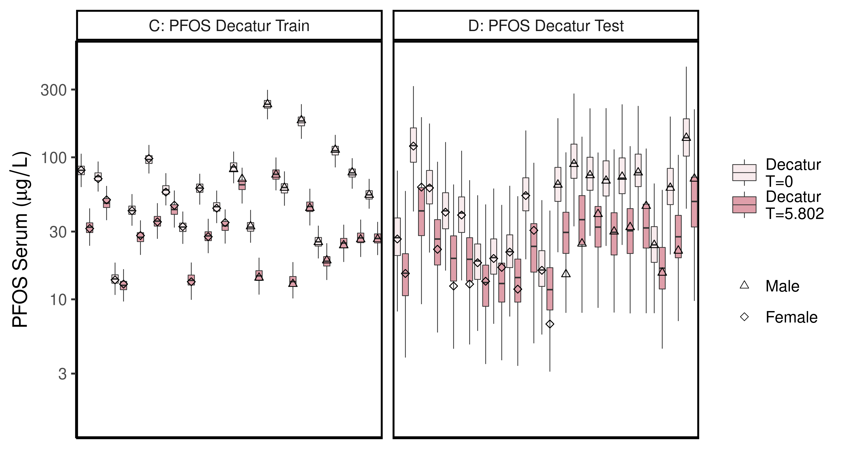

ggsave(here ("output-plots",paste0( sa,"DecaturTrainTestboxplot",pfas_name,".pdf")),plt_train,dpi=600)

## Saving 6.5 x 3.5 in image

## All boxplots

Changed grey start to 1 instead of 0.8, end at 0.6 instead of 0.4. Added shapes and fills to data points.

lets <- LETTERS;  
names(lets)[1:(length(unique(df_check$dataset))-4)]<-as.character(unique(df_check$dataset))[5:length(unique(df_check$dataset))]  
  
for (d in unique(df_check$dataset)) { # d = unique(df_check$dataset)[11]  
 ddset <- df_check %>%   
 filter(dataset == d)   
   
 aes_lut_ddset <- ddset %>% select(legend_label, City,Train_Test,datatype, Time.desc ) %>% unique () %>% inner_join(aes_lut)  
   
 gt <- ifelse(is.na(lets[d]),d,paste0(lets[d],": ", d))  
 plt <- plot_sum_boxplot(dframe = ddset, aes_lut= aes_lut_ddset, gtitle= gt, facets = FALSE, pfas_nom = pfas_name)  
   
 print(plt)  
 ggsave(here ("output-plots",  
 paste0( sa, d,"-boxplot-",   
 pfas_name,".pdf")) ,  
 plt,dpi=600)  
  
}

## Joining, by = c("legend_label", "City", "Train_Test", "datatype", "Time.desc")

## Warning: Column `City` joining factor and character vector, coercing into  
## character vector

## Warning: Column `Train_Test` joining factor and character vector, coercing into  
## character vector

## Saving 6.5 x 3.5 in image  
## Joining, by = c("legend_label", "City", "Train_Test", "datatype", "Time.desc")

## Warning: Column `City` joining factor and character vector, coercing into  
## character vector  
  
## Warning: Column `Train_Test` joining factor and character vector, coercing into  
## character vector

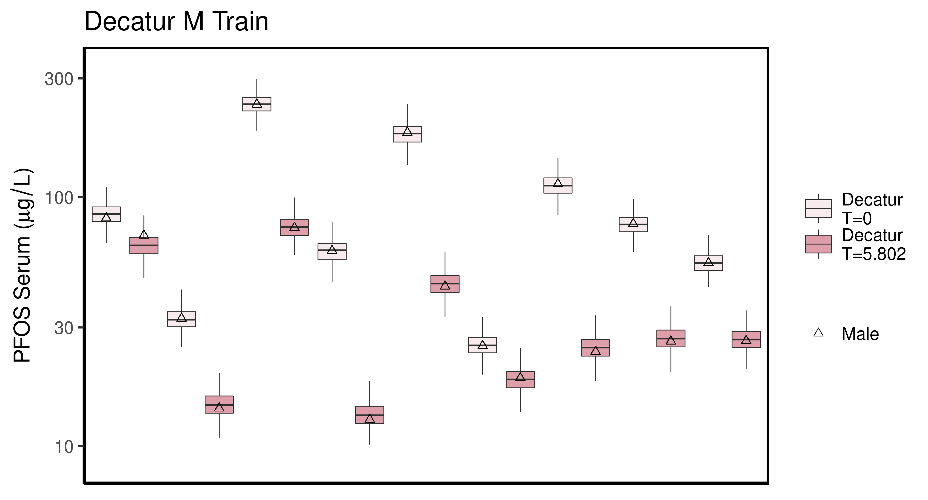

## Saving 6.5 x 3.5 in image  
## Joining, by = c("legend_label", "City", "Train_Test", "datatype", "Time.desc")

## Warning: Column `City` joining factor and character vector, coercing into  
## character vector  
  
## Warning: Column `Train_Test` joining factor and character vector, coercing into  
## character vector

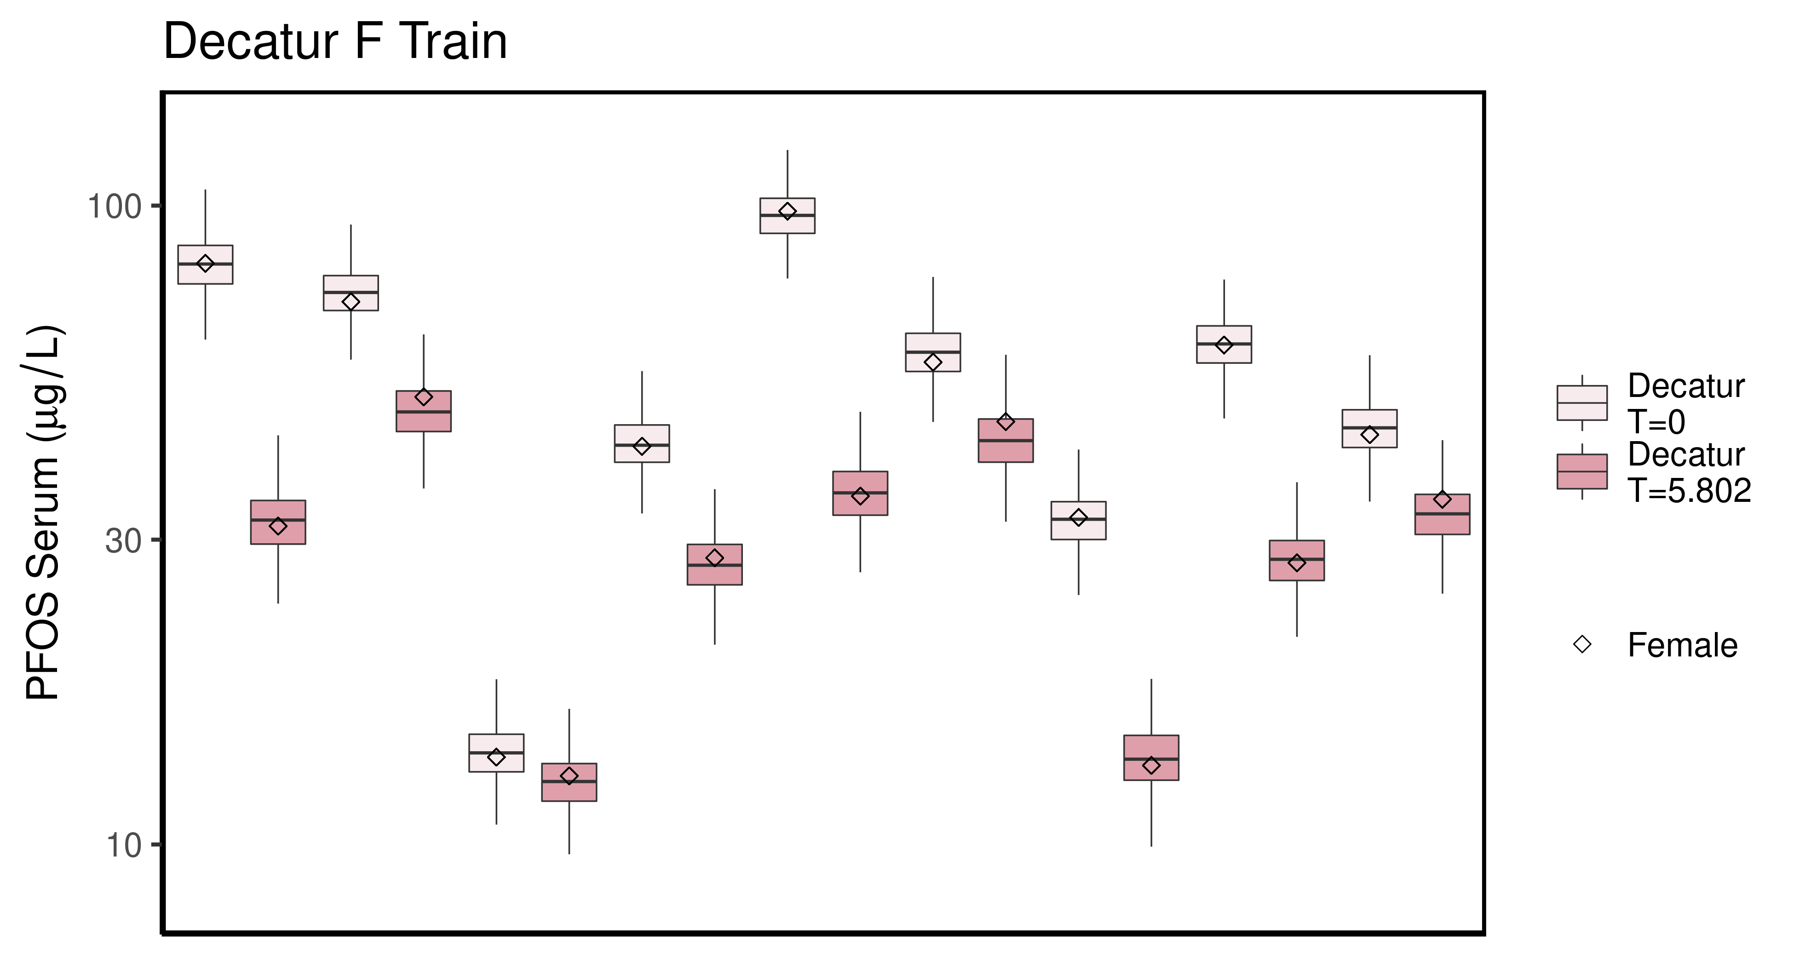

## Saving 6.5 x 3.5 in image  
## Joining, by = c("legend_label", "City", "Train_Test", "datatype", "Time.desc")

## Warning: Column `City` joining factor and character vector, coercing into  
## character vector  
  
## Warning: Column `Train_Test` joining factor and character vector, coercing into  
## character vector

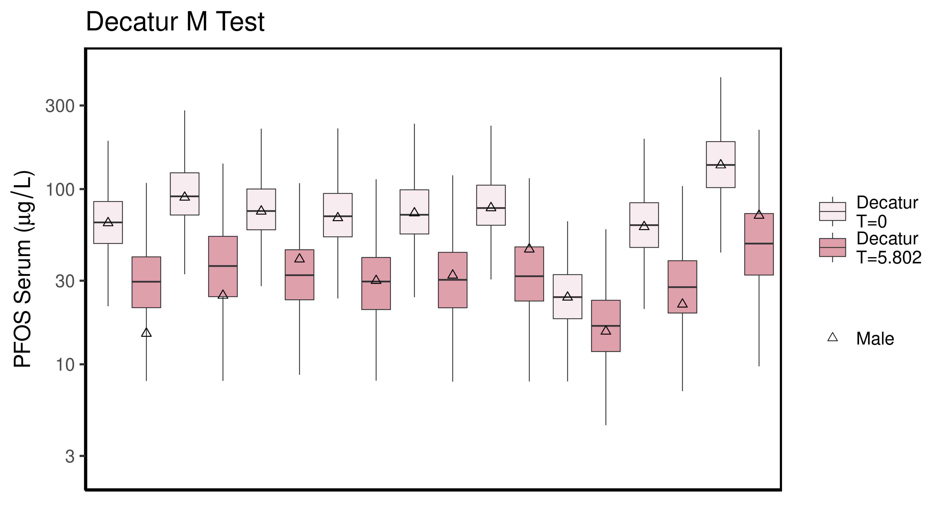

## Saving 6.5 x 3.5 in image  
## Joining, by = c("legend_label", "City", "Train_Test", "datatype", "Time.desc")

## Warning: Column `City` joining factor and character vector, coercing into  
## character vector  
  
## Warning: Column `Train_Test` joining factor and character vector, coercing into  
## character vector

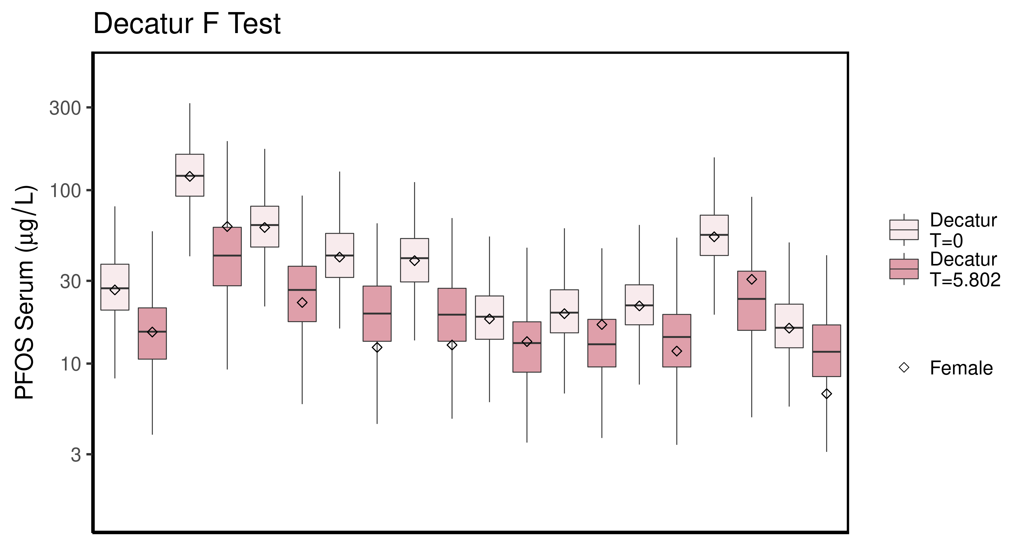

## Saving 6.5 x 3.5 in image  
## Joining, by = c("legend_label", "City", "Train_Test", "datatype", "Time.desc")

## Warning: Column `City` joining factor and character vector, coercing into  
## character vector  
  
## Warning: Column `Train_Test` joining factor and character vector, coercing into  
## character vector

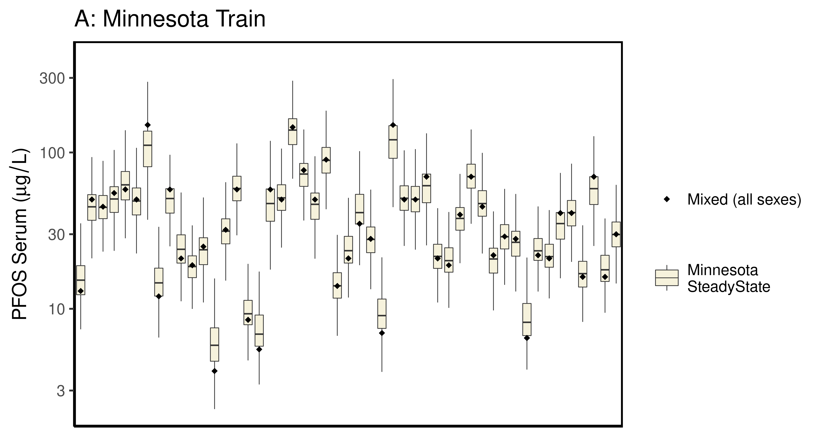

## Saving 6.5 x 3.5 in image  
## Joining, by = c("legend_label", "City", "Train_Test", "datatype", "Time.desc")

## Warning: Column `City` joining factor and character vector, coercing into  
## character vector  
  
## Warning: Column `Train_Test` joining factor and character vector, coercing into  
## character vector

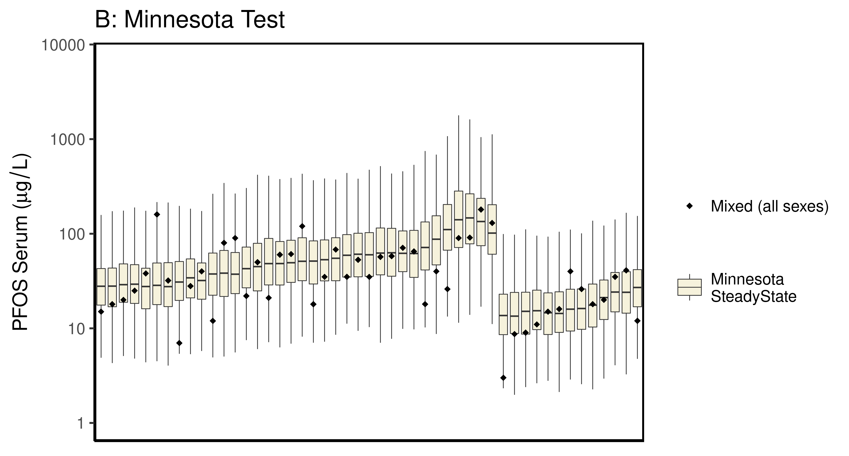

## Saving 6.5 x 3.5 in image  
## Joining, by = c("legend_label", "City", "Train_Test", "datatype", "Time.desc")

## Warning: Column `City` joining factor and character vector, coercing into  
## character vector  
  
## Warning: Column `Train_Test` joining factor and character vector, coercing into  
## character vector

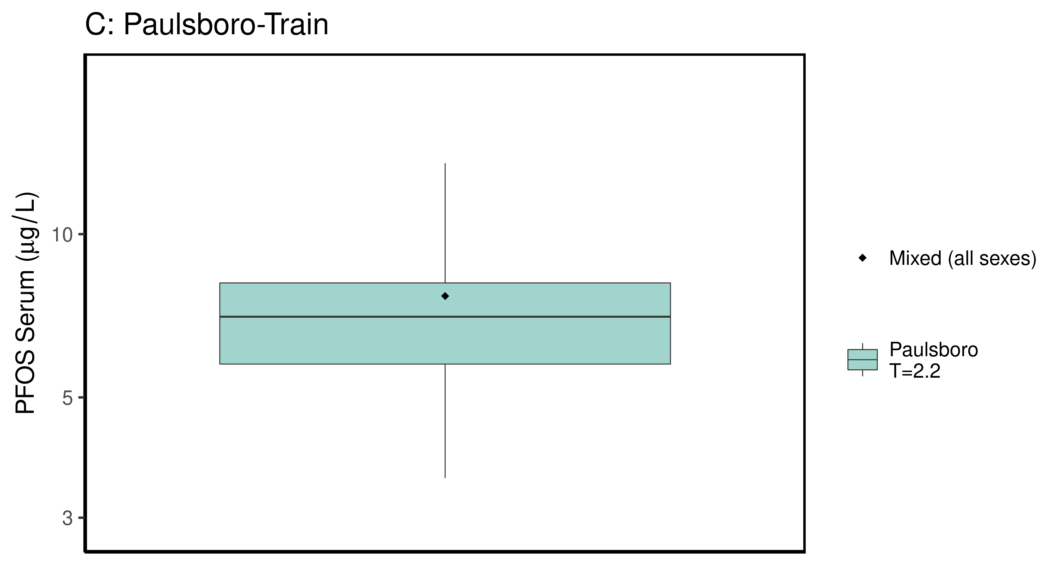

## Saving 6.5 x 3.5 in image  
## Joining, by = c("legend_label", "City", "Train_Test", "datatype", "Time.desc")

## Warning: Column `City` joining factor and character vector, coercing into  
## character vector  
  
## Warning: Column `Train_Test` joining factor and character vector, coercing into  
## character vector

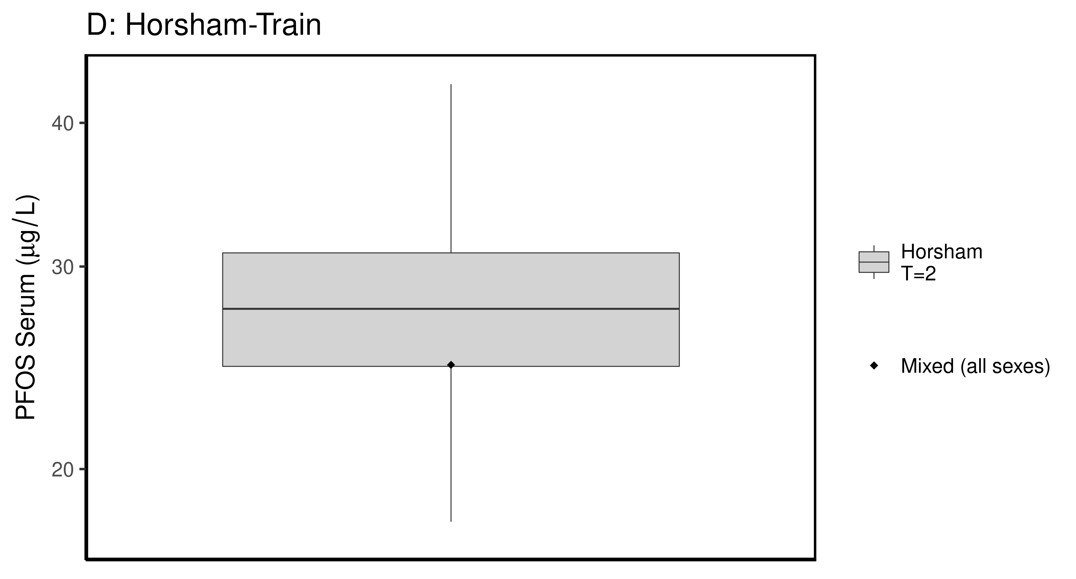

## Saving 6.5 x 3.5 in image  
## Joining, by = c("legend_label", "City", "Train_Test", "datatype", "Time.desc")

## Warning: Column `City` joining factor and character vector, coercing into  
## character vector  
  
## Warning: Column `Train_Test` joining factor and character vector, coercing into  
## character vector

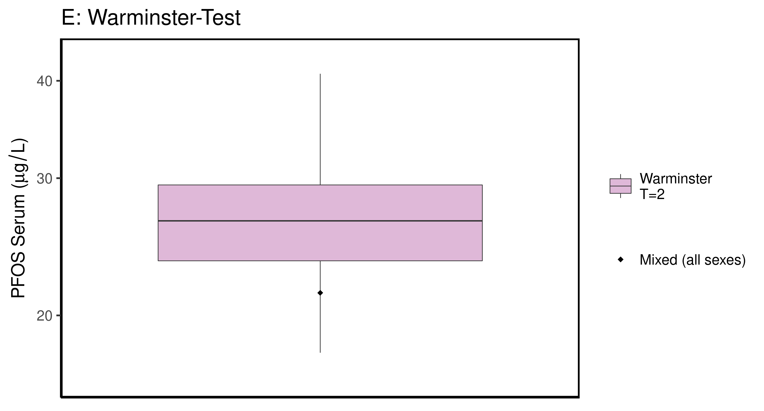

## Saving 6.5 x 3.5 in image

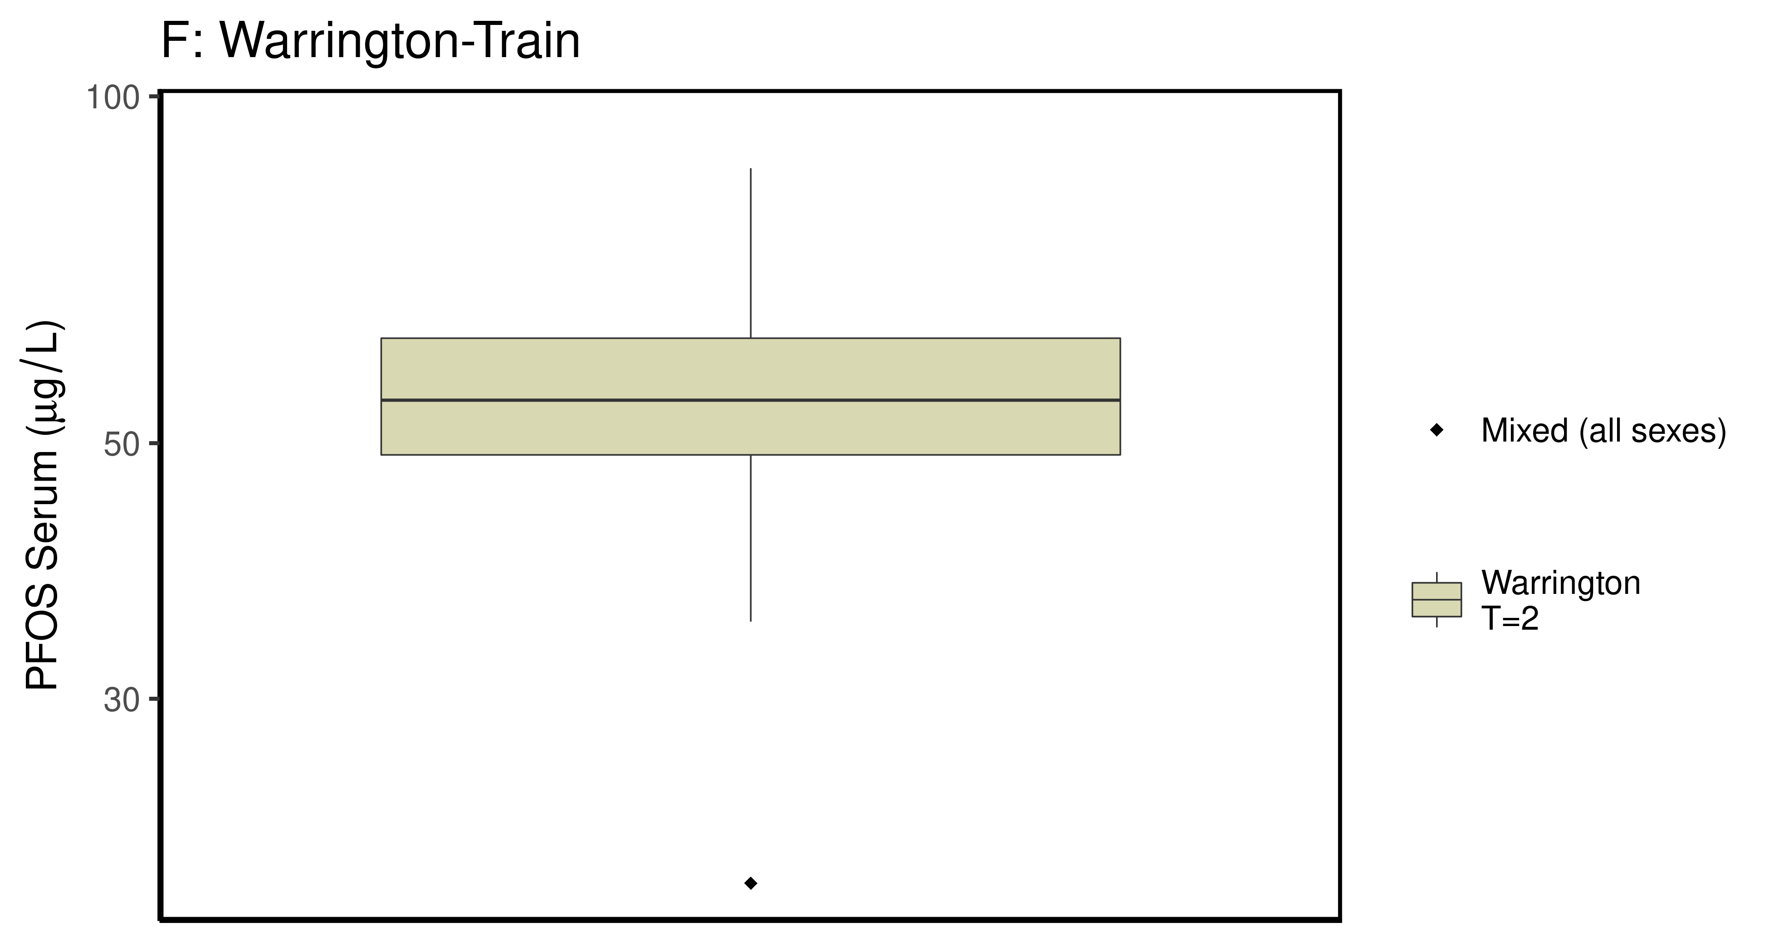

### make Training plot   
  
df_d_trt <- df_check %>%   
 filter( (Train_Test == "Train") & ((Output_Var == "M_Cbgd_Css") | (Output_Var == "M_Cserum"))) %>%  
 mutate_if(is.factor, as.character) %>% # drop factor levels unused  
 mutate(Dataset.Time = factor(Dataset.Time))   
   
  
 aes_lut_df_d_trt <- df_d_trt %>% select(City, datatype,Time, Time.desc, legend_label) %>%   
 inner_join(aes_lut ) %>%   
 select(-Train_Test) %>% ungroup () %>% unique ()

## Joining, by = c("City", "datatype", "Time", "Time.desc", "legend_label")

plt_train <- plot_sum_boxplot(dframe = df_d_trt, aes_lut= aes_lut_df_d_trt,   
 gtitle="C: Summary Data - Train" , facets = FALSE,   
 pfas_nom = pfas_name )  
 print(plt_train)

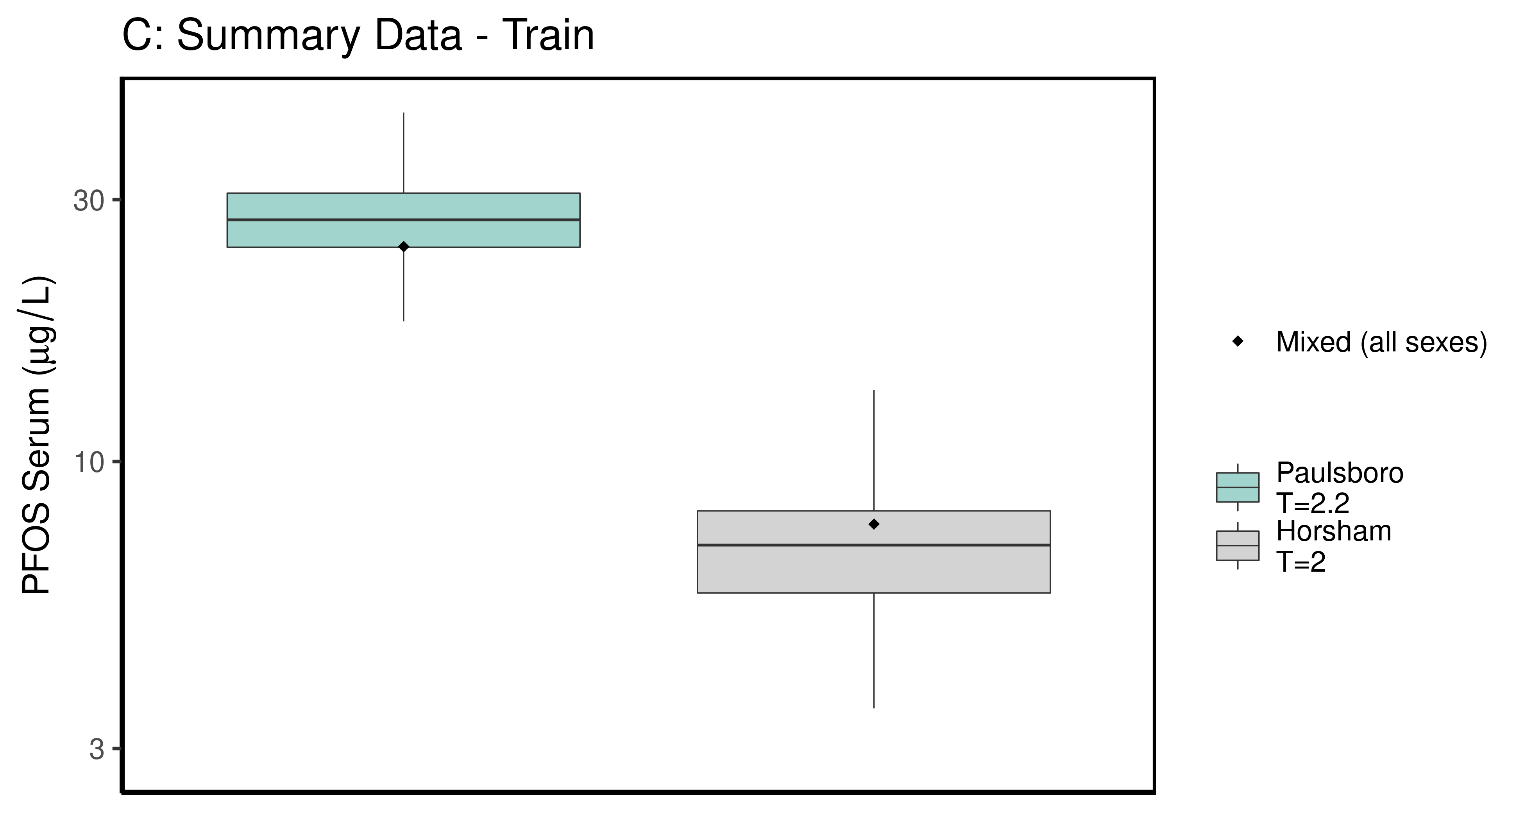

ggsave(here ("output-plots", paste0( sa, "SummaryTrainDataboxplot",pfas_name,".pdf")), plt_train,dpi=600)

## Saving 6.5 x 3.5 in image

### make Test plot  
df_d_test <- df_check %>%   
 filter((Train_Test == "Test") &   
 ((Output_Var == "M_Cbgd_Css") | (Output_Var == "M_Cserum"))) %>%  
 mutate_if(is.factor, as.character) %>% # drop factor levels unused  
 mutate(Dataset.Time = factor(Dataset.Time))   
  
aes_lut_df_d_test <- df_d_test %>% select(City, datatype,Time, Time.desc, legend_label) %>%   
 inner_join(aes_lut ) %>%   
 select(-Train_Test) %>% ungroup () %>% unique ()

## Joining, by = c("City", "datatype", "Time", "Time.desc", "legend_label")

plt_test <- plot_sum_boxplot(dframe = df_d_test, aes_lut= aes_lut_df_d_test,   
 gtitle="D: Summary Data - Test", facets = FALSE ,   
 pfas_nom = pfas_name)  
 print(plt_test)

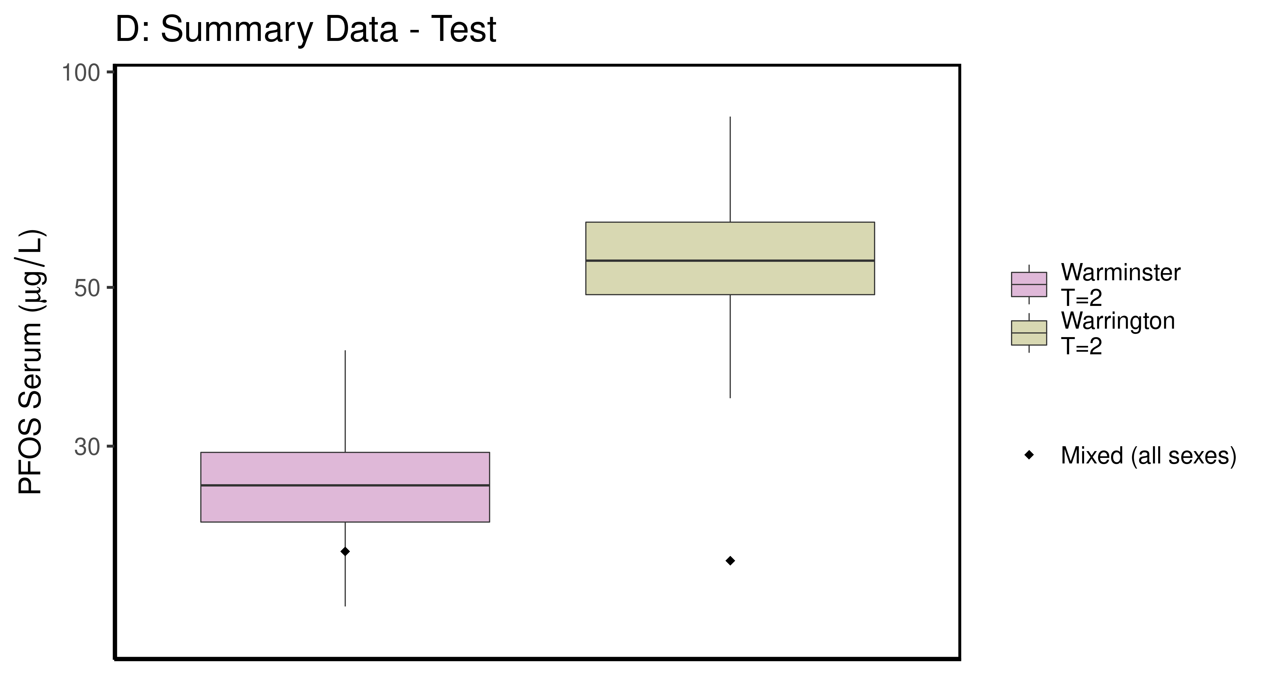

ggsave(here ("output-plots",paste0( sa, "SummaryTestDataboxplot",pfas_name,".pdf")), plt_test,dpi=600)

## Saving 6.5 x 3.5 in image

## PFOS

### Background posteriors

Shows shift in background estimate.

gmscale<-0.8  
  
dat <- multicheck$parms.samp[,grep("M_ln_Cbgd",names(multicheck$parms.samp))]  
datasetnames <- as.character(unique(calibdata$dataset))  
datasetnames <- gsub(" M","",datasetnames)  
datasetnames <- gsub(" F","",datasetnames)  
datasetnames<-datasetnames[!duplicated(datasetnames)]  
names(dat) <- datasetnames  
dat <- dat[,grep("Train",names(dat))]  
dat.df <- pivot_longer(dat,1:ncol(dat))  
dat.df <- rbind(dat.df,  
 data.frame(name="Prior",value=rnorm(5000,m=log(gmscale),sd=0.4055)))  
dat.df$name <- factor(dat.df$name,levels=rev(  
 c("Prior",datasetnames[grep("Train",datasetnames)])))  
dat.df$value <- exp(dat.df$value)  
  
p<-ggplot(dat.df)+  
 #geom_violin(aes(x=name,y=value,fill=name=="Prior"))+  
 geom_boxplot(aes(x=name,y=value,fill=name=="Prior"),outlier.shape=NA)+  
 scale_y_log10()+coord_flip()+  
 scale_fill_manual(name=NULL,   
 values=c("#009988", "#EE7733" )) +  
 theme_classic() +   
 geom_hline(yintercept = gmscale,color="grey")+  
 theme(legend.position="none",  
 panel.background = element_rect(color="black",size=1))+  
 ylab("Posterior shift in Background Concentration")  
  
print(p)

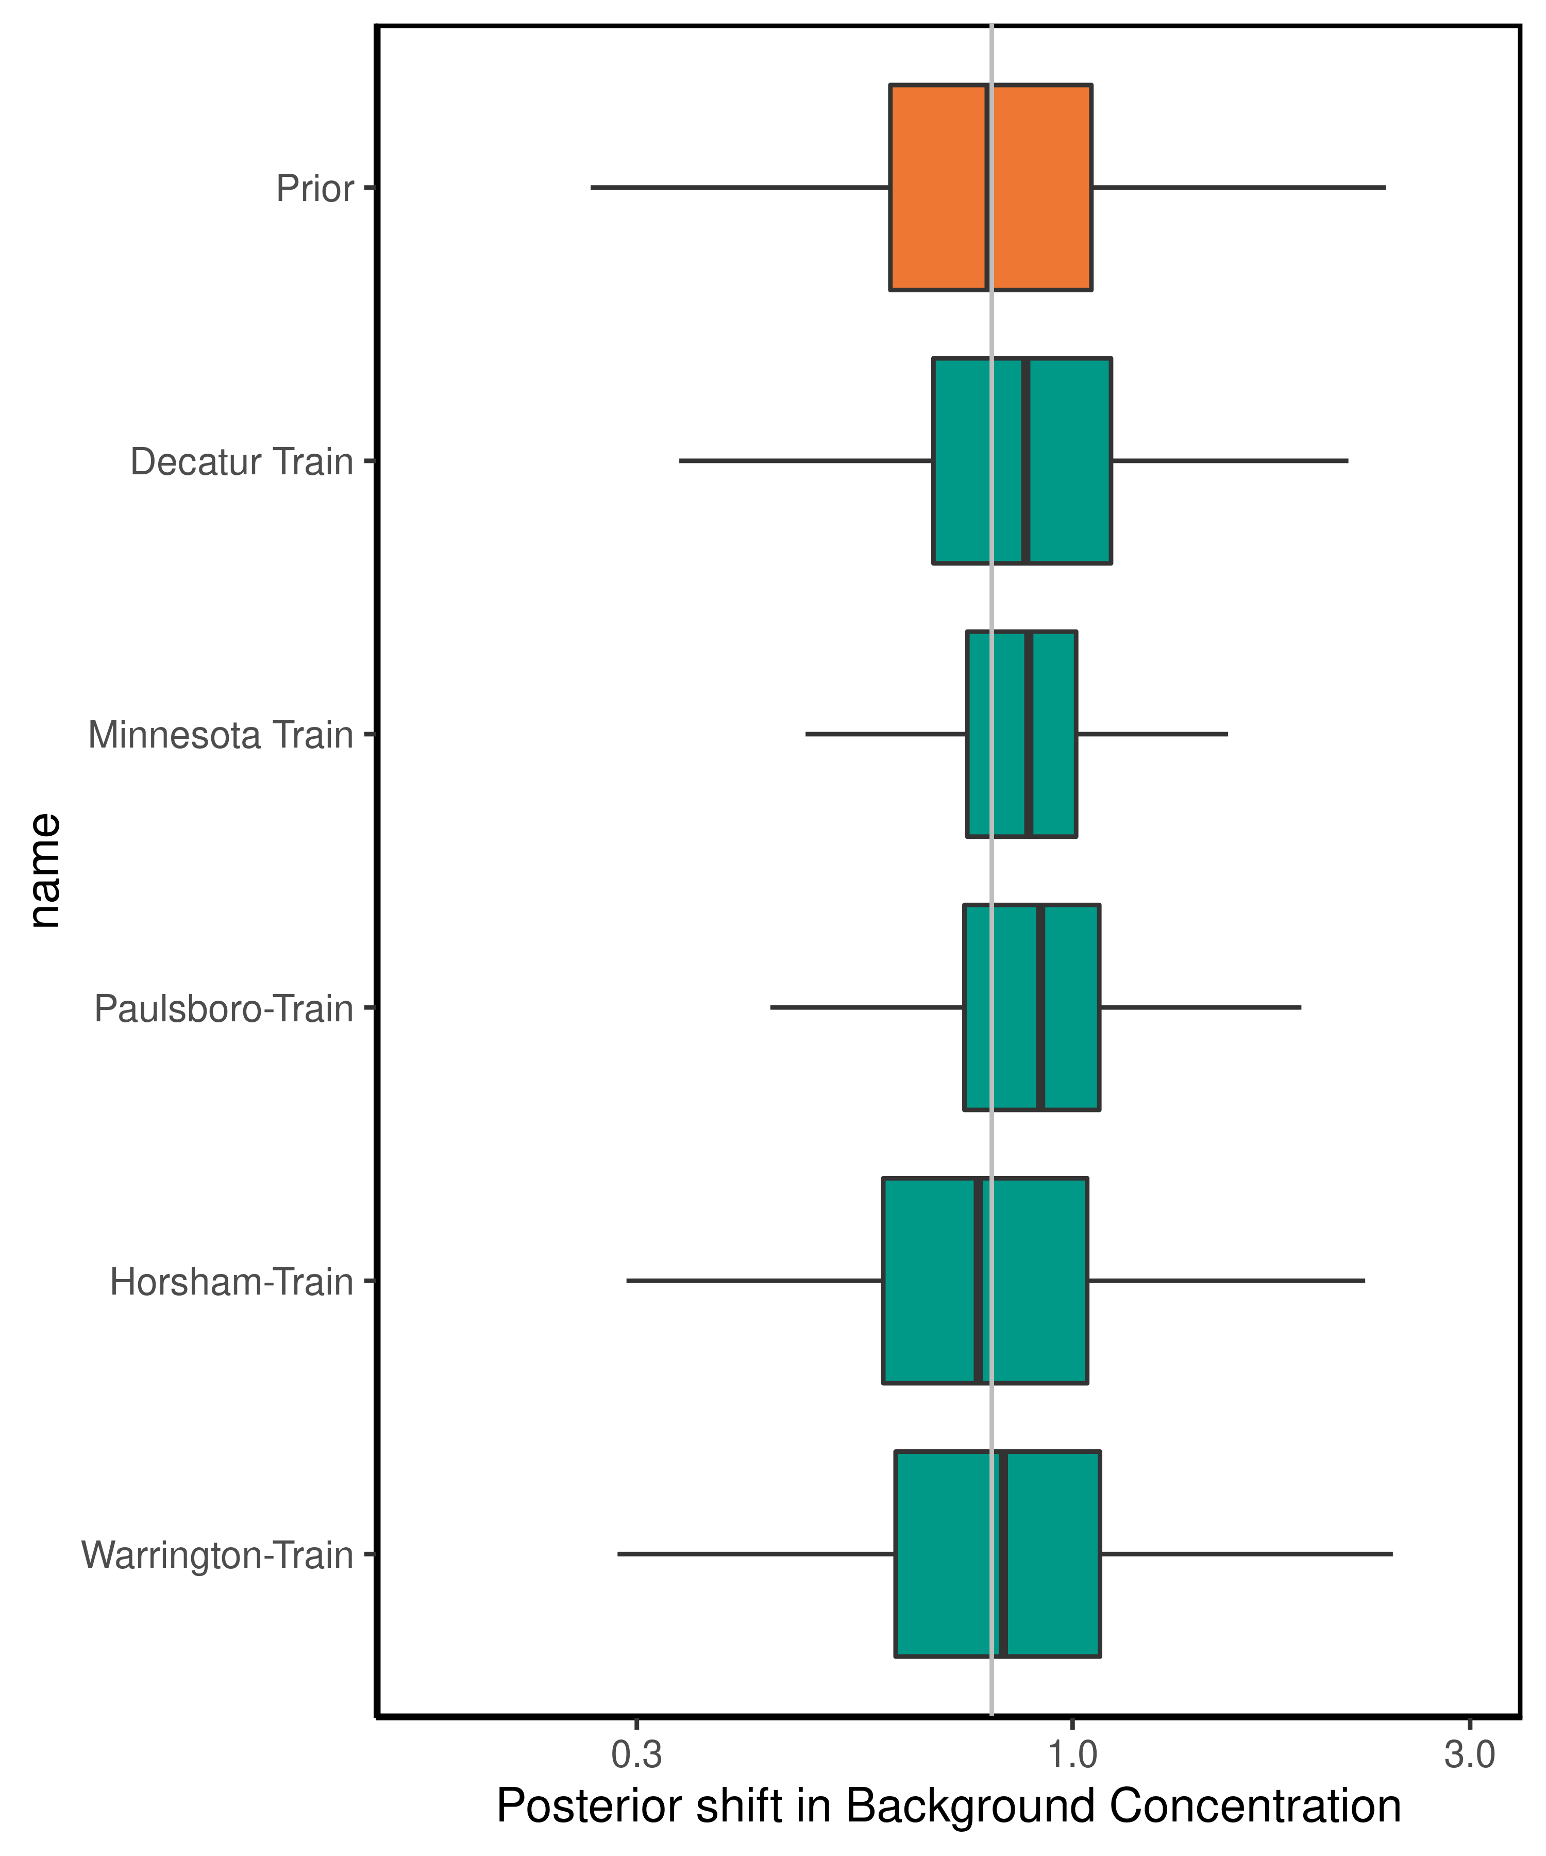

ggsave(here ("output-plots",paste0( sa,"PFOS_GM_Cbgd.pdf")) , p, dpi=600)

## Saving 5 x 6 in image

### Half-life

For PFOS, the population GM of the half-life has a posterior distribution that is narrower than the prior, with a posterior median (95% CI) estimate of 3.06 (2.16-4.37) years. The population GSD posterior is larger than the prior at 1.47(1.44-1.75).

dat <- multicheck$parms.samp[,c("M_ln_k.1.","V_ln_k.1.", "M_ln_Vd.1.", "SD_ln_Vd.1.")]  
names(dat) <- c("M_ln_k(1)","V_ln_k(1)", "M_ln_Vd(1)", "SD_ln_Vd(1)")  
   
set.seed(3.14159)  
dat$z_ln_k <- rnorm(nrow(dat))  
dat$z_ln_Vd <- rnorm(nrow(dat))  
dat %>% rename_()

## Warning: rename_() is deprecated.   
## Please use rename() instead  
##   
## The 'programming' vignette or the tidyeval book can help you  
## to program with rename() : https://tidyeval.tidyverse.org  
## This warning is displayed once per session.

## M_ln_k(1) V_ln_k(1) M_ln_Vd(1) SD_ln_Vd(1) z_ln_k z_ln_Vd  
## 12503 -1.80142 0.2493520 -0.853990 0.170477000 -0.961933416 -2.139841913  
## 15901 -1.33075 0.2849910 -1.067040 0.125258000 -0.292525723 -1.263479244  
## 17543 -1.69677 0.1810560 -0.796718 0.021589200 0.258788216 0.083307969  
## 18721 -1.50091 0.2093370 -1.099880 0.283855000 -1.152131886 0.188325130  
## 11662 -1.82122 0.3232300 -1.254000 0.186498000 0.195782826 0.189814193  
## 13403 -1.74717 0.1884050 -0.800359 0.212961000 0.030123945 0.217615352  
## 13192 -1.59766 0.1961840 -0.932979 0.057111600 0.085417732 -0.648814142  
## 15663 -1.70030 0.2283710 -1.125130 0.300527000 1.116610213 0.254774383  
## 1246 -1.38222 0.2126810 -1.145780 0.021153300 -1.218857416 -0.468830015  
## 16132 -1.75640 0.1520930 -1.238180 0.070154200 1.267368722 -1.192510054  
## 10602 -1.41101 0.2549250 -1.171000 0.283895000 -0.744781596 0.121228235  
## 10563 -1.35088 0.2704290 -1.497640 0.007612380 -1.131218571 -1.035932658  
## 15932 -1.46864 0.2160390 -1.087090 0.035962300 -0.716358490 -0.191888295  
## 1114 -1.59765 0.1934460 -1.106040 0.019999000 0.252652370 -0.970546336  
## 1699 -1.25380 0.2005020 -1.158870 0.022670500 0.152045707 0.057771938  
## 1141 -1.69137 0.1503610 -0.971573 0.323528000 -0.307656430 -2.110692675  
## 13383 -1.65586 0.2320610 -0.788420 0.206814000 -0.953017331 0.978176274  
## 12832 -1.59973 0.2483860 -1.050400 0.071489900 -0.648242811 0.371021737  
## 19552 -1.47402 0.1866610 -1.394360 0.043794500 1.224313624 0.720910931  
## 14423 -1.42654 0.2032610 -1.050000 0.017716000 0.199811608 1.879594880  
## 12372 -1.73978 0.1966500 -1.047850 0.101399000 -0.578483722 -0.396316112  
## 12042 -1.57819 0.2024940 -1.020970 0.079152500 -0.942300733 0.110322947  
## 10473 -1.52688 0.2094750 -1.033260 0.141417000 -0.203728180 -0.593140881  
## 1509 -1.59699 0.1513500 -1.042760 0.081875500 -1.666474840 0.419621770  
## 1552 -1.60436 0.1069670 -1.224140 0.127091000 -0.484455109 -0.545738743  
## 19513 -1.76102 0.2110670 -0.678831 0.236013000 -0.741072661 1.160921499  
## 17471 -1.46415 0.1914050 -1.046070 0.114509000 1.160615779 0.639817834  
## 18092 -1.70813 0.1753040 -1.044900 0.211173000 1.012067125 -0.122020443  
## 1613 -1.72620 0.2368840 -0.970445 0.287585000 -0.072078474 0.184645026  
## 14383 -1.44356 0.1656100 -1.071030 0.196698000 -1.136782298 -0.517806023  
## 14263 -1.42284 0.2062110 -1.214950 0.055714400 0.900624729 0.067988352  
## 18291 -1.57812 0.2026870 -1.089750 0.079875000 0.851770447 -0.184797156  
## 1945 -1.44260 0.1090070 -1.226000 0.399401000 0.727715174 -1.403691615  
## 19613 -1.77658 0.2309380 -0.940752 0.167968000 0.736502146 0.229740706  
## 1842 -1.36224 0.1185410 -1.191760 0.103705000 -0.352129617 -0.889081301  
## 1873 -1.44114 0.3404740 -1.509170 0.124685000 0.705515513 -0.160401177  
## 19423 -1.55603 0.1710020 -0.801237 0.051303100 1.300357989 -0.242136794  
## 19352 -1.78221 0.2155180 -0.951192 0.098931000 0.038252014 -0.028837196  
## 11812 -1.54866 0.3055310 -0.940588 0.305390000 -0.979283770 -0.316215474  
## 14982 -1.77238 0.1021860 -0.865588 0.152685000 0.793761231 -0.416160087  
## 11263 -1.53182 0.2734820 -1.072330 0.185308000 0.786506872 -1.023895957  
## 1028 -1.69160 0.2088630 -1.219490 0.129497000 -0.310463131 1.099495275  
## 1051 -1.63075 0.1884320 -1.085680 0.251683000 1.698884846 0.817712470  
## 17222 -1.62096 0.2175530 -0.966124 0.247455000 -0.794593709 0.168875510  
## 1747 -1.62743 0.3257960 -1.267250 0.265420000 0.348437716 0.038665440  
## 1284 -1.65537 0.3241440 -0.741802 0.120784000 -2.265401074 1.078174892  
## 1564 -1.54364 0.1787600 -1.079270 0.022798400 -0.162205279 0.379427297  
## 18632 -1.75041 0.1821260 -1.246680 0.007379850 1.130864991 -1.078174559  
## 19142 -1.76499 0.1479750 -1.008890 0.210604000 -0.455545976 0.188763468  
## 15793 -1.58279 0.2692080 -0.819012 0.006651540 -0.899166316 1.583133508  
## 1126 -1.61291 0.1662270 -1.181770 0.118518000 0.726838902 -0.250112295  
## 16502 -1.41153 0.2246510 -1.333880 0.111596000 -0.809440902 0.342994219  
## 15103 -1.78206 0.1902610 -0.797043 0.261782000 0.267085116 -0.124701883  
## 11251 -1.63549 0.2536970 -1.308490 0.030522200 -1.737263711 -0.993314763  
## 11732 -1.83302 0.1816080 -1.086160 0.005611510 -1.411425136 -1.021439085  
## 18382 -1.50753 0.2495950 -1.186310 0.035433800 -0.453551227 0.840642928  
## 13433 -1.75000 0.2422780 -0.846725 0.243120000 -1.035491275 0.849573118  
## 16403 -1.70686 0.1739940 -0.919111 0.054366900 1.362142893 0.469618942  
## 11871 -1.41192 0.1378790 -1.285290 0.002945430 0.917456737 -1.269655261  
## 1988 -1.65038 0.2484330 -1.078820 0.313110000 -0.785142161 -1.105120219  
## 1589 -1.47317 0.1501520 -1.392710 0.025054900 0.573518173 -1.897945965  
## 1449 -1.54083 0.2254390 -1.310940 0.213988000 0.918196208 0.491787265  
## 1232 -1.32170 0.1724520 -1.406560 0.020808100 0.256287273 -0.704722317  
## 10171 -1.38062 0.2411050 -1.244390 0.157708000 0.351966556 1.777576130  
## 1259 -1.42908 0.1729930 -1.637170 0.167504000 1.174337357 -0.245389029  
## 18503 -1.69480 0.2016330 -0.904579 0.128397000 -0.480846375 -2.111252318  
## 10801 -1.44331 0.1703890 -1.219610 0.153326000 -0.418829722 -0.585314536  
## 15263 -1.52290 0.2968910 -1.177330 0.225092000 0.955112803 -0.517903726  
## 1042 -1.56440 0.1901080 -1.186340 0.084739900 -1.289006611 0.513919145  
## 18363 -1.42724 0.1971510 -1.359830 0.290097000 0.186197433 -0.626426919  
## 19072 -1.85036 0.1796840 -0.998868 0.127045000 -0.031325502 0.192142595  
## 16632 -1.44689 0.2264780 -1.278840 0.030874000 0.467097310 -1.427277992  
## 1401 -1.47302 0.1757020 -1.393810 0.127235000 1.024197674 0.400991028  
## 14691 -1.40777 0.1534670 -1.579600 0.056476800 0.267358452 1.161564956  
## 17041 -1.29387 0.1905220 -1.128380 0.068074800 0.231826103 0.326346805  
## 19822 -1.42515 0.1549590 -1.520160 0.242644000 0.747592465 -1.014982273  
## 13613 -1.78599 0.2401760 -0.775977 0.182089000 1.217068511 0.101258362  
## 11013 -1.81642 0.1933730 -0.918885 0.109647000 0.383358345 0.991893279  
## 15791 -1.59573 0.1746760 -1.015040 0.011312000 -0.988052822 1.102650759  
## 16531 -1.94281 0.1931920 -1.164840 0.003940340 -0.156852910 0.280375017  
## 1970 -1.72013 0.2562450 -1.208150 0.035925300 1.735535216 -0.406177410  
## 16331 -1.69404 0.2450750 -1.050400 0.175109000 -0.352298306 1.286412690  
## 1242 -1.56017 0.3104400 -1.245760 0.028715200 0.688640044 -0.254030579  
## 15251 -1.42584 0.2674190 -1.149160 0.088400300 1.224406096 -1.144448704  
## 1653 -1.43222 0.2017660 -1.286120 0.066775100 0.794296303 0.266410910  
## 1140 -1.75519 0.2498500 -0.971573 0.174177000 -0.006402398 0.636855748  
## 17771 -1.70256 0.3148570 -0.804586 0.019783200 0.219150635 -1.402115093  
## 18012 -1.46289 0.1259780 -1.104390 0.052245000 -0.886463751 -1.511824827  
## 14062 -1.45032 0.2056640 -1.528750 0.048325800 0.439760291 -0.301192859  
## 1964 -1.59195 0.1425800 -0.978554 0.081392100 -0.886389751 0.491361149  
## 18413 -1.42677 0.2040000 -1.162570 0.043163000 -0.853818454 -0.898156496  
## 13791 -1.67831 0.2136050 -1.253660 0.161301000 -0.989994331 -1.575054814  
## 15832 -1.66815 0.2181370 -0.782389 0.184934000 -0.650877737 -0.503256667  
## 1060 -1.61726 0.1395820 -1.248230 0.103700000 1.053946660 -0.622908441  
## 12073 -1.66090 0.2158960 -1.160410 0.141073000 -0.390878033 -0.684829990  
## 15683 -1.66529 0.1616080 -1.188490 0.129948000 -0.070586394 -0.221516764  
## 1693 -1.46137 0.1406100 -0.975688 0.006582610 -0.462050809 0.388050833  
## 17531 -1.35084 0.1861160 -1.133450 0.113407000 0.540908267 -0.806316456  
## 10311 -1.57061 0.1968490 -1.268740 0.011303800 0.931634971 -0.547213054  
## 18041 -1.69578 0.2409910 -0.945776 0.160114000 -0.209274345 1.213494144  
## 19672 -1.27803 0.3577380 -1.321030 0.077437600 0.617350048 -0.417013230  
## 18351 -1.55941 0.1400720 -1.177790 0.154158000 -0.405077513 0.164593185  
## 13741 -1.33670 0.1636530 -1.314910 0.064834200 1.053103763 -1.569627007  
## 11892 -1.47725 0.1539150 -1.348990 0.117047000 0.602284246 1.466675890  
## 18762 -1.73467 0.1327550 -1.095280 0.108602000 1.017461177 -1.496085449  
## 1808 -1.75742 0.1342810 -0.790074 0.068537900 0.608167318 -1.150289019  
## 15861 -1.59874 0.2612390 -1.287560 0.006637380 0.206735995 -2.023009144  
## 12312 -1.85788 0.1748890 -0.869557 0.103144000 -1.897727292 -0.681652395  
## 13473 -1.68122 0.1864800 -0.903669 0.245733000 -0.682582832 0.507010414  
## 1040 -1.55180 0.2317690 -1.151850 0.243505000 0.481338415 0.747111894  
## 17573 -1.73687 0.2303020 -0.991991 0.052469800 -0.463031038 0.175989014  
## 19872 -1.37986 0.1767060 -1.460860 0.091434300 -0.279741696 -0.437523579  
## 1953 -1.42221 0.2085580 -1.500550 0.322549000 -0.413690145 0.942726154  
## 15883 -1.49946 0.2289970 -1.202700 0.294130000 1.618766521 0.891044960  
## 1663 -1.47280 0.2413910 -1.230680 0.194670000 -0.721055711 -1.691785958  
## 18913 -1.62990 0.2083650 -1.183020 0.049667100 -0.453093157 -0.712147393  
## 1005 -1.55690 0.2202300 -0.887922 0.046124500 0.014257161 -0.332268892  
## 1878 -1.60266 0.2207480 -1.280440 0.076177700 0.215764621 0.983033453  
## 15553 -1.70865 0.1926380 -1.034720 0.050126400 0.188870195 -0.988041784  
## 19433 -1.61164 0.2856220 -0.851723 0.043298200 -0.050148494 0.265546446  
## 15642 -1.46468 0.2381250 -1.437160 0.062770500 -1.495419632 -0.728186155  
## 13873 -1.54101 0.2327770 -1.291350 0.278013000 0.367837753 1.375405013  
## 17882 -1.27107 0.1768120 -1.691280 0.058026300 0.517144022 -0.599264333  
## 1857 -1.63030 0.1799020 -1.037450 0.080117600 -0.484335465 -0.272173202  
## 1103 -1.49705 0.2075100 -1.280910 0.169940000 0.674855616 0.405324773  
## 12581 -1.63162 0.1446160 -1.096500 0.223040000 -0.762448605 0.846734123  
## 1974 -1.75740 0.2604300 -0.978581 0.082568200 0.386073791 0.518125984  
## 13822 -1.71894 0.1549340 -0.994288 0.063431000 -0.664003345 1.579413771  
## 1101 -1.57505 0.1815070 -1.327280 0.005971050 -1.724344195 -0.112951698  
## 1198 -1.49612 0.2157540 -1.310670 0.087910600 1.156319079 -0.484652932  
## 19762 -1.23654 0.1777130 -1.621650 0.297043000 0.693506590 -2.377853826  
## 18271 -1.48604 0.1732950 -1.161410 0.003306850 0.143156356 -0.636048007  
## 18911 -1.49348 0.2595060 -1.073310 0.164290000 1.492813560 0.035663770  
## 19111 -1.63712 0.2067810 -0.810438 0.247167000 -1.632153479 -0.109166877  
## 1374 -1.87416 0.1948600 -0.858210 0.217461000 0.127846023 -1.871305162  
## 1920 -1.53136 0.1743850 -1.254220 0.044112100 -2.403663727 -0.079333090  
## 1504 -1.61585 0.2477820 -1.197850 0.069285200 1.443928256 -0.318596856  
## 16771 -1.46320 0.2232840 -1.233610 0.145733000 -0.878893050 0.118181119  
## 19693 -1.59229 0.1963430 -1.120100 0.111283000 -1.306438327 0.532403631  
## 13331 -1.60487 0.2666910 -1.206690 0.088838300 -0.877198993 -0.197683940  
## 18422 -1.69387 0.2279480 -1.133490 0.211692000 -1.164380459 1.664379027  
## 11663 -1.68281 0.2706920 -0.852092 0.139323000 -1.982347680 0.314495086  
## 13082 -1.57110 0.1915890 -1.062560 0.102309000 -0.989944235 0.601591759  
## 14941 -1.54076 0.1350040 -1.506110 0.262162000 -0.151684601 -1.429557536  
## 1073 -1.61897 0.1496740 -0.829098 0.012684700 0.912506791 -0.472999146  
## 1781 -1.47180 0.2568520 -1.150650 0.106659000 0.407669808 -0.487888829  
## 15091 -1.74046 0.2586450 -0.899978 0.072581500 -1.242184375 1.027388649  
## 13413 -1.73329 0.2129790 -0.800359 0.154899000 -0.642694412 -1.095763686  
## 12463 -1.76972 0.1727930 -0.719371 0.251963000 1.930243689 -0.916445608  
## 11261 -1.55347 0.2423260 -1.135360 0.061771300 0.410199364 1.054094779  
## 10231 -1.61776 0.2007290 -0.980742 0.221915000 -1.291349321 -1.439834035  
## 16911 -1.25592 0.3494360 -1.167300 0.353934000 2.635045375 0.532564109  
## 12011 -1.65635 0.2459230 -0.874537 0.030191000 0.487072288 -1.046928774  
## 14342 -1.54589 0.1493150 -1.129510 0.030510100 0.853892318 0.087385881  
## 1170 -1.48757 0.1870220 -1.095370 0.010599000 1.088442705 -0.174111691  
## 17372 -1.38343 0.2209420 -1.491610 0.043063100 0.226013957 -0.533826331  
## 1839 -1.41853 0.1247980 -1.338650 0.167621000 0.068198838 0.099317747  
## 11531 -1.34425 0.2225030 -1.227100 0.033556900 -0.984815533 -1.020107099  
## 16811 -1.41464 0.2510640 -1.226390 0.049240900 -1.310854422 0.430041832  
## 1825 -1.42684 0.3252130 -1.580160 0.016726800 2.464055335 1.502847759  
## 12443 -1.60789 0.2599160 -0.948714 0.089926300 -0.665428070 -0.270760795  
## 12893 -1.90972 0.2544090 -0.943509 0.201418000 0.912862648 0.871555415  
## 1694 -1.43401 0.1824920 -0.916941 0.074959400 0.964664226 -1.216293810  
## 11843 -1.53648 0.1827450 -1.001350 0.002545060 1.608002937 -1.892738669  
## 15731 -1.68774 0.2201710 -0.943119 0.061162800 1.835399525 -0.822382571  
## 15783 -1.51771 0.3056300 -1.227080 0.227351000 0.702462733 0.751782015  
## 11601 -1.53655 0.2389310 -1.202380 0.197221000 1.217854079 0.773574518  
## 17572 -1.38274 0.1688670 -1.390260 0.032753900 -1.123653829 -1.787532258  
## 1062 -1.56855 0.1697110 -1.246250 0.182033000 0.668330116 0.088817469  
## 12182 -1.52487 0.2020360 -0.841445 0.269202000 1.216411488 -0.180052904  
## 18073 -1.64871 0.1325350 -0.913735 0.155656000 0.234575354 -1.471714902  
## 1773 -1.45864 0.2595550 -1.367170 0.148999000 -0.418696588 0.490094947  
## 12412 -1.70055 0.1706870 -0.582437 0.060415700 0.238220090 -0.397833206  
## 14813 -1.67254 0.3218510 -0.919686 0.057462200 -0.550588192 -0.169679442  
## 19503 -1.75617 0.2136650 -0.647163 0.058267900 -0.500602769 -2.214982820  
## 1029 -1.74481 0.1754470 -1.203500 0.133848000 1.163897492 1.008145236  
## 1473 -1.60252 0.2020990 -1.019690 0.183359000 2.155536954 0.524260695  
## 1430 -1.49357 0.1931440 -1.343860 0.144346000 -1.709157009 0.264820635  
## 12303 -1.33371 0.2070020 -1.413410 0.046063000 -1.600822615 -0.388256354  
## 1738 -1.44177 0.1537250 -1.429160 0.388258000 -1.038553413 -0.399451920  
## 11051 -1.74155 0.1767650 -1.079970 0.280302000 0.323094221 0.227146190  
## 18882 -1.71416 0.1375880 -0.890053 0.042590600 -0.888847154 -0.611156980  
## 14953 -1.59802 0.2719900 -0.964553 0.149160000 0.393678982 0.540650478  
## 17223 -1.58201 0.1895410 -1.236520 0.049403300 0.236541468 0.909955002  
## 10543 -1.45833 0.2801030 -1.481790 0.045436200 -0.430496813 1.406622276  
## 19871 -1.64748 0.2342100 -1.193640 0.119721000 -0.547933126 -0.755587121  
## 15571 -1.69969 0.2352080 -0.782257 0.170305000 -1.322251659 -0.020592429  
## 19333 -1.56796 0.1806280 -1.388750 0.260031000 0.682126749 0.137858516  
## 1357 -1.64377 0.1919970 -1.005730 0.023198400 2.162789482 -0.921540392  
## 12813 -1.60121 0.1929180 -1.057910 0.057513200 -0.416669649 0.576523431  
## 1222 -1.18552 0.1563030 -1.599190 0.068297900 -1.357317897 0.298893720  
## 19032 -1.70181 0.1655110 -1.214070 0.199536000 -0.671226462 -0.862301037  
## 1190 -1.28746 0.1599830 -1.320850 0.239923000 0.649918243 -0.810138091  
## 17662 -1.47722 0.1649130 -1.091810 0.276040000 0.771291175 0.472555898  
## 1570 -1.61903 0.1463060 -1.001390 0.074747400 2.676631927 0.568499025  
## 12933 -1.84228 0.1569710 -0.945698 0.050148500 -1.370871421 1.413098269  
## 17162 -1.53990 0.2207550 -1.239490 0.006072870 0.057759145 0.058817380  
## 18321 -1.62959 0.1811330 -1.001420 0.094481700 -0.197067508 -0.583447921  
## 13532 -1.42845 0.1996380 -1.310010 0.093340800 -1.261517626 0.270123085  
## 14012 -1.46343 0.2129280 -1.348550 0.180194000 -0.662442562 1.078046441  
## 19571 -1.44795 0.2523630 -1.059760 0.155857000 -1.332352324 -0.146579622  
## 12991 -1.57590 0.2632740 -1.239800 0.186836000 0.277323621 -0.635253591  
## 17063 -1.52158 0.2392220 -1.536120 0.057788300 1.085533849 0.524084655  
## 19203 -1.72916 0.2264180 -0.980474 0.081099100 -1.642718489 1.105146081  
## 14513 -1.28666 0.2577040 -1.362840 0.289166000 -0.457180258 -0.501011903  
## 18052 -1.59505 0.1807310 -1.017510 0.077025900 1.461171845 0.424192601  
## 1957 -1.55833 0.2413930 -1.171950 0.024067200 -1.672532602 -1.077357662  
## 1965 -1.62611 0.1964750 -1.091970 0.068684200 1.561095996 -0.625837491  
## 13273 -1.36206 0.2441940 -1.368250 0.279710000 -1.493370648 0.840120571  
## 1789 -1.56843 0.1599290 -0.940395 0.229032000 -1.182449141 -0.059466609  
## 13492 -1.55697 0.1736590 -1.350260 0.300593000 -0.356586881 -0.077217546  
## 12513 -1.78626 0.2485890 -0.732586 0.242287000 -0.915640125 0.416709627  
## 14672 -1.45122 0.1677280 -1.042330 0.165107000 0.849485485 -1.379914328  
## 18373 -1.33187 0.1813080 -1.390380 0.450913000 -0.489607238 -1.482149933  
## 11793 -1.61308 0.1344590 -1.131950 0.053685000 0.727983210 0.122071411  
## 1361 -1.74700 0.1570430 -1.107350 0.171650000 -0.619313219 1.195887446  
## 15123 -1.91526 0.2411880 -0.831472 0.118101000 0.343735543 -0.254062405  
## 18791 -1.51099 0.1884000 -1.222900 0.001497550 1.813625401 -0.344407316  
## 10681 -1.29387 0.2065480 -1.317050 0.015978000 1.453226830 -1.809799151  
## 11143 -1.72779 0.2238790 -1.264760 0.259178000 0.412429443 -1.630895018  
## 1194 -1.42823 0.2305210 -1.168260 0.010581800 0.201975959 -0.271965872  
## 1330 -1.75748 0.2971200 -1.022770 0.051346400 1.684346898 -1.790901346  
## 18142 -1.59072 0.1807190 -1.060530 0.014197300 -0.964824478 -0.228499227  
## 1934 -1.66644 0.1922260 -1.123070 0.095693000 0.662155194 1.784240948  
## 1622 -1.85534 0.1880170 -1.079380 0.089527700 -0.553343994 -0.166313575  
## 14913 -1.72884 0.2162230 -0.777261 0.134747000 2.444205231 0.809087394  
## 14073 -1.59377 0.1876110 -1.115670 0.118853000 -0.304629836 -0.972329346  
## 19561 -1.49304 0.1423140 -1.223950 0.103425000 -0.117369869 -1.952502354  
## 1231 -1.32037 0.1359190 -1.360600 0.020808100 0.969428787 1.786422520  
## 1849 -1.47165 0.1896180 -1.298980 0.019915600 0.590939630 1.312987748  
## 15711 -1.73584 0.1993340 -0.929362 0.024458100 -1.208958402 1.108674735  
## 13711 -1.47063 0.2292990 -1.489870 0.020220000 -0.301928423 -0.993200725  
## 17031 -1.29763 0.2640250 -1.128390 0.221291000 0.401260475 0.526099803  
## 16543 -1.65662 0.2023280 -1.170710 0.114522000 -1.688368241 -0.768071012  
## 17671 -1.44403 0.1744240 -1.466450 0.173614000 -0.712992471 0.529000051  
## 19841 -1.75263 0.1821990 -1.187260 0.204887000 -0.254300337 0.142537992  
## 19063 -1.41329 0.2842170 -1.058460 0.616350000 -1.001566828 -1.540493313  
## 17851 -1.57198 0.1732320 -1.082170 0.149318000 -0.924100354 -0.776809099  
## 1478 -1.68055 0.1917960 -0.921510 0.150389000 0.440245569 -3.053299791  
## 18823 -1.46935 0.1559750 -1.220630 0.180006000 -0.326816611 0.871474290  
## 10932 -1.62473 0.1634660 -1.210630 0.151288000 -0.274475875 0.190962149  
## 12382 -1.71986 0.1677610 -1.086810 0.145641000 1.284142059 0.849572629  
## 11613 -1.59091 0.1823810 -1.046560 0.041215000 0.304211777 -0.563481733  
## 12701 -1.77984 0.2292760 -0.966488 0.034828100 1.273682656 1.204416928  
## 14801 -1.48665 0.2141860 -1.348760 0.054829800 1.033447932 1.704492687  
## 13023 -1.62059 0.1398750 -1.324700 0.030265300 0.665384156 -0.058008606  
## 12123 -1.54273 0.2198040 -1.158020 0.064915100 -0.313328109 0.770876717  
## 10272 -1.80539 0.2122970 -1.307020 0.012608000 0.464076685 -0.027690324  
## 18622 -1.84365 0.1970700 -1.087400 0.043586100 0.478605860 1.303131096  
## 15523 -1.71092 0.1431420 -0.907414 0.000403399 2.536235795 -0.711585886  
## 15201 -1.63570 0.1373630 -1.275300 0.002071850 -0.535063085 -0.771192049  
## 14391 -1.58912 0.1727710 -1.335740 0.078308500 1.368106222 -1.338907825  
## 1658 -1.36888 0.1986470 -1.353120 0.181305000 0.141844290 0.408160652  
## 17003 -1.56036 0.3622950 -1.523930 0.163250000 -0.782814969 0.206537589  
## 1316 -1.50485 0.1716230 -1.228860 0.046198000 1.881518733 -0.224476304  
## 15442 -1.61637 0.1086930 -1.443760 0.192763000 0.552922865 -1.504028164  
## 1008 -1.52626 0.1624380 -0.898557 0.103589000 -1.844856583 0.238798379  
## 18082 -1.65879 0.1794350 -0.858343 0.135325000 -0.550307914 -0.440094481  
## 1931 -1.65806 0.1488460 -1.123070 0.027310600 -0.026014759 1.085948334  
## 1192 -1.37413 0.1644130 -1.316030 0.079747400 -2.159250362 0.287937278  
## 16292 -1.68956 0.1776670 -1.185900 0.029907200 1.770600080 -0.592582238  
## 12013 -1.65021 0.2105330 -1.198160 0.036470700 0.760473482 -1.030482341  
## 1999 -1.45367 0.1721260 -1.087180 0.039016500 -0.484542846 0.722738858  
## 15621 -1.69318 0.2198180 -0.957036 0.146622000 -0.472763899 -0.814832560  
## 17171 -1.41607 0.1521020 -1.337770 0.047626300 0.331672075 0.414635154  
## 19781 -1.54962 0.1783650 -1.156590 0.085700700 -0.972300798 -0.192636529  
## 11202 -1.79244 0.2319560 -1.185370 0.218071000 -0.531244209 -0.410108658  
## 16253 -1.76374 0.2433450 -0.905049 0.093397000 0.062036740 0.206361537  
## 16722 -1.42833 0.1988230 -1.046830 0.032495500 0.103529988 0.284630186  
## 18962 -1.69497 0.2337740 -0.991015 0.019355900 1.169799329 -0.604884836  
## 1076 -1.75847 0.1791730 -0.994574 0.232541000 0.394189201 0.583220593  
## 1501 -1.50211 0.1590340 -1.370310 0.093982300 -0.134102361 0.280145010  
## 10951 -1.48045 0.1505450 -1.206620 0.066450400 -0.379875566 1.315610342  
## 15121 -1.58566 0.1713610 -1.083880 0.168829000 1.278666582 -1.452676821  
## 1006 -1.57046 0.1863840 -0.887922 0.011995500 -0.699332309 -1.158009146  
## 16093 -1.66915 0.2402050 -1.228580 0.142797000 0.564250526 -0.047178285  
## 18592 -1.81833 0.1539700 -1.329990 0.219680000 0.302941956 0.162912346  
## 16783 -1.66967 0.2235670 -1.212330 0.138890000 0.215441157 0.940933129  
## 17292 -1.50560 0.2564600 -1.174660 0.107361000 0.921002999 -0.392834083  
## 11801 -1.60564 0.2504230 -1.312930 0.041666500 -0.887551892 -0.562332042  
## 16312 -1.68164 0.2337510 -1.231910 0.194273000 -0.002893014 1.502073402  
## 1104 -1.42949 0.1987700 -1.289610 0.124315000 -0.195173624 -0.477261637  
## 13902 -1.56002 0.2464970 -1.453520 0.191705000 -2.234678901 -0.750163568  
## 1347 -1.96726 0.2675790 -0.735485 0.224625000 0.478322985 -1.018058650  
## 1769 -1.41082 0.2797960 -1.372880 0.168064000 1.622692015 -1.054689491  
## 11621 -1.51292 0.1960840 -1.026960 0.022905200 -1.196074086 -0.641345254  
## 18953 -1.47756 0.1570260 -1.352400 0.033411400 1.659509162 1.404537373  
## 10771 -1.46692 0.2360070 -1.457360 0.159818000 0.204545434 -0.065751336  
## 1117 -1.68719 0.2162280 -1.027920 0.211197000 1.385975853 -0.049392617  
## 10782 -1.75463 0.2539310 -1.000680 0.054898200 -0.857811795 0.510827457  
## 16763 -1.56873 0.1788460 -1.440170 0.092881100 0.685862076 0.285062593  
## 12292 -1.78807 0.1748890 -0.995590 0.078731200 -0.581662540 -0.044179742  
## 14191 -1.46759 0.1572560 -1.321170 0.256942000 -0.684552910 2.160619408  
## 15113 -1.91526 0.1736580 -0.985522 0.122432000 0.378472922 0.251437855  
## 19862 -1.36498 0.1702250 -1.343150 0.033307400 1.312957410 -0.757802743  
## 16053 -1.62597 0.1815710 -1.279020 0.025767600 0.314021521 2.029114324  
## 11031 -1.72802 0.1287760 -1.047170 0.235525000 -0.502185174 -0.759754169  
## 10963 -1.57015 0.1222920 -1.059620 0.132090000 1.252114604 0.540998808  
## 1755 -1.38460 0.1964860 -1.216490 0.126390000 -0.303155378 -2.266765003  
## 16961 -1.49870 0.1337110 -1.059490 0.398774000 0.811231864 -1.367218227  
## 1616 -1.75303 0.1548020 -1.098400 0.187930000 -1.259378794 1.046089176  
## 12221 -1.40704 0.1583880 -1.316010 0.030693600 0.762987289 0.345531150  
## 15873 -1.55554 0.1932730 -1.316690 0.300180000 -0.803453540 1.169703621  
## 1387 -1.73442 0.1731100 -1.014960 0.033446800 -0.379383917 1.622790746  
## 18883 -1.47820 0.1485820 -1.216820 0.032510000 -1.366494285 -0.277961194  
## 12152 -1.44618 0.2458330 -0.981067 0.058511200 3.519299065 -1.162967695  
## 1874 -1.53445 0.2390420 -1.297080 0.129657000 -1.213148497 0.875151132  
## 11321 -1.44016 0.1790740 -0.814322 0.090559600 0.194357317 0.244195278  
## 17601 -1.28494 0.1702530 -1.686680 0.217152000 0.094365637 -0.025469417  
## 16001 -1.27310 0.1873870 -1.464580 0.176842000 -0.878491419 -0.077051330  
## 15491 -1.53336 0.1751220 -1.150520 0.046334500 0.260435859 -2.050564466  
## 15013 -1.57404 0.2974440 -1.168360 0.092087400 0.657707063 0.061337130  
## 15821 -1.56407 0.2023090 -1.257030 0.076267900 0.765796530 -0.494998449  
## 15921 -1.21831 0.3675510 -1.283510 0.126569000 -2.235360626 0.479269669  
## 1852 -1.51059 0.1798500 -1.069620 0.342099000 -0.902826117 0.751390595  
## 10712 -1.59275 0.1816180 -0.993969 0.191585000 -0.166383835 0.172589245  
## 1394 -1.72403 0.2037730 -1.209790 0.015328700 -0.065499417 -0.060847194  
## 13771 -1.38889 0.2155300 -1.546170 0.026134500 -0.505638021 0.636966353  
## 11862 -1.44835 0.2579270 -1.092560 0.238914000 0.520286715 -1.463983320  
## 1966 -1.68978 0.1997980 -0.984832 0.212929000 0.035701483 -0.849069592  
## 11292 -1.33901 0.1372930 -1.604940 0.144192000 -0.910689564 0.508940075  
## 10831 -1.37912 0.1721680 -1.270180 0.301357000 0.914343124 0.632460951  
## 17903 -1.45231 0.2830270 -0.991741 0.010393200 -0.336709121 1.166244744  
## 1644 -1.61457 0.1911530 -1.364160 0.078612700 0.094762857 0.390579179  
## 1565 -1.54364 0.1771720 -1.095640 0.166538000 2.127220716 -0.136916556  
## 13241 -1.69535 0.2055890 -0.961629 0.081829400 0.196584478 -1.093804247  
## 16871 -1.16174 0.2907680 -1.797730 0.185104000 -0.967604740 -1.669799789  
## 1229 -1.32854 0.0993001 -1.214540 0.234614000 -0.284897245 1.131946555  
## 10372 -1.45568 0.1674760 -1.288570 0.209672000 0.164445997 0.569647807  
## 16003 -1.44550 0.2244740 -1.412950 0.128420000 -1.111870811 -0.629400068  
## 11721 -1.79690 0.2023180 -1.310190 0.120760000 -1.929364819 -0.917405418  
## 14731 -1.57715 0.1925000 -1.342080 0.204991000 -0.470260857 0.995658022  
## 14522 -1.59955 0.2586500 -1.157350 0.419483000 0.534387834 -0.889488176  
## 1525 -1.68293 0.1841870 -0.994583 0.061727300 -0.921049943 1.325976748  
## 16992 -1.21003 0.3650710 -1.531590 0.088757600 0.684374353 0.340950621  
## 16511 -1.78409 0.2311520 -1.162900 0.021288500 1.522078770 1.262076498  
## 14453 -1.43704 0.1976240 -1.317830 0.018104500 0.194613305 2.189657376  
## 11523 -1.88389 0.2708130 -0.899715 0.103871000 1.697224718 1.866736427  
## 13622 -1.43010 0.2496610 -1.200170 0.215834000 0.278068186 0.735091166  
## 15022 -1.77726 0.2015960 -0.659722 0.139483000 -0.571010463 -0.786304399  
## 1807 -1.75024 0.1767180 -0.621199 0.081135400 -0.157879440 -0.876974257  
## 13841 -1.67959 0.2856440 -1.317730 0.079328900 2.488339353 -1.220868128  
## 13602 -1.50733 0.2777260 -1.211150 0.576781000 1.071369094 1.616651857  
## 12461 -1.50713 0.2609270 -1.071870 0.024641200 0.342219077 0.498043756  
## 1135 -1.65141 0.2111820 -0.953937 0.131197000 0.221327427 1.602559271  
## 19683 -1.66861 0.2085390 -1.060620 0.277401000 0.068362742 0.635575578  
## 1320 -1.61263 0.1721230 -0.876073 0.139445000 0.307421602 -1.068431798  
## 12102 -1.57495 0.2108270 -1.089970 0.010425100 1.508633864 -1.707926964  
## 1567 -1.59219 0.2201640 -1.226670 0.034010400 0.615842239 -1.021218419  
## 19002 -1.59602 0.2050490 -1.164060 0.170542000 0.089812018 -0.227106122  
## 10362 -1.42351 0.2286330 -1.490810 0.113154000 -2.398452730 1.242464352  
## 15102 -1.76417 0.1406390 -0.834098 0.059885000 0.047807291 -0.578908578  
## 11942 -1.46274 0.2088560 -1.125770 0.040468000 0.336143355 1.032077158  
## 12732 -1.54685 0.1642380 -1.312510 0.125784000 0.434845736 -0.191477506  
## 1255 -1.31150 0.2664000 -1.169570 0.020563400 0.211023629 -0.424186098  
## 12453 -1.68799 0.2046500 -0.890171 0.014158200 0.110793489 -2.391613110  
## 13211 -1.66976 0.1637110 -0.821134 0.200982000 -1.993322911 1.646065343  
## 10972 -1.60182 0.1635430 -1.272260 0.318903000 1.505015705 -0.767060351  
## 16851 -1.46400 0.1396550 -1.218220 0.035110300 0.354157119 0.756270977  
## 1031 -1.67018 0.2006110 -1.091500 0.048252000 0.434837780 1.492709667  
## 10612 -1.52413 0.2332250 -1.171000 0.280230000 0.768243915 0.655936058  
## 16583 -1.61581 0.1676000 -1.096890 0.009660980 0.409688369 0.494717169  
## 14233 -1.46744 0.2718460 -1.197650 0.053932800 -1.976651601 -0.253101875  
## 10792 -1.65393 0.2451400 -0.877584 0.174708000 -1.087579363 -0.662941615  
## 1698 -1.39041 0.2445660 -1.291530 0.078489000 1.064863970 0.562125564  
## 1626 -1.75078 0.2282700 -1.093050 0.202088000 2.120202537 -0.779297892  
## 14002 -1.51841 0.2842170 -1.304930 0.018010600 -0.505837533 0.858962271  
## 1228 -1.41521 0.1456870 -1.318380 0.050642900 0.406987081 0.934961145  
## 1155 -1.50843 0.1861590 -1.195680 0.086879100 2.040025754 -0.791952504  
## 19331 -1.61178 0.3048150 -1.033540 0.068812100 -0.193935372 1.359486952  
## 1281 -1.79241 0.2735200 -0.679002 0.055857200 1.370222895 0.019649377  
## 17963 -1.48765 0.1568710 -1.142120 0.238154000 -0.515357348 -1.185940292  
## 17163 -1.61159 0.2620260 -1.221920 0.042903900 -0.718232806 0.343632123  
## 15473 -1.76918 0.1634820 -0.853758 0.082219200 -0.177242285 0.585487847  
## 16942 -1.45124 0.1980690 -1.150720 0.028542200 -0.401576463 -1.430200670  
## 13951 -1.29855 0.2199450 -1.381070 0.065618600 0.829883568 1.019029395  
## 17981 -1.50965 0.1743330 -0.955535 0.077895900 -0.785806614 0.320298932  
## 17043 -1.54265 0.2156560 -1.481230 0.092062700 -0.938501217 -0.501576176  
## 19892 -1.45251 0.1528690 -1.172140 0.135433000 0.417806768 -0.141376028  
## 16761 -1.48243 0.1227070 -1.168600 0.186104000 2.098097844 -1.430818217  
## 14713 -1.50179 0.1713240 -1.202280 0.097834700 -0.448862342 0.587857654  
## 12702 -1.68328 0.2250110 -1.179110 0.106596000 -1.095288092 0.868963574  
## 10551 -1.77219 0.3280030 -1.063890 0.161406000 -0.528972750 0.456654992  
## 10322 -1.67262 0.2205510 -1.470790 0.029668700 -0.484793938 -1.355959524  
## 18782 -1.67525 0.1424050 -1.246990 0.091134200 0.127757042 0.643807790  
## 10061 -1.49656 0.2070550 -1.036680 0.238163000 -0.074673107 0.070101188  
## 1083 -1.61105 0.1759020 -1.218860 0.144700000 -0.359162136 0.010391561  
## 14773 -1.72140 0.2208190 -1.039710 0.052474300 -2.048480559 0.721199978  
## 13932 -1.43157 0.1614430 -1.475420 0.096690800 -0.751180021 0.093814902  
## 14413 -1.50186 0.3185800 -1.054670 0.148744000 -1.581383000 -0.564257032  
## 15182 -1.73389 0.2055450 -0.887112 0.067537200 -0.289776058 0.007023682  
## 1371 -1.85084 0.2925460 -1.076670 0.065126600 -0.691954528 -0.561537486  
## 11582 -1.64541 0.2383030 -1.409060 0.072313500 -0.171987946 1.755959697  
## 11852 -1.40765 0.2256150 -1.077540 0.067736000 -0.222564010 0.170426604  
## 11001 -1.69245 0.1454910 -1.027090 0.172125000 0.919241279 1.065195204  
## 1943 -1.54984 0.1816270 -1.245430 0.192067000 -1.110065480 1.504156131  
## 15613 -1.70104 0.1773240 -1.033680 0.269444000 -0.660888997 0.659959697  
## 1793 -1.70708 0.1682110 -0.814696 0.050002200 -0.873774912 -0.838201076  
## 11502 -1.62216 0.1766700 -0.918084 0.032106300 -0.132809701 0.394689060  
## 16553 -1.65662 0.1155030 -1.092240 0.081378200 0.305489104 -0.379625994  
## 11162 -1.74505 0.2216360 -1.118960 0.152758000 2.163842485 2.066779896  
## 13412 -1.56644 0.1196000 -0.961730 0.178569000 0.880378505 -1.029749769  
## 14722 -1.47487 0.4775430 -1.053070 0.048182200 0.505116253 -0.123095504  
## 12323 -1.49250 0.2252780 -1.375930 0.075716700 0.110590205 0.173957707  
## 1722 -1.54319 0.1742930 -1.370870 0.162650000 -0.292858583 0.553190600  
## 1256 -1.30482 0.2507260 -1.372690 0.087629500 0.772319992 -0.759068678  
## 13092 -1.61133 0.2363580 -0.978320 0.033869100 2.128794229 0.035829594  
## 14762 -1.42314 0.1487560 -1.388810 0.157410000 0.547967970 -0.003495063  
## 18661 -1.61696 0.1237750 -1.008580 0.151110000 1.532129229 -0.220190416  
## 1032 -1.65692 0.1876240 -1.033670 0.134383000 1.666430854 -1.557680246  
## 12772 -1.44281 0.2059480 -1.387980 0.153474000 -0.478000049 -0.238045956  
## 1346 -1.94479 0.2396940 -0.726904 0.019610400 -0.368681625 0.424982482  
## 14222 -1.60021 0.1667070 -1.160290 0.041022400 -0.516166127 -0.446779715  
## 1432 -1.39524 0.1953770 -1.312740 0.126206000 0.396937689 -1.401854780  
## 1420 -1.37477 0.1758480 -1.234100 0.088502300 -0.314871760 -0.547414257  
## 15641 -1.62304 0.2177940 -1.132010 0.203779000 -0.684689801 0.247941769  
## 1591 -1.29157 0.1791460 -1.439100 0.046662900 1.632247789 -1.351702539  
## 10181 -1.41015 0.2413830 -1.146300 0.088910000 -0.684533761 1.285374670  
## 15213 -1.71978 0.1527750 -1.080850 0.123285000 -0.313076970 2.096632994  
## 18383 -1.35131 0.2515590 -1.513320 0.486157000 -0.640032652 -1.075716671  
## 17121 -1.58824 0.1907260 -1.332270 0.039455300 0.635304358 0.643818555  
## 11961 -1.48608 0.2555860 -0.858021 0.163138000 0.024848366 0.811107086  
## 1550 -1.73175 0.1152980 -0.909206 0.193682000 0.227622212 -0.373369162  
## 1021 -1.65428 0.2026270 -1.061150 0.052179100 -0.246068246 -0.117755702  
## 13783 -1.78730 0.2103460 -0.889392 0.030213700 0.024223829 0.939509301  
## 1472 -1.60252 0.1686890 -0.958022 0.000499893 -1.244582466 -0.223544486  
## 17673 -1.49990 0.1579680 -1.359740 0.026277700 -1.205974540 -1.188865752  
## 14023 -1.58702 0.1576610 -1.217330 0.201054000 0.273093950 0.599961163  
## 15453 -1.64878 0.1760630 -1.012680 0.038171300 1.729414034 -0.863306018  
## 16151 -1.30448 0.2124380 -1.334160 0.197624000 -1.064950869 -0.669136112  
## 14392 -1.66337 0.2441820 -0.922419 0.205119000 -0.113736688 0.758080913  
## 1606 -1.58209 0.1632230 -1.128590 0.235642000 -0.643751471 0.977212323  
## 14853 -1.72773 0.2275740 -0.916556 0.246829000 0.940648418 1.486960427  
## 16371 -1.76238 0.2268630 -1.016960 0.003627540 1.918810176 0.809182023  
## 14261 -1.73913 0.2391750 -1.359820 0.346195000 -1.006045550 1.049591298  
## 13171 -1.44714 0.2000050 -0.942965 0.075801900 0.547082630 -1.378317315  
## 10481 -1.60438 0.1747180 -1.022170 0.026152700 0.033847059 -1.166379732  
## 14142 -1.40472 0.2778480 -1.482980 0.042335500 -0.315828929 0.450531663  
## 15372 -1.59891 0.2483080 -1.156740 0.013146400 0.288544593 0.553986739  
## 13811 -1.53126 0.2518220 -1.180010 0.027698500 -0.344392202 0.171533785  
## 1300 -1.63480 0.2070840 -1.029870 0.088273800 0.116631435 -0.806881470  
## 1855 -1.55151 0.2021100 -0.920308 0.086983600 0.542965968 0.978852878  
## 18943 -1.50537 0.1626130 -1.298810 0.100194000 1.143947544 1.171035498  
## 18831 -1.47188 0.2324920 -1.245600 0.098661400 -1.284548845 -0.254750999  
## 1629 -1.68727 0.2011840 -0.931957 0.271430000 0.919811790 -0.261779474  
## 11953 -1.64228 0.2055450 -1.232940 0.075065000 -0.846090161 1.357008537  
## 13562 -1.41112 0.1923990 -1.259150 0.155737000 -1.419304273 1.048195428  
## 18421 -1.71737 0.2225070 -0.783155 0.210179000 -2.665697589 2.228898486  
## 20003 -1.49215 0.2106140 -1.039740 0.019768400 0.835106141 -1.470518812  
## 11401 -1.53976 0.1738100 -1.188570 0.051182300 2.377446549 -1.031250041  
## 1048 -1.54193 0.3177270 -1.172580 0.166563000 0.013969708 0.164813527  
## 12143 -1.40185 0.1909080 -1.253530 0.015887900 -1.633423995 -1.243838156  
## 1075 -1.64379 0.2320340 -0.790570 0.061541600 0.488932473 0.116308174  
## 18021 -1.72279 0.1385020 -0.995043 0.180275000 -1.019179409 1.197547370  
## 17623 -1.81527 0.2077940 -0.981700 0.060115900 1.090553483 -0.698130988  
## 1499 -1.55342 0.2692160 -1.159330 0.276123000 -1.139469805 0.293604948  
## 18673 -1.52368 0.2218970 -1.250930 0.137455000 -0.015725635 0.437297744  
## 1093 -1.56502 0.2140250 -1.230870 0.032996500 0.297491282 0.627762573  
## 13553 -1.73378 0.2307790 -1.260090 0.029437100 3.200590040 -1.160543514  
## 12592 -1.75684 0.2508010 -0.818875 0.055645700 0.089244244 -0.020788418  
## 12912 -1.48590 0.1433990 -1.354200 0.120168000 0.570972338 1.044724089  
## 1785 -1.56714 0.2986130 -1.071050 0.183863000 0.528685630 1.311594585  
## 14041 -1.39814 0.1924830 -1.305820 0.129477000 -0.440904798 -0.082439028  
## 1624 -1.76545 0.2339300 -0.908638 0.004069150 -0.672793368 0.919224762  
## 1841 -1.42755 0.1451730 -1.341910 0.210463000 2.154313365 -0.243269921  
## 19553 -1.85510 0.2230390 -0.735430 0.052806900 0.593852716 0.351094377  
## 12722 -1.57593 0.1594370 -1.312510 0.063735200 -0.384063768 -1.340384172  
## 15122 -1.64299 0.1477960 -1.011570 0.061591200 0.719783276 0.425846094  
## 1348 -1.91962 0.2829390 -0.620540 0.010489600 1.708173402 -0.814353733  
## 15183 -1.81874 0.1499260 -1.091110 0.103718000 1.075215667 0.693374081  
## 14432 -1.64776 0.1610770 -1.028450 0.002494180 0.777420367 0.705544556  
## 1468 -1.67556 0.2155600 -0.856809 0.089933100 0.052200047 0.278350539  
## 17953 -1.50613 0.2074470 -1.197250 0.388557000 -1.083698485 -1.202692142  
## 1557 -1.67197 0.2153900 -0.805881 0.180799000 -0.008856207 0.642761817  
## 19642 -1.40143 0.1675350 -1.439470 0.024199400 2.030643112 -0.605973945  
## 16191 -1.30688 0.2109720 -1.045880 0.146657000 -1.113328933 -1.377257613  
## 17011 -1.36745 0.2463770 -1.136360 0.221291000 1.138271925 -0.925992687  
## 1820 -1.72021 0.1831130 -1.036110 0.159953000 -0.614892642 0.567243857  
## 10851 -1.31680 0.2657500 -1.355230 0.037516300 -2.193536615 2.595481260  
## 13483 -1.68122 0.1878290 -0.903669 0.265844000 -1.215686372 -0.239984547  
## 13183 -1.52580 0.1235930 -1.450810 0.234876000 -0.045326362 0.687536401  
## 18462 -1.62277 0.2238930 -1.241640 0.180416000 1.598812624 -0.151788986  
## 15542 -1.69629 0.3648440 -1.317020 0.086871300 0.927542200 0.227544260  
## 18752 -1.76095 0.1551010 -1.139730 0.108602000 0.829284552 -0.668648038  
## 12081 -1.56404 0.1211220 -1.029330 0.310887000 1.024603876 0.030829067  
## 1014 -1.66843 0.2590590 -1.130590 0.064545900 -0.476238068 0.028429558  
## 15612 -1.48288 0.1896450 -1.184050 0.167148000 1.638868393 -0.365455074  
## 14833 -1.65586 0.2351110 -0.786566 0.182061000 -0.632050958 -2.208012195  
## 1639 -1.59013 0.1656190 -1.258690 0.106575000 -1.379618576 0.297039427  
## 10353 -1.57695 0.1746650 -1.175470 0.127344000 -0.257455748 2.129700659  
## 15011 -1.62712 0.1981910 -1.273900 0.010661300 1.679972711 1.325041143  
## 12253 -1.33077 0.2099170 -1.308900 0.028637400 -2.545858038 -0.116171447  
## 10793 -1.29243 0.2230800 -1.342710 0.119481000 0.012078784 -1.470146221  
## 10103 -1.63586 0.2055260 -1.355910 0.039419000 1.960925111 -0.379271835  
## 1903 -1.43079 0.2477340 -1.298380 0.225564000 -0.385905481 -1.465005931  
## 1679 -1.41372 0.2080930 -1.204000 0.025828700 0.910757548 1.075148263  
## 1795 -1.74408 0.1573570 -0.796299 0.061298000 -1.448130794 -1.226124877  
## 1489 -1.86707 0.2601220 -1.228760 0.074651800 -1.121614596 -3.056328234  
## 1881 -1.40138 0.1417070 -1.209370 0.081398400 -0.973617906 1.450657775  
## 15061 -1.66003 0.1755920 -1.016900 0.195986000 -0.067186922 0.717976859

dat$ln_k_i <- dat$`M_ln_k(1)` + sqrt(dat$`V_ln_k(1)`)*dat$z_ln_k  
dat$ln_Vd_i <- dat$`M_ln_Vd(1)`+ dat$`SD_ln_Vd(1)`*dat$z_ln_Vd  
linmod <- lm(ln_Vd_i ~ ln_k_i,data=dat)  
ggplot(dat) + geom_point(aes(ln_k_i,ln_Vd_i)) +   
 labs(subtitle=paste("Adj R2 =",signif(summary(linmod)$adj.r.squared,2)))

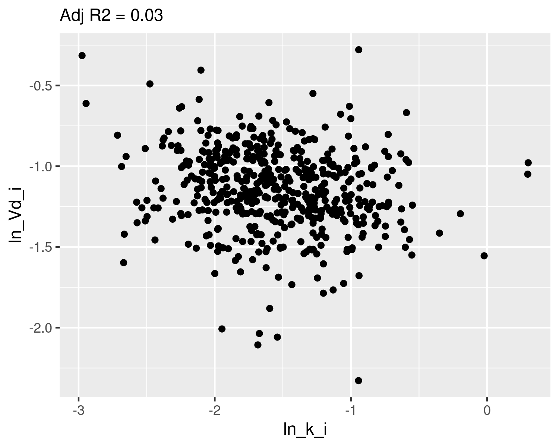

## Check normality

qqnorm(dat$ln_k_i,main="ln k Q-Q Normal")  
qqline(dat$ln_k_i,col="red")

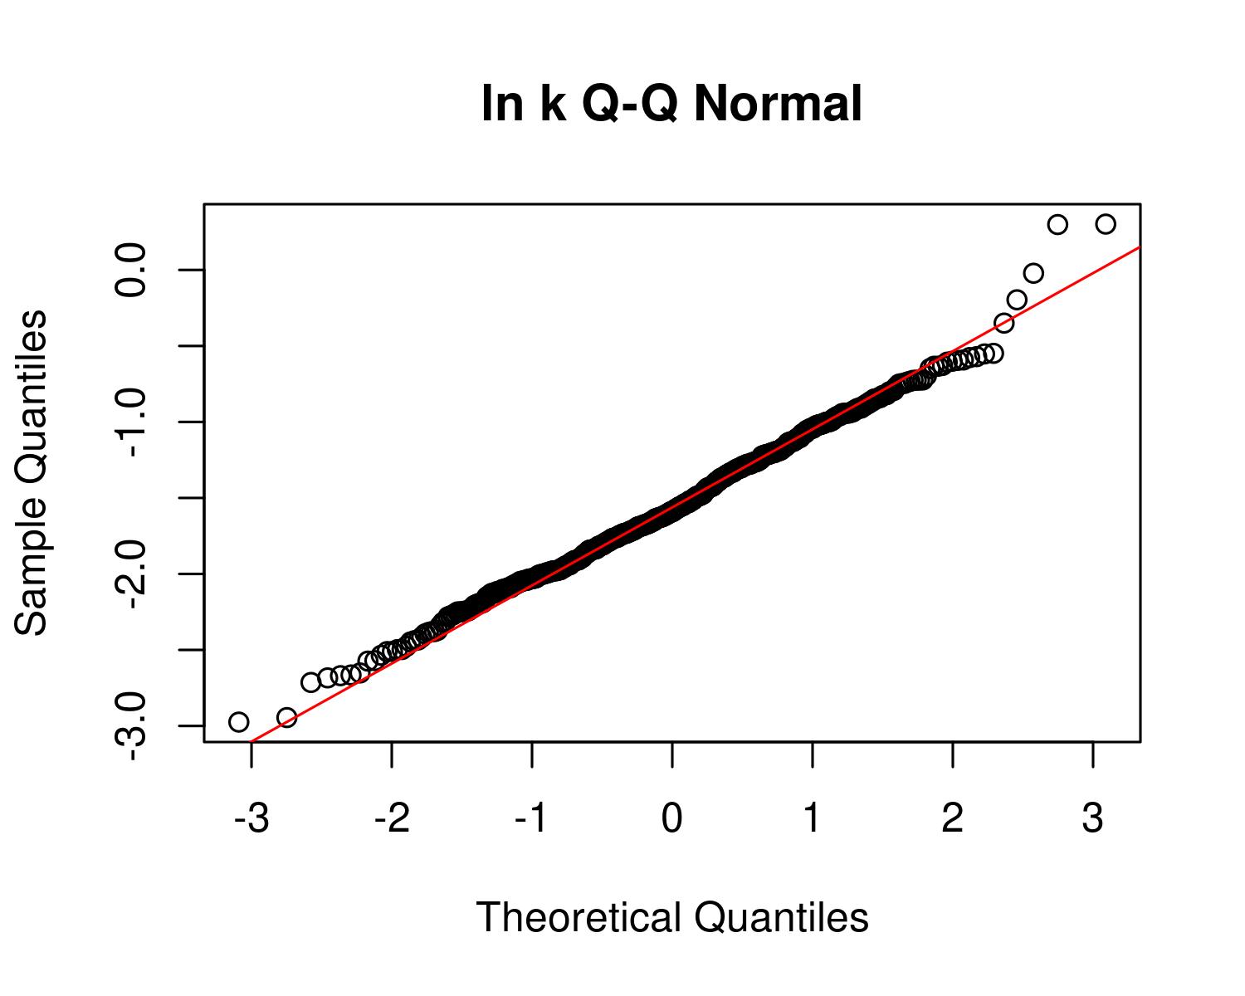

plot(ecdf(dat$ln_k_i))  
x <- seq(-3,1,0.01)  
m_ln_k_i <- mean(dat$ln_k_i)  
sd_ln_k_i <- sd(dat$ln_k_i)  
lines(x,pnorm(x,mean=m_ln_k_i,sd=sd_ln_k_i),col="red")  
text(m_ln_k_i-2*sd_ln_k_i,0.9,paste("m =",signif(m_ln_k_i,4),"\nsd =",signif(sd_ln_k_i,4)))

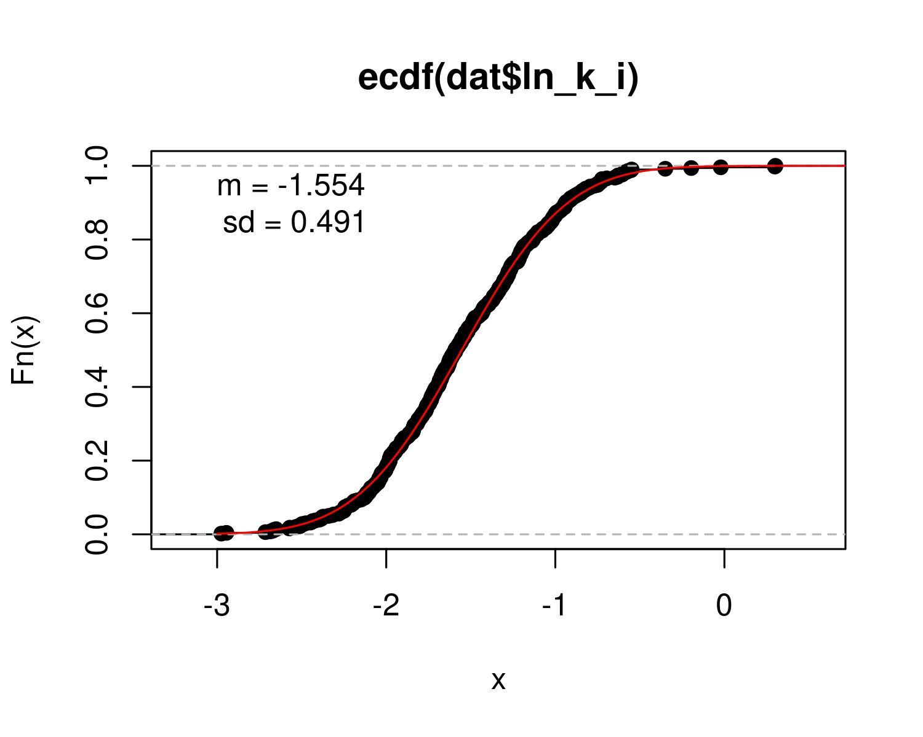

qqnorm(dat$ln_Vd_i,main="ln Vd Q-Q Normal")  
qqline(dat$ln_Vd_i,col="red")

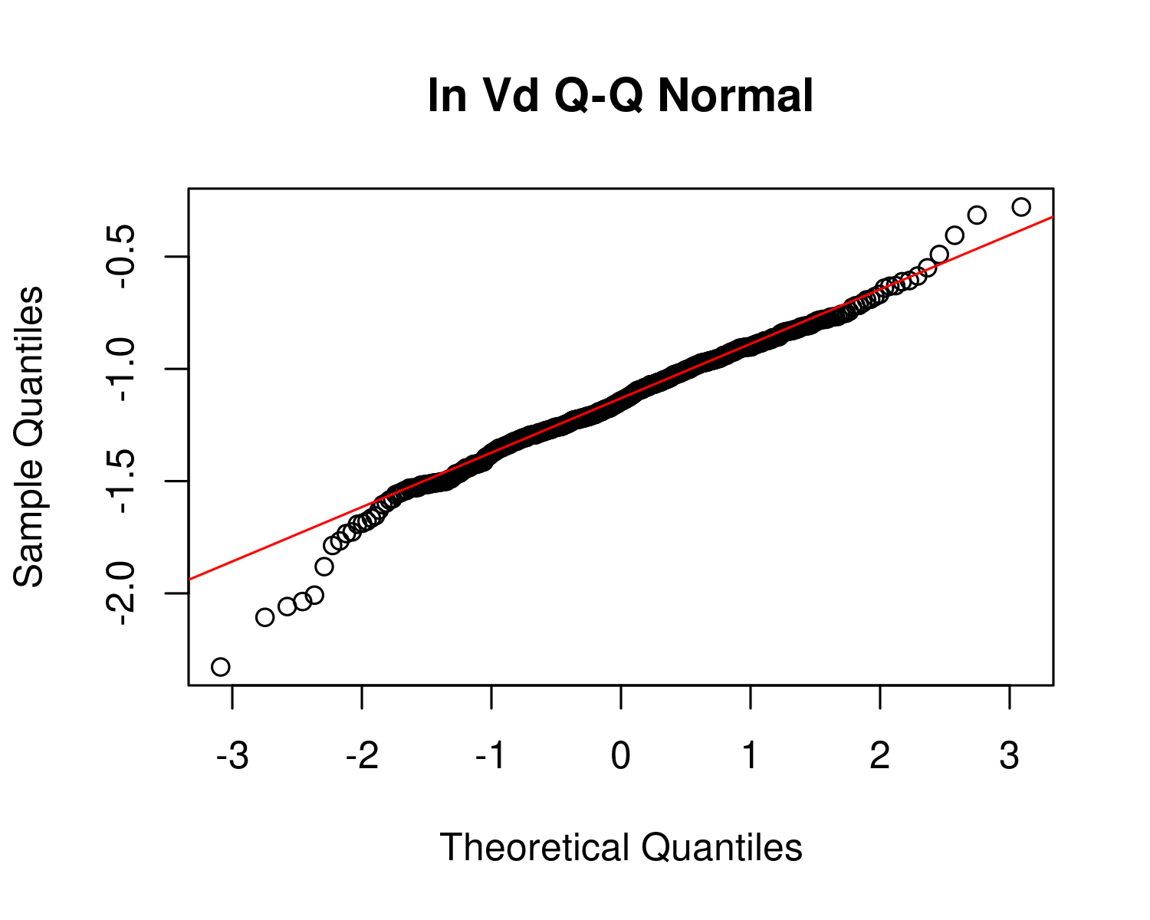

plot(ecdf(dat$ln_Vd_i))  
x <- seq(-3,1,0.01)  
m_ln_Vd_i <- mean(dat$ln_Vd_i)  
sd_ln_Vd_i <- sd(dat$ln_Vd_i)  
  
lines(x,pnorm(x,mean=m_ln_Vd_i,sd=sd_ln_Vd_i),col="red")  
text(m_ln_Vd_i-2*sd_ln_Vd_i,0.9,paste("m =",signif(m_ln_Vd_i,4),"\nsd =",signif(sd_ln_Vd_i,4)))

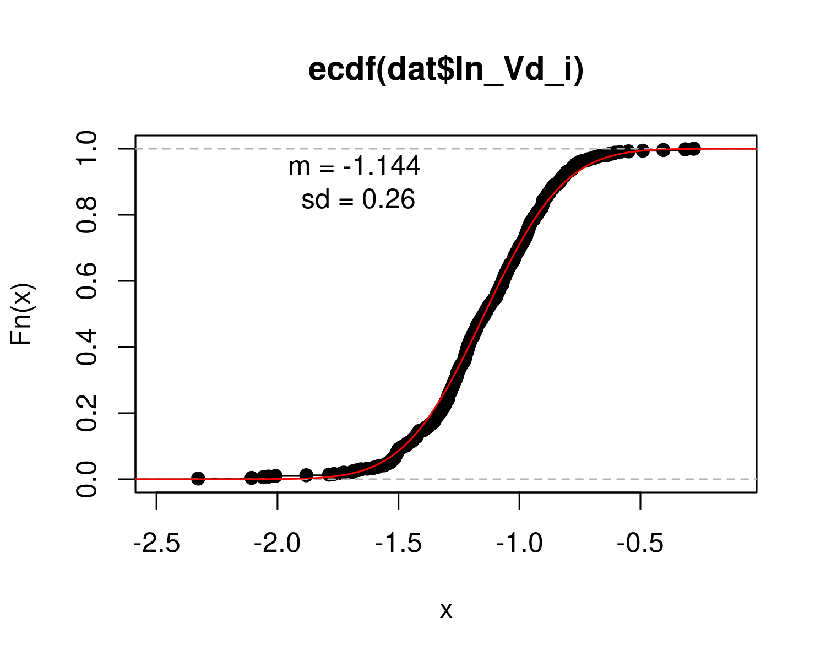

## Calculate table values for individual-level

hl_i <- log(2)/ exp(dat$ln_k_i) # individual half-life   
med_hl_i <- paste(signif (median (hl_i), 3)) # median of individual half-life  
ci_med_hl_i <- paste(signif (quantile(hl_i, prob=c(0.025,0.975)), 3),collapse="-") # 95ci med individual halflife  
gm_hl_i <- paste(signif (exp(mean(log(hl_i))), 3)) # gm (which should be really close)  
gsd_hl_i <- paste(signif (exp(sd(log(hl_i))), 3)) # gsd individual  
  
med_Vd_i <- paste(signif (median(exp(dat$ln_Vd_i)), 3)) # median individual Vd  
ci_med_Vd_i <-paste(signif (quantile(exp(dat$ln_Vd_i), prob=c(0.025,0.975)), 3),collapse="-") # 95ci med individual Vd  
gm_vd_i <- paste(signif (exp(mean(dat$ln_Vd_i)), 3)) # gm (which should be really close)  
gsd_vd_i<- paste(signif (exp(sd(dat$ln_Vd_i)), 3)) # gsd indiv

PFOS_priors <- data.frame(  
 halflife_GM= log(2)/rlnorm(50000,  
 meanlog=-1.8971,sdlog=0.4055))  
M_k <- exp(as.numeric(dat$`M_ln_k(1)`))  
PFOS_halflife_GM <- log(2)/M_k  
  
PFOS_hlgm_pr_med <- signif(median(PFOS_priors$halflife_GM,3))  
PFOS_hlgm_pr_med_95ci <-paste(signif(quantile(PFOS_priors$halflife_GM,  
 prob=c(0.025,0.975)),  
 3),  
 collapse="-")  
  
PFOS_hl_median_gm <- signif(median(PFOS_halflife_GM),3)  
PFOS_hl_median_gm_95ci <- paste(signif(quantile(PFOS_halflife_GM,  
 prob=c(0.025,0.975)),3),collapse="-")  
  
p<-ggplot()+  
 stat_density(aes(halflife_GM, color = "Prior"),data=PFOS_priors,geom="line",size=2)+  
 stat_density(aes(PFOS_halflife_GM,stat(density),color="Posterior"),geom="line",size=1.5 )+  
 xlim(0,15)+  
 labs(title = bquote("C: PFOS"~T[1/2]~"Population GM") ,  
 subtitle=paste("Posterior Median (95% CI): ",  
 PFOS_hl_median_gm," (",  
 PFOS_hl_median_gm_95ci,  
 ")",sep=""))+  
 xlab(bquote("Population GM"~T[1/2]~"(yrs)")) +  
 scale_color_manual(name=NULL,#  
 values=c(Prior="#009988", Posterior="#EE7733" )) +   
 theme_classic() +   
 theme(legend.title = element_blank(),legend.position=c(0.8,0.7),  
 panel.background = element_rect(color="black",size=1),  
 legend.background = element_rect(fill="transparent", color=NA))  
print(p)

## Warning: Removed 80 rows containing non-finite values (stat_density).

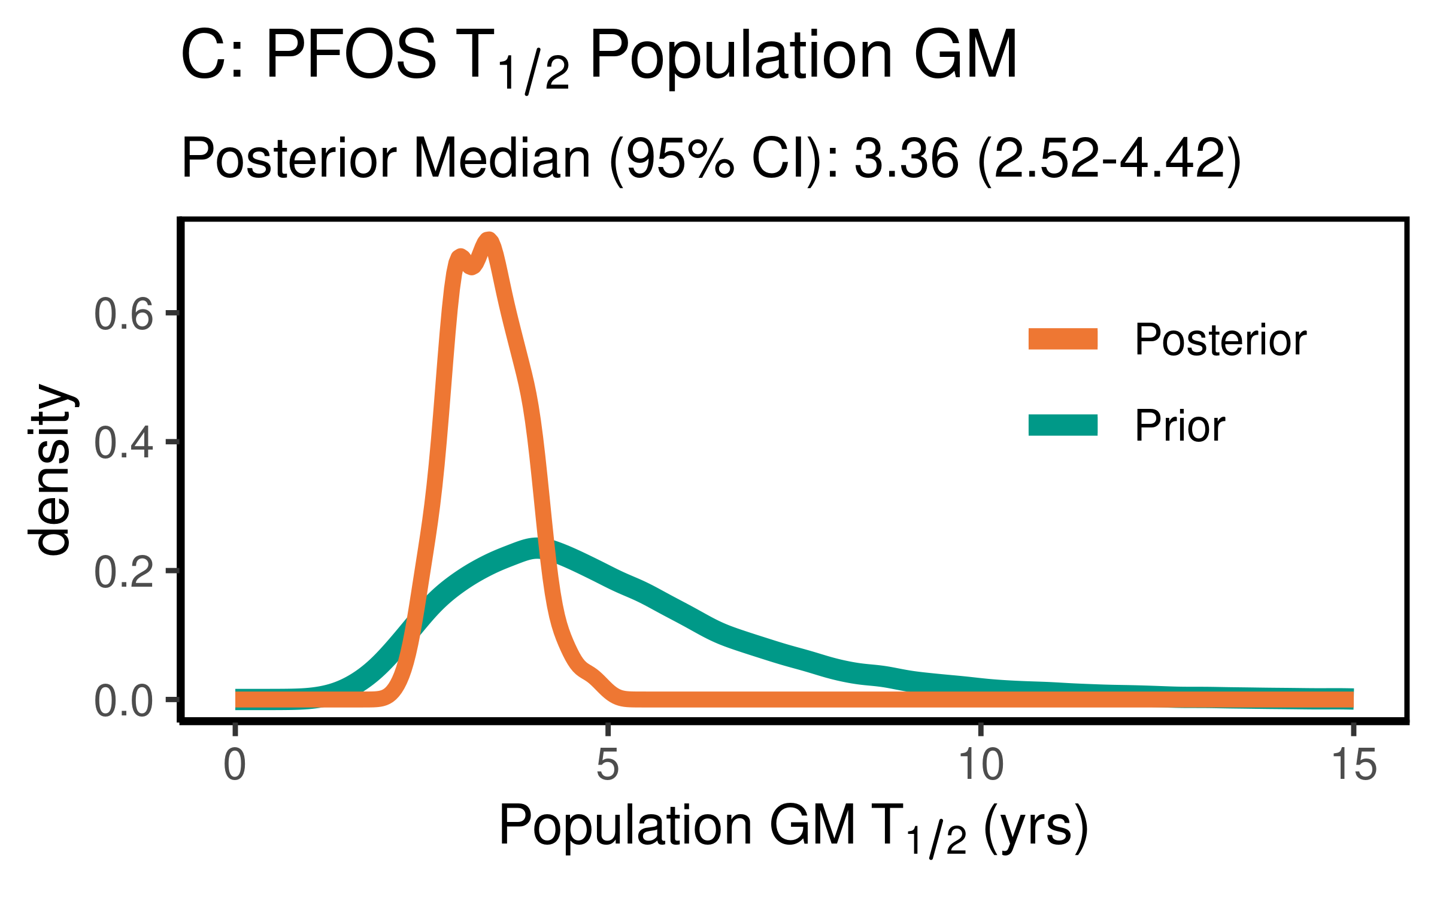

ggsave(here ("output-plots",paste0( sa,"PFOS_hl_gm.pdf")), p, dpi=600)

## Saving 4 x 2.5 in image

## Warning: Removed 80 rows containing non-finite values (stat_density).

PFOS_priors$halflife_GSD = exp(sqrt(exp(rnorm(50000,m=log(0.2000),sd=log(1.275)))))   
PFOS_halflife_GSD <- exp(sqrt(dat$`V_ln_k(1)`))  
  
PFOS_hlgsd_pr_med <- signif(median(PFOS_priors$halflife_GSD,3))  
PFOS_hlgsd_pr_med_95ci <-paste(signif(quantile(PFOS_priors$halflife_GSD,  
 prob=c(0.025,0.975)),  
 3),  
 collapse="-")  
PFOS_hl_gsd_med <- signif(median(PFOS_halflife_GSD),3)  
PFOS_hl_gsd_med_95ci <- paste(signif(quantile(PFOS_halflife_GSD,  
 prob=c(0.025,0.975)),3),collapse="-")  
p<-ggplot()+  
 stat_density(aes(halflife_GSD, color = "Prior"),data=PFOS_priors,geom="line",size=2)+  
 stat_density(aes(PFOS_halflife_GSD,stat(density), color = "Posterior"),geom="line",size=1.5)+  
 xlim(1,3)+  
 labs(title = bquote("D: PFOS"~T[1/2]~"Population GSD"),   
 subtitle=paste("Posterior Median (95% CI): ",  
 PFOS_hl_gsd_med," (",  
 PFOS_hl_gsd_med_95ci,  
 ")",sep=""))+  
 xlab(bquote("Population GSD"~T[1/2]))+  
 scale_color_manual(name=NULL,#  
 values=c(Prior="#009988", Posterior="#EE7733" ))+   
 theme_classic() +   
 theme(legend.title = element_blank(),legend.position=c(0.8,0.7),  
 panel.background = element_rect(color="black",size=1),  
 legend.background = element_rect(fill="transparent", color=NA))  
print(p)

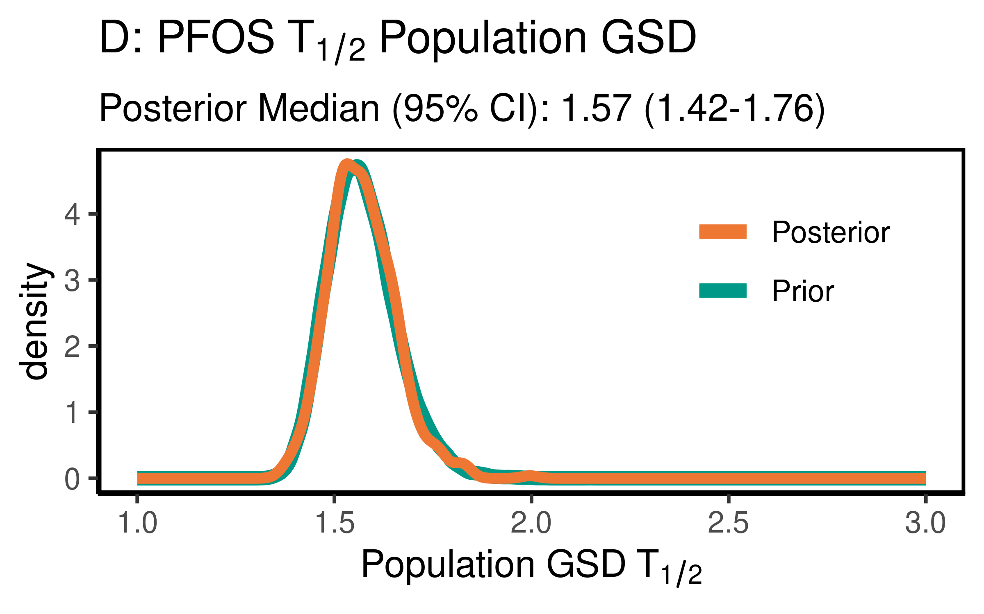

ggsave(here ("output-plots",paste0( sa, "PFOS_hl_gsd.pdf")), p, dpi=600)

### Distribution Volume

For PFOS, the data were not particularly informative, but slightly increased the estimate of the median to 0.308(0.223-0.548) slightly. They were not informative as to the population GSD, with the posterior distributions essentially unchanged from the priors.

PFOS_priors$Vd_GM <- rlnorm(50000,  
 meanlog=-1.46968,  
 sdlog=0.2624)  
PFOS_Vd_GM <- exp(dat$`M_ln_Vd(1)`)  
  
   
  
PFOS_vd_gm_pr_med <- signif(median(PFOS_priors$Vd_GM,3))  
PFOS_vd_gm_pr_med_95ci <- paste(signif(quantile(PFOS_priors$Vd_GM,  
 prob=c(0.025,0.975)), 3), collapse="-")  
PFOS_vd_gm_med <- signif(median(PFOS_Vd_GM),3)  
PFOS_vd_gm_med_95ci <- paste(signif(quantile(PFOS_Vd_GM,  
 prob=c(0.025,0.975)),3),collapse="-")  
  
p<-ggplot()+  
 stat_density(aes(Vd_GM, color = "Prior"),data=PFOS_priors,geom="line",size=2)+  
 stat_density(aes(PFOS_Vd_GM,stat(density), color = "Posterior"),geom="line",size=1.5)+  
 xlim(0,1)+labs(title = bquote("C: PFOS"~V[d]~"Population GM"),  
 subtitle=paste("Posterior Median (95% CI): ",  
 PFOS_vd_gm_med," (",   
 PFOS_vd_gm_med_95ci,")",sep=""))+  
 xlab(bquote("Population GM"~V[d]~"(l/kg)"))+  
 scale_fill_manual(name=NULL,#  
 values=c(Prior="#009988", Posterior="#EE7733" )) + theme_classic() +   
 theme(legend.title = element_blank(),legend.position=c(0.8,0.7),  
 panel.background = element_rect(color="black",size=1),  
 legend.background = element_rect(fill="transparent", color=NA))  
print(p)

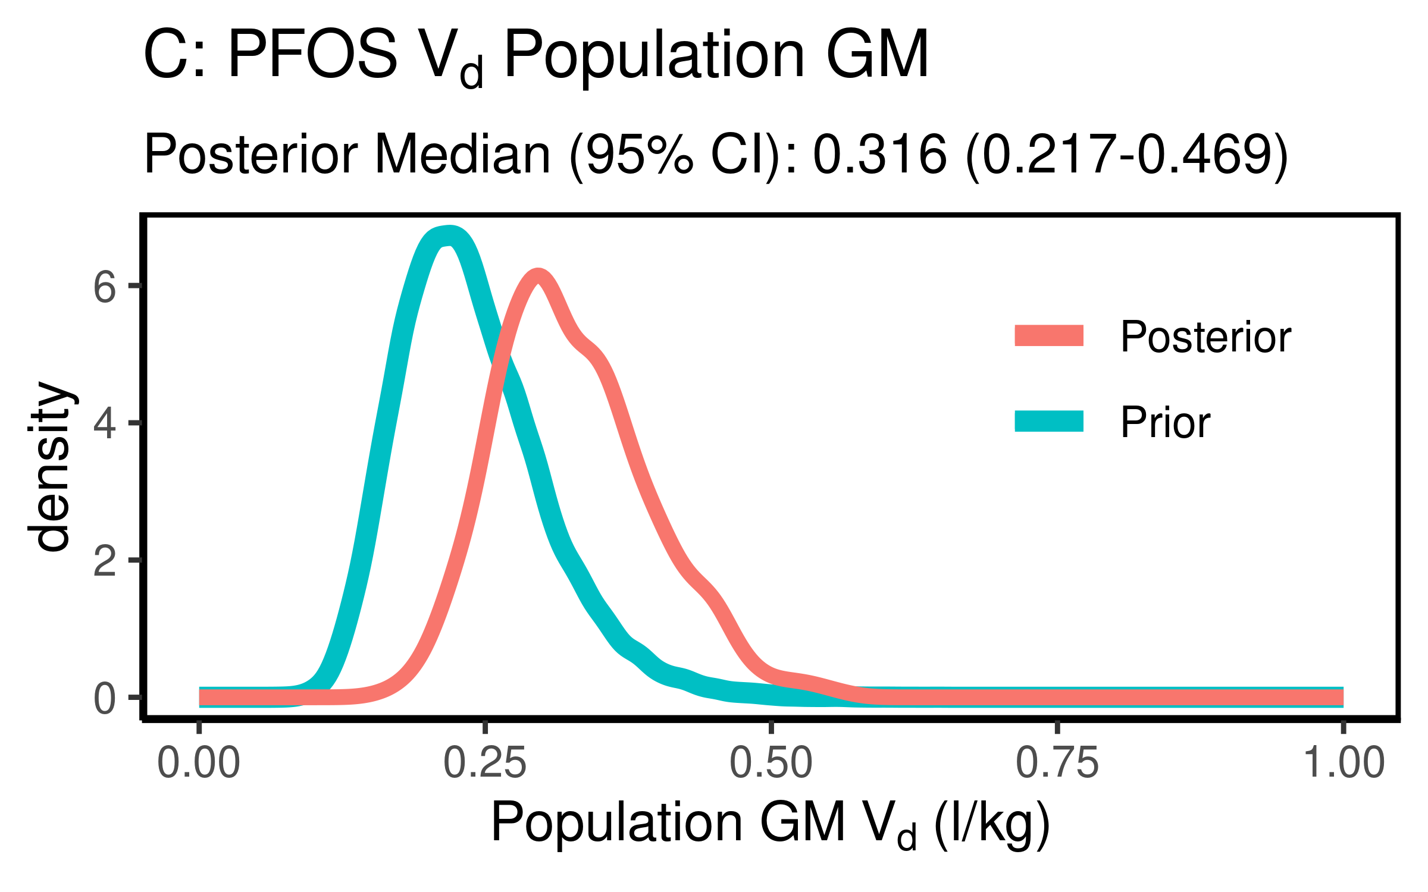

ggsave(here ("output-plots",paste0( sa, "PFOS_vd_gm.pdf")), p, dpi=600)

PFOS_priors$Vd_GSD = exp(abs(rnorm(50000,sd=0.17)))  
PFOS_Vd_GSD <- exp(dat$`SD_ln_Vd(1)`)  
  
PFOS_vd_gsd_pr_med <- signif(median(PFOS_priors$Vd_GSD,3))  
PFOS_vd_gsd_pr_med_95ci <- paste(signif(quantile(PFOS_priors$Vd_GSD,  
 prob=c(0.025,0.975)), 3), collapse="-")  
  
PFOS_vd_gsd_med <- signif(median(PFOS_Vd_GSD),3)  
PFOS_vd_gsd_med_95ci <- paste(signif(quantile(PFOS_Vd_GSD,  
 prob=c(0.025,0.975)),3),collapse="-")  
  
p<-ggplot()+  
 stat_density(aes(Vd_GSD, color = "Prior"),data=PFOS_priors,geom="line",size=2)+  
 stat_density(aes(PFOS_Vd_GSD,stat(density), color = "Posterior"),geom="line",size=1.5)+  
 xlim(1,3)+  
 labs(title = bquote("D: PFOS"~V[d]~"Population GSD "),  
 subtitle=paste("Posterior Median (95% CI): ",  
 PFOS_vd_gsd_med," (",  
 PFOS_vd_gsd_med_95ci,  
 ")",sep=""))+  
 xlab(bquote("Population GSD"~V[d]))+  
 scale_color_manual(name=NULL,   
 values=c(Prior="#009988", Posterior="#EE7733" )) +   
 theme_classic() +   
 theme(legend.title = element_blank(),legend.position=c(0.8,0.7),  
 panel.background = element_rect(color="black",size=1),  
 legend.background = element_rect(fill="transparent", color=NA))  
print(p)

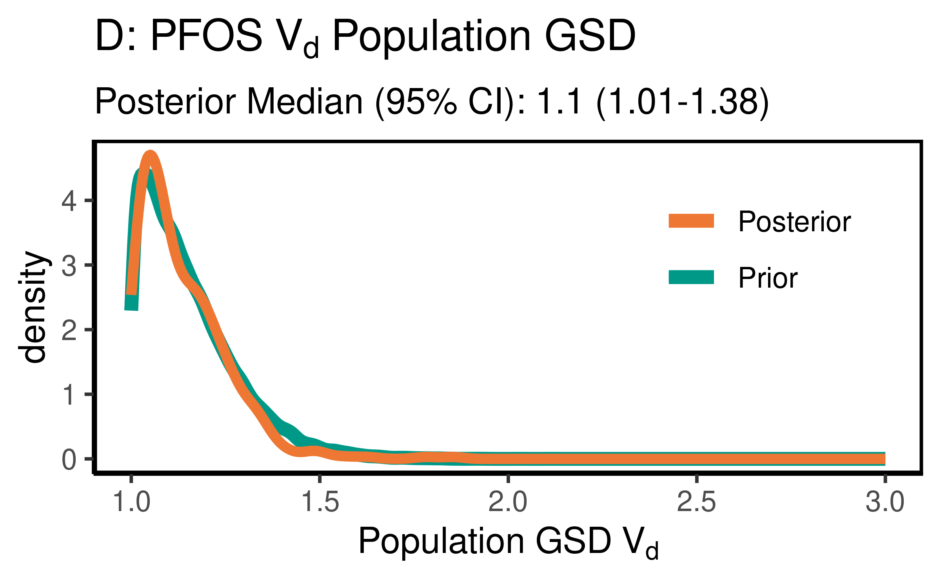

ggsave(here ("output-plots",paste0( sa, "PFOS_vd_gsd.pdf")), p, dpi=600)

### Clearance (just pop GM)

Cl is k * Vd

PFOS_priors$CL_GM <- PFOS_priors$Vd_GM * (log(2)/PFOS_priors$halflife_GM)  
PFOS_CL_GM <- exp(dat$`M_ln_Vd(1)` + dat$`M_ln_k(1)`)  
  
PFOS_cl_gm_pr_med <- signif(median(PFOS_priors$CL_GM,3))  
PFOS_cl_gm_pr_med_95ci <- paste(signif(quantile(PFOS_priors$CL_GM,  
 prob=c(0.025,0.975)), 3), collapse="-")  
PFOS_cl_gm_med <- signif(median(PFOS_CL_GM),3)  
PFOS_cl_gm_med_95ci <- paste(signif(quantile(PFOS_CL_GM,  
 prob=c(0.025,0.975)),3),collapse="-")  
  
p<-ggplot()+  
 stat_density(aes(CL_GM, color = "Prior"),data=PFOS_priors,geom="line",size=2)+  
 stat_density(aes(PFOS_CL_GM,stat(density), color = "Posterior"),geom="line",size=1.5)+  
 xlim(0,0.25)+labs(title = "B: PFOS Clearance Pop. GM ",subtitle=paste("Posterior Median (95% CI): ",  
 PFOS_cl_gm_med," (",  
 PFOS_cl_gm_med_95ci,  
 ")",sep=""))+  
 xlab("Pop. GM CL (l/(kg-yr))")+  
 scale_color_manual(name=NULL,#  
 values=c(Prior="#009988", Posterior="#EE7733" )) +   
 theme_classic() +   
 theme(legend.title = element_blank(),legend.position=c(0.8,0.7),  
 panel.background = element_rect(color="black",size=1),  
 legend.background = element_rect(fill="transparent", color=NA))  
print(p)

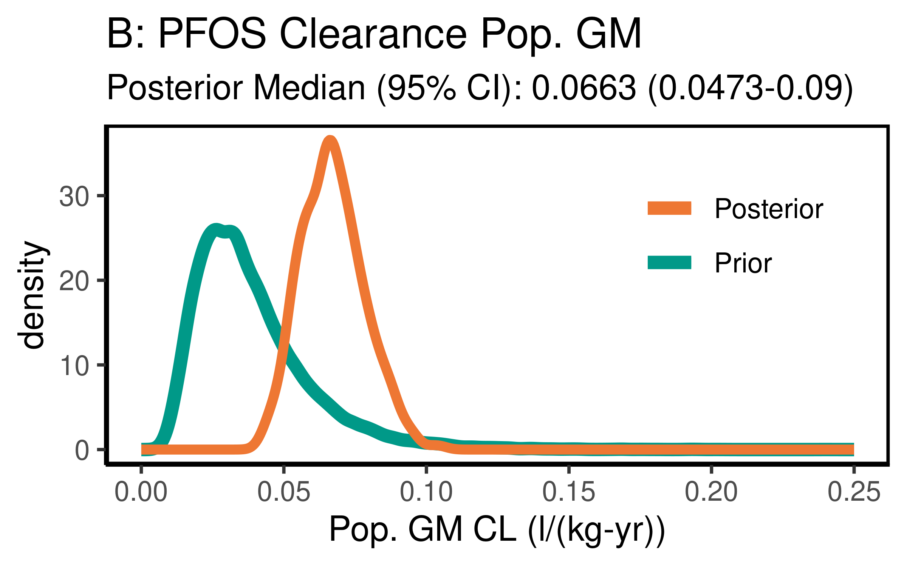

ggsave(here ("output-plots",paste0( sa, "PFOS_CL_gm.pdf")), p, dpi=600)

## Table significant digit values

PFOS_hlgm_pr_med <- paste(signif(PFOS_hlgm_pr_med, 3))  
PFOS_hl_median_gm<- paste(signif(PFOS_hl_median_gm, 3))  
PFOS_hlgsd_pr_med<- paste(signif(PFOS_hlgsd_pr_med, 3))  
PFOS_hl_gsd_med<- paste(signif(PFOS_hl_gsd_med, 3))  
PFOS_vd_gm_pr_med<- paste(signif(PFOS_vd_gm_pr_med, 3))  
PFOS_vd_gm_med<- paste(signif(PFOS_vd_gm_med, 3))  
PFOS_vd_gsd_pr_med<- paste(signif(PFOS_vd_gsd_pr_med, 3))  
PFOS_vd_gsd_med<- paste(signif(PFOS_vd_gsd_med, 3))  
PFOS_cl_gm_pr_med<- paste(signif(PFOS_cl_gm_pr_med, 3))  
PFOS_cl_gm_med<- paste(signif(PFOS_cl_gm_med, 3))

### Population median estimates [95% CI]

|  |  |  |  |  |
| --- | --- | --- | --- | --- |
| Parameter | Prior GM | Posterior GM | Prior GSD | Posterior GSD |
| Half-life (years) | 4.62 | 3.36 | 1.56 | 1.57 |
| HL [95% CI] | [2.08-10.3] | [2.52-4.42] | [1.42-1.77] | [1.42-1.76] |
| Volume of distribution | 0.23 | 0.316 | 1.12 | 1.1 |
| [95% CI] | [0.137-0.384] | [0.217-0.469] | [1.01-1.46] | [1.01-1.38] |
| Clearance | 0.0344 | 0.0663 |  |  |
| [95% CI] | [0.0133-0.0894] | [0.0473-0.09] | [] | [] |

### Individual Posterior estimates

|  |  |  |  |
| --- | --- | --- | --- |
| Parameter | median GM [95% CI] | GM calculator input | GSD individual |
| Half-life (years) | 3.4 [ 1.28-8.42 ] | 3.28 | 1.63 |
| Volume of distribution | 0.319 [ 0.188-0.505 ] | 0.318 | 1.3 |

## ─ Session info ───────────────────────────────────────────────────────────────  
## setting value   
## version R version 3.6.1 (2019-07-05)   
## os Red Hat Enterprise Linux Server 7.9 (Maipo)  
## system x86_64, linux-gnu   
## ui X11   
## language (EN)   
## collate en_US.UTF-8   
## ctype en_US.UTF-8   
## tz America/New_York   
## date 2021-03-02   
##   
## ─ Packages ───────────────────────────────────────────────────────────────────  
## package * version date lib source   
## assertthat 0.2.1 2019-03-21 [2] CRAN (R 3.6.1)  
## backports 1.1.5 2019-10-02 [2] CRAN (R 3.6.1)  
## bayesplot * 1.7.0 2019-05-23 [2] CRAN (R 3.6.1)  
## broom 0.5.2 2019-04-07 [2] CRAN (R 3.6.1)  
## callr 3.3.2 2019-09-22 [2] CRAN (R 3.6.1)  
## cellranger 1.1.0 2016-07-27 [2] CRAN (R 3.6.1)  
## cli 1.1.0 2019-03-19 [2] CRAN (R 3.6.1)  
## coda * 0.19-3 2019-07-05 [2] CRAN (R 3.6.1)  
## codetools 0.2-16 2018-12-24 [2] CRAN (R 3.6.1)  
## colorspace 1.4-1 2019-03-18 [2] CRAN (R 3.6.1)  
## crayon 1.3.4 2017-09-16 [2] CRAN (R 3.6.1)  
## DBI 1.0.0 2018-05-02 [2] CRAN (R 3.6.1)  
## dbplyr 1.4.2 2019-06-17 [2] CRAN (R 3.6.1)  
## desc 1.2.0 2018-05-01 [2] CRAN (R 3.6.1)  
## devtools 2.2.1 2019-09-24 [2] CRAN (R 3.6.1)  
## digest 0.6.23 2019-11-23 [2] CRAN (R 3.6.1)  
## dplyr * 0.8.3 2019-07-04 [2] CRAN (R 3.6.1)  
## ellipsis 0.3.0 2019-09-20 [2] CRAN (R 3.6.1)  
## evaluate 0.14 2019-05-28 [2] CRAN (R 3.6.1)  
## farver 2.0.1 2019-11-13 [2] CRAN (R 3.6.1)  
## forcats * 0.4.0 2019-02-17 [2] CRAN (R 3.6.1)  
## fs 1.3.1 2019-05-06 [2] CRAN (R 3.6.1)  
## generics 0.0.2 2018-11-29 [2] CRAN (R 3.6.1)  
## ggplot2 * 3.2.1 2019-08-10 [2] CRAN (R 3.6.1)  
## ggridges 0.5.1 2018-09-27 [2] CRAN (R 3.6.1)  
## ggsci * 2.9 2018-05-14 [2] CRAN (R 3.6.1)  
## glue 1.3.1 2019-03-12 [2] CRAN (R 3.6.1)  
## gtable 0.3.0 2019-03-25 [2] CRAN (R 3.6.1)  
## haven 2.2.0 2019-11-08 [2] CRAN (R 3.6.1)  
## here * 0.1 2017-05-28 [2] CRAN (R 3.6.1)  
## hms 0.5.2 2019-10-30 [2] CRAN (R 3.6.1)  
## htmltools 0.4.0 2019-10-04 [2] CRAN (R 3.6.1)  
## httr 1.4.1 2019-08-05 [2] CRAN (R 3.6.1)  
## jsonlite 1.6 2018-12-07 [2] CRAN (R 3.6.1)  
## khroma * 1.4.0 2020-10-05 [1] CRAN (R 3.6.1)  
## knitr 1.26 2019-11-12 [2] CRAN (R 3.6.1)  
## labeling 0.3 2014-08-23 [2] CRAN (R 3.6.1)  
## lattice 0.20-38 2018-11-04 [2] CRAN (R 3.6.1)  
## lazyeval 0.2.2 2019-03-15 [2] CRAN (R 3.6.1)  
## lifecycle 0.1.0 2019-08-01 [2] CRAN (R 3.6.1)  
## lubridate 1.7.4 2018-04-11 [2] CRAN (R 3.6.1)  
## magrittr 1.5 2014-11-22 [2] CRAN (R 3.6.1)  
## memoise 1.1.0 2017-04-21 [2] CRAN (R 3.6.1)  
## modelr 0.1.5 2019-08-08 [2] CRAN (R 3.6.1)  
## munsell 0.5.0 2018-06-12 [2] CRAN (R 3.6.1)  
## nlme 3.1-142 2019-11-07 [2] CRAN (R 3.6.1)  
## pillar 1.4.2 2019-06-29 [2] CRAN (R 3.6.1)  
## pkgbuild 1.0.6 2019-10-09 [2] CRAN (R 3.6.1)  
## pkgconfig 2.0.3 2019-09-22 [2] CRAN (R 3.6.1)  
## pkgload 1.0.2 2018-10-29 [2] CRAN (R 3.6.1)  
## plyr 1.8.4 2016-06-08 [2] CRAN (R 3.6.1)  
## prettyunits 1.0.2 2015-07-13 [2] CRAN (R 3.6.1)  
## processx 3.4.1 2019-07-18 [2] CRAN (R 3.6.1)  
## ps 1.3.0 2018-12-21 [2] CRAN (R 3.6.1)  
## purrr * 0.3.3 2019-10-18 [2] CRAN (R 3.6.1)  
## R6 2.4.1 2019-11-12 [2] CRAN (R 3.6.1)  
## Rcpp 1.0.3 2019-11-08 [2] CRAN (R 3.6.1)  
## readr * 1.3.1 2018-12-21 [2] CRAN (R 3.6.1)  
## readxl 1.3.1 2019-03-13 [2] CRAN (R 3.6.1)  
## remotes 2.1.0 2019-06-24 [2] CRAN (R 3.6.1)  
## reprex 0.3.0 2019-05-16 [2] CRAN (R 3.6.1)  
## reshape2 * 1.4.3 2017-12-11 [2] CRAN (R 3.6.1)  
## rlang 0.4.2 2019-11-23 [2] CRAN (R 3.6.1)  
## rmarkdown 1.18 2019-11-27 [2] CRAN (R 3.6.1)  
## rprojroot 1.3-2 2018-01-03 [2] CRAN (R 3.6.1)  
## rstudioapi 0.10 2019-03-19 [2] CRAN (R 3.6.1)  
## rvest 0.3.5 2019-11-08 [2] CRAN (R 3.6.1)  
## scales 1.1.0 2019-11-18 [2] CRAN (R 3.6.1)  
## sessioninfo 1.1.1 2018-11-05 [2] CRAN (R 3.6.1)  
## stringi 1.4.3 2019-03-12 [2] CRAN (R 3.6.1)  
## stringr * 1.4.0 2019-02-10 [2] CRAN (R 3.6.1)  
## testthat 2.3.0 2019-11-05 [2] CRAN (R 3.6.1)  
## tibble * 2.1.3 2019-06-06 [2] CRAN (R 3.6.1)  
## tidyr * 1.0.0 2019-09-11 [2] CRAN (R 3.6.1)  
## tidyselect 0.2.5 2018-10-11 [2] CRAN (R 3.6.1)  
## tidyverse * 1.3.0 2019-11-21 [2] CRAN (R 3.6.1)  
## usethis 1.5.1 2019-07-04 [2] CRAN (R 3.6.1)  
## vctrs 0.2.0 2019-07-05 [2] CRAN (R 3.6.1)  
## withr 2.1.2 2018-03-15 [2] CRAN (R 3.6.1)  
## xfun 0.11 2019-11-12 [2] CRAN (R 3.6.1)  
## xml2 1.2.2 2019-08-09 [2] CRAN (R 3.6.1)  
## yaml 2.2.0 2018-07-25 [2] CRAN (R 3.6.1)  
## zeallot 0.1.0 2018-01-28 [2] CRAN (R 3.6.1)  
##   
## [1] /home/ad.abt.local/wchiu/R/library  
## [2] /opt/R/3.6.1/lib64/R/library