PFOS 1 compartment Plots (v8)

Weihsueh Chiu, Claire Lay, Parker Malek

2021-03-28

library(coda)  
library(bayesplot)

## This is bayesplot version 1.7.0

## - Online documentation and vignettes at mc-stan.org/bayesplot

## - bayesplot theme set to bayesplot::theme_default()

## * Does _not_ affect other ggplot2 plots

## * See ?bayesplot_theme_set for details on theme setting

library(ggplot2)  
library(ggsci)  
library(khroma)  
library(tidyverse)

## ── Attaching packages ─────────────────────────────────── tidyverse 1.3.0 ──

## ✓ tibble 3.0.5 ✓ dplyr 1.0.3  
## ✓ tidyr 1.0.0 ✓ stringr 1.4.0  
## ✓ readr 1.3.1 ✓ forcats 0.4.0  
## ✓ purrr 0.3.3

## ── Conflicts ────────────────────────────────────── tidyverse_conflicts() ──  
## x dplyr::filter() masks stats::filter()  
## x dplyr::lag() masks stats::lag()

library(reshape2)

##   
## Attaching package: 'reshape2'

## The following object is masked from 'package:tidyr':  
##   
## smiths

library(here)

## here() starts at /media/projects/Projects/PFAS_PBPK/user/weihsueh_2021/sensitivity/PFAS_1cpt_v8_Cbgd-80/PFOS_1cpt_v8_Cbgd-80

knitr::opts_chunk$set(echo = TRUE, dpi = 300 )

Set up MCSim file

# this markdown file must be saved in top level directory for the following to work; the mcsim code depends on getwd results.  
mdir <- "MCSim"  
source(here::here(mdir,"setup_MCSim.R"))  
# Make mod.exe (used to create mcsim executable from model file)  
makemod()

## The mod.exe had been created.

## Set filenames and load data

## Set up dataset

id_lut <- multicheck$df_check %>% select(Level) %>% unique () %>%  
 mutate(dataset = c(   
 rep("Decatur M Train", 9),  
 rep("Decatur F Train", 9),  
 rep("Decatur M Test", 9),  
 rep("Decatur F Test", 10),  
 rep("Minnesota Train", 49),  
 rep("Minnesota Test", 49),  
 'Paulsboro-Train','Horsham-Train',  
 'Warminster-Test','Warrington-Train'),   
 Sex = c(   
 rep("M", 9),  
 rep("F", 9),  
 rep("M", 9),  
 rep("F", 10),  
 rep("Mixed", 49),  
 rep("Mixed", 49),   
 rep("Mixed", 4)),  
 City = c(   
 rep("Decatur", 18),  
 rep("Decatur", 19),  
 rep("Minnesota", 98),  
 'Paulsboro','Horsham','Warminster','Warrington'),   
 Train_Test = c(   
 rep("Train", 9),  
 rep("Train", 9),  
 rep("Test", 9),  
 rep("Test", 10),  
 rep("Train", 49),  
 rep("Test", 49),  
 'Train','Train',  
 'Test','Test'),  
 datatype = c(  
 rep("Individual",9+9+9+10+49+49),  
 rep("Summary",4)),  
 Simulation = row_number(),  
 variable = paste0(dataset, " ",Simulation))  
  
id_lut$dataset <- factor(id_lut$dataset,levels=  
 c("Decatur M Train","Decatur F Train","Arnsberg M Train",  
 "Arnsberg F Train","Decatur M Test","Decatur F Test","Arnsberg M Test",  
 "Arnsberg F Test","Minnesota Train","Minnesota Test",  
 'Lubeck-Bartell-Train', 'Lubeck-Bartell-Test',  
 'Little Hocking-Bartell-Train', 'Little Hocking-Bartell-Test',  
 'Little Hocking-Emmett-Test','Paulsboro-Train','Horsham-Train',  
 'Warminster-Test','Warrington-Train'))  
id_lut$City <- factor(id_lut$City,levels =   
 c("Decatur","Arnsberg","Minnesota",'Lubeck-Bartell',  
 'Little Hocking-Bartell','Little Hocking-Emmett',  
 'Paulsboro','Horsham','Warminster','Warrington'))  
   
  
indiv_lut <- id_lut %>%   
 filter(City %in% c("Decatur", "Minnesota")) %>%  
 mutate( dataset = as.factor(dataset))  
  
nv <- data.frame(dataset =unique(indiv_lut$dataset),   
 variable= rep("Pop GM", 6),  
 type= rep("Pop GM", 6), stringsAsFactors = FALSE)

## Scatter plot of predictions (median of multicheck samples) versus data.

This is a Figure 2 panel. Needed to use “scale=1.1” in ggsave to match PFOA.

nrow(multicheck$df_check)

## [1] 88000

nrow(id_lut)

## [1] 139

multicheck$df_check %>% left_join(id_lut) %>% nrow()

## Joining, by = c("Level", "Simulation")

## [1] 88000

names(multicheck$df_check)

## [1] "Level" "Simulation" "Output_Var" "Time" "Data"   
## [6] "Prediction"

multicheck2 <- multicheck$df_check %>% left_join(id_lut)%>%   
 group_by_at ( vars(-Prediction)) %>%   
 summarise(Prediction = median(Prediction)) %>%  
 ungroup() %>%  
 group_by(City) %>%   
 mutate(Train_Test = factor(Train_Test, levels = c("Train", "Test")),  
 `City (datatype)` = factor (paste0(City, "\n(", datatype, ")\n") ),  
 label = case_when(Train_Test=="Train" ~ "C: PFOS Train",  
 Train_Test=="Test" ~"D: PFOS Test",  
 TRUE ~ ""))

## Joining, by = c("Level", "Simulation")

## `summarise()` has grouped output by 'Level', 'Simulation', 'Output_Var', 'Time', 'Data', 'dataset', 'Sex', 'City', 'Train_Test', 'datatype'. You can override using the `.groups` argument.

#define color for testing boxplots  
bp_cols <- c (as.character (khroma::colour("muted")(9)) , "#191919")   
bp_cols <-bp_cols[c(1,3, 7, 10:8)]# plot_scheme_colourblind(bp_cols)   
  
### Create aesthetics lookup  
aes_lut <- multicheck2 %>% ungroup() %>%   
 group_by(City, datatype, `City (datatype)` ) %>% summarise () %>% ungroup() %>%  
 mutate( cols = bp_cols, city_fills = bp_cols ,   
 # for individual level on point plot (multicheck2), darken outlines for visibility, use standard colors otherwise  
 city_outlines = if_else(datatype == "Individual" , colorspace::darken(city_fills, 0.3), city_fills) ,   
 shapes = case_when(datatype == "Individual" & `City` %in% c('Decatur', 'Arnsberg', 'Minnesota') ~ 23,  
 datatype == "Summary" &`City` %in% c("Horsham", "Warminster", "Warrington") ~ 2,  
 datatype == "Summary" & `City` == "Paulsboro" ~ 1,  
 TRUE ~ 18 ),   
 size = if_else(datatype =="Individual", 1.75, 2.5 ) )

## `summarise()` has grouped output by 'City', 'datatype'. You can override using the `.groups` argument.

source( paste0(gsub(basename(here()), 'shared_functions', here()), '/plot_scatter_mcheck.r'))  
  
p2 <- plot_scatter_mcheck(dframe = multicheck2, pfas_nom = pfas_name, aes_lut_fn = aes_lut )  
print(p2)

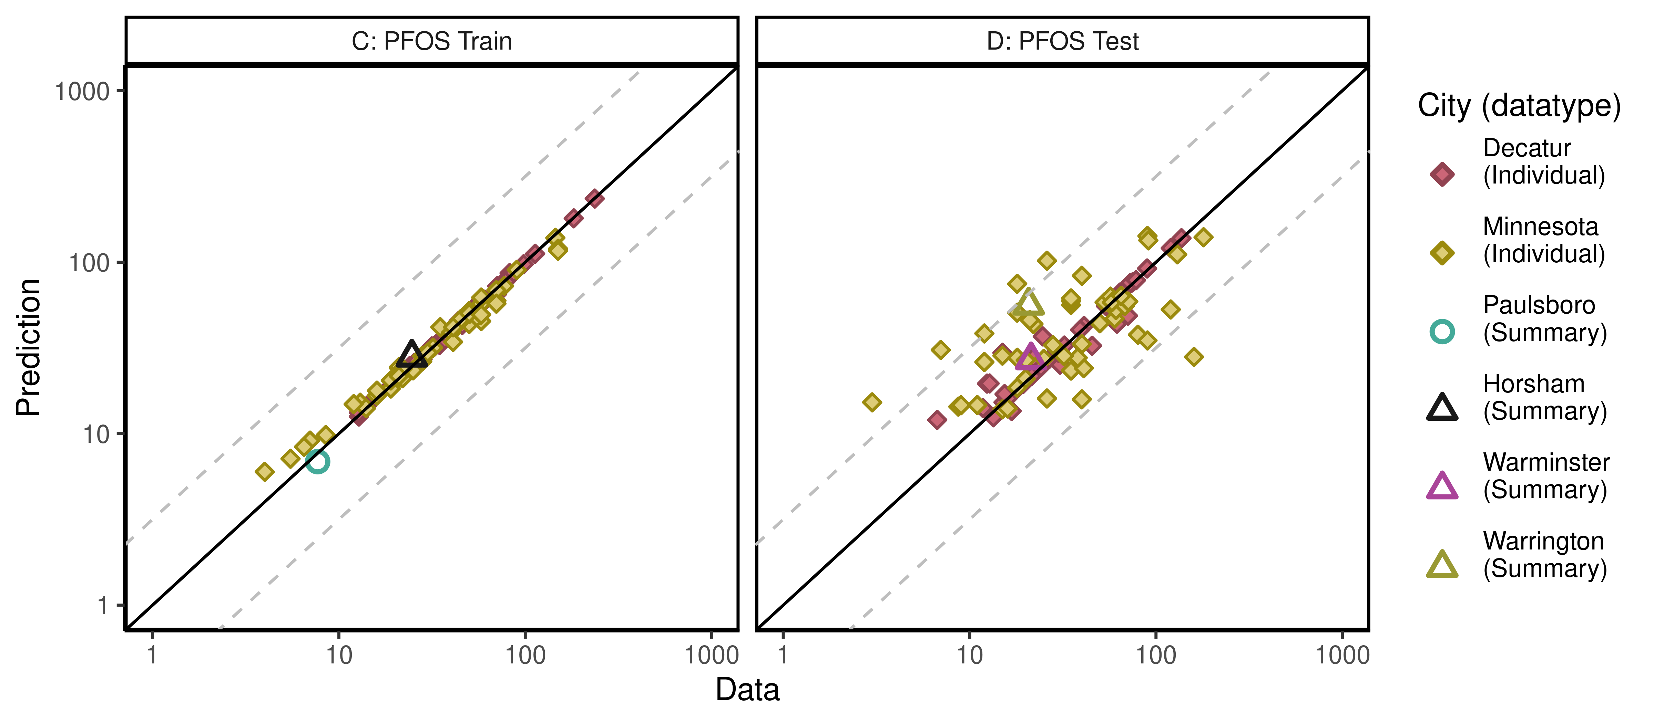

ggsave(here ("output-plots", paste0( sa,"multicheckplot_", pfas_name,  
 ".pdf")),p2,dpi=600, scale=1.1)

## Saving 8.8 x 3.85 in image

## Parse multicheck

df_check <- multicheck$df_check  
df_check <- subset(df_check,Data > 0)   
  
n1 <- nrow(df_check)  
id_chks <- df_check %>% select(Level) %>% unique() %>% bind_cols(id_lut) %>%  
 mutate(dataset = as.factor(dataset), Sex = as.factor(Sex), City = as.factor(City),   
 Train_Test = as.factor(Train_Test))

## New names:  
## * Level -> Level...1  
## * Level -> Level...2

df_check <- df_check %>% left_join(id_chks)%>%  
 mutate(Dataset = paste(as.character(dataset), Simulation),  
 Sex = ordered(Sex, levels = c("M", "F", "Mixed"),   
 labels = c("Female", "Male", "Mixed (all sexes)")))

## Joining, by = "Simulation"

n2 <- nrow(df_check)  
if(n1 != n2)print("duplicates created in id-lut join")

df_check$Time.desc <- as.character(paste0("T=",df_check$Time))  
df_check$Time.desc[df_check$Time.desc == "T=1e-06"] <- "SteadyState"  
df_check$Dataset.Time <- interaction(df_check$Dataset,  
 df_check$Time.desc,lex.order=TRUE)  
df_check$Dataset.Time <- factor(df_check$Dataset.Time,  
 levels=levels(df_check$Dataset.Time))  
calibdata <- df_check[,names(df_check) != "Prediction"]  
calibdata <- calibdata[!duplicated(calibdata),]  
print(calibdata)

## Level Simulation Output_Var Time Data Level...1 Level...2  
## 1 1_1_1 1 Cserum_t 0.000000 82.400 1_1_1 1_1_1  
## 2 1_1_1 1 Cserum_t 5.802000 70.300 1_1_1 1_1_1  
## 3 1_1_2 2 Cserum_t 0.000000 32.600 1_1_2 1_1_2  
## 4 1_1_2 2 Cserum_t 5.802000 14.200 1_1_2 1_1_2  
## 5 1_1_3 3 Cserum_t 0.000000 236.000 1_1_3 1_1_3  
## 6 1_1_3 3 Cserum_t 5.802000 75.400 1_1_3 1_1_3  
## 7 1_1_4 4 Cserum_t 0.000000 61.000 1_1_4 1_1_4  
## 8 1_1_4 4 Cserum_t 5.802000 12.800 1_1_4 1_1_4  
## 9 1_1_5 5 Cserum_t 0.000000 182.000 1_1_5 1_1_5  
## 10 1_1_5 5 Cserum_t 5.802000 43.900 1_1_5 1_1_5  
## 11 1_1_6 6 Cserum_t 0.000000 25.300 1_1_6 1_1_6  
## 12 1_1_6 6 Cserum_t 5.802000 18.800 1_1_6 1_1_6  
## 13 1_1_7 7 Cserum_t 0.000000 113.000 1_1_7 1_1_7  
## 14 1_1_7 7 Cserum_t 5.802000 24.000 1_1_7 1_1_7  
## 15 1_1_8 8 Cserum_t 0.000000 78.200 1_1_8 1_1_8  
## 16 1_1_8 8 Cserum_t 5.802000 26.400 1_1_8 1_1_8  
## 17 1_1_9 9 Cserum_t 0.000000 54.400 1_1_9 1_1_9  
## 18 1_1_9 9 Cserum_t 5.802000 26.500 1_1_9 1_1_9  
## 19 1_1_10 10 Cserum_t 0.000000 81.200 1_1_10 1_1_10  
## 20 1_1_10 10 Cserum_t 5.802000 31.500 1_1_10 1_1_10  
## 21 1_1_11 11 Cserum_t 0.000000 70.700 1_1_11 1_1_11  
## 22 1_1_11 11 Cserum_t 5.802000 50.200 1_1_11 1_1_11  
## 23 1_1_12 12 Cserum_t 0.000000 13.700 1_1_12 1_1_12  
## 24 1_1_12 12 Cserum_t 5.802000 12.800 1_1_12 1_1_12  
## 25 1_1_13 13 Cserum_t 0.000000 42.000 1_1_13 1_1_13  
## 26 1_1_13 13 Cserum_t 5.802000 28.100 1_1_13 1_1_13  
## 27 1_1_14 14 Cserum_t 0.000000 98.000 1_1_14 1_1_14  
## 28 1_1_14 14 Cserum_t 5.802000 35.100 1_1_14 1_1_14  
## 29 1_1_15 15 Cserum_t 0.000000 56.900 1_1_15 1_1_15  
## 30 1_1_15 15 Cserum_t 5.802000 45.900 1_1_15 1_1_15  
## 31 1_1_16 16 Cserum_t 0.000000 32.500 1_1_16 1_1_16  
## 32 1_1_16 16 Cserum_t 5.802000 13.300 1_1_16 1_1_16  
## 33 1_1_17 17 Cserum_t 0.000000 60.500 1_1_17 1_1_17  
## 34 1_1_17 17 Cserum_t 5.802000 27.600 1_1_17 1_1_17  
## 35 1_1_18 18 Cserum_t 0.000000 43.800 1_1_18 1_1_18  
## 36 1_1_18 18 Cserum_t 5.802000 34.700 1_1_18 1_1_18  
## 37 1_2_1 19 Cserum_t 0.000000 64.100 1_2_1 1_2_1  
## 38 1_2_1 19 Cserum_t 5.802000 15.000 1_2_1 1_2_1  
## 39 1_2_2 20 Cserum_t 0.000000 89.600 1_2_2 1_2_2  
## 40 1_2_2 20 Cserum_t 5.802000 24.700 1_2_2 1_2_2  
## 41 1_2_3 21 Cserum_t 0.000000 74.700 1_2_3 1_2_3  
## 42 1_2_3 21 Cserum_t 5.802000 39.800 1_2_3 1_2_3  
## 43 1_2_4 22 Cserum_t 0.000000 68.400 1_2_4 1_2_4  
## 44 1_2_4 22 Cserum_t 5.802000 30.000 1_2_4 1_2_4  
## 45 1_2_5 23 Cserum_t 0.000000 72.900 1_2_5 1_2_5  
## 46 1_2_5 23 Cserum_t 5.802000 32.200 1_2_5 1_2_5  
## 47 1_2_6 24 Cserum_t 0.000000 78.100 1_2_6 1_2_6  
## 48 1_2_6 24 Cserum_t 5.802000 45.400 1_2_6 1_2_6  
## 49 1_2_7 25 Cserum_t 0.000000 24.100 1_2_7 1_2_7  
## 50 1_2_7 25 Cserum_t 5.802000 15.400 1_2_7 1_2_7  
## 51 1_2_8 26 Cserum_t 0.000000 60.900 1_2_8 1_2_8  
## 52 1_2_8 26 Cserum_t 5.802000 22.000 1_2_8 1_2_8  
## 53 1_2_9 27 Cserum_t 0.000000 137.000 1_2_9 1_2_9  
## 54 1_2_9 27 Cserum_t 5.802000 70.700 1_2_9 1_2_9  
## 55 1_2_10 28 Cserum_t 0.000000 26.600 1_2_10 1_2_10  
## 56 1_2_10 28 Cserum_t 5.802000 15.200 1_2_10 1_2_10  
## 57 1_2_11 29 Cserum_t 0.000000 120.000 1_2_11 1_2_11  
## 58 1_2_11 29 Cserum_t 5.802000 61.700 1_2_11 1_2_11  
## 59 1_2_12 30 Cserum_t 0.000000 60.900 1_2_12 1_2_12  
## 60 1_2_12 30 Cserum_t 5.802000 22.500 1_2_12 1_2_12  
## 61 1_2_13 31 Cserum_t 0.000000 41.100 1_2_13 1_2_13  
## 62 1_2_13 31 Cserum_t 5.802000 12.400 1_2_13 1_2_13  
## 63 1_2_14 32 Cserum_t 0.000000 39.200 1_2_14 1_2_14  
## 64 1_2_14 32 Cserum_t 5.802000 12.800 1_2_14 1_2_14  
## 65 1_2_15 33 Cserum_t 0.000000 18.100 1_2_15 1_2_15  
## 66 1_2_15 33 Cserum_t 5.802000 13.400 1_2_15 1_2_15  
## 67 1_2_16 34 Cserum_t 0.000000 19.400 1_2_16 1_2_16  
## 68 1_2_16 34 Cserum_t 5.802000 16.800 1_2_16 1_2_16  
## 69 1_2_17 35 Cserum_t 0.000000 21.500 1_2_17 1_2_17  
## 70 1_2_17 35 Cserum_t 5.802000 11.800 1_2_17 1_2_17  
## 71 1_2_18 36 Cserum_t 0.000000 53.800 1_2_18 1_2_18  
## 72 1_2_18 36 Cserum_t 5.802000 30.600 1_2_18 1_2_18  
## 73 1_2_19 37 Cserum_t 0.000000 16.000 1_2_19 1_2_19  
## 74 1_2_19 37 Cserum_t 5.802000 6.700 1_2_19 1_2_19  
## 75 1_3_1 38 Cbgd_Css 0.000001 13.000 1_3_1 1_3_1  
## 76 1_3_2 39 Cbgd_Css 0.000001 50.000 1_3_2 1_3_2  
## 77 1_3_3 40 Cbgd_Css 0.000001 45.000 1_3_3 1_3_3  
## 78 1_3_4 41 Cbgd_Css 0.000001 55.000 1_3_4 1_3_4  
## 79 1_3_5 42 Cbgd_Css 0.000001 58.000 1_3_5 1_3_5  
## 80 1_3_6 43 Cbgd_Css 0.000001 50.000 1_3_6 1_3_6  
## 81 1_3_7 44 Cbgd_Css 0.000001 150.000 1_3_7 1_3_7  
## 82 1_3_8 45 Cbgd_Css 0.000001 12.000 1_3_8 1_3_8  
## 83 1_3_9 46 Cbgd_Css 0.000001 58.000 1_3_9 1_3_9  
## 84 1_3_10 47 Cbgd_Css 0.000001 21.000 1_3_10 1_3_10  
## 85 1_3_11 48 Cbgd_Css 0.000001 19.000 1_3_11 1_3_11  
## 86 1_3_12 49 Cbgd_Css 0.000001 25.000 1_3_12 1_3_12  
## 87 1_3_13 50 Cbgd_Css 0.000001 4.000 1_3_13 1_3_13  
## 88 1_3_14 51 Cbgd_Css 0.000001 32.000 1_3_14 1_3_14  
## 89 1_3_15 52 Cbgd_Css 0.000001 58.000 1_3_15 1_3_15  
## 90 1_3_16 53 Cbgd_Css 0.000001 8.500 1_3_16 1_3_16  
## 91 1_3_17 54 Cbgd_Css 0.000001 5.500 1_3_17 1_3_17  
## 92 1_3_18 55 Cbgd_Css 0.000001 58.000 1_3_18 1_3_18  
## 93 1_3_19 56 Cbgd_Css 0.000001 50.000 1_3_19 1_3_19  
## 94 1_3_20 57 Cbgd_Css 0.000001 145.000 1_3_20 1_3_20  
## 95 1_3_21 58 Cbgd_Css 0.000001 77.000 1_3_21 1_3_21  
## 96 1_3_22 59 Cbgd_Css 0.000001 50.000 1_3_22 1_3_22  
## 97 1_3_23 60 Cbgd_Css 0.000001 90.000 1_3_23 1_3_23  
## 98 1_3_24 61 Cbgd_Css 0.000001 14.000 1_3_24 1_3_24  
## 99 1_3_25 62 Cbgd_Css 0.000001 21.000 1_3_25 1_3_25  
## 100 1_3_26 63 Cbgd_Css 0.000001 35.000 1_3_26 1_3_26  
## 101 1_3_27 64 Cbgd_Css 0.000001 28.000 1_3_27 1_3_27  
## 102 1_3_28 65 Cbgd_Css 0.000001 7.000 1_3_28 1_3_28  
## 103 1_3_29 66 Cbgd_Css 0.000001 150.000 1_3_29 1_3_29  
## 104 1_3_30 67 Cbgd_Css 0.000001 50.000 1_3_30 1_3_30  
## 105 1_3_31 68 Cbgd_Css 0.000001 50.000 1_3_31 1_3_31  
## 106 1_3_32 69 Cbgd_Css 0.000001 70.000 1_3_32 1_3_32  
## 107 1_3_33 70 Cbgd_Css 0.000001 21.000 1_3_33 1_3_33  
## 108 1_3_34 71 Cbgd_Css 0.000001 19.000 1_3_34 1_3_34  
## 109 1_3_35 72 Cbgd_Css 0.000001 40.000 1_3_35 1_3_35  
## 110 1_3_36 73 Cbgd_Css 0.000001 70.000 1_3_36 1_3_36  
## 111 1_3_37 74 Cbgd_Css 0.000001 45.000 1_3_37 1_3_37  
## 112 1_3_38 75 Cbgd_Css 0.000001 22.000 1_3_38 1_3_38  
## 113 1_3_39 76 Cbgd_Css 0.000001 29.000 1_3_39 1_3_39  
## 114 1_3_40 77 Cbgd_Css 0.000001 28.000 1_3_40 1_3_40  
## 115 1_3_41 78 Cbgd_Css 0.000001 6.500 1_3_41 1_3_41  
## 116 1_3_42 79 Cbgd_Css 0.000001 22.000 1_3_42 1_3_42  
## 117 1_3_43 80 Cbgd_Css 0.000001 21.000 1_3_43 1_3_43  
## 118 1_3_44 81 Cbgd_Css 0.000001 41.000 1_3_44 1_3_44  
## 119 1_3_45 82 Cbgd_Css 0.000001 41.000 1_3_45 1_3_45  
## 120 1_3_46 83 Cbgd_Css 0.000001 16.000 1_3_46 1_3_46  
## 121 1_3_47 84 Cbgd_Css 0.000001 70.000 1_3_47 1_3_47  
## 122 1_3_48 85 Cbgd_Css 0.000001 16.000 1_3_48 1_3_48  
## 123 1_3_49 86 Cbgd_Css 0.000001 30.000 1_3_49 1_3_49  
## 124 1_4_1 87 Cbgd_Css 0.000001 3.000 1_4_1 1_4_1  
## 125 1_4_2 88 Cbgd_Css 0.000001 8.700 1_4_2 1_4_2  
## 126 1_4_3 89 Cbgd_Css 0.000001 9.000 1_4_3 1_4_3  
## 127 1_4_4 90 Cbgd_Css 0.000001 11.000 1_4_4 1_4_4  
## 128 1_4_5 91 Cbgd_Css 0.000001 15.000 1_4_5 1_4_5  
## 129 1_4_6 92 Cbgd_Css 0.000001 16.000 1_4_6 1_4_6  
## 130 1_4_7 93 Cbgd_Css 0.000001 40.000 1_4_7 1_4_7  
## 131 1_4_8 94 Cbgd_Css 0.000001 26.000 1_4_8 1_4_8  
## 132 1_4_9 95 Cbgd_Css 0.000001 18.000 1_4_9 1_4_9  
## 133 1_4_10 96 Cbgd_Css 0.000001 20.000 1_4_10 1_4_10  
## 134 1_4_11 97 Cbgd_Css 0.000001 35.000 1_4_11 1_4_11  
## 135 1_4_12 98 Cbgd_Css 0.000001 41.000 1_4_12 1_4_12  
## 136 1_4_13 99 Cbgd_Css 0.000001 12.000 1_4_13 1_4_13  
## 137 1_4_14 100 Cbgd_Css 0.000001 15.000 1_4_14 1_4_14  
## 138 1_4_15 101 Cbgd_Css 0.000001 18.000 1_4_15 1_4_15  
## 139 1_4_16 102 Cbgd_Css 0.000001 20.000 1_4_16 1_4_16  
## 140 1_4_17 103 Cbgd_Css 0.000001 25.000 1_4_17 1_4_17  
## 141 1_4_18 104 Cbgd_Css 0.000001 38.000 1_4_18 1_4_18  
## 142 1_4_19 105 Cbgd_Css 0.000001 160.000 1_4_19 1_4_19  
## 143 1_4_20 106 Cbgd_Css 0.000001 32.000 1_4_20 1_4_20  
## 144 1_4_21 107 Cbgd_Css 0.000001 7.000 1_4_21 1_4_21  
## 145 1_4_22 108 Cbgd_Css 0.000001 28.000 1_4_22 1_4_22  
## 146 1_4_23 109 Cbgd_Css 0.000001 40.000 1_4_23 1_4_23  
## 147 1_4_24 110 Cbgd_Css 0.000001 12.000 1_4_24 1_4_24  
## 148 1_4_25 111 Cbgd_Css 0.000001 80.000 1_4_25 1_4_25  
## 149 1_4_26 112 Cbgd_Css 0.000001 90.000 1_4_26 1_4_26  
## 150 1_4_27 113 Cbgd_Css 0.000001 22.000 1_4_27 1_4_27  
## 151 1_4_28 114 Cbgd_Css 0.000001 50.000 1_4_28 1_4_28  
## 152 1_4_29 115 Cbgd_Css 0.000001 21.000 1_4_29 1_4_29  
## 153 1_4_30 116 Cbgd_Css 0.000001 60.000 1_4_30 1_4_30  
## 154 1_4_31 117 Cbgd_Css 0.000001 61.000 1_4_31 1_4_31  
## 155 1_4_32 118 Cbgd_Css 0.000001 120.000 1_4_32 1_4_32  
## 156 1_4_33 119 Cbgd_Css 0.000001 18.000 1_4_33 1_4_33  
## 157 1_4_34 120 Cbgd_Css 0.000001 35.000 1_4_34 1_4_34  
## 158 1_4_35 121 Cbgd_Css 0.000001 68.000 1_4_35 1_4_35  
## 159 1_4_36 122 Cbgd_Css 0.000001 35.000 1_4_36 1_4_36  
## 160 1_4_37 123 Cbgd_Css 0.000001 53.000 1_4_37 1_4_37  
## 161 1_4_38 124 Cbgd_Css 0.000001 35.000 1_4_38 1_4_38  
## 162 1_4_39 125 Cbgd_Css 0.000001 57.000 1_4_39 1_4_39  
## 163 1_4_40 126 Cbgd_Css 0.000001 58.000 1_4_40 1_4_40  
## 164 1_4_41 127 Cbgd_Css 0.000001 71.000 1_4_41 1_4_41  
## 165 1_4_42 128 Cbgd_Css 0.000001 65.000 1_4_42 1_4_42  
## 166 1_4_43 129 Cbgd_Css 0.000001 18.000 1_4_43 1_4_43  
## 167 1_4_44 130 Cbgd_Css 0.000001 40.000 1_4_44 1_4_44  
## 168 1_4_45 131 Cbgd_Css 0.000001 26.000 1_4_45 1_4_45  
## 169 1_4_46 132 Cbgd_Css 0.000001 90.000 1_4_46 1_4_46  
## 170 1_4_47 133 Cbgd_Css 0.000001 91.000 1_4_47 1_4_47  
## 171 1_4_48 134 Cbgd_Css 0.000001 180.000 1_4_48 1_4_48  
## 172 1_4_49 135 Cbgd_Css 0.000001 130.000 1_4_49 1_4_49  
## 173 1_5_1 136 M_Cbgd_Css 2.200000 7.690 1_5_1 1_5_1  
## 174 1_6_1 137 M_Cbgd_Css 2.000000 24.639 1_6_1 1_6_1  
## 175 1_7_1 138 M_Cbgd_Css 2.000000 21.378 1_7_1 1_7_1  
## 176 1_8_1 139 M_Cbgd_Css 2.000000 20.754 1_8_1 1_8_1  
## dataset Sex City Train_Test datatype  
## 1 Decatur M Train Female Decatur Train Individual  
## 2 Decatur M Train Female Decatur Train Individual  
## 3 Decatur M Train Female Decatur Train Individual  
## 4 Decatur M Train Female Decatur Train Individual  
## 5 Decatur M Train Female Decatur Train Individual  
## 6 Decatur M Train Female Decatur Train Individual  
## 7 Decatur M Train Female Decatur Train Individual  
## 8 Decatur M Train Female Decatur Train Individual  
## 9 Decatur M Train Female Decatur Train Individual  
## 10 Decatur M Train Female Decatur Train Individual  
## 11 Decatur M Train Female Decatur Train Individual  
## 12 Decatur M Train Female Decatur Train Individual  
## 13 Decatur M Train Female Decatur Train Individual  
## 14 Decatur M Train Female Decatur Train Individual  
## 15 Decatur M Train Female Decatur Train Individual  
## 16 Decatur M Train Female Decatur Train Individual  
## 17 Decatur M Train Female Decatur Train Individual  
## 18 Decatur M Train Female Decatur Train Individual  
## 19 Decatur F Train Male Decatur Train Individual  
## 20 Decatur F Train Male Decatur Train Individual  
## 21 Decatur F Train Male Decatur Train Individual  
## 22 Decatur F Train Male Decatur Train Individual  
## 23 Decatur F Train Male Decatur Train Individual  
## 24 Decatur F Train Male Decatur Train Individual  
## 25 Decatur F Train Male Decatur Train Individual  
## 26 Decatur F Train Male Decatur Train Individual  
## 27 Decatur F Train Male Decatur Train Individual  
## 28 Decatur F Train Male Decatur Train Individual  
## 29 Decatur F Train Male Decatur Train Individual  
## 30 Decatur F Train Male Decatur Train Individual  
## 31 Decatur F Train Male Decatur Train Individual  
## 32 Decatur F Train Male Decatur Train Individual  
## 33 Decatur F Train Male Decatur Train Individual  
## 34 Decatur F Train Male Decatur Train Individual  
## 35 Decatur F Train Male Decatur Train Individual  
## 36 Decatur F Train Male Decatur Train Individual  
## 37 Decatur M Test Female Decatur Test Individual  
## 38 Decatur M Test Female Decatur Test Individual  
## 39 Decatur M Test Female Decatur Test Individual  
## 40 Decatur M Test Female Decatur Test Individual  
## 41 Decatur M Test Female Decatur Test Individual  
## 42 Decatur M Test Female Decatur Test Individual  
## 43 Decatur M Test Female Decatur Test Individual  
## 44 Decatur M Test Female Decatur Test Individual  
## 45 Decatur M Test Female Decatur Test Individual  
## 46 Decatur M Test Female Decatur Test Individual  
## 47 Decatur M Test Female Decatur Test Individual  
## 48 Decatur M Test Female Decatur Test Individual  
## 49 Decatur M Test Female Decatur Test Individual  
## 50 Decatur M Test Female Decatur Test Individual  
## 51 Decatur M Test Female Decatur Test Individual  
## 52 Decatur M Test Female Decatur Test Individual  
## 53 Decatur M Test Female Decatur Test Individual  
## 54 Decatur M Test Female Decatur Test Individual  
## 55 Decatur F Test Male Decatur Test Individual  
## 56 Decatur F Test Male Decatur Test Individual  
## 57 Decatur F Test Male Decatur Test Individual  
## 58 Decatur F Test Male Decatur Test Individual  
## 59 Decatur F Test Male Decatur Test Individual  
## 60 Decatur F Test Male Decatur Test Individual  
## 61 Decatur F Test Male Decatur Test Individual  
## 62 Decatur F Test Male Decatur Test Individual  
## 63 Decatur F Test Male Decatur Test Individual  
## 64 Decatur F Test Male Decatur Test Individual  
## 65 Decatur F Test Male Decatur Test Individual  
## 66 Decatur F Test Male Decatur Test Individual  
## 67 Decatur F Test Male Decatur Test Individual  
## 68 Decatur F Test Male Decatur Test Individual  
## 69 Decatur F Test Male Decatur Test Individual  
## 70 Decatur F Test Male Decatur Test Individual  
## 71 Decatur F Test Male Decatur Test Individual  
## 72 Decatur F Test Male Decatur Test Individual  
## 73 Decatur F Test Male Decatur Test Individual  
## 74 Decatur F Test Male Decatur Test Individual  
## 75 Minnesota Train Mixed (all sexes) Minnesota Train Individual  
## 76 Minnesota Train Mixed (all sexes) Minnesota Train Individual  
## 77 Minnesota Train Mixed (all sexes) Minnesota Train Individual  
## 78 Minnesota Train Mixed (all sexes) Minnesota Train Individual  
## 79 Minnesota Train Mixed (all sexes) Minnesota Train Individual  
## 80 Minnesota Train Mixed (all sexes) Minnesota Train Individual  
## 81 Minnesota Train Mixed (all sexes) Minnesota Train Individual  
## 82 Minnesota Train Mixed (all sexes) Minnesota Train Individual  
## 83 Minnesota Train Mixed (all sexes) Minnesota Train Individual  
## 84 Minnesota Train Mixed (all sexes) Minnesota Train Individual  
## 85 Minnesota Train Mixed (all sexes) Minnesota Train Individual  
## 86 Minnesota Train Mixed (all sexes) Minnesota Train Individual  
## 87 Minnesota Train Mixed (all sexes) Minnesota Train Individual  
## 88 Minnesota Train Mixed (all sexes) Minnesota Train Individual  
## 89 Minnesota Train Mixed (all sexes) Minnesota Train Individual  
## 90 Minnesota Train Mixed (all sexes) Minnesota Train Individual  
## 91 Minnesota Train Mixed (all sexes) Minnesota Train Individual  
## 92 Minnesota Train Mixed (all sexes) Minnesota Train Individual  
## 93 Minnesota Train Mixed (all sexes) Minnesota Train Individual  
## 94 Minnesota Train Mixed (all sexes) Minnesota Train Individual  
## 95 Minnesota Train Mixed (all sexes) Minnesota Train Individual  
## 96 Minnesota Train Mixed (all sexes) Minnesota Train Individual  
## 97 Minnesota Train Mixed (all sexes) Minnesota Train Individual  
## 98 Minnesota Train Mixed (all sexes) Minnesota Train Individual  
## 99 Minnesota Train Mixed (all sexes) Minnesota Train Individual  
## 100 Minnesota Train Mixed (all sexes) Minnesota Train Individual  
## 101 Minnesota Train Mixed (all sexes) Minnesota Train Individual  
## 102 Minnesota Train Mixed (all sexes) Minnesota Train Individual  
## 103 Minnesota Train Mixed (all sexes) Minnesota Train Individual  
## 104 Minnesota Train Mixed (all sexes) Minnesota Train Individual  
## 105 Minnesota Train Mixed (all sexes) Minnesota Train Individual  
## 106 Minnesota Train Mixed (all sexes) Minnesota Train Individual  
## 107 Minnesota Train Mixed (all sexes) Minnesota Train Individual  
## 108 Minnesota Train Mixed (all sexes) Minnesota Train Individual  
## 109 Minnesota Train Mixed (all sexes) Minnesota Train Individual  
## 110 Minnesota Train Mixed (all sexes) Minnesota Train Individual  
## 111 Minnesota Train Mixed (all sexes) Minnesota Train Individual  
## 112 Minnesota Train Mixed (all sexes) Minnesota Train Individual  
## 113 Minnesota Train Mixed (all sexes) Minnesota Train Individual  
## 114 Minnesota Train Mixed (all sexes) Minnesota Train Individual  
## 115 Minnesota Train Mixed (all sexes) Minnesota Train Individual  
## 116 Minnesota Train Mixed (all sexes) Minnesota Train Individual  
## 117 Minnesota Train Mixed (all sexes) Minnesota Train Individual  
## 118 Minnesota Train Mixed (all sexes) Minnesota Train Individual  
## 119 Minnesota Train Mixed (all sexes) Minnesota Train Individual  
## 120 Minnesota Train Mixed (all sexes) Minnesota Train Individual  
## 121 Minnesota Train Mixed (all sexes) Minnesota Train Individual  
## 122 Minnesota Train Mixed (all sexes) Minnesota Train Individual  
## 123 Minnesota Train Mixed (all sexes) Minnesota Train Individual  
## 124 Minnesota Test Mixed (all sexes) Minnesota Test Individual  
## 125 Minnesota Test Mixed (all sexes) Minnesota Test Individual  
## 126 Minnesota Test Mixed (all sexes) Minnesota Test Individual  
## 127 Minnesota Test Mixed (all sexes) Minnesota Test Individual  
## 128 Minnesota Test Mixed (all sexes) Minnesota Test Individual  
## 129 Minnesota Test Mixed (all sexes) Minnesota Test Individual  
## 130 Minnesota Test Mixed (all sexes) Minnesota Test Individual  
## 131 Minnesota Test Mixed (all sexes) Minnesota Test Individual  
## 132 Minnesota Test Mixed (all sexes) Minnesota Test Individual  
## 133 Minnesota Test Mixed (all sexes) Minnesota Test Individual  
## 134 Minnesota Test Mixed (all sexes) Minnesota Test Individual  
## 135 Minnesota Test Mixed (all sexes) Minnesota Test Individual  
## 136 Minnesota Test Mixed (all sexes) Minnesota Test Individual  
## 137 Minnesota Test Mixed (all sexes) Minnesota Test Individual  
## 138 Minnesota Test Mixed (all sexes) Minnesota Test Individual  
## 139 Minnesota Test Mixed (all sexes) Minnesota Test Individual  
## 140 Minnesota Test Mixed (all sexes) Minnesota Test Individual  
## 141 Minnesota Test Mixed (all sexes) Minnesota Test Individual  
## 142 Minnesota Test Mixed (all sexes) Minnesota Test Individual  
## 143 Minnesota Test Mixed (all sexes) Minnesota Test Individual  
## 144 Minnesota Test Mixed (all sexes) Minnesota Test Individual  
## 145 Minnesota Test Mixed (all sexes) Minnesota Test Individual  
## 146 Minnesota Test Mixed (all sexes) Minnesota Test Individual  
## 147 Minnesota Test Mixed (all sexes) Minnesota Test Individual  
## 148 Minnesota Test Mixed (all sexes) Minnesota Test Individual  
## 149 Minnesota Test Mixed (all sexes) Minnesota Test Individual  
## 150 Minnesota Test Mixed (all sexes) Minnesota Test Individual  
## 151 Minnesota Test Mixed (all sexes) Minnesota Test Individual  
## 152 Minnesota Test Mixed (all sexes) Minnesota Test Individual  
## 153 Minnesota Test Mixed (all sexes) Minnesota Test Individual  
## 154 Minnesota Test Mixed (all sexes) Minnesota Test Individual  
## 155 Minnesota Test Mixed (all sexes) Minnesota Test Individual  
## 156 Minnesota Test Mixed (all sexes) Minnesota Test Individual  
## 157 Minnesota Test Mixed (all sexes) Minnesota Test Individual  
## 158 Minnesota Test Mixed (all sexes) Minnesota Test Individual  
## 159 Minnesota Test Mixed (all sexes) Minnesota Test Individual  
## 160 Minnesota Test Mixed (all sexes) Minnesota Test Individual  
## 161 Minnesota Test Mixed (all sexes) Minnesota Test Individual  
## 162 Minnesota Test Mixed (all sexes) Minnesota Test Individual  
## 163 Minnesota Test Mixed (all sexes) Minnesota Test Individual  
## 164 Minnesota Test Mixed (all sexes) Minnesota Test Individual  
## 165 Minnesota Test Mixed (all sexes) Minnesota Test Individual  
## 166 Minnesota Test Mixed (all sexes) Minnesota Test Individual  
## 167 Minnesota Test Mixed (all sexes) Minnesota Test Individual  
## 168 Minnesota Test Mixed (all sexes) Minnesota Test Individual  
## 169 Minnesota Test Mixed (all sexes) Minnesota Test Individual  
## 170 Minnesota Test Mixed (all sexes) Minnesota Test Individual  
## 171 Minnesota Test Mixed (all sexes) Minnesota Test Individual  
## 172 Minnesota Test Mixed (all sexes) Minnesota Test Individual  
## 173 Paulsboro-Train Mixed (all sexes) Paulsboro Train Summary  
## 174 Horsham-Train Mixed (all sexes) Horsham Train Summary  
## 175 Warminster-Test Mixed (all sexes) Warminster Test Summary  
## 176 Warrington-Train Mixed (all sexes) Warrington Test Summary  
## variable Dataset Time.desc  
## 1 Decatur M Train 1 Decatur M Train 1 T=0  
## 2 Decatur M Train 1 Decatur M Train 1 T=5.802  
## 3 Decatur M Train 2 Decatur M Train 2 T=0  
## 4 Decatur M Train 2 Decatur M Train 2 T=5.802  
## 5 Decatur M Train 3 Decatur M Train 3 T=0  
## 6 Decatur M Train 3 Decatur M Train 3 T=5.802  
## 7 Decatur M Train 4 Decatur M Train 4 T=0  
## 8 Decatur M Train 4 Decatur M Train 4 T=5.802  
## 9 Decatur M Train 5 Decatur M Train 5 T=0  
## 10 Decatur M Train 5 Decatur M Train 5 T=5.802  
## 11 Decatur M Train 6 Decatur M Train 6 T=0  
## 12 Decatur M Train 6 Decatur M Train 6 T=5.802  
## 13 Decatur M Train 7 Decatur M Train 7 T=0  
## 14 Decatur M Train 7 Decatur M Train 7 T=5.802  
## 15 Decatur M Train 8 Decatur M Train 8 T=0  
## 16 Decatur M Train 8 Decatur M Train 8 T=5.802  
## 17 Decatur M Train 9 Decatur M Train 9 T=0  
## 18 Decatur M Train 9 Decatur M Train 9 T=5.802  
## 19 Decatur F Train 10 Decatur F Train 10 T=0  
## 20 Decatur F Train 10 Decatur F Train 10 T=5.802  
## 21 Decatur F Train 11 Decatur F Train 11 T=0  
## 22 Decatur F Train 11 Decatur F Train 11 T=5.802  
## 23 Decatur F Train 12 Decatur F Train 12 T=0  
## 24 Decatur F Train 12 Decatur F Train 12 T=5.802  
## 25 Decatur F Train 13 Decatur F Train 13 T=0  
## 26 Decatur F Train 13 Decatur F Train 13 T=5.802  
## 27 Decatur F Train 14 Decatur F Train 14 T=0  
## 28 Decatur F Train 14 Decatur F Train 14 T=5.802  
## 29 Decatur F Train 15 Decatur F Train 15 T=0  
## 30 Decatur F Train 15 Decatur F Train 15 T=5.802  
## 31 Decatur F Train 16 Decatur F Train 16 T=0  
## 32 Decatur F Train 16 Decatur F Train 16 T=5.802  
## 33 Decatur F Train 17 Decatur F Train 17 T=0  
## 34 Decatur F Train 17 Decatur F Train 17 T=5.802  
## 35 Decatur F Train 18 Decatur F Train 18 T=0  
## 36 Decatur F Train 18 Decatur F Train 18 T=5.802  
## 37 Decatur M Test 19 Decatur M Test 19 T=0  
## 38 Decatur M Test 19 Decatur M Test 19 T=5.802  
## 39 Decatur M Test 20 Decatur M Test 20 T=0  
## 40 Decatur M Test 20 Decatur M Test 20 T=5.802  
## 41 Decatur M Test 21 Decatur M Test 21 T=0  
## 42 Decatur M Test 21 Decatur M Test 21 T=5.802  
## 43 Decatur M Test 22 Decatur M Test 22 T=0  
## 44 Decatur M Test 22 Decatur M Test 22 T=5.802  
## 45 Decatur M Test 23 Decatur M Test 23 T=0  
## 46 Decatur M Test 23 Decatur M Test 23 T=5.802  
## 47 Decatur M Test 24 Decatur M Test 24 T=0  
## 48 Decatur M Test 24 Decatur M Test 24 T=5.802  
## 49 Decatur M Test 25 Decatur M Test 25 T=0  
## 50 Decatur M Test 25 Decatur M Test 25 T=5.802  
## 51 Decatur M Test 26 Decatur M Test 26 T=0  
## 52 Decatur M Test 26 Decatur M Test 26 T=5.802  
## 53 Decatur M Test 27 Decatur M Test 27 T=0  
## 54 Decatur M Test 27 Decatur M Test 27 T=5.802  
## 55 Decatur F Test 28 Decatur F Test 28 T=0  
## 56 Decatur F Test 28 Decatur F Test 28 T=5.802  
## 57 Decatur F Test 29 Decatur F Test 29 T=0  
## 58 Decatur F Test 29 Decatur F Test 29 T=5.802  
## 59 Decatur F Test 30 Decatur F Test 30 T=0  
## 60 Decatur F Test 30 Decatur F Test 30 T=5.802  
## 61 Decatur F Test 31 Decatur F Test 31 T=0  
## 62 Decatur F Test 31 Decatur F Test 31 T=5.802  
## 63 Decatur F Test 32 Decatur F Test 32 T=0  
## 64 Decatur F Test 32 Decatur F Test 32 T=5.802  
## 65 Decatur F Test 33 Decatur F Test 33 T=0  
## 66 Decatur F Test 33 Decatur F Test 33 T=5.802  
## 67 Decatur F Test 34 Decatur F Test 34 T=0  
## 68 Decatur F Test 34 Decatur F Test 34 T=5.802  
## 69 Decatur F Test 35 Decatur F Test 35 T=0  
## 70 Decatur F Test 35 Decatur F Test 35 T=5.802  
## 71 Decatur F Test 36 Decatur F Test 36 T=0  
## 72 Decatur F Test 36 Decatur F Test 36 T=5.802  
## 73 Decatur F Test 37 Decatur F Test 37 T=0  
## 74 Decatur F Test 37 Decatur F Test 37 T=5.802  
## 75 Minnesota Train 38 Minnesota Train 38 SteadyState  
## 76 Minnesota Train 39 Minnesota Train 39 SteadyState  
## 77 Minnesota Train 40 Minnesota Train 40 SteadyState  
## 78 Minnesota Train 41 Minnesota Train 41 SteadyState  
## 79 Minnesota Train 42 Minnesota Train 42 SteadyState  
## 80 Minnesota Train 43 Minnesota Train 43 SteadyState  
## 81 Minnesota Train 44 Minnesota Train 44 SteadyState  
## 82 Minnesota Train 45 Minnesota Train 45 SteadyState  
## 83 Minnesota Train 46 Minnesota Train 46 SteadyState  
## 84 Minnesota Train 47 Minnesota Train 47 SteadyState  
## 85 Minnesota Train 48 Minnesota Train 48 SteadyState  
## 86 Minnesota Train 49 Minnesota Train 49 SteadyState  
## 87 Minnesota Train 50 Minnesota Train 50 SteadyState  
## 88 Minnesota Train 51 Minnesota Train 51 SteadyState  
## 89 Minnesota Train 52 Minnesota Train 52 SteadyState  
## 90 Minnesota Train 53 Minnesota Train 53 SteadyState  
## 91 Minnesota Train 54 Minnesota Train 54 SteadyState  
## 92 Minnesota Train 55 Minnesota Train 55 SteadyState  
## 93 Minnesota Train 56 Minnesota Train 56 SteadyState  
## 94 Minnesota Train 57 Minnesota Train 57 SteadyState  
## 95 Minnesota Train 58 Minnesota Train 58 SteadyState  
## 96 Minnesota Train 59 Minnesota Train 59 SteadyState  
## 97 Minnesota Train 60 Minnesota Train 60 SteadyState  
## 98 Minnesota Train 61 Minnesota Train 61 SteadyState  
## 99 Minnesota Train 62 Minnesota Train 62 SteadyState  
## 100 Minnesota Train 63 Minnesota Train 63 SteadyState  
## 101 Minnesota Train 64 Minnesota Train 64 SteadyState  
## 102 Minnesota Train 65 Minnesota Train 65 SteadyState  
## 103 Minnesota Train 66 Minnesota Train 66 SteadyState  
## 104 Minnesota Train 67 Minnesota Train 67 SteadyState  
## 105 Minnesota Train 68 Minnesota Train 68 SteadyState  
## 106 Minnesota Train 69 Minnesota Train 69 SteadyState  
## 107 Minnesota Train 70 Minnesota Train 70 SteadyState  
## 108 Minnesota Train 71 Minnesota Train 71 SteadyState  
## 109 Minnesota Train 72 Minnesota Train 72 SteadyState  
## 110 Minnesota Train 73 Minnesota Train 73 SteadyState  
## 111 Minnesota Train 74 Minnesota Train 74 SteadyState  
## 112 Minnesota Train 75 Minnesota Train 75 SteadyState  
## 113 Minnesota Train 76 Minnesota Train 76 SteadyState  
## 114 Minnesota Train 77 Minnesota Train 77 SteadyState  
## 115 Minnesota Train 78 Minnesota Train 78 SteadyState  
## 116 Minnesota Train 79 Minnesota Train 79 SteadyState  
## 117 Minnesota Train 80 Minnesota Train 80 SteadyState  
## 118 Minnesota Train 81 Minnesota Train 81 SteadyState  
## 119 Minnesota Train 82 Minnesota Train 82 SteadyState  
## 120 Minnesota Train 83 Minnesota Train 83 SteadyState  
## 121 Minnesota Train 84 Minnesota Train 84 SteadyState  
## 122 Minnesota Train 85 Minnesota Train 85 SteadyState  
## 123 Minnesota Train 86 Minnesota Train 86 SteadyState  
## 124 Minnesota Test 87 Minnesota Test 87 SteadyState  
## 125 Minnesota Test 88 Minnesota Test 88 SteadyState  
## 126 Minnesota Test 89 Minnesota Test 89 SteadyState  
## 127 Minnesota Test 90 Minnesota Test 90 SteadyState  
## 128 Minnesota Test 91 Minnesota Test 91 SteadyState  
## 129 Minnesota Test 92 Minnesota Test 92 SteadyState  
## 130 Minnesota Test 93 Minnesota Test 93 SteadyState  
## 131 Minnesota Test 94 Minnesota Test 94 SteadyState  
## 132 Minnesota Test 95 Minnesota Test 95 SteadyState  
## 133 Minnesota Test 96 Minnesota Test 96 SteadyState  
## 134 Minnesota Test 97 Minnesota Test 97 SteadyState  
## 135 Minnesota Test 98 Minnesota Test 98 SteadyState  
## 136 Minnesota Test 99 Minnesota Test 99 SteadyState  
## 137 Minnesota Test 100 Minnesota Test 100 SteadyState  
## 138 Minnesota Test 101 Minnesota Test 101 SteadyState  
## 139 Minnesota Test 102 Minnesota Test 102 SteadyState  
## 140 Minnesota Test 103 Minnesota Test 103 SteadyState  
## 141 Minnesota Test 104 Minnesota Test 104 SteadyState  
## 142 Minnesota Test 105 Minnesota Test 105 SteadyState  
## 143 Minnesota Test 106 Minnesota Test 106 SteadyState  
## 144 Minnesota Test 107 Minnesota Test 107 SteadyState  
## 145 Minnesota Test 108 Minnesota Test 108 SteadyState  
## 146 Minnesota Test 109 Minnesota Test 109 SteadyState  
## 147 Minnesota Test 110 Minnesota Test 110 SteadyState  
## 148 Minnesota Test 111 Minnesota Test 111 SteadyState  
## 149 Minnesota Test 112 Minnesota Test 112 SteadyState  
## 150 Minnesota Test 113 Minnesota Test 113 SteadyState  
## 151 Minnesota Test 114 Minnesota Test 114 SteadyState  
## 152 Minnesota Test 115 Minnesota Test 115 SteadyState  
## 153 Minnesota Test 116 Minnesota Test 116 SteadyState  
## 154 Minnesota Test 117 Minnesota Test 117 SteadyState  
## 155 Minnesota Test 118 Minnesota Test 118 SteadyState  
## 156 Minnesota Test 119 Minnesota Test 119 SteadyState  
## 157 Minnesota Test 120 Minnesota Test 120 SteadyState  
## 158 Minnesota Test 121 Minnesota Test 121 SteadyState  
## 159 Minnesota Test 122 Minnesota Test 122 SteadyState  
## 160 Minnesota Test 123 Minnesota Test 123 SteadyState  
## 161 Minnesota Test 124 Minnesota Test 124 SteadyState  
## 162 Minnesota Test 125 Minnesota Test 125 SteadyState  
## 163 Minnesota Test 126 Minnesota Test 126 SteadyState  
## 164 Minnesota Test 127 Minnesota Test 127 SteadyState  
## 165 Minnesota Test 128 Minnesota Test 128 SteadyState  
## 166 Minnesota Test 129 Minnesota Test 129 SteadyState  
## 167 Minnesota Test 130 Minnesota Test 130 SteadyState  
## 168 Minnesota Test 131 Minnesota Test 131 SteadyState  
## 169 Minnesota Test 132 Minnesota Test 132 SteadyState  
## 170 Minnesota Test 133 Minnesota Test 133 SteadyState  
## 171 Minnesota Test 134 Minnesota Test 134 SteadyState  
## 172 Minnesota Test 135 Minnesota Test 135 SteadyState  
## 173 Paulsboro-Train 136 Paulsboro-Train 136 T=2.2  
## 174 Horsham-Train 137 Horsham-Train 137 T=2  
## 175 Warminster-Test 138 Warminster-Test 138 T=2  
## 176 Warrington-Train 139 Warrington-Train 139 T=2  
## Dataset.Time  
## 1 Decatur M Train 1.T=0  
## 2 Decatur M Train 1.T=5.802  
## 3 Decatur M Train 2.T=0  
## 4 Decatur M Train 2.T=5.802  
## 5 Decatur M Train 3.T=0  
## 6 Decatur M Train 3.T=5.802  
## 7 Decatur M Train 4.T=0  
## 8 Decatur M Train 4.T=5.802  
## 9 Decatur M Train 5.T=0  
## 10 Decatur M Train 5.T=5.802  
## 11 Decatur M Train 6.T=0  
## 12 Decatur M Train 6.T=5.802  
## 13 Decatur M Train 7.T=0  
## 14 Decatur M Train 7.T=5.802  
## 15 Decatur M Train 8.T=0  
## 16 Decatur M Train 8.T=5.802  
## 17 Decatur M Train 9.T=0  
## 18 Decatur M Train 9.T=5.802  
## 19 Decatur F Train 10.T=0  
## 20 Decatur F Train 10.T=5.802  
## 21 Decatur F Train 11.T=0  
## 22 Decatur F Train 11.T=5.802  
## 23 Decatur F Train 12.T=0  
## 24 Decatur F Train 12.T=5.802  
## 25 Decatur F Train 13.T=0  
## 26 Decatur F Train 13.T=5.802  
## 27 Decatur F Train 14.T=0  
## 28 Decatur F Train 14.T=5.802  
## 29 Decatur F Train 15.T=0  
## 30 Decatur F Train 15.T=5.802  
## 31 Decatur F Train 16.T=0  
## 32 Decatur F Train 16.T=5.802  
## 33 Decatur F Train 17.T=0  
## 34 Decatur F Train 17.T=5.802  
## 35 Decatur F Train 18.T=0  
## 36 Decatur F Train 18.T=5.802  
## 37 Decatur M Test 19.T=0  
## 38 Decatur M Test 19.T=5.802  
## 39 Decatur M Test 20.T=0  
## 40 Decatur M Test 20.T=5.802  
## 41 Decatur M Test 21.T=0  
## 42 Decatur M Test 21.T=5.802  
## 43 Decatur M Test 22.T=0  
## 44 Decatur M Test 22.T=5.802  
## 45 Decatur M Test 23.T=0  
## 46 Decatur M Test 23.T=5.802  
## 47 Decatur M Test 24.T=0  
## 48 Decatur M Test 24.T=5.802  
## 49 Decatur M Test 25.T=0  
## 50 Decatur M Test 25.T=5.802  
## 51 Decatur M Test 26.T=0  
## 52 Decatur M Test 26.T=5.802  
## 53 Decatur M Test 27.T=0  
## 54 Decatur M Test 27.T=5.802  
## 55 Decatur F Test 28.T=0  
## 56 Decatur F Test 28.T=5.802  
## 57 Decatur F Test 29.T=0  
## 58 Decatur F Test 29.T=5.802  
## 59 Decatur F Test 30.T=0  
## 60 Decatur F Test 30.T=5.802  
## 61 Decatur F Test 31.T=0  
## 62 Decatur F Test 31.T=5.802  
## 63 Decatur F Test 32.T=0  
## 64 Decatur F Test 32.T=5.802  
## 65 Decatur F Test 33.T=0  
## 66 Decatur F Test 33.T=5.802  
## 67 Decatur F Test 34.T=0  
## 68 Decatur F Test 34.T=5.802  
## 69 Decatur F Test 35.T=0  
## 70 Decatur F Test 35.T=5.802  
## 71 Decatur F Test 36.T=0  
## 72 Decatur F Test 36.T=5.802  
## 73 Decatur F Test 37.T=0  
## 74 Decatur F Test 37.T=5.802  
## 75 Minnesota Train 38.SteadyState  
## 76 Minnesota Train 39.SteadyState  
## 77 Minnesota Train 40.SteadyState  
## 78 Minnesota Train 41.SteadyState  
## 79 Minnesota Train 42.SteadyState  
## 80 Minnesota Train 43.SteadyState  
## 81 Minnesota Train 44.SteadyState  
## 82 Minnesota Train 45.SteadyState  
## 83 Minnesota Train 46.SteadyState  
## 84 Minnesota Train 47.SteadyState  
## 85 Minnesota Train 48.SteadyState  
## 86 Minnesota Train 49.SteadyState  
## 87 Minnesota Train 50.SteadyState  
## 88 Minnesota Train 51.SteadyState  
## 89 Minnesota Train 52.SteadyState  
## 90 Minnesota Train 53.SteadyState  
## 91 Minnesota Train 54.SteadyState  
## 92 Minnesota Train 55.SteadyState  
## 93 Minnesota Train 56.SteadyState  
## 94 Minnesota Train 57.SteadyState  
## 95 Minnesota Train 58.SteadyState  
## 96 Minnesota Train 59.SteadyState  
## 97 Minnesota Train 60.SteadyState  
## 98 Minnesota Train 61.SteadyState  
## 99 Minnesota Train 62.SteadyState  
## 100 Minnesota Train 63.SteadyState  
## 101 Minnesota Train 64.SteadyState  
## 102 Minnesota Train 65.SteadyState  
## 103 Minnesota Train 66.SteadyState  
## 104 Minnesota Train 67.SteadyState  
## 105 Minnesota Train 68.SteadyState  
## 106 Minnesota Train 69.SteadyState  
## 107 Minnesota Train 70.SteadyState  
## 108 Minnesota Train 71.SteadyState  
## 109 Minnesota Train 72.SteadyState  
## 110 Minnesota Train 73.SteadyState  
## 111 Minnesota Train 74.SteadyState  
## 112 Minnesota Train 75.SteadyState  
## 113 Minnesota Train 76.SteadyState  
## 114 Minnesota Train 77.SteadyState  
## 115 Minnesota Train 78.SteadyState  
## 116 Minnesota Train 79.SteadyState  
## 117 Minnesota Train 80.SteadyState  
## 118 Minnesota Train 81.SteadyState  
## 119 Minnesota Train 82.SteadyState  
## 120 Minnesota Train 83.SteadyState  
## 121 Minnesota Train 84.SteadyState  
## 122 Minnesota Train 85.SteadyState  
## 123 Minnesota Train 86.SteadyState  
## 124 Minnesota Test 87.SteadyState  
## 125 Minnesota Test 88.SteadyState  
## 126 Minnesota Test 89.SteadyState  
## 127 Minnesota Test 90.SteadyState  
## 128 Minnesota Test 91.SteadyState  
## 129 Minnesota Test 92.SteadyState  
## 130 Minnesota Test 93.SteadyState  
## 131 Minnesota Test 94.SteadyState  
## 132 Minnesota Test 95.SteadyState  
## 133 Minnesota Test 96.SteadyState  
## 134 Minnesota Test 97.SteadyState  
## 135 Minnesota Test 98.SteadyState  
## 136 Minnesota Test 99.SteadyState  
## 137 Minnesota Test 100.SteadyState  
## 138 Minnesota Test 101.SteadyState  
## 139 Minnesota Test 102.SteadyState  
## 140 Minnesota Test 103.SteadyState  
## 141 Minnesota Test 104.SteadyState  
## 142 Minnesota Test 105.SteadyState  
## 143 Minnesota Test 106.SteadyState  
## 144 Minnesota Test 107.SteadyState  
## 145 Minnesota Test 108.SteadyState  
## 146 Minnesota Test 109.SteadyState  
## 147 Minnesota Test 110.SteadyState  
## 148 Minnesota Test 111.SteadyState  
## 149 Minnesota Test 112.SteadyState  
## 150 Minnesota Test 113.SteadyState  
## 151 Minnesota Test 114.SteadyState  
## 152 Minnesota Test 115.SteadyState  
## 153 Minnesota Test 116.SteadyState  
## 154 Minnesota Test 117.SteadyState  
## 155 Minnesota Test 118.SteadyState  
## 156 Minnesota Test 119.SteadyState  
## 157 Minnesota Test 120.SteadyState  
## 158 Minnesota Test 121.SteadyState  
## 159 Minnesota Test 122.SteadyState  
## 160 Minnesota Test 123.SteadyState  
## 161 Minnesota Test 124.SteadyState  
## 162 Minnesota Test 125.SteadyState  
## 163 Minnesota Test 126.SteadyState  
## 164 Minnesota Test 127.SteadyState  
## 165 Minnesota Test 128.SteadyState  
## 166 Minnesota Test 129.SteadyState  
## 167 Minnesota Test 130.SteadyState  
## 168 Minnesota Test 131.SteadyState  
## 169 Minnesota Test 132.SteadyState  
## 170 Minnesota Test 133.SteadyState  
## 171 Minnesota Test 134.SteadyState  
## 172 Minnesota Test 135.SteadyState  
## 173 Paulsboro-Train 136.T=2.2  
## 174 Horsham-Train 137.T=2  
## 175 Warminster-Test 138.T=2  
## 176 Warrington-Train 139.T=2

#Multicheck plot  
  
# Split Steady State Group into different populations for boxplot grouping  
#df_check[df_check$Time.desc == "SteadyState" & grepl("Lubeck",df_check$Dataset),]$Time.desc <- "Lubeck"  
#df_check[df_check$Time.desc == "SteadyState" & grepl("Little Hocking",df_check$Dataset),]$Time.desc <- "Little Hocking"

Modify aesthetics lookup table for boxplots

## additional source aesthetic lookup table for grey-scale time (years); merged legends save space on plotting output  
times <- df_check%>% select(Time.desc, Time) %>% unique () %>%   
 mutate(rank = rank(Time) , grey = grey.colors(start=1,end=0.4, n = n()),  
 alpha = (rank)/8) %>%   
 select(-Time)  
   
df_check <- df_check %>% mutate (legend_label = (paste0(City, "\n", Time.desc ) )) # add legend-labels  
aes_lut <- df_check %>%   
 select(City, Train_Test, datatype,Time, Time.desc, legend_label) %>% unique () %>%  
 left_join(aes_lut[, c("City", "cols")], by = "City") %>% ungroup () %>% unique ()%>%  
 left_join (times, by = "Time.desc") %>%   
 arrange(datatype, City, Train_Test, Time) %>%   
 mutate(alpha = if_else(City == "Horsham", alpha/2, alpha)) %>% # otherwise too dark with this color  
 mutate_if(is.factor, as.character)

## Decatur boxplots

Changed grey start to 1 instead of 0.8, end at 0.6 instead of 0.4. Changed shape of symbols so they are filled.

#CD  
 # Decatur   
  
df_decat <- df_check %>%   
 filter(City == "Decatur" & Train_Test %in% c ("Train", "Test")) %>%   
 mutate(panel = ordered (Train_Test, levels = c ("Train", "Test"),   
 labels = c("C: PFOS Decatur Train", "D: PFOS Decatur Test") ))  
  
aes_lut_df_df_decat <- aes_lut %>%   
 filter(City == "Decatur" & Train_Test %in% c ("Train", "Test")) %>%   
 mutate_if(is.factor, as.character)   
  
source( paste0(gsub(basename(here()), 'shared_functions', here()), '/plot_sum_boxplot.r'))  
  
  
plt_train <- plot_sum_boxplot (dframe = df_decat, aes_lut= aes_lut_df_df_decat, facets = TRUE , pfas_nom = pfas_name )   
print(plt_train)

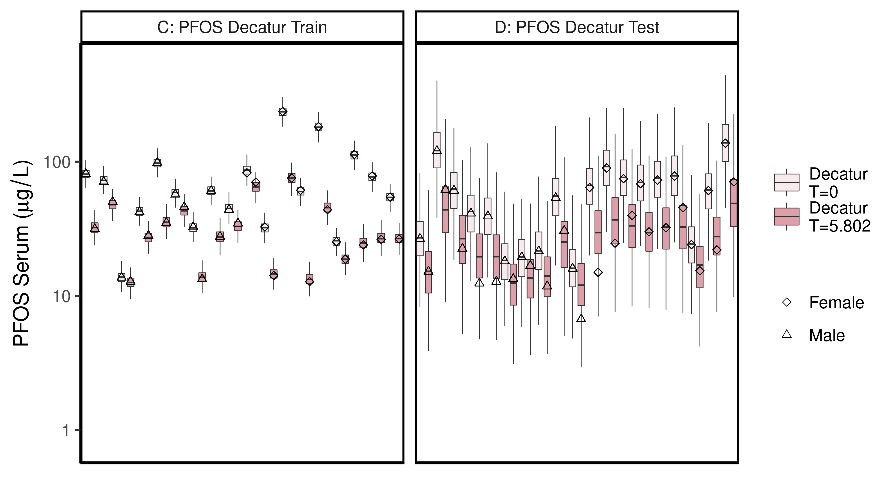

ggsave(here ("output-plots",paste0( sa,"DecaturTrainTestboxplot",pfas_name,".pdf")),plt_train,dpi=600)

## Saving 6.5 x 3.5 in image

## All boxplots

Changed grey start to 1 instead of 0.8, end at 0.6 instead of 0.4. Added shapes and fills to data points.

lets <- LETTERS;  
names(lets)[1:(length(unique(df_check$dataset))-4)]<-as.character(unique(df_check$dataset))[5:length(unique(df_check$dataset))]  
  
for (d in unique(df_check$dataset)) { # d = unique(df_check$dataset)[11]  
 ddset <- df_check %>%   
 filter(dataset == d)   
   
 aes_lut_ddset <- ddset %>% select(legend_label, City,Train_Test,datatype, Time.desc ) %>% unique () %>% inner_join(aes_lut)  
   
 gt <- ifelse(is.na(lets[d]),d,paste0(lets[d],": ", d))  
 plt <- plot_sum_boxplot(dframe = ddset, aes_lut= aes_lut_ddset, gtitle= gt, facets = FALSE, pfas_nom = pfas_name)  
   
 print(plt)  
 ggsave(here ("output-plots",  
 paste0( sa, d,"-boxplot-",   
 pfas_name,".pdf")) ,  
 plt,dpi=600)  
  
}

## Joining, by = c("legend_label", "City", "Train_Test", "datatype", "Time.desc")

## Saving 6.5 x 3.5 in image

## Joining, by = c("legend_label", "City", "Train_Test", "datatype", "Time.desc")

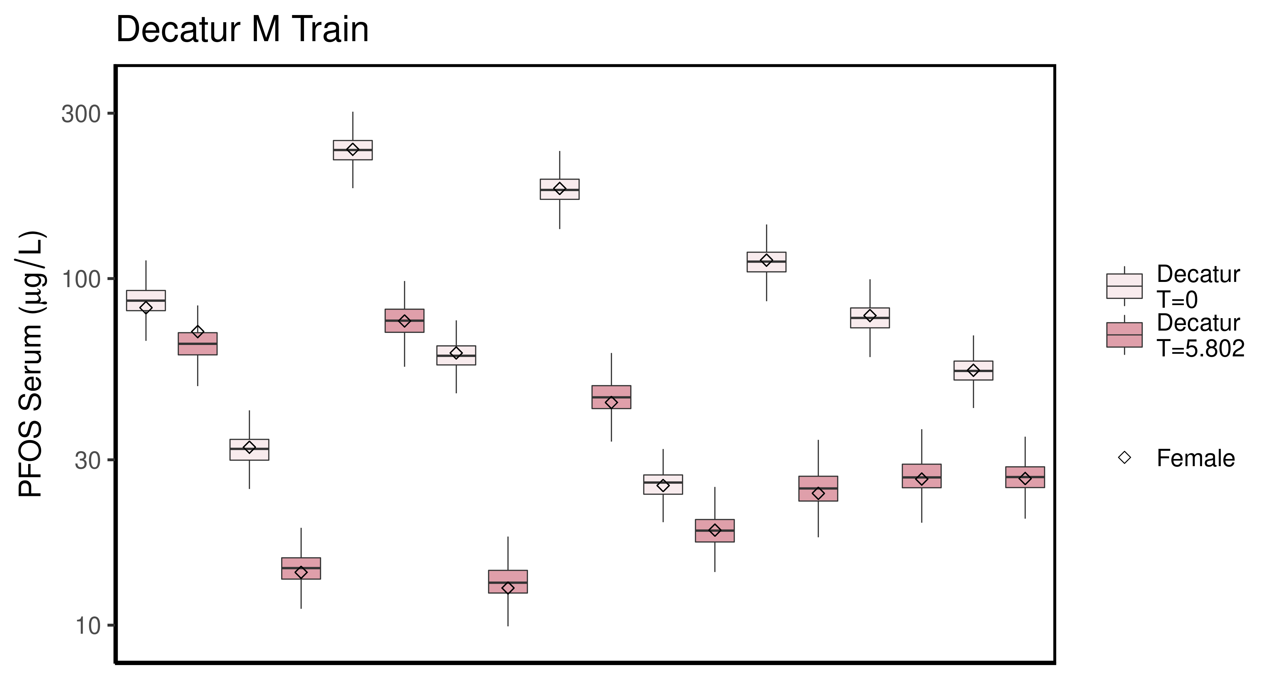

## Saving 6.5 x 3.5 in image  
## Joining, by = c("legend_label", "City", "Train_Test", "datatype", "Time.desc")

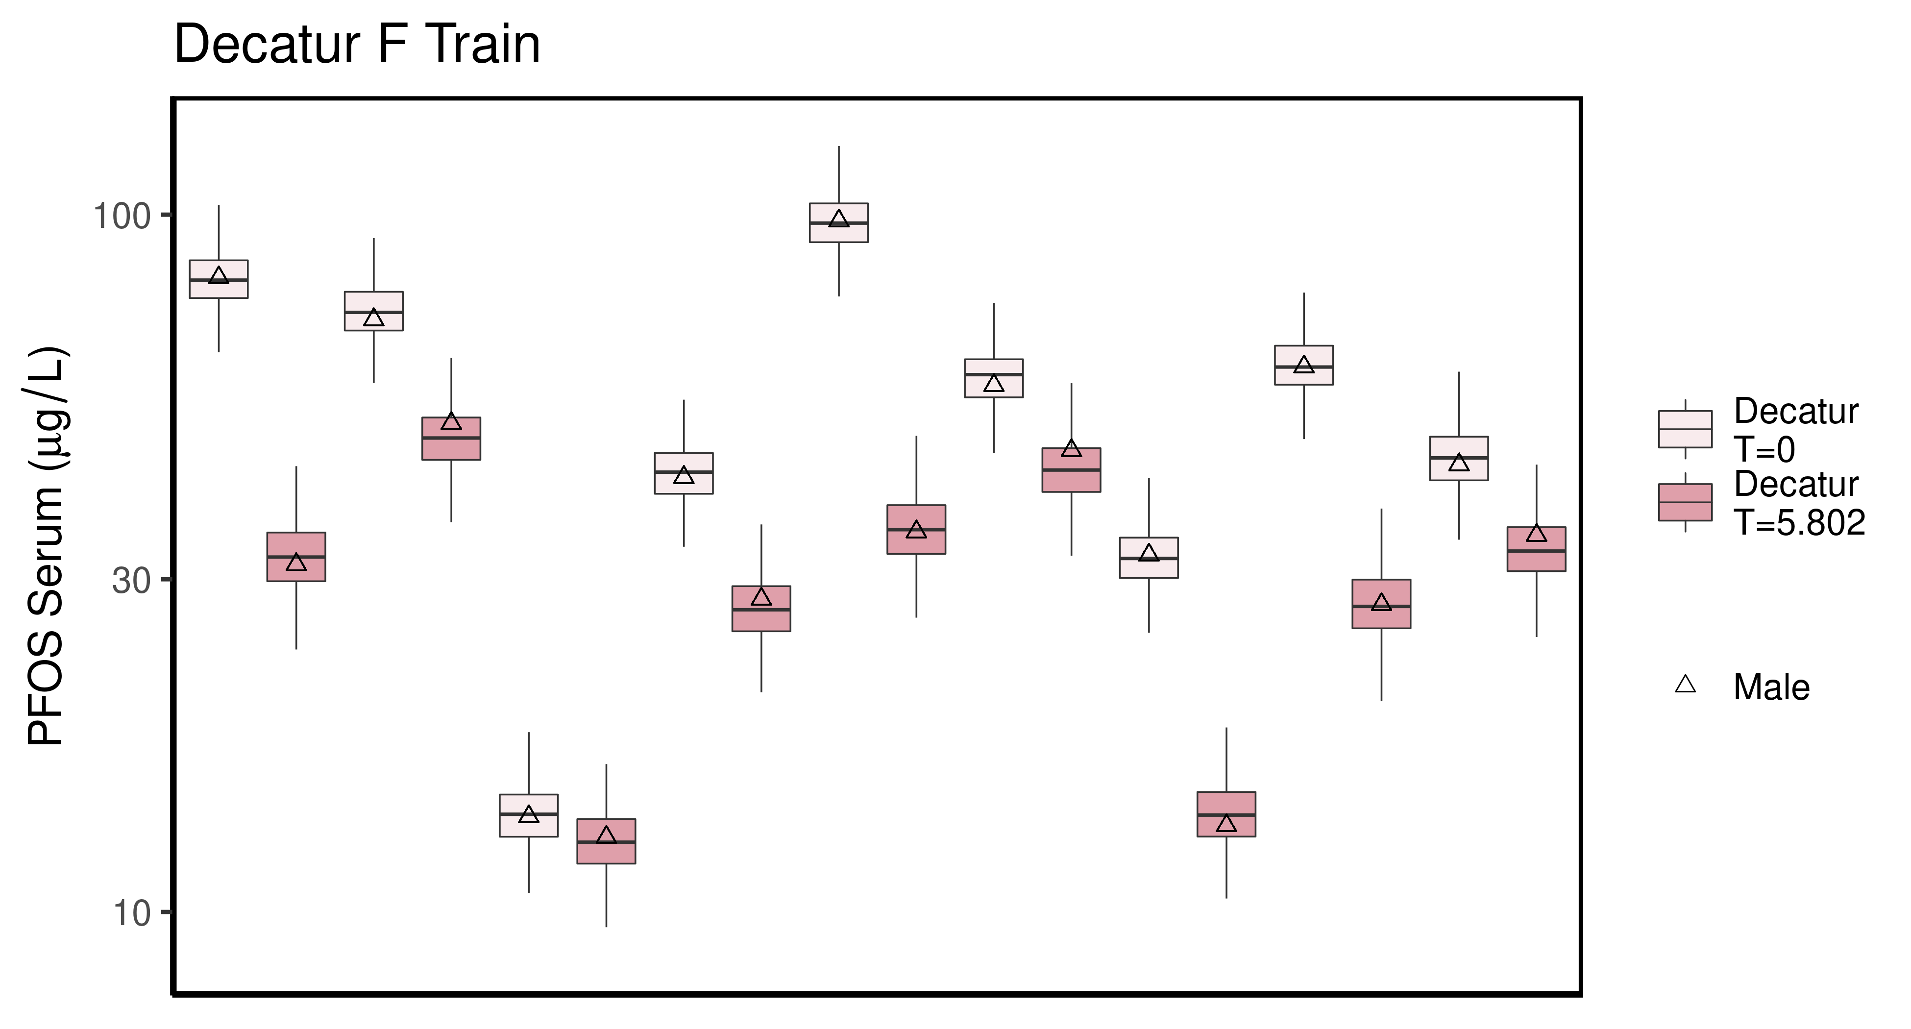

## Saving 6.5 x 3.5 in image  
## Joining, by = c("legend_label", "City", "Train_Test", "datatype", "Time.desc")

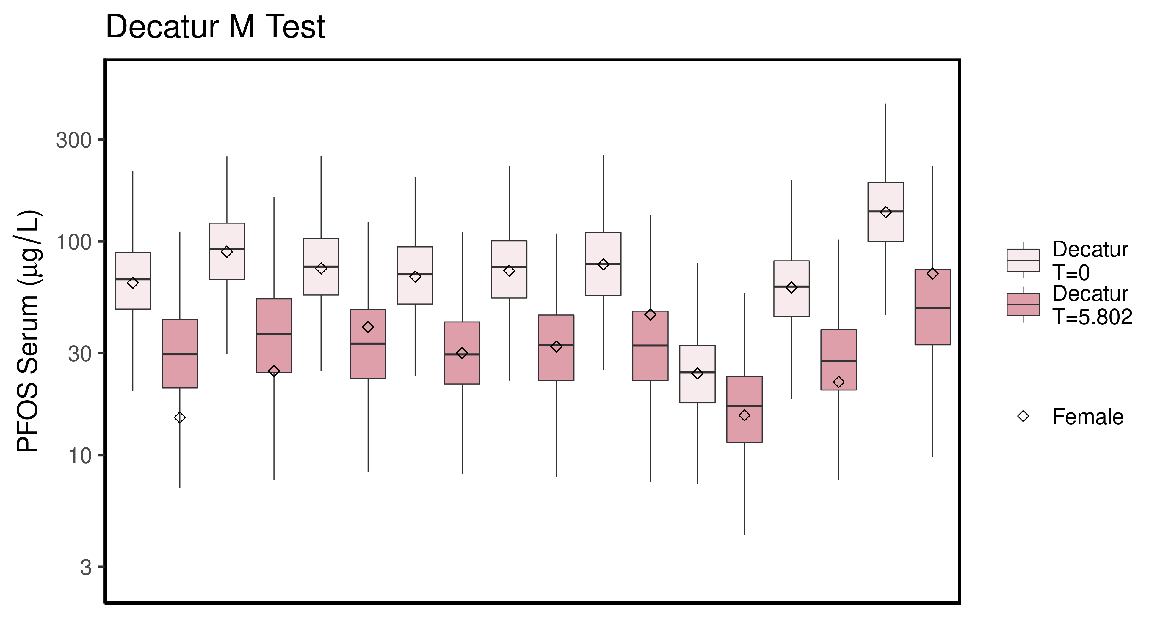

## Saving 6.5 x 3.5 in image  
## Joining, by = c("legend_label", "City", "Train_Test", "datatype", "Time.desc")

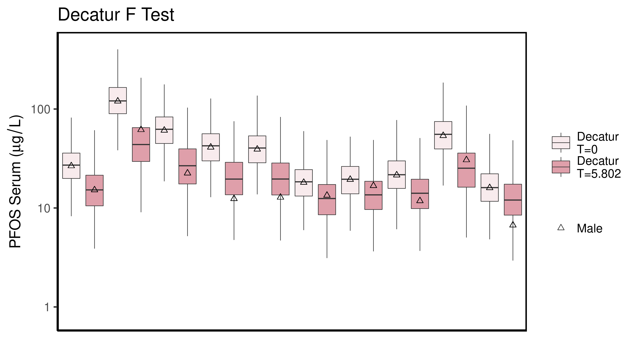

## Saving 6.5 x 3.5 in image  
## Joining, by = c("legend_label", "City", "Train_Test", "datatype", "Time.desc")

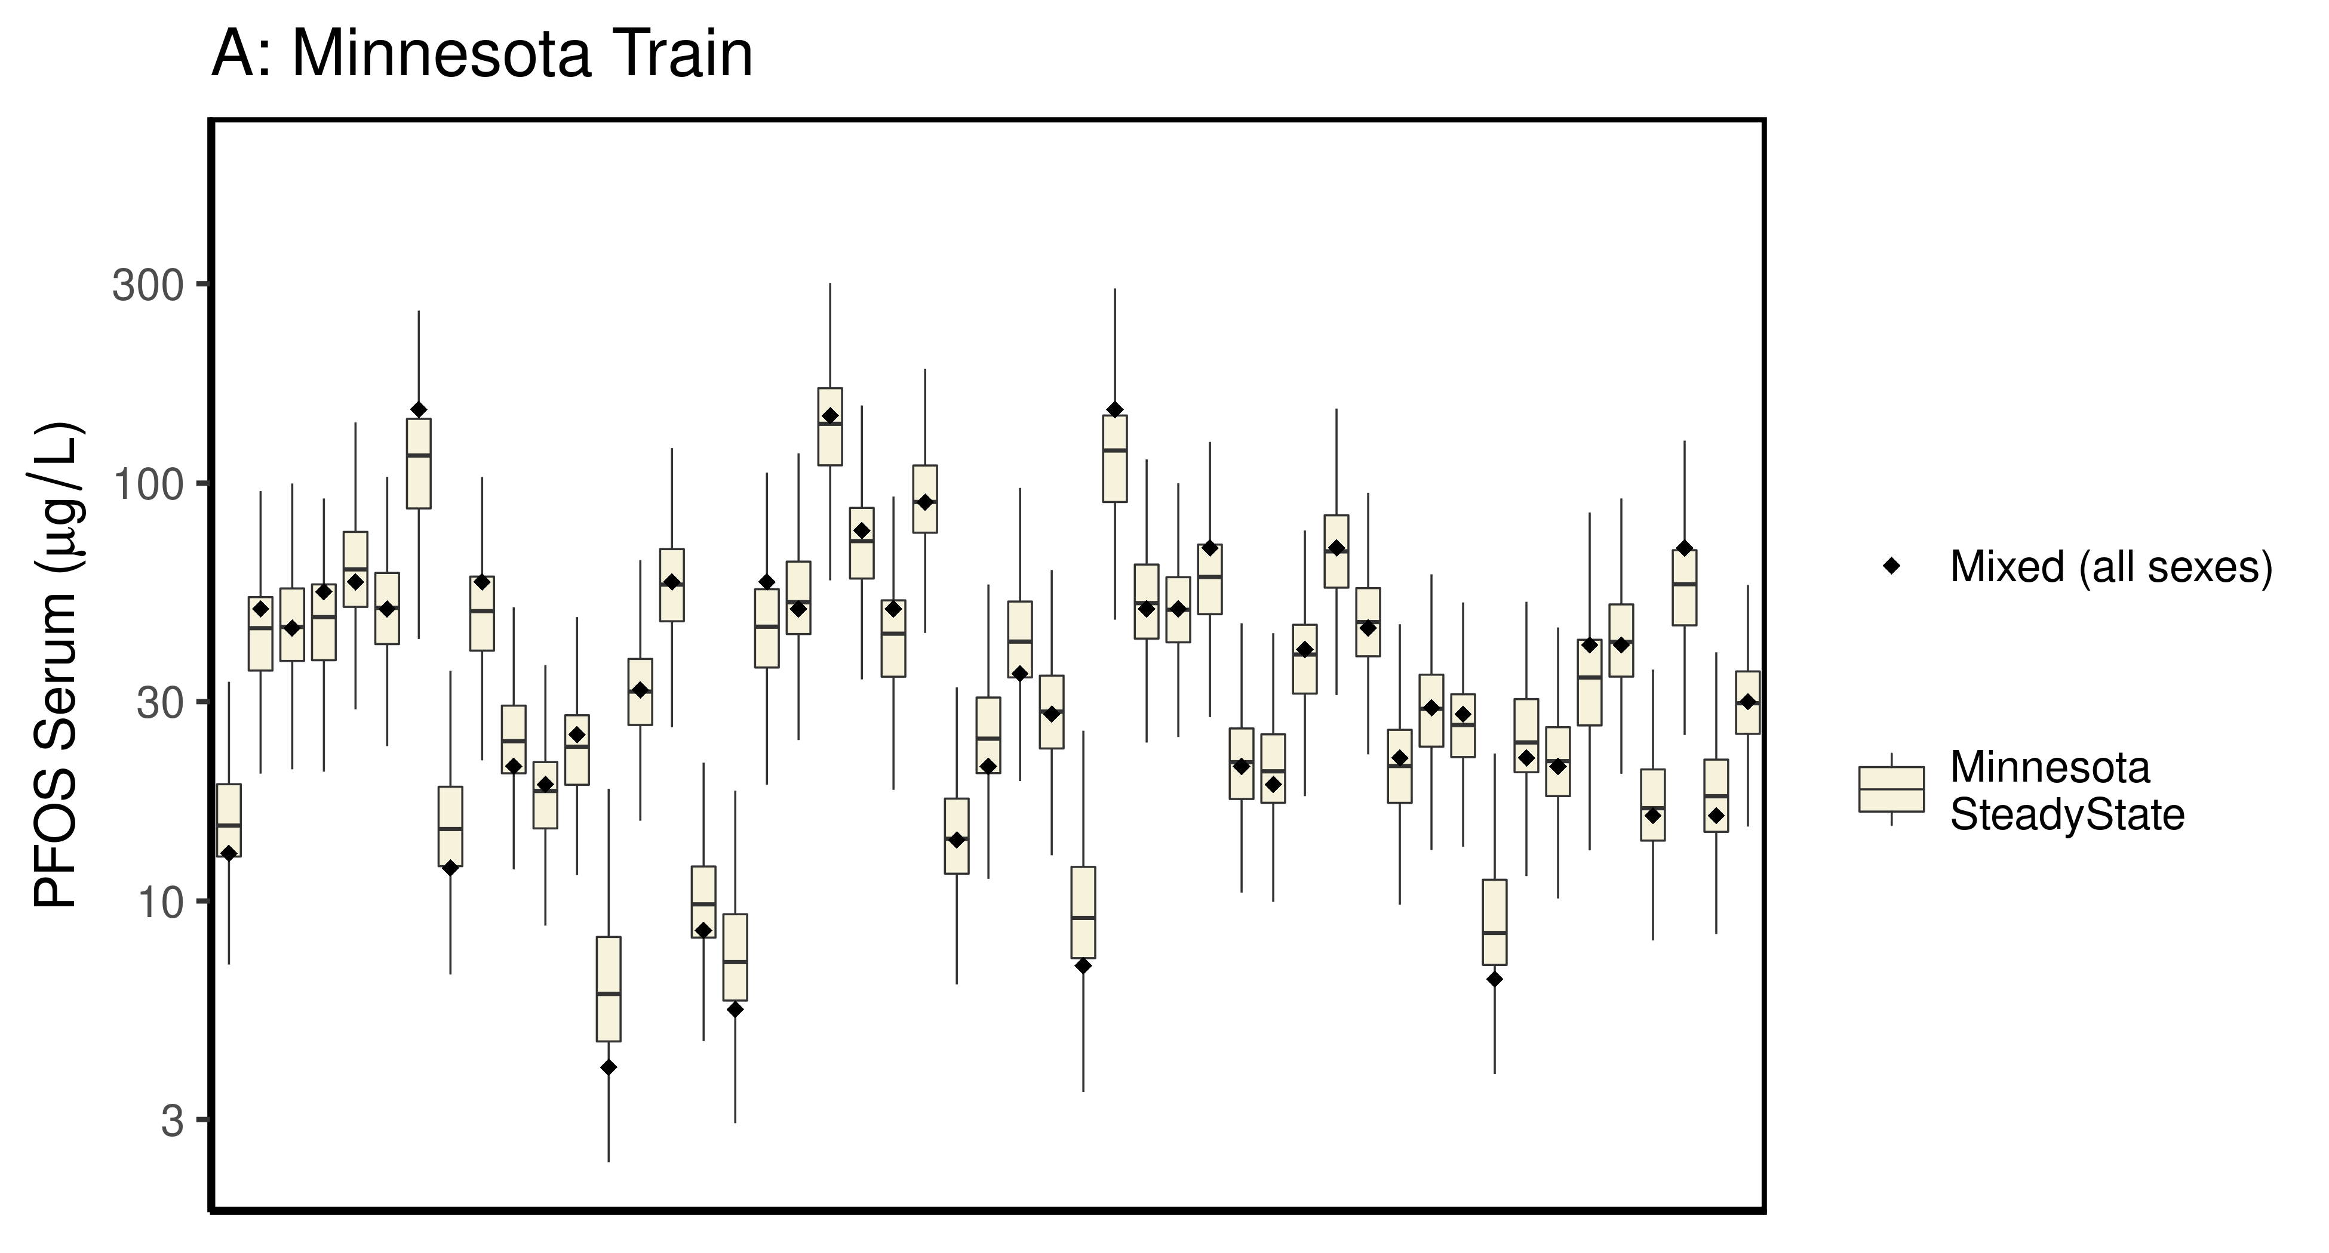

## Saving 6.5 x 3.5 in image  
## Joining, by = c("legend_label", "City", "Train_Test", "datatype", "Time.desc")

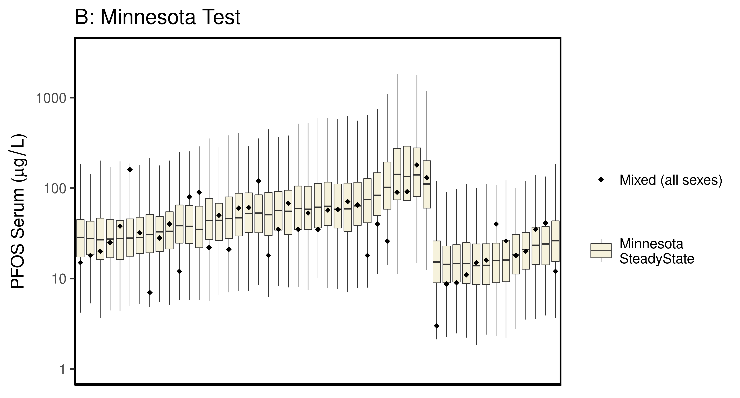

## Saving 6.5 x 3.5 in image  
## Joining, by = c("legend_label", "City", "Train_Test", "datatype", "Time.desc")

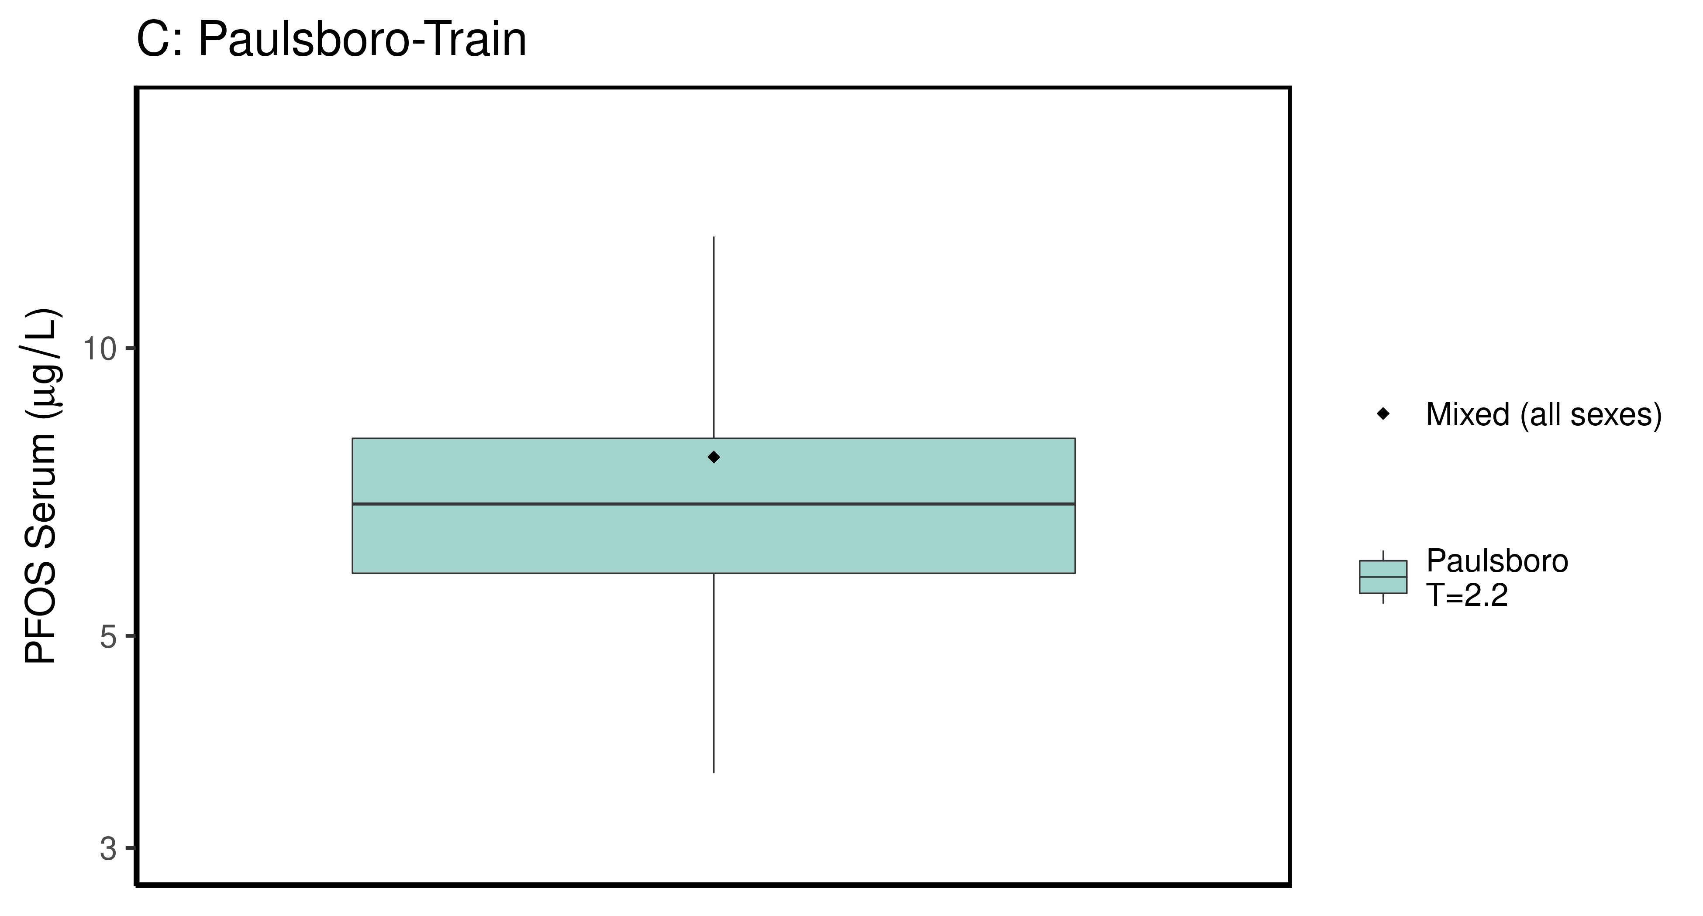

## Saving 6.5 x 3.5 in image  
## Joining, by = c("legend_label", "City", "Train_Test", "datatype", "Time.desc")

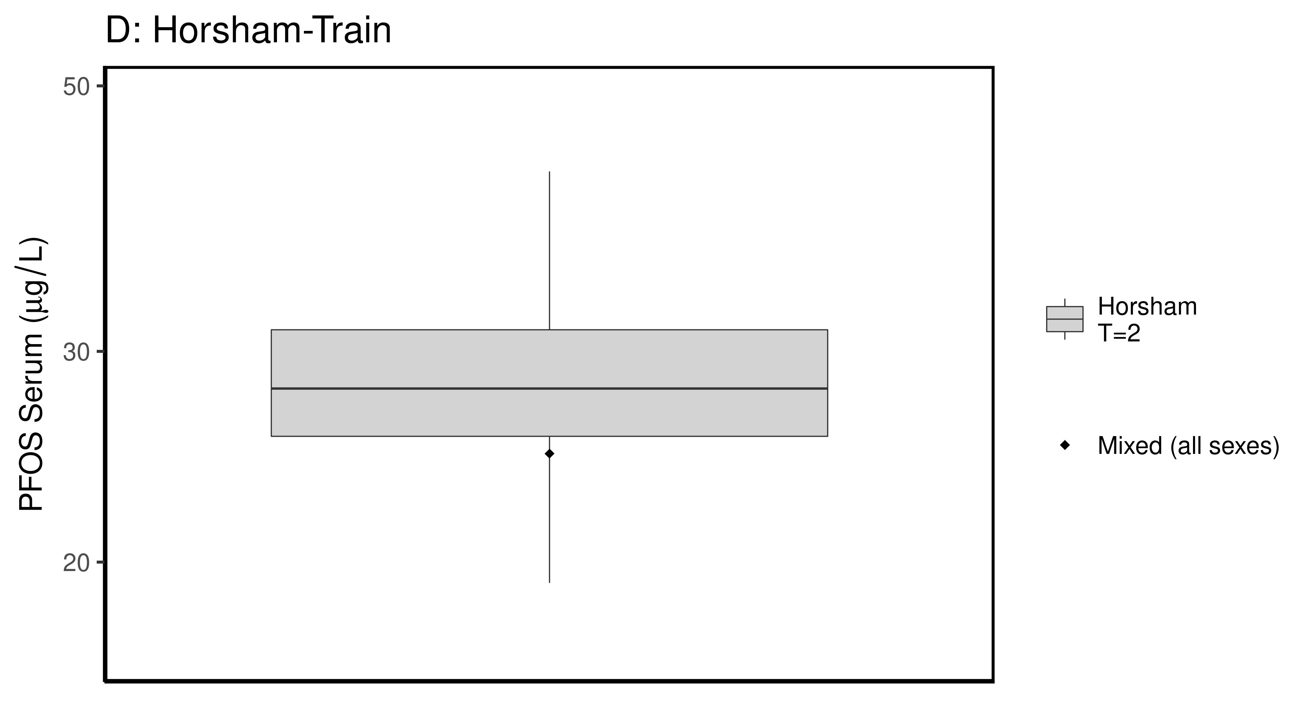

## Saving 6.5 x 3.5 in image  
## Joining, by = c("legend_label", "City", "Train_Test", "datatype", "Time.desc")

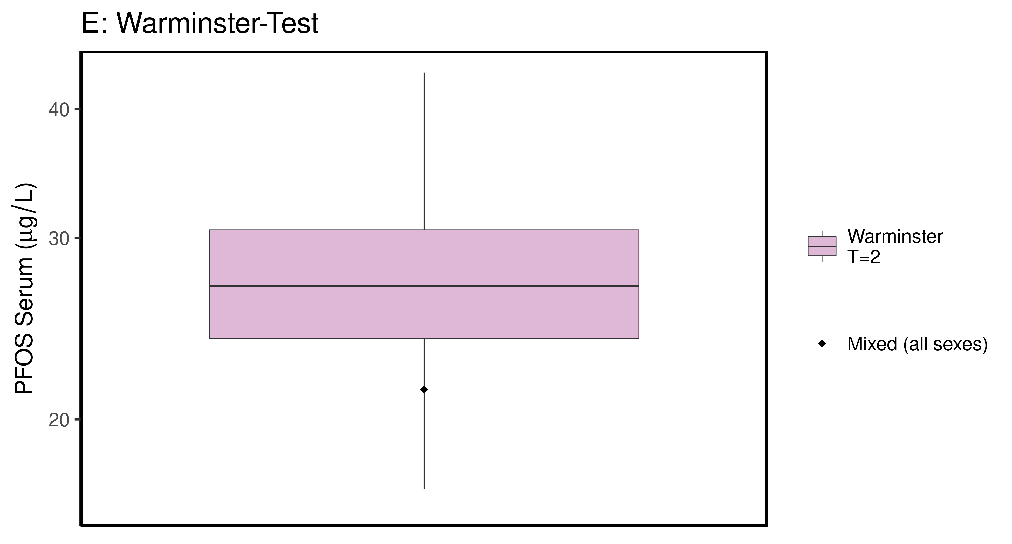

## Saving 6.5 x 3.5 in image

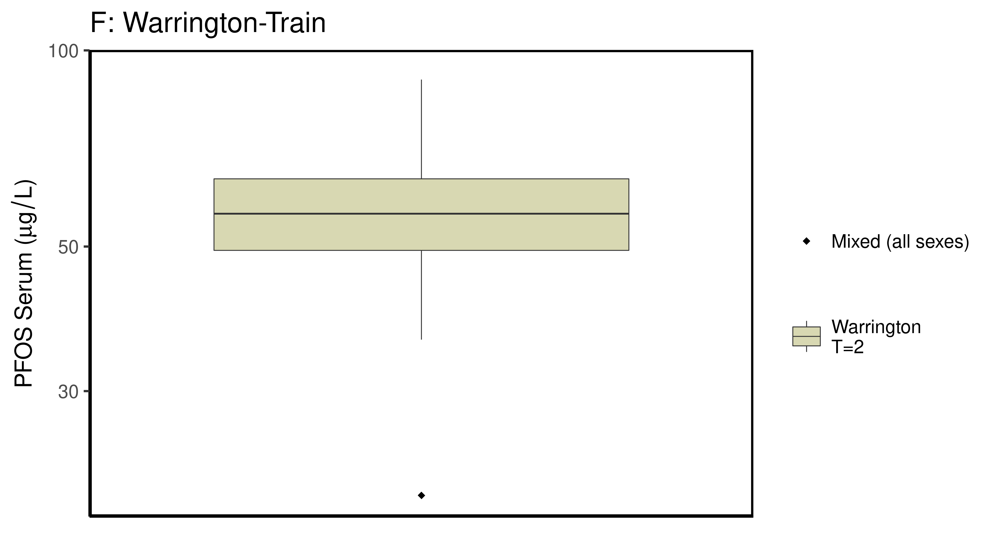

### make Training plot   
  
df_d_trt <- df_check %>%   
 filter( (Train_Test == "Train") & ((Output_Var == "M_Cbgd_Css") | (Output_Var == "M_Cserum"))) %>%  
 mutate_if(is.factor, as.character) %>% # drop factor levels unused  
 mutate(Dataset.Time = factor(Dataset.Time))   
   
  
 aes_lut_df_d_trt <- df_d_trt %>% select(City, datatype,Time, Time.desc, legend_label) %>%   
 inner_join(aes_lut ) %>%   
 select(-Train_Test) %>% ungroup () %>% unique ()

## Joining, by = c("City", "datatype", "Time", "Time.desc", "legend_label")

plt_train <- plot_sum_boxplot(dframe = df_d_trt, aes_lut= aes_lut_df_d_trt,   
 gtitle="C: Summary Data - Train" , facets = FALSE,   
 pfas_nom = pfas_name )  
 print(plt_train)

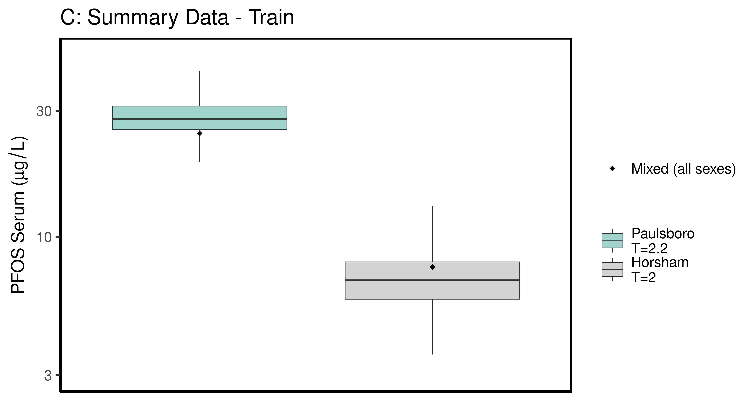

ggsave(here ("output-plots", paste0( sa, "SummaryTrainDataboxplot",pfas_name,".pdf")), plt_train,dpi=600)

## Saving 6.5 x 3.5 in image

### make Test plot  
df_d_test <- df_check %>%   
 filter((Train_Test == "Test") &   
 ((Output_Var == "M_Cbgd_Css") | (Output_Var == "M_Cserum"))) %>%  
 mutate_if(is.factor, as.character) %>% # drop factor levels unused  
 mutate(Dataset.Time = factor(Dataset.Time))   
  
aes_lut_df_d_test <- df_d_test %>% select(City, datatype,Time, Time.desc, legend_label) %>%   
 inner_join(aes_lut ) %>%   
 select(-Train_Test) %>% ungroup () %>% unique ()

## Joining, by = c("City", "datatype", "Time", "Time.desc", "legend_label")

plt_test <- plot_sum_boxplot(dframe = df_d_test, aes_lut= aes_lut_df_d_test,   
 gtitle="D: Summary Data - Test", facets = FALSE ,   
 pfas_nom = pfas_name)  
 print(plt_test)

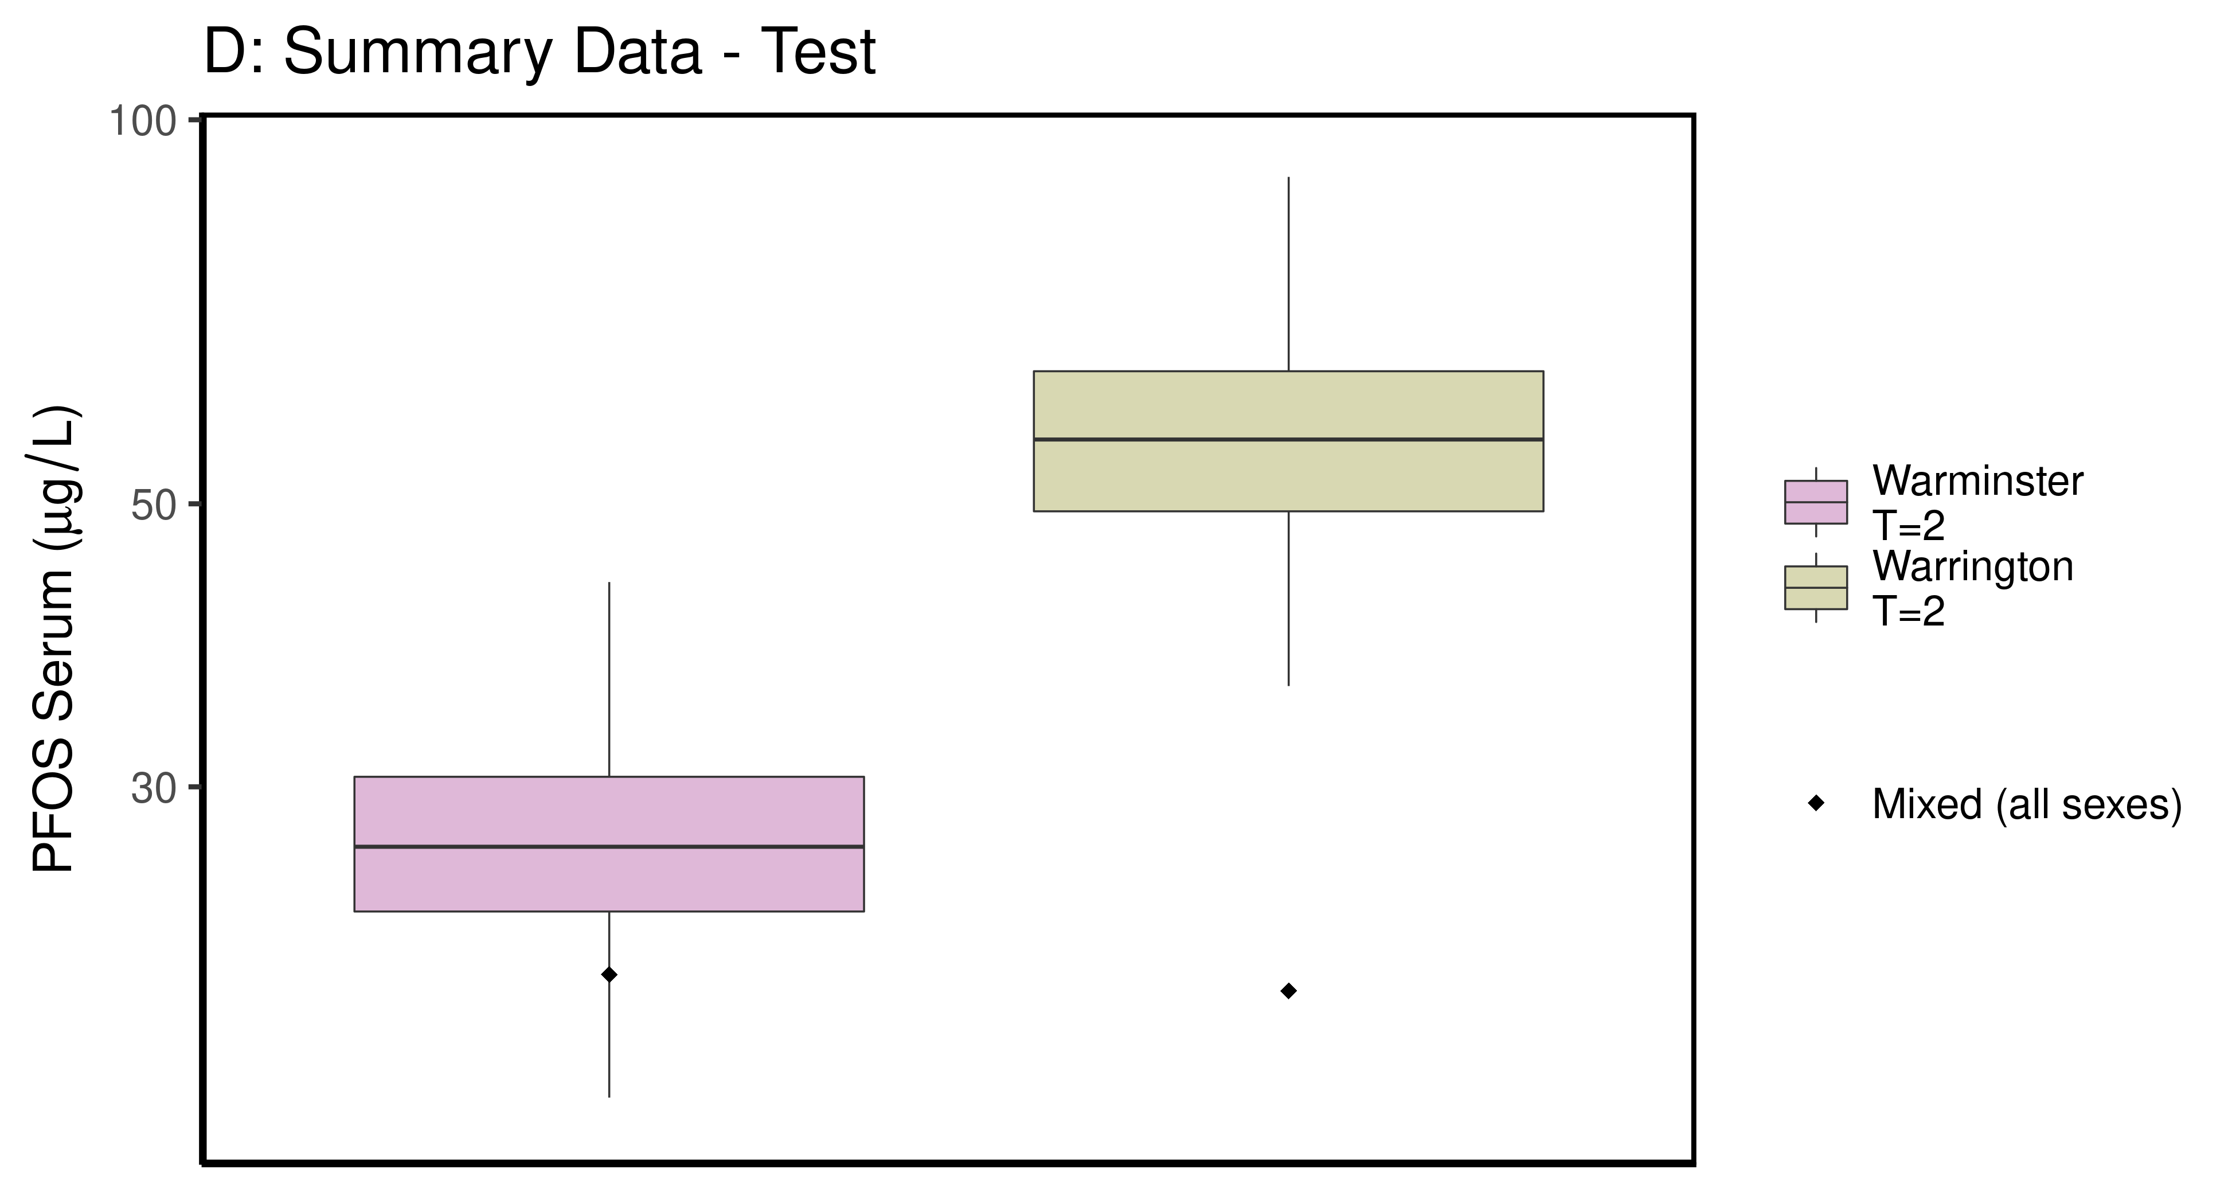

ggsave(here ("output-plots",paste0( sa, "SummaryTestDataboxplot",pfas_name,".pdf")), plt_test,dpi=600)

## Saving 6.5 x 3.5 in image

## PFOS

### Background posteriors

Shows shift in background estimate.

gmscale<-0.8  
  
dat <- multicheck$parms.samp[,grep("M_ln_Cbgd",names(multicheck$parms.samp))]  
datasetnames <- as.character(unique(calibdata$dataset))  
datasetnames <- gsub(" M","",datasetnames)  
datasetnames <- gsub(" F","",datasetnames)  
datasetnames<-datasetnames[!duplicated(datasetnames)]  
names(dat) <- datasetnames  
dat <- dat[,grep("Train",names(dat))]  
dat.df <- pivot_longer(dat,1:ncol(dat))  
dat.df <- rbind(dat.df,  
 data.frame(name="Prior",value=rnorm(5000,m=log(gmscale),sd=0.4055)))  
dat.df$name <- factor(dat.df$name,levels=rev(  
 c("Prior",datasetnames[grep("Train",datasetnames)])))  
dat.df$value <- exp(dat.df$value)  
  
p<-ggplot(dat.df)+  
 #geom_violin(aes(x=name,y=value,fill=name=="Prior"))+  
 geom_boxplot(aes(x=name,y=value,fill=name=="Prior"),outlier.shape=NA)+  
 scale_y_log10()+coord_flip()+  
 scale_fill_manual(name=NULL,   
 values=c("#009988", "#EE7733" )) +  
 theme_classic() +   
 geom_hline(yintercept = gmscale,color="grey")+  
 theme(legend.position="none",  
 panel.background = element_rect(color="black",size=1))+  
 ylab("Posterior shift in Background Concentration")  
  
print(p)

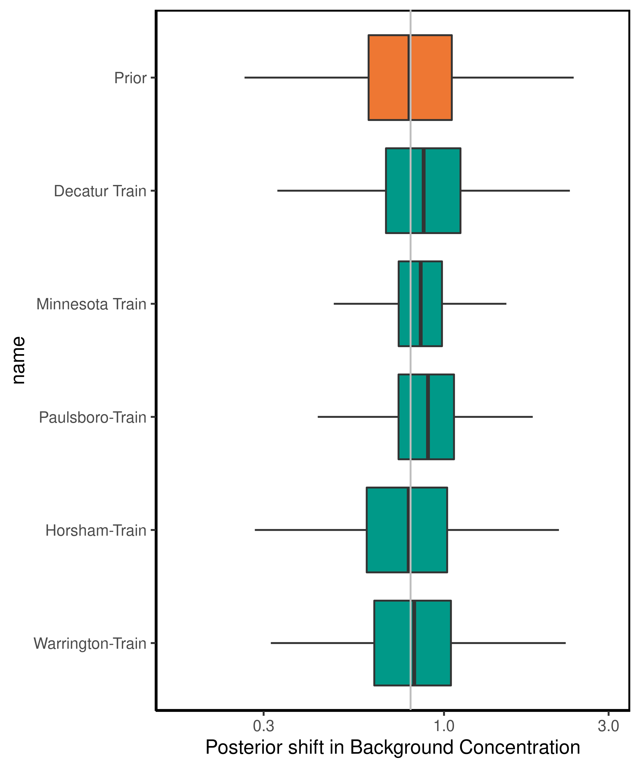

ggsave(here ("output-plots",paste0( sa,"PFOS_GM_Cbgd.pdf")) , p, dpi=600)

## Saving 5 x 6 in image

### Half-life

For PFOS, the population GM of the half-life has a posterior distribution that is narrower than the prior, with a posterior median (95% CI) estimate of 3.06 (2.16-4.37) years. The population GSD posterior is larger than the prior at 1.47(1.44-1.75).

dat <- multicheck$parms.samp[,c("M_ln_k.1.","V_ln_k.1.", "M_ln_Vd.1.", "SD_ln_Vd.1.")]  
names(dat) <- c("M_ln_k(1)","V_ln_k(1)", "M_ln_Vd(1)", "SD_ln_Vd(1)")  
   
set.seed(3.14159)  
dat$z_ln_k <- rnorm(nrow(dat))  
dat$z_ln_Vd <- rnorm(nrow(dat))  
dat %>% rename_()

## Warning: `rename_()` is deprecated as of dplyr 0.7.0.  
## Please use `rename()` instead.  
## This warning is displayed once every 8 hours.  
## Call `lifecycle::last_warnings()` to see where this warning was generated.

## M_ln_k(1) V_ln_k(1) M_ln_Vd(1) SD_ln_Vd(1) z_ln_k z_ln_Vd  
## 12503 -1.78081 0.285228 -0.952589 0.099030200 -0.961933416 -2.139841913  
## 15901 -1.58629 0.201249 -0.969862 0.117249000 -0.292525723 -1.263479244  
## 17543 -1.51202 0.201935 -0.990878 0.099988900 0.258788216 0.083307969  
## 18721 -1.77048 0.192680 -0.504773 0.079285300 -1.152131886 0.188325130  
## 11662 -1.64655 0.247044 -1.118770 0.155813000 0.195782826 0.189814193  
## 13403 -1.67037 0.204080 -0.987917 0.076863000 0.030123945 0.217615352  
## 13192 -1.48840 0.205743 -1.161630 0.097435400 0.085417732 -0.648814142  
## 15663 -1.73395 0.161690 -0.941647 0.133450000 1.116610213 0.254774383  
## 1246 -1.56178 0.234900 -1.118080 0.083615400 -1.218857416 -0.468830015  
## 16132 -1.47170 0.220846 -1.348210 0.039526200 1.267368722 -1.192510054  
## 10602 -1.66126 0.145580 -1.006460 0.119143000 -0.744781596 0.121228235  
## 10563 -1.55578 0.219351 -0.915973 0.133472000 -1.131218571 -1.035932658  
## 15932 -1.53965 0.225097 -1.212150 0.304727000 -0.716358490 -0.191888295  
## 1114 -1.57212 0.143150 -1.353580 0.060456400 0.252652370 -0.970546336  
## 1699 -1.72310 0.181150 -1.394070 0.002710170 0.152045707 0.057771938  
## 1141 -1.71915 0.235515 -1.115950 0.317802000 -0.307656430 -2.110692675  
## 13383 -1.58035 0.187495 -1.067820 0.078978300 -0.953017331 0.978176274  
## 12832 -1.52325 0.206817 -1.147450 0.080134500 -0.648242811 0.371021737  
## 19552 -1.73858 0.269688 -1.041740 0.014100600 1.224313624 0.720910931  
## 14423 -1.72443 0.244522 -1.020560 0.245251000 0.199811608 1.879594880  
## 12372 -1.88535 0.200824 -0.824227 0.051924500 -0.578483722 -0.396316112  
## 12042 -1.68883 0.222860 -1.231820 0.081923900 -0.942300733 0.110322947  
## 10473 -1.41388 0.260457 -0.974745 0.184174000 -0.203728180 -0.593140881  
## 1509 -1.79090 0.322931 -1.208560 0.122928000 -1.666474840 0.419621770  
## 1552 -1.48118 0.164918 -1.359260 0.026906900 -0.484455109 -0.545738743  
## 19513 -1.71252 0.211311 -0.989702 0.061660400 -0.741072661 1.160921499  
## 17471 -1.74664 0.186104 -1.032350 0.007978960 1.160615779 0.639817834  
## 18092 -1.54205 0.294871 -0.959400 0.073912900 1.012067125 -0.122020443  
## 1613 -1.41711 0.229896 -1.243510 0.174357000 -0.072078474 0.184645026  
## 14383 -1.67568 0.140886 -0.946274 0.006121810 -1.136782298 -0.517806023  
## 14263 -1.60634 0.154418 -1.108690 0.326070000 0.900624729 0.067988352  
## 18291 -1.43525 0.146936 -1.151450 0.108204000 0.851770447 -0.184797156  
## 1945 -1.53114 0.162382 -1.290380 0.191541000 0.727715174 -1.403691615  
## 19613 -1.44761 0.173023 -1.218000 0.010419300 0.736502146 0.229740706  
## 1842 -1.70720 0.161055 -1.071380 0.243799000 -0.352129617 -0.889081301  
## 1873 -1.63256 0.198483 -1.109280 0.055205400 0.705515513 -0.160401177  
## 19423 -1.63666 0.186280 -1.106420 0.231938000 1.300357989 -0.242136794  
## 19352 -1.33777 0.242559 -1.514870 0.101520000 0.038252014 -0.028837196  
## 11812 -1.72255 0.244641 -1.128230 0.005779080 -0.979283770 -0.316215474  
## 14982 -1.74793 0.182659 -1.195730 0.201199000 0.793761231 -0.416160087  
## 11263 -1.63248 0.227020 -1.226210 0.098182600 0.786506872 -1.023895957  
## 1028 -1.44108 0.227241 -1.497500 0.279376000 -0.310463131 1.099495275  
## 1051 -1.37358 0.197145 -1.192990 0.212443000 1.698884846 0.817712470  
## 17222 -1.60673 0.263080 -0.775905 0.156705000 -0.794593709 0.168875510  
## 1747 -1.57055 0.149488 -1.244460 0.152799000 0.348437716 0.038665440  
## 1284 -1.76566 0.205009 -0.927193 0.155017000 -2.265401074 1.078174892  
## 1564 -1.39835 0.190503 -1.229860 0.106511000 -0.162205279 0.379427297  
## 18632 -1.69984 0.246145 -0.962312 0.219132000 1.130864991 -1.078174559  
## 19142 -1.49432 0.277124 -1.311020 0.113689000 -0.455545976 0.188763468  
## 15793 -1.45490 0.212432 -1.067970 0.047360900 -0.899166316 1.583133508  
## 1126 -1.83714 0.174658 -1.107620 0.284544000 0.726838902 -0.250112295  
## 16502 -1.26098 0.272060 -1.405550 0.027308000 -0.809440902 0.342994219  
## 15103 -1.65713 0.300501 -0.859839 0.003772110 0.267085116 -0.124701883  
## 11251 -1.54440 0.186044 -1.058990 0.193359000 -1.737263711 -0.993314763  
## 11732 -1.51094 0.190952 -1.069270 0.330080000 -1.411425136 -1.021439085  
## 18382 -1.63138 0.156777 -0.821314 0.003612510 -0.453551227 0.840642928  
## 13433 -1.72083 0.286872 -1.185120 0.048436000 -1.035491275 0.849573118  
## 16403 -1.49849 0.220428 -1.152780 0.271335000 1.362142893 0.469618942  
## 11871 -1.90996 0.256734 -0.801532 0.272806000 0.917456737 -1.269655261  
## 1988 -1.46352 0.208679 -1.202260 0.073981600 -0.785142161 -1.105120219  
## 1589 -1.62702 0.228766 -0.857880 0.026353000 0.573518173 -1.897945965  
## 1449 -1.63749 0.268761 -0.898316 0.008537480 0.918196208 0.491787265  
## 1232 -1.59660 0.122014 -1.028280 0.023843300 0.256287273 -0.704722317  
## 10171 -1.70334 0.165137 -0.899507 0.002197390 0.351966556 1.777576130  
## 1259 -1.67965 0.244416 -1.029540 0.045773700 1.174337357 -0.245389029  
## 18503 -1.62141 0.281811 -0.916597 0.025199800 -0.480846375 -2.111252318  
## 10801 -1.56184 0.160558 -1.087670 0.011910700 -0.418829722 -0.585314536  
## 15263 -1.63365 0.158429 -1.245860 0.063717400 0.955112803 -0.517903726  
## 1042 -1.63500 0.112791 -1.455090 0.278074000 -1.289006611 0.513919145  
## 18363 -1.81543 0.177697 -0.904480 0.167001000 0.186197433 -0.626426919  
## 19072 -1.49758 0.156010 -1.267290 0.294721000 -0.031325502 0.192142595  
## 16632 -1.42791 0.219975 -1.082510 0.121078000 0.467097310 -1.427277992  
## 1401 -1.70459 0.140659 -1.277230 0.217652000 1.024197674 0.400991028  
## 14691 -1.63344 0.223510 -1.074580 0.103091000 0.267358452 1.161564956  
## 17041 -1.65381 0.187618 -1.153790 0.029494500 0.231826103 0.326346805  
## 19822 -1.57438 0.192184 -1.373020 0.029530200 0.747592465 -1.014982273  
## 13613 -1.38181 0.211897 -1.181510 0.204589000 1.217068511 0.101258362  
## 11013 -1.44548 0.233857 -0.942005 0.029099600 0.383358345 0.991893279  
## 15791 -1.63349 0.172057 -0.932907 0.083961800 -0.988052822 1.102650759  
## 16531 -1.76624 0.276848 -1.011370 0.185471000 -0.156852910 0.280375017  
## 1970 -1.77635 0.170294 -1.316550 0.360671000 1.735535216 -0.406177410  
## 16331 -1.77113 0.267449 -0.943777 0.151679000 -0.352298306 1.286412690  
## 1242 -1.51136 0.152753 -1.046730 0.157399000 0.688640044 -0.254030579  
## 15251 -1.69412 0.206801 -1.157560 0.071277200 1.224406096 -1.144448704  
## 1653 -1.68646 0.195778 -1.056470 0.011467300 0.794296303 0.266410910  
## 1140 -1.81294 0.216499 -1.143960 0.020811900 -0.006402398 0.636855748  
## 17771 -1.49366 0.200313 -1.270720 0.559634000 0.219150635 -1.402115093  
## 18012 -1.76699 0.156428 -1.060250 0.071046800 -0.886463751 -1.511824827  
## 14062 -1.75501 0.175106 -0.791353 0.026396500 0.439760291 -0.301192859  
## 1964 -1.48856 0.149098 -1.006080 0.100621000 -0.886389751 0.491361149  
## 18413 -1.86768 0.152420 -0.930806 0.058462100 -0.853818454 -0.898156496  
## 13791 -1.63684 0.326519 -1.064930 0.063342800 -0.989994331 -1.575054814  
## 15832 -1.43340 0.241072 -1.448570 0.099880700 -0.650877737 -0.503256667  
## 1060 -1.35552 0.175796 -1.280680 0.113980000 1.053946660 -0.622908441  
## 12073 -1.57967 0.167069 -1.033730 0.023281200 -0.390878033 -0.684829990  
## 15683 -1.81712 0.178913 -0.814154 0.326121000 -0.070586394 -0.221516764  
## 1693 -1.58316 0.263506 -1.183660 0.219953000 -0.462050809 0.388050833  
## 17531 -1.57278 0.154848 -1.341400 0.154075000 0.540908267 -0.806316456  
## 10311 -1.53406 0.212237 -1.073860 0.076524700 0.931634971 -0.547213054  
## 18041 -1.42976 0.296373 -1.451770 0.074486700 -0.209274345 1.213494144  
## 19672 -1.40786 0.217904 -1.377050 0.105114000 0.617350048 -0.417013230  
## 18351 -1.50913 0.195666 -1.048540 0.071737500 -0.405077513 0.164593185  
## 13741 -1.68800 0.286321 -0.963830 0.066911100 1.053103763 -1.569627007  
## 11892 -1.54367 0.196785 -1.261580 0.090387200 0.602284246 1.466675890  
## 18762 -1.52973 0.274066 -0.942639 0.334317000 1.017461177 -1.496085449  
## 1808 -1.34505 0.352865 -1.080810 0.211969000 0.608167318 -1.150289019  
## 15861 -1.58091 0.138326 -0.975470 0.049974600 0.206735995 -2.023009144  
## 12312 -1.60792 0.160238 -1.069650 0.102337000 -1.897727292 -0.681652395  
## 13473 -1.65173 0.281197 -0.986854 0.071614600 -0.682582832 0.507010414  
## 1040 -1.58430 0.281501 -1.338630 0.118919000 0.481338415 0.747111894  
## 17573 -1.39373 0.123788 -1.135280 0.176467000 -0.463031038 0.175989014  
## 19872 -1.52489 0.225053 -1.268170 0.334098000 -0.279741696 -0.437523579  
## 1953 -1.62736 0.158289 -1.313060 0.014187400 -0.413690145 0.942726154  
## 15883 -1.40054 0.211396 -1.400500 0.153562000 1.618766521 0.891044960  
## 1663 -1.58827 0.201379 -1.120860 0.120865000 -0.721055711 -1.691785958  
## 18913 -1.68001 0.149845 -1.420150 0.142080000 -0.453093157 -0.712147393  
## 1005 -1.47665 0.240503 -1.006310 0.176570000 0.014257161 -0.332268892  
## 1878 -1.55079 0.216250 -1.045270 0.262957000 0.215764621 0.983033453  
## 15553 -1.61085 0.245026 -1.558870 0.209524000 0.188870195 -0.988041784  
## 19433 -1.55771 0.161607 -1.126080 0.002561330 -0.050148494 0.265546446  
## 15642 -1.31965 0.158509 -1.499780 0.211088000 -1.495419632 -0.728186155  
## 13873 -1.52477 0.164246 -1.377590 0.174149000 0.367837753 1.375405013  
## 17882 -1.61973 0.189075 -0.980670 0.230434000 0.517144022 -0.599264333  
## 1857 -1.67697 0.151947 -1.078200 0.079303400 -0.484335465 -0.272173202  
## 1103 -1.70324 0.241663 -1.231420 0.338033000 0.674855616 0.405324773  
## 12581 -1.59117 0.269125 -1.367100 0.214679000 -0.762448605 0.846734123  
## 1974 -1.67911 0.162292 -1.370240 0.339186000 0.386073791 0.518125984  
## 13822 -1.71248 0.251145 -0.981260 0.075015400 -0.664003345 1.579413771  
## 1101 -1.58949 0.227144 -1.264230 0.140905000 -1.724344195 -0.112951698  
## 1198 -1.45825 0.196425 -1.163380 0.002858330 1.156319079 -0.484652932  
## 19762 -1.35610 0.125779 -1.477440 0.022144400 0.693506590 -2.377853826  
## 18271 -1.54542 0.216744 -1.096960 0.132420000 0.143156356 -0.636048007  
## 18911 -1.58122 0.178538 -1.383840 0.054469800 1.492813560 0.035663770  
## 19111 -1.79564 0.145718 -1.120650 0.231506000 -1.632153479 -0.109166877  
## 1374 -1.65911 0.175639 -1.194050 0.073960400 0.127846023 -1.871305162  
## 1920 -1.63960 0.256817 -1.109250 0.058825100 -2.403663727 -0.079333090  
## 1504 -1.68477 0.289039 -1.341230 0.078346900 1.443928256 -0.318596856  
## 16771 -1.69506 0.264637 -1.157500 0.125614000 -0.878893050 0.118181119  
## 19693 -1.43884 0.167662 -1.377840 0.073848900 -1.306438327 0.532403631  
## 13331 -1.52000 0.193011 -1.098750 0.203880000 -0.877198993 -0.197683940  
## 18422 -1.94221 0.234858 -0.948120 0.079788400 -1.164380459 1.664379027  
## 11663 -1.71038 0.198835 -1.134060 0.068187100 -1.982347680 0.314495086  
## 13082 -1.70630 0.174241 -1.275160 0.172886000 -0.989944235 0.601591759  
## 14941 -1.69812 0.172252 -0.763797 0.128923000 -0.151684601 -1.429557536  
## 1073 -1.81372 0.176768 -1.085600 0.033201000 0.912506791 -0.472999146  
## 1781 -1.49399 0.250093 -1.019400 0.094940900 0.407669808 -0.487888829  
## 15091 -1.69785 0.223057 -0.683510 0.270866000 -1.242184375 1.027388649  
## 13413 -1.66815 0.224952 -1.033990 0.244815000 -0.642694412 -1.095763686  
## 12463 -1.72073 0.283731 -1.138440 0.271224000 1.930243689 -0.916445608  
## 11261 -1.44314 0.198470 -1.211480 0.056171300 0.410199364 1.054094779  
## 10231 -1.46131 0.219322 -1.435090 0.216686000 -1.291349321 -1.439834035  
## 16911 -1.57040 0.150956 -0.913522 0.137091000 2.635045375 0.532564109  
## 12011 -1.68243 0.234813 -1.036200 0.032346400 0.487072288 -1.046928774  
## 14342 -1.71463 0.275233 -1.330050 0.049855200 0.853892318 0.087385881  
## 1170 -1.49406 0.212159 -1.075710 0.099529000 1.088442705 -0.174111691  
## 17372 -1.54756 0.214524 -0.998752 0.257620000 0.226013957 -0.533826331  
## 1839 -1.58489 0.153066 -1.111950 0.090316500 0.068198838 0.099317747  
## 11531 -1.73568 0.214170 -0.974910 0.306485000 -0.984815533 -1.020107099  
## 16811 -1.82221 0.205627 -0.801821 0.217206000 -1.310854422 0.430041832  
## 1825 -1.65343 0.252136 -1.141630 0.222240000 2.464055335 1.502847759  
## 12443 -1.67303 0.264674 -1.108760 0.359680000 -0.665428070 -0.270760795  
## 12893 -1.71546 0.207174 -0.956468 0.210223000 0.912862648 0.871555415  
## 1694 -1.55023 0.230632 -1.392220 0.250117000 0.964664226 -1.216293810  
## 11843 -1.58818 0.188757 -1.292740 0.178992000 1.608002937 -1.892738669  
## 15731 -1.69001 0.196782 -0.812479 0.045036500 1.835399525 -0.822382571  
## 15783 -1.42494 0.200944 -1.104570 0.267126000 0.702462733 0.751782015  
## 11601 -1.66359 0.167998 -1.145860 0.086387100 1.217854079 0.773574518  
## 17572 -1.64434 0.175319 -1.114460 0.060460600 -1.123653829 -1.787532258  
## 1062 -1.39822 0.244794 -1.206630 0.292017000 0.668330116 0.088817469  
## 12182 -1.88587 0.234329 -0.984042 0.000592717 1.216411488 -0.180052904  
## 18073 -1.57366 0.122574 -1.223050 0.087276200 0.234575354 -1.471714902  
## 1773 -1.48881 0.343258 -1.139110 0.016178100 -0.418696588 0.490094947  
## 12412 -2.00857 0.308970 -0.969907 0.464436000 0.238220090 -0.397833206  
## 14813 -1.55120 0.185884 -1.325500 0.174711000 -0.550588192 -0.169679442  
## 19503 -1.71215 0.231289 -1.137110 0.051620800 -0.500602769 -2.214982820  
## 1029 -1.39254 0.128341 -1.378620 0.280799000 1.163897492 1.008145236  
## 1473 -1.76643 0.152978 -1.265420 0.209002000 2.155536954 0.524260695  
## 1430 -1.72357 0.103356 -0.560674 0.212524000 -1.709157009 0.264820635  
## 12303 -1.72043 0.193878 -0.911478 0.060944300 -1.600822615 -0.388256354  
## 1738 -1.53909 0.236367 -1.214400 0.013860500 -1.038553413 -0.399451920  
## 11051 -1.66182 0.282939 -0.939606 0.125316000 0.323094221 0.227146190  
## 18882 -1.60860 0.229195 -1.066780 0.036944400 -0.888847154 -0.611156980  
## 14953 -1.44781 0.291376 -1.087110 0.019545800 0.393678982 0.540650478  
## 17223 -1.86086 0.251116 -1.177280 0.033316900 0.236541468 0.909955002  
## 10543 -1.38396 0.209859 -1.103940 0.070332800 -0.430496813 1.406622276  
## 19871 -1.24341 0.294562 -1.162200 0.203892000 -0.547933126 -0.755587121  
## 15571 -1.97461 0.197689 -0.806898 0.166897000 -1.322251659 -0.020592429  
## 19333 -1.59078 0.185368 -0.980932 0.087376500 0.682126749 0.137858516  
## 1357 -1.53824 0.184350 -1.150400 0.082404100 2.162789482 -0.921540392  
## 12813 -1.67526 0.216107 -0.820046 0.034276700 -0.416669649 0.576523431  
## 1222 -1.71255 0.142629 -1.272530 0.017784700 -1.357317897 0.298893720  
## 19032 -1.66284 0.174592 -1.338280 0.557558000 -0.671226462 -0.862301037  
## 1190 -1.51919 0.139015 -1.279920 0.011689300 0.649918243 -0.810138091  
## 17662 -1.71953 0.232317 -1.045250 0.072308100 0.771291175 0.472555898  
## 1570 -1.27831 0.158539 -1.839080 0.090189500 2.676631927 0.568499025  
## 12933 -1.62589 0.122162 -1.006430 0.173629000 -1.370871421 1.413098269  
## 17162 -1.54042 0.335647 -0.875364 0.067315200 0.057759145 0.058817380  
## 18321 -1.52029 0.154706 -0.925641 0.202610000 -0.197067508 -0.583447921  
## 13532 -1.32645 0.206204 -1.318570 0.202864000 -1.261517626 0.270123085  
## 14012 -1.76074 0.259152 -1.194600 0.121421000 -0.662442562 1.078046441  
## 19571 -1.40669 0.184552 -1.217450 0.062569000 -1.332352324 -0.146579622  
## 12991 -1.47570 0.136538 -1.266000 0.081892800 0.277323621 -0.635253591  
## 17063 -1.71430 0.115575 -0.954727 0.019685000 1.085533849 0.524084655  
## 19203 -1.56555 0.191343 -1.476690 0.091165000 -1.642718489 1.105146081  
## 14513 -1.55717 0.260452 -1.249290 0.044672600 -0.457180258 -0.501011903  
## 18052 -1.74163 0.170636 -0.856364 0.009637140 1.461171845 0.424192601  
## 1957 -1.70382 0.222379 -1.324310 0.072986100 -1.672532602 -1.077357662  
## 1965 -1.59408 0.173849 -1.133730 0.012451300 1.561095996 -0.625837491  
## 13273 -1.51537 0.154831 -1.249770 0.241453000 -1.493370648 0.840120571  
## 1789 -1.58877 0.172311 -0.826946 0.347252000 -1.182449141 -0.059466609  
## 13492 -1.52665 0.212432 -1.211060 0.049584800 -0.356586881 -0.077217546  
## 12513 -1.79214 0.246195 -1.117000 0.015274000 -0.915640125 0.416709627  
## 14672 -1.62974 0.185755 -1.400430 0.126982000 0.849485485 -1.379914328  
## 18373 -1.86358 0.220609 -0.989764 0.074828900 -0.489607238 -1.482149933  
## 11793 -1.65338 0.182475 -1.089190 0.168598000 0.727983210 0.122071411  
## 1361 -1.68520 0.185396 -0.950798 0.097015900 -0.619313219 1.195887446  
## 15123 -1.82752 0.199857 -0.862510 0.230873000 0.343735543 -0.254062405  
## 18791 -1.66295 0.221685 -1.036160 0.036424600 1.813625401 -0.344407316  
## 10681 -1.49342 0.180177 -1.231350 0.005090450 1.453226830 -1.809799151  
## 11143 -1.58251 0.138112 -1.140040 0.043252000 0.412429443 -1.630895018  
## 1194 -1.43035 0.160513 -1.252660 0.014490400 0.201975959 -0.271965872  
## 1330 -1.37313 0.159875 -1.458460 0.159292000 1.684346898 -1.790901346  
## 18142 -1.71703 0.232916 -1.074580 0.165100000 -0.964824478 -0.228499227  
## 1934 -1.43352 0.155109 -1.213220 0.220038000 0.662155194 1.784240948  
## 1622 -1.41100 0.218696 -1.226380 0.040221100 -0.553343994 -0.166313575  
## 14913 -1.43165 0.146154 -1.260850 0.195945000 2.444205231 0.809087394  
## 14073 -1.50538 0.161331 -1.391920 0.039094200 -0.304629836 -0.972329346  
## 19561 -1.52156 0.265099 -1.208450 0.032537700 -0.117369869 -1.952502354  
## 1231 -1.52494 0.171519 -1.151110 0.145656000 0.969428787 1.786422520  
## 1849 -1.65805 0.184921 -1.132590 0.009961870 0.590939630 1.312987748  
## 15711 -1.67245 0.171245 -0.751170 0.068942000 -1.208958402 1.108674735  
## 13711 -1.65293 0.186875 -1.055410 0.276812000 -0.301928423 -0.993200725  
## 17031 -1.62458 0.207517 -1.230230 0.038143300 0.401260475 0.526099803  
## 16543 -1.37792 0.187822 -1.325710 0.119717000 -1.688368241 -0.768071012  
## 17671 -1.45261 0.217097 -1.201890 0.018623100 -0.712992471 0.529000051  
## 19841 -1.33491 0.282941 -1.090030 0.242754000 -0.254300337 0.142537992  
## 19063 -1.46100 0.150410 -1.161430 0.128029000 -1.001566828 -1.540493313  
## 17851 -1.55528 0.153408 -0.989879 0.001846590 -0.924100354 -0.776809099  
## 1478 -1.61856 0.238871 -1.320700 0.103133000 0.440245569 -3.053299791  
## 18823 -1.73566 0.245870 -0.918050 0.151080000 -0.326816611 0.871474290  
## 10932 -1.47212 0.237117 -1.402900 0.203651000 -0.274475875 0.190962149  
## 12382 -1.85578 0.299226 -1.115990 0.114914000 1.284142059 0.849572629  
## 11613 -1.44561 0.182092 -1.340450 0.004279170 0.304211777 -0.563481733  
## 12701 -1.56737 0.125355 -1.488870 0.238044000 1.273682656 1.204416928  
## 14801 -1.57499 0.114199 -0.888041 0.284019000 1.033447932 1.704492687  
## 13023 -1.54047 0.146146 -1.172610 0.103512000 0.665384156 -0.058008606  
## 12123 -1.47455 0.176671 -1.310210 0.346282000 -0.313328109 0.770876717  
## 10272 -1.72961 0.292326 -1.019230 0.378998000 0.464076685 -0.027690324  
## 18622 -1.72113 0.240461 -0.980447 0.275283000 0.478605860 1.303131096  
## 15523 -1.55668 0.183201 -1.313680 0.043878000 2.536235795 -0.711585886  
## 15201 -1.67985 0.199026 -1.360450 0.061598600 -0.535063085 -0.771192049  
## 14391 -1.69927 0.202085 -1.199160 0.315141000 1.368106222 -1.338907825  
## 1658 -1.79387 0.190428 -0.999339 0.079260500 0.141844290 0.408160652  
## 17003 -1.56714 0.197379 -1.341130 0.093446200 -0.782814969 0.206537589  
## 1316 -1.47180 0.246320 -1.519550 0.175130000 1.881518733 -0.224476304  
## 15442 -1.47139 0.259444 -1.459700 0.022651300 0.552922865 -1.504028164  
## 1008 -1.49237 0.133079 -0.843670 0.100955000 -1.844856583 0.238798379  
## 18082 -1.57080 0.250610 -1.040750 0.019568500 -0.550307914 -0.440094481  
## 1931 -1.37959 0.222295 -1.288770 0.224259000 -0.026014759 1.085948334  
## 1192 -1.39813 0.157833 -1.052020 0.052889800 -2.159250362 0.287937278  
## 16292 -1.68915 0.224974 -1.245130 0.142451000 1.770600080 -0.592582238  
## 12013 -1.73603 0.228743 -0.788543 0.018413100 0.760473482 -1.030482341  
## 1999 -1.76624 0.149218 -0.870667 0.037400500 -0.484542846 0.722738858  
## 15621 -1.81914 0.217838 -0.805825 0.117726000 -0.472763899 -0.814832560  
## 17171 -1.65391 0.180096 -0.805248 0.002154690 0.331672075 0.414635154  
## 19781 -1.42673 0.160123 -1.210600 0.299895000 -0.972300798 -0.192636529  
## 11202 -1.74936 0.254723 -0.703145 0.137127000 -0.531244209 -0.410108658  
## 16253 -1.27997 0.200849 -1.382990 0.121350000 0.062036740 0.206361537  
## 16722 -1.69547 0.160146 -1.223200 0.144859000 0.103529988 0.284630186  
## 18962 -1.67865 0.187408 -1.179120 0.153993000 1.169799329 -0.604884836  
## 1076 -1.58810 0.250006 -1.251010 0.188026000 0.394189201 0.583220593  
## 1501 -1.72187 0.236814 -1.219050 0.136509000 -0.134102361 0.280145010  
## 10951 -1.75999 0.223037 -0.637636 0.158412000 -0.379875566 1.315610342  
## 15121 -1.68538 0.225279 -0.982831 0.186149000 1.278666582 -1.452676821  
## 1006 -1.49142 0.270123 -1.032330 0.068422100 -0.699332309 -1.158009146  
## 16093 -1.34793 0.202010 -1.619190 0.102029000 0.564250526 -0.047178285  
## 18592 -1.52901 0.191122 -0.977172 0.103001000 0.302941956 0.162912346  
## 16783 -1.53382 0.199349 -1.419910 0.152653000 0.215441157 0.940933129  
## 17292 -1.57946 0.243252 -0.959066 0.037742800 0.921002999 -0.392834083  
## 11801 -1.73903 0.208328 -0.988668 0.083480300 -0.887551892 -0.562332042  
## 16312 -1.68915 0.218680 -1.234930 0.203934000 -0.002893014 1.502073402  
## 1104 -1.56227 0.237214 -1.307360 0.350536000 -0.195173624 -0.477261637  
## 13902 -1.67715 0.146043 -0.762732 0.076907800 -2.234678901 -0.750163568  
## 1347 -1.63791 0.181888 -1.042750 0.274551000 0.478322985 -1.018058650  
## 1769 -1.47189 0.259149 -1.228390 0.122398000 1.622692015 -1.054689491  
## 11621 -1.64711 0.141441 -1.109120 0.028437300 -1.196074086 -0.641345254  
## 18953 -1.57100 0.222507 -1.191710 0.070784100 1.659509162 1.404537373  
## 10771 -1.50854 0.192128 -1.277710 0.192634000 0.204545434 -0.065751336  
## 1117 -1.46287 0.202504 -1.187420 0.184363000 1.385975853 -0.049392617  
## 10782 -1.56039 0.184035 -1.155440 0.114157000 -0.857811795 0.510827457  
## 16763 -1.46847 0.237515 -1.481440 0.372126000 0.685862076 0.285062593  
## 12292 -1.49743 0.288181 -1.186540 0.013577900 -0.581662540 -0.044179742  
## 14191 -1.78062 0.196870 -0.830567 0.280475000 -0.684552910 2.160619408  
## 15113 -1.77275 0.226568 -0.760180 0.083368800 0.378472922 0.251437855  
## 19862 -1.51194 0.338434 -1.232830 0.188288000 1.312957410 -0.757802743  
## 16053 -1.25017 0.182963 -1.644790 0.010847200 0.314021521 2.029114324  
## 11031 -1.62595 0.230061 -0.826297 0.210895000 -0.502185174 -0.759754169  
## 10963 -1.54692 0.133833 -1.235060 0.102481000 1.252114604 0.540998808  
## 1755 -1.53234 0.234248 -1.034010 0.019659700 -0.303155378 -2.266765003  
## 16961 -1.59258 0.127773 -1.243100 0.038805800 0.811231864 -1.367218227  
## 1616 -1.53002 0.232692 -1.249600 0.053442200 -1.259378794 1.046089176  
## 12221 -1.52812 0.214031 -1.357650 0.083027000 0.762987289 0.345531150  
## 15873 -1.44373 0.219131 -1.343910 0.042775100 -0.803453540 1.169703621  
## 1387 -1.69195 0.171358 -1.131170 0.039230500 -0.379383917 1.622790746  
## 18883 -1.83085 0.169430 -0.669934 0.176184000 -1.366494285 -0.277961194  
## 12152 -1.84382 0.234987 -1.060400 0.176381000 3.519299065 -1.162967695  
## 1874 -1.60309 0.211477 -1.170550 0.235305000 -1.213148497 0.875151132  
## 11321 -1.62880 0.206549 -1.134620 0.056014300 0.194357317 0.244195278  
## 17601 -1.33513 0.142853 -1.081680 0.101315000 0.094365637 -0.025469417  
## 16001 -1.55957 0.165699 -0.917155 0.135112000 -0.878491419 -0.077051330  
## 15491 -1.85643 0.208494 -0.891307 0.005556080 0.260435859 -2.050564466  
## 15013 -1.58789 0.161089 -0.951656 0.150997000 0.657707063 0.061337130  
## 15821 -1.67726 0.220209 -0.917976 0.121539000 0.765796530 -0.494998449  
## 15921 -1.58741 0.236364 -0.968786 0.184021000 -2.235360626 0.479269669  
## 1852 -1.66341 0.212294 -0.837386 0.014870400 -0.902826117 0.751390595  
## 10712 -1.87132 0.220505 -1.031820 0.190113000 -0.166383835 0.172589245  
## 1394 -1.70658 0.181157 -0.986109 0.238941000 -0.065499417 -0.060847194  
## 13771 -1.65597 0.219025 -0.742778 0.102108000 -0.505638021 0.636966353  
## 11862 -1.73081 0.256131 -1.064160 0.132550000 0.520286715 -1.463983320  
## 1966 -1.62786 0.190009 -1.141250 0.044703700 0.035701483 -0.849069592  
## 11292 -1.70858 0.169399 -0.932399 0.006453320 -0.910689564 0.508940075  
## 10831 -1.73754 0.243735 -0.913640 0.046702000 0.914343124 0.632460951  
## 17903 -1.69343 0.233745 -1.081530 0.019893200 -0.336709121 1.166244744  
## 1644 -1.50203 0.231251 -1.181030 0.069546700 0.094762857 0.390579179  
## 1565 -1.40070 0.190503 -1.137920 0.036502600 2.127220716 -0.136916556  
## 13241 -1.49217 0.227124 -1.249380 0.125588000 0.196584478 -1.093804247  
## 16871 -1.81595 0.161575 -0.919877 0.190275000 -0.967604740 -1.669799789  
## 1229 -1.51753 0.166943 -1.150860 0.004038810 -0.284897245 1.131946555  
## 10372 -1.91268 0.268329 -0.924512 0.078239100 0.164445997 0.569647807  
## 16003 -1.31518 0.320993 -1.360680 0.052288600 -1.111870811 -0.629400068  
## 11721 -1.76345 0.126924 -1.094790 0.142779000 -1.929364819 -0.917405418  
## 14731 -1.63302 0.328117 -0.930301 0.483638000 -0.470260857 0.995658022  
## 14522 -1.77830 0.174904 -0.825345 0.035540900 0.534387834 -0.889488176  
## 1525 -1.42331 0.211995 -1.436770 0.079054800 -0.921049943 1.325976748  
## 16992 -1.53104 0.187043 -1.277880 0.091585700 0.684374353 0.340950621  
## 16511 -1.89286 0.228677 -1.011340 0.053001500 1.522078770 1.262076498  
## 14453 -1.59090 0.246580 -0.789994 0.117633000 0.194613305 2.189657376  
## 11523 -1.31924 0.199000 -1.536040 0.121613000 1.697224718 1.866736427  
## 13622 -1.44973 0.152393 -1.144600 0.061173900 0.278068186 0.735091166  
## 15022 -1.52362 0.114495 -1.299500 0.056010200 -0.571010463 -0.786304399  
## 1807 -1.43394 0.205797 -1.105410 0.056179400 -0.157879440 -0.876974257  
## 13841 -1.63612 0.131334 -1.088450 0.015428900 2.488339353 -1.220868128  
## 13602 -1.41582 0.224285 -0.952770 0.101630000 1.071369094 1.616651857  
## 12461 -1.32848 0.189182 -1.276320 0.095280700 0.342219077 0.498043756  
## 1135 -1.71348 0.321761 -1.051850 0.051197800 0.221327427 1.602559271  
## 19683 -1.36638 0.254141 -1.441150 0.052013200 0.068362742 0.635575578  
## 1320 -1.52988 0.175820 -1.353480 0.121345000 0.307421602 -1.068431798  
## 12102 -1.67750 0.153720 -0.704322 0.279924000 1.508633864 -1.707926964  
## 1567 -1.45058 0.238314 -1.252090 0.237969000 0.615842239 -1.021218419  
## 19002 -1.84972 0.194940 -1.159200 0.011943600 0.089812018 -0.227106122  
## 10362 -1.90217 0.274373 -0.924320 0.026235700 -2.398452730 1.242464352  
## 15102 -1.55357 0.215986 -1.519170 0.261065000 0.047807291 -0.578908578  
## 11942 -1.50528 0.171862 -1.067580 0.063023500 0.336143355 1.032077158  
## 12732 -1.38866 0.146242 -1.505150 0.053858300 0.434845736 -0.191477506  
## 1255 -1.74033 0.137809 -1.231870 0.166102000 0.211023629 -0.424186098  
## 12453 -1.71981 0.257631 -1.247710 0.496028000 0.110793489 -2.391613110  
## 13211 -1.40364 0.319982 -1.212180 0.020247600 -1.993322911 1.646065343  
## 10972 -1.70641 0.213014 -1.027720 0.170747000 1.505015705 -0.767060351  
## 16851 -1.80887 0.176037 -1.231620 0.096467500 0.354157119 0.756270977  
## 1031 -1.41507 0.159756 -1.251620 0.173584000 0.434837780 1.492709667  
## 10612 -1.69184 0.168198 -0.934236 0.233723000 0.768243915 0.655936058  
## 16583 -1.42024 0.191513 -1.295500 0.152850000 0.409688369 0.494717169  
## 14233 -1.60110 0.209052 -1.259140 0.143403000 -1.976651601 -0.253101875  
## 10792 -1.66224 0.170004 -1.194000 0.033731500 -1.087579363 -0.662941615  
## 1698 -1.67277 0.134447 -1.005350 0.069630300 1.064863970 0.562125564  
## 1626 -1.49699 0.258374 -1.178350 0.305556000 2.120202537 -0.779297892  
## 14002 -1.77656 0.266183 -1.237710 0.258827000 -0.505837533 0.858962271  
## 1228 -1.47698 0.151779 -1.140380 0.170703000 0.406987081 0.934961145  
## 1155 -1.62964 0.147796 -1.163680 0.008536580 2.040025754 -0.791952504  
## 19331 -1.58970 0.169620 -1.442600 0.143047000 -0.193935372 1.359486952  
## 1281 -1.79786 0.244370 -1.137030 0.018408500 1.370222895 0.019649377  
## 17963 -1.65746 0.161398 -1.232720 0.046738300 -0.515357348 -1.185940292  
## 17163 -1.58998 0.231540 -0.786170 0.262877000 -0.718232806 0.343632123  
## 15473 -1.57211 0.172141 -1.445670 0.007589480 -0.177242285 0.585487847  
## 16942 -1.45989 0.201522 -1.117270 0.078006600 -0.401576463 -1.430200670  
## 13951 -1.72812 0.226729 -0.974660 0.167134000 0.829883568 1.019029395  
## 17981 -1.42095 0.223242 -1.592580 0.120682000 -0.785806614 0.320298932  
## 17043 -1.70884 0.216122 -1.214660 0.004451160 -0.938501217 -0.501576176  
## 19892 -1.45018 0.151683 -1.328880 0.270981000 0.417806768 -0.141376028  
## 16761 -1.72324 0.201397 -1.123970 0.024002700 2.098097844 -1.430818217  
## 14713 -1.51287 0.203365 -1.213530 0.185800000 -0.448862342 0.587857654  
## 12702 -1.52450 0.292307 -1.207540 0.039593200 -1.095288092 0.868963574  
## 10551 -1.45159 0.168305 -1.123050 0.088667300 -0.528972750 0.456654992  
## 10322 -1.91806 0.207352 -0.931127 0.218955000 -0.484793938 -1.355959524  
## 18782 -1.31164 0.143150 -1.377440 0.116631000 0.127757042 0.643807790  
## 10061 -1.78852 0.188569 -0.986140 0.118014000 -0.074673107 0.070101188  
## 1083 -1.69432 0.168803 -0.969028 0.033399000 -0.359162136 0.010391561  
## 14773 -1.59866 0.239661 -1.093570 0.002968210 -2.048480559 0.721199978  
## 13932 -1.49382 0.264765 -1.330970 0.147117000 -0.751180021 0.093814902  
## 14413 -1.59396 0.208908 -1.019130 0.373157000 -1.581383000 -0.564257032  
## 15182 -1.62919 0.183351 -0.885017 0.009129670 -0.289776058 0.007023682  
## 1371 -1.70488 0.180799 -0.999683 0.036434700 -0.691954528 -0.561537486  
## 11582 -1.59527 0.186784 -1.282500 0.245951000 -0.171987946 1.755959697  
## 11852 -1.70195 0.256131 -1.093000 0.014901400 -0.222564010 0.170426604  
## 11001 -1.71137 0.226740 -0.911263 0.033573400 0.919241279 1.065195204  
## 1943 -1.36037 0.285475 -1.321880 0.189502000 -1.110065480 1.504156131  
## 15613 -1.66729 0.185917 -1.369460 0.224420000 -0.660888997 0.659959697  
## 1793 -1.45553 0.358459 -1.164740 0.009356710 -0.873774912 -0.838201076  
## 11502 -1.61793 0.189122 -1.141460 0.067994300 -0.132809701 0.394689060  
## 16553 -1.37792 0.194149 -1.216950 0.004178270 0.305489104 -0.379625994  
## 11162 -1.71960 0.260742 -1.097050 0.060166800 2.163842485 2.066779896  
## 13412 -1.50351 0.183723 -1.308560 0.224737000 0.880378505 -1.029749769  
## 14722 -1.70051 0.333534 -1.098220 0.132131000 0.505116253 -0.123095504  
## 12323 -1.54328 0.242109 -0.835763 0.204472000 0.110590205 0.173957707  
## 1722 -1.59898 0.256728 -1.017500 0.131303000 -0.292858583 0.553190600  
## 1256 -1.65970 0.314575 -1.227000 0.006938740 0.772319992 -0.759068678  
## 13092 -1.70181 0.202845 -1.311320 0.038237400 2.128794229 0.035829594  
## 14762 -1.64144 0.246839 -1.081260 0.116438000 0.547967970 -0.003495063  
## 18661 -1.59972 0.163723 -0.718082 0.228132000 1.532129229 -0.220190416  
## 1032 -1.49296 0.135031 -1.254350 0.206246000 1.666430854 -1.557680246  
## 12772 -1.46429 0.144216 -1.483790 0.085746400 -0.478000049 -0.238045956  
## 1346 -1.55406 0.181888 -1.274040 0.253097000 -0.368681625 0.424982482  
## 14222 -1.77315 0.188838 -0.866460 0.185968000 -0.516166127 -0.446779715  
## 1432 -1.71204 0.181039 -0.536862 0.107862000 0.396937689 -1.401854780  
## 1420 -1.56578 0.222082 -0.884740 0.240770000 -0.314871760 -0.547414257  
## 15641 -1.85786 0.234898 -0.578307 0.274289000 -0.684689801 0.247941769  
## 1591 -1.68383 0.198944 -0.881354 0.181925000 1.632247789 -1.351702539  
## 10181 -1.71625 0.215440 -0.984333 0.028401000 -0.684533761 1.285374670  
## 15213 -1.71454 0.249477 -1.234240 0.020098400 -0.313076970 2.096632994  
## 18383 -1.82874 0.137127 -1.005410 0.013949600 -0.640032652 -1.075716671  
## 17121 -1.56768 0.225361 -1.045650 0.102583000 0.635304358 0.643818555  
## 11961 -1.73764 0.197132 -0.829998 0.249690000 0.024848366 0.811107086  
## 1550 -1.44417 0.284657 -1.553280 0.104435000 0.227622212 -0.373369162  
## 1021 -1.37612 0.168161 -1.213670 0.112715000 -0.246068246 -0.117755702  
## 13783 -1.55809 0.193112 -1.163660 0.120606000 0.024223829 0.939509301  
## 1472 -1.72611 0.146393 -1.265420 0.123868000 -1.244582466 -0.223544486  
## 17673 -1.50447 0.182532 -0.877748 0.170260000 -1.205974540 -1.188865752  
## 14023 -1.55412 0.208886 -1.098770 0.204210000 0.273093950 0.599961163  
## 15453 -1.51930 0.262638 -1.340270 0.142218000 1.729414034 -0.863306018  
## 16151 -1.89147 0.179307 -0.799630 0.054041300 -1.064950869 -0.669136112  
## 14392 -1.80081 0.178461 -1.111430 0.003913800 -0.113736688 0.758080913  
## 1606 -1.64006 0.249315 -1.005980 0.164095000 -0.643751471 0.977212323  
## 14853 -1.43355 0.157849 -1.475190 0.133416000 0.940648418 1.486960427  
## 16371 -1.66504 0.179100 -1.017970 0.066589600 1.918810176 0.809182023  
## 14261 -1.83681 0.271075 -0.986102 0.007673740 -1.006045550 1.049591298  
## 13171 -1.42532 0.235895 -1.168000 0.017481100 0.547082630 -1.378317315  
## 10481 -1.35921 0.189932 -1.418170 0.122907000 0.033847059 -1.166379732  
## 14142 -1.47444 0.262208 -1.250680 0.050387000 -0.315828929 0.450531663  
## 15372 -1.56098 0.243115 -1.109900 0.058967300 0.288544593 0.553986739  
## 13811 -1.66290 0.298611 -1.329170 0.292273000 -0.344392202 0.171533785  
## 1300 -1.69781 0.201582 -1.357560 0.085789000 0.116631435 -0.806881470  
## 1855 -1.54091 0.213963 -1.312670 0.278625000 0.542965968 0.978852878  
## 18943 -1.59517 0.214792 -1.293070 0.402979000 1.143947544 1.171035498  
## 18831 -1.46818 0.198024 -1.026390 0.067922800 -1.284548845 -0.254750999  
## 1629 -1.61353 0.220760 -0.941448 0.195108000 0.919811790 -0.261779474  
## 11953 -1.81291 0.154371 -0.727955 0.103357000 -0.846090161 1.357008537  
## 13562 -1.35218 0.175117 -1.313600 0.006670860 -1.419304273 1.048195428  
## 18421 -1.64553 0.191739 -1.010020 0.026602900 -2.665697589 2.228898486  
## 20003 -1.30824 0.143392 -1.321170 0.247964000 0.835106141 -1.470518812  
## 11401 -1.68610 0.208248 -0.890513 0.166912000 2.377446549 -1.031250041  
## 1048 -1.18649 0.133805 -1.702010 0.011215500 0.013969708 0.164813527  
## 12143 -1.51637 0.191372 -1.437550 0.283044000 -1.633423995 -1.243838156  
## 1075 -1.62699 0.295869 -1.148840 0.237787000 0.488932473 0.116308174  
## 18021 -1.34489 0.287951 -1.449690 0.014336100 -1.019179409 1.197547370  
## 17623 -1.63211 0.230542 -0.957265 0.008806150 1.090553483 -0.698130988  
## 1499 -1.70673 0.253401 -1.243180 0.166719000 -1.139469805 0.293604948  
## 18673 -1.65524 0.144727 -0.950627 0.019642400 -0.015725635 0.437297744  
## 1093 -1.58098 0.262768 -0.931401 0.029045400 0.297491282 0.627762573  
## 13553 -1.64468 0.112668 -1.381070 0.158695000 3.200590040 -1.160543514  
## 12592 -1.56243 0.221979 -0.810870 0.017618100 0.089244244 -0.020788418  
## 12912 -1.47563 0.253248 -1.449350 0.267489000 0.570972338 1.044724089  
## 1785 -1.56519 0.234420 -0.961575 0.337497000 0.528685630 1.311594585  
## 14041 -1.55624 0.200230 -1.682980 0.039643900 -0.440904798 -0.082439028  
## 1624 -1.58871 0.206067 -1.067880 0.117994000 -0.672793368 0.919224762  
## 1841 -1.59702 0.242987 -1.157960 0.050034900 2.154313365 -0.243269921  
## 19553 -1.58897 0.176284 -0.974234 0.016211400 0.593852716 0.351094377  
## 12722 -1.52174 0.124294 -1.499270 0.173234000 -0.384063768 -1.340384172  
## 15122 -1.43917 0.225557 -1.345530 0.071023900 0.719783276 0.425846094  
## 1348 -1.58841 0.181888 -1.044740 0.045054800 1.708173402 -0.814353733  
## 15183 -1.65215 0.194633 -1.161910 0.235166000 1.075215667 0.693374081  
## 14432 -1.86349 0.159467 -1.069830 0.085695500 0.777420367 0.705544556  
## 1468 -1.60422 0.172838 -1.233920 0.097173900 0.052200047 0.278350539  
## 17953 -1.64563 0.161398 -1.277810 0.051313600 -1.083698485 -1.202692142  
## 1557 -1.66389 0.208662 -1.326200 0.039139600 -0.008856207 0.642761817  
## 19642 -1.36383 0.151261 -1.230990 0.125808000 2.030643112 -0.605973945  
## 16191 -1.90796 0.183750 -0.794787 0.091698600 -1.113328933 -1.377257613  
## 17011 -1.52187 0.232224 -1.208410 0.040071900 1.138271925 -0.925992687  
## 1820 -1.54997 0.147997 -1.149720 0.087674700 -0.614892642 0.567243857  
## 10851 -1.74327 0.190786 -0.866111 0.092164700 -2.193536615 2.595481260  
## 13483 -1.69765 0.239625 -1.050810 0.098970100 -1.215686372 -0.239984547  
## 13183 -1.42996 0.196183 -1.349920 0.006047990 -0.045326362 0.687536401  
## 18462 -1.78429 0.255510 -1.050510 0.302213000 1.598812624 -0.151788986  
## 15542 -1.36531 0.145370 -1.549210 0.113384000 0.927542200 0.227544260  
## 18752 -1.47846 0.263995 -0.931570 0.141422000 0.829284552 -0.668648038  
## 12081 -1.58205 0.167345 -1.022160 0.129913000 1.024603876 0.030829067  
## 1014 -1.62575 0.146259 -0.873709 0.107367000 -0.476238068 0.028429558  
## 15612 -1.39444 0.170533 -1.357100 0.095935100 1.638868393 -0.365455074  
## 14833 -1.51299 0.153173 -1.247730 0.098087600 -0.632050958 -2.208012195  
## 1639 -1.64404 0.167499 -1.087890 0.010836000 -1.379618576 0.297039427  
## 10353 -1.68356 0.185246 -0.988275 0.062948000 -0.257455748 2.129700659  
## 15011 -1.73574 0.138168 -0.785989 0.210057000 1.679972711 1.325041143  
## 12253 -1.56823 0.192441 -1.132960 0.050170900 -2.545858038 -0.116171447  
## 10793 -1.60612 0.210550 -1.125460 0.134709000 0.012078784 -1.470146221  
## 10103 -1.53976 0.164855 -1.254430 0.067924900 1.960925111 -0.379271835  
## 1903 -1.60294 0.163912 -0.921678 0.075232200 -0.385905481 -1.465005931  
## 1679 -1.57705 0.197029 -1.197260 0.086086800 0.910757548 1.075148263  
## 1795 -1.44186 0.169519 -1.282230 0.071725800 -1.448130794 -1.226124877  
## 1489 -1.70365 0.151234 -1.189020 0.172850000 -1.121614596 -3.056328234  
## 1881 -1.57304 0.259497 -1.020810 0.273858000 -0.973617906 1.450657775  
## 15061 -1.69238 0.285552 -0.977120 0.099873800 -0.067186922 0.717976859

dat$ln_k_i <- dat$`M_ln_k(1)` + sqrt(dat$`V_ln_k(1)`)*dat$z_ln_k  
dat$ln_Vd_i <- dat$`M_ln_Vd(1)`+ dat$`SD_ln_Vd(1)`*dat$z_ln_Vd  
linmod <- lm(ln_Vd_i ~ ln_k_i,data=dat)  
ggplot(dat) + geom_point(aes(ln_k_i,ln_Vd_i)) +   
 labs(subtitle=paste("Adj R2 =",signif(summary(linmod)$adj.r.squared,2)))

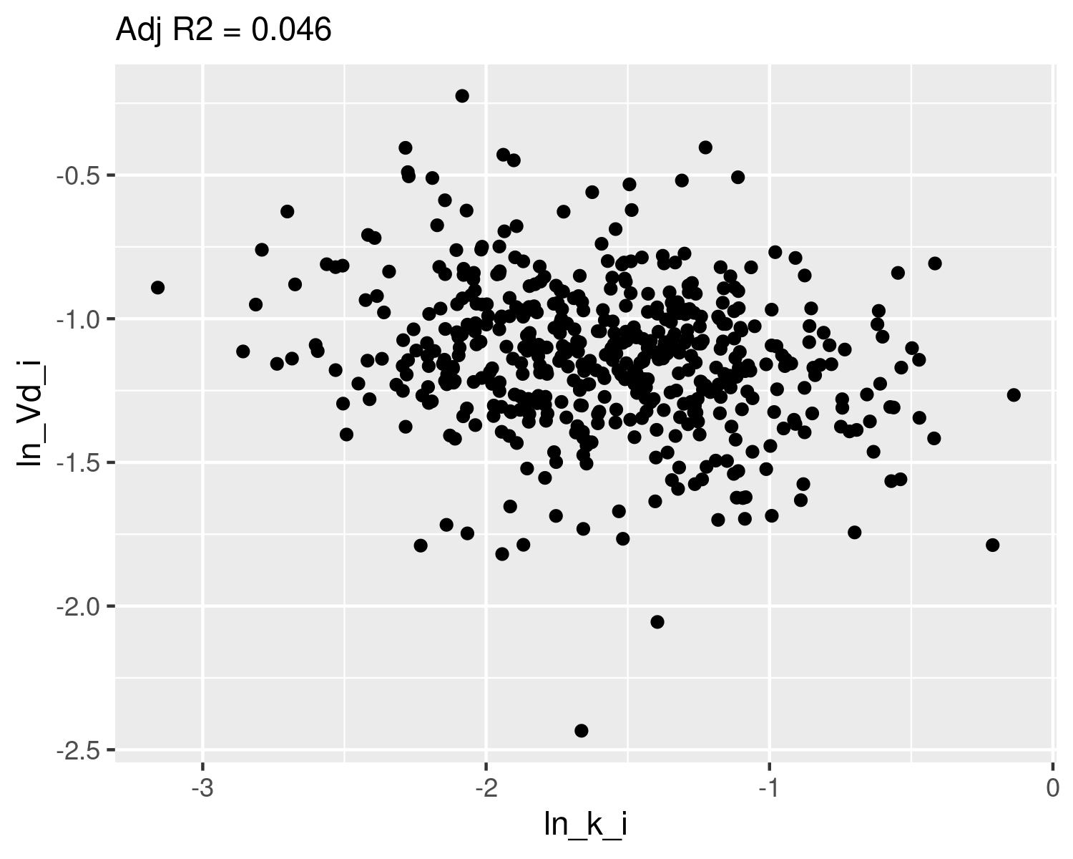

## Check normality

qqnorm(dat$ln_k_i,main="ln k Q-Q Normal")  
qqline(dat$ln_k_i,col="red")

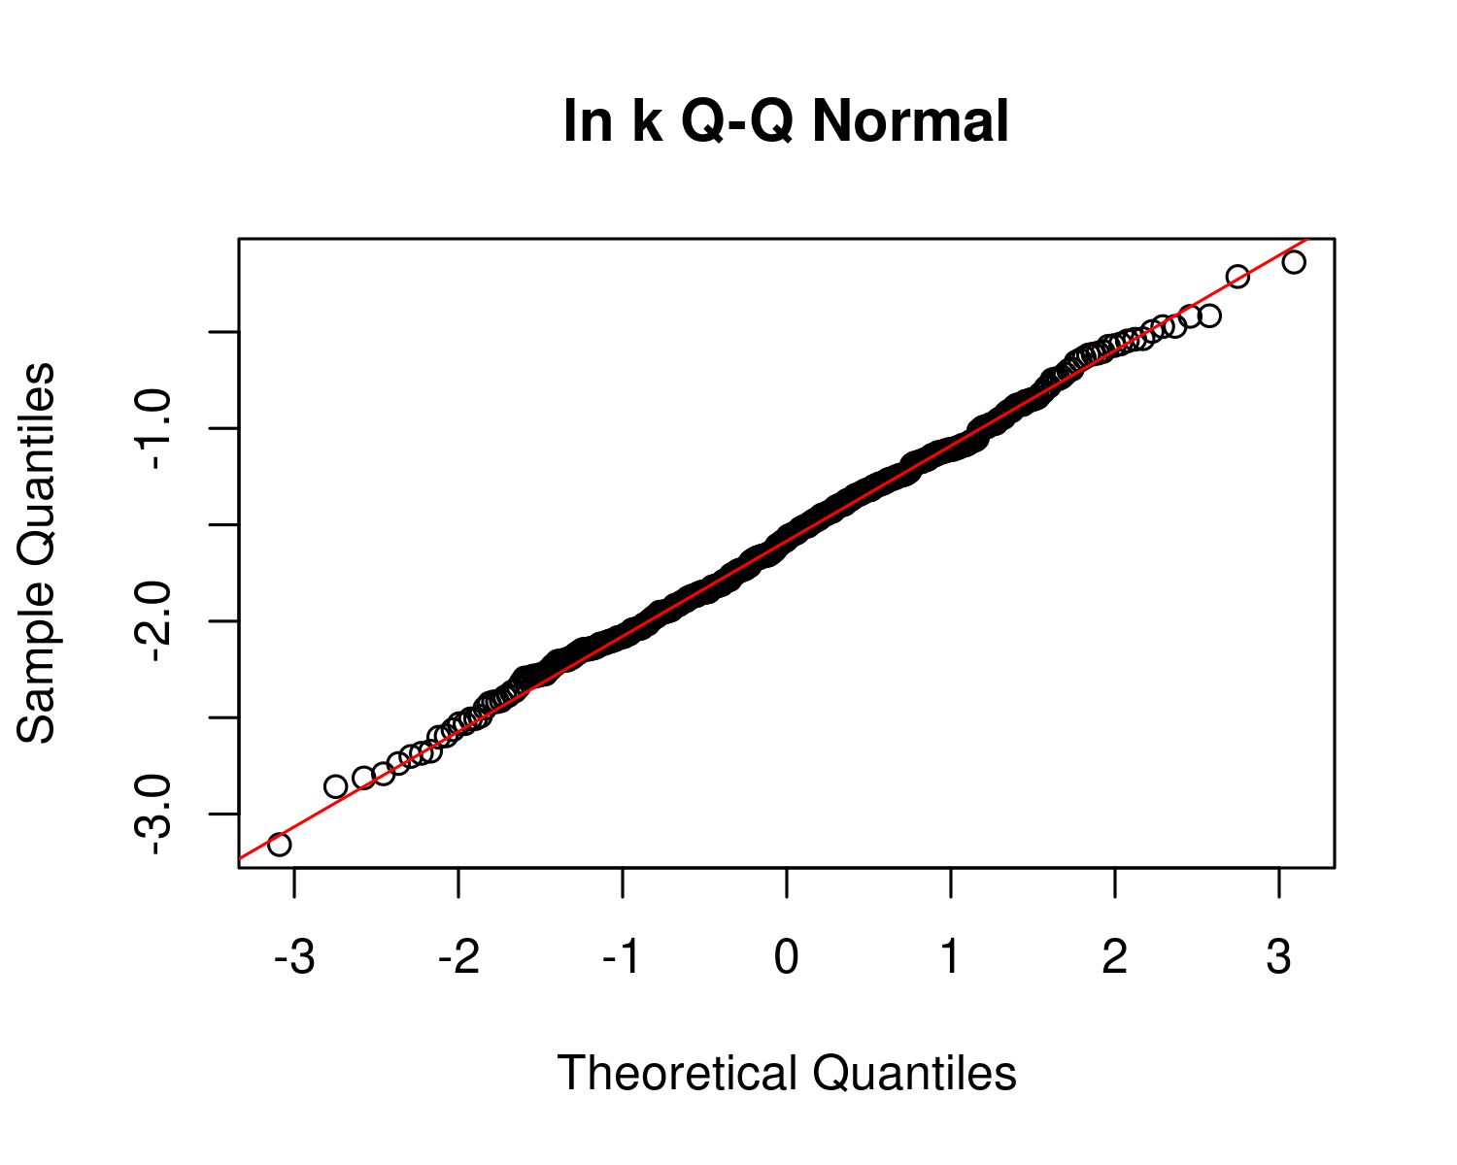

plot(ecdf(dat$ln_k_i))  
x <- seq(-3,1,0.01)  
m_ln_k_i <- mean(dat$ln_k_i)  
sd_ln_k_i <- sd(dat$ln_k_i)  
lines(x,pnorm(x,mean=m_ln_k_i,sd=sd_ln_k_i),col="red")  
text(m_ln_k_i-2*sd_ln_k_i,0.9,paste("m =",signif(m_ln_k_i,4),"\nsd =",signif(sd_ln_k_i,4)))

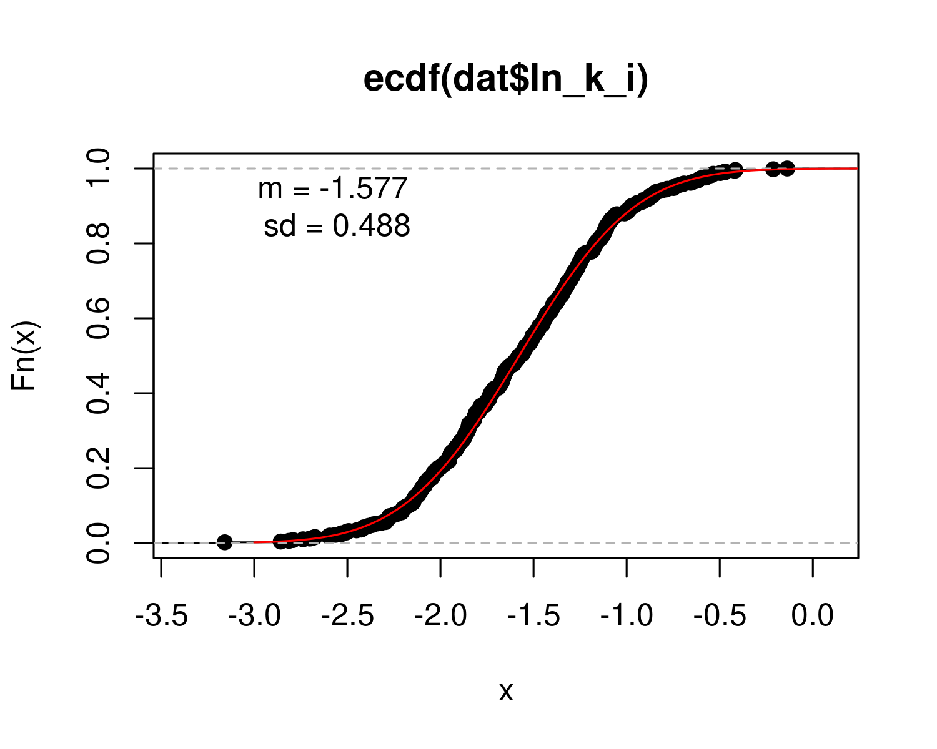

qqnorm(dat$ln_Vd_i,main="ln Vd Q-Q Normal")  
qqline(dat$ln_Vd_i,col="red")

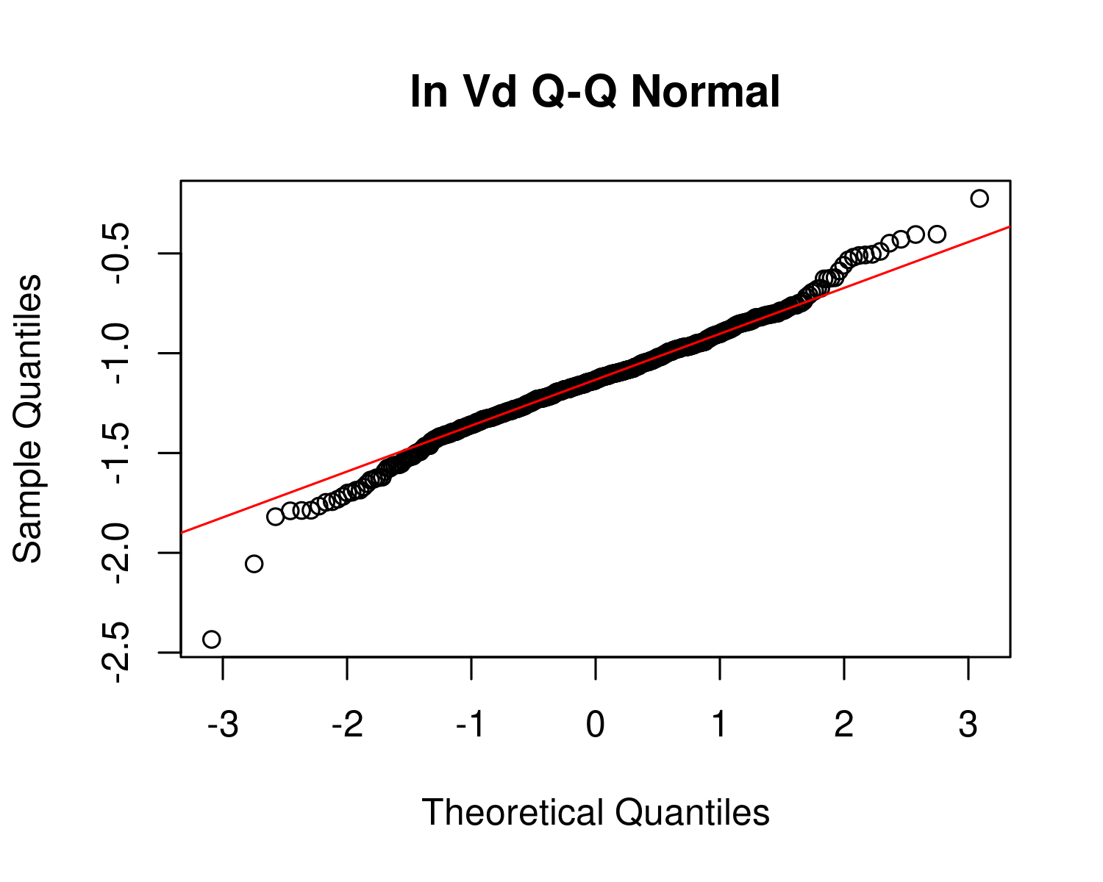

plot(ecdf(dat$ln_Vd_i))  
x <- seq(-3,1,0.01)  
m_ln_Vd_i <- mean(dat$ln_Vd_i)  
sd_ln_Vd_i <- sd(dat$ln_Vd_i)  
  
lines(x,pnorm(x,mean=m_ln_Vd_i,sd=sd_ln_Vd_i),col="red")  
text(m_ln_Vd_i-2*sd_ln_Vd_i,0.9,paste("m =",signif(m_ln_Vd_i,4),"\nsd =",signif(sd_ln_Vd_i,4)))

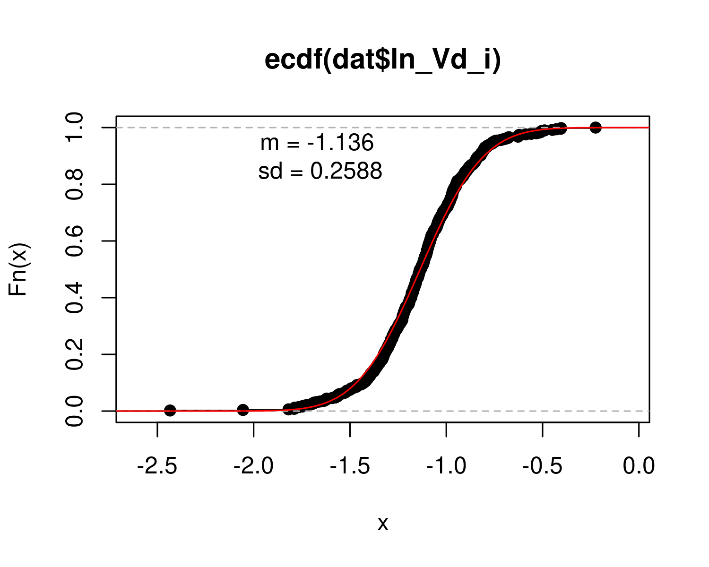

## Calculate table values for individual-level

hl_i <- log(2)/ exp(dat$ln_k_i) # individual half-life   
med_hl_i <- paste(signif (median (hl_i), 3)) # median of individual half-life  
ci_med_hl_i <- paste(signif (quantile(hl_i, prob=c(0.025,0.975)), 3),collapse="-") # 95ci med individual halflife  
gm_hl_i <- paste(signif (exp(mean(log(hl_i))), 3)) # gm (which should be really close)  
gsd_hl_i <- paste(signif (exp(sd(log(hl_i))), 3)) # gsd individual  
  
med_Vd_i <- paste(signif (median(exp(dat$ln_Vd_i)), 3)) # median individual Vd  
ci_med_Vd_i <-paste(signif (quantile(exp(dat$ln_Vd_i), prob=c(0.025,0.975)), 3),collapse="-") # 95ci med individual Vd  
gm_vd_i <- paste(signif (exp(mean(dat$ln_Vd_i)), 3)) # gm (which should be really close)  
gsd_vd_i<- paste(signif (exp(sd(dat$ln_Vd_i)), 3)) # gsd indiv

PFOS_priors <- data.frame(  
 halflife_GM= log(2)/rlnorm(50000,  
 meanlog=-1.8971,sdlog=0.4055))  
M_k <- exp(as.numeric(dat$`M_ln_k(1)`))  
PFOS_halflife_GM <- log(2)/M_k  
  
PFOS_hlgm_pr_med <- signif(median(PFOS_priors$halflife_GM,3))  
PFOS_hlgm_pr_med_95ci <-paste(signif(quantile(PFOS_priors$halflife_GM,  
 prob=c(0.025,0.975)),  
 3),  
 collapse="-")  
  
PFOS_hl_median_gm <- signif(median(PFOS_halflife_GM),3)  
PFOS_hl_median_gm_95ci <- paste(signif(quantile(PFOS_halflife_GM,  
 prob=c(0.025,0.975)),3),collapse="-")  
  
p<-ggplot()+  
 stat_density(aes(halflife_GM, color = "Prior"),data=PFOS_priors,geom="line",size=2)+  
 stat_density(aes(PFOS_halflife_GM,stat(density),color="Posterior"),geom="line",size=1.5 )+  
 xlim(0,15)+  
 labs(title = bquote("C: PFOS"~T[1/2]~"Population GM") ,  
 subtitle=paste("Posterior Median (95% CI): ",  
 PFOS_hl_median_gm," (",  
 PFOS_hl_median_gm_95ci,  
 ")",sep=""))+  
 xlab(bquote("Population GM"~T[1/2]~"(yrs)")) +  
 scale_color_manual(name=NULL,#  
 values=c(Prior="#009988", Posterior="#EE7733" )) +   
 theme_classic() +   
 theme(legend.title = element_blank(),legend.position=c(0.8,0.7),  
 panel.background = element_rect(color="black",size=1),  
 legend.background = element_rect(fill="transparent", color=NA))  
print(p)

## Warning: Removed 80 rows containing non-finite values (stat_density).

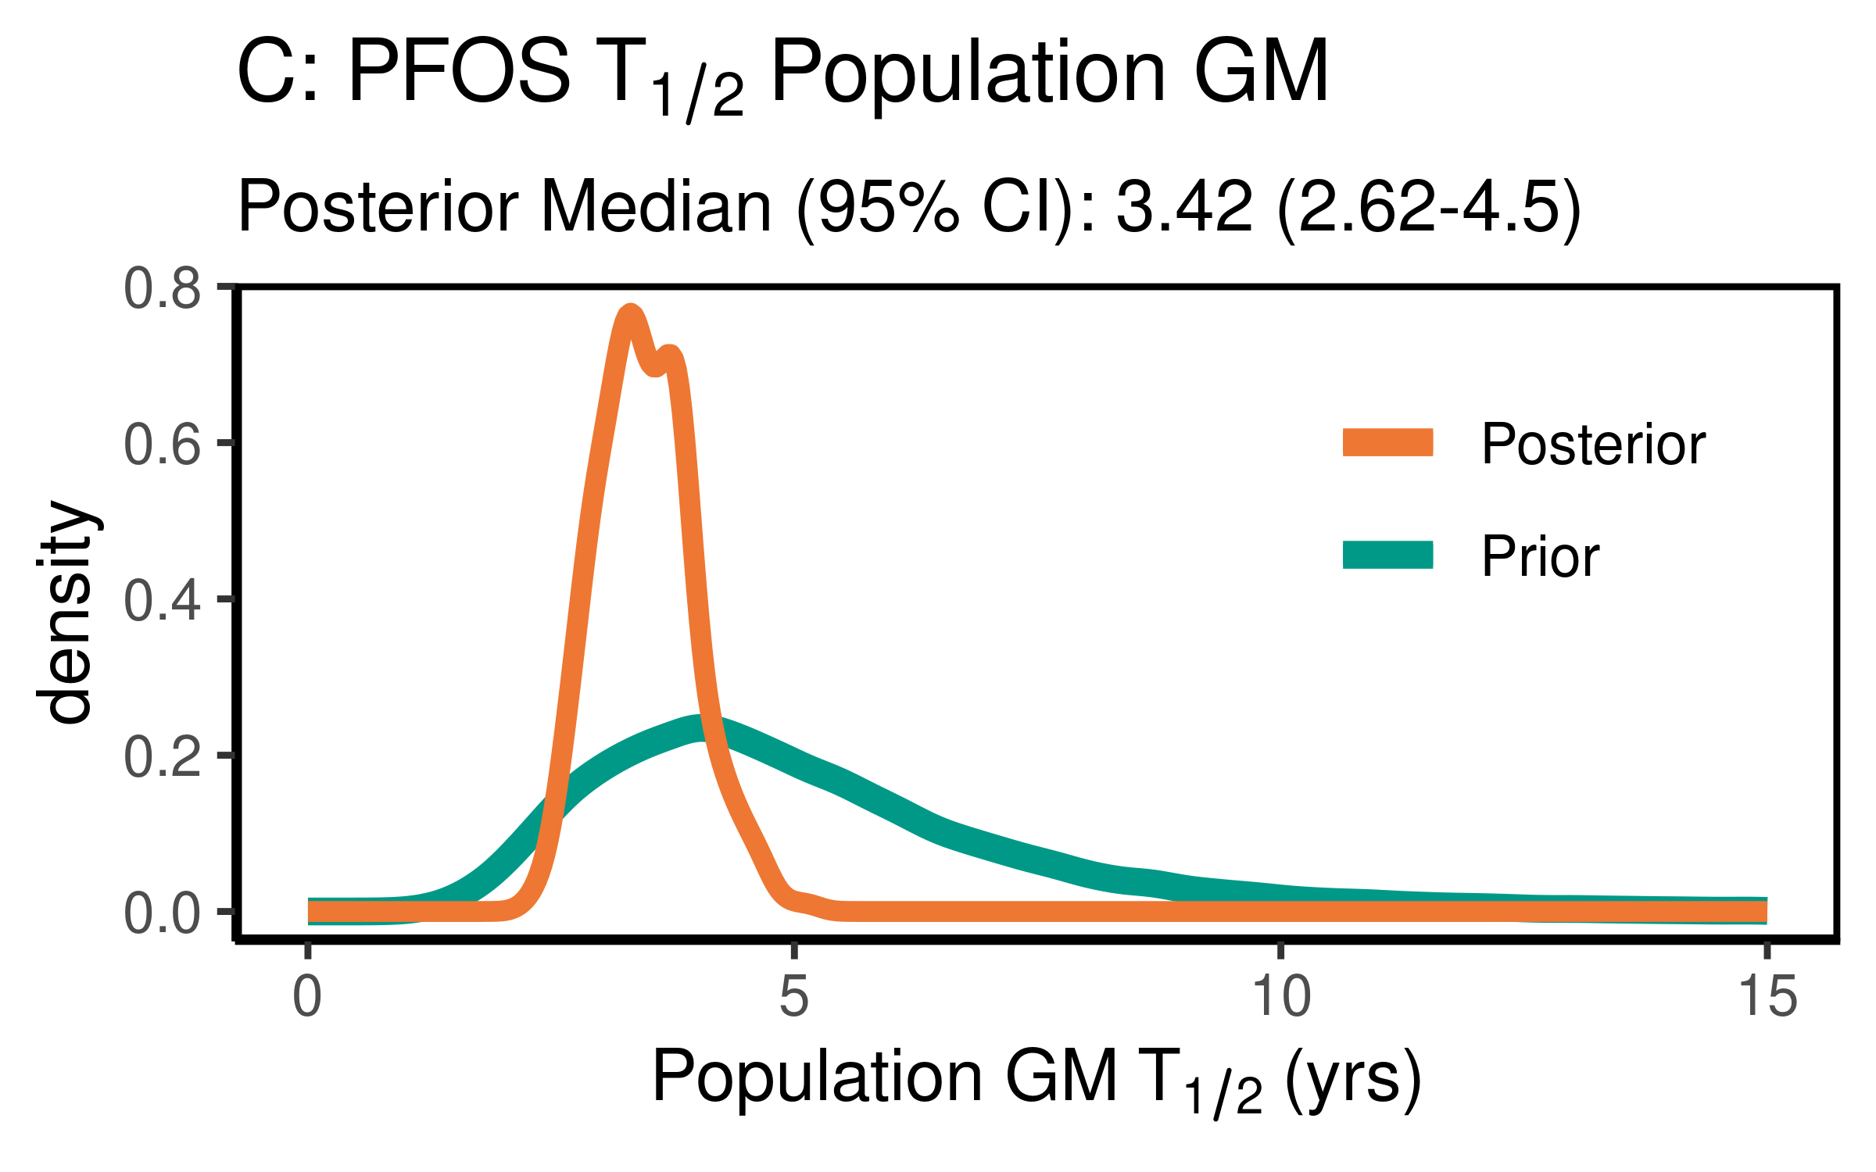

ggsave(here ("output-plots",paste0( sa,"PFOS_hl_gm.pdf")), p, dpi=600)

## Saving 4 x 2.5 in image

## Warning: Removed 80 rows containing non-finite values (stat_density).

PFOS_priors$halflife_GSD = exp(sqrt(exp(rnorm(50000,m=log(0.1987),sd=log(1.267)))))   
PFOS_halflife_GSD <- exp(sqrt(dat$`V_ln_k(1)`))  
  
PFOS_hlgsd_pr_med <- signif(median(PFOS_priors$halflife_GSD,3))  
PFOS_hlgsd_pr_med_95ci <-paste(signif(quantile(PFOS_priors$halflife_GSD,  
 prob=c(0.025,0.975)),  
 3),  
 collapse="-")  
PFOS_hl_gsd_med <- signif(median(PFOS_halflife_GSD),3)  
PFOS_hl_gsd_med_95ci <- paste(signif(quantile(PFOS_halflife_GSD,  
 prob=c(0.025,0.975)),3),collapse="-")  
p<-ggplot()+  
 stat_density(aes(halflife_GSD, color = "Prior"),data=PFOS_priors,geom="line",size=2)+  
 stat_density(aes(PFOS_halflife_GSD,stat(density), color = "Posterior"),geom="line",size=1.5)+  
 xlim(1,3)+  
 labs(title = bquote("D: PFOS"~T[1/2]~"Population GSD"),   
 subtitle=paste("Posterior Median (95% CI): ",  
 PFOS_hl_gsd_med," (",  
 PFOS_hl_gsd_med_95ci,  
 ")",sep=""))+  
 xlab(bquote("Population GSD"~T[1/2]))+  
 scale_color_manual(name=NULL,#  
 values=c(Prior="#009988", Posterior="#EE7733" ))+   
 theme_classic() +   
 theme(legend.title = element_blank(),legend.position=c(0.8,0.7),  
 panel.background = element_rect(color="black",size=1),  
 legend.background = element_rect(fill="transparent", color=NA))  
print(p)

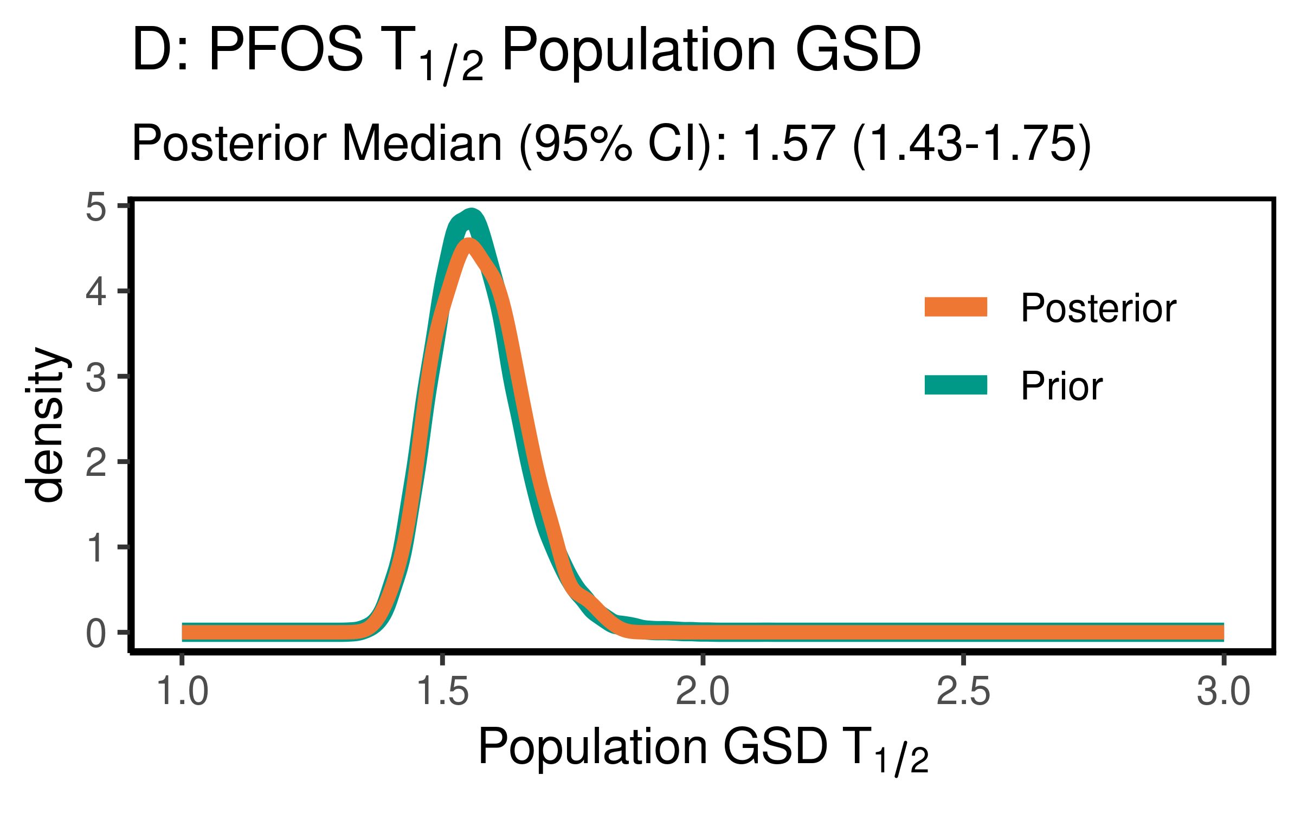

ggsave(here ("output-plots",paste0( sa, "PFOS_hl_gsd.pdf")), p, dpi=600)

### Distribution Volume

For PFOS, the data were not particularly informative, but slightly increased the estimate of the median to 0.308(0.223-0.548) slightly. They were not informative as to the population GSD, with the posterior distributions essentially unchanged from the priors.

PFOS_priors$Vd_GM <- rlnorm(50000,  
 meanlog=-1.46968,  
 sdlog=0.2624)  
PFOS_Vd_GM <- exp(dat$`M_ln_Vd(1)`)  
  
   
  
PFOS_vd_gm_pr_med <- signif(median(PFOS_priors$Vd_GM,3))  
PFOS_vd_gm_pr_med_95ci <- paste(signif(quantile(PFOS_priors$Vd_GM,  
 prob=c(0.025,0.975)), 3), collapse="-")  
PFOS_vd_gm_med <- signif(median(PFOS_Vd_GM),3)  
PFOS_vd_gm_med_95ci <- paste(signif(quantile(PFOS_Vd_GM,  
 prob=c(0.025,0.975)),3),collapse="-")  
  
p<-ggplot()+  
 stat_density(aes(Vd_GM, color = "Prior"),data=PFOS_priors,geom="line",size=2)+  
 stat_density(aes(PFOS_Vd_GM,stat(density), color = "Posterior"),geom="line",size=1.5)+  
 xlim(0,1)+labs(title = bquote("C: PFOS"~V[d]~"Population GM"),  
 subtitle=paste("Posterior Median (95% CI): ",  
 PFOS_vd_gm_med," (",   
 PFOS_vd_gm_med_95ci,")",sep=""))+  
 xlab(bquote("Population GM"~V[d]~"(l/kg)"))+  
 scale_color_manual(name=NULL,#  
 values=c(Prior="#009988", Posterior="#EE7733" )) + theme_classic() +   
 theme(legend.title = element_blank(),legend.position=c(0.8,0.7),  
 panel.background = element_rect(color="black",size=1),  
 legend.background = element_rect(fill="transparent", color=NA))  
print(p)

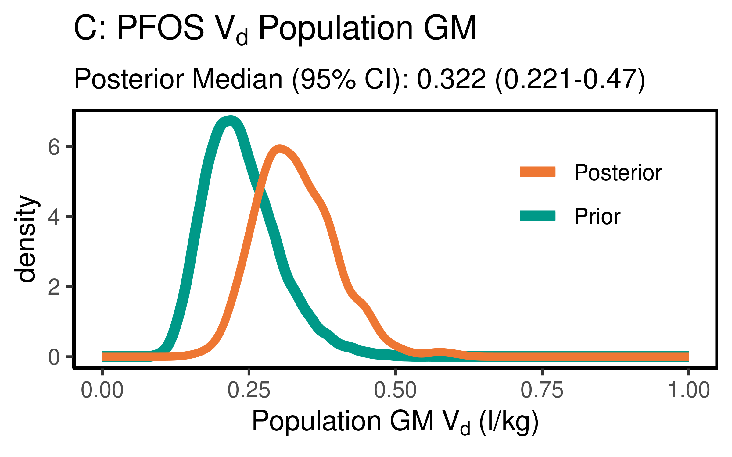

ggsave(here ("output-plots",paste0( sa, "PFOS_vd_gm.pdf")), p, dpi=600)

PFOS_priors$Vd_GSD = exp(abs(rnorm(50000,sd=0.17)))  
PFOS_Vd_GSD <- exp(dat$`SD_ln_Vd(1)`)  
  
PFOS_vd_gsd_pr_med <- signif(median(PFOS_priors$Vd_GSD,3))  
PFOS_vd_gsd_pr_med_95ci <- paste(signif(quantile(PFOS_priors$Vd_GSD,  
 prob=c(0.025,0.975)), 3), collapse="-")  
  
PFOS_vd_gsd_med <- signif(median(PFOS_Vd_GSD),3)  
PFOS_vd_gsd_med_95ci <- paste(signif(quantile(PFOS_Vd_GSD,  
 prob=c(0.025,0.975)),3),collapse="-")  
  
p<-ggplot()+  
 stat_density(aes(Vd_GSD, color = "Prior"),data=PFOS_priors,geom="line",size=2)+  
 stat_density(aes(PFOS_Vd_GSD,stat(density), color = "Posterior"),geom="line",size=1.5)+  
 xlim(1,3)+  
 labs(title = bquote("D: PFOS"~V[d]~"Population GSD "),  
 subtitle=paste("Posterior Median (95% CI): ",  
 PFOS_vd_gsd_med," (",  
 PFOS_vd_gsd_med_95ci,  
 ")",sep=""))+  
 xlab(bquote("Population GSD"~V[d]))+  
 scale_color_manual(name=NULL,   
 values=c(Prior="#009988", Posterior="#EE7733" )) +   
 theme_classic() +   
 theme(legend.title = element_blank(),legend.position=c(0.8,0.7),  
 panel.background = element_rect(color="black",size=1),  
 legend.background = element_rect(fill="transparent", color=NA))  
print(p)

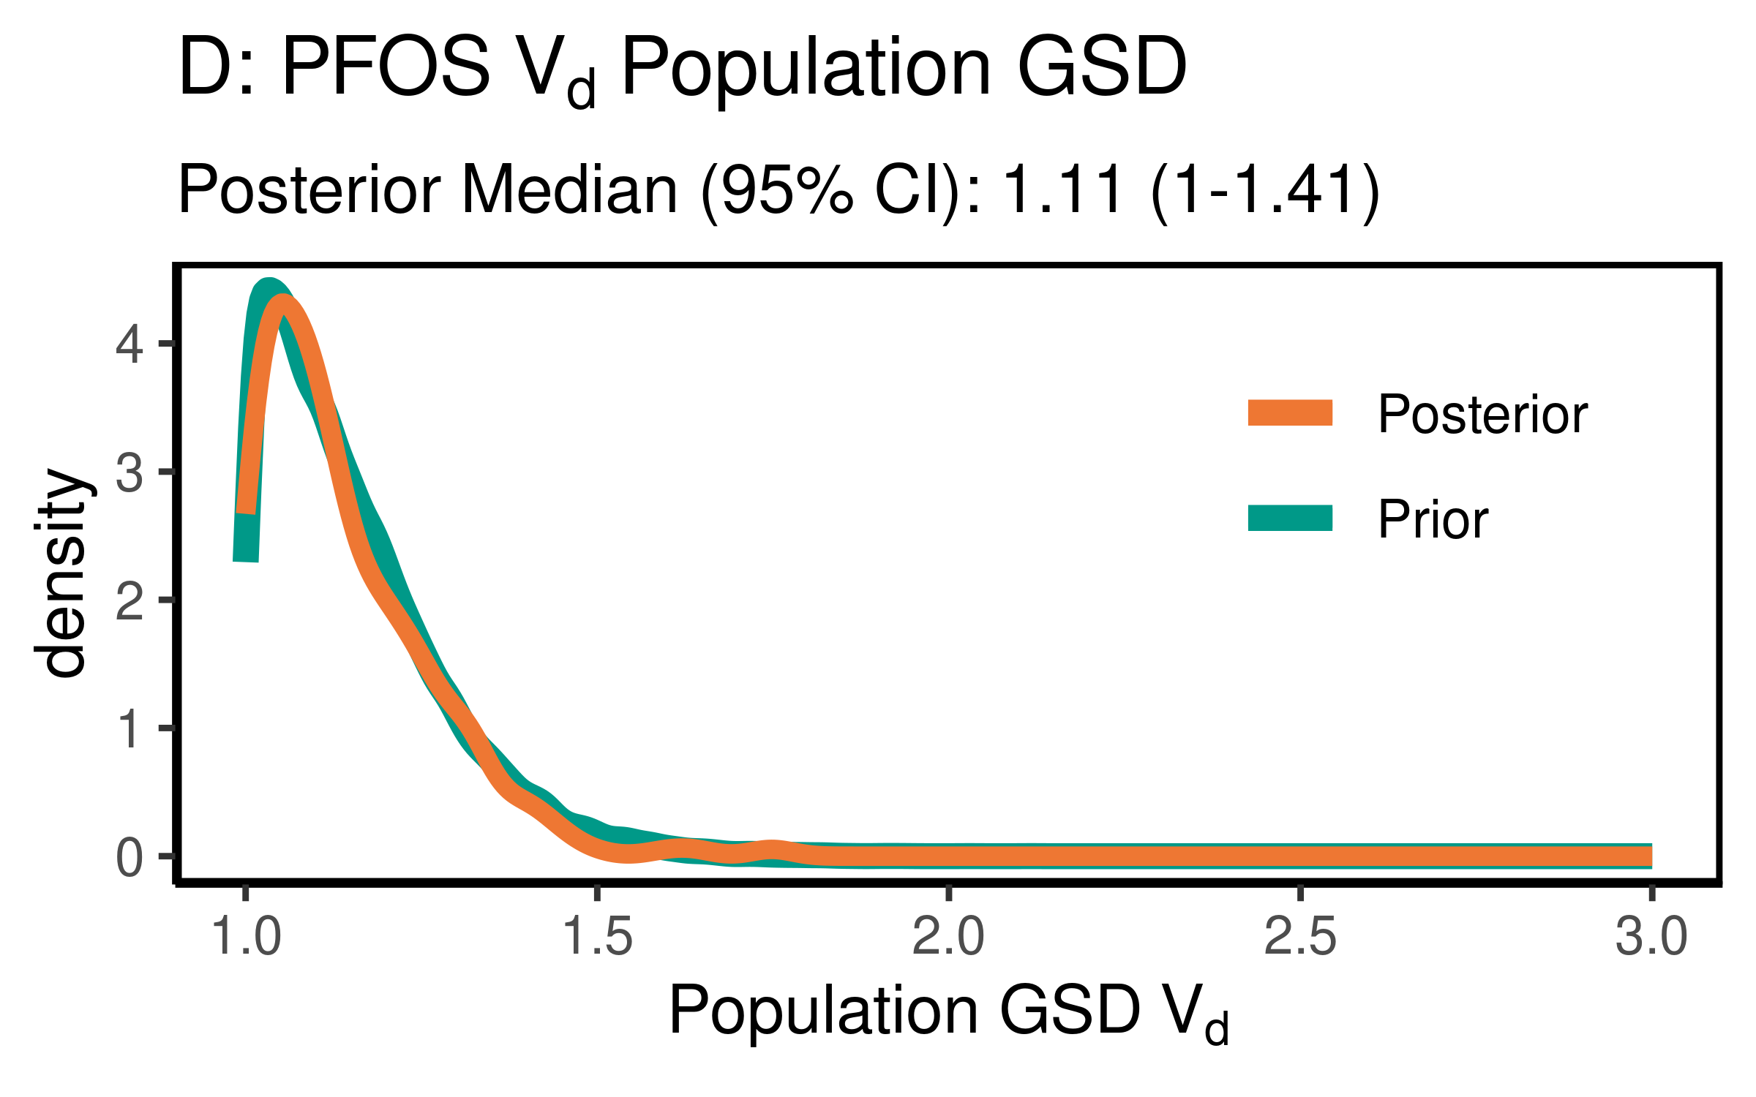

ggsave(here ("output-plots",paste0( sa, "PFOS_vd_gsd.pdf")), p, dpi=600)

### Clearance (just pop GM)

Cl is k * Vd

PFOS_priors$CL_GM <- PFOS_priors$Vd_GM * (log(2)/PFOS_priors$halflife_GM)  
PFOS_CL_GM <- exp(dat$`M_ln_Vd(1)` + dat$`M_ln_k(1)`)  
  
PFOS_cl_gm_pr_med <- signif(median(PFOS_priors$CL_GM,3))  
PFOS_cl_gm_pr_med_95ci <- paste(signif(quantile(PFOS_priors$CL_GM,  
 prob=c(0.025,0.975)), 3), collapse="-")  
PFOS_cl_gm_med <- signif(median(PFOS_CL_GM),3)  
PFOS_cl_gm_med_95ci <- paste(signif(quantile(PFOS_CL_GM,  
 prob=c(0.025,0.975)),3),collapse="-")  
  
p<-ggplot()+  
 stat_density(aes(CL_GM, color = "Prior"),data=PFOS_priors,geom="line",size=2)+  
 stat_density(aes(PFOS_CL_GM,stat(density), color = "Posterior"),geom="line",size=1.5)+  
 xlim(0,0.25)+labs(title = "B: PFOS Clearance Pop. GM ",subtitle=paste("Posterior Median (95% CI): ",  
 PFOS_cl_gm_med," (",  
 PFOS_cl_gm_med_95ci,  
 ")",sep=""))+  
 xlab("Pop. GM CL (l/(kg-yr))")+  
 scale_color_manual(name=NULL,#  
 values=c(Prior="#009988", Posterior="#EE7733" )) +   
 theme_classic() +   
 theme(legend.title = element_blank(),legend.position=c(0.8,0.7),  
 panel.background = element_rect(color="black",size=1),  
 legend.background = element_rect(fill="transparent", color=NA))  
print(p)

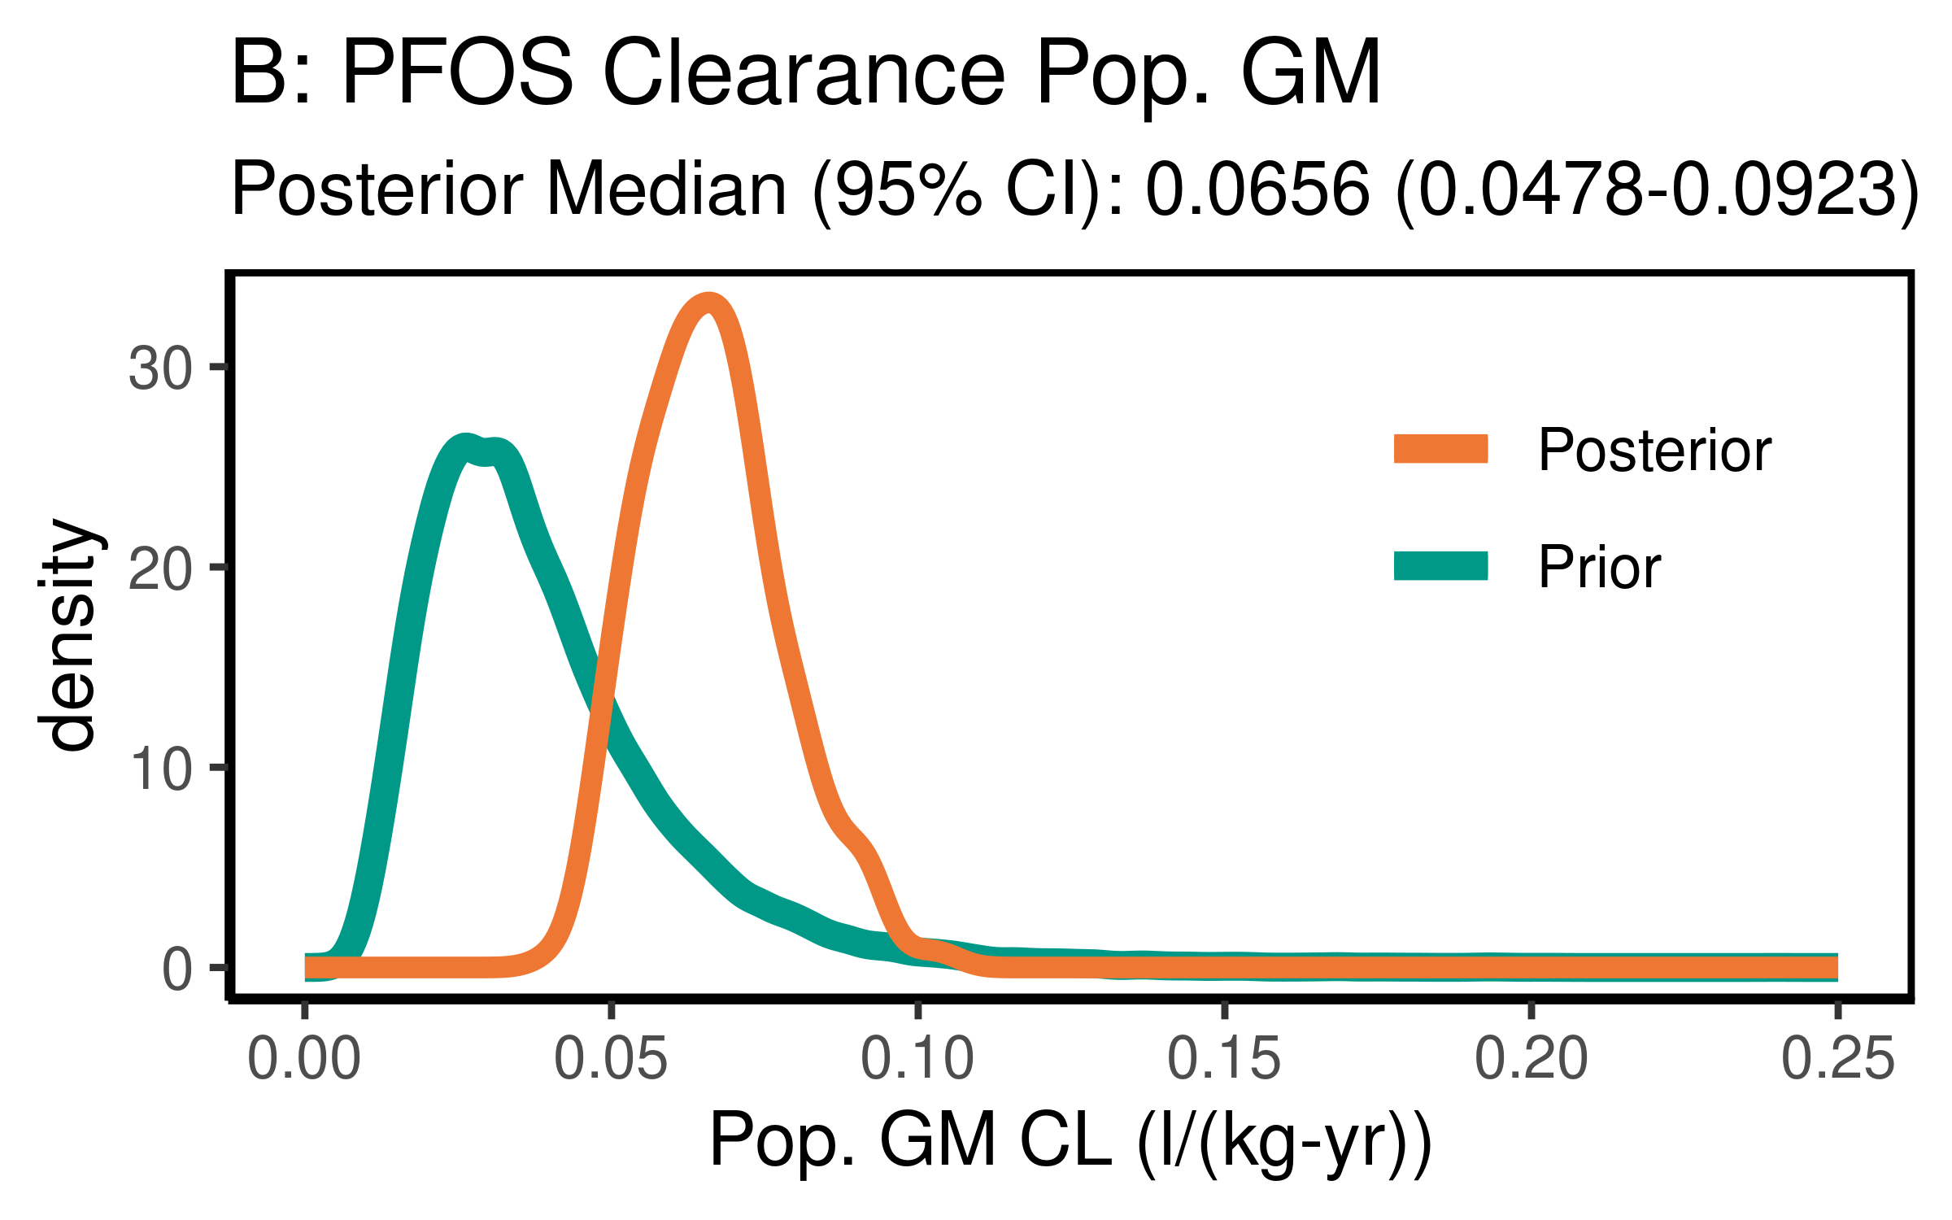

ggsave(here ("output-plots",paste0( sa, "PFOS_CL_gm.pdf")), p, dpi=600)

## Table significant digit values

PFOS_hlgm_pr_med <- paste(signif(PFOS_hlgm_pr_med, 3))  
PFOS_hl_median_gm<- paste(signif(PFOS_hl_median_gm, 3))  
PFOS_hlgsd_pr_med<- paste(signif(PFOS_hlgsd_pr_med, 3))  
PFOS_hl_gsd_med<- paste(signif(PFOS_hl_gsd_med, 3))  
PFOS_vd_gm_pr_med<- paste(signif(PFOS_vd_gm_pr_med, 3))  
PFOS_vd_gm_med<- paste(signif(PFOS_vd_gm_med, 3))  
PFOS_vd_gsd_pr_med<- paste(signif(PFOS_vd_gsd_pr_med, 3))  
PFOS_vd_gsd_med<- paste(signif(PFOS_vd_gsd_med, 3))  
PFOS_cl_gm_pr_med<- paste(signif(PFOS_cl_gm_pr_med, 3))  
PFOS_cl_gm_med<- paste(signif(PFOS_cl_gm_med, 3))

### Population median estimates [95% CI]

|  |  |  |  |  |
| --- | --- | --- | --- | --- |
| Parameter | Prior GM | Posterior GM | Prior GSD | Posterior GSD |
| Half-life (years) | 4.62 | 3.42 | 1.56 | 1.57 |
| HL [95% CI] | [2.08-10.3] | [2.62-4.5] | [1.42-1.76] | [1.43-1.75] |
| Volume of distribution | 0.23 | 0.322 | 1.12 | 1.11 |
| [95% CI] | [0.137-0.384] | [0.221-0.47] | [1.01-1.46] | [1-1.41] |
| Clearance | 0.0344 | 0.0656 |  |  |
| [95% CI] | [0.0133-0.0894] | [0.0478-0.0923] | [] | [] |

### Individual Posterior estimates

|  |  |  |  |
| --- | --- | --- | --- |
| Parameter | median GM [95% CI] | GM calculator input | GSD individual |
| Half-life (years) | 3.35 [ 1.25-8.61 ] | 3.36 | 1.63 |
| Volume of distribution | 0.322 [ 0.184-0.547 ] | 0.321 | 1.3 |

## Error in get(genname, envir = envir) : object 'testthat_print' not found

## ─ Session info ───────────────────────────────────────────────────────────────  
## setting value   
## version R version 3.6.1 (2019-07-05)  
## os Oracle Linux Server 7.9   
## system x86_64, linux-gnu   
## ui X11   
## language (EN)   
## collate en_US.UTF-8   
## ctype en_US.UTF-8   
## tz America/New_York   
## date 2021-03-28   
##   
## ─ Packages ───────────────────────────────────────────────────────────────────  
## package * version date lib source   
## assertthat 0.2.1 2019-03-21 [2] CRAN (R 3.6.1)   
## backports 1.1.5 2019-10-02 [2] CRAN (R 3.6.1)   
## bayesplot * 1.7.0 2019-05-23 [2] CRAN (R 3.6.1)   
## broom 0.7.3 2020-12-16 [1] CRAN (R 3.6.1)   
## callr 3.3.2 2019-09-22 [2] CRAN (R 3.6.1)   
## cellranger 1.1.0 2016-07-27 [2] CRAN (R 3.6.1)   
## cli 2.0.0 2019-12-09 [1] CRAN (R 3.6.1)   
## coda * 0.19-3 2019-07-05 [2] CRAN (R 3.6.1)   
## codetools 0.2-16 2018-12-24 [2] CRAN (R 3.6.1)   
## colorspace 1.4-1 2019-03-18 [2] CRAN (R 3.6.1)   
## crayon 1.3.4 2017-09-16 [2] CRAN (R 3.6.1)   
## DBI 1.1.0 2019-12-15 [1] CRAN (R 3.6.1)   
## dbplyr 1.4.2 2019-06-17 [2] CRAN (R 3.6.1)   
## desc 1.2.0 2018-05-01 [2] CRAN (R 3.6.1)   
## devtools 2.2.1 2019-09-24 [2] CRAN (R 3.6.1)   
## digest 0.6.23 2019-11-23 [2] CRAN (R 3.6.1)   
## dplyr * 1.0.3 2021-01-15 [1] CRAN (R 3.6.1)   
## ellipsis 0.3.0 2019-09-20 [2] CRAN (R 3.6.1)   
## evaluate 0.14 2019-05-28 [2] CRAN (R 3.6.1)   
## fansi 0.4.0 2018-10-05 [2] CRAN (R 3.6.1)   
## farver 2.0.1 2019-11-13 [2] CRAN (R 3.6.1)   
## forcats * 0.4.0 2019-02-17 [2] CRAN (R 3.6.1)   
## fs 1.3.1 2019-05-06 [2] CRAN (R 3.6.1)   
## generics 0.0.2 2018-11-29 [2] CRAN (R 3.6.1)   
## ggplot2 * 3.3.2 2020-06-19 [1] CRAN (R 3.6.1)   
## ggridges 0.5.1 2018-09-27 [2] CRAN (R 3.6.1)   
## ggsci * 2.9 2018-05-14 [1] CRAN (R 3.6.1)   
## glue 1.4.2 2020-08-27 [1] CRAN (R 3.6.1)   
## gtable 0.3.0 2019-03-25 [2] CRAN (R 3.6.1)   
## haven 2.2.0 2019-11-08 [2] CRAN (R 3.6.1)   
## here * 0.1 2017-05-28 [2] CRAN (R 3.6.1)   
## hms 0.5.2 2019-10-30 [2] CRAN (R 3.6.1)   
## htmltools 0.4.0 2019-10-04 [2] CRAN (R 3.6.1)   
## httr 1.4.1 2019-08-05 [2] CRAN (R 3.6.1)   
## jsonlite 1.6 2018-12-07 [2] CRAN (R 3.6.1)   
## khroma * 1.4.1 2021-02-18 [1] Github (nfrerebeau/khroma@cc795c1)  
## knitr 1.26 2019-11-12 [2] CRAN (R 3.6.1)   
## labeling 0.3 2014-08-23 [2] CRAN (R 3.6.1)   
## lattice 0.20-38 2018-11-04 [2] CRAN (R 3.6.1)   
## lifecycle 0.2.0 2020-03-06 [1] CRAN (R 3.6.1)   
## lubridate 1.7.4 2018-04-11 [2] CRAN (R 3.6.1)   
## magrittr 1.5 2014-11-22 [2] CRAN (R 3.6.1)   
## memoise 1.1.0 2017-04-21 [2] CRAN (R 3.6.1)   
## modelr 0.1.5 2019-08-08 [2] CRAN (R 3.6.1)   
## munsell 0.5.0 2018-06-12 [2] CRAN (R 3.6.1)   
## pillar 1.4.3 2019-12-20 [1] CRAN (R 3.6.1)   
## pkgbuild 1.0.6 2019-10-09 [2] CRAN (R 3.6.1)   
## pkgconfig 2.0.3 2019-09-22 [2] CRAN (R 3.6.1)   
## pkgload 1.0.2 2018-10-29 [2] CRAN (R 3.6.1)   
## plyr 1.8.4 2016-06-08 [2] CRAN (R 3.6.1)   
## prettyunits 1.0.2 2015-07-13 [2] CRAN (R 3.6.1)   
## processx 3.4.1 2019-07-18 [2] CRAN (R 3.6.1)   
## ps 1.3.0 2018-12-21 [2] CRAN (R 3.6.1)   
## purrr * 0.3.3 2019-10-18 [2] CRAN (R 3.6.1)   
## R6 2.4.1 2019-11-12 [2] CRAN (R 3.6.1)   
## Rcpp 1.0.3 2019-11-08 [2] CRAN (R 3.6.1)   
## readr * 1.3.1 2018-12-21 [2] CRAN (R 3.6.1)   
## readxl 1.3.1 2019-03-13 [2] CRAN (R 3.6.1)   
## remotes 2.1.0 2019-06-24 [2] CRAN (R 3.6.1)   
## reprex 0.3.0 2019-05-16 [2] CRAN (R 3.6.1)   
## reshape2 * 1.4.3 2017-12-11 [2] CRAN (R 3.6.1)   
## rlang 0.4.10 2020-12-30 [1] CRAN (R 3.6.1)   
## rmarkdown 2.3 2020-06-18 [1] CRAN (R 3.6.1)   
## rprojroot 1.3-2 2018-01-03 [2] CRAN (R 3.6.1)   
## rstudioapi 0.10 2019-03-19 [2] CRAN (R 3.6.1)   
## rvest 0.3.5 2019-11-08 [2] CRAN (R 3.6.1)   
## scales 1.1.0 2019-11-18 [2] CRAN (R 3.6.1)   
## sessioninfo 1.1.1 2018-11-05 [2] CRAN (R 3.6.1)   
## stringi 1.4.3 2019-03-12 [2] CRAN (R 3.6.1)   
## stringr * 1.4.0 2019-02-10 [2] CRAN (R 3.6.1)   
## testthat 2.3.0 2019-11-05 [2] CRAN (R 3.6.1)   
## tibble * 3.0.5 2021-01-15 [1] CRAN (R 3.6.1)   
## tidyr * 1.0.0 2019-09-11 [2] CRAN (R 3.6.1)   
## tidyselect 1.1.0 2020-05-11 [1] CRAN (R 3.6.1)   
## tidyverse * 1.3.0 2019-11-21 [2] CRAN (R 3.6.1)   
## usethis 1.5.1 2019-07-04 [2] CRAN (R 3.6.1)   
## vctrs 0.3.6 2020-12-17 [1] CRAN (R 3.6.1)   
## withr 2.1.2 2018-03-15 [2] CRAN (R 3.6.1)   
## xfun 0.11 2019-11-12 [2] CRAN (R 3.6.1)   
## xml2 1.2.2 2019-08-09 [2] CRAN (R 3.6.1)   
## yaml 2.2.0 2018-07-25 [2] CRAN (R 3.6.1)   
##   
## [1] /home/ad.abt.local/layc/R/library  
## [2] /opt/R/3.6.1/lib64/R/library