OPC Servant Documentation

B. J. Hill

2022-03-12

Table of Contents
1 Introduction 5
2 Installation 5
3 Licences 6
3.1 Prerequisites 6
3.1.1 Packages Built From Sources 6
3.1.2 From Repositories 6
3.1.3 OPC Servant Sources 6
3.2 Creating the Runtime Environment 7
3.3 Running the application 7
3.4 udev Rules 7
3.5 Local Database 7
3.6 Wt Data directory 7
4 User Guide 8
4.1 Overview 8
4.1.1 Desktop Interface 8
4.1.1.1 System Properties 8
4.1.1.2 User Configuration 9
4.1.1.3 Navigator 10
4.1.1.3.1 System Tab 10
4.1.1.4 Reports 11
4.1.1.5 Trace 12
4.1.1.6 Item Tab Views 13
5 Web Interface 13
5.1 System Configuration 14
5.2 HMI 14
5.3 Reports 15
5.4 Maridb (MySQL) Database 15
5.5 MQTT 15
5.5.1 Publish 15
5.5.2 Commands 15
5.6 OPC UA 16
6 Programmer’s Guide 17
6.1 Functional Overview 17
6.2 Classes 18
6.2.1 MRL::VariantPropertyTree 18
6.2.2 MRL::PropertyPath 18
6.2.3 MRL::ObjectManager 18
6.2.4 MRL::Bobject 19
6.2.5 MRL::RTObject 19
6.2.6 MRL::Message 20
6.2.7 MRL::Plugin 20
6.2.8 MRL::Common 20
6.3 Module Developer Guide 21
6.4 Configuration Dialogues 22
6.4.1 Desktop 22
6.4.2 Web 22
6.5 Runtime Interface 22
7 Procedural Nodes 23
7.1 Features 23
7.2 Program Structure 24
7.3 GUI 25
7.4 Web Interface 25
7.5 Sub-Flows 25
7.6 Building 25

Glossary

SBC Single Board Computer
OPCS OPC Servant Application

Introduction

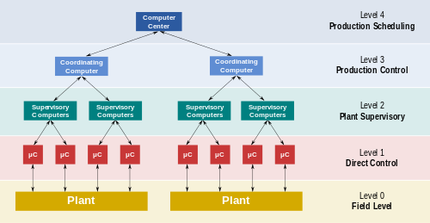
OPC Servant (OPCS) is a framework for providing SCADA level 0 and 1 capabilities with desktop and web HMI for configuration and monitoring.

Alternatively OpcServant can be viewed as a framework for developing OPC UA servers with desktop and web configuration interfaces.

The framework can be run headless, web based or with a desktop (touchscreen ) interface. The framework is suitable for stand alone instruments using common Single Board Computers, such as the Raspberry Pi.

The framework supports common network connectivity such as OPC UA, MQTT and SQL databases. This means OPCS based systems are easy to connect to other systems, such as Node Red and Crystal Reports. OPCS provides a basic HMI and reporting interfaces. Using packages like Node Red and Crystal Reports allows a wide range of user customisation.

OPCS is modular application written in C++ built on the wxWidgets, Wt, open62541 and open62541Cpp frameworks. WxCrafter is used to design the GUI layouts.

Installation
OPC Servant is a Linux application. Building for Microsoft Windows and Apple Mac is expected to be possible. This how to build from sources.

Refer to the document “Raspberry Pi 4 – System Setup” for how to setup a Raspberry Pi. Much of the configuration for a Raspberry Pi applies to any Linux system.

Licences
The OPC Servant application is open source and covered by the Mozilla Public License v2.0.

OPC Servant uses many other 3rd party packages. These are open source with the exception of Wt.

Wt is dual licenced. If you wish to use OPC Servant for commercial purposes you must buy a Wt developer licence (https://www.webtoolkit.eu/wt/).

With the Raspberry Pi, VNC server support is included. However if the Raspberry Pi is used in a commercial product then a licence for VNC must be purchased.

Prerequisites

Packages Built From Sources

These are available from on GitHub. Versions in the repositories may be out of date.

- Mosquitto (https://github.com/eclipse/mosquitto.git)
- These can be cross compiled:
- Wt (https://www.webtoolkit.eu/wt)
- wxWidgets (https://www.wxwidgets.org/)
- open62541 (https://github.com/open62541/open62541.git)
- open62541cpp (git@github.com:bazza2jw/open62541Cpp.git)
- MySql++

From Repositories

The following development packages are required:

libboost-all-dev perl libnet-ssleay-perl openssl libauthen-pam-perl
libpam-runtime libio-pty-perl python libgraphicsmagick libgraphicsmagick++
libhpdf-dev qtcreator qt5-default autoconf cmake cmake-curses-gui cmake-extras
extra-cmake-modules libsqlite3-dev sqlitebrowser minicom libmariadbclient-dev
libcjson-dev libssl-dev xsltproc libgtk3-dev libsoup-dev libsdl2-dev gstreamer-dev
libmodbus-dev apache2 libfcgi-dev htmldoc

OPC Servant Sources

Get the sources from GitHub:

https://github.com/bazza2jw/OpcServant

Build the OPCS using cmake. Qt Creator can be used as the IDE or it can be built from the command line using cmake.

Creating the Runtime Environment
- Create a directory /usr/local/OpcServant and make the directory writeable for the default user. Edit the cmake files to change the install directory.
- Copy all of the files in the OpcServant/Runtime directory to this directory.
- OPCS can now be installed with make install
- Link /var/www/html/reports to the directory /usr/local/OpcServant/data/reports. This makes the generated reports accessible via the web server.

Running the application

- Change to the installation directory (/usr/local/OpcServant)
- Change to the bin directory
- Run ./Servant

udev Rules
The udev rules map USB devices so they have well known, fixed, device names.
A typical for a USB serial device is entry is:
SUBSYSTEM=="tty", ATTRS{idVendor}=="04d8", ATTRS{idProduct}=="00df",ATTRS{serial}=="0006900382" SYMLINK+="ttyFixedA"

Local Database
All published data and process messages are written to a local SQLITE database (LOCAL.DB).
There is a constraint when generating reports. If the same report is generated at the same time by different users this may fail as a result of a SQLLITE database being locked.

Wt Data directory
The Wt runtime data files are in the resources directory under /usr/local/OpcServant/bin
Refer to the Wt documentation for further details.

User Guide

Overview
There are two user interface modes, Desktop where interface runs locally and Web where the interface runs on the target but is displayed on a web browser.
OPCS can run headless that is without a display. When running headless system configuration is done using Webmin (https://webmin.com/).
It is possible for users to interact with the display and via the web concurrently.

Desktop Interface

System Properties
This form sets up the basic system parameters. This is displayed when no configuration is defined.
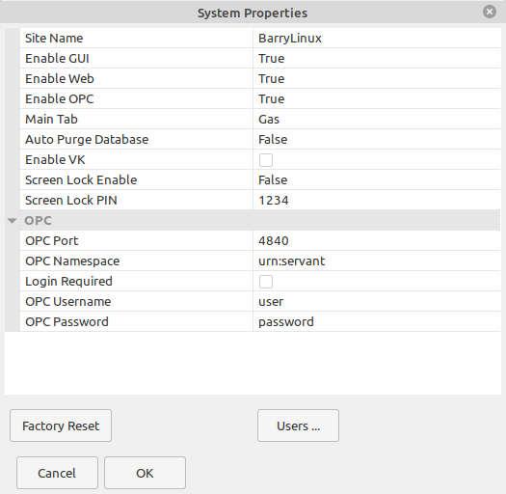
Site Name This is the name of the site.
Site Password The password to access system configuration
Enable GUI Selects if the GUI is displayed
Enable Web Selects if the web interface is enabled
Enable OPC Selects if the OPC server is enabled
MainTab This sets tab to be displayed when the system starts
OPC Port The port to run the OPC server
OPC Namespace The OPC namespace
Login Required When set an username and password is required
OPC Username The OPC username
OPC Password The OPC password

User Configuration

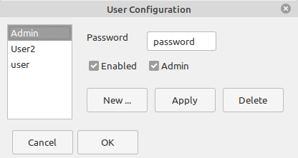
This dialogue manages users.
New adds a new user
Apply saves any changes
Delete removes a user
Enabled is checked to make a user active
Admin is checked to make a user an administrator

Navigator
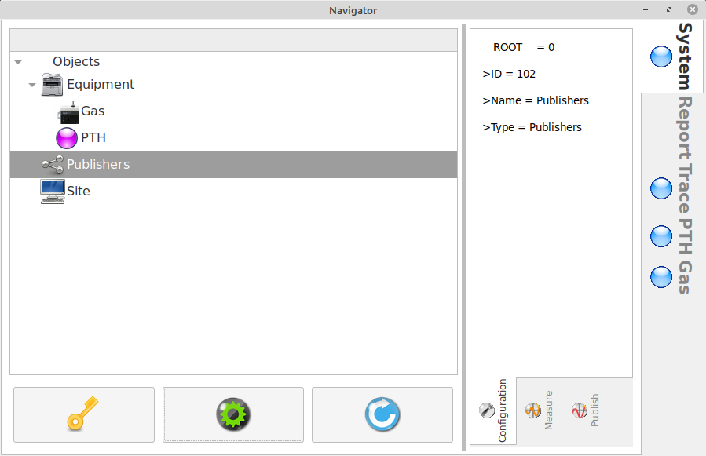
The navigator display on the desktop is a collection of tab panes.

System Tab
This configures the components.
Equipment. These are the interfaces to hardware. Right click on Equipment and select Add.
To configure an item select Properties
To delete an item select Delete
Publishers. These are interfaces to output data, and sometimes control. Right click on Equipment and select Add.

Reports
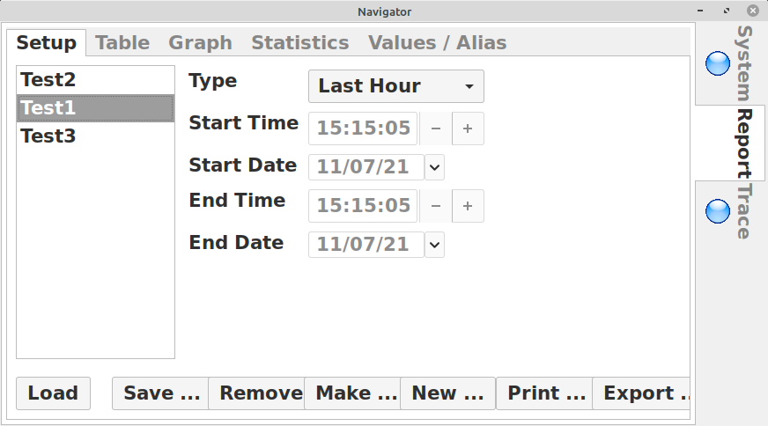
Reports provide tables, graphs and statistics for selected inputs and time range. The reports are generated from a local SQLITE database. Using applications such as Crystal Reports can give more comprehensive reports.
Setup Tab
Type This selects the time range type.
Last Hour Data is retrieved for the last hour from the time the report is run.
Last Day Data is retrieved for the last 24 hours from the time the report is run.
Last Week Data is retrieved for the last seven days from the time the report is run.
Exact The Start Time Start Date, End Time, End Date are specified.
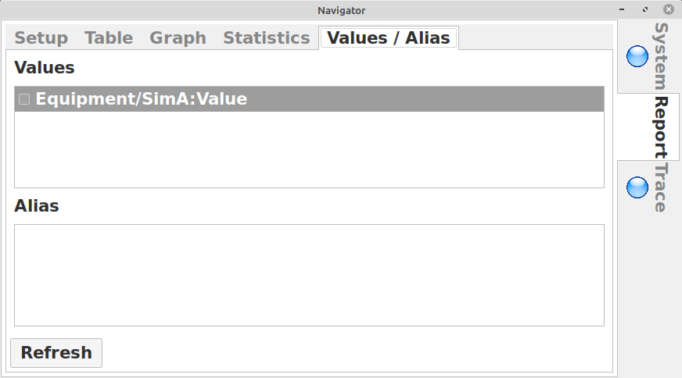
Values/Alias Tab
This selects the data items that are to be read. Values are the paths to the inputs on the interfaces. Aliases are meaningful names assigned to the values. For example IN3 on an ADC module can be named Temperature_Room108.
Making Reports
After selecting the time frame and the values/aliases click the Save button (Setup Tab).
To make the report click Make. The Table tab will have a set of tables, one for each data source.
The Graph Tab has a plot of all the values. It is best to have reports that have the save data ranges.
The Statistics Tab has a summary for each of the data sources in the report.
Printing Reports
Click on Print to print a report. Use this option to print a report in PDF format.
Export as CSV
This exports data in CSV format. After making a report the extracted data is in a SQLITE database in the report directory. This can be copied and used with report generators or other data processors.

Trace
This window shows diagnostic messages.

Item Tab Views
When an interface object has Enable Tab View set a tab is created for an assumed runtime display. This is usually current values. The System tab is for configuration.

Web Interface
The web interface is accessed on port 8082.
There are three possible displays to access.
http://hostname:8082/admin accesses the system configuration. This is similar to the system tab on the desktop interface. This requires administrator access.
http://hostname:8082/ui accesses the interface specific tab views. This is similar to the display on the desktop.
http://hostname:8082/report selects the web based report page
Each page is password protected.

System Configuration
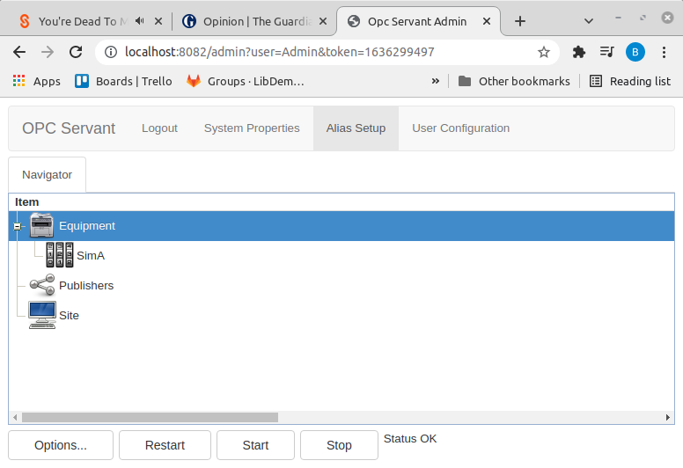

HMI
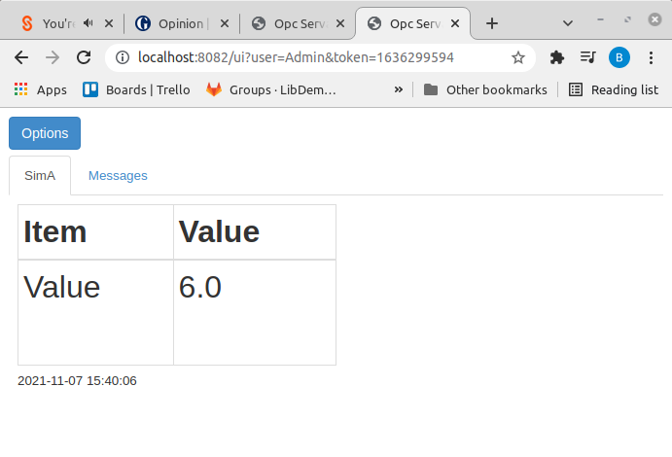

Reports
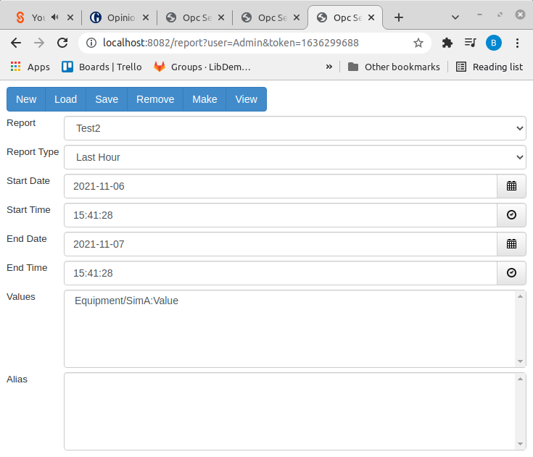

Maridb (MySQL) Database
A Mariadb publisher service sends published records to Mariadb SQL database.

MQTT
MQTT is de facto standard message passing protocol. Messages (usually as JSON) are passed to a broker and so on to subscribers (listeners). The MQTT broker can be anywhere on a network. More than one MQTT publisher can be defined with differing filtering configurations.

Publish
Published values are sent to the MQTT broker. The key is the path to the object value. If the object value has an alias this is used.
The data is sent as a JSON record. Node Red can be used to process and display these records.

Commands
Messages can be received by OPC Servant. These can be mapped on commands. Typically this is used by applications such as Node Red to control outputs.
The MqttCommand class handles MQTT commands. Derive and register command handlers in a module’s plugin class.

OPC UA
Opc Servant includes an OPC UA server based on open62541 and open62541Cpp. Objects can be designed to publish values and to expose methods.
UA Expert can be used to explore the OPC UA interface. Reading and setting values and invoking methods. (see: https://www.unified-automation.com/products/development-tools/uaexpert.html)

Programmer’s Guide

Functional Overview
OpcServant is composed of:
- Servant Application
- Shared Libraries
- Modules

The application is extended by adding modules. Modules are shared libraries with self registration embedded as part of the start up code.

The application is based, mainly, on the following libraries:

- wxWidgets. GUI and application framework
- Wt Web interface and the some signal/slot support
- Open62451 / Open62541Cpp OPC UA

The OpcServant application has the following threads (there may be others created by the other frameworks). These threads are created when the application starts:

- GUI wxWidgets desktop interface
- Web Wt web interface
- OPC UA Open652541 OPC UA
- Data Acquisition OpcServant classes

These threads communicate using Wt signals and slots. Typically messages are sent via the data acquisition thread. Messages are received to message queues and processed at a later time within the thread that owns the object.

Classes
The key OpcServant classes are:

MRL::VariantPropertyTree
This is the main data structure. Values are stored in variants in a property tree.

MRL::PropertyPath
This is the path to an object in a tree.

MRL::ObjectManager
This is the factory for the runtime objects and the configuration and display interfaces. The key functions, that will need deriving for a given implementation are:
bool createRT(const PropertyPath &path)
Creates a runtime object.

bool edit(wxWindow *w, const PropertyPath &s)
Edits a runtime object’s configuration in the GUI.

bool edit(Wt::WWidget *w, const PropertyPath &s)
Edits a runtime object’s configuration in the web interface.

bool buildMenu(wxMenu *m, const PropertyPath &s)
Builds the context menu for an object in the GUI

bool buildMenu(Wt::WPopupMenu *m, const PropertyPath &s)
Builds the context menu for an object in the web interface

wxWindow * createTabWindow(wxWindow *parent, unsigned id)
Creates a tab window in the GUI interface for the user interface

Wt::WContainerWidget * createWebWindow( Wt::WContainerWidget *root,unsigned id);
Creates a tab window in the web interface for the user interface

There are templates for common forms:

ObjectManagerRT A typical data collection / interface

ObjectManagerPublisher A typical publisher

ObjectManagerI2cRT A typical I2C interface

There is a set of standard configuration dialogues for network, serial and I2C interfaces, that can be used with these templates. Often an object manager can be defined in a single line:

typedef ObjectManagerI2cRT<BME280RT> BME280ObjectManager;

MRL::Bobject
Base object, derived from Wt::WObject that mainly handles messages. BObject messaging is thread safe. The process() function must be called from time to time by the owning thread to action messages.

MRL::RTObject
The run time object for interfaces and publishers. These are called in the context of the DAQ thread, unless otherwise noted.
void start();
When an object starts the object’s configuration is loaded and initialised.

void stop();
When an object stops any claimed resources are released and clean up.

void publish()
Publishing values takes place at the publish interval. Published data is passed to the publishing objects such as MQTT and SQL databases. Published data is best thought of as permanently recorded data.

void measure();
This function is called at the Measure Interval. Measured values are typically used to update displays and perform control and alarm functions.

void updateOpc(OpcServer &server, Open62541::NodeId &objectNode)
This function is invoked to update the OPC data structures. This is called from the OPC thread in response to an object update event (usually from the measure event).

void initialiseOpc(OpcServer &server, Open62541::NodeId &objectNode)
This is invoked by the OPC thread in response to an object start event. The RTObject typically makes local references to the OPC value nodes. The OPC server browser functions can be used to generate and manipulate a tree of NodeIds.

The polling functions are called periodically by the Daq object.

void process() Called at 20 ms (approx) intervals

These functions are called at the following intervals (if enabled by the usexxx method):
void onOneSecond(time_t t)
void onOneMinute(time_t t) - hh:mm:00
void onOneHour(time_t t) - hh:00:00
void onOneDay(time_t t) - 00:00:00
void updateObject(int state = STATES::States::StateOk, time_t timeStamp = wxDateTime::GetTimeNow())
This function is called to mark that an object has updated all of its runtime data. This generates a message that triggers user interfaces to update and the OPC server to update the data for the RTObject.

void updateValue(const T &v, const std::string & tag = VALUE_TAG, int state = STATES::States::StateOk)
This function updates one value for the object in the runtime data and generates an object value update message.

void publishValue(***)
These functions publish an object value and send an object publish message, to any publishers.

void publishRecord(***)
these functions publish a record of object data. A record is typically a JSON object that includes all the object values and meta data. It is free form.

StringVector & inputs()
This is the list of input value tags (names). These can be statically defined or dynamic.

StringVector &outputs()
This is the list of output value tags (names)

MRL::Message
The message packet object. This is a flexible message structure (a map of variants) used to communicate between objects and threads.

MRL::Plugin
The module self registration class. Provides the entry points to the modules. A module may define many different types of object.
virtual void initialise();
This entry point is called on start up from the main thread to create the object managers.

virtual void initialiseOpc();
This entry point is called by the OPC server to create the OPC Type Objects factory for each of the objects defined in the initialise() function. The association is by name.
An OPC type object is a collection of OPC Nodes that is instantiated for each instance of a run time object.

MRL::Common
This is a singleton that holds the global data.

Module Developer Guide
OpcServant is extended by adding modules to the application.

There are two types of module interface and publisher.

Interface modules communicate with input / output sub systems, such as voltage inputs, relay outputs and sensor modules. Publishers send the processed data to places like SQL databases and data processors (via for example MQTT)

To develop a new module refer to the existing modules. Copying an existing module that does something similar and doing a global name change will be a large part of the required work.

Most of the work is in the runtime (RT) object periodic processing (usually as a state machine) and the configuration dialogues. The OPC type object functions usually require adapting but to a lesser extent.

The configuration dialogues are mostly getting and setting fields between the configuration object and the forms. The stock dialogues handle the common cases.

Runtime object configurations are stored as JSON records in a SQLITE database index by the object id. Objects are also held in a tree structure. Hence objects can be accessed by object id and object path. The object directory is stored as JSON as a record.

Each object has configuration data as a variant property tree and runtime data as a variant property tree. Accessing these trees is thread safe.

Generally in the periodic processing function, call down to the base class and only claim resources (file handles) while in the function. That is open on entry and close on exit this avoids contention with other objects sharing the same bus.

Configuration Dialogues
The standard configuration dialogues are based on a tabbed container to which pages are added.

Desktop
Desktop configuration dialogues use MRL::SetupDialog as the container

The standard dialogues are:

SetupI2cDialog
SetupSerialDialog
SetupNetworkDialog
SetupNodeSerial
SetupDatabaseDialog

Web
Web configuration dialogues use MRL::ConfigurationWebForm as the container

The standard dialogues are:

ConfigurationI2CWebDialog
ConfigurationSerialWebDialog
ConfigurationDatabaseWebDialog
ConfigurationNetworkWebDialog
ConfigureSerialNodeWebDialog

Runtime Interface

Runtime interfaces are added as tabs to the display. Runtime interfaces can be used to show current values and to control. In this way instrument HMIs (front panels) can be developed.

Node Red is an alternative method for web based instrument HMIs. Node Red has the advantage of being easily customisable to meet varied needs of different users. There are SCADA Node Red nodes included with OPC Servant. These provide scale and offset, action/alert handling, alarm groups and SPC alarms. Node Red does not have to run on the OPC Servant host, it only requires access to the MQTT broker.

Each runtime display maps on to a runtime object through the runtime object identifier. References to objects should not be cached, they may change. Rather the reference to the runtime object should be obtained from the DaqCommon object (via the static function Common::daq()) when required. References are volatile.

Information is passed between the interfaces by messaging or accessing the object’s runtime data tree. The runtime data tree is thread safe for access.

Procedural Nodes
Procedural nodes is a design pattern that is a graph of functional nodes.

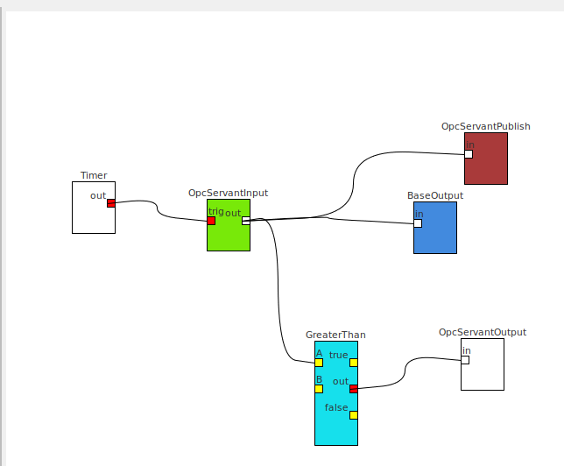

These are useful for defining a range of data processing and control strategies that can be easily adapted and changed interactively.

Node types can be readily developed to provide specific functionality in the data processing pipe lines. The source tree includes many examples.

Features

- Multiple inputs are supported
- Multiple outputs are supported
- Plugins are supported
- Node Sets (flows) can be nodes
- Relational operators nodes can act as data packet routers
- Binary operators can have the B input defaulted otherwise both A and B inputs have to be triggered to generate an output

There are data processing nodes, such as rolling statisics.

Data packets (JSON Values) can be routed by topic. Topic can be changed.

Program Structure

Generally the functions are performed by NodeType derived classes. The other classes hold data. In some cases classes derived form Node are required to store extra data items (eg serial ports, MQTT).

The NodeSet class is the graph of the nodes (Node) and the connections (Edge). The NodeSet is the execution context. To run a flow the NodeSet is executed/processed (by calling NodeSet::step). The NodeSet::start function is called to initialise all nodes. A NodeSet has a Variant Property Tree to store the node layout and node properties and anything else that springs to mind.

All nodes receive the step call then the trigger call.

Data / event source nodes emit data on the trigger call. Data is sent from outputs to connected inputs by calling post. The data is received and processed by the process function

Data is passed as Json Values. Each value has a "Topic" attribute and a "Payload" attribute (c.f. Node Red). Other attributes can be added.

The node set execution flow is:

Call NodeSet::start to initialise the nodes

while

- Call NodeSet::step. This first invokes NodeType::step for each node. If true is returned by the NodeTypeStep::step the node is ready to be triggered (it is the left most node of the flow). The NodeType::trigger function is now called for these nodes.

- Data is sent to conencted nodes using the NodeType::post function and processed by the NodeType::process function. The NodeType::process function then posts the results to output(s). This repeats (recurses) until the end of the flow.

- Flows are executed from start to finish. Flows must not block. The step function can be used to drive state machines. Do not assume any given flow (or branch) will run before or after any other flow.
- Read the set output queue and process the packets. The output messages can be passed to the UI components, databases etc based on the topic attribute. In the GUI run mode the messages from the node set are displayed in the trace panel.

endwhile

GUI
The GUI is a graphical node set editor. Drag and drop nodes form the list on the left on to canvas. Connect nodes by left-down on an output and draging to an input. Right click on a node ot get a context menu that includes editing properties and deleting nodes. To delete connections right click on a input or output and select delete connections.

Node connections have colour coded type. Nodes must be of the same type (Bool, Integer, Float and String) to be connected. There is an Any type that can connect to any other type.

Web Interface
The web version of the Node Editor has been written using Wt. The port is 8083. Right click on the canvas to add nodes.

Sub-Flows
There is a Node that encapsulates another Node Set, in effect a sub flow. Currently duplicate the node set file and modify for a given instance.

Building

The Node Flow library can be used separately from OpcServant. Use Cmake to build.

The GUI is wxWidgets based. However changing to Qt or Wt (for web based UI) should not be complex.

The MrlLib from the OpcServant project is required. Boost is required.

Look at the modules for how to extend the node set and how to implement functions

It is expected to be able to embed Node Flow in other applications as a visual alternative to scripting and configuration.

Function Scripting
The function node uses LUA scripting.

The minimal interface is:

function process(inputId)

end

The input data packet is passed to LUA . This packet can be changed and then posted to selected outputs. The LUA functions to access NodeFlow are:

Node.Id() Node ID
Node.Post(outputId) Posts the data packet to the output
Node.GetInt(name) Get integer from data packet
Node.GetDouble(name) Get Double from data packet
Node.GetBool(name) Get bool
Node.GetString(name) Get string
Node.SetInt(name, I)
Node.SetDouble(name,v)
Node.SetBool(name,b)
Node.SetString(name,s)
Access to the NodeSet property tree
NodeSetData.GetBool(path)
NodeSetData.GetInt(path)
NodeSetData.GetDouble(path)
NodeSetData.GetString(path)
NodeSetData.SetBool(path, b)
NodeSetData.SetInt(path,i)
NodeSetData.SetDouble(path,d)
NodeSetData.SetString(path,s)
NodeSetData.Remove(path)
The C++/LUA interface is based on Seline. Refer to the API documentation and the examples in the function node code.

