Introduction:

In order to build a reinforcement learning application, we need two things: (1) an environment that the agent can interact with and learn from (2) the agent, that observes the state(s) of the environment and chooses appropriate actions using Q-values, that (ideally) result in high rewards for the agent. An environment is typically provided as a so-called gym, a class that contains the necessary code to emulate the states and rewards of the environment as a function of the agent’s actions as well further information, e.g. about the possible action space.
Gym environments contain most of the functionalities needed to use them in a reinforcement learning scenario. However, there are certain features that do not come prebuilt into the gym, such as image downscaling, frame skipping and stacking, reward clipping and so on. Luckily, there exist so called gym wrappers that provide such kinds of utility functions. An example that can be used for many video games such as Atari.
In this project Iam going to train super-Mario-bros game using DQN, DDQN And PPO.
I have used CNN in my layers to train my model. I used SGD as the optimizer and created 4 hidden layers. Now Iam going to show you some results.

Reward Result:
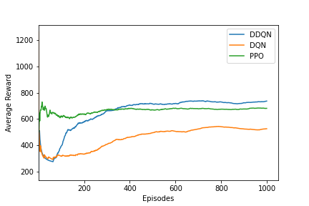

This Figure represent the average reward of 3 different DRL algorithms (DDQN, DQN AND PPO). We can see that DDQN and DQN are still increasing which means they haven’t learned the optimal policy yet. But DDQN show higher reward w.r.t DQN which means that DDQN is learning better. However, for PPO we can see that after 300 episodes the average reward is constant which probably means it learned he local optima.

Steps Result:
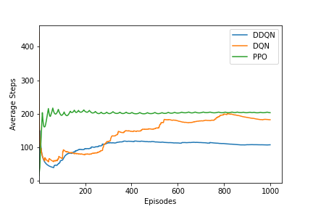
This figure represents the average steps per episode. As we can see that for DQN is still increasing which means it is still learning well, for DDQN it is lightly increasing. However, for PPO we can say it is stuck at 200 steps in the game.

Time Result:
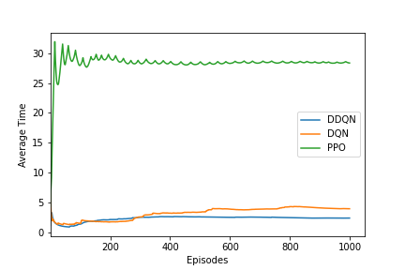
This figure represents the average time taken for each episode, the average time before Mario is dead. PPO shows us that it has very large time, which make sure that our conclusion in the previous figure is true, PPO is stuck in the game at some stage. Therefore, PPO is converged to local optima in our case.
In another hand DQN and DDQN shows still increasing with time which conclude they are still learning well.

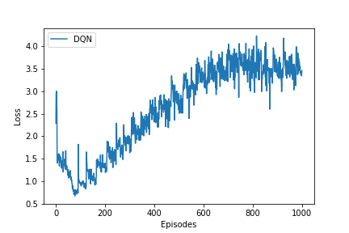
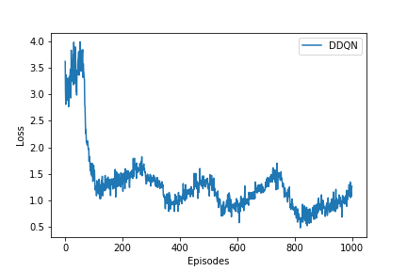
Loss Result:
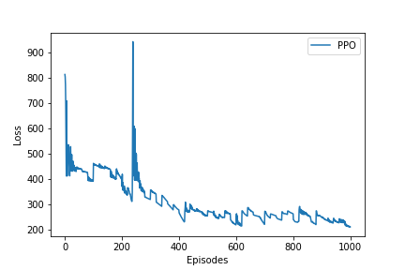

The loss function of DDQN and PPO shows it is still decreasing which means it is apparently improving. For DQN we can see that the loss increased till episode 700, this may happen because at this time I took the exploration ratio big. So, at this time our algorithm was exploring.

Conclusion:
DDQN takes much less episode to train in comparison with DQN. Thus, the DDQN network helps to eliminate overestimation issues found in the DQN network. Both DQN and DDQN networks are able to train. However, DDQN learning is more reliable and more accurate.
For PPO we can see that it is stuck at some place in the game, but if we train this model for more episodes, it might get off that stage and complete learning.

