Simple DOCX Interoperability Test
Purpose: a small DOCX fixture with common Word features, simpler than the full calibre demo document.
This file contains: headings, inline formatting, styled paragraphs, a hyperlink, lists, a table, a merged cell, an image, and header/footer text.
External link test: OpenAI website (standard external hyperlink).

1. Inline text formatting
Bold, italic, underlined, strikethrough, red text, highlighted text, H₂O and x².
Styled paragraph test: this paragraph uses a custom paragraph style rather than direct inline formatting.

2. Lists
- Bulleted item one
- Bulleted item two with a longer line to check indentation after wrapping in converters.
- Numbered item one
- Numbered item two

3. Table
A compact table with a header row, mixed numeric/text cells, and one merged note row.
Item | Owner | Status | Score
Text | Library | Pass | 10
Table | Renderer | Review | 8
Image | Parser | Pass | 9
Merged row note: this row checks basic cell merge support without nested tables.

4. Image
Inline image follows: 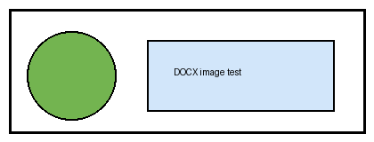 The same image is also shown as a centered block below.


5. Second page checks
This page exists to verify page breaks, header/footer repetition, and multi-page handling.
Continuation paragraph 1: simple text for extraction and pagination checks.
Continuation paragraph 2: simple text for extraction and pagination checks.
Continuation paragraph 3: simple text for extraction and pagination checks.
Continuation paragraph 4: simple text for extraction and pagination checks.
Continuation paragraph 5: simple text for extraction and pagination checks.

