|  |  |
| --- | --- |
|  | **2015** |
|  | Bashkim Bekteshi  Bb19500 |

|  |
| --- |
| **[Phone gap homework 3]** |

# Introduction and Installation

Phone gab is a free open source framework that you can create mobile apps on it. For our homework we have to install first phone gap. The installation procedure can be done I two different ways, the first one using node JS terminal and the other by downloading the desktop app of phone gap.

For the first procedure we need to run some code into Node JS terminal, the first thing is to install phone gap into node JS and that is done with this code:

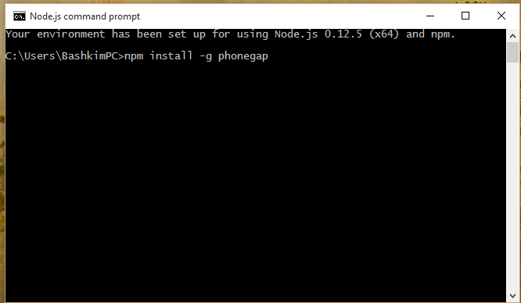

After the installation is finished we have to try if it works, best way is to create a project like in the picture:

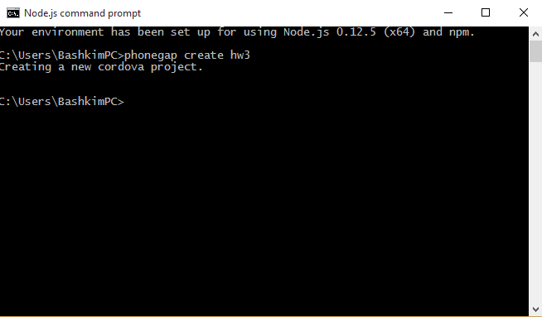

One folder will be created in the user folder with the name given HW3. In it there will be lots of files and folders. What we need is to go to the www folder and start editing our HTML/CSS/JavaScript code.  
Another useful command is the run command. This command runs the project from the node JS cmd.

First we need to enter to the project that we created:

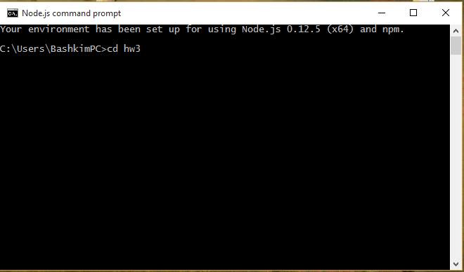

Then we need to run the project:

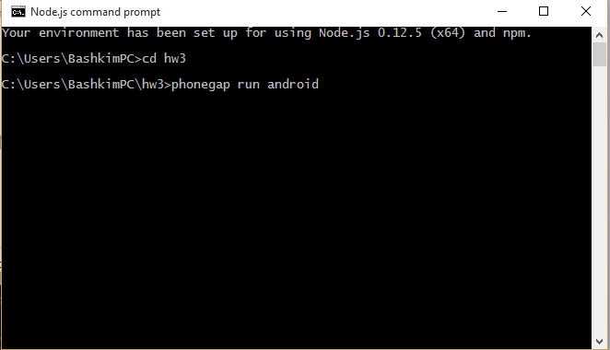

And the result is:

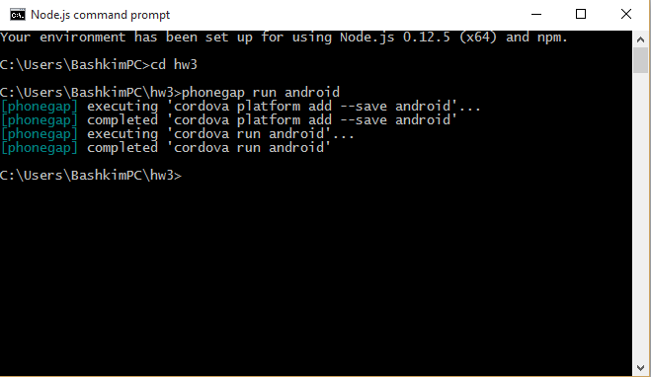

The second way of installing Phone Gap is the desktop version. You can download it on this page <http://docs.phonegap.com/getting-started/1-install-phonegap/desktop/> for Windows and IOS Operating systems. The installation is similar to all installations.

After installing the Phone Gap the app looks like :

* The + button is where you can create a new project

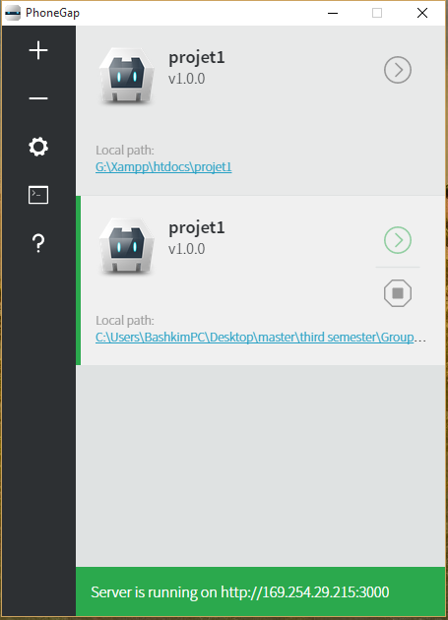

* The – button is where you can delete a project
* The Settings button is where you can configure the app and its server IP
* Also there is a terminal button which records the activity log of the app

For running the created project we can use some tools one of them is Phone Gap mobile. This app is installed into your smartphone and then using the given server IP you can access your project remotely form your smartphone.

The other tool is the tool that builds the app and makes it downloadable for smartphones.

To do so first we need to register to this site: <https://build.phonegap.com/plans> , after registering you will be on this page :

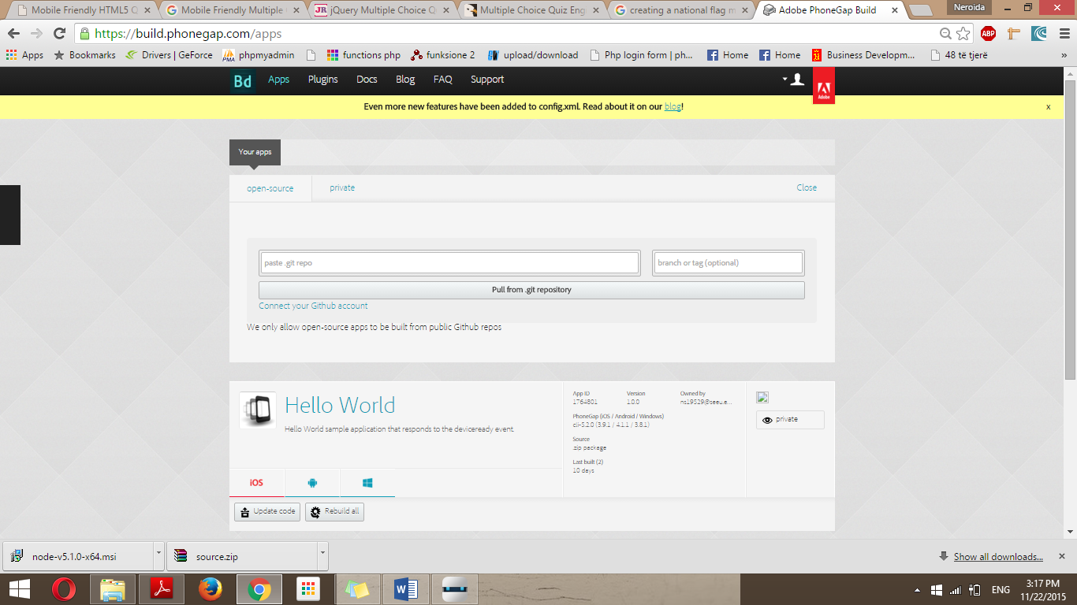

Here you can pull your app from GitHub directly if you have already placed your app into GitHub or you can do it manually and every time you update your code you will have to update the index.html file

After you upload the code the screen will appear like this:

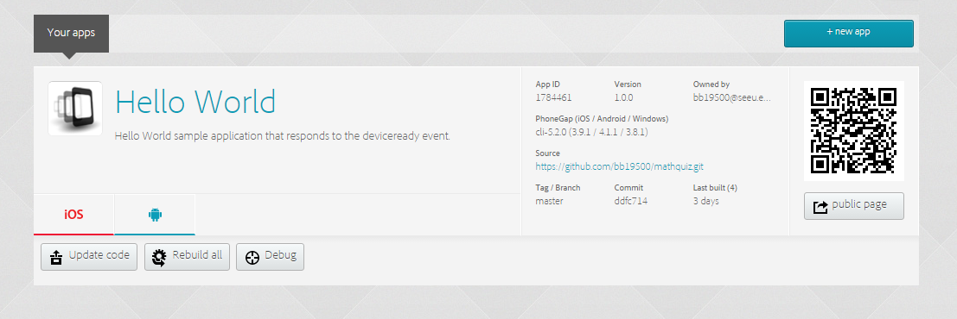

For my project I used GitHub to pull the project every time there is an update. The pull is simple you click on Update code and then Pull from GitHub.  
This is my repo URL: <https://github.com/bb19500/mathquiz.git>

In this page you can download the apk file or the IOS one to directly install it on your device. You also can use Ripple in Google Chrome, it’s a plugin that makes the browser like a mobile phone browser.

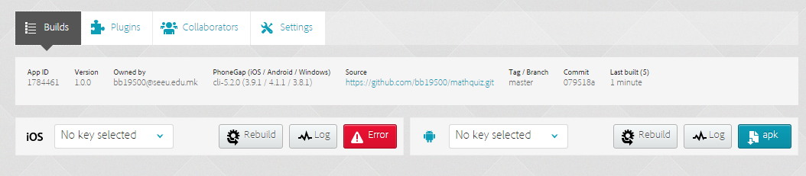

# Math Quiz Home Work 3

For this homework I have to create a math quiz game that users have to do for a certain time limitation.

All the functions that are created are into the cal.js file. This first function is the timer function, the player has 45 sec to answer as many questions as he can. Also here is the code that records all the score that after finishing is the timer is saved into local Storage

1. <!--START OF TIMER SCRIPT-->
2. //how much time they get
3. **var** time=45;
4. **var** timesup=0;
5. **var** started=0;
6. **function** CountDown() {
7. **if**(time>0)
8. {document.math.timer.value=time;
9. time=time-1;
10. **var** gameTimer=setTimeout("CountDown()", 1000)}
11. **else** **if** (time==0)
12. {document.math.timer.value="0";
13. timesup=1;
14. //alert('Time\'s Up! Youre Score is:' );
15. document.math.firstnum.value="";
16. document.math.operator.value="";
17. document.math.secondnum.value="";
18. document.math.answer.value="";
20. **var** sp = document.getElementById("sp").value;
21. alert('Time\'s Up! Youre Score is: ' + sp);
22. //saveScore(sp);
23. sp [0] = prompt("New score");
24. localStorage["sp"] = JSON.stringfy(sp);
26. **var** storedscore = JSON.prase(localStorage['sp']);
27. }
28. }
30. <!--END OF TIMER SCRIPT-->

Start game function:

1. **function** startgame()
2. {
3. **if** (started!=0)
4. {alert('You\'ve Already Started!');
5. }
6. **else**
7. {
8. started=1;
9. CountDown();
10. getProb();
11. }
12. }

The script that generates random mathematical operations:

1. <!--START OF RANDOM NUMBER SCRIPT-->
2. **function** randnum(min,max)
3. {
4. **var** num=Math.round(Math.random()*(max-min))+min;
5. **return** num;
6. }
7. <!--END OF RANDOM NUMBER SCRIPT-->
9. **var** choose, rightanswer
10. **function** getProb()
11. {
12. choose=randnum(1,4);
13. **if** (choose=="1")
14. {document.math.operator.value="+";
15. **var** choose1=randnum(0,50);
16. **var** choose2=randnum(0,50);
17. document.math.firstnum.value=choose1;
18. document.math.secondnum.value=choose2;
19. rightanswer=choose1 + choose2;
20. }
21. **if** (choose=="2")
22. {document.math.operator.value="-";
23. **var** choose2=randnum(0,50);
24. **var** choose1=randnum(choose2,50);
25. document.math.firstnum.value=choose1;
26. document.math.secondnum.value=choose2;
27. rightanswer=choose1 -  choose2;
28. }
29. **if** (choose=="3")
30. {document.math.operator.value="x";
31. **var** choose1=randnum(0,10);
32. **var** choose2=randnum(0,10);
33. document.math.firstnum.value=choose1;
34. document.math.secondnum.value=choose2;
35. rightanswer=choose1 * choose2;
36. }
37. **if** (choose=="4")
38. {document.math.operator.value="/";
39. **var** choose2=randnum(1,10);
40. **var** choose1=choose2 * randnum(0,10);
41. document.math.firstnum.value=choose1;
42. document.math.secondnum.value=choose2;
43. rightanswer=choose1 /  choose2;
44. }
45. }

And also there is a function answerit alert the user for the mistakes made in the quiz:

1. **function** answerit()
2. {
3. **if** (started==0)
4. {alert('You Must Click The Button Labeled \'Start\'!');}
5. **else**
6. {
7. **if** (timesup!=0)
8. {alert('Time Ran Out!');}
9. **else**
10. {
11. **var** theiranswer=eval(document.math.answer.value);
12. **var** theirpoints=eval(document.math.points.value);
13. **if** (theiranswer==**null**)
14. {alert('Put Your Answer In The Box  ');
15. document.math.answer.select();}
16. **else**
17. {
18. **if** (theiranswer==rightanswer)
19. {
20. // alert('Right');
21. theirpoints++;
22. document.math.points.value=theirpoints;
23. }
24. **else**
25. {alert(theiranswer + " is wrong!\n\n"+rightanswer + " is correct!")}
26. document.math.answer.select();
27. getProb();
28. }
29. }
30. }
31. document.getElementById("number").value = "";
32. }

Other functions are the virtual keyboard function which has all the numb keys, backspace and delete all.

The other part is the HTML code in this part there are 3 main pages

First is Index.html that has two buttons: Start Game and High Score

The second page is the game.html in here all the code is generated and the game is played

The third page has a table with the High Score table and a back button.  
For the css I used a simple css with some button and background combinations. For detail check the project.