

**Year 10 Information Technology**

***Application Programming Project***

Name: Bradyn Walsh Due Date: Tuesday Week 6

*You will have about 4 weeks for this project.*

**Overview**

Your task is to create a fairly simple, but innovative application (app) using Visual Studio.

It is recommended that you base the structure of this application on an existing application you have constructed as part of the formative part of this course and it will most likely exist of only a single window.

Draw on your experience of what makes a ‘good’ user interface to ensure the application is user friendly.

**Scope**

This is not intended to be a huge project. A simple calculator application, while not appropriate because it is not innovative at all and is just copying what has been done in class, is about the appropriate scope.

**Process**

1. Identify the purpose of your project. Think creatively and use innovation (perhaps reusing or combining existing ideas in a different context) to document the purpose clearly and effectively. Brainstorming with the SCAMPER model may assist in this process (<https://www.youtube.com/watch?v=G8w0rJhztJ4>). – *approximately 2 lessons*
2. Plan the project. – *approximately 3 lessons*
   1. Break the project into modules / problems and document the strategies you will use to develop each of these modules.
   2. Create a mockup (even hand drawn) of the user interface and justify the decisions you make for this. Your justification needs to refer to the elements of a UI: target audience, consistency, help, accessibility and UI patterns.
3. Develop / Create your project using Visual Studio. – *approximately 9 lessons*
4. Provide evidence of your coding (see below for more details). – *approximately 2 lessons*

**Marking Rubric**

You will be marked according to the criteria in the rubric below (from A-E in each). The following rubric will give an indicator about the difference required between a C and an A:

|  |  |  |
| --- | --- | --- |
|  | C Grade | A Grade |
| Purpose and Innovation | There is a purpose for the project communicated in a basic manner. | An innovative and purposeful solution has been identified and effectively communicated. |
| Planning | A mockup of the user interface is included. Some justification included that refers to some of the elements of the user interface investigation. The student has attempted to break the project into small modules with some documentation of the strategies for their development. | A clear mockup of the user interface is included with clear justification for the design decisions made, referring to the elements of the user interface investigation. The student has systematically and logically broken the project into small modules and has documented the strategies for their development. |
| Development | A user interface and coding have created a basic application. | An easy to use and functional application has been created with a user friendly interface and accurate, modular coding |
| Evidence of Coding | A simple section of coding is explained accurately to show the student has written it themselves. | A complex piece of coding is explained systematically and in an insightful way to prove the student has written it themselves. |

You will need to submit your development (source code) and documentation.

Your documentation should include 3 main sections:

1. Purpose and Innovation – this is like a design brief / requirement description and should clearly articulate the purpose of your project and demonstrate innovation through reusing existing ideas in alternative ways.
2. Planning – this should include:
   1. Mockup / plan of User Interface – including justification of the design decisions made. This may be annotations to the mockup and / or separate explanations that refer to the elements of a UI (as per the User Interface Investigation.
   2. An iterative approach to breaking down the problem into smaller modules (perhaps through a hierarchy or other diagram) with strategies for their development.
3. Evidence of Coding – choose a piece of code you have written entirely by yourself that demonstrates a complex algorithm and / or a neat solution to a problem. In essence, you need to prove that you have written it by annotating the code and explaining (in sentences or a flow diagram) how it functions. Higher marks will be given for accurate and insightful explanations that prove you have written the code and understand it completely.

**Purpose**

The purpose of my project is to create a text editor that uses the xi-editor core that is currently in a very early development stage for all text manipulation operations. This text editor should be intuitive and easy for users to use. It will allow for having multiple tabs open at once using tabs and will be able to open and save files per user input. Additionally, it will have a command mode like Vim’s (another text editor) for keyboard shortcuts to make activating them easier for people with disabilities.

**Innovation**

This text editor differs from a standard text editor because it uses an external process (the xi-editor core written in Rust) to handle all text manipulation. This means that the developer of a frontend for the core, which is what my project is, does not have to focus on writing high-performance text manipulation operations and can instead focus on building a native interface for the frontend. Additionally, it will be easy to extend and improve my text editor as more work is done on the core as it is a whole lot easier to add a few commands to communicate to the core with than to just write them how you would for a normal text editor.

**Mock-up of User Interface**

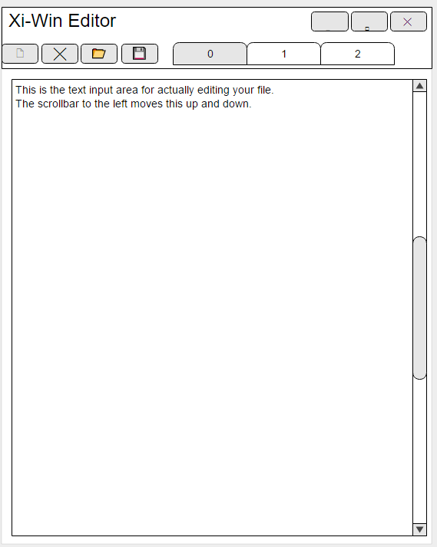

**Design Decisions**

As you may notice in the UI mock-up, the tabs are numbered rather than given a proper name, like the file they are editing. This is a current limitation of the core process, but when it is fixed in the core it will be automatically fixed in the text editor. But while the tabs take up little space, I decided to put the buttons for creating, closing, opening and saving on the same line as the tab bar to save some vertical space which can then be used for showing more text.

Another design decision made was to have the text editor open its README.md file whenever it launches, which cannot be seen in the mock-up. This is very like what Vim and Emacs do on launch and should be helpful to any people new to using the editor as it explains how to use it and current issues with the editor. Additionally, advanced users can use this feature to quick-open any file on launch by replacing the README.md file, which is quite a useful feature to have in some circumstances.

**Target Audience**

The target audience for my text editor is people who use text editors everyday as part of their professional life, such as developers. This is because this app can be customized extensively by adding plugins to the core process, meaning that professionals can optimize their day-to-day workflow.

**Consistency**

My text editor is quite consistent in its rather Spartan interface. All the buttons for interacting with the editor use Unicode icons instead of text, all UI elements that are next to each other or otherwise related have the same size and colour scheme is consistent with standard Windows theming throughout the whole application.

**Help**

Whenever someone launches my text editor, it shows up a help file. This is extremely useful to users who have never used it before as it quickly runs through how to use it, how the command mode and keyboard shortcuts work and current bugs and issues with the editor. Additionally, as this project is hosted on GitHub, any user can submit an issue to the main repository if they have a problem and I can see if I can fix it.

**Accessibility**

My text editor is very accessible and intuitive to use for anybody. Using icons for the buttons means that non-English speakers can still use the editor and as the editor does support Unicode characters because of accessibility, they can input non-English characters. Additionally, many of the UI elements, such as the tab bar, can be found in many other applications and therefore should be very easy and intuitive for any user to use.

If I could add more accessibility features, I would add the ability to change the font size and colour and the colours for the rest of the UI, which would help visually impaired and colour blind people.

**Modules and Strategies for Development**

My text editor can be very easily broken down into 3 distinct and separate modules:

1. ***CoreCommunication Module***

This module of the text editor is responsible for starting up and communicating with the xi-core process. It is also responsible for closing the core process and cleaning up after it when the user closes the program.

To develop this, it would probably be best to put this module in its own class and use C#’s Process and Thread libraries for the heavy lifting of communicating with and starting/closing the core.

1. ***Command Interface Module***

To make it a lot easier to develop the frontend, it would be good to have a command interface we could hook into to parse incoming commands and to compose the JSON we need to send from standard C# objects. This would mean that our frontend will not have to deal with raw JSON strings but rather with nicely typed objects.

To develop this, I think that it would be best to create an interface describing what a command can do (be converted to JSON, be parsed from a string, etc.) and then create a class for each type of command implementing this interface.

1. ***Editor Frontend/UI Module***

This module is responsible for displaying the UI, processing incoming commands into text and sending out user keypresses for the core to input as text. Additionally, this module needs to handle opening tabs, closing them and file manipulation (open/save) through the commands provided by the core.

To develop this, it would be best to use the XAML designer to design the interface and then put all user interaction code into the resulting .cs file. This code should be extensively using the other 2 modules for doing all the heavy lifting and it should just focus on updating the UI elements and processing user input.

**Explanation of Coding**

***Core Input Processing***

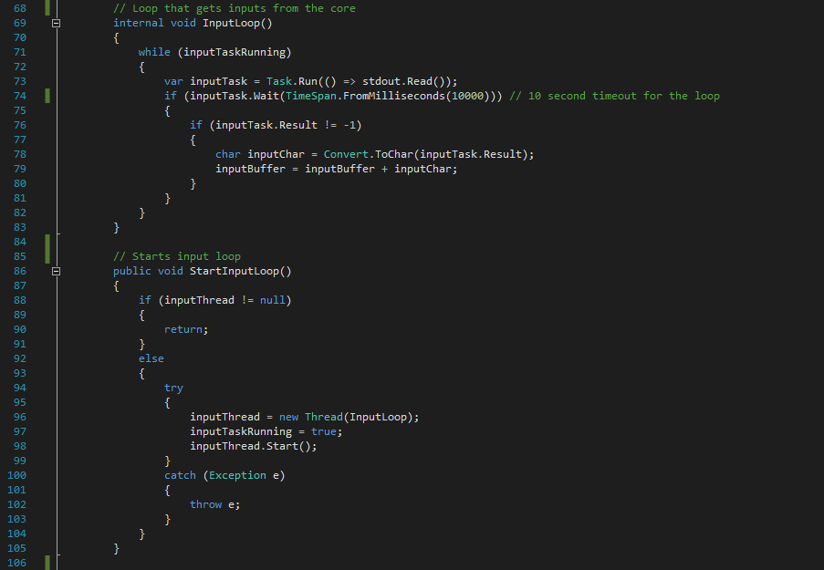

A major problem I had while developing the application was the application stalling because the app was sending info to the core process and waiting for it to be read while the core was writing something to my program waiting for it to be read. To fix this deadlock, StartInputLoop creates a new Thread which runs the InputLoop function.

The InputLoop function simply tries to read from the core process, timing out and restarting every 10 seconds. If it does receive any input, it will add it to the inputBuffer which is a string used by the rest of the CoreCommunication class. It will continue to do this as long as inputTaskRunning, which is a Boolean defined in the class, is true.

***Update Command Parsing***

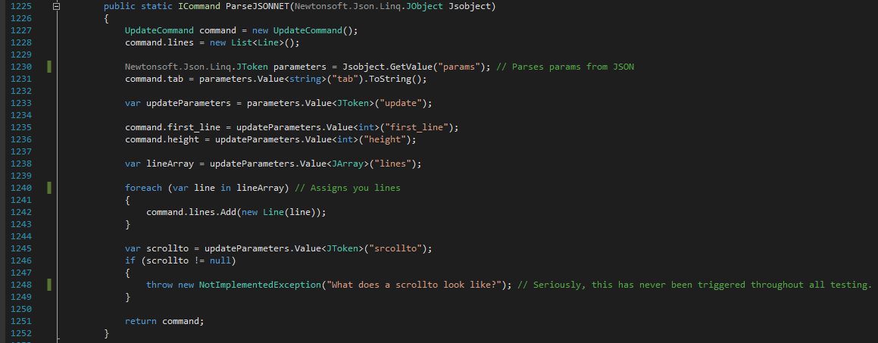

This function, which is in the UpdateCommand class, is responsible for parsing all ‘update’ commands that the core sends to our application. It starts by creating a black updateCommand and initializing the lines array. It then extracts the parametres from the JSON using Newtonsoft’s JSON library. From these parameters, it extracts all the values inside and puts them in the correct variable in the class. It also then parses each line given by the core into a Line object. This function does throw an exception if the core returns a ‘scrollto’ value, but I have not seen that happen with the commands currently implemented.

***Updating and Rendering UI State***

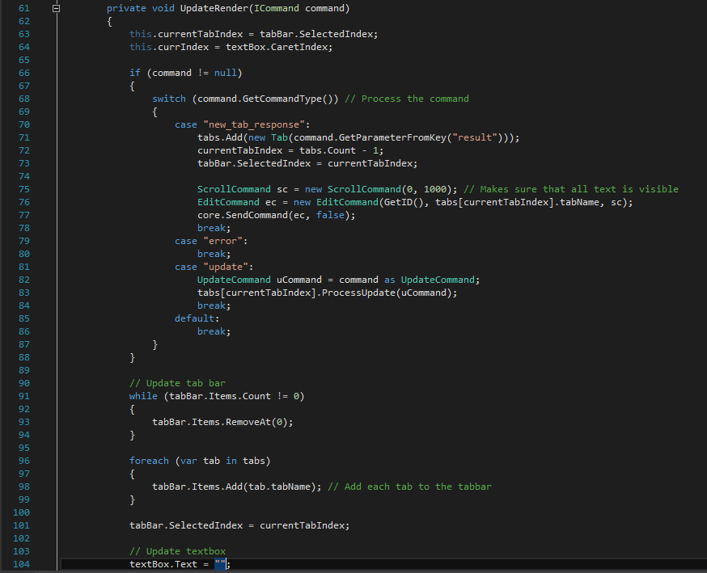

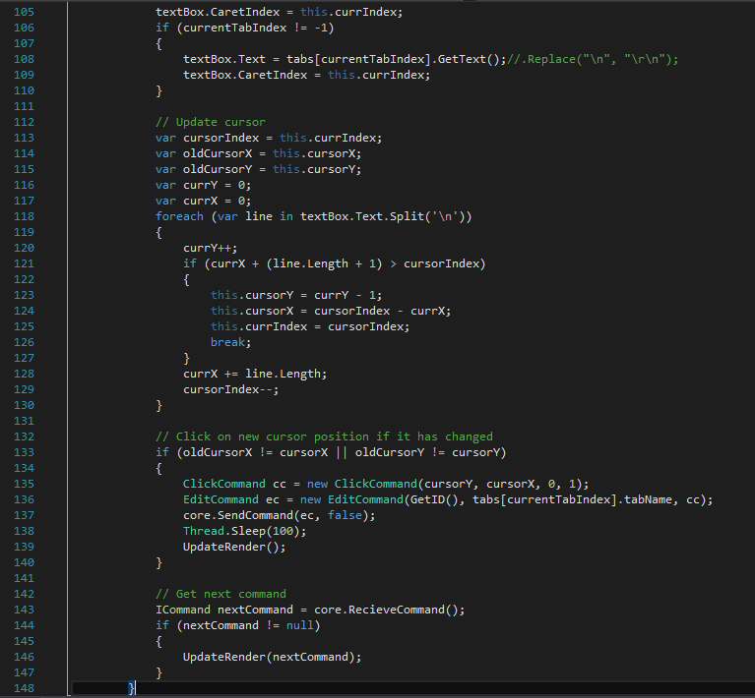

This function is responsible for processing all incoming commands and updating the state of the UI. The first if and switch statement process all the incoming commands, depending on their type. Then we remove all items from and repopulate the tab bar with all the tabs that we have stored. After that, we clear the text input box and insert what should be there, based off what tab is open. Then we figure out the 2D coordinates of the cursor, which is what the core uses, from the 1D coordinates provided by C# and send a click to the core if the caret (text cursor) has moved. After that we see if there is another command. If there is, we call the function again with that command and if not, we just return.