**Micro Project Report**

**On**

**Department Management System**

**Diploma Computer Engineering**

**Semester 4**

**(Introduction to Web Development - 4340704)**

|  |  |  |
| --- | --- | --- |
| **Group Members** | | |
| **Sr. No.** | **Enrollment No.** | **Student Name** |
| **1** | **226090307004** | **Bhargav Bhatt** |

**Guided By :-**

**Miss. SHAILY LANGHNOJA**

**Lecturer, CE Department,**

**C. U. Shah Polytechnic, Surendranagar**

**Index**

|  |  |  |
| --- | --- | --- |
| **Sr. No.** | **Topic Name** | **Page no.** |
| 1 | Scope of the system. | 3 |
| 2 | Functional requirements of the system. | 4 |
| 3 | ER diagram for the system | 5 |
| 4 | Code of Project | 6 |
| 5 | Output | 15 |
| 4 | References & Tools | 18 |

**Scope of the project**

The Department Management System (DMS) includes user management, event tracking, practical submission, subject assignments, attendance management, result management, and e-notice board. It is designed to be adaptive to the specific requirements of faculty, and students, creating a unified and accessible user interface. The system's functionality covers a wide range of academic and administrative processes, ensuring a holistic solution for the college community.

* Abstract of Project: DMS is a web-based solution crafted to simplify and enhance the management processes within educational institutions. This system caters to the unique needs of administrators, faculty, and students, offering a user-friendly platform for streamlined administrative tasks and improved communication. From handling attendance records to facilitating practical submissions and collaborative e-notice boards, the system aims to provide a comprehensive solution that fosters efficiency and transparency in the academic environment.
* Need of System: This need arises from the increasing complexity of administrative tasks within educational institutes. With a growing number of students, faculty, and events, there is a need for a centralized and efficient system to manage these tasks and improve communication between administration, faculty, and students.

**Functional Requirements of the system**

DMS is distributed in 2 types of user which all has different functionalities to perform and has a different rights over the system users are Faculty and Student . Functional Requirements are listed below as per the use

* Faculty:
* Take Attendance.
* Manage Practical Submissions (Add, Verify, Reupload).
* Add Tasks for Practical Submissions.
* Check Practical Submissions and Verify.
* Manage Results (Add, Update).
* View Own Data.
* Student:
* Submit Practical.
* View Attendance.
* View Results.
* View Notice Board.
* Post on Notice Board (Approval needed).

**Entity-Relationship Diagram**

ER diagram :- An Entity-Relationship (ER) diagram is a graphical representation used to depict the relationships between entities (important things) in a database system. It visually portrays how data is organized within a database, focusing on the entities, their attributes (descriptive details), and the connections between them.

* 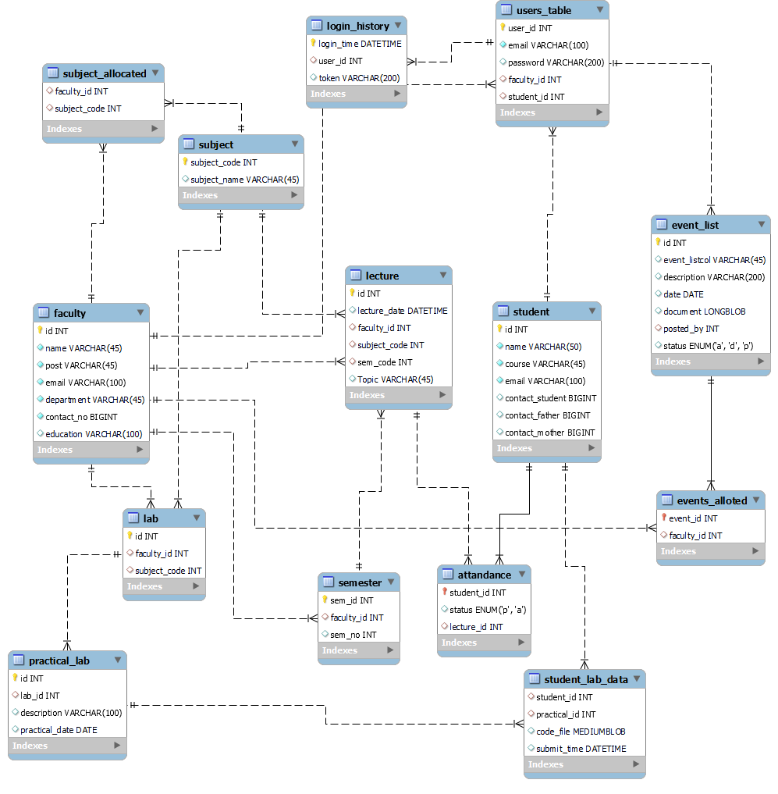ER diagram of DMS

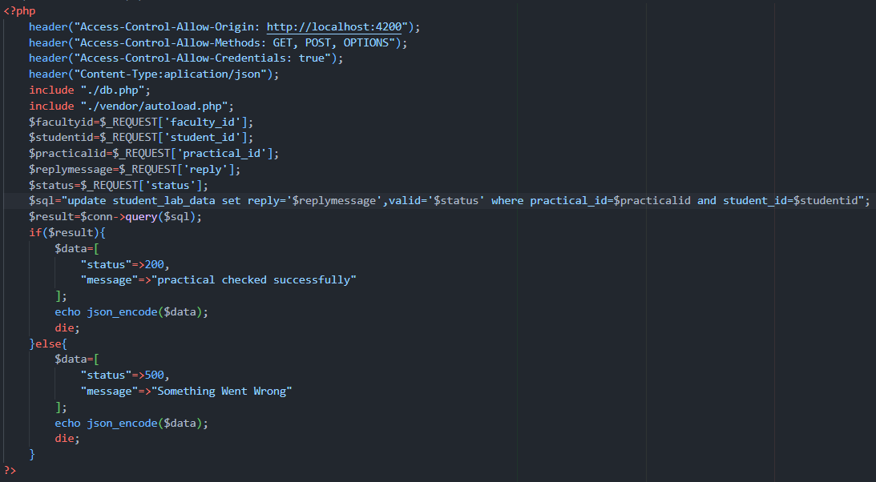

**Code of Project**

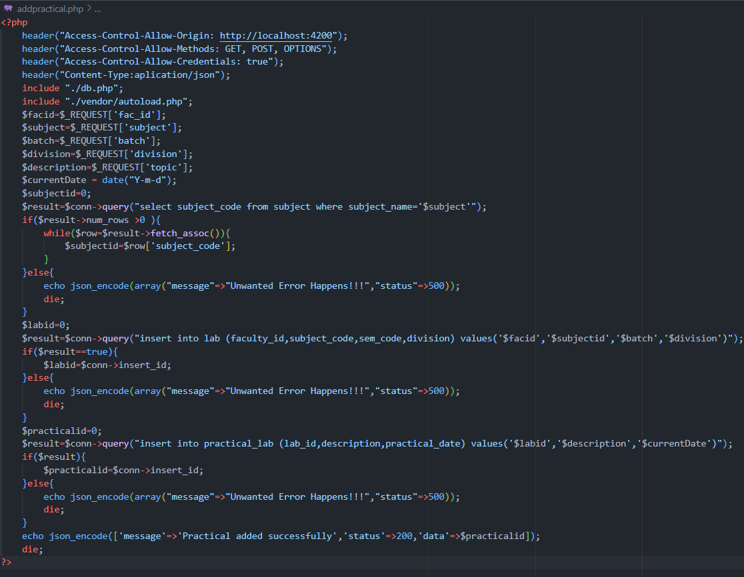

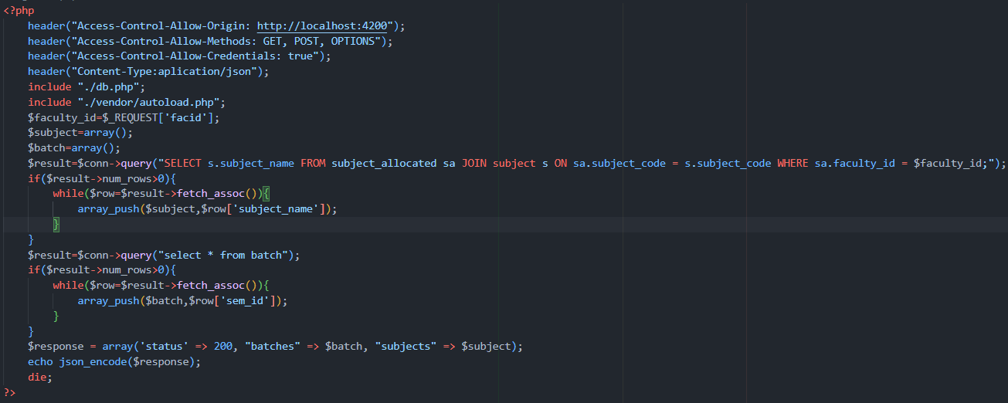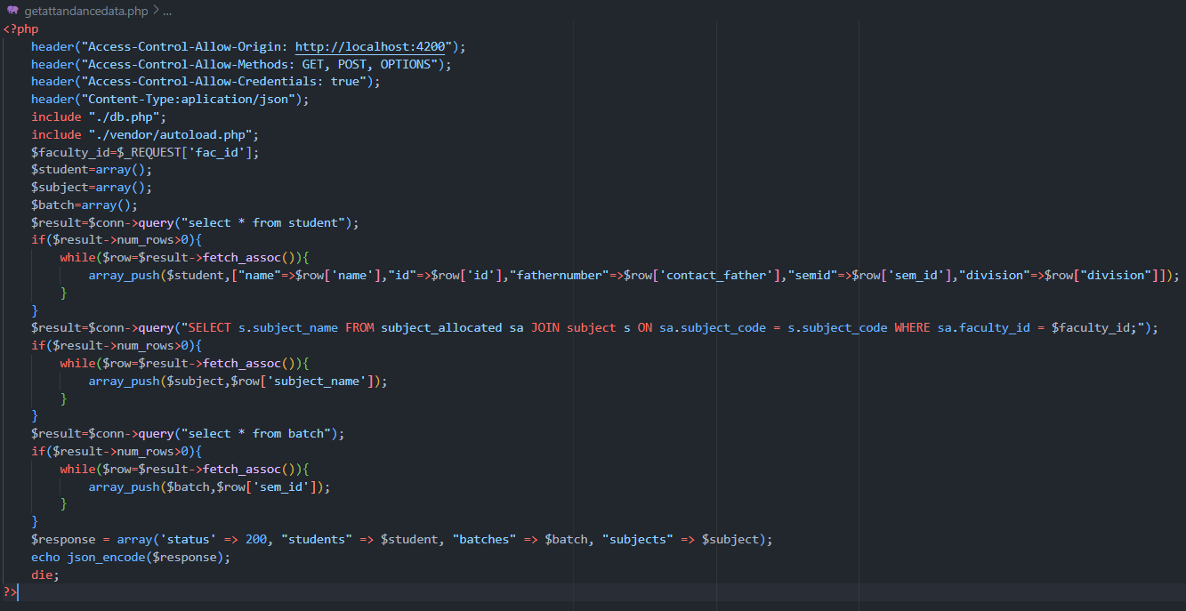

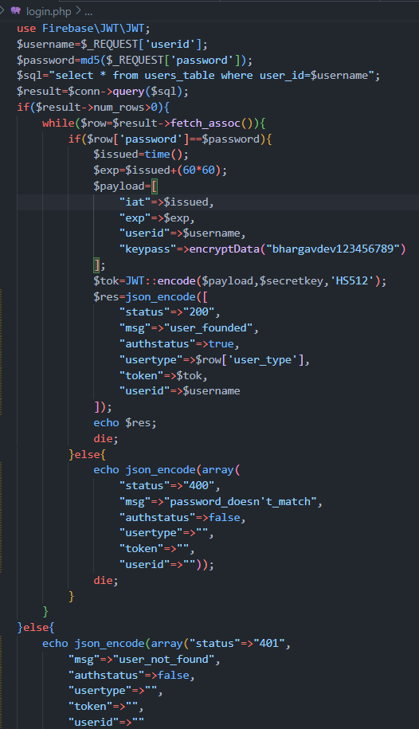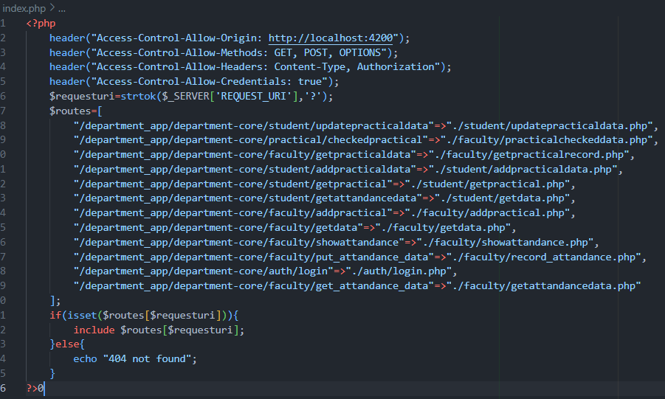

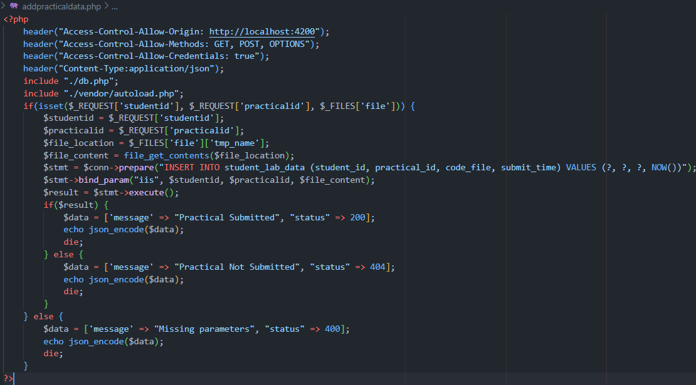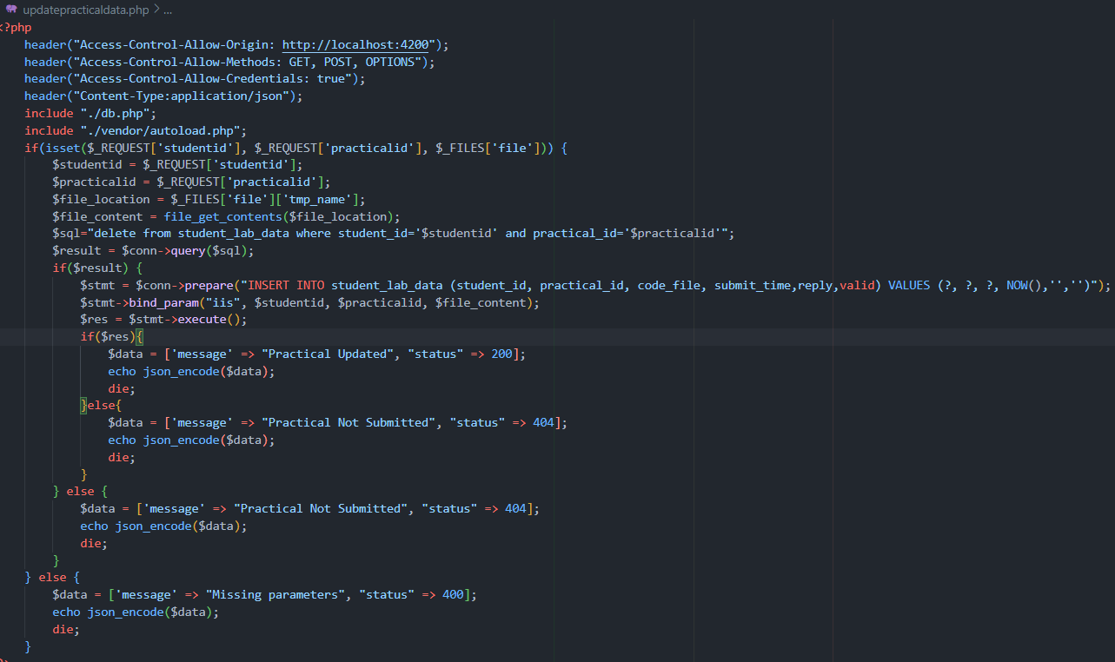

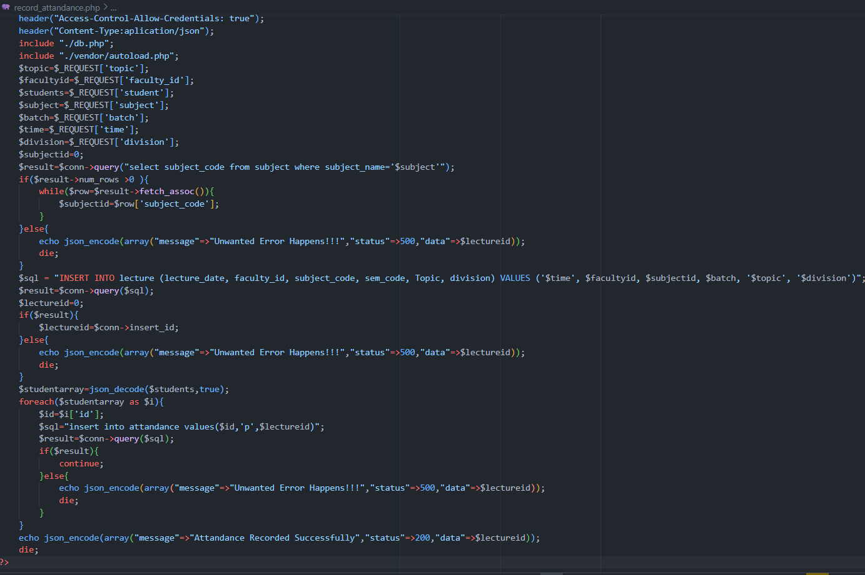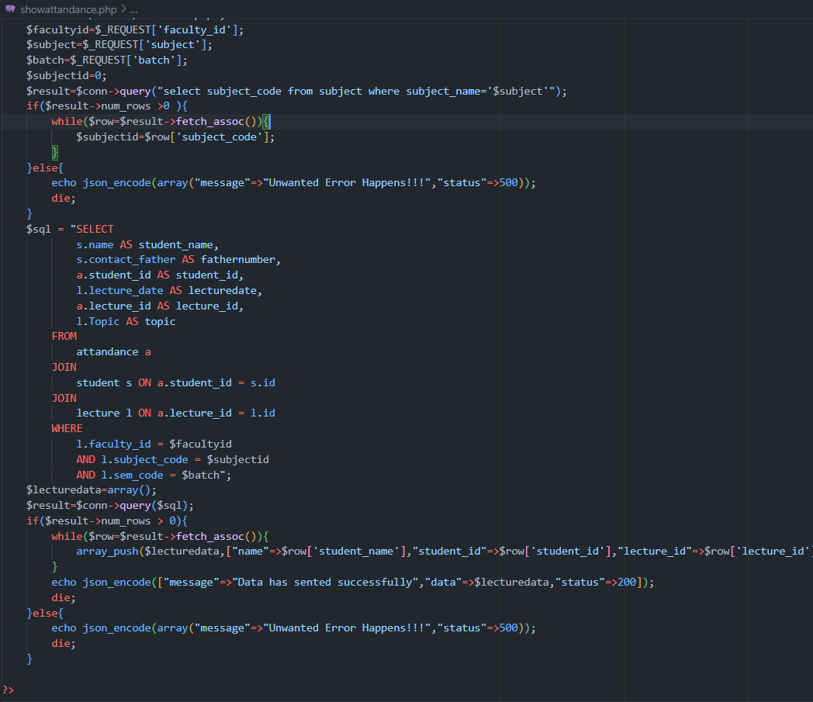

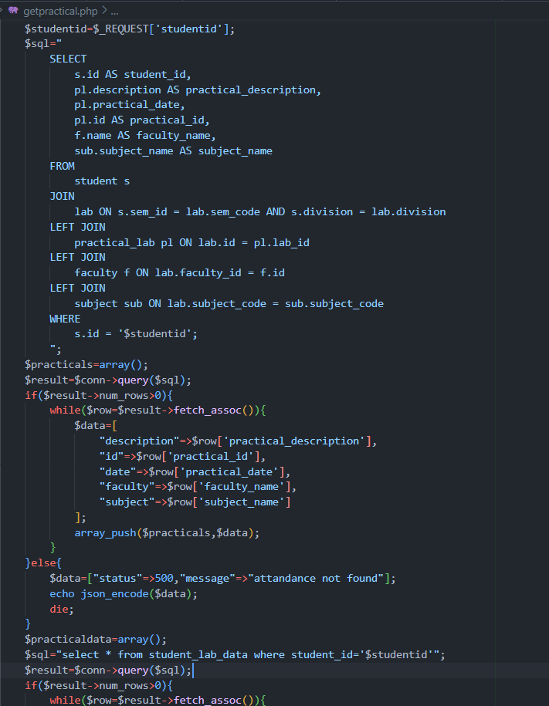

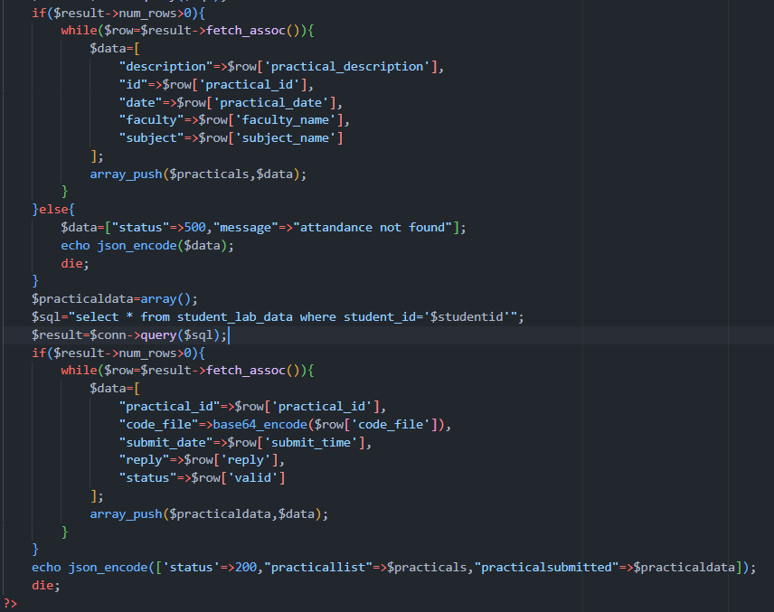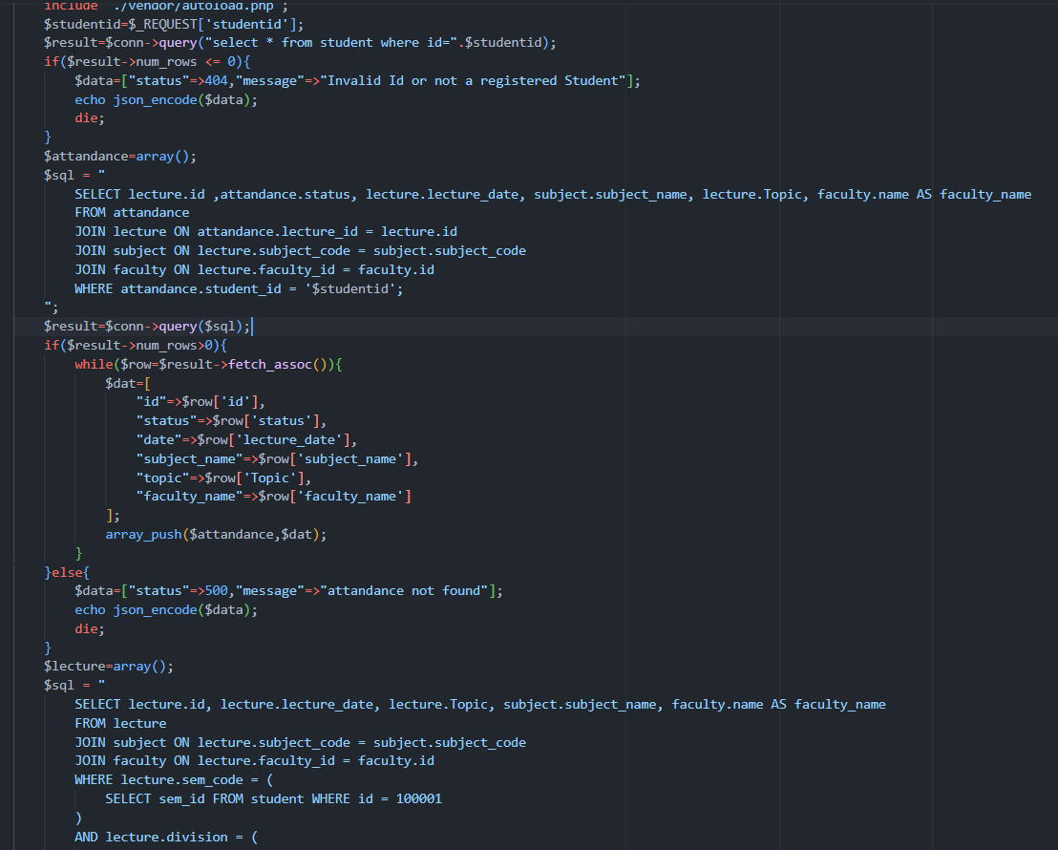

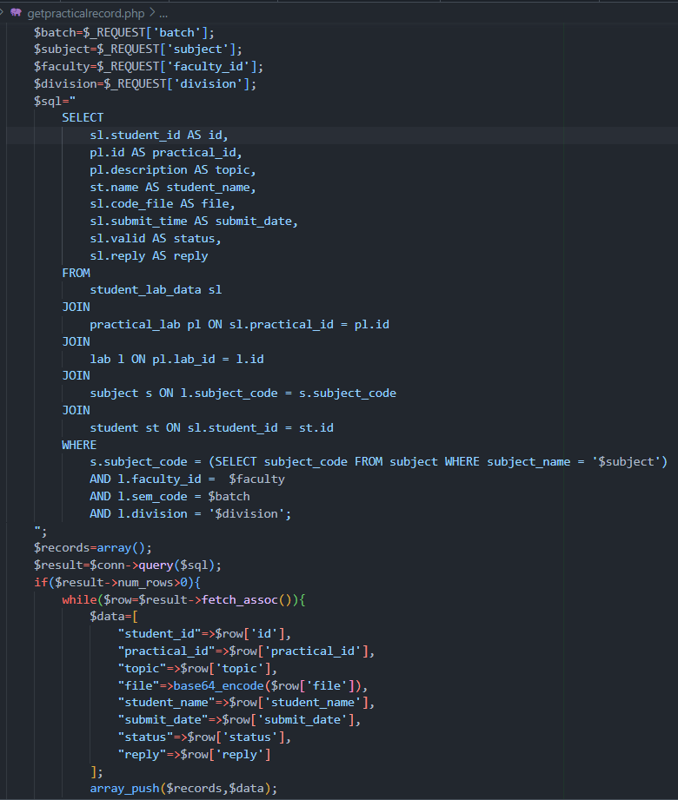



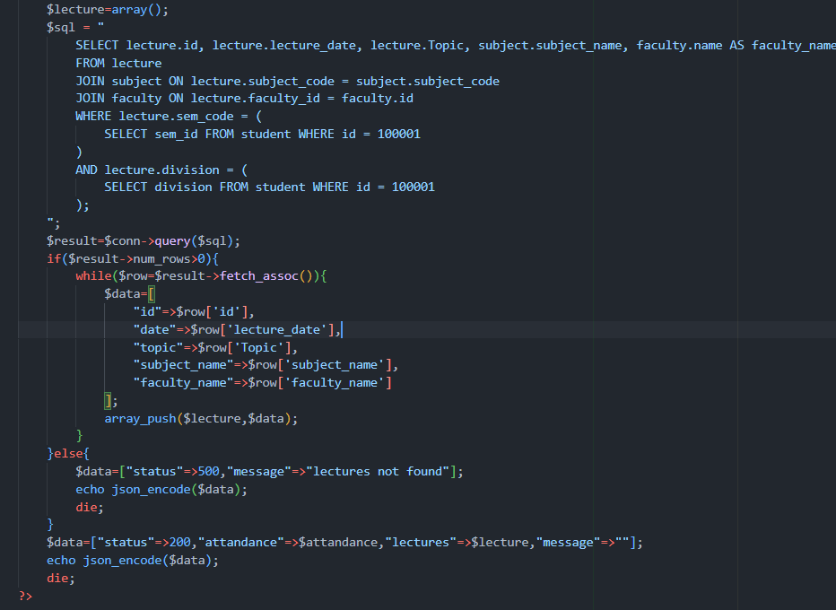

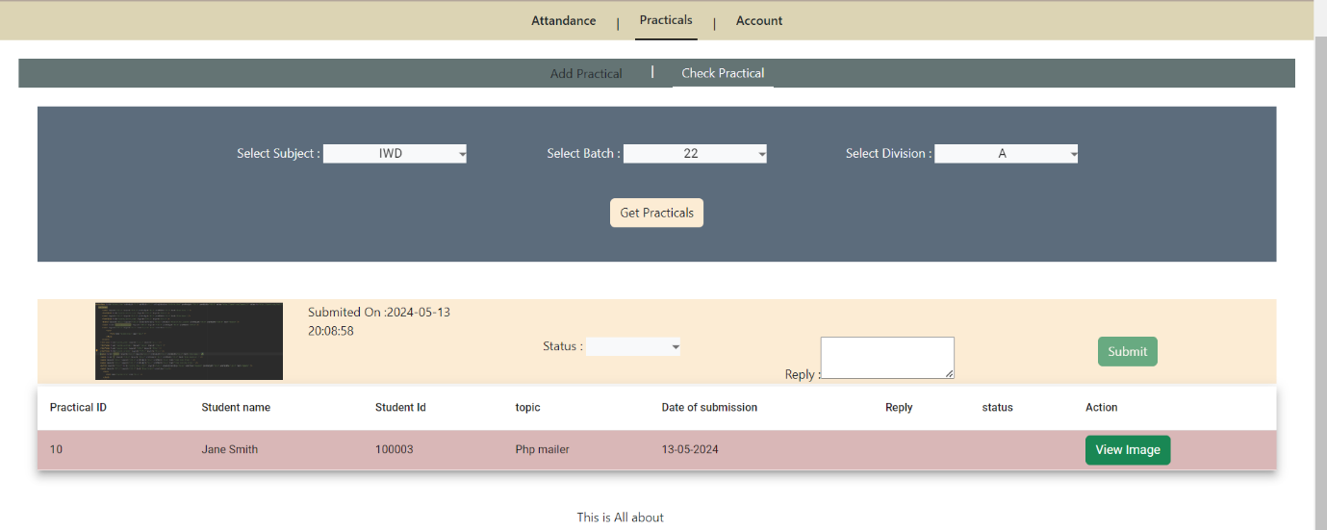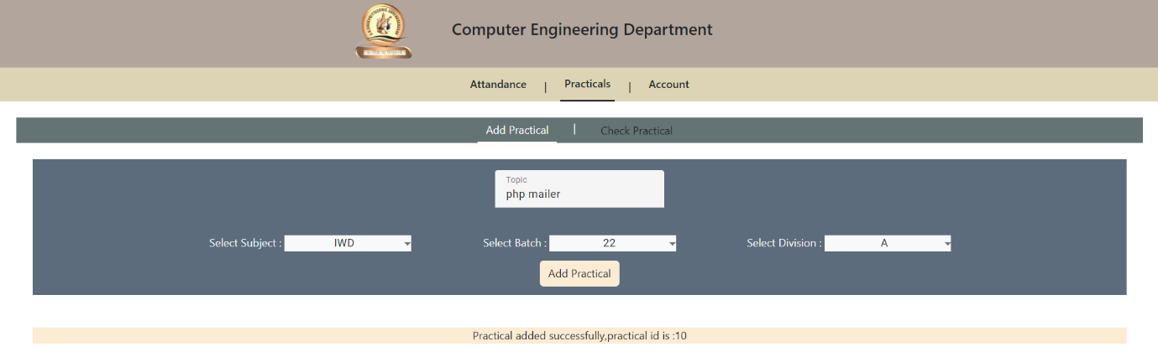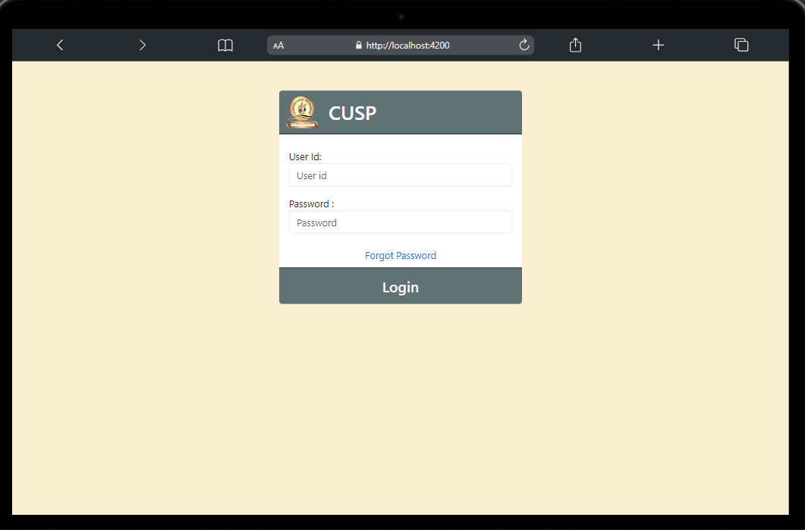

**Output**

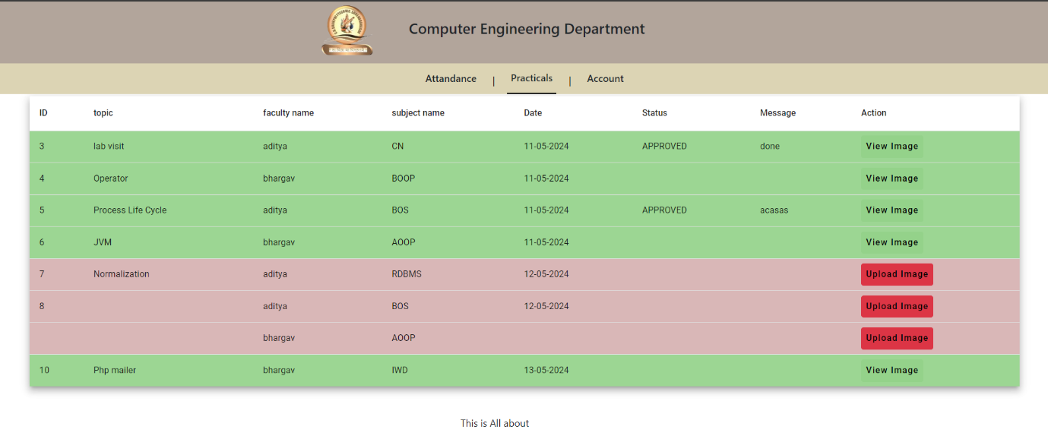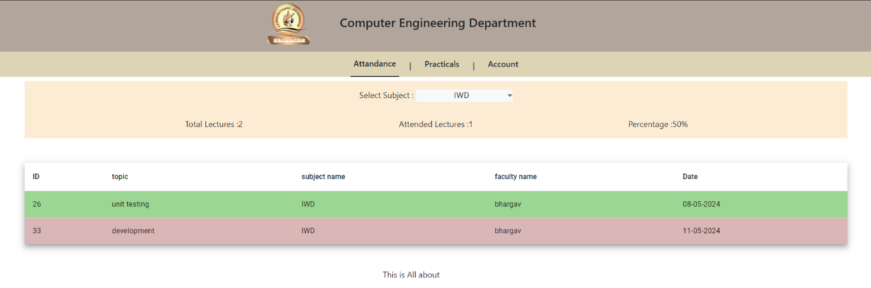

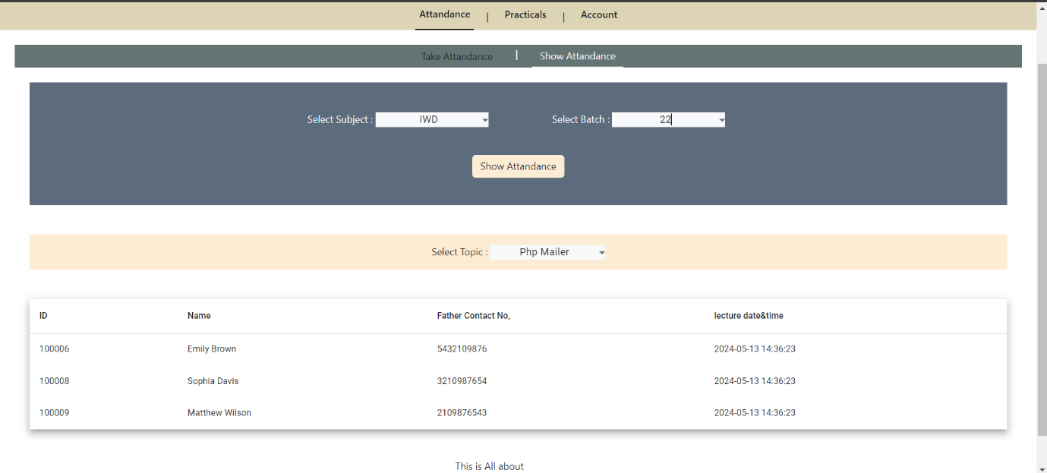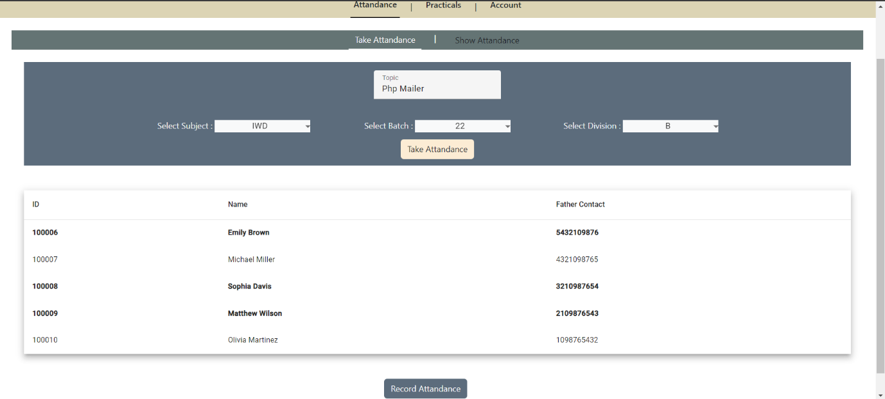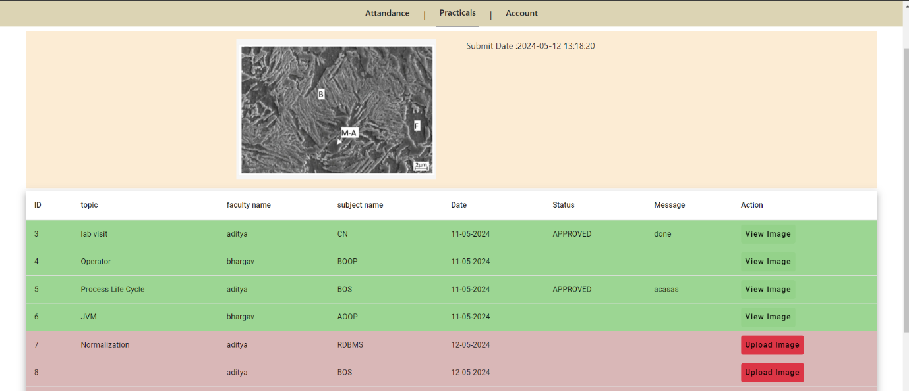

**References & Tools**

* Websites & Apps :-
* <https://www.geeksforgeeks.org/software-engineering/>
* <https://online.visual-paradigm.com/diagrams/>
* <https://app.creately.com/d/start/dashboard>
* <https://www.edrawmax.com/online-data-flow-diagram-maker.html>
* <https://www.w3schools.com/php/>