IS117 – Exam 1

HTML5 – Boiler Plate Diagram – You can use the image or go to the repository to view the code. https://github.com/h5bp/html5-boilerplate/blob/master/index.html

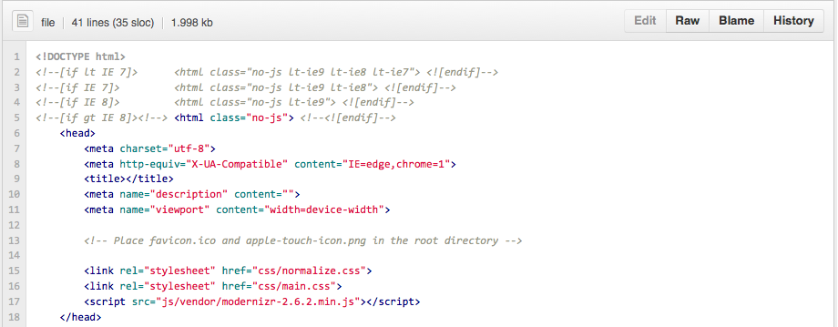
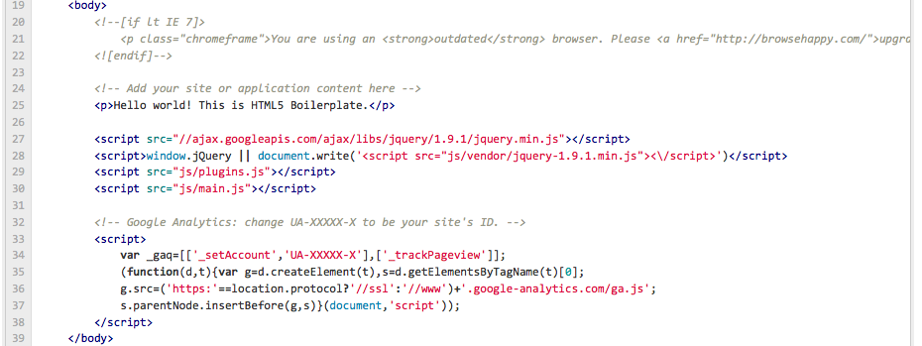

I will ask the question and indicate the line number. Please answer it briefly in only one sentence or less.

HTML Questions 2 Points Each:

- What does line 1 do?
- What are lines 2-4 for?
- What is line 7 for?
- What is line 9 for?
- What is line 15 for?
- What is line 16 for?
- What is line 17 for?
- What happens if the IE 6 browser views this page? What line causes it to happen?
- Why are many of the JS files loaded at the end of the page?
- What is a CDN and which line(s) in the page use one?

HTML Questions 5 Points Each

1. Identify the proper names for the two parts of this HTML statement:

Part 1
Part 2

<a href=http://www.google.com>Google</a>

2. Write 5 HTML tags not in the image above and what they do.

3 Points Each - CSS Questions

h2 { color: #666; }

- What is the proper css identification / naming convention for : “H2” ?
- What is the proper css identification / naming convention for: color: #666; ?
- What is the proper css identification / naming convention for: color:
- What is the proper css identification / naming convention for: #666?
- What does the H2 element used for?

Git Questions 1 Point Each:

- What is GIT?
- How do you think you would use GIT in the future?
- Why use version control when writing a program?
- What does the command gitinit do?
- What does the command git add do?
- What does this command do: git commit –m “my first commit”
- What does this command do: git push origin master
- What is origin in the previous command?
- What is master in the previous command?
- Explain what this command is doing:

git remote add origin git@github.com:h5bp/html5-boilerplate.git

Layout Creation – 20 Points Total

Using Adobe Illustrator create a layout for a website using the golden ratio horizontally and vertically. The width of the layout should be 960px and you should use the golden ratio to determine the height of the website. Just use a wire frame that includes the lines associated with the major regions. You do not need to include links or be detailed. I expect to see 3-4 instances of the golden ratio being used within the layout. Export a PNG or GIF file of your layout and paste it into your test.

Typography Questions – 15 Points (5 Points Each)

- Name an example of a Serif and Sans Serif Font?
- What is the difference between a Sans Serif font and a Serif font?
- What font is used for New York City street signs?

Audience Analysis – 10 Points

Analyze the following website and identify what is being done correctly and indicate what you would change. Think about how this website is and is not being used as a billboard. Identify any layout patterns such as golden ratio or equal spacing. What are the primary links? You should visit the website to fully see how it appears to visitors.

http://www.simpleremovals.co.uk/home

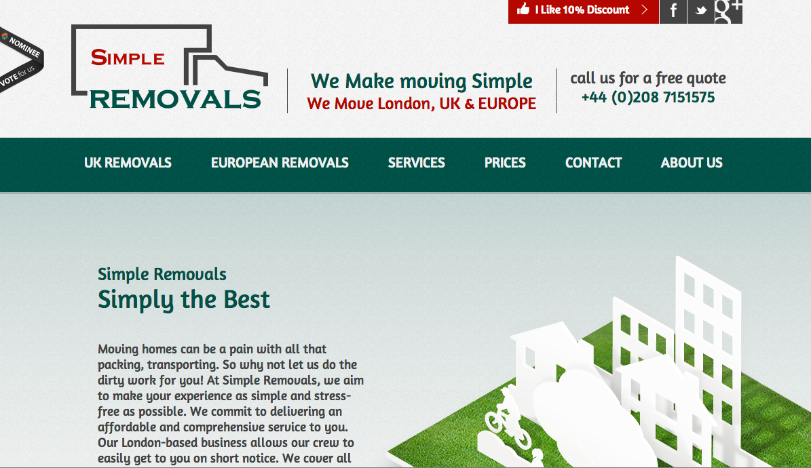

Exam 1 Answer Sheet

You Name: Balasubrahmanya Balakrishna

HTML Questions - 20 - Points
1. It is an instruction to the web browser about what version of HTML the page is written in.
2. The lines 2-4 is to support users using IE versions less than or equal version 8 in which case the classes specified in the tag would be verified.
3. UTF-8 can represent any character in the Unicode standard. UTF-8 is backwards compatible with ASCII.
4. The <title> tag is required in all HTML documents and it defines the title of the document
5. This is a HTML <link> tag is used for defining a link to an external document. Here the tag is point to a css file, normalize.css specified in the css folder and the MIME type is stylesheet.
6. This is a HTML <link> tag is used for defining a link to an external document. Here the tag is point to a css file, main.css specified in the css folder and the MIME type is stylesheet.
7. This is a for declaring a script (such as JavaScript) within your HTML document. Here the tag is point to a javascript file, modernizr-2.6.2.min.js located in the js/vendor/ folder.
8.Condition block atarting at line 21 executes and the the message in line 22is shown to the user. That is, “You are using an outdated browser. Please http://browsehappy.com/ upgrade your browser or http://www.google.com/chromeframe/?redirect=true activate Google Chrome Frame to improve your experience”.
9. If you include external js files at the bottom of your page, you give the priority of your HTTP requests to the visual display that will be presented to the client instead of to the logic of interaction or dynamics.
By loading js at the end of the file you can access the DOM(most of the time) without having to call a document.ready() function.
10. CDN refers to Content delivery network or content distribution network (CDN) , is a large distributed system of servers deployed in multiple data centers in the Internet.

HTML Questions - 10 - Points
1. part 1: <a> is called an anchor tag and part 2: hypertext reference
2. (i) <p>This is a paragraph.</p>
This repsents a paragraph tag, are used to define HTML headings.
(ii) <h1> This is a header tag</h1>
This represents a header tag, are used to define HTML headings.
(iii) <img src=”img/image1.png”/>
This is an image tag used define an image in an HTML page.
(iv) <div style="color:black ">
<h3>This is a heading</h3>
<p>This is a paragraph.</p>
</div>
The <div> tag defines a division or a section in an HTML document.
(v) <ol>
<li>Yellow</li>
<li>Fellow</li>
<li>Nellow</li>
</ol>
</ol> defines the ordered list and the <li> tag defines a list item.

CSS Questions - 15 - Points
1. In CSS, the “H2” to is referred to as “Selector”.
2. The color: #666 as a whole is referred to as “Declaration”.
3. Color: is referred as Property.
4. #666: is referred as Value.
5. Whenever the HTML page referring to the CSS style sheet is referred to the color of the header (h2) will be corresponding to color #666.

GIT Questions - 10 - Points
1. GIT is a very popular and efficient open source Version Control System.
2. GIT could be used as version control system.
3. We’d need a version control system while writing a code so as to track the changes being to a particular module and to go back to the last (/older) version if the changes commit aren’t functioning as intended.
4. git init: To creates a repository from an existing directory of files, we simply run git init in that directory.
5. git add :adds file contents to staging area before you can commit them. If the file is new, you can run git add to initially add the file to your staging area, but even if the file is already "tracked" - ie, it was in your last commit - you still need to call git add to add new modifications to your staging area.
6. Once, you have staged the content you want to snapshot with the git add command, you run git commit to actually record the snapshot. We’ll use the -m option to provide the commit message on the command line.
7. This command pushes our changes to the remote repository.
8. Origin is an alias.
9. Master is the branch/new branch on the alias remote.
10.Command to add a remote to existing git repository.

Layout – 20 – Points

Insert PNG/GIF here

Typography Questions – 15 Points
1.Alexandria, Aldus are few of the examples of Serif typefaces.Arial, Calibri are few of the examples of a Sans Serif typefaces.
2. Serif fonts have little "feet" at the bottom, like Times New Roman; And Sans Serif fonts don't have little "feet" like the font.
3. Hevetica.

Audience Analysis – 10 – Points
At the offset, the foremost objective is to plan the redesign of the website which would be done as below:

a.)Website visitor should be given an option to learn about the parent orgaization (by "About Us" link ), Industry recognition etc. for which reasons a primary navigation menu becomes essential to the website. Also visitors who has knowledge about the website and the business should be able to navigate to a specific business description content page using the drop list on the right side corner from the main page without wasting much time finding it.

b.)Refactoring navigation: The content on the page needs to be worked upon so as to avoild uncessay scrolling.

c.) The font has be chnaged to something which is more nutral and clear, Heveltica based are preferred.

The website style could still be maintained considering the look and feel of the website.

2-3 Paragraphs Expected

Link to Github with a repository and commit made during the testing period:

5 Bonus Points

