Welcome to use Co-location-Miner, this document tells you how to use it.

Co-location-Miner has a very simple UI, you can easily learn how to use it.

* Generating data

Once opening the system, a new set of data and default configuration will be generated for you to watch their format.

If you do not have any data files, just generate random data. Before generating your own random data, please set your configuration first. As picture shown below, just modify your configuration because data is generated based on configuration.

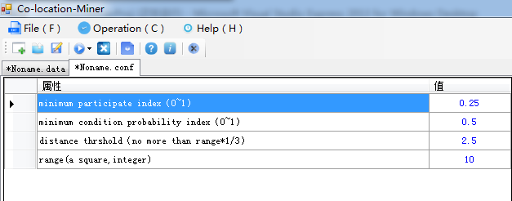

Configure configuration

After configuration, you can generate random data, just click menu Operation->Generate Random data, you will be asked to input feature Count and instance count, then press OK, data will be generated on the left side.

If you want to load your own data file, you should have 2 files, \*.data contains data information formatted as system required, \*.conf contains 4 parameters. Also, when you save data to file, \*.data and \*.conf will be created at the same time.

* Running main method

While data generated, choose one method to run(operation->run->…), you can see the current information on the interface.

The system to quite easy to use, just click the menu to run it. Welcome to use it.