MOD6
CATALOG CONTROL CENTER
Detailed Operating, Excel-Cockpit & Publishing Manual
Discogs Toolkit V1.0 • BBaya Publishing Studio
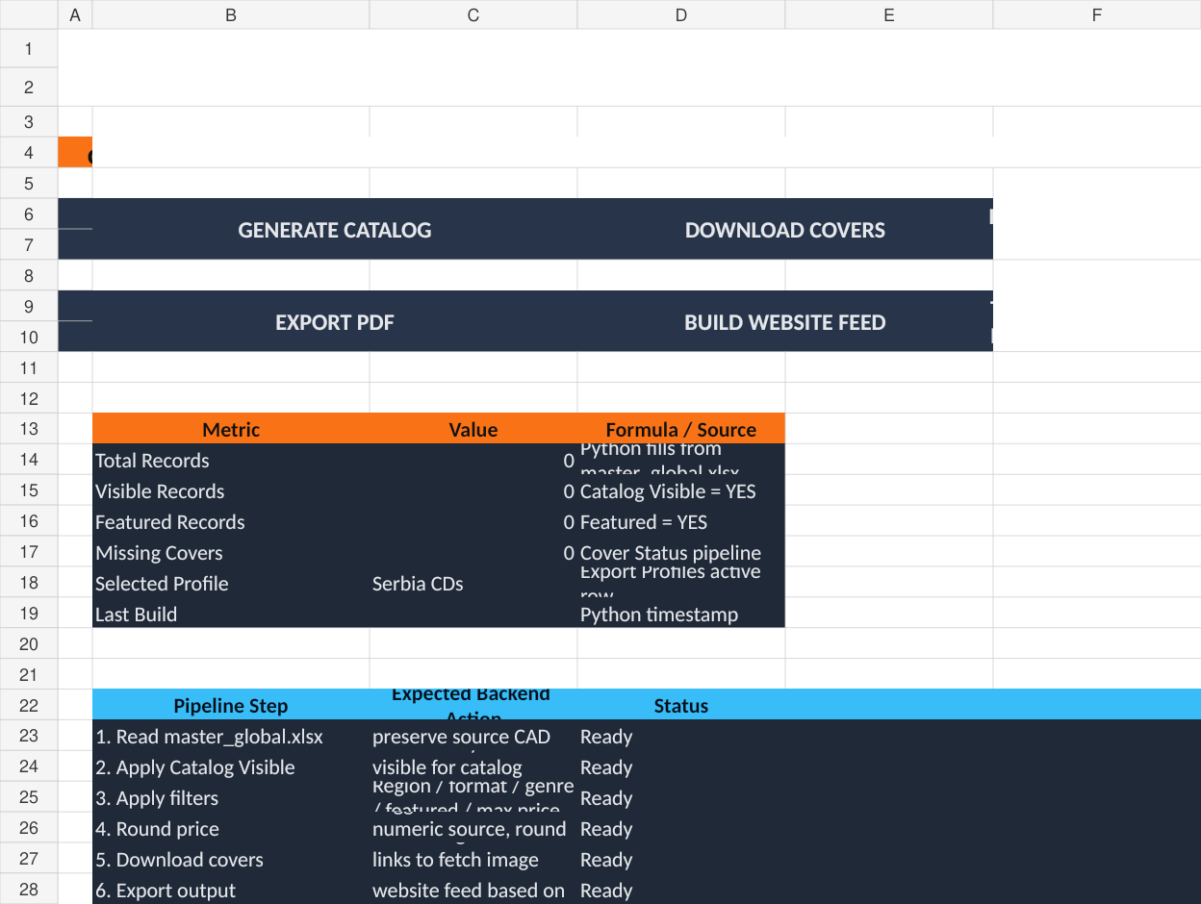
Excel Control Center → Python Processing Engine → Catalogs, Websites & Library Packages
Revision 1.0 | July 2026

Document Control

Revision History
Revision | Date | Description | Status
1.0 | July 2026 | Detailed MOD6 manual with complete Excel-sheet correlation and publishing workflow. | Current

Purpose
This manual explains MOD6 as both a desktop Publishing Studio and an Excel-controlled catalog-generation system. It documents how the BBaya_Catalog_Control_Center.xlsx workbook communicates publishing instructions to the Python backend and how those instructions become Excel catalogs, HTML catalogs, PDFs, JSON feeds, record pages and integrated website Library packages.

Source basis
- The supplied BBaya Catalog Control Center operating guide.
- The actual BBaya_Catalog_Control_Center.xlsx workbook and its ten worksheets.
- The current MOD6 Library Integration architecture, where MOD0 defines website profiles and MOD6 executes the build.
IMPORTANT TERMINOLOGY
The supplied workbook still contains some legacy “BBaja” labels. The approved public brand spelling is “BBaya”. Update public-facing workbook values when preparing final production catalogs.

Table of Contents
1. MOD6 at a Glance
2. The Three-Layer Architecture
3. Starting MOD6 and Required Files
4. End-to-End Publishing Workflow
5. How the Excel Control Center Correlates
6. Dashboard Sheet
7. Field Selector Sheet
8. Catalog Filters Sheet
9. Price Rules Sheet
10. Branding Sheet
11. Export Profiles Sheet
12. Layout Sheet
13. Cover Status Sheet
14. Text Blocks Sheet
15. README Sheet
16. Precedence and Override Rules
17. Working with the Master Workbook
18. Website & Library Integration
19. Output Types and Generated Files
20. Multi-Language and Multi-Currency Publishing
21. Covers and Record Pages
22. Safe Publishing and Build Manifests
23. Recommended Daily Workflow
24. Troubleshooting
25. Workbook Editing Rules
26. Configuration Reference
27. Examples and Scenarios
28. Future Expansion Notes

1. MOD6 at a Glance
MOD6 is the publishing layer of the BBaya Discogs Toolkit. It transforms the normalized and enriched master collection into presentation-ready outputs while preserving the master workbook as the source of truth.
- Build visually rich HTML catalogs and storefronts.
- Generate filtered lists, Excel catalogs, JSON feeds, PDF catalogs and publishing packages.
- Use one central collection to create regional, format-specific, featured or inventory-only outputs.
- Apply configurable fields, labels, filters, price rules, branding, layouts and text blocks.
- Publish a complete standalone storefront or only the Library portion of an existing website.
- Support multiple storefront profiles, languages and currencies without changing the master data.
CORE PRINCIPLE
The Excel workbook is the cockpit. The Python backend is the engine. Generated catalogs are outputs, not the source database.

2. The Three-Layer Architecture
Layer | Primary responsibility | Examples
MOD0 — Control Center | Defines shared paths, website profiles, routes, publishing scope, cart behavior, localization and safe-publishing rules. | BBaya.net Production profile, Library destination, domain, staging root
MOD6 — Publishing Studio | Loads collection data, previews templates, reads workbook/profile settings, builds outputs and reports results. | Build website, export Excel, generate JSON, validate Library package
Excel Control Center | Stores catalog-specific choices that are easy to review and reuse in a spreadsheet. | Fields, filters, price rules, branding, export profiles, layouts, text blocks

The master workbook sits below all three layers as the record source. MOD6 must never treat generated catalogs as the authoritative database.
master.xlsx / master_global.xlsx
↓
MOD0 website profile + MOD6 project
↓
BBaya_Catalog_Control_Center.xlsx
↓
Python publishing engine
↓
HTML / Library / Excel / PDF / JSON / Package

3. Starting MOD6 and Required Files

3.1 Typical project structure
Discogs_Toolkit_v1\
├── pipeline\data\master.xlsx
├── pipeline\data\covers\
├── pipeline\config\website_profiles.json
└── pipeline\mod6_catalog_control_center\
├── BBaya_Catalog_Control_Center.xlsx
├── templates\
├── assets\
├── generated_catalogs\
└── Python application files

3.2 Essential inputs
Input | Why it is needed
Master workbook | Contains the collection, inventory, pricing, conditions, visibility, region and cover references.
Excel Control Center | Defines how the source data is selected, renamed, filtered, priced and presented.
Templates | Define actual HTML, PDF, Excel or Markdown presentation.
Covers folder | Provides stable local artwork without hotlinking Discogs images.
Website profile from MOD0 | Defines destination folders, routes, cart mode and safe publishing boundaries.

4. End-to-End Publishing Workflow
- Update and reconcile the master collection in MOD1.
- Normalize artist sorting and storage codes in MOD2.
- Enrich metadata and covers in MOD3.
- Promote records to inventory, manage Discogs status and confirm prices in MOD4.
- Optionally research marketplace pricing and prepare listings in MOD5.
- Open MOD0 and validate the website/publishing profile.
- Open MOD6 and select the master workbook, project, template and publishing profile.
- Review the Excel Control Center sheets or configure the equivalent controls in MOD6.
- Preview the selected output.
- Build into staging, validate links and assets, then publish to production.
- Review the build manifest and generated report.

5. How the Excel Control Center Correlates
The workbook does not independently generate catalogs. It acts as a structured configuration contract between the operator and the Python backend. Each worksheet controls a distinct stage of the publishing pipeline.
Excel sheet | Pipeline question answered | Backend effect
Dashboard | What is the current project and processing status? | Shows operator summary, selected profile and last-build metrics.
Field Selector | Which master fields appear, under what names, and in what order? | Creates the output schema for Excel, HTML and PDF.
Catalog Filters | Which records qualify for the output? | Filters source rows before layout/rendering.
Price Rules | Which source price is used and how is it transformed? | Computes the public price and currency label.
Branding | How should the catalog identify and style itself? | Applies title, logo, banner, colors, theme and display switches.
Export Profiles | Which reusable combination of filters/output/layout should run? | Selects a complete publishing recipe and destination.
Layout | How should records be arranged? | Controls cards per row, cover size, compactness, borders and shadows.
Cover Status | Are cover assets available and where are they located? | Tracks cover download/validation results and errors.
Text Blocks | Which public information appears around the catalog? | Adds header, footer or sidebar content in a defined order.
README | What assumptions must the backend honor? | Documents workbook contract and operational rules.

KEY CORRELATION
A selected Export Profile normally references or overrides Catalog Filters, Branding and Layout. Field Selector and Price Rules remain shared unless the backend supports profile-specific overrides.

6. Dashboard Sheet
Dashboard worksheet: operational cockpit and pipeline summary.
The Dashboard is an operator-facing summary. In the supplied workbook, buttons are visual placeholders because heavy VBA and macros are intentionally avoided. The Python desktop application performs the actual actions.
Dashboard element | Source / expected behavior
Total Records | Python counts rows from the master workbook.
Visible Records | Count where Catalog Visible qualifies under the selected profile.
Featured Records | Count where Featured = YES.
Missing Covers | Derived from Cover Status or cover-path validation.
Selected Profile | Active row in Export Profiles.
Last Build | Timestamp written after a successful generation.
Pipeline status | Backend reports Read → Filter → Price → Cover → Export progress.

Recommended behavior: MOD6 should update Dashboard metrics after loading the master and after each completed build. It should not rely on manual formulas for large collections.

7. Field Selector Sheet
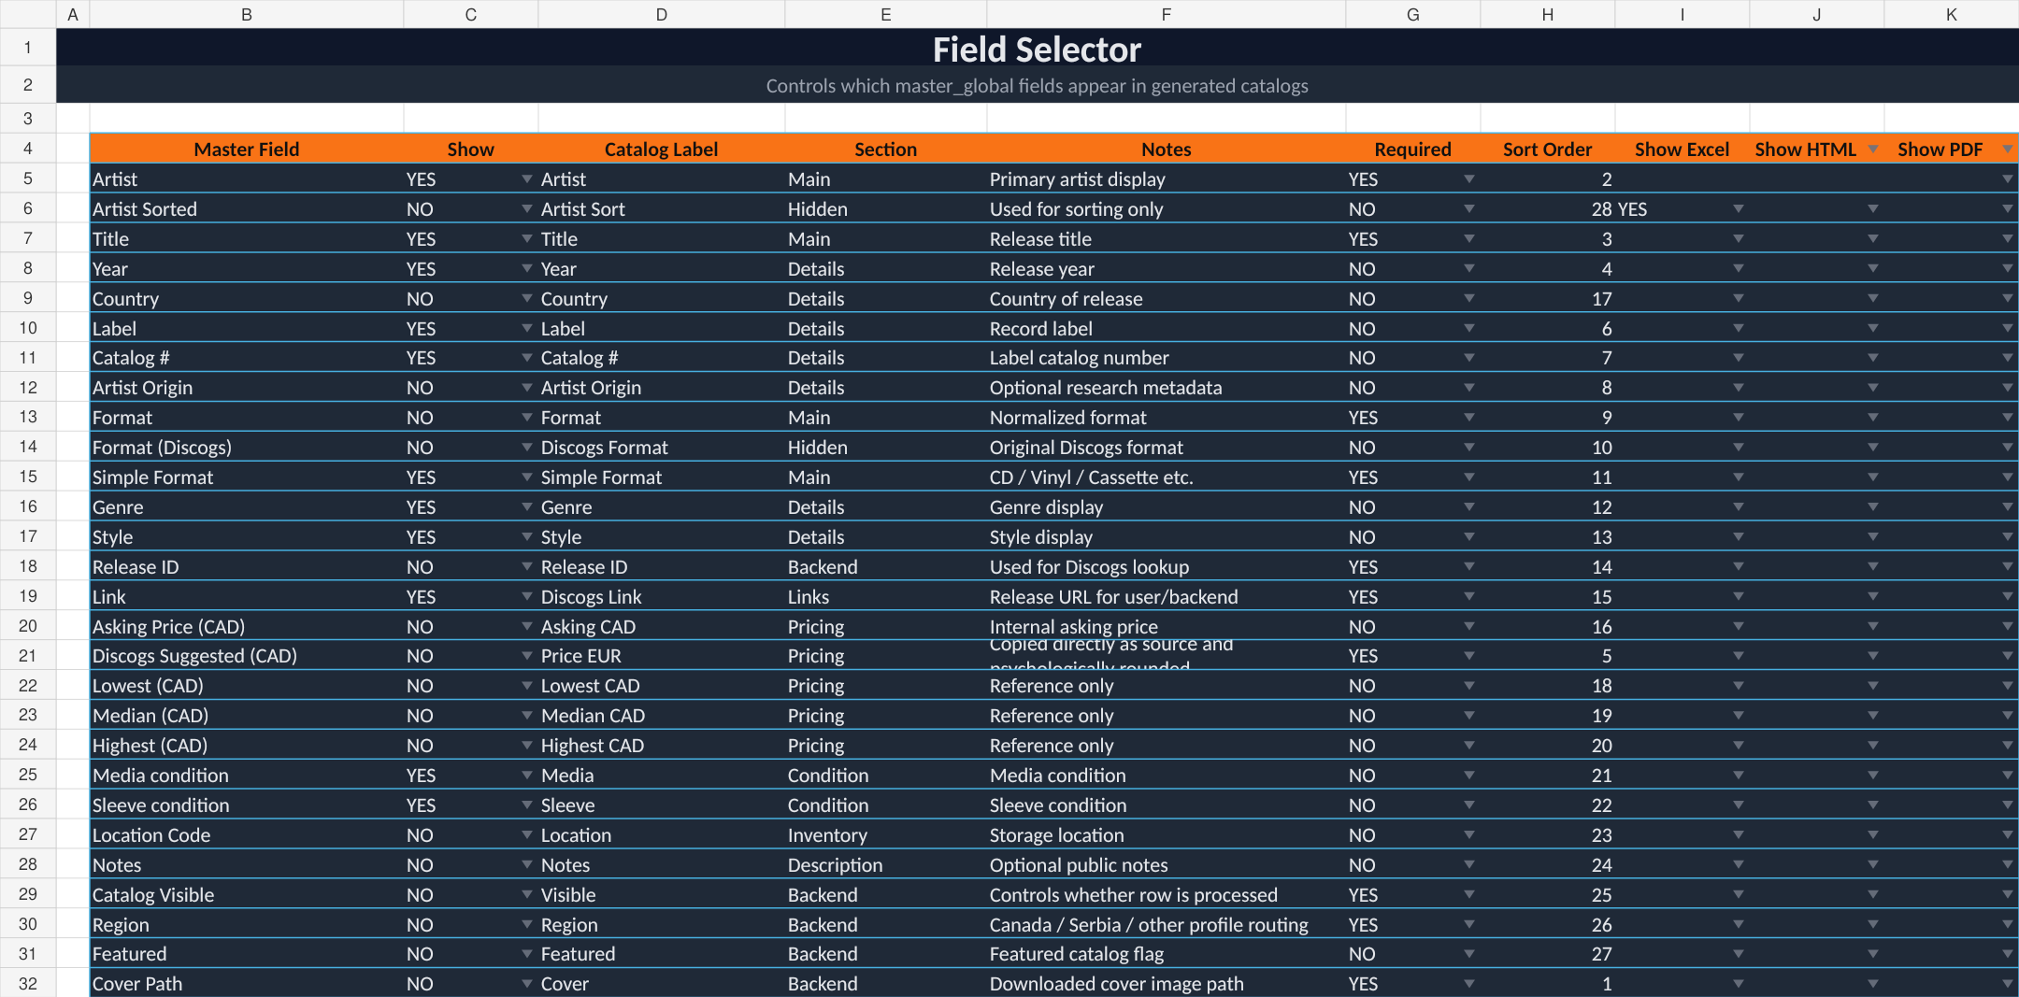
Field Selector worksheet: controls output fields, labels, sections and order.

7.1 Meaning of each column
Column | Meaning
Master Field | Exact source-column name expected in the master workbook.
Show | Global default inclusion switch. YES includes; NO hides from normal output.
Catalog Label | Public label used instead of the master-column name.
Section | Logical group such as Main, Details, Pricing, Condition, Inventory or Backend.
Notes | Human explanation of the field.
Required | Whether the backend should treat a missing source field as an error.
Sort Order | Output position. Lower numbers appear earlier.
Show Excel / Show HTML / Show PDF | Format-specific override switches where implemented.

7.2 Correlation example
Master field | Workbook instruction | Generated result
Title | Show = YES; Catalog Label = Title; Sort Order = 3 | Title appears as the third selected public field.
Artist Sorted | Show = NO; used for sorting | Hidden from the card/list but still available as the sort key.
Release ID | Show = NO; Required = YES; Section = Backend | Not displayed publicly, but retained for cover lookup and record links.
Discogs Suggested (CAD) | Show = NO; Required = YES; Catalog Label = Price EUR | Used by Price Rules even when hidden as a raw field.
Cover Path | Show = NO; Required = YES; Sort Order = 1 | Used as the visual image source, not printed as text.

DO NOT CONFUSE DISPLAY WITH AVAILABILITY
A field can be hidden from the catalog and still be essential to the backend. Release ID, Catalog Visible, Region, Cover Path and Artist Sorted are common examples.

8. Catalog Filters Sheet
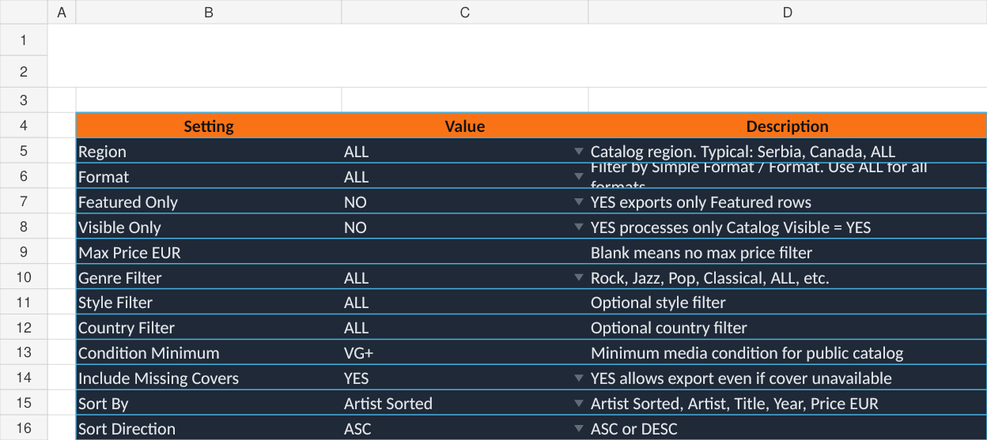
Catalog Filters worksheet: default record-selection rules.

8.1 Filter order
Load master rows
→ apply profile region/format
→ apply Catalog Visible when Visible Only = YES
→ apply Featured Only
→ apply genre/style/country/condition filters
→ apply price limit
→ sort result
Setting | Behavior
Region | Matches the Region field; ALL disables the filter.
Format | Matches Simple Format or normalized Format; ALL disables the filter.
Featured Only | YES restricts output to Featured = YES.
Visible Only | YES restricts output to Catalog Visible = YES.
Max Price EUR | Blank means no cap; otherwise removes records above the computed public price.
Genre / Style / Country | Optional exact or normalized filters depending on backend implementation.
Condition Minimum | Applies a condition-ranking rule rather than simple alphabetic comparison.
Include Missing Covers | NO excludes records whose cover cannot be resolved.
Sort By | Selects the source or computed field for ordering.
Sort Direction | ASC or DESC.

8.2 Catalog Visible as the main switch
Catalog Visible should be used to hide records without deleting them. This permits temporary removal, damaged-copy exclusion, private collection separation and controlled inventory publishing while preserving the master row.

9. Price Rules Sheet
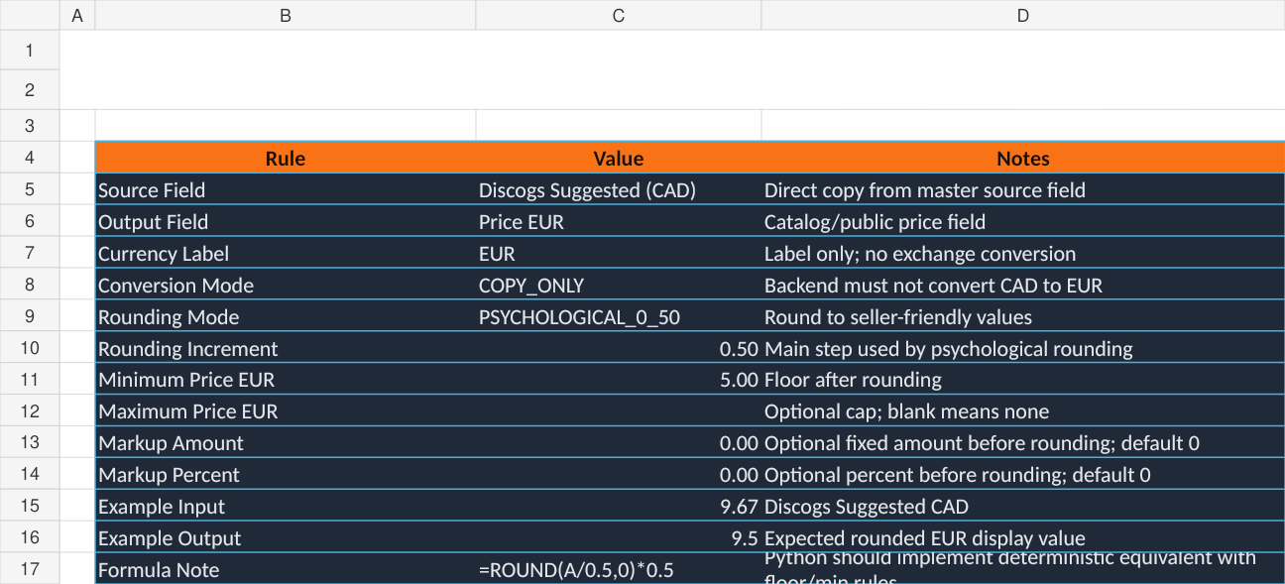
Price Rules worksheet: source field, label, rounding and price boundaries.
The supplied workbook documents a legacy pricing model in which Discogs Suggested (CAD) is copied numerically, labeled EUR and psychologically rounded without exchange conversion. The attached guide explicitly states that this is intentional. In the current BBaya architecture, storefront profiles may instead define proper currency conversion; therefore the operator must choose the intended pricing mode and avoid mixing the two models.
Rule | Supplied workbook value | Effect
Source Field | Discogs Suggested (CAD) | Reads this master-column value.
Output Field | Price EUR | Names the computed catalog field.
Currency Label | EUR | Displays EUR as the symbol/label.
Conversion Mode | COPY_ONLY | Does not apply an exchange rate.
Rounding Mode | PSYCHOLOGICAL_0_50 | Rounds to seller-friendly half-unit or .99 values.
Minimum Price EUR | 5 | Applies a floor after markup and rounding.
Maximum Price EUR | Blank | No upper cap.
Markup Amount / Percent | 0 / 0 | No price increase before rounding.

9.1 Deterministic computation order
source value
→ fixed markup
→ percentage markup
→ conversion step (only when selected mode requires it)
→ psychological rounding
→ minimum floor
→ maximum cap
→ currency formatting
CURRENT-SYSTEM RECOMMENDATION
Use a profile-driven currency engine for modern storefront publishing: numeric conversion and currency symbol must change together. Keep COPY_ONLY only for legacy or deliberately non-converted catalogs.

10. Branding Sheet
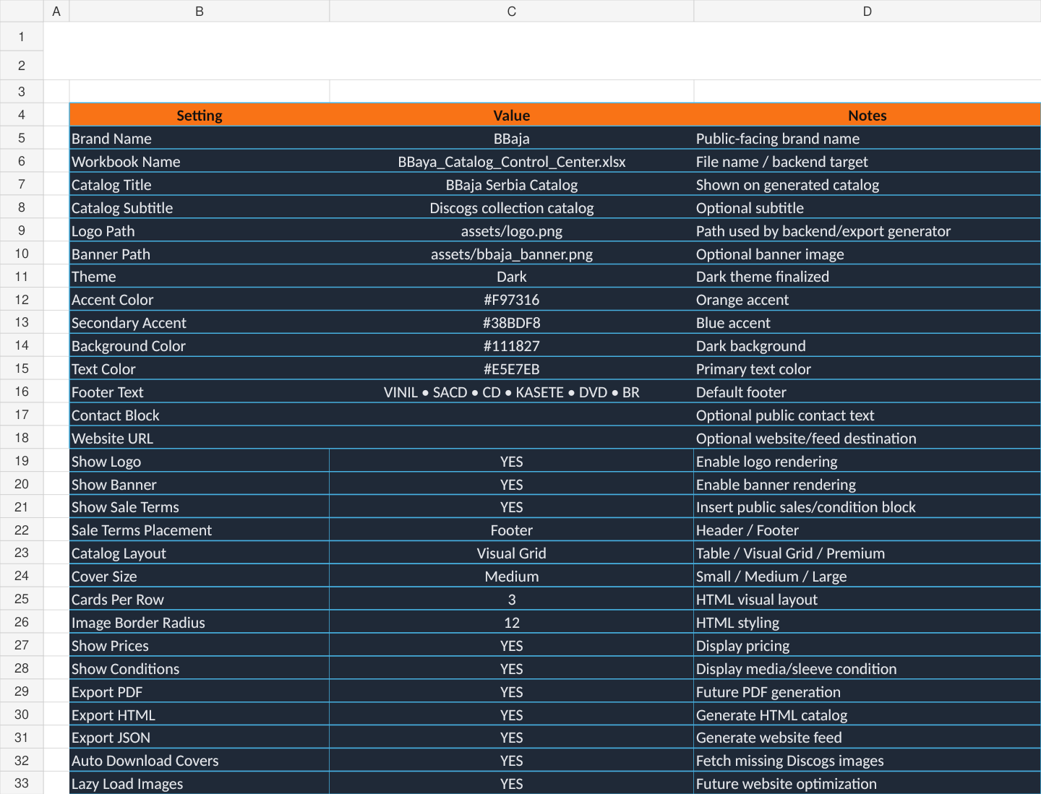
Branding worksheet: identity, theme, visibility switches and default layout.
Branding group | Examples | Backend use
Identity | Brand Name, Catalog Title, Subtitle | Displayed in headers, metadata and document titles.
Artwork | Logo Path, Banner Path | Copied or referenced in generated output.
Theme | Dark, accent, background and text colors | Applied to template variables or CSS.
Public information | Footer Text, Contact Block, Website URL | Placed in catalog chrome or text blocks.
Visibility switches | Show Logo, Show Banner, Show Prices, Show Conditions | Enables or suppresses elements.
Default presentation | Catalog Layout, Cover Size, Cards Per Row, Border Radius | Used when the selected profile does not override layout.
Output switches | Export PDF, HTML, JSON | Legacy/global defaults; Export Profiles may override.

BRAND CORRECTION
Change public values from BBaja to BBaya before production output. The workbook filename can remain BBaya_Catalog_Control_Center.xlsx.

11. Export Profiles Sheet
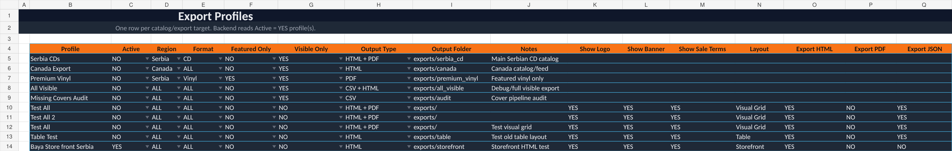
Export Profiles worksheet: one reusable publishing recipe per row.
Export Profiles are the most important reusable controls in the workbook. Instead of repeatedly changing filters and output options, activate a named row and let MOD6 build that catalog.

11.1 Column correlation
Profile column | Correlates with
Region / Format / Featured Only / Visible Only | Catalog Filters overrides for this run.
Output Type | Determines which generators run.
Output Folder | Destination relative to the project or configured publishing root.
Show Logo / Banner / Sale Terms | Branding overrides.
Layout | Selects a row in the Layout sheet.
Export HTML / PDF / JSON | Explicit output switches.
Active | Tells the backend which profile or profiles are eligible to run.

11.2 Active-profile rules
- For an interactive MOD6 build, the selected profile in the application should take precedence over multiple YES rows.
- For batch generation, every Active = YES row may be processed in sequence.
- Profile names should be unique.
- Production and test profiles should have clearly different names and folders.
- A profile should never write to the main website root unless its publishing scope explicitly allows it.

12. Layout Sheet
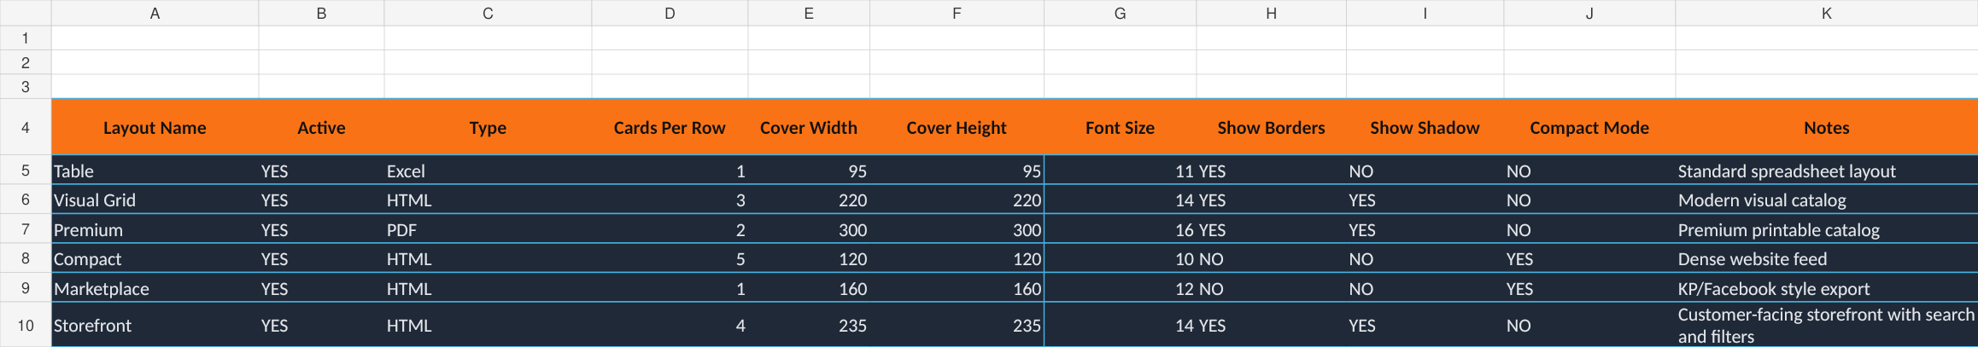
Layout worksheet: reusable visual arrangements for different output types.
Layout | Intended use | Key behavior
Table | Excel | One record per row, compact data-oriented display.
Visual Grid | HTML | Three-card modern catalog grid.
Premium | PDF | Two large cards per row for printable presentation.
Compact | HTML | Five cards per row for dense browsing.
Marketplace | HTML | Single-column listing-style output.
Storefront | HTML | Four-card customer-facing storefront with search and filters.

The Export Profile Layout value should match an active Layout Name. Template-specific settings may further refine card sizes, responsive breakpoints and image behavior.

13. Cover Status Sheet
Cover Status is primarily a backend output/audit sheet. It records Release ID, artist-title, Discogs link, local cover path, status, last-checked timestamp, errors and catalog visibility.
Column | Use
Release ID | Stable key and recommended image filename.
Artist - Title | Human-readable audit label.
Discogs Link | Source for API or scraper lookup.
Cover Path | Local published image location.
Status | EXISTS, DOWNLOADED, MISSING, ERROR or similar.
Last Checked | Freshness/audit timestamp.
Error / Notes | Reason a cover could not be resolved.
Catalog Visible | Optional cross-check with the master row.

Release ID / Link
→ check existing local path
→ download when missing and allowed
→ save locally
→ update Cover Path
→ update status and timestamp
→ include/exclude according to Include Missing Covers
LOCAL COVERS ARE PREFERRED
Local files make catalogs faster, stable offline and independent of third-party hotlinks.

14. Text Blocks Sheet
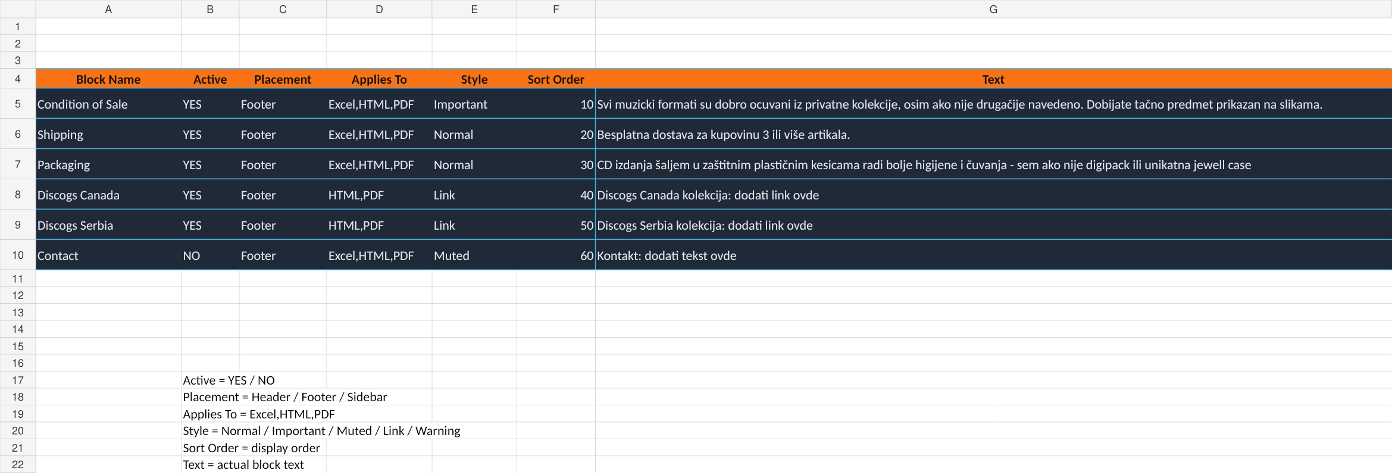
Text Blocks worksheet: reusable public text ordered by placement and format.
Column | Meaning
Block Name | Internal reusable identifier.
Active | YES includes the block.
Placement | Header, Footer or Sidebar.
Applies To | Comma-separated output types such as Excel, HTML and PDF.
Style | Normal, Important, Muted, Link or Warning.
Sort Order | Controls sequence within the placement area.
Text | Actual public content.

Text Blocks are more flexible than a single Branding footer field. When both are configured, MOD6 should either use Text Blocks as the structured source or define a clear merge rule to prevent duplication.

15. README Sheet
README documents the contract between the workbook and the backend. It confirms that Python performs the work, the master is preserved, Catalog Visible controls inclusion, price logic is deterministic, covers use Release ID/Link and Export Profiles define the run.
OPERATOR RULE
When the workbook behavior changes, update README so future backend revisions and operators understand the intended contract.

16. Precedence and Override Rules
A predictable system needs a defined order of authority. The recommended order is:
Priority | Source | Example
1 — Highest | MOD0 website profile safety and destination | Production Library scope prevents overwriting the homepage.
2 | MOD6 current project/run selection | Operator selects a specific template and profile for this build.
3 | Selected Export Profile row | Region, format, output folder and layout for the catalog.
4 | Format-specific Field Selector switches | Show HTML / Show PDF / Show Excel.
5 | Global workbook sheets | Catalog Filters, Price Rules, Branding, Layout defaults.
6 — Lowest | Template built-in defaults | Used only when no explicit setting is supplied.

16.1 Conflict examples
Conflict | Recommended result
Branding says Export PDF = YES, profile says Export PDF = NO | Profile wins for that run.
Catalog Filters Region = Serbia, selected profile Region = Canada | Selected profile wins.
Branding Catalog Layout = Visual Grid, profile Layout = Storefront | Profile Layout wins.
Field Show = YES, Show PDF = NO | Hide in PDF; retain in other enabled formats.
MOD0 scope disables homepage, MOD6 template can generate homepage | Homepage must not be written. Safety scope wins.

17. Working with the Master Workbook
The master workbook is the source of truth. MOD6 should read it without deleting or rewriting unrelated fields.
Field group | Typical required fields
Identity | Artist, Artist Sorted, Title, Release ID
Release data | Year, Country, Label, Catalog #, Format, Simple Format, Genre, Style
Pricing | Asking Price, Discogs Suggested, Lowest, Median, Highest
Condition | Media condition, Sleeve condition, Notes
Publishing control | Catalog Visible, Region, Featured
Assets and routing | Link, Cover Path, Location Code / SKU where relevant

- Never edit generated catalog files as a substitute for correcting the master.
- Normalize artist names, formats and regions before publishing.
- Use Catalog Visible to hide rows without deleting them.
- Keep required backend fields available even when not shown publicly.
- Back up the master before any workflow that can write back cover paths or status.

18. Website & Library Integration
For an existing BBaya.net website, MOD6 should use Library Integration mode rather than rebuilding the complete site.
BBAYA.NET\
├── index.html
├── shipping.html
├── toolkit\
├── rdmplaystudio\
└── library\
├── index.html
├── library.json
├── assets\
├── covers\
├── records\
└── bbaya-publish-manifest.json

18.1 Responsibilities
MOD0 profile defines | MOD6 performs
Website and Library roots | Writes to the selected destination.
Routes to Home, Toolkit, RDM, Shipping, Cart | Rewrites generated links at the correct page depth.
Publishing scope | Generates only permitted pages/resources.
Cart mode | Connects to main cart, generates a Library cart or disables cart.
Languages and currencies | Builds the selected localized output.
Safety rules | Stages, validates, backs up and protects unmanaged files.

19. Output Types and Generated Files
Output | Purpose | Typical files
HTML / Storefront | Customer-facing browsing and selling. | index.html, assets/, records/, covers/
Library JSON | Client-side search, filters, cart and record data. | library.json
Excel Catalog | Portable table or visual catalog. | catalog.xlsx
PDF Catalog | Printable or shareable curated catalog. | catalog.pdf
Full JSON | Structured integration/export data. | catalog.json
CSV | Simple data exchange or audit. | catalog.csv
Markdown | Listings, documentation or compact sharing. | catalog.md
Publishing Package | Bundled output for deployment or transfer. | ZIP/folder + manifest

A Library-only profile should not create duplicate About, Shipping, Terms, homepage, preview JPG, README, Excel or CSV files unless those outputs are explicitly enabled.

20. Multi-Language and Multi-Currency Publishing
Language and currency belong to the publishing profile because different storefronts may target different audiences. The same master record can be rendered with localized labels, text blocks, number formats and routes.
Profile example | Language | Currency | Typical use
BBaya.net Canada | English | CAD | Primary Canadian storefront.
BBaya Serbia | Serbian | EUR or RSD | Regional catalog/storefront.
International Catalog | English | USD | Broad external audience.
Bilingual Preview | English + Serbian | CAD / EUR selector | Testing localized website controls.

CURRENCY CONSISTENCY
For converted pricing, the numeric amount and currency symbol must be changed together in preview, HTML, JSON, Excel and PDF. Never relabel a value accidentally unless COPY_ONLY is the deliberate selected rule.

21. Covers and Record Pages
The Storefront layout may generate a Library index plus individual record pages. Paths differ by directory depth:
Page location | Home route | Library route | Cart route
library/index.html | ../index.html | index.html | ../cart.html
library/records/record.html | ../../index.html | ../index.html | ../../cart.html

MOD6 should validate every generated record-page link, cover reference and shared asset before production publishing.

22. Safe Publishing and Build Manifests
- Build into staging before production.
- Back up managed production files before replacement.
- Validate internal links and required assets.
- Remove only obsolete files recorded in the previous MOD6 manifest.
- Preserve manually added photos and branding assets.
- Never clean the complete Library folder blindly.
- Require confirmation before a production publish.
The build manifest should identify the selected project/profile, generated timestamp, source master, output types and exact managed files.

23. Recommended Daily Workflow
- Import and reconcile new Discogs inventory.
- Normalize data and sorting.
- Enrich metadata and download missing covers.
- Update inventory, visibility and pricing.
- Open MOD0 and validate the intended website profile.
- Open MOD6 and select the project, Excel Control Center and export profile.
- Review filters, fields, prices, branding, layout and text blocks.
- Preview representative records.
- Build into staging.
- Validate links, assets, record pages, language, currency and cart.
- Publish and archive the build report/manifest.

24. Troubleshooting
Problem | Likely cause | Corrective action
Expected records are missing | Visible Only, Region, Format, Featured, condition or max-price filter excludes them. | Review selected Export Profile and Catalog Filters; check Catalog Visible in master.
Unexpected records appear | Visible Only = NO or profile override. | Enable Visible Only and verify profile settings.
Wrong field labels | Catalog Label values are outdated. | Correct Field Selector labels.
Field missing in one output only | Format-specific Show column overrides global Show. | Review Show Excel/HTML/PDF.
Prices look wrong | Source field, conversion mode, markup, rounding or currency label mismatch. | Review Price Rules and publishing profile currency.
Duplicate footer text | Branding footer and Text Blocks both add similar content. | Disable one source or define merge behavior.
Logo/banner missing | Path invalid or asset not copied. | Validate Branding paths and asset publishing.
Covers missing | Release ID/Link absent, path invalid or Include Missing Covers logic. | Review Cover Status and cover-folder permissions.
Wrong layout | Profile Layout overrides Branding default. | Review selected Export Profile and Layout sheet.
Library links broken | Routes are wrong for page depth. | Correct MOD0 routes and rebuild.
Main website overwritten | Publishing scope/destination misconfigured. | Restore backup; use Library Integration profile with safe scope.
MOD6 ignores workbook changes | Workbook not saved or MOD6 cached settings. | Save Excel file and reload/reopen project.

25. Workbook Editing Rules
- Keep worksheet names unchanged unless the backend is updated simultaneously.
- Keep header names exact; the parser depends on them.
- Use YES/NO consistently in control columns.
- Use unique Export Profile names.
- Do not place explanatory text inside the active data table except in designated Notes columns.
- Keep required source field names synchronized with the master workbook.
- Use relative paths only when the project structure guarantees them.
- Save a backup before major redesigns.
- Update README after changing system assumptions.
- Use BBaya in all public-facing names and text.

26. Configuration Reference
Worksheet | Primary key / control | Read or written by backend
Dashboard | Selected Profile / metrics | Read and written
Field Selector | Master Field | Read
Catalog Filters | Setting | Read
Price Rules | Rule | Read
Branding | Setting | Read
Export Profiles | Profile | Read
Layout | Layout Name | Read
Cover Status | Release ID | Written/audited
Text Blocks | Block Name | Read
README | Topic | Human contract/reference

27. Examples and Scenarios

27.1 BBaya.net production Library
Control | Value
MOD0 Profile | BBaya.net — Production
Profile Type | Library Integration
Publishing Scope | Library index, records, data, assets only
Export Profile | Baya Store front Serbia or production equivalent
Layout | Storefront
Outputs | HTML + Library JSON + Manifest
Cart | Main website cart
Destination | BBAYA.NET\library

27.2 Premium vinyl PDF
Control | Value
Export Profile | Premium Vinyl
Region | Serbia
Format | Vinyl
Featured Only | YES
Visible Only | YES
Layout | Premium
Output | PDF
Branding | Logo/banner enabled

27.3 Missing-cover audit
Control | Value
Export Profile | Missing Covers Audit
Region / Format | ALL / ALL
Output | CSV
Purpose | List records whose local cover path is missing or invalid
Follow-up | Run cover download/repair and update Cover Status

28. Future Expansion Notes
- Profile-specific price-rule sets.
- Language-specific Text Blocks and Catalog Labels.
- Direct MOD0 website-profile selector inside MOD6.
- Automated deployment to Netlify, SFTP or Git repositories.
- Workbook validation report highlighting unknown fields and duplicate profiles.
- In-app editing synchronized back to the Excel Control Center.
- Per-output template galleries with visual thumbnails.
- Expanded analytics and build-history dashboard.
FINAL PHILOSOPHY
MOD6 is not merely an export utility. It is the publishing layer that turns one controlled master collection into professional catalogs, storefronts and reusable selling assets while keeping the operator in control.

Appendix A — Quick Correlation Matrix
When you want to change… | Edit this workbook area | Also check
Which records are included | Catalog Filters or Export Profile | Master Catalog Visible / Region / Featured
Which columns appear | Field Selector | Format-specific Show columns
Public labels | Field Selector → Catalog Label | Language/profile configuration
Public price | Price Rules | MOD0/MOD6 currency profile
Logo, title and colors | Branding | Template assets and MOD0 profile branding
Card density and cover size | Layout | Export Profile Layout
Header/footer text | Text Blocks | Branding Footer Text / Sale Terms
Output files and destination | Export Profiles | MOD0 publishing scope and paths
Cover image status | Cover Status | Master Link, Release ID and Cover Path
Overall project status | Dashboard | MOD6 build report and manifest

Appendix B — Pre-Publish Checklist
Check | Required
Master backed up | Yes
Correct MOD0 website profile selected | Yes
Website profile validation READY | Yes
Correct Export Profile selected | Yes
Catalog Visible reviewed | Yes
Currency amount and symbol verified | Yes
Representative covers and record pages previewed | Yes
Internal links validated | Yes
Staging build reviewed | Yes
Build manifest generated | Yes
Production confirmation completed | Yes

