MOD6
CATALOG CONTROL CENTER
Publishing Studio & Configuration Studio
Detailed User, Project, Preview, Build and Publishing Manual
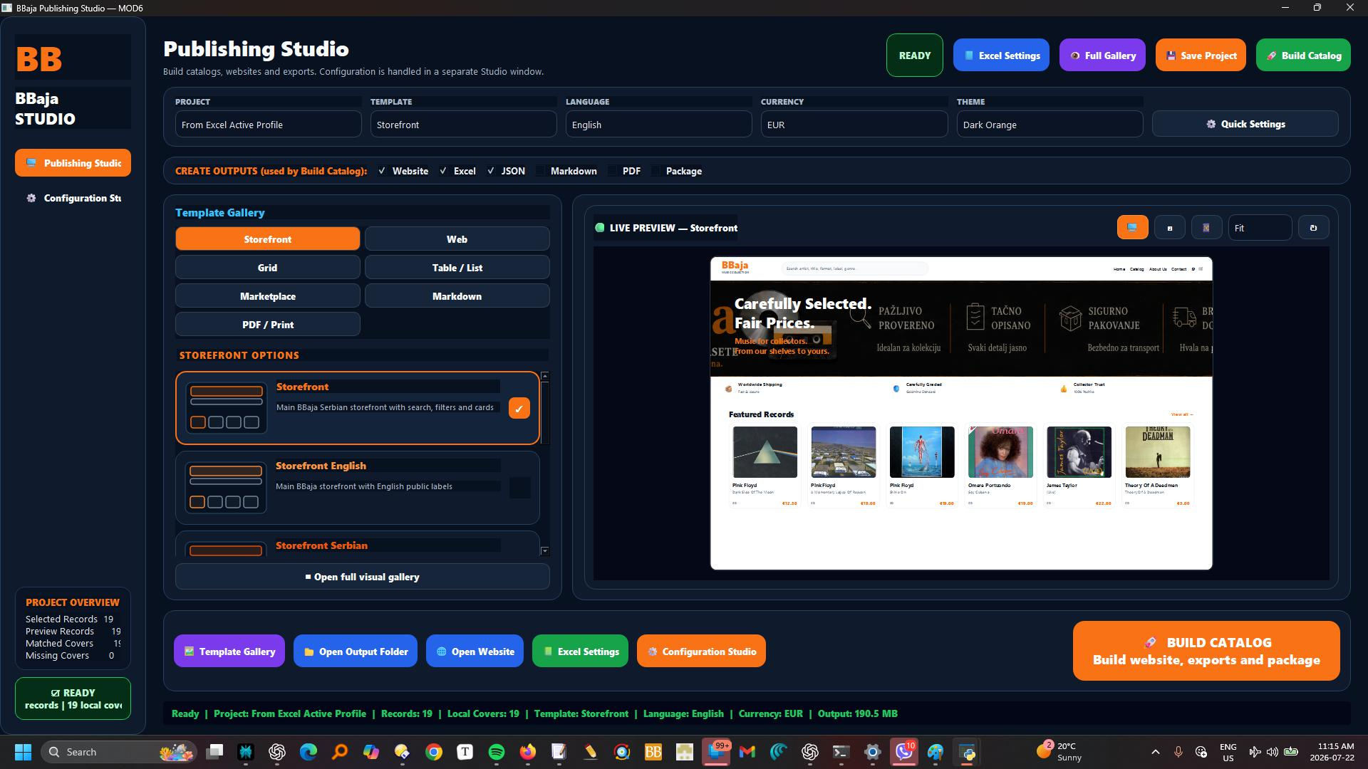
Revision 1.0 | July 2026

Document Control
Revision | Date | Description | Status
1.0 | July 2026 | Complete MOD6 application manual with Excel correlation chapter. | Current

Purpose
This manual documents the MOD6 desktop application itself: its Publishing Studio, Configuration Studio, project system, template gallery, branding and graphics controls, languages, paths, preview modes, output selection, build process, Library Integration publishing, generated files and troubleshooting. A separate chapter explains how the Excel Control Center influences MOD6 and the Python build engine.
IMPORTANT CORRECTION
The Excel workbook is one configuration source used by MOD6; it is not MOD6 itself. MOD6 is the desktop Publishing Studio and Python-based build system described throughout this manual.

Table of Contents
1. MOD6 at a Glance
2. Starting MOD6
3. Architecture and Data Flow
4. Publishing Studio Tour
5. Configuration Studio Tour
6. Project Management
7. Master Workbook and Covers
8. Template Selection
9. Branding, Logos and Graphics
10. Marketplace Output Configuration
11. Publishing and Output Selection
12. Languages and Currency
13. Paths and Library Integration
14. Advanced Settings
15. Preview System
16. Building a Catalog
17. Generated Outputs and Folder Structure
18. BBaya.net Library Integration Workflow
19. Excel Control Center Correlation
20. Setting Precedence and Source of Truth
21. Safe Publishing and Manifests
22. Recommended Workflows
23. Troubleshooting
24. Configuration File Reference
25. Quick Reference Checklists

1. MOD6 at a Glance
MOD6 is the publishing module of the Discogs Toolkit. It transforms the selected master collection into polished websites, storefronts, lists, spreadsheets, JSON feeds, PDFs, Markdown catalogs and complete publishing packages.
- Loads a selected master workbook and local cover library.
- Applies saved project settings, templates, branding, language, currency, filters and output choices.
- Provides fast template and real-record previews before a full build.
- Creates the actual generated website, which is the authoritative visual result.
- Supports complete standalone storefronts and Library Integration into an existing website such as BBaya.net.
- Keeps Excel as an optional control cockpit while Python performs processing and file generation.
CORE PHILOSOPHY
One trusted master collection can be presented many ways without editing the source data for each catalog.

2. Starting MOD6

2.1 Main application file
pipeline\mod6_catalog_control_center\mod6_publishing_center.py

2.2 Typical launch
py -m pipeline.mod6_catalog_control_center.mod6_publishing_center
Depending on the Toolkit launcher, MOD6 may also be opened from MOD0 or the main module launcher.

2.3 First-start expectations
- The main window opens as the Publishing Studio.
- Configuration is available in a separate Configuration Studio window.
- The application loads saved GUI, project, template, graphics, theme, build-target and currency settings from the settings folder.
- A master workbook must be selected before real-record preview and build operations can produce meaningful results.

3. Architecture and Data Flow
MOD0 website profile / shared paths
↓
MOD6 saved project + Configuration Studio
↓
Selected master workbook + local covers
↓
Optional Excel Control Center rules
↓
Python build engine
↓
HTML / JSON / Excel / PDF / Markdown / Package / Library Integration
Component | Responsibility
MOD0 | Defines shared website destinations, routes and safe-publishing profiles.
MOD6 Publishing Studio | Selects source, outputs and starts preview/build operations.
MOD6 Configuration Studio | Defines project, template, branding, language, paths and advanced behavior.
Excel Control Center | Stores structured field, filter, price, branding and export-profile rules when used.
Python build engine | Reads configuration and master data, applies rules and writes outputs.
Generated website | Final authoritative HTML/CSS/JavaScript result.

4. Publishing Studio Tour
The Publishing Studio is the operational build screen. It is intentionally simpler than Configuration Studio so normal publishing does not require navigating every setting.
Area / control | Purpose
Publishing Studio button | Returns to the main publishing screen.
Configuration Studio button | Opens the detailed project and publishing configuration window.
Source Master | Shows the selected master workbook used for preview and build.
Create Outputs | Final output checkboxes used by the current build.
Build Catalog / Build website, exports and package | Runs the complete build using current project and output settings.
Quick Settings | Provides fast access to selected commonly changed options.
Ready indicator | Summarizes whether a source and build configuration are available.

FINAL OUTPUT TRUTH
The Create Outputs checkboxes on the Publishing Studio are the final truth for the current build. Selecting an output elsewhere does not override an unchecked final output box.

5. Configuration Studio Tour
Configuration Studio is the detailed editor. Its tabs are:
Tab | What it controls
General | Project identity and general catalog behavior.
Template | Template family and visual layout.
Branding | Store name, identity, theme and related visual settings.
Logos | Logo and banner selection with preview and fit behavior.
Graphics | Available image assets with filename, dimensions and file size.
Marketplace | Marketplace output selection and feed/template choices.
Publishing | Publishing mode, output types and BBaya.net integration behavior.
Languages | Language and visible-label behavior.
Paths | Master, covers, output and website destinations.
Advanced | Additional build and debugging settings.

Use the “← Publishing Studio” control to return without closing the entire application.

6. Project Management
Control | Action
New Project | Creates a new saved project.
Duplicate | Copies the selected project as a starting point for a regional, test or alternate-output configuration.
Delete | Removes the selected project after confirmation.
Save Project | Writes the current project configuration.
Preview Project | Opens the preview workflow for the selected project.
Export / Import | Moves project settings between installations or backups.
Build With This Project | Runs the build using the selected project.

6.1 Recommended project names
- BBaya.net — Production Library
- BBaya.net — Test Library
- Serbia Storefront — EUR
- Canada Catalog — CAD
- Premium Vinyl PDF
- Missing Covers Audit
PROJECT RULE
Duplicate a working profile before making major changes. Do not repeatedly rewrite the production profile for experiments.

7. Master Workbook and Covers

7.1 Selecting the master
- Open Configuration Studio → Paths.
- Click Select Master or Browse.
- Choose the current master workbook.
- Use Open in Excel only for inspection or controlled source edits.
- Reload Preview Data after changing the workbook.
The build uses the exact Master, Covers and Output paths shown on the Paths page. The current patched build does not silently fall back to another master workbook.

7.2 Covers
- The selected Covers folder provides local artwork for preview and publishing.
- Local covers are preferred over hotlinked remote images.
- A missing cover produces a placeholder unless the selected template handles it differently.
- Record pages and catalog cards depend on stable cover paths or Release ID-based filenames.

7.3 Reset helper
“Reset Master and Covers to pipeline\data” restores the common Toolkit source locations when a project was pointed at temporary test files.

8. Template Selection
The Template tab and visual gallery control the presentation family. The gallery is grouped to make layout selection faster and uses miniature layout representations rather than generic icons.
- Select a template from the project configuration.
- Open the full visual gallery for a wider comparison.
- Use Template Layout preview for immediate composition and color-family feedback.
- Use Real Sample Records to verify the template with the selected master and covers.
- Build the actual website before approving JavaScript, filters, Inspector, cart or responsive behavior.
TEMPLATE VS DATA
A template changes presentation. It does not change the source master records. Filters, fields, pricing and language determine what data the template receives.

9. Branding, Logos and Graphics

9.1 Branding tab
Branding defines the visible identity of the generated catalog or storefront, including store name, theme, accent family and text identity.

9.2 Logos tab
- Select an image and choose Use as Logo or Use as Banner.
- Logo and banner previews show the selected files.
- The default scaling behavior is FIT so artwork is resized without distortion inside the template.
- Changing project branding does not modify the original image file.

9.3 Graphics tab
Graphics shows available MOD6 image assets as thumbnails with filename, pixel dimensions and file size. Use it to inspect and manage assets before assigning them on the Logos page.

10. Marketplace Output Configuration
The Marketplace tab chooses marketplace-oriented outputs or feed templates. It is separate from MOD5 assisted posting: MOD6 produces catalog/feed/template files; MOD5 manages research and posting workflows.
- Choose only the marketplace outputs needed by the current project.
- Use platform-specific templates where required.
- Keep general website output separate from marketplace exports.
- Verify currency and language for each target market.

11. Publishing and Output Selection

11.1 Major publishing modes
Mode | Use
Complete Standalone Storefront | Creates a self-contained website with its own supporting pages and assets.
Library Integration Package | Publishes only the files needed inside an existing website Library section.
Catalog/Data Outputs | Creates selected Excel, JSON, CSV, PDF or Markdown outputs without a complete website.

11.2 Output checkboxes
Output | Result
Website | HTML/CSS/JavaScript catalog or storefront.
Excel | Formatted catalog workbook.
JSON | Structured catalog data.
PDF | Printable catalog.
Package | Bundled deliverable containing selected outputs and assets.
Markdown | Selected card, one-line or table-style Markdown listing.
CSV | Flat data export where enabled.

Markdown options include Default fields, All fields, One-line layout, Select All and a field selector for one-line/table exports.

12. Languages and Currency

12.1 Languages
- The Languages tab controls the project language and visible preview labels.
- Changing language refreshes visible preview labels immediately.
- Templates must provide localized labels or the build uses available fallback text.
- A project can be duplicated to create separate regional-language variants.

12.2 Currency
- Currency settings determine the displayed symbol and, where configured, the numeric conversion behavior.
- A complete currency change must update both numeric value and symbol consistently in preview and outputs.
- Do not relabel CAD values as EUR unless the intended project rule is explicitly a direct-copy pricing model.
- Saved rates and currency behavior are stored in the MOD6 settings files.
CURRENCY SAFETY
Verify at least three prices in the actual generated website after changing currency. The displayed symbol and numeric value must follow the same rule.

13. Paths and Library Integration
Path | Purpose
Master | Source workbook for records and metadata.
Covers | Local artwork source.
Output | Destination for generated catalogs and packages.
BBaya.net Website Root | Root of the combined website.
BBaya.net Library Root | Destination for Library Integration output.

13.1 Library Integration behavior
- Publishes into the existing website’s `library` folder.
- Renames generated `library.html` to `index.html`.
- Keeps the main homepage, Toolkit, RDM Play Studio and Shipping pages untouched.
- Can use the main website cart, generate a Library cart or disable cart behavior.
- Can clean only MOD6-managed files while preserving manual record photos and branding assets.
BBAYA.NET\
├── index.html
├── shipping.html
├── toolkit\
├── rdmplaystudio\
└── library\
├── index.html
├── library.json
├── assets\
├── covers\
├── records\
└── bbaya-publish-manifest.json

14. Advanced Settings
Advanced settings are intended for controlled changes, debugging and specialized output behavior. Save the project before changing advanced values and test in a duplicate project or staging destination.
- Use Open Settings Folder to inspect MOD6 configuration files.
- Use Open Last Build Manifest to review the most recent managed output list.
- Avoid editing JSON settings while MOD6 is open.
- Restore a known project or imported project package if experimental settings produce unexpected results.

15. Preview System
MOD6 has three deliberately different preview levels:
Preview | What it proves | What it does not prove
Template Layout | Instant composition, spacing and color family. | Real record density, cover availability or JavaScript behavior.
Real Sample Records | Typography, covers, card density, prices and chosen color family using the selected master. | Complete filters, cart, Inspector and responsive behavior.
Actual Generated Website | Final HTML, JavaScript, filters, Inspector, cart and responsive behavior. | Nothing significant; this is the authoritative visual result.

AUTHORITATIVE PREVIEW
The actual generated website opened in the default browser is the final visual truth. Fast previews are design aids, not a substitute for a complete build.

16. Building a Catalog
- Select or load the intended project.
- Confirm the source master and covers.
- Choose the template, branding, language, currency and paths.
- Select the final Create Outputs checkboxes in Publishing Studio.
- Run Preview Project and inspect Real Sample Records.
- Click Build Catalog / Build website, exports and package.
- Wait for the build process to complete.
- Open the actual generated website.
- Review the last build manifest and output folder.

16.1 Build readiness
The project overview and READY indicator summarize the current configuration. A READY display does not remove the need to visually inspect the final website and confirm the destination before production publishing.

17. Generated Outputs and Folder Structure
File/folder | Meaning
index.html or library.html | Main generated catalog page. Library Integration renames to index.html.
library.json | Structured data used by the Library and JavaScript.
records/ | Individual record-detail pages.
covers/ | Published local artwork where copied into the output.
assets/ | CSS, JavaScript, icons, logos and shared images.
cart.html / checkout.html | Generated only when the selected cart mode requires local pages.
bbaya-build-manifest.json | Build metadata for a complete standalone output.
bbaya-publish-manifest.json | Managed-file record for Library Integration.
Excel/PDF/Markdown/CSV files | Optional selected catalog exports.
ZIP/package | Optional bundled publishing deliverable.

17.1 Do not edit generated files as source
Generated files may be replaced by the next build. Make persistent changes in the master workbook, MOD6 project, template, branding asset or Excel Control Center rule—not directly in generated output unless it is intentionally unmanaged and protected.

18. BBaya.net Library Integration Workflow
- In MOD0, validate the BBaya.net production publishing profile.
- In MOD6, select the matching Library Integration project/profile.
- Confirm the Website Root and Library Root.
- Choose Use Main Website Cart, Generate Library Cart or Disable Cart.
- Enable preservation of manual photos and branding.
- Enable clean managed files, link validation and asset validation.
- Build to staging or a test website first.
- Open the actual generated Library and test Home, Toolkit, RDM, Shipping, Account and Cart links.
- Publish to the production Library folder only after approval.
- Review `bbaya-publish-manifest.json`.
NEVER BLINDLY CLEAN THE LIBRARY
Cleanup must remove only files recorded as MOD6-managed. Manually maintained site pages and assets are not eligible for deletion.

19. Excel Control Center Correlation
The Excel Control Center acts as a structured rules workbook. MOD6 and its Python backend read those rules when the selected project/build path uses the workbook. The Excel guide describes the workbook as the cockpit and Python as the processing engine.
Excel sheet / concept | MOD6 relationship | Build effect
Dashboard | Status/reference cockpit; not the MOD6 GUI dashboard. | Provides operational overview; does not itself run heavy automation.
Field Selector | Correlates with MOD6 field choices and template-visible data. | Show=YES includes a field; Show=NO hides it; Label changes the display name.
Catalog Filters | Correlates with project filters and publishing scope. | Determines which records are exported.
Price Rules | Correlates with MOD6 currency/pricing configuration. | Selects source price, markup, minimum and rounding behavior.
Branding | Correlates with MOD6 Branding and Logos tabs. | Controls title, theme, accents, logo and banner.
Export Profiles | Correlates with MOD6 saved projects/build targets. | Creates repeatable region/format/featured combinations.
Cover Status | Correlates with selected Covers path and missing-cover behavior. | Tracks local cover availability and paths.
Layout / Text Blocks (current workbook variants) | Correlates with Template and visible content blocks. | Controls presentation options and reusable text.

19.1 Field Selector example
Excel row: Title | Show=YES | Label=Album
↓
MOD6 build receives Title field
↓
Generated page displays heading “Album”

19.2 Filter example
Catalog Visible = YES
Region = Canada
Format = CD
Featured Only = NO
↓
Only visible Canadian CD records are passed to the template

19.3 Price example
Source Field: Discogs Suggested (CAD)
Minimum Price: 5
Markup: 0
Rounding: selected project rule
Currency: project currency setting
↓
Calculated display price in HTML / Excel / PDF / JSON

19.4 Branding example
Excel Catalog Title + Theme + Accent + Logo Path
↓
MOD6 project branding and selected assets
↓
Template receives final visible brand settings

19.5 Export Profile example
Excel profile: Premium Vinyl / Serbia / Vinyl / Featured=YES
↓
MOD6 saved project or build target
↓
Website + PDF + selected outputs for that filtered collection
EXCEL DOES NOT OVERRIDE EVERYTHING
The workbook provides rules, but the final MOD6 project, final output checkboxes, selected paths and publishing mode determine what the current build actually creates.

20. Setting Precedence and Source of Truth
Priority | Setting source | Rule
1 | Publishing Studio final output checkboxes | Determine which outputs are created in the current build.
2 | Selected MOD6 project / Configuration Studio | Determines template, paths, branding, language, currency and publishing mode.
3 | MOD0 website profile | Provides shared destination, routes and safety rules when integrated.
4 | Excel Control Center | Provides structured field, filter, price, branding and export-profile rules where enabled.
5 | Template defaults | Fill values not explicitly set by higher-priority configuration.
6 | Master workbook | Provides source record data and flags.

When two values conflict, do not guess. Verify which source the current project/build target reads, then make the correction in the highest-priority intended source.

21. Safe Publishing and Manifests
- Create a backup before production publishing.
- Use staging before the production Library.
- Validate internal links and required assets.
- Preserve manual record photos and configured branding.
- Never overwrite unmanaged files.
- Require confirmation for production publishing.
- Use the manifest to identify files MOD6 owns.
Open Last Build Manifest from Configuration Studio to inspect the most recent build record.

22. Recommended Workflows

22.1 Normal BBaya.net Library update
- Update master through MOD1–MOD4.
- Confirm covers through MOD3.
- Validate BBaya.net profile in MOD0.
- Open MOD6 production Library project.
- Reload master and preview data.
- Review Real Sample Records.
- Select Website + Library JSON + manifest.
- Build staging.
- Open actual generated website and test.
- Publish production and inspect manifest.

22.2 New regional storefront
- Duplicate a proven project.
- Change name, language, currency and domain/destination.
- Change branding only where required.
- Create or select an appropriate Excel export profile.
- Build into a new staging folder.
- Approve before changing the environment to production.

22.3 PDF-only catalog
- Duplicate a project.
- Select the desired master/filter/export profile.
- Choose a print-appropriate template or layout.
- Select PDF as the final output and clear unnecessary outputs.
- Build and inspect every page.

23. Troubleshooting
Problem | Likely cause | Action
Real Sample Records is empty | No valid master selected or preview data not reloaded. | Select Master and click Reload Preview Data.
Build uses wrong records | Wrong project, Excel filter or master workbook. | Verify project, exact Master path, Catalog Visible and export profile.
Output missing despite configuration | Final Publishing Studio checkbox is not selected. | Select the output in Create Outputs.
Website language is wrong | Project language and template labels disagree. | Set Languages, reload preview, then rebuild.
Currency symbol changes but values do not | Only label changed or conversion rule disabled. | Review currency mode and price rule; test actual output.
Covers missing | Wrong Covers path or absent local file. | Verify Covers path, Release ID filenames and Cover Path.
Preview looks good but website differs | Fast preview is not the actual generated site. | Open Actual Generated Website and treat it as final truth.
Library overwrites main site files | Wrong publishing mode or destination. | Use Library Integration and verify Library Root before building.
Old files remain | Managed cleanup disabled or old manifest missing. | Enable clean managed files and review manifest; never delete unmanaged files blindly.
PDF or Package not created | Output checkbox not selected in Publishing Studio. | Select PDF or Package in the final output area.
MOD6 uses an old project setting | Project not saved or app has stale state. | Save Project, reload it or restart MOD6.

24. Configuration File Reference
File | Purpose
settings/mod6_gui_projects.json | Saved GUI projects.
settings/mod6_gui_settings.json | General GUI state.
settings/mod6_studio_settings.json | Configuration Studio state.
settings/projects.json | Project definitions.
settings/templates.json | Template registry.
settings/graphics.json | Graphics asset registry.
settings/themes.json | Theme definitions.
settings/currency_rates.json | Currency-rate settings.
settings/build_targets.json | Saved build target definitions.
BBaya_Catalog_Control_Center.xlsx | Optional Excel rules cockpit.
MOD6_LIBRARY_INTEGRATION_MODE_README.md | Library Integration design and behavior notes.

25. Quick Reference Checklists

25.1 Before preview
- Correct project selected.
- Correct master selected.
- Correct covers path.
- Template selected.
- Language and currency verified.
- Reload Preview Data completed.

25.2 Before build
- Final output checkboxes selected.
- Output destination verified.
- Publishing mode verified.
- Filters and Excel export profile verified.
- Branding assets present.
- Project saved.

25.3 Before production publish
- MOD0 profile READY.
- Staging build reviewed.
- Actual generated website tested.
- Home/Toolkit/RDM/Shipping/Cart links tested.
- Manual assets preservation enabled.
- Backup created.
- Manifest reviewed.

Appendix A — MOD6 Visual Reference
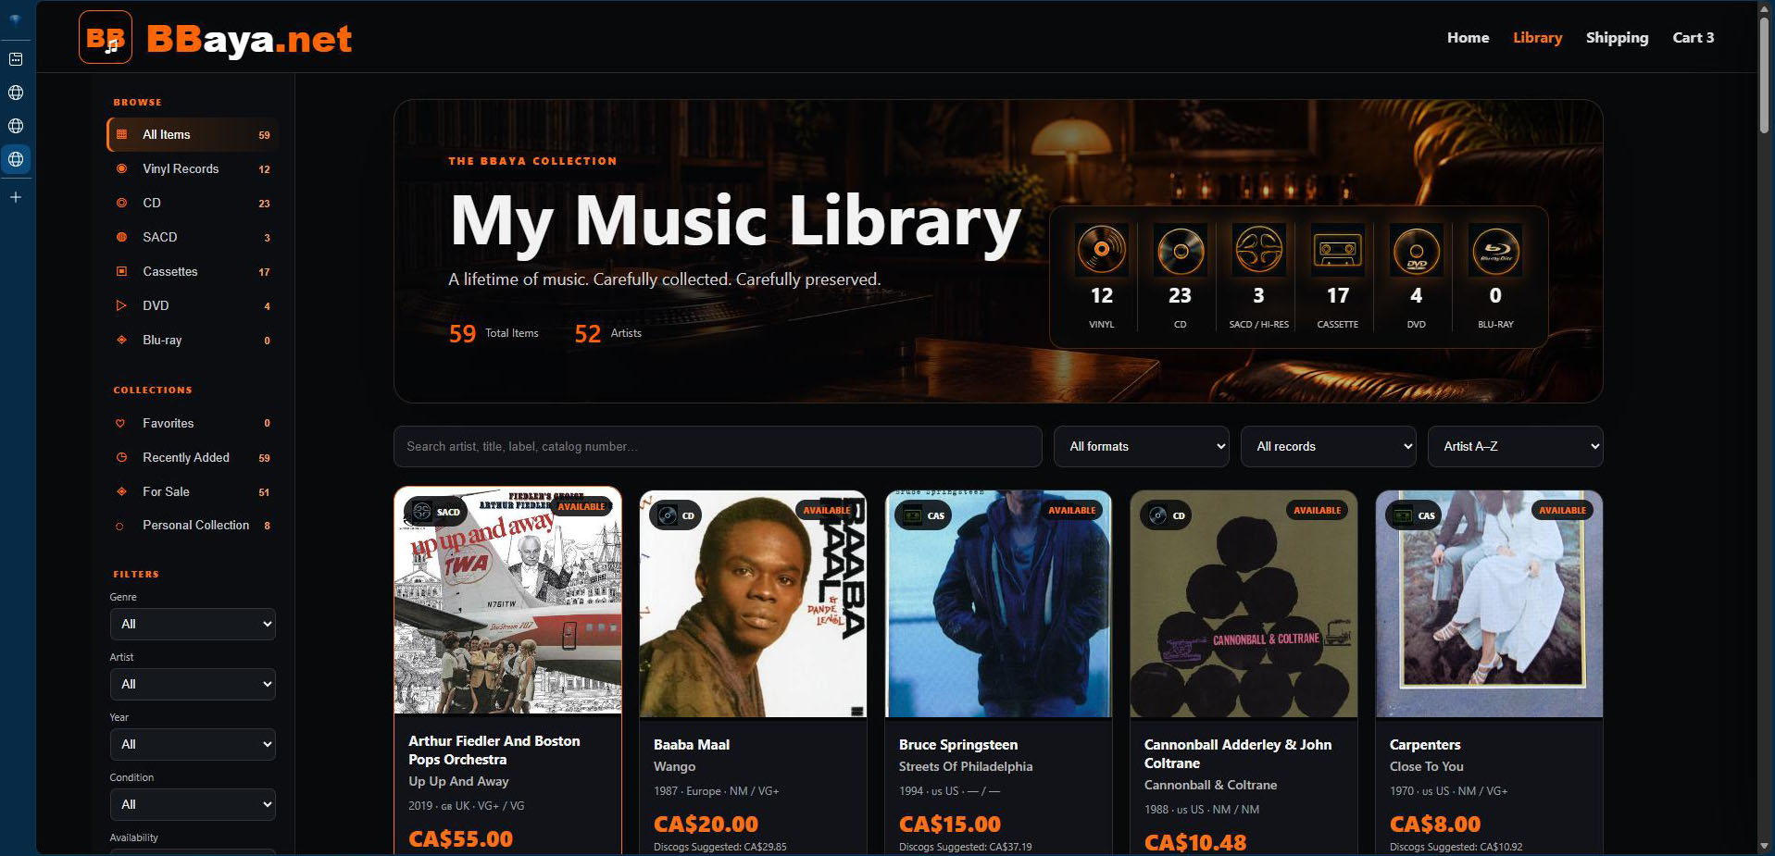
Representative MOD6 Publishing Studio / generated-output visual. Interface details may vary by saved project and current build.

