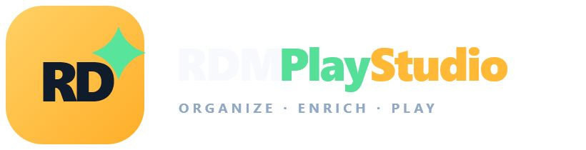
USER MANUAL
AND SYSTEM REQUIREMENTS
Organize. Enrich. Play.
Your private media library. On every screen in your home.
Document version | 1.2 - Windows 11 edition
Application | RDM PlayStudio for Windows 11
Updated | July 2026

For personal media you are legally entitled to access.

Contents
This guide combines the installation requirements and operating manual for the Windows 11 installer edition.
GET READY | 1 About RDM PlayStudio / 2 System requirements / 3 Quick-start checklist
START AND CONNECT | 4 Starting and stopping / 5 Startup dashboard / 6 Accounts and APIs / 7 Synchronisation
ORGANISE | 8 Browsing / 9 Matching, Home Videos and private TV / 10 Movies and duplicates / 11 TV shows and DMM
WATCH | 12 Playback / 13 iPhone and iPad / 14 Google TV and casting
PERSONALISE | 15 Profiles, collections and shelves / 16 Artwork / 17 Subtitles
MAINTAIN | 18 Hiding and deleting / 19 Backup and restore / 20 Export / 21 Diagnostics
SUPPORT | 22 Troubleshooting / 23 Security / 24 Requirements checklist / 25 Limitations / Appendices
TIP Use Word's Navigation pane to jump directly between numbered headings.

1. About RDM PlayStudio
RDM PlayStudio is a Windows-hosted media library for a Real-Debrid account. It synchronises torrents and downloaded video files, enriches them with TMDb and IMDb metadata, groups television episodes, and provides modern browsing and playback interfaces for Windows and trusted devices on the same home network.
IMPORTANT RDM PlayStudio is a library and playback manager. It does not supply media, torrent magnets, API subscriptions, or rights to content. Use it only with material you may lawfully access.

What the application includes
- A Windows desktop startup dashboard and advanced library editor.
- A responsive web library for Windows, iPhone, iPad, and television browsers.
- Real-Debrid torrent and Downloads-history synchronisation.
- TMDb artwork and metadata, OMDb-powered IMDb search, and OpenSubtitles integration.
- Movies, grouped TV seasons and episodes, Home Videos, duplicate versions, missing-episode reporting, profiles, favourites, Continue Watching, franchises, and custom shelves.
- Direct browser playback, Real-Debrid streams, local FFmpeg transcoding, VLC fallback, and Google Cast.
- Encrypted credentials, local artwork storage, backup restoration, diagnostics, and collection export.

2. System requirements

Windows host computer
Component | Minimum | Recommended
Operating system | Windows 11, 64-bit | Windows 11 with current updates
Processor | Modern dual-core x64 | Four or more cores for transcoding
Memory | 4 GB RAM | 8 GB or more
Free storage | 500 MB plus database | 5-20 GB for artwork and transcode cache
Network | Internet connection | Wired Ethernet or strong 5 GHz/6 GHz Wi-Fi
Display | 1280 x 720 | 1920 x 1080 or larger

Required and optional services
Service | Status | Purpose
Real-Debrid account and private token | Required | Synchronisation, link preparation, streaming, deletion
TMDb API key | Strongly recommended | Posters, fanart, genres, cast, runtime, TV grouping
OMDb API key | Optional | IMDb title search and exact IMDb assignment
OpenSubtitles.com account/API key | Optional | External subtitle search and download
Debrid Media Manager (DMM) | Optional external service | Find cached missing episodes or alternative releases
VLC media player | Recommended | Reliable MKV, HEVC, multichannel audio, TV playback
RDM PlayStudio media engine | Installed automatically | Automatic local transcoding and richer media inspection

Home-network devices
- iPhone or iPad: current Safari; installable as a full-screen Home Screen web app.
- Google TV/Android TV: a compatible browser for the library and VLC for the most reliable playback.
- Chromecast/Google TV casting: supported browser and Google Cast receiver on the same network.
- All devices must be on the same trusted LAN/Wi-Fi as the Windows host when Home network access is enabled.
NETWORK PORT RDM PlayStudio normally listens on TCP port 8787. Allow it only on Private networks. Never forward this port through the router or expose the application directly to the public internet.

3. Quick-start checklist
- Download the RDM PlayStudio Windows 11 installer from the official distribution page.
- Run the installer and accept the default per-user application-data location.
- Install VLC on the Windows host if you want the broadest external-player support.
- Open RDM PlayStudio from the Start menu or desktop shortcut.
- Confirm that Library database and Database backup show healthy results.
- Open the library and enter the Real-Debrid token and TMDb key in Settings.
- Return to the startup dashboard and use Force everything, or press Sync account in the library.
- Run Add artwork or use automatic/bulk matching for unmatched items.
- Run Playback diagnostics before testing another device.
- Enable Home network access only when remote devices need the library.
SAVED AUTOMATICALLY The SQLite database retains imports, corrected matches, artwork references, profiles, playback progress, shelves, subtitles, and hidden status between restarts.

4. Starting and stopping RDM PlayStudio

Start the desktop application
Open RDM PlayStudio from the Windows Start menu or desktop shortcut. The startup dashboard opens in its own window; a separate browser is not required for the editor. Keep RDM PlayStudio running while other devices browse or play media.

Stop the application
Use Exit from the RDM PlayStudio menu or close the desktop window. The application stops home-network access and finishes pending database work before exiting. Do not force-close it during synchronisation, backup restoration, or library repair.

Port already in use
If the dashboard reports that port 8787 is already being used, another RDM PlayStudio instance or another application is using the network port. Close the older RDM PlayStudio instance, then start the application again. Do not run two instances against the same library.

5. Startup dashboard
Panel | What it does
Library database | Shows database health, item count, size, modification date, and data location.
Database backup | Shows backup count and latest backup; creates and restores verified backups.
Real-Debrid sync | Forces torrents, downloaded files, or a complete account refresh.
Home network access | Starts/stops LAN access, shows the device address, and manages an admin PIN.
System status | Shows library, backup, and artwork folders plus API health and local artwork controls.
Playback diagnostics | Tests Real-Debrid, VLC, FFmpeg, browser codecs, playable sources, server, and firewall.

6. Connecting accounts and API services

Main credentials
Open the web library, select Settings, and enter the Real-Debrid private API token, TMDb API key, and optional OMDb API key. Leave an existing field blank when you do not want to replace its saved value.

OpenSubtitles
Open the editor's Subtitles tab and enter the OpenSubtitles.com API key, username, and password. The account is used only when searching or downloading external subtitles.
CREDENTIAL PROTECTION On Windows, saved secrets are encrypted with Windows DPAPI. They are bound to the Windows user profile and are not stored as readable text in library.db.

Testing services
Use Test APIs on the startup dashboard. A configured key can still fail because of an expired token, incorrect subscription, unavailable internet connection, DNS filtering, or a temporary service outage.

7. Synchronising the Real-Debrid library

Force everything
Use this after adding new torrents or downloads. RDM PlayStudio scans both the torrent list and Real-Debrid Downloads history. Obvious non-video entries are ignored, and duplicate single-file Downloads-history records may be skipped when an equivalent torrent already exists.

Force torrents / Force downloaded files
Use the narrower controls when only one Real-Debrid list changed. The library stores the result in SQLite; normal restarts do not require a complete re-import.

Text import
Settings also accepts a previous magnet text export. Use a title line followed by its magnet link and an optional blank line. Imported records remain local until Real-Debrid identifies or processes the associated torrent.
LARGE ACCOUNTS Synchronisation and enrichment may take several minutes. Wait for the activity overlay to close; do not stop the server while the database is being updated.

8. Browsing and filtering
The left library panel supports title, filename, actor, tag, genre, and director searches. Filters separate Movies, TV shows, visible items, hidden items, Real-Debrid files, favourites, duplicates, and records that still need assignment or enrichment. Sort by title or date added.

Selection
Use card checkboxes for multiple selection. Ctrl-click toggles individual titles; Shift-click selects a range. Selection is used by bulk matching, repair, and export actions.

9. Correcting titles and enriching metadata

TMDb search
- Select the incorrect item and edit its proposed title, year, and media type.
- Choose Search TMDb and review the poster, year, rating, and overview.
- Assign the correct result. RDM PlayStudio saves the TMDb ID and extended metadata.
- Use Full details or refresh metadata when cast, runtime, studio, language, country, or director is missing.

IMDb search and exact ID
Search IMDb uses OMDb. You may also paste an IMDb URL or ID such as tt23172090. RDM PlayStudio maps the IMDb record back to TMDb so artwork and television grouping continue to work.

Bulk automatic matching
Select titles, choose Auto-match selected, and review the proposed queue. Update all applies the available suggestions. Accepted titles lose their review check; questionable results remain available for correction.

Manual title
Save title without artwork when no metadata provider has the correct entry. Manual assignments are protected from later synchronisation, but they will not have provider artwork or season data until linked to TMDb/IMDb.

Home Videos and private productions
Use Home Videos for recordings that have no TMDb or IMDb record. Select Home movie for one film, event, trip, performance, or family recording. Select Home TV series for several named episodes that belong under one private show. Enter your own title, year, overview, genres, people, studio, tags, notes, runtime, language, and country. Home Videos are saved in library.db and excluded from automatic online matching and the Needs assignment filter.
Open the Home Video · Edit tab to choose the Home type and build its artwork. Enter a capture time, then create a portrait poster or widescreen background directly from the selected video. You can also upload your own poster and background. Use the Home videos filter to find the finished titles later; their gold Home Movie or Home TV Series pill keeps them visually separate from commercial movies and shows.
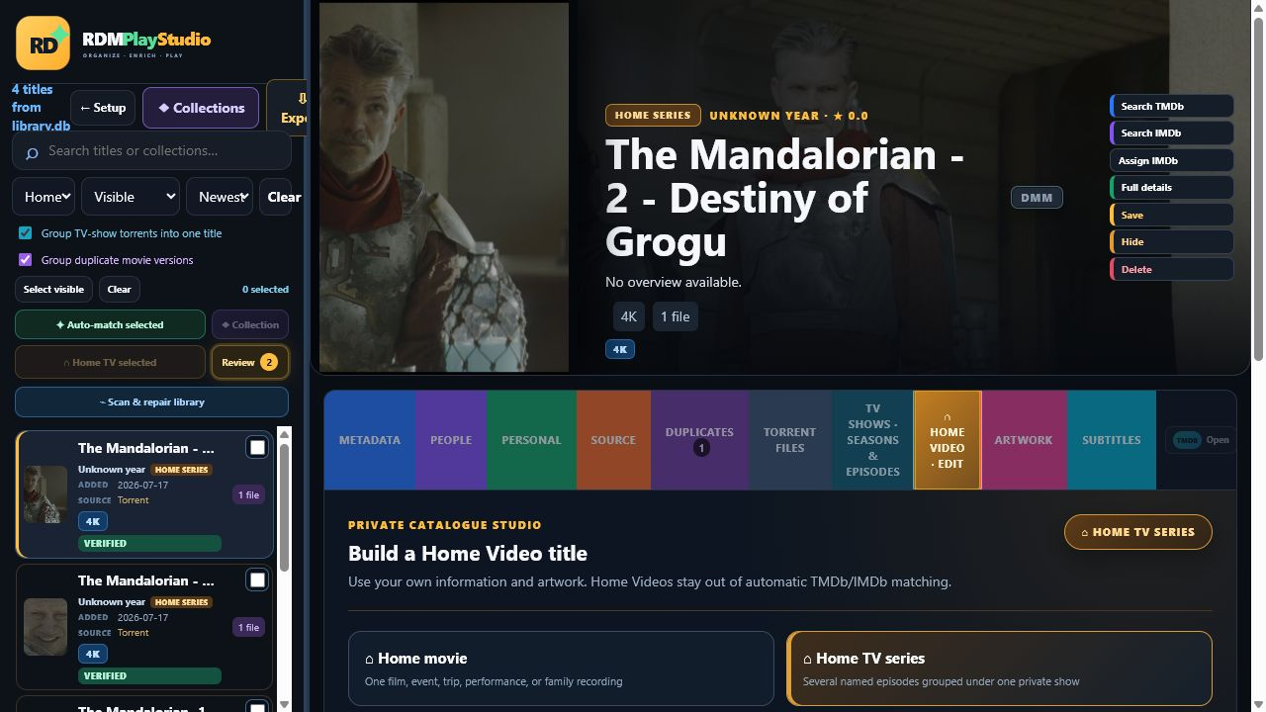
Home Video Studio: create a Home Movie or Home TV series and use private metadata and artwork.

Create one Home TV series from several videos
- Filter the left panel to Needs assignment or Home videos, then select every recording that belongs to the same private series. Use the checkboxes, Ctrl-click for separate items, or Shift-click for a range.
- Choose Home TV selected. Enter the common series title and the starting season.
- Review the proposed episode order. Each original title or filename becomes an editable episode title; no Real-Debrid file is moved or deleted.
- Choose Create Home TV series. The separate library cards are grouped into one gold Home TV Series title.
- Open TV shows · Seasons & episodes to edit each season number, episode number, and episode title, then save the episode.
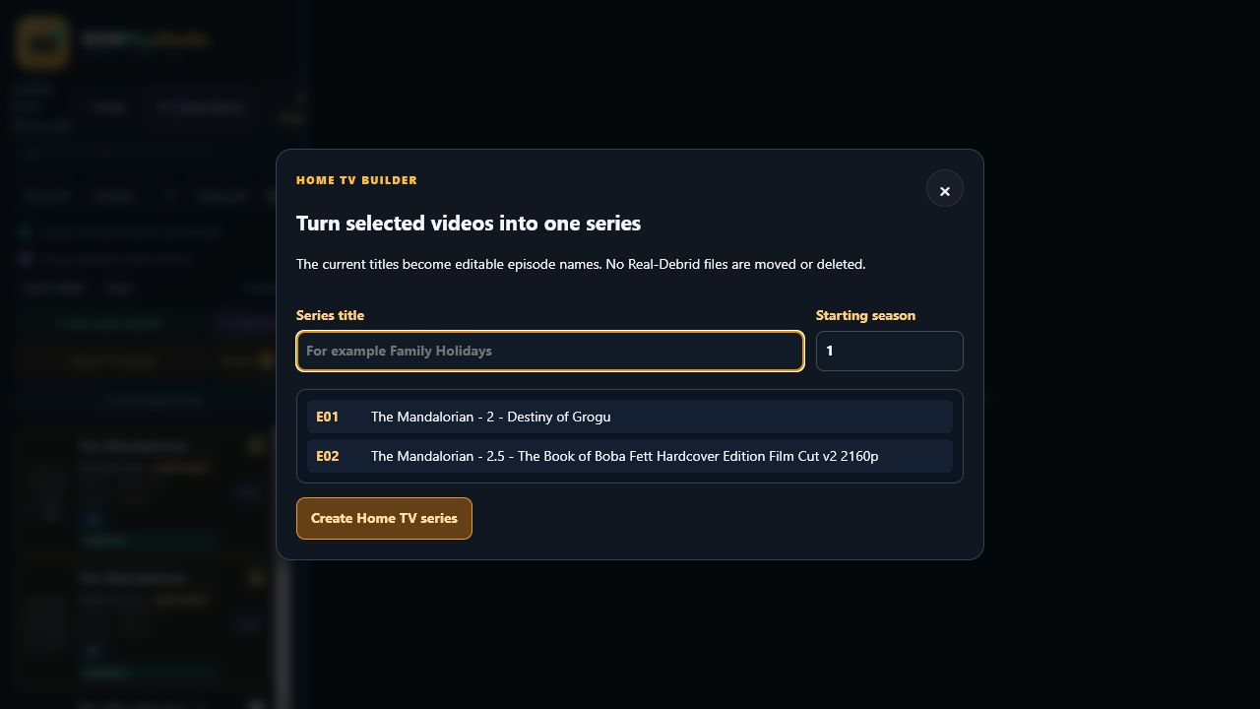
Home TV Builder: selected recordings become editable episodes in one private series.
ASSIGNMENT COMPLETE A Home Movie or Home TV Series leaves the Needs assignment view as soon as its Home type is saved. It does not require TMDb or IMDb artwork, IDs, or approval.

10. Movies, duplicates, and collection torrents

Duplicate versions
Duplicate movies can be grouped as one title. The preferred version is chosen by resolution, HDR capability, and size; 4K/HDR versions normally appear first. Open Duplicates or Torrent files to inspect and change versions.

One torrent containing several movies
Open Torrent files to list the files inside a collection torrent. Individual catalog entries can be created from its video files and assigned their own IMDb/TMDb titles without deleting the parent torrent.

Repair tools
Scan & repair library finds likely duplicates, collections, and mismatched records. Review destructive or identity-changing actions before applying them; create a backup first for large repairs.

11. TV shows, seasons, and episodes
Torrents assigned to the same TMDb TV show are grouped into one library title. Season packs and individual episode torrents disappear from the main list and become versions or episodes inside the grouped show.
Recognised pattern | Example
Season/episode | S02E04
Words | Season 2 Episode 4
Compact | 2x04
Season pack | Show Name S02 Complete

Missing episodes
The missing-episode report compares the catalogued files with TMDb's aired episode list and highlights gaps such as S02E04. Future or unaired episodes are not treated as missing.

Find a missing episode or better version with DMM
A green DMM badge appears beside an assigned movie or TV title when an IMDb ID is available. It opens Debrid Media Manager in a separate browser window at the matching movie page or TV season. The missing-episode report opens the exact season whenever it can determine one.
- Assign or verify the title so the record has the correct IMDb ID. A grey or absent DMM badge means the IMDb ID is not available yet.
- Select DMM beside the title, or choose Find on DMM from the missing-episode report.
- In DMM, select a cached release or episode and add its magnet to the same Real-Debrid account.
- Return to RDM PlayStudio and choose Sync account, or use Force everything on the startup dashboard.
- Review the imported release. TV episodes join the existing show; alternative movie releases appear as versions/duplicates with the best quality ranked first.
EXTERNAL INTEGRATION DMM is an independent external service. RDM PlayStudio opens the correctly identified page and later imports what your Real-Debrid account contains; it does not control DMM search results or availability.

Episode versions
When several files represent the same episode, RDM PlayStudio ranks the highest resolution/HDR version first. You can choose another version when the preferred source is unavailable or has incompatible audio.

12. Playback

Automatic playback order
Press Play and RDM PlayStudio prepares a temporary Real-Debrid link. Depending on the file and browser, it tries compatible browser playback, a Real-Debrid stream, local FFmpeg transcoding, the original file, and VLC. Prepared links expire and are not permanently stored.
Option | Best use
Play in browser | MP4/H.264/AAC and other browser-compatible media
Transcoded stream | MKV/HEVC or incompatible audio when FFmpeg is available
Open direct stream | Testing the original Real-Debrid file URL
Open in VLC | Most reliable playback for MKV, HEVC, HDR, subtitles, and multiple tracks
Google Cast | Sending a compatible prepared stream to Chromecast/Google TV

Audio and subtitles
VLC provides the broadest control of embedded audio streams and subtitle tracks. A browser can expose supported tracks but cannot decode every codec or container. Use the Subtitles tab to attach an external SRT, ASS, or VTT file when necessary.

Continue Watching
Playback position is saved per profile. Partially watched movies and episodes appear in Continue Watching and resume near the previous position. Marking a title watched or clearing progress updates that profile only.
BUFFERING If direct browser playback buffers but VLC does not, use VLC. Local transcoding needs CPU capacity and stable network throughput; 4K transcoding can exceed the capability of older computers.

13. iPhone and iPad
- Enable Home network access on the Windows dashboard.
- On the iPhone/iPad, open the displayed http://192.168.x.x:8787 address in Safari.
- Use Share > Add to Home Screen to install the full-screen RDM PlayStudio web app.
- Keep the Windows host awake and RDM PlayStudio running during browsing and playback.
- Use VLC for iOS when Safari cannot play the container, video codec, or audio codec.

14. Google TV and casting

Television browser
Open the dashboard's device address in a Google TV browser. The television layout supports D-pad focus and larger controls, but VLC remains the recommended player for demanding files.

VLC on Google TV
Install VLC from Google Play. Choose Open in VLC from a movie or episode. If a direct stream has no audio, choose another version or the audio-compatible/transcoded option; the source may use a codec unsupported by that television.

Google Cast
Choose the Cast icon, select the receiver, then choose a movie or episode. Casting depends on the receiver supporting the prepared stream; local transcoding may be used when direct playback is unsuitable.

15. Profiles, favourites, and shelves

Profiles
Create up to eight profiles. Each profile has separate favourites, watched status, and playback progress. Library metadata, files, and title assignments remain shared.

Favourites
Select the heart icon on a card or title. The Favourites panel reveals the profile's saved movies and shows, including resume information when available.

Collections and playlists
Collections are visual groupings of already assigned and playable titles. They are different from splitting a multi-film torrent and from building a Home TV series: a collection does not change title identity, merge episodes, move files, or delete anything from Real-Debrid.
Feature | Purpose | Effect on media
TMDb franchise | Automatic groups such as James Bond, The Matrix, or Mission: Impossible | Read-only grouping; members remain individual
Manual collection | Your own named set of assigned movies and/or TV shows | Virtual grouping; custom poster is optional
Custom shelf / playlist | Profile-oriented watchlist such as Weekend or Family | A title can belong to several shelves
Multi-film torrent | Catalogue several video files from one source torrent | Creates separate title records from source files
Home TV series | Turn private recordings into editable episodes | Groups selected videos under one private show

Automatic franchise collections
When two or more assigned titles share the same TMDb collection, PlayStudio creates an automatic franchise card. These collections update from the shared library database and do not need manual maintenance. They are labelled TMDb franchise and use collection artwork when available.

Create a manual collection
- In Studio, select two or more assigned movies or TV shows. Mixed movie-and-TV collections are allowed.
- Choose Collection above the left library list.
- Enter the collection name and optionally choose a portrait collection poster.
- Review the selected members, then choose Create collection.
- Open Collections to confirm the new card. Removing the collection later removes only the virtual grouping, never its titles or Real-Debrid files.
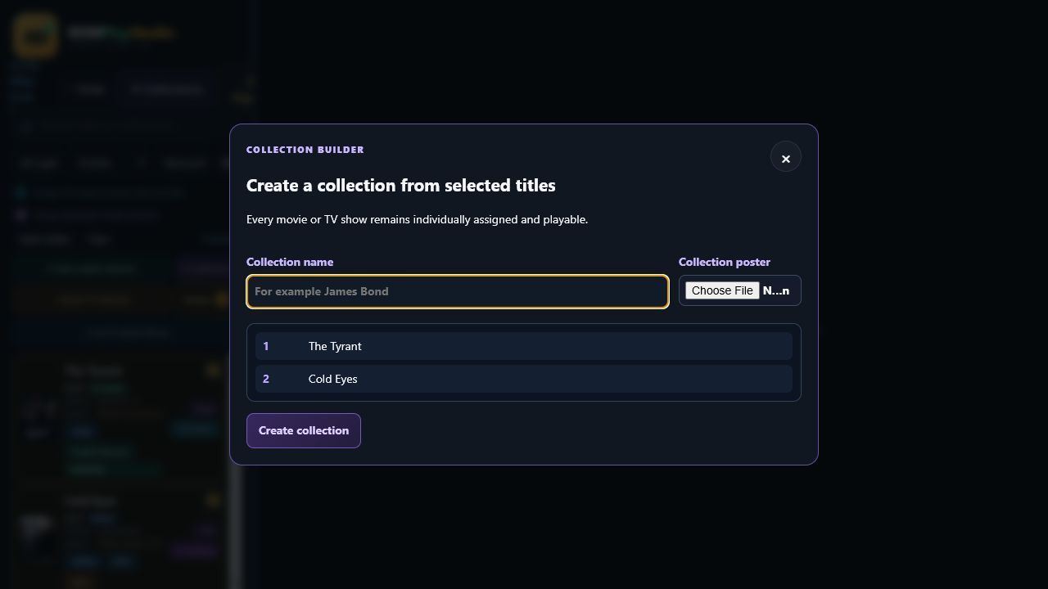
Collection Builder: selected assigned titles remain individual and playable inside a custom collection.

Browse collections in Studio and around the home
Choose Collections beside Setup in Studio to open the full collection library. Selecting a member jumps directly to that title in the editor. The same Collections button appears in the local and 192.168.x.x home-network player; there, selecting a member opens it for playback. Both interfaces read the same library.db, so collection names, membership, posters, profiles, favourites, and progress remain synchronized.
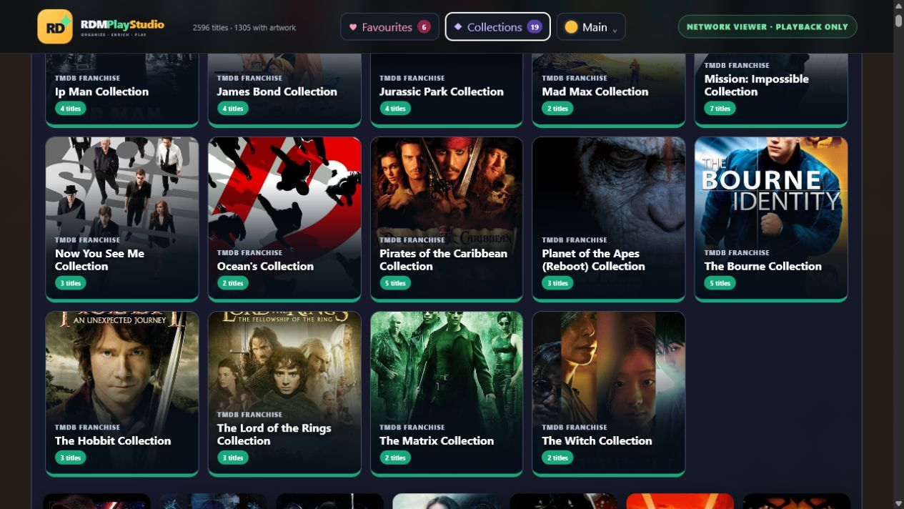
Collections in the home-network player: visual franchise cards are available on every trusted screen.
SEARCH Normal Studio search checks title, original filename, automatic franchise name, and manual collection name. Use prefixes such as actor:, director:, genre:, tag:, studio:, or all: for a wider metadata search.

16. Artwork and local offline storage
Posters and fanart normally load from metadata-provider image servers. Enable Store artwork locally on the startup dashboard, then choose Cache artwork now. Cached posters and backdrops improve speed and remain available when the internet is temporarily unavailable.

Custom artwork
The Artwork tab accepts a local poster or backdrop, a permitted image URL, the assigned TMDb artwork, or a frame captured from the actual video. Posters are displayed proportionally in the editor and collection exports.
STORAGE GROWTH The SQLite database stays small because images are stored as files in the artwork cache, not inside library.db. A large collection may require several gigabytes of artwork storage.

17. Subtitles
The Subtitles tab lists detected embedded and external subtitle languages. You can attach local SRT, ASS, or VTT files, choose a preferred saved track for VLC, or search OpenSubtitles by title, language, season, and episode.
- Assign the correct movie or TV title first.
- Configure the OpenSubtitles API key and account.
- Choose the required language and, for TV, the season and episode.
- Review the results and download the selected subtitle.
- Test timing and character encoding in VLC.

18. Hiding and deleting items
Action | Local library | Real-Debrid account
Hide | Removed from normal views; available under Hidden items | No change
Unhide | Restored to normal views | No change
Delete catalog child | Removes the split/derived local entry | Parent torrent remains
Delete torrent/RD file | Removes the local record | Permanently deletes the matching RD item/history entry

DELETION IS PERMANENT Read the confirmation carefully. Hide is the safe choice when an item is confusing but may still be needed for a grouped show or collection.

19. Backup and restoration

Create a backup
Choose Create backup now before bulk repair, large matching operations, or application updates. Backups are timestamped SQLite files in data/backups.

Restore safely
- Open Restore backup on the startup dashboard.
- Select a backup and review its date, size, item count, and integrity result.
- Close other RDM windows and avoid synchronisation during restoration.
- Type RESTORE exactly and confirm.
- Reopen the editor and verify several titles, profiles, and settings.
ARTWORK Database backup protects SQLite data. Copy the artwork cache and attached subtitle folders separately when making a complete archival backup.

20. Exporting the collection
Exports use the current search, type, source, and sort order, or the selected titles when Selected only is enabled.
Export | Result
Excel workbook | Formatted, filterable collection spreadsheet
CSV | Portable data list for other programs
Detailed card website | Large side-poster cards with rich metadata
Cinematic card website | Large poster layered over faded fanart
Printable list | Compact browser page for printing or PDF
Collector PNG/PDF | Polished individual cards for selected titles

Saved exports are written to the RDM PlayStudio Exports folder under Downloads. Previously exported HTML files are self-contained snapshots and do not update when the library changes.

21. Playback diagnostics
Check | What a successful result means
Real-Debrid | The account token works and link preparation is available.
VLC player | VLC is installed and can be launched on Windows.
FFmpeg and codecs | FFmpeg/FFprobe are discoverable for transcoding and inspection.
Browser codecs | The browser reports baseline formats; actual file support may still vary.
Playable sources | Library entries have Real-Debrid playback identifiers.
Home-network server | The local/LAN address responds on port 8787.
Windows Firewall | The local server is reachable; Private-network permission may still be required.

22. Troubleshooting
Symptom | Recommended action
Network error while importing/syncing | Confirm the server is running, test APIs, check internet/DNS, then retry.
Only some titles appear | Clear filters; check Movies/TV, Hidden items, needs-metadata, and grouped-TV options.
Poster or actors are missing | Assign TMDb/IMDb, choose Full details, and verify the TMDb key.
Playback could not be prepared / infringing_file | Try another version or release; Real-Debrid rejected that source.
hoster_unavailable | Wait and retry, or choose another file/version. This is usually upstream.
Browser video has no audio | Use audio-compatible transcoding or VLC; the audio codec is unsupported.
Google TV direct stream buffers | Use VLC, wired/strong Wi-Fi, or a lower-resolution version.
VLC does not open | Install VLC, rerun diagnostics, and allow protocol/app launching when prompted.
New TV episodes are not grouped | Force sync, assign the same TMDb show, and verify SxxExx-style filenames.
DMM badge is grey or missing | Assign the correct IMDb ID, refresh full metadata, then reopen the title.
A DMM selection does not appear | Confirm DMM added it to the same Real-Debrid account, then run Sync account or Force everything.
Port 8787 already used | Close the older RDM PlayStudio instance or the other application using that port.
API search reports socket/network error | Check firewall, VPN/proxy, DNS security software, and provider availability.
Interface feels slow | Avoid concurrent sync/transcode jobs; enable local artwork and restart after large repairs.

23. Data, privacy, and security
- library.db contains metadata, IDs, profiles, progress, shelves, settings, and encrypted credentials.
- Artwork, attached subtitles, backups, and transcode files are stored separately under the data folder.
- Secrets are protected by Windows DPAPI and normally work only for the same Windows user.
- Home network access should be enabled only on a trusted Private network.
- The application is not designed for direct internet exposure or public multi-user hosting.
- Prepared Real-Debrid URLs are temporary and should not be shared.

24. Pre-installation requirements checklist
Check | Ready when...
Windows | 64-bit Windows 11 is updated and the user can install applications.
Real-Debrid | A valid account and private API token are available.
TMDb | A valid API key is available for enrichment and TV grouping.
Playback | VLC is installed; FFmpeg and FFprobe pass diagnostics.
Storage | At least 5 GB is free for normal use; more for artwork/transcoding.
Network | Port 8787 is allowed on Private networks and no older RDM server is running.
Backups | The backup folder is writable and at least one known-good backup exists.
Optional services | OMDb and OpenSubtitles credentials are ready if those features are required.

25. Compatibility and service limitations
- Automatic application updates and commercial licence activation are not yet implemented.
- Browser, Cast, and television codec support depends on the destination device.
- Real-Debrid, DMM, and metadata-provider availability, policies, and API limits are outside RDM PlayStudio's control.
- High-resolution transcoding is limited by the host CPU/GPU and network throughput.
RELEASE PLANNING Commercial licensing and the safe update mechanism are separate product services and may vary by RDM PlayStudio edition.

Appendix A - Important locations
Item | Windows 11 installer location
Application | %ProgramFiles%/RDM PlayStudio
Active database | %LOCALAPPDATA%/RDM PlayStudio/data/library.db
Database backups | %LOCALAPPDATA%/RDM PlayStudio/data/backups
Artwork cache | %LOCALAPPDATA%/RDM PlayStudio/data/artwork_cache
Temporary transcodes | %LOCALAPPDATA%/RDM PlayStudio/data/transcode
Saved exports | Downloads/RDM PlayStudio Exports

Application updates replace program files but keep the per-user database, backups, artwork, subtitles, profiles, and viewing progress in the local application-data folder.

Appendix B - Support information to collect
- RDM PlayStudio version and Windows version.
- Exact error message and the action that produced it.
- Playback diagnostics result.
- Whether the issue occurs on Windows, iOS, Google TV, VLC, browser, or Cast.
- Media filename, container, resolution, video codec, and audio codec (do not share prepared RD URLs).
- Whether the problem remains after restart, force sync, and selecting another version.

