**Resource Management and job offloading on IoT**

The general IoT has three layers: cloud layer, edge layer, and mobile devices layer (terminal layer).

The cloud layer has a centralized infrastructure that comprises several data centres that can be utilized for long-term storage and less time-sensitive application operations.

The fog layer has a distributed infrastructure, and is closer to terminals (edge layer). The fog nodes utilize high-performance servers for time-sensitive applications that require a quick response.

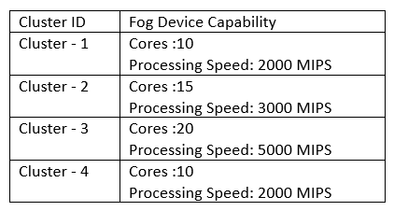

At the fog layer, every fog node serves a group of mobile(edge) devices from the third layer; these mobile devices can include sensors, PCs, and phones

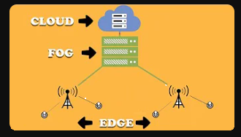

**Job types with details needs to be uploaded from edge to Fog/Cloud**

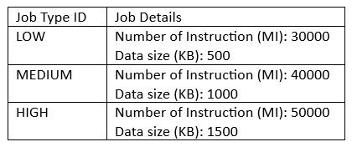

|  |  |  |
| --- | --- | --- |
| Variables / Constants | Description/Definition | Description/Definition |
| MAX_SIMULATION_TIME | Total Simulation Time |  |
| numOfFDs | The total number of cluster-fog resources |  |
| numOfEDs | Number of edge (mobile devices per cluster) |  |
| S = { s1, s2, s3 .... sq} | **S** is the set of slots. **q** is the max number of slots in the simulation time. |  |
| Ts1 = {T1s1, T2s1 . . .Tn1s1} | **Ts1** is a set of tasks submitted to system for resource scheduling/allocation at slot **s1** |  |
| LATENCY_ED_FR | The upload time consumption of the task from edge to fog resource |  |
| **T1s1** | **task completion time for task T1 in slot s1**. | **T1s1 =** T1s1 upload time + size of T1s1 / speed of allocated resource |
| **Avg_TT_s1** | average task completion time for slot s1 with n tasks, | **sum_of(**T1s1+T2s1+T3s1....Tns1**) /** n1 |
| **Avg_TT_S(DELAY)** | average task completion time for simulation for SIMULATION_TIME | **sum_of(**Avg_TT_s1 + Avg_TT_s2+Avg_TT_s3+ ...Avg_TT_ss**) /** S |
| LATENCY_CS_FR | The upload time consumption of the task from fog to cloud. |  |
| Nu | Total Network Utilisation |  |

**Results:**

