this is a sample developed to simulate "AutoDrivr - CAR” system using iFogSim Simulator.

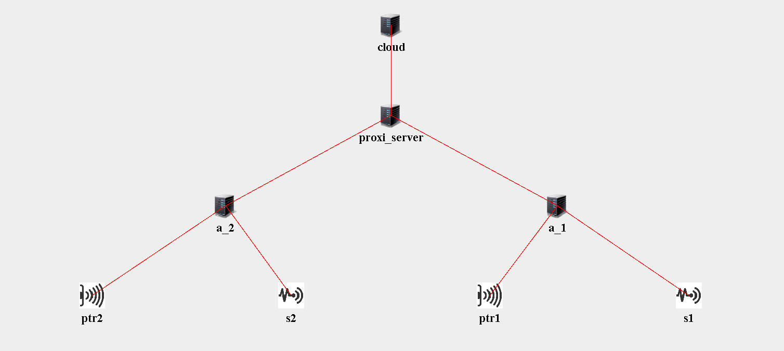

the topology is having, two cars (a_1, a_2), each has Fog device that connected to sensers(s1,s2) and output devices (ptr1,ptr2). Fog devices(cars) collects date from sensers(s1,s2) for each 5ms process it for output and takes action on output PTR devises(ptr1,ptr2). all the data will be backed up in cloud server. fog devises are connected to Cloud via proxy_server.

Value of parameters of Fog, Proxy and Cloud for fog devises:

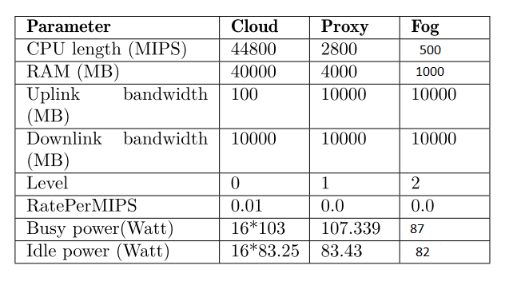

Simulation Results:

=========================================

EXECUTION TIME : 1667891652771

=========================================

APPLICATION LOOP DELAYS

=========================================

[SENSOR, process_d, store_d] ---> 147.50624999999997

[SENSOR, process_d, ACTUATOR] ---> 46.099999999999945

=========================================

TUPLE CPU EXECUTION DELAY

=========================================

processed_data ---> 0.1416666666666515

SENSOR ---> 5.0

=========================================

cloud : Energy Consumed = 1954569.1361530323

a_2 : Energy Consumed = 214055.4338000019

a_1 : Energy Consumed = 214055.4338000019

proxi_server : Energy Consumed = 0.0

Cost of execution in cloud = 9173.999999999533

Total network usage = 7446.0