Capstone Document Processing System
Technical Architecture Document
AI-Powered Document Q&A System using RAG and ReActAgent

Generative AI and ML Capstone Project
By Balaji Baskaran
Document Version 1.0 — June 2026

Table of Contents
Table of Contents 2
1. Overview 3
1.1 Project Goals 3
1.2 Key Technologies 3
2. System Architecture 4
2.1 Layer Summary 4
3. Component Deep Dive 5
3.1 Interface Layer 5
FastAPI Swagger UI (primary) 5
Streamlit UI (optional bonus) 5
3.2 API Layer 5
3.3 Document Service 6
3.4 Embedding Service 6
3.5 Retrieval Service 6
3.6 ReActAgent (Single Agent, Four Roles) 6
3.7 Data Layer 7
ChromaDB 7
Groq (Llama 3.1 8B Instant) 7
4. Data Flow 7
4.1 Document Upload Flow 7
4.2 Question and Answer Flow 7
5. Reliability and Safety Controls 8
6. Deployment 8
7. Limitations and Assumptions 8
7.1 Key Assumptions 8
7.2 Key Limitations 9
8. Project Folder Structure 9
9. Conclusion 9

1. Overview
The Capstone Document Processing System is a Generative AI-powered application that enables users to upload enterprise documents and ask natural language questions about their content. The system uses Retrieval-Augmented Generation (RAG) combined with a single autonomous ReActAgent to retrieve relevant information from uploaded documents and generate accurate, grounded responses.
The system was built to satisfy the capstone requirements of demonstrating a complete Generative AI and Agentic AI workflow: document ingestion, semantic chunking, vector-based retrieval, retrieval-augmented generation, and agent-based reasoning, all wrapped in a working REST API with reliability and safety controls.

1.1 Project Goals
- Allow users to upload documents in multiple formats (PDF, TXT, CSV, Excel, JSON, YAML).
- Allow users to ask natural language questions about the content of those documents.
- Ground every answer strictly in the uploaded document content, not in the LLM's general training knowledge.
- Demonstrate a single agent performing multiple reasoning roles (plan, retrieve, reason, respond), as specified by the course instructor.
- Run entirely on free-tier infrastructure with no recurring cost.

1.2 Key Technologies
Layer | Technology | Purpose
API framework | FastAPI | REST endpoints with auto-generated Swagger UI
Optional UI | Streamlit | Visual upload and chat-style Q&A on top of the same API
AI orchestration | LlamaIndex | Document loading, chunking, embedding, retrieval pipeline
Agent framework | LlamaIndex ReActAgent | Single agent: plan, retrieve, reason, respond
LLM provider | Groq (Llama 3.1 8B Instant) | Free, fast inference for response generation
Vector database | ChromaDB | Local, persistent vector storage and similarity search
Embedding model | sentence-transformers (all-MiniLM-L6-v2) | Converts text to 384-dimension vectors, runs locally
Development environment | GitHub Codespaces | Cloud-based, zero local setup
Containerization | Docker | Portable, reproducible deployment package

2. System Architecture
The architecture follows a layered design: an interface layer, an API layer, a service layer, a single agent layer, and a data layer. Each layer has a single, well-defined responsibility, and data flows strictly downward through the stack and back up again.
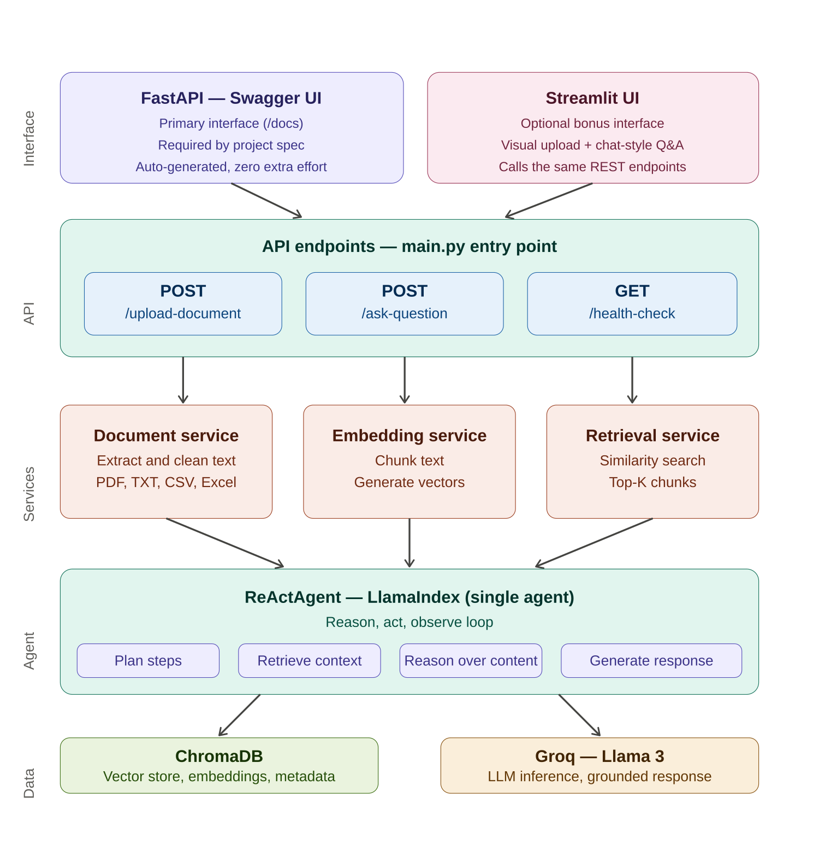
Figure 1 — High-level system architecture

2.1 Layer Summary
Layer | Component | Responsibility
Interface | FastAPI Swagger UI | Primary, required interface — auto-generated from the API, lets reviewers try every endpoint directly in the browser
Interface (bonus) | Streamlit app | Optional visual layer added after the core API was working; calls the same REST endpoints, no backend duplication
API | main.py + endpoints.py | Defines and exposes the three REST endpoints; validates input; routes requests to services
Service | document_service.py | Validates and extracts text from uploaded files across six formats
Service | embedding_service.py | Chunks extracted text and generates vector embeddings; stores them in ChromaDB
Service | retrieval_service.py | Embeds the user's question and performs similarity search against ChromaDB
Agent | react_agent.py | Single ReActAgent that plans, retrieves, reasons, and responds in one reasoning loop
Data | ChromaDB | Persistent local vector store holding chunk text, embeddings, and metadata
Data | Groq API | External LLM call that generates the final grounded natural-language answer

3. Component Deep Dive

3.1 Interface Layer

FastAPI Swagger UI (primary)
FastAPI automatically generates an interactive Swagger UI at the /docs route from the API's own route definitions and Pydantic models. This was the instructor-recommended interface, chosen specifically because it requires zero additional UI development effort while still giving reviewers a fully interactive way to call every endpoint, inspect request/response schemas, and see live results.

Streamlit UI (optional bonus)
After the core REST API was complete and tested, a Streamlit application (streamlit_app.py) was added as a second, optional interface. It is a thin client that calls the exact same FastAPI endpoints over HTTP using the requests library — no backend logic is duplicated. It provides a drag-and-drop upload widget and a simple question/answer text interface, intended to make the system easier to demonstrate visually.

3.2 API Layer
main.py is the application entry point. On startup it loads configuration from environment variables, creates the required data directories, and registers the API router. All three endpoints are versioned under the /api/v1 prefix.
Method | Endpoint | Purpose
POST | /api/v1/upload-document | Accepts a file upload, validates it, extracts text, generates embeddings, and stores them in ChromaDB
POST | /api/v1/ask-question | Accepts a natural language question and returns a grounded answer generated by the ReActAgent
GET | /api/v1/health-check | Returns service status and the current number of chunks stored in ChromaDB

3.3 Document Service
document_service.py is responsible for everything that happens before text reaches the embedding pipeline. It performs three sequential checks before any processing occurs.
- Extension validation — rejects any file type not in the allowed list (pdf, txt, csv, xlsx, json, yaml).
- Size validation — rejects files larger than the configured MAX_FILE_SIZE_MB limit.
- Format-specific extraction — routes the file to the correct extractor (pypdf for PDF, pandas for CSV/Excel, json/yaml standard libraries for those formats, direct decode for TXT).
Every supported format is normalized into the same output structure: a plain text string plus metadata (filename, character count, size). This consistency means every downstream component works identically regardless of the original file format.

3.4 Embedding Service
embedding_service.py takes the normalized text from the document service and prepares it for semantic search in two steps.
- Chunking — LlamaIndex's SentenceSplitter divides the text into overlapping chunks (512 tokens per chunk, 50 token overlap), preserving sentence boundaries so meaning is not cut mid-sentence.
- Embedding and storage — each chunk is converted into a 384-dimension vector using the all-MiniLM-L6-v2 sentence-transformers model, then stored in ChromaDB along with the original chunk text and source filename as metadata.
This service runs once per uploaded document, at upload time.

3.5 Retrieval Service
retrieval_service.py runs at question time, not upload time. It embeds the user's question using the identical embedding model used during ingestion (this consistency is essential — embeddings from two different models are not comparable), then performs a cosine-similarity search against every stored chunk in ChromaDB. The top-K most similar chunks (configurable, default 3) are returned along with their similarity scores and source filenames.

3.6 ReActAgent (Single Agent, Four Roles)
Per the instructor's explicit guidance, this system implements one single agent that performs multiple reasoning roles internally, rather than multiple separate agents. This is a standard Generative AI application with one ReAct-style agent — not a multi-agent Agentic AI system.
The ReActAgent, provided by LlamaIndex, follows a Reason → Act → Observe loop:
- Plan — the agent reasons about what it needs to do to answer the question.
- Retrieve — the agent calls its one available tool, search_documents, which wraps the retrieval service.
- Reason — the agent reviews the retrieved chunks and decides if it has enough grounded context to answer.
- Respond — the agent sends the question plus retrieved context to the Groq LLM, which generates the final natural-language answer.
A system prompt instructs the agent to always use the search tool before answering, to base its answer only on retrieved content, and to explicitly say it cannot find an answer rather than fabricate one. This is the project's primary safety guardrail against hallucination.

3.7 Data Layer

ChromaDB
ChromaDB is a local, file-based vector database. It requires no external server or account, persisting its data as a SQLite file plus an index folder under data/chroma_db. It stores each chunk's text, its 384-dimension embedding vector, and metadata (source filename) together, and exposes a similarity-search query used by the retrieval service.

Groq (Llama 3.1 8B Instant)
Groq provides free, low-latency hosted inference for an open-weight Llama 3 model. The agent calls Groq only at the final response-generation step, sending the user's question together with the retrieved document context. The model temperature is set to 0.0 to maximize answer consistency.

4. Data Flow

4.1 Document Upload Flow
- User uploads a file via Swagger UI or Streamlit.
- FastAPI receives the file and passes it to document_service for validation and text extraction.
- Extracted text is passed to embedding_service, which chunks it and generates embeddings.
- Embeddings, chunk text, and metadata are stored in ChromaDB.
- A success response is returned, including the number of chunks created.

4.2 Question and Answer Flow
- User submits a natural language question via Swagger UI or Streamlit.
- FastAPI validates the question is non-empty and passes it to the ReActAgent.
- The agent calls the search_documents tool, which embeds the question and queries ChromaDB via retrieval_service.
- The top-K most relevant chunks are returned to the agent as context.
- The agent sends the question and context to Groq, which generates a grounded natural-language answer.
- The answer is returned to the user through the API response.

5. Reliability and Safety Controls
Several controls were implemented to reduce errors, validate input, and constrain the system to safe, grounded behaviour.
Control | Implementation
Input validation | Pydantic models validate every request; file extension and size are checked before processing; empty questions are rejected with a 400 error
Hallucination guardrail | System prompt forces the agent to answer only from retrieved context and to explicitly state when no answer is found
Retry logic | The tenacity library automatically retries Groq API calls up to 3 times with exponential backoff if rate-limited
Structured logging | Loguru logs every significant event — uploads, searches, agent reasoning steps, and errors — with timestamps
Health monitoring | A dedicated /health-check endpoint reports service status and current knowledge-base size
Secrets management | API keys are loaded from a .env file, excluded from version control via .gitignore, with a .env.example template provided

6. Deployment
The application is fully containerized using Docker, with the Dockerfile validated as building and running correctly end-to-end. Cloud deployment to Render was attempted and partially completed; the image built and started successfully, confirming the Dockerfile is production-ready. Full continuous hosting was not pursued further after the free-tier instance ran out of memory loading the ML embedding model, a known resource constraint, not a defect in the application. Detailed evidence and reasoning for this decision are provided in the project's known-limitations documentation.
For development, testing, and submission, the application runs on GitHub Codespaces, which provides sufficient memory and disk resources for the full pipeline, including local embedding model inference.

7. Limitations and Assumptions

7.1 Key Assumptions
- ChromaDB runs in-process and does not require a separate database server.
- Sample documents are used to demonstrate functionality; the system is not connected to a production document repository.
- Groq's free tier is sufficient for capstone demonstration purposes but is not intended for production-scale traffic.
- Production observability (metrics, tracing, alerting) is out of scope for this capstone; structured logging via Loguru is used as a lightweight substitute.

7.2 Key Limitations
Extensive testing surfaced several genuine, well-diagnosed limitations of the system as built. A full account of each, including root cause analysis and evidence from application logs, is maintained in docs/known-limitations.md. In summary:
- The small, fast LLM (Llama 3.1 8B Instant) used for free-tier speed occasionally shows non-deterministic tool-use behaviour — it does not always invoke the search tool before answering, which can produce an incorrect “not found” response even when the correct chunk exists in the knowledge base.
- When the knowledge base contains documents on very different topics, a short, correct chunk can occasionally be “lost” among longer, unrelated retrieved chunks in the LLM's reasoning.
- The free-tier hosting environment (512MB RAM) is insufficient to load the local embedding model, constraining continuous public deployment without a paid hosting tier.
Each of these was investigated with reproducible evidence, root-caused, and where practical, mitigated (for example, lowering LLM temperature to 0.0 improved consistency, and switching the agent from chat-mode to query-mode resolved a context-accumulation bug).

8. Project Folder Structure
capstone-document-processing-system/
app/
api/ REST endpoint definitions
services/ document, embedding, retrieval services
agents/ ReActAgent definition
core/ configuration management
utils/ helper functions
data/
uploads/ saved uploaded documents
chroma_db/ persistent vector database
docs/ tech stack and limitations documentation
main.py application entry point
streamlit_app.py optional visual interface
requirements.txt Python dependencies
Dockerfile container definition
.env.example environment variable template

9. Conclusion
This project delivers a complete, working Generative AI document Q&A system that satisfies every required component of the capstone specification: multi-format document ingestion, semantic chunking, vector-based retrieval, a retrieval-augmented generation pipeline, single-agent reasoning, reliability and safety controls, and a documented, containerized deployment path. Beyond the minimum requirements, the system was extensively stress-tested, with every discovered limitation root-caused, evidenced, and documented rather than hidden, reflecting genuine production-engineering practice within the constraints of a free-tier, time-boxed capstone project.

