**Overview**

A company named myapps.com has a number of applications hosted in their on-premise environment. These applications focus on ensuring the company can provide online training to its customers.

The company wants to move its existing application and new applications to Azure. They want to make use of serverless computing wherever possible.

**Current Infrastructure**

They have a virtual machine on their on-premise environment that runs BizTalk Server 2016. These servers run the following workflows

* New Courses – This workflow gets information on new course requirements
* Course Improvements - This workflow gets information on new features for existing courses

The virtual machine environment supports the following REST API calls

* Course API – This API provides information on the course description, the number of videos and number of questions in the course.
* Student API – This API provides the number of students per course.
* Application API – This API provides complete details on the courses and students

The course and the student data are stored in a MongoDB database

A site named http:// myapps.com provides information on the students and the courses.

**Propose solution**

They want to migrate the on-premise solution to Azure. They setup a new Azure virtual machine to host the BizTalk Server.

The architecture of the proposed setup is given below

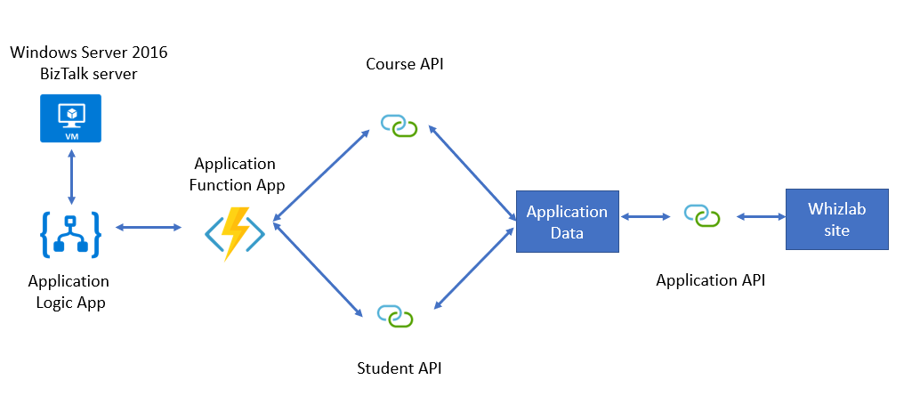

**Requirements**

* The Logic App must support industry-standard protocol X12 messages
* Resources used by the Azure Logic App must be secured to the corporate virtual network and also use dedicated storage resources with a fixed costing model
* For the function app, you need to implement secure function endpoints by using app-level security and also include Azure Active Directory.
* The Azure Logic App must maintain on-premise connectivity to support legacy applications and also ensure the final Biztalk migrations can take place
* The REST API’s must
  + Secure resources to the virtual network
  + They must allow deployment to a testing location within Azure without any additional costs
  + The API’s must be able to scale to double its capacity during peak times.
* The data migration from the on-premise VM to Azure must minimize costs and downtime.

After migration the myapps.com site to an Azure Web App for testing purposes, you are getting the following error when trying to test the API’s

**“Failed to load**[**http://test-appapi. myapps.com/**](http://test-appapi.whizlab.com/)**: No ‘Access-Control-Allow-Origin’ header is present on the requested resource. Origin**[**http://test. myapps.com/**](http://test.whizlab.com/)**is therefore not allowed access’**