**[Classification c1,] "Outside cover reuse"**

<DisplayName> **Outside cover reuse** </DisplayName>

<KeyboardShortcut> **O** </KeyboardShortcut>

<DirectoryName> **Outside_Cover_Reuse** </DirectoryName>

<AddedFilenameEnding> **orc** </AddedFilenameEnding>

Front cover, back cover, spine, all three. The text/decoration/illumination is visible on the outside cover surface is visible through from the other side. It must be on the codex/book. Limp vellum covers OK, but not wrappers.

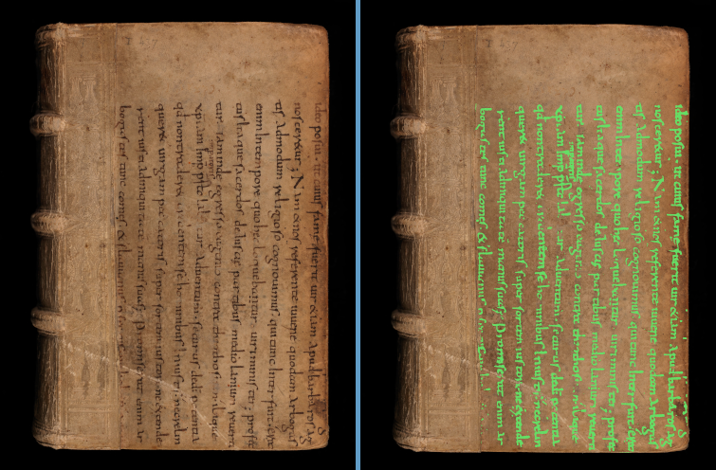

BaselUniversitatsbib_-_Le-VI-12_00001

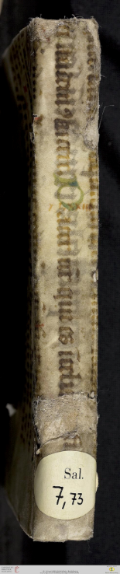

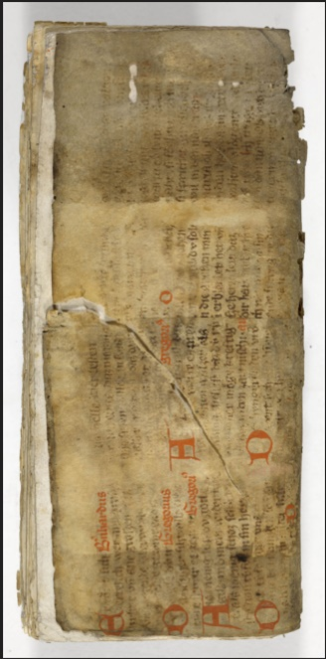

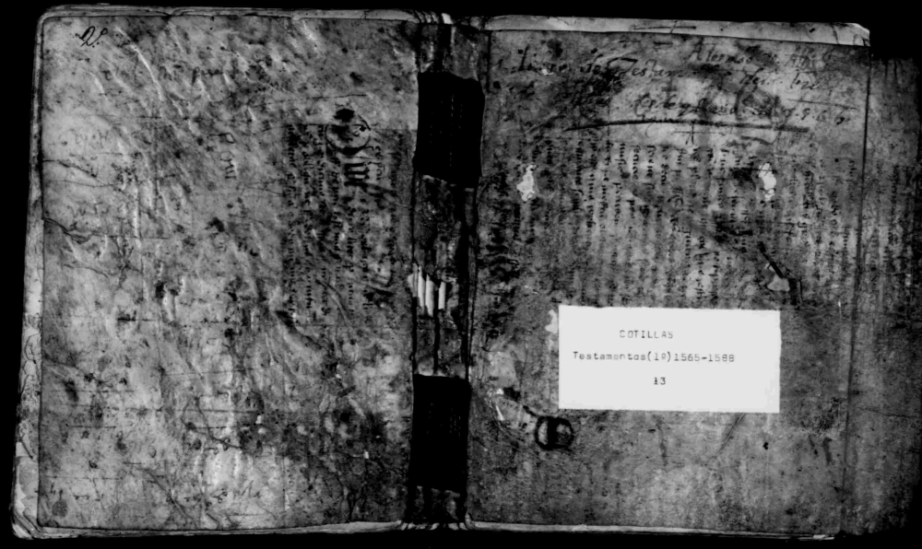

Heidelberg_-_

salVII73__

z4_00249

FamilySearch_-_DGS004090639_00701

Ba,berg+=+JV<Msc359_00073

**[Classification c2,] "Under cover reuse"**

<DisplayName> **Outside cover reuse** </DisplayName>

<KeyboardShortcut> **O** </KeyboardShortcut>

<DirectoryName> **Outside_Cover_Reuse** </DirectoryName>

<AddedFilenameEnding> **orc** </AddedFilenameEnding>

Front cover

f

f

font