Let’s get some simple DFT stuff. Before, when illustrating this, I could use Wolfram|Alpha, but they’ve lessened their functionality, even when signed in. Luckily, there’s still the sandbox.

<https://sandbox.open.wolframcloud.com>

I’m signing in, so I can save it, but this can all be done without signing in.

Go to the top of the document, click on the "+"

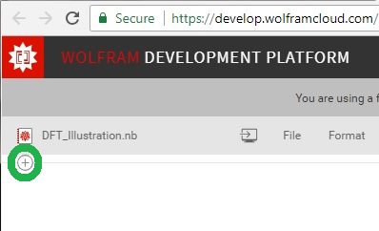

and choose "Wolfram Language Input (default)".

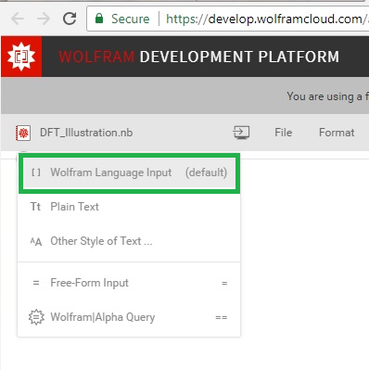

Then, you can type the following (I don’t know if it will let you copy/paste.) I have some extra comments in my input. Note that I’ll put this down lower as well, and tell you to press [Shift] + [Enter] to cause it to evaluate.

(Just FYI, you’ll have to re-do this step with the plus, “Wolfram Language Input”, etc., each time you want to do a new entry.)

freq = 25; nSamples = 100;

waveformWithXAxisTime=Table[N[Cos[2*Pi*freq*t / nSamples]+(RandomReal[] - 0.5)],{t,nSamples}]

You’ll need to press [Shift] + [Enter] if you want it to evaluate. Here’s what it looked like on my input (not signed in).

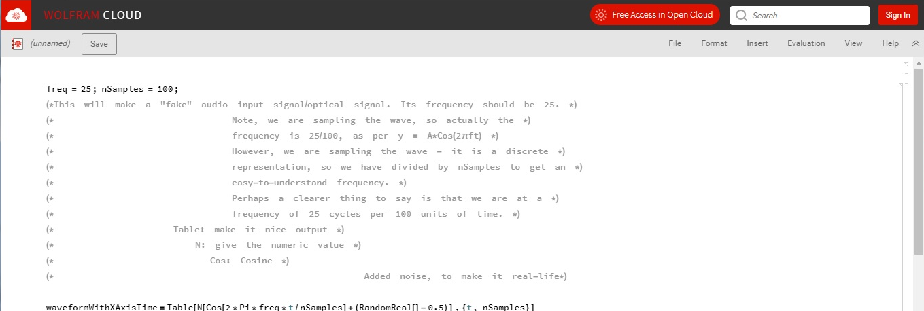

Those comments look a little hard to read, so I’ll type the info here.

*This will make a "fake" audio signal/optical signal. Its frequency should be “mostly” 25. Note: We are sampling our fake wave, so, actually, the frequency is 25/100, as per . However, because we are sampling the wave, it is a discrete representation. Because of this, we have divided by the number of samples to get an easy-to-understand frequency. Perhaps a clearer thing to say is that we are at a frequency of 25 cycles per 100 units of time.*

Here’s a hopefully clearer illustration of what the commands do:

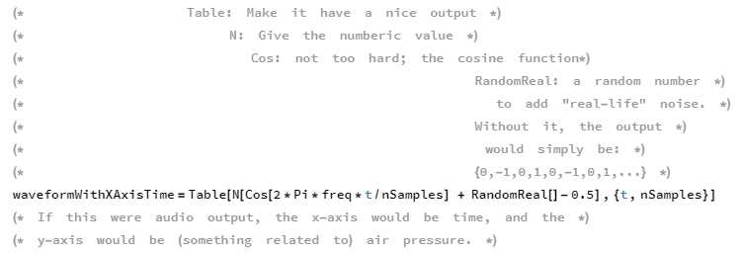

Here’s the bare code again, just in case you didn’t copy/paste before. P.S.: Wolfram is like the anti-Cygwin; you can press [Ctrl] + [V], but you can’t right-click and paste. (You’re also welcome to type it in.)

freq = 25; nSamples = 100;

waveformWithXAxisTime=Table[N[Cos[2*Pi*freq*t / nSamples]+(RandomReal[] - 0.5)],{t,nSamples}]

Press [Shift] + [Enter], just because Wolfram likes to be weird that way.

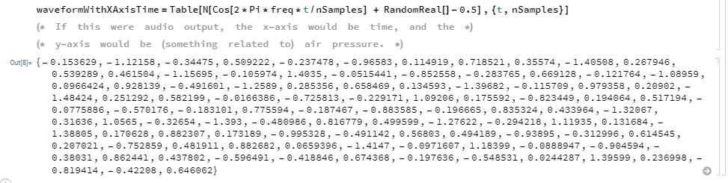

We’ll plot it, and then we’ll run a Discrete Fourier Transform (DFT)

ListLinePlot[waveformWithXAxisTime, AxesOrigin->{1,0}]

Remember to press [Shift] + [Enter] , and look at the pretty plot.

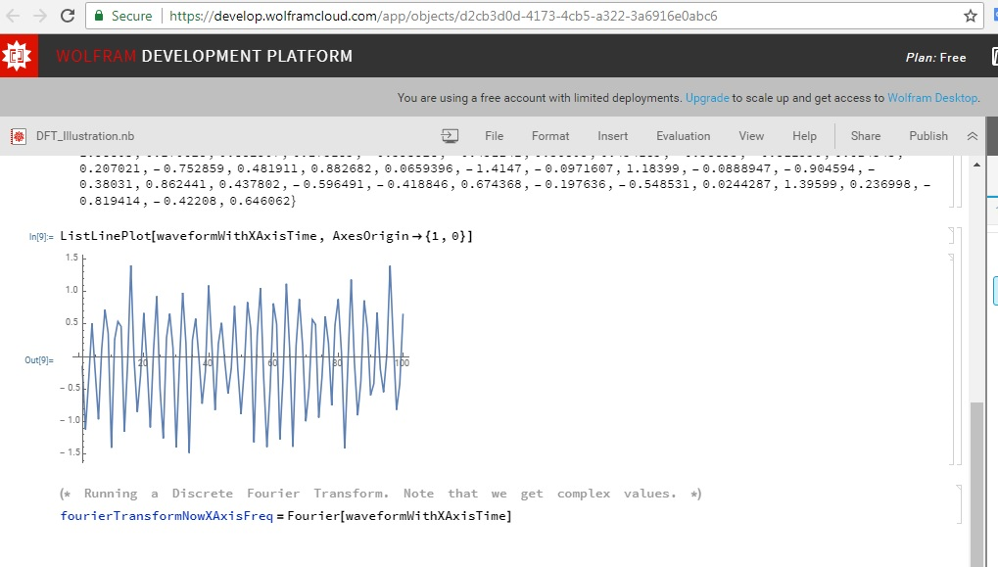

(* Running a Discrete Fourier Transform. Note that we will get complex values. *)

fourierTransformNowXAxisFreq=Fourier[waveformWithXAxisTime]

I’ll just go straight on to plotting it. We have to take the norm of the complex numbers with Abs

ListLinePlot[Abs[fourierTransformNowXAxisFreq],PlotRange->All]

[Go onto the next page to see the Fourier transform graph.]

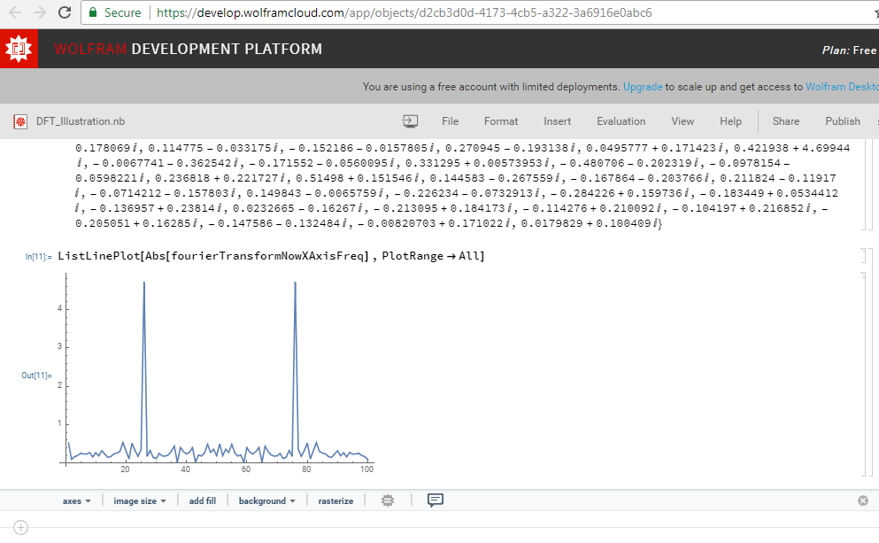

We’ve now gone from a time profile to a frequency profile, where we can see that the most important frequency is 25. I’m pretty sure that the peak at 75 is just a reflection of the frequency component and has to do with our sampling, i.e.

A conceptual explanation is that, with a “window” of 100 (100 samples), it would be impossible to draw out frequencies greater than 50/100. That (pure) frequency of 50 would mean that we would need to "see" the graph going from 1 to -1 with every tick of the axis: {1,-1,1,-1,1,…}. (Maybe you can see why I used cosine instead of sine.) Hopefully, it’s obvious that we can’t get a frequency higher than that - the granularity of our sampling makes it impossible to go "all the way" to 100.

**Factor of 2; Nyquist Frequency; .**

**100/2 = 50**

Also remember the concept that

Let’s now do a couple of frequencies together - meaning we’ll have two principle frequencies. I’ll have extra semicolons to suppress output.

freq1 = 25; amp1 = 10; freq2 = 75; amp2 = 5; nSamplesMix = 500;

waveformMixed=Table[N[amp1*Cos[2*Pi*freq1*t / nSamplesMix]+(RandomReal[] - 0.5)+ amp2*Cos[2*Pi*freq2*t / nSamplesMix]+(RandomReal[] - 0.5)],{t,nSamplesMix}];

ListLinePlot[waveformMixed,AxesOrigin->{1,0}]

fourierMixed=Fourier[waveformMixed];

ListLinePlot[Abs[fourierMixed],PlotRange->All]

The code:

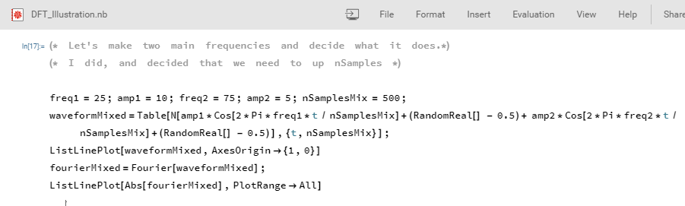

The plots:

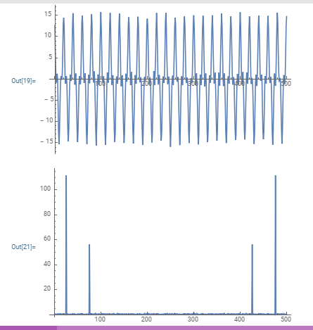

Finally, I have data that come from me, playing of a piano, and from my wife, playing an accordion. We’re each playing what should be Concert A (440 Hz)

(The first part is me, talking. The second part is the note)

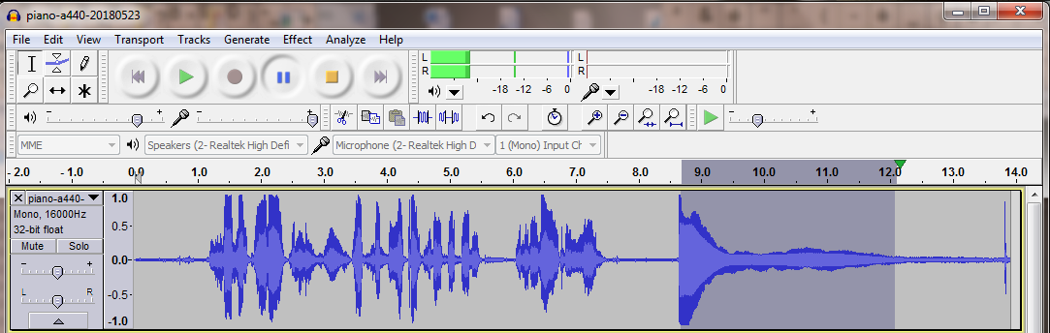

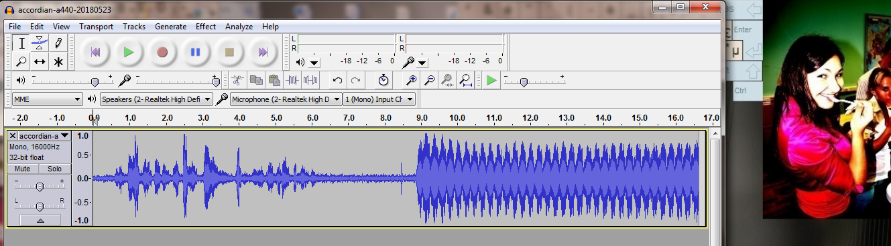

Note that the Project Rate is 16 kHz = 16000 samples/second

That’s the same as 6.25e-5 seconds/sample

Here’s an online thing with the plot of a piano’s Note the big peak at 440.

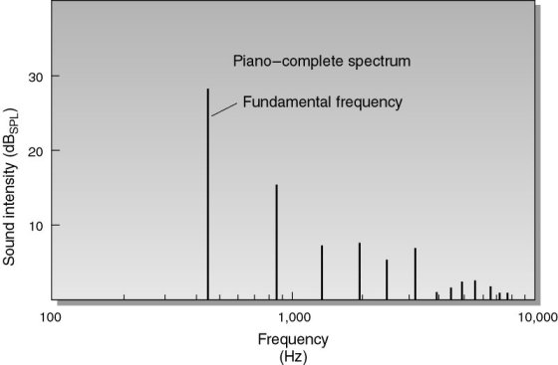

Source: [https://www.quora.com/How-does-the-pitch-of-a-C-note-vary-on-different-instruments](https://www.quora.com/How-does-the-pitch-of-a-C-note-vary-on-different-instruments%20)

pianoFourier=Abs[Fourier[pianoA440]];

accordionFourier=Abs[Fourier[accordionA440]];

ListLinePlot[pianoFourier,PlotRange->{{0,1500./2},{0,13}},PlotLabel->"Piano A440 Fourier"]

lineStyle1={Thick,Red,Dashed};

lineStyle2={Automatic};

line=Line[{{42,0},{42,13}}]

ListLinePlot[pianoFourier,PlotRange->{{30,50},{0,13}},PlotLabel->"Piano Fourier Zoom, line: x=42",

PlotStyle->{Directive[lineStyle2],Directive[lineStyle1]},Epilog->{Directive[lineStyle1], line}]

Print["Frequency is 42 cycles per 0.09375 seconds = ",42/0.09375," Hz. I only need to tune my piano a little."]

Print["Actually, since 1 \"tick\" on the x-axis is 1/0.09375 = ",1/0.09375," Hz., I’m right on, within sampling error."]

I’m going to put in the real data to the Wolfram stuff. Since each data set has 1500 samples, and that takes a lot of space on the page, I’ll have the data after the rest of the document. That way, you won’t see a bunch of sample numbers here, but you’ll still be able to copy and paste the information in and follow along. The internal hyperlinks are on the next page. You could also copy and paste from the attached *.dat files. By the way, at this point, you might want to open a new tab and go to a new, fresh <https://sandbox.open.wolframcloud.com> page. I think they limit the amount of processing that can be done on one page with this free, not-signed-in version. I have done it without the new page, but it’s slow.

Paste the piano data and the accordion data in the same cell. (Remember to click the '+', then choose "Wolfram Language Input (default)". Also remember that you have to push [Shift] + [Enter] to get the code to evaluate. Just paste in the whole code from pianoA440={ all the way to the last }; Then press enter in the cell for a new line and paste in everything between accordionA440={ and };

After pasting everything in, you’ll plot both waveforms. I’ll put in a screenshot of the beginning of the copy/paste stuff as well as its end here, and then write in the plot commands.

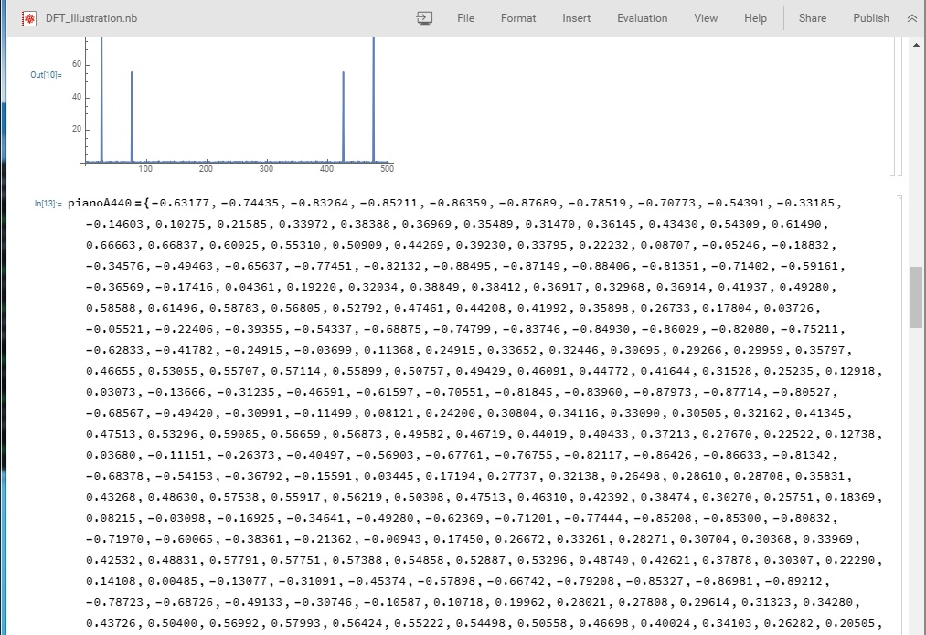

…you see the lots of numbers…

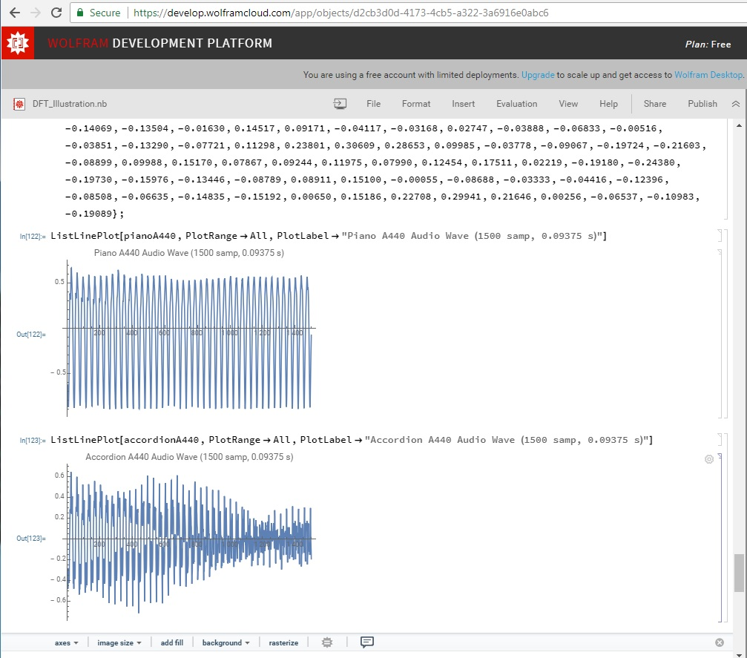

…and now, you see the plot commands:

ListLinePlot[pianoA440, PlotRange->All, PlotLabel-> "Piano A440 Audio Wave (1500 samp, 0.09375 s"]

ListLinePlot[accordionA440, PlotRange->All, PlotLabel-> "Accordion A440 Audio Wave (1500 samp, 0.09375 s"]

Next, we’ll put in all the Fourier code (except the complete plotting) at once. Note that I have comments in here that will only make sense after you’ll see the graphs.

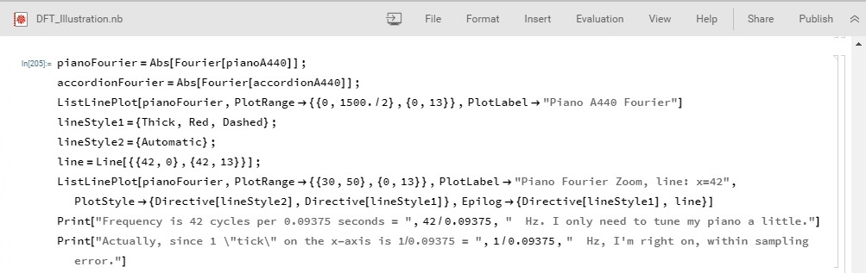

pianoFourier=Abs[Fourier[pianoA440]];

accordionFourier=Abs[Fourier[accordionA440]];

ListLinePlot[pianoFourier,PlotRange->{{0,1500./2},{0,13}},PlotLabel->"Piano A440 Fourier"]

lineStyle1={Thick,Red,Dashed};

lineStyle2={Automatic};

line=Line[{{42,0},{42,13}}];

ListLinePlot[pianoFourier,PlotRange->{{30,50},{0,13}},PlotLabel->"Piano Fourier Zoom, line: x=42",

PlotStyle->{Directive[lineStyle2],Directive[lineStyle1]},Epilog->{Directive[lineStyle1], line}]

Print["Frequency is 42 cycles per 0.09375 seconds = ",42/0.09375," Hz. I only need to tune my piano a little."]

Print["Actually, since 1 \"tick\" on the x-axis is 1/0.09375 = ",1/0.09375," Hz., I’m right on, within sampling error."]

Push [Shift] + [Enter]

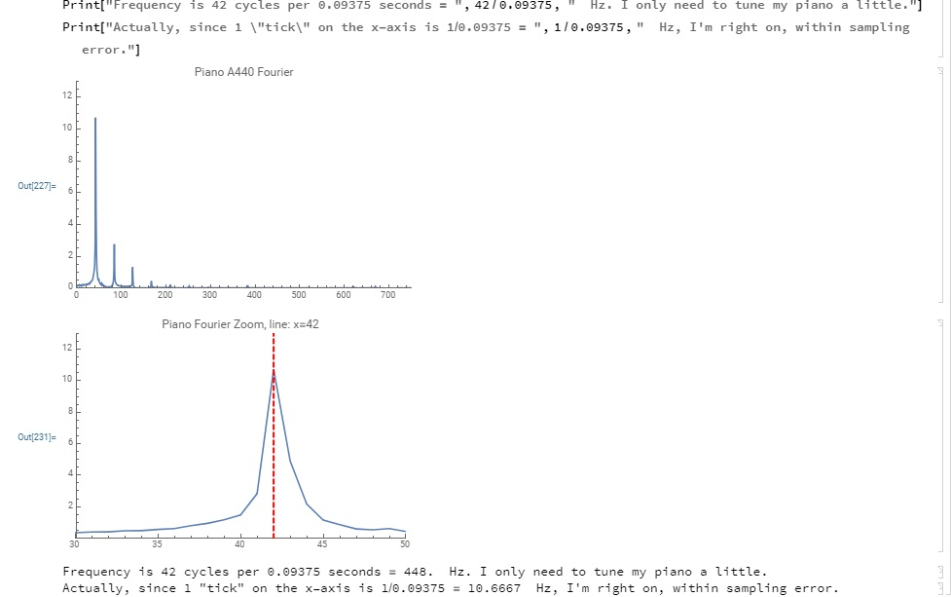

Now, you can do the accordion analysis.

line2=Line[{{42,0},{42,5}}];

(* accordionFourier was defined in the last code block, but just in case, you can uncomment the next line *)

(* accordionFourier=Abs[Fourier[accordionA440]]; *)

ListLinePlot[accordionFourier,PlotRange->{{0,1500./2},{0,5}},PlotLabel->"Accordion A440 Fourier"]

ListLinePlot[accordionFourier,PlotRange->{{30,50},{0,5}},PlotLabel->"Accordion Fourier Zoom, line: x=42",

PlotStyle->{Directive[lineStyle2],Directive[lineStyle1]},Epilog->{Directive[lineStyle1], line2}]

Print["It seems as if my wife and I can play together without too much cacophony. Hooray!"]

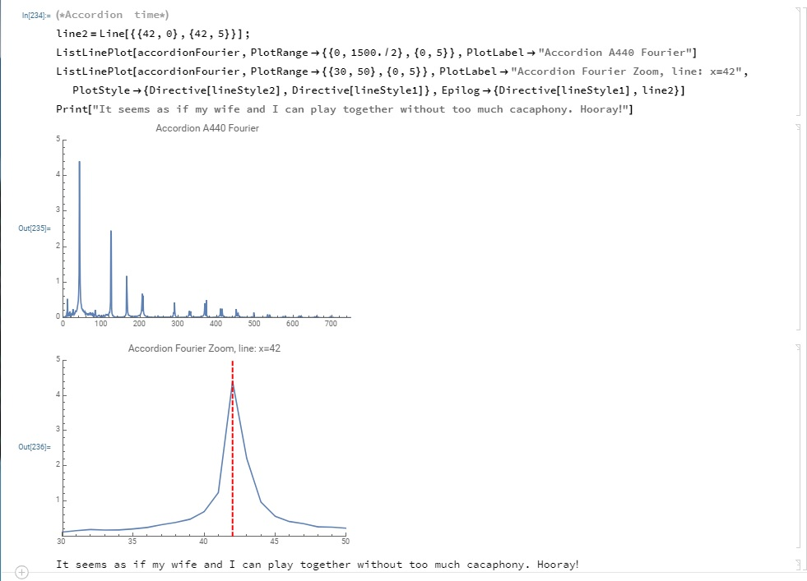

Besides the fact that my wife and I can play in tune, you should notice different patterns after (and before) the main, 440 Hz peak (which appears around 42 in our graph.) The differences in the “other lines”, which are called harmonics, make the difference in sound between an accordion and a piano playing the same note. Voices are quite a bit more complicated in their frequency spectra, especially if one is not just singing one note. You might want to record your voice and feed it through this “pattern” to see more of that.

I hope it helps. -DWB

The Instrument Data. If the copy/paste stuff isn’t working, you might want to copy/paste from the *.dat files.

**Piano** (back to step-by-step)

pianoA440={-0.63177, -0.74435, -0.83264, -0.85211, -0.86359, -0.87689, -0.78519, -0.70773, -0.54391, -0.33185, -0.14603, 0.10275, 0.21585, 0.33972, 0.38388, 0.36969, 0.35489, 0.31470, 0.36145, 0.43430, 0.54309, 0.61490, 0.66663, 0.66837, 0.60025, 0.55310, 0.50909, 0.44269, 0.39230, 0.33795, 0.22232, 0.08707, -0.05246, -0.18832, -0.34576, -0.49463, -0.65637, -0.77451, -0.82132, -0.88495, -0.87149, -0.88406, -0.81351, -0.71402, -0.59161, -0.36569, -0.17416, 0.04361, 0.19220, 0.32034, 0.38849, 0.38412, 0.36917, 0.32968, 0.36914, 0.41937, 0.49280, 0.58588, 0.61496, 0.58783, 0.56805, 0.52792, 0.47461, 0.44208, 0.41992, 0.35898, 0.26733, 0.17804, 0.03726, -0.05521, -0.22406, -0.39355, -0.54337, -0.68875, -0.74799, -0.83746, -0.84930, -0.86029, -0.82080, -0.75211, -0.62833, -0.41782, -0.24915, -0.03699, 0.11368, 0.24915, 0.33652, 0.32446, 0.30695, 0.29266, 0.29959, 0.35797, 0.46655, 0.53055, 0.55707, 0.57114, 0.55899, 0.50757, 0.49429, 0.46091, 0.44772, 0.41644, 0.31528, 0.25235, 0.12918, 0.03073, -0.13666, -0.31235, -0.46591, -0.61597, -0.70551, -0.81845, -0.83960, -0.87973, -0.87714, -0.80527, -0.68567, -0.49420, -0.30991, -0.11499, 0.08121, 0.24200, 0.30804, 0.34116, 0.33090, 0.30505, 0.32162, 0.41345, 0.47513, 0.53296, 0.59085, 0.56659, 0.56873, 0.49582, 0.46719, 0.44019, 0.40433, 0.37213, 0.27670, 0.22522, 0.12738, 0.03680, -0.11151, -0.26373, -0.40497, -0.56903, -0.67761, -0.76755, -0.82117, -0.86426, -0.86633, -0.81342, -0.68378, -0.54153, -0.36792, -0.15591, 0.03445, 0.17194, 0.27737, 0.32138, 0.26498, 0.28610, 0.28708, 0.35831, 0.43268, 0.48630, 0.57538, 0.55917, 0.56219, 0.50308, 0.47513, 0.46310, 0.42392, 0.38474, 0.30270, 0.25751, 0.18369, 0.08215, -0.03098, -0.16925, -0.34641, -0.49280, -0.62369, -0.71201, -0.77444, -0.85208, -0.85300, -0.80832, -0.71970, -0.60065, -0.38361, -0.21362, -0.00943, 0.17450, 0.26672, 0.33261, 0.28271, 0.30704, 0.30368, 0.33969, 0.42532, 0.48831, 0.57791, 0.57751, 0.57388, 0.54858, 0.52887, 0.53296, 0.48740, 0.42621, 0.37878, 0.30307, 0.22290, 0.14108, 0.00485, -0.13077, -0.31091, -0.45374, -0.57898, -0.66742, -0.79208, -0.85327, -0.86981, -0.89212, -0.78723, -0.68726, -0.49133, -0.30746, -0.10587, 0.10718, 0.19962, 0.28021, 0.27808, 0.29614, 0.31323, 0.34280, 0.43726, 0.50400, 0.56992, 0.57993, 0.56424, 0.55222, 0.54498, 0.50558, 0.46698, 0.40024, 0.34103, 0.26282, 0.20505, 0.10590, -0.00851, -0.14493, -0.32831, -0.41376, -0.56906, -0.67099, -0.76035, -0.84540, -0.86084, -0.89886, -0.80789, -0.70474, -0.54105, -0.32755, -0.12656, 0.08514, 0.18494, 0.27231, 0.30096, 0.31821, 0.33823, 0.38086, 0.45969, 0.54001, 0.57965, 0.59909, 0.59213, 0.59048, 0.56134, 0.52527, 0.49280, 0.39499, 0.36142, 0.25919, 0.20200, 0.12296, -0.04004, -0.14661, -0.31354, -0.42386, -0.56763, -0.68179, -0.74283, -0.84277, -0.86475, -0.89615, -0.82993, -0.73700, -0.57983, -0.35181, -0.13705, 0.05585, 0.19095, 0.28055, 0.33624, 0.34613, 0.35699, 0.40643, 0.47607, 0.56195, 0.58490, 0.64636, 0.62790, 0.61731, 0.60693, 0.53281, 0.52451, 0.42450, 0.36636, 0.31525, 0.23383, 0.15387, -0.00470, -0.10187, -0.26462, -0.40308, -0.53326, -0.64810, -0.72690, -0.83203, -0.87692, -0.89545, -0.87189, -0.78232, -0.61713, -0.40192, -0.17432, -0.00217, 0.15570, 0.24191, 0.30664, 0.29343, 0.30417, 0.37296, 0.40018, 0.49609, 0.52246, 0.56238, 0.59348, 0.55728, 0.57297, 0.52393, 0.49225, 0.40439, 0.35248, 0.31320, 0.21689, 0.14398, 0.02231, -0.08832, -0.23926, -0.38287, -0.50037, -0.61050, -0.71680, -0.79590, -0.86377, -0.88126, -0.88675, -0.79544, -0.63721, -0.43594, -0.20279, -0.04434, 0.15274, 0.25137, 0.28098, 0.31824, 0.30469, 0.37375, 0.40027, 0.45529, 0.50665, 0.53143, 0.55106, 0.53040, 0.55658, 0.50864, 0.46088, 0.41858, 0.37714, 0.33347, 0.26712, 0.19315, 0.10559, -0.03558, -0.16660, -0.30963, -0.42542, -0.53830, -0.66690, -0.73676, -0.84225, -0.88455, -0.89575, -0.84268, -0.65952, -0.51279, -0.29349, -0.10455, 0.05383, 0.17517, 0.20627, 0.26077, 0.28241, 0.33215, 0.36200, 0.42969, 0.49359, 0.50912, 0.54678, 0.57300, 0.56750, 0.53949, 0.48425, 0.45279, 0.39554, 0.34573, 0.31070, 0.24643, 0.18460, 0.04327, -0.07727, -0.20087, -0.35028, -0.44992, -0.59705, -0.67947, -0.78391, -0.89294, -0.89572, -0.86353, -0.72180, -0.56744, -0.36319, -0.16855, -0.00830, 0.10349, 0.15897, 0.22971, 0.25180, 0.28110, 0.35425, 0.40872, 0.47131, 0.51202, 0.56192, 0.60184, 0.58441, 0.57883, 0.52521, 0.48303, 0.42746, 0.35107, 0.32486, 0.23572, 0.15262, 0.04056, -0.09351, -0.18439, -0.34656, -0.45050, -0.56339, -0.67050, -0.78741, -0.88348, -0.89438, -0.86002, -0.73260, -0.57831, -0.37354, -0.16409, -0.02774, 0.10440, 0.18793, 0.23404, 0.27798, 0.30215, 0.36633, 0.39377, 0.43689, 0.49728, 0.53244, 0.58130, 0.56790, 0.56134, 0.54160, 0.47025, 0.44891, 0.38065, 0.35052, 0.28394, 0.17828, 0.09216, -0.02600, -0.15042, -0.29422, -0.39832, -0.51974, -0.64285, -0.76495, -0.87616, -0.89377, -0.88272, -0.79678, -0.61609, -0.43695, -0.23434, -0.07532, 0.05777, 0.16599, 0.21484, 0.27716, 0.31796, 0.35599, 0.40198, 0.42447, 0.50372, 0.52835, 0.56345, 0.58118, 0.55280, 0.54236, 0.47842, 0.45218, 0.41440, 0.36313, 0.29346, 0.21243, 0.13440, 0.00497, -0.11014, -0.24100, -0.35556, -0.45792, -0.61374, -0.72601, -0.82687, -0.89383, -0.88361, -0.81094, -0.65045, -0.48199, -0.30658, -0.11743, -0.00391, 0.11682, 0.18082, 0.25388, 0.31949, 0.33316, 0.40048, 0.42722, 0.49243, 0.54025, 0.56110, 0.58249, 0.56122, 0.52994, 0.47656, 0.45398, 0.40164, 0.33148, 0.28537, 0.19986, 0.12799, 0.00644, -0.11911, -0.21167, -0.33337, -0.45026, -0.57675, -0.70367, -0.79800, -0.88599, -0.87280, -0.79797, -0.67316, -0.49551, -0.33762, -0.14670, -0.03400, 0.07571, 0.17233, 0.23129, 0.29712, 0.32001, 0.36456, 0.41141, 0.46967, 0.52188, 0.55212, 0.58267, 0.54385, 0.51880, 0.47928, 0.43188, 0.38837, 0.31494, 0.27075, 0.21057, 0.11343, 0.02255, -0.08505, -0.17703, -0.28802, -0.41653, -0.51700, -0.66864, -0.76636, -0.85419, -0.85968, -0.78375, -0.68204, -0.49854, -0.33328, -0.16806, -0.03842, 0.06973, 0.17111, 0.23099, 0.28915, 0.30402, 0.34744, 0.37842, 0.42004, 0.49487, 0.52539, 0.54544, 0.53580, 0.51010, 0.49719, 0.45078, 0.39731, 0.36517, 0.31271, 0.26233, 0.15646, 0.08060, -0.02048, -0.13550, -0.23297, -0.36407, -0.47125, -0.62701, -0.74747, -0.82855, -0.86606, -0.81015, -0.71985, -0.54953, -0.38861, -0.23065, -0.09760, 0.01395, 0.13544, 0.19009, 0.24478, 0.28125, 0.29904, 0.34070, 0.39490, 0.46057, 0.51413, 0.51657, 0.53275, 0.51785, 0.50735, 0.47217, 0.43210, 0.42334, 0.35370, 0.30112, 0.21353, 0.12820, 0.03384, -0.09460, -0.18665, -0.31656, -0.44595, -0.60553, -0.74088, -0.83942, -0.89615, -0.85236, -0.77243, -0.60986, -0.44641, -0.29977, -0.14935, -0.01511, 0.09549, 0.19119, 0.23605, 0.27414, 0.29410, 0.32568, 0.39996, 0.44876, 0.50204, 0.51050, 0.53131, 0.52032, 0.48660, 0.47308, 0.43280, 0.41409, 0.34964, 0.29422, 0.22800, 0.13336, 0.03934, -0.06985, -0.15659, -0.28760, -0.41714, -0.56866, -0.71304, -0.82602, -0.89145, -0.88089, -0.78397, -0.65601, -0.50385, -0.34824, -0.20596, -0.05704, 0.05023, 0.16748, 0.22256, 0.25851, 0.28516, 0.32275, 0.40601, 0.43845, 0.49341, 0.52271, 0.52814, 0.51761, 0.47791, 0.47458, 0.43567, 0.40112, 0.34589, 0.30060, 0.23819, 0.14551, 0.06180, -0.03027, -0.12744, -0.23798, -0.38147, -0.51950, -0.65585, -0.80267, -0.86398, -0.87244, -0.79315, -0.67813, -0.54123, -0.38010, -0.24454, -0.09174, 0.02570, 0.14597, 0.20822, 0.23257, 0.28122, 0.31949, 0.39377, 0.43436, 0.49808, 0.53122, 0.53067, 0.52209, 0.50403, 0.49710, 0.45969, 0.42239, 0.38055, 0.32211, 0.25122, 0.17554, 0.08411, 0.01227, -0.09213, -0.21057, -0.33978, -0.48700, -0.63446, -0.79059, -0.86066, -0.88046, -0.82236, -0.71048, -0.58350, -0.41946, -0.29041, -0.12625, 0.01346, 0.12384, 0.18997, 0.22723, 0.27191, 0.31064, 0.36951, 0.43176, 0.49924, 0.52365, 0.52710, 0.52356, 0.53061, 0.50400, 0.48117, 0.45328, 0.40622, 0.35544, 0.27051, 0.20517, 0.12308, 0.04285, -0.05963, -0.17529, -0.29330, -0.45703, -0.61078, -0.77982, -0.85916, -0.89240, -0.85812, -0.74576, -0.62790, -0.47781, -0.33521, -0.16397, -0.01505, 0.09323, 0.16849, 0.22784, 0.25687, 0.30734, 0.36502, 0.44302, 0.50320, 0.52121, 0.54871, 0.54242, 0.54581, 0.52267, 0.50082, 0.48355, 0.43173, 0.38031, 0.29901, 0.24896, 0.16388, 0.08661, -0.00082, -0.11813, -0.22659, -0.40375, -0.56689, -0.73154, -0.84207, -0.88858, -0.86304, -0.77515, -0.66583, -0.54666, -0.38617, -0.22226, -0.08298, 0.03955, 0.12033, 0.18811, 0.20764, 0.25833, 0.33353, 0.39755, 0.46628, 0.49551, 0.53021, 0.53339, 0.53912, 0.52167, 0.51486, 0.50449, 0.44852, 0.40845, 0.33279, 0.28973, 0.20615, 0.12286, 0.04849, -0.05719, -0.18738, -0.34811, -0.52533, -0.69556, -0.82819, -0.89734, -0.87173, -0.82516, -0.72446, -0.60135, -0.45203, -0.28409, -0.15070, -0.00885, 0.08118, 0.14197, 0.18106, 0.24496, 0.31961, 0.39334, 0.46515, 0.49866, 0.54846, 0.54510, 0.55466, 0.54681, 0.53674, 0.52115, 0.46201, 0.40613, 0.35098, 0.28244, 0.19998, 0.13235, 0.05457, -0.03369, -0.17563, -0.32025, -0.49817, -0.68640, -0.80774, -0.88901, -0.88037, -0.85040, -0.75851, -0.63153, -0.49567, -0.32712, -0.17975, -0.02905, 0.05099, 0.12045, 0.16208, 0.22931, 0.30328, 0.36310, 0.44427, 0.48834, 0.52689, 0.53519, 0.53918, 0.55093, 0.54672, 0.51849, 0.48871, 0.43338, 0.38116, 0.31519, 0.23444, 0.18997, 0.10547, 0.01630, -0.10828, -0.26239, -0.44669, -0.64624, -0.76877, -0.86273, -0.88135, -0.86758, -0.77448, -0.67383, -0.53912, -0.36853, -0.22174, -0.06448, 0.01935, 0.09128, 0.14911, 0.21030, 0.28644, 0.35907, 0.43277, 0.50116, 0.52585, 0.54126, 0.56403, 0.56436, 0.57471, 0.54138, 0.51807, 0.47278, 0.39886, 0.34680, 0.26590, 0.21835, 0.12222, 0.04266, -0.07224, -0.23688, -0.42661, -0.61484, -0.75043, -0.86584, -0.89706, -0.88525, -0.81378, -0.71848, -0.58774, -0.41666, -0.25443, -0.11353, -0.01041, 0.05786, 0.12109, 0.18814, 0.24335, 0.33447, 0.40579, 0.46405, 0.50140, 0.51254, 0.55743, 0.54800, 0.56100, 0.54745, 0.52338, 0.47147, 0.40277, 0.35410, 0.27765, 0.22354, 0.14285, 0.07907, -0.04156, -0.21155, -0.38843, -0.57623, -0.73013, -0.84210, -0.89279, -0.88550, -0.84241, -0.76004, -0.61658, -0.46045, -0.28326, -0.14362, -0.04037, 0.05328, 0.10379, 0.18039, 0.22983, 0.32623, 0.39603, 0.44009, 0.48447, 0.50452, 0.53702, 0.52777, 0.55350, 0.54538, 0.51993, 0.47000, 0.42459, 0.37463, 0.29645, 0.25351, 0.19940, 0.12848, 0.01144, -0.14600, -0.32364, -0.50995, -0.68347, -0.80154, -0.87027, -0.89578, -0.86469, -0.80856, -0.66251, -0.51062, -0.34323, -0.19595, -0.08527, 0.01825, 0.06787, 0.14072, 0.20633, 0.30347, 0.36880, 0.42715, 0.48135, 0.51147, 0.53540, 0.54440, 0.57224, 0.56186, 0.52945, 0.50238, 0.45587, 0.38559, 0.32748, 0.28342, 0.23801, 0.16489, 0.04962, -0.08374, -0.27737, -0.45535, -0.63058, -0.76849, -0.84219, -0.89627, -0.88062, -0.82721, -0.68915, -0.54166, -0.37894, -0.22876, -0.10349, -0.00964, 0.04993, 0.13437, 0.20743, 0.28851, 0.35803, 0.42865, 0.47815, 0.50000, 0.53104, 0.55280, 0.56897, 0.55933, 0.54504, 0.51718, 0.47018, 0.39145, 0.34756, 0.30981, 0.25244, 0.20493, 0.09439, -0.03088, -0.22250, -0.40463, -0.58130, -0.72238, -0.81122, -0.88419, -0.88040, -0.83044, -0.71262, -0.57446, -0.41733, -0.25757, -0.14032, -0.04919, 0.02142, 0.10638, 0.17453, 0.24463, 0.32956, 0.39801, 0.43683, 0.47894, 0.51947, 0.54410, 0.55902, 0.55905, 0.57025, 0.52402, 0.48022, 0.42130, 0.37439, 0.33627, 0.29037, 0.24298, 0.14154, 0.01709, -0.17365, -0.36261, -0.53317, -0.68271, -0.79694, -0.87686, -0.89560, -0.85498, -0.75775, -0.63077, -0.45685, -0.30453, -0.18613, -0.08655, -0.00110, 0.07355, 0.13721, 0.23016, 0.30634, 0.37878, 0.41562, 0.47510, 0.51294, 0.52335, 0.54944, 0.56039, 0.55978, 0.51831, 0.48398, 0.42273, 0.37845, 0.34729, 0.30640, 0.26660, 0.18344, 0.05551, -0.12396, -0.30756, -0.47815, -0.63522, -0.77240, -0.85870, -0.89075, -0.88342, -0.79898, -0.66837, -0.50134, -0.36646, -0.23639, -0.12817, -0.04279, 0.02606, 0.10538, 0.20969, 0.27393, 0.34509, 0.40421, 0.46585, 0.49146, 0.51559, 0.55219, 0.56287, 0.56561, 0.53360, 0.48868, 0.43509, 0.38724, 0.35086, 0.32339, 0.28934, 0.21054, 0.08533, -0.08682, -0.24707, -0.42310, -0.58640, -0.72668, -0.81955, -0.87979, -0.88657, -0.80594, -0.68466, -0.53732, -0.40604, -0.25903, -0.16257, -0.08270, -0.00220, 0.08478, 0.17203, 0.23248, 0.31497, 0.37759, 0.42969, 0.46198, 0.49332, 0.53162, 0.55188, 0.55875, 0.53046, 0.50201, 0.44589, 0.40417, 0.37183, 0.35715, 0.33112, 0.24866, 0.12781, -0.02304, -0.18491, -0.37134, -0.53110, -0.67731, -0.78915, -0.87823, -0.88428, -0.81479, -0.71585, -0.57458, -0.43030, -0.28857, -0.20221, -0.11453, -0.01465, 0.06076, 0.14496, 0.22797, 0.30899, 0.37329, 0.43091, 0.46173, 0.50281, 0.54279, 0.56326, 0.57178, 0.54858, 0.51602, 0.45969, 0.40762, 0.38113, 0.37436, 0.33789, 0.27179, 0.16327, 0.02756, -0.14383, -0.32269, -0.47662, -0.63666, -0.77362, -0.86377, -0.87402, -0.83646, -0.74786, -0.59979, -0.45639, -0.33624, -0.23926, -0.13037, -0.05087, 0.02795, 0.11423, 0.18900, 0.27582, 0.33359, 0.39148, 0.42731, 0.47028, 0.51178, 0.54123, 0.54990, 0.54547, 0.51407, 0.45657, 0.41812, 0.40341, 0.40137, 0.36765, 0.31442, 0.22186, 0.07202, -0.09039, -0.25943, -0.42313, -0.60599, -0.75381, -0.84567, -0.89481, -0.88004, -0.78763, -0.65366, -0.53513, -0.39948, -0.29819, -0.19098, -0.10046, -0.02560, 0.06747, 0.15555, 0.23401, 0.31085, 0.36328, 0.41205, 0.46527, 0.50052, 0.53842, 0.55823, 0.56198, 0.52350, 0.46240, 0.44168, 0.42227, 0.40961, 0.38638, 0.34781, 0.25043, 0.10129, -0.03891, -0.20444, -0.38309, -0.56876, -0.70084, -0.83163, -0.89651, -0.87616, -0.80740, -0.68481, -0.56207, -0.43695, -0.31686, -0.21707, -0.12595, -0.04111, 0.04584, 0.14481, 0.22299, 0.29227, 0.35632, 0.40881, 0.46008, 0.49939, 0.54892, 0.58310, 0.57938, 0.54050, 0.49429, 0.47205, 0.43848, 0.43546, 0.42096, 0.37164, 0.26309, 0.14633, 0.01685, -0.16919, -0.33426, -0.50702, -0.67584, -0.80722, -0.88956, -0.88095, -0.81787, -0.71713, -0.58310, -0.46240, -0.34192, -0.23169, -0.14621, -0.05206, 0.04782, 0.14029, 0.21878, 0.28540, 0.35648, 0.40085, 0.43906, 0.48672, 0.55304, 0.56824, 0.55804, 0.53369, 0.48984, 0.45334, 0.42456, 0.44794, 0.42825, 0.36655, 0.29959, 0.18683, 0.05133, -0.10736, -0.28186, -0.45618, -0.63766, -0.78293, -0.86646, -0.87982, -0.82959, -0.73288, -0.61560, -0.48959, -0.37289, -0.26563, -0.18182, -0.07785};

**Accordion** (back to step-by-step)

accordionA440={-0.33398, -0.47940, -0.47449, -0.31250, -0.27994, -0.37558, -0.36816, -0.35257, -0.40054, -0.42117, -0.35037, -0.16086, 0.01483, 0.09961, 0.21222, 0.28622, 0.25040, 0.24734, 0.31970, 0.50818, 0.64780, 0.63110, 0.53412, 0.45630, 0.41394, 0.30087, 0.24155, 0.26440, 0.38376, 0.41223, 0.17456, 0.01135, -0.03818, -0.22113, -0.42593, -0.42371, -0.33032, -0.39047, -0.47791, -0.34662, -0.21710, -0.28806, -0.33511, -0.31955, -0.34644, -0.38312, -0.37823, -0.24731, -0.03140, 0.11508, 0.20093, 0.28824, 0.31085, 0.28055, 0.26413, 0.38440, 0.58597, 0.60077, 0.49463, 0.44302, 0.42624, 0.33395, 0.23581, 0.22247, 0.32059, 0.43185, 0.29510, 0.02802, -0.05930, -0.15433, -0.41898, -0.53336, -0.45416, -0.41147, -0.48685, -0.43942, -0.25537, -0.24002, -0.32410, -0.34348, -0.35873, -0.40414, -0.43213, -0.38889, -0.20789, -0.00116, 0.11334, 0.18192, 0.24323, 0.24725, 0.18689, 0.20978, 0.40967, 0.52597, 0.41751, 0.33685, 0.35870, 0.29706, 0.18289, 0.13605, 0.19272, 0.35641, 0.37283, 0.14960, -0.04398, -0.08566, -0.28784, -0.51627, -0.51233, -0.45068, -0.45169, -0.46603, -0.31958, -0.22568, -0.27509, -0.32706, -0.36099, -0.39957, -0.43808, -0.44467, -0.35217, -0.13831, 0.04678, 0.13672, 0.20294, 0.27896, 0.26312, 0.21790, 0.34164, 0.52866, 0.49326, 0.34946, 0.36734, 0.36661, 0.24081, 0.17590, 0.17365, 0.30945, 0.42551, 0.31677, 0.07852, -0.04184, -0.12454, -0.38953, -0.49734, -0.46606, -0.42413, -0.41263, -0.34180, -0.20837, -0.21036, -0.25568, -0.31714, -0.36667, -0.39810, -0.41998, -0.38412, -0.22064, 0.00967, 0.17090, 0.23224, 0.31152, 0.36752, 0.30194, 0.31964, 0.48987, 0.55984, 0.41202, 0.35281, 0.42007, 0.33148, 0.23828, 0.21741, 0.29343, 0.45523, 0.45111, 0.27222, 0.05194, -0.04498, -0.24100, -0.46597, -0.50565, -0.48682, -0.41544, -0.34961, -0.23294, -0.17191, -0.18600, -0.23773, -0.31174, -0.34625, -0.38263, -0.39246, -0.31705, -0.11765, 0.09705, 0.20355, 0.25116, 0.35312, 0.35794, 0.31046, 0.40237, 0.52258, 0.45633, 0.31760, 0.37485, 0.36441, 0.24692, 0.20218, 0.22891, 0.38040, 0.45972, 0.37949, 0.17517, -0.01410, -0.14746, -0.38370, -0.52502, -0.56451, -0.50854, -0.37756, -0.28149, -0.20645, -0.18921, -0.20340, -0.29630, -0.36340, -0.39816, -0.42911, -0.40332, -0.28174, -0.06128, 0.11414, 0.16550, 0.24152, 0.32651, 0.28482, 0.30704, 0.40894, 0.42273, 0.28180, 0.26044, 0.32382, 0.23169, 0.16214, 0.15543, 0.26260, 0.37717, 0.36508, 0.25079, 0.02884, -0.14340, -0.30579, -0.49478, -0.60059, -0.61508, -0.47061, -0.31998, -0.26563, -0.23532, -0.21732, -0.27509, -0.38126, -0.42026, -0.44962, -0.44955, -0.38461, -0.21381, 0.01895, 0.14493, 0.19812, 0.32135, 0.35971, 0.33722, 0.39420, 0.41855, 0.32635, 0.22568, 0.27490, 0.25006, 0.15768, 0.12012, 0.18646, 0.31232, 0.33835, 0.30637, 0.15900, -0.08112, -0.24512, -0.38351, -0.54190, -0.62680, -0.53738, -0.29495, -0.17926, -0.17001, -0.12375, -0.12854, -0.24219, -0.32840, -0.36511, -0.39905, -0.37753, -0.29367, -0.08887, 0.11050, 0.18152, 0.28101, 0.39880, 0.41922, 0.44736, 0.46249, 0.40668, 0.30890, 0.30884, 0.32599, 0.26614, 0.21271, 0.22961, 0.34961, 0.39749, 0.39395, 0.34671, 0.12958, -0.12738, -0.24936, -0.39471, -0.57111, -0.59753, -0.38025, -0.15396, -0.14951, -0.13342, -0.08447, -0.15253, -0.27316, -0.32126, -0.34955, -0.35056, -0.30450, -0.16946, 0.06052, 0.19330, 0.25623, 0.36346, 0.43164, 0.45157, 0.44180, 0.37173, 0.28732, 0.27371, 0.30042, 0.27560, 0.23633, 0.21704, 0.31931, 0.39127, 0.37506, 0.38266, 0.26657, -0.02939, -0.23923, -0.31830, -0.51120, -0.64789, -0.52927, -0.22906, -0.12555, -0.17130, -0.11621, -0.13382, -0.25864, -0.35638, -0.38742, -0.40021, -0.37054, -0.29706, -0.10425, 0.10294, 0.20190, 0.29221, 0.39868, 0.46793, 0.45944, 0.36453, 0.24570, 0.21225, 0.21741, 0.19217, 0.18198, 0.15649, 0.21121, 0.31641, 0.30786, 0.31506, 0.31250, 0.10226, -0.20392, -0.30164, -0.41360, -0.62848, -0.64594, -0.38110, -0.12479, -0.14639, -0.13748, -0.09161, -0.17264, -0.29608, -0.36810, -0.39142, -0.39041, -0.35446, -0.24973, -0.04352, 0.11871, 0.21725, 0.31458, 0.42996, 0.48056, 0.39310, 0.23624, 0.16495, 0.19312, 0.15805, 0.14523, 0.14905, 0.16351, 0.26569, 0.28058, 0.25546, 0.29120, 0.21204, -0.10001, -0.32193, -0.36856, -0.56174, -0.71280, -0.56705, -0.24207, -0.13443, -0.18796, -0.13718, -0.15497, -0.26578, -0.37057, -0.40488, -0.40250, -0.37555, -0.31122, -0.15601, 0.04788, 0.19949, 0.29483, 0.40372, 0.52338, 0.48413, 0.29941, 0.15115, 0.17953, 0.17480, 0.12872, 0.16776, 0.19141, 0.28198, 0.34756, 0.31653, 0.34128, 0.36450, 0.16470, -0.15646, -0.26227, -0.36548, -0.59180, -0.59879, -0.32440, -0.07501, -0.08282, -0.08743, -0.05533, -0.12949, -0.23996, -0.31729, -0.32523, -0.31332, -0.27472, -0.17819, -0.01285, 0.18127, 0.31845, 0.40445, 0.55246, 0.61005, 0.44574, 0.21774, 0.17426, 0.21606, 0.14706, 0.15259, 0.20148, 0.27307, 0.34775, 0.31641, 0.29785, 0.34363, 0.27884, -0.01352, -0.24506, -0.31082, -0.48471, -0.61545, -0.45023, -0.14929, -0.01819, -0.04471, -0.02393, -0.04626, -0.14853, -0.26028, -0.31573, -0.31454, -0.31195, -0.26419, -0.16522, 0.00705, 0.20798, 0.30682, 0.43295, 0.59036, 0.51199, 0.25180, 0.10846, 0.16547, 0.13654, 0.08725, 0.14496, 0.22372, 0.30969, 0.30304, 0.26776, 0.28885, 0.29935, 0.12033, -0.16922, -0.32364, -0.43356, -0.60553, -0.58514, -0.33316, -0.10226, -0.05002, -0.06989, -0.07019, -0.13034, -0.23816, -0.33563, -0.34515, -0.34399, -0.32126, -0.26105, -0.15445, 0.06033, 0.21976, 0.30673, 0.48062, 0.53583, 0.30945, 0.06555, 0.05942, 0.09180, 0.02005, 0.03668, 0.13156, 0.24402, 0.25830, 0.20242, 0.19711, 0.23013, 0.16647, -0.06326, -0.29190, -0.40878, -0.53452, -0.61777, -0.47107, -0.24103, -0.08438, -0.07538, -0.10526, -0.12317, -0.19354, -0.29303, -0.34085, -0.32703, -0.32172, -0.27670, -0.22150, -0.06015, 0.16272, 0.26654, 0.39908, 0.53934, 0.41608, 0.12668, 0.01791, 0.06952, 0.04132, 0.02393, 0.11890, 0.26978, 0.34680, 0.29568, 0.27402, 0.29309, 0.27356, 0.13409, -0.11255, -0.32715, -0.44614, -0.54248, -0.50204, -0.32300, -0.12405, -0.00092, -0.03296, -0.06146, -0.09222, -0.17749, -0.26459, -0.27502, -0.27023, -0.24951, -0.21198, -0.12552, 0.10538, 0.29126, 0.41232, 0.56467, 0.56686, 0.30228, 0.08237, 0.07687, 0.07712, 0.04721, 0.08945, 0.24075, 0.37802, 0.34714, 0.29523, 0.30939, 0.30585, 0.24628, 0.09738, -0.15073, -0.34268, -0.41714, -0.43365, -0.34406, -0.19418, -0.00293, 0.04541, -0.03217, -0.05936, -0.10876, -0.20700, -0.26102, -0.25513, -0.24222, -0.20612, -0.17691, -0.00708, 0.23138, 0.38217, 0.52606, 0.61426, 0.45740, 0.17288, 0.07993, 0.07187, 0.03851, 0.03574, 0.13840, 0.31985, 0.35013, 0.27136, 0.25995, 0.25888, 0.20728, 0.12735, -0.06152, -0.33035, -0.44742, -0.45218, -0.41068, -0.32733, -0.15784, 0.01627, -0.02261, -0.08221, -0.09091, -0.15872, -0.24359, -0.27307, -0.27023, -0.25293, -0.24847, -0.17300, 0.04477, 0.25131, 0.41309, 0.52271, 0.47433, 0.22162, 0.04727, 0.00354, -0.02890, -0.02448, 0.02798, 0.21530, 0.33398, 0.26788, 0.21732, 0.21869, 0.16000, 0.10046, 0.02628, -0.22437, -0.45294, -0.45837, -0.40140, -0.37610, -0.30133, -0.10104, -0.02640, -0.13733, -0.16937, -0.19440, -0.27127, -0.32040, -0.31879, -0.28601, -0.27582, -0.24646, -0.08594, 0.13330, 0.33603, 0.46576, 0.46906, 0.29166, 0.06863, -0.02579, -0.08377, -0.08109, -0.04248, 0.11008, 0.30185, 0.30411, 0.23718, 0.23441, 0.20294, 0.12540, 0.11597, -0.02530, -0.32654, -0.43073, -0.34451, -0.31503, -0.31238, -0.16122, 0.03815, 0.01202, -0.07477, -0.07379, -0.12274, -0.19577, -0.23813, -0.22089, -0.21051, -0.21768, -0.11838, 0.07816, 0.32413, 0.52142, 0.55392, 0.44427, 0.25204, 0.10837, 0.00079, -0.03156, 0.01297, 0.10010, 0.29715, 0.37393, 0.30734, 0.26593, 0.24585, 0.15799, 0.12506, 0.10938, -0.14615, -0.39087, -0.34427, -0.26007, -0.30429, -0.27011, -0.06104, 0.05475, -0.04538, -0.08429, -0.09332, -0.15259, -0.22128, -0.24286, -0.22388, -0.25400, -0.21027, -0.07224, 0.14212, 0.39841, 0.49573, 0.40652, 0.25558, 0.12427, -0.01407, -0.10791, -0.06769, 0.01187, 0.18106, 0.33334, 0.31915, 0.25861, 0.22595, 0.15286, 0.07559, 0.09375, -0.02148, -0.31320, -0.39713, -0.26117, -0.26254, -0.31427, -0.19037, 0.01114, 0.02216, -0.07071, -0.06854, -0.08859, -0.15500, -0.21710, -0.20044, -0.21292, -0.21716, -0.11008, 0.04620, 0.31332, 0.50720, 0.44638, 0.28476, 0.17368, 0.03650, -0.13580, -0.15714, -0.07761, 0.05319, 0.22586, 0.27698, 0.23746, 0.19458, 0.13837, 0.04474, 0.03995, 0.05069, -0.15765, -0.36316, -0.28165, -0.18982, -0.27863, -0.28146, -0.11887, 0.00562, -0.06613, -0.12720, -0.12067, -0.15756, -0.23120, -0.25562, -0.24414, -0.26746, -0.19672, -0.07584, 0.14124, 0.42358, 0.47385, 0.30853, 0.21170, 0.14563, -0.03964, -0.14847, -0.08646, 0.04251, 0.20163, 0.29544, 0.29355, 0.26178, 0.19382, 0.09665, 0.04575, 0.07266, -0.00980, -0.24139, -0.29749, -0.16098, -0.18289, -0.25842, -0.17859, -0.00977, 0.04907, -0.03452, -0.04944, -0.04501, -0.11246, -0.18472, -0.19308, -0.23022, -0.21530, -0.12454, 0.01706, 0.29590, 0.47110, 0.35623, 0.20895, 0.20258, 0.06894, -0.12076, -0.13388, -0.01556, 0.14136, 0.23959, 0.26758, 0.26343, 0.20447, 0.09225, 0.02060, 0.02472, 0.01901, -0.12228, -0.27798, -0.21164, -0.14563, -0.24121, -0.25659, -0.14175, 0.00369, 0.00253, -0.06964, -0.05521, -0.07205, -0.15256, -0.19153, -0.21545, -0.22687, -0.15369, -0.06067, 0.16202, 0.41403, 0.40237, 0.21786, 0.19000, 0.16174, -0.04099, -0.14160, -0.06360, 0.11563, 0.23975, 0.27740, 0.30179, 0.28629, 0.17126, 0.06180, 0.03564, 0.03003, -0.02017, -0.15961, -0.20209, -0.11514, -0.15146, -0.23434, -0.20380, -0.07993, 0.03137, -0.01602, -0.04666, -0.01822, -0.07703, -0.14740, -0.19336, -0.22726, -0.18399, -0.11090, 0.03583, 0.28662, 0.38803, 0.23087, 0.11560, 0.14340, 0.00476, -0.17862, -0.18796, -0.02512, 0.14075, 0.17474, 0.20813, 0.24451, 0.17126, 0.02274, -0.02249, -0.03055, -0.05804, -0.10663, -0.18735, -0.17227, -0.14749, -0.22293, -0.26801, -0.21896, -0.07471, -0.00671, -0.06607, -0.04727, -0.04556, -0.11325, -0.17166, -0.21527, -0.18457, -0.12054, -0.02573, 0.19162, 0.35873, 0.29059, 0.13135, 0.13324, 0.09674, -0.09116, -0.18982, -0.09637, 0.10532, 0.17514, 0.18347, 0.24252, 0.23553, 0.09085, -0.00330, -0.00122, -0.03329, -0.03110, -0.03778, -0.07813, -0.07675, -0.10715, -0.18671, -0.22214, -0.14566, 0.00586, 0.00415, -0.03580, -0.00052, -0.03741, -0.10867, -0.19458, -0.20184, -0.14078, -0.07620, 0.08917, 0.28104, 0.31094, 0.18265, 0.13095, 0.14471, 0.02863, -0.12067, -0.12994, 0.05444, 0.19217, 0.18573, 0.23370, 0.28564, 0.19293, 0.05325, 0.03238, 0.00192, -0.02676, 0.03491, 0.02942, -0.04074, -0.05594, -0.09995, -0.18350, -0.19495, -0.05862, 0.06650, 0.02118, 0.02011, 0.03204, -0.02075, -0.11880, -0.17413, -0.11688, -0.06845, 0.04822, 0.21494, 0.27661, 0.19885, 0.11890, 0.11435, 0.06412, -0.06354, -0.15732, -0.05750, 0.11600, 0.13315, 0.12747, 0.19522, 0.16959, 0.01312, -0.07101, -0.08655, -0.13910, -0.08167, 0.03098, -0.01892, -0.09952, -0.10034, -0.16998, -0.26038, -0.22275, -0.04932, 0.01349, -0.03662, -0.02280, -0.03046, -0.10703, -0.20496, -0.17532, -0.11304, -0.02878, 0.12750, 0.20044, 0.15906, 0.10056, 0.08252, 0.04877, -0.01779, -0.12570, -0.12476, 0.03720, 0.12155, 0.09497, 0.14090, 0.18158, 0.07700, -0.04025, -0.06674, -0.10809, -0.10574, 0.05832, 0.12137, -0.01227, -0.05826, -0.07031, -0.19064, -0.25272, -0.14252, 0.01804, 0.02213, -0.00851, 0.01422, -0.01825, -0.13937, -0.17886, -0.12137, -0.06674, 0.06491, 0.14041, 0.09592, 0.05450, 0.06036, 0.01205, -0.02640, -0.07404, -0.12927, -0.03018, 0.09982, 0.11456, 0.11862, 0.17587, 0.13458, 0.01913, -0.05096, -0.09439, -0.13467, -0.02222, 0.16107, 0.08768, -0.07190, -0.06284, -0.12531, -0.25290, -0.22974, -0.05075, 0.08649, 0.06253, 0.06216, 0.08218, -0.01498, -0.11542, -0.08878, -0.04581, 0.06320, 0.15961, 0.10330, 0.03656, 0.07660, 0.06042, -0.00851, -0.00238, -0.04465, -0.02328, 0.08011, 0.13092, 0.12244, 0.15903, 0.17020, 0.08746, 0.00891, -0.05411, -0.10272, -0.05811, 0.14795, 0.23254, 0.05206, -0.04248, -0.04581, -0.18201, -0.27390, -0.18903, 0.00504, 0.07846, 0.03079, 0.05728, 0.02832, -0.08331, -0.09811, -0.05444, 0.03662, 0.15433, 0.11932, 0.00098, 0.02481, 0.07614, -0.01205, -0.02298, -0.00055, -0.01144, 0.03372, 0.08929, 0.11462, 0.13132, 0.15262, 0.11401, 0.05835, -0.01770, -0.08966, -0.08194, 0.07986, 0.27841, 0.21625, 0.03296, 0.00464, -0.06564, -0.21680, -0.23495, -0.09567, 0.08063, 0.08133, 0.04727, 0.06125, -0.03076, -0.09756, -0.09296, -0.03711, 0.08545, 0.08728, -0.06509, -0.10349, 0.00345, -0.03159, -0.10260, -0.05405, -0.03030, -0.02679, -0.02106, 0.00168, 0.02576, 0.03342, 0.00662, -0.02588, -0.07501, -0.17163, -0.19702, -0.07907, 0.14880, 0.24402, 0.09058, -0.03448, -0.05753, -0.18689, -0.29288, -0.23285, -0.03986, 0.09424, 0.05865, 0.06625, 0.03687, -0.03635, -0.06302, -0.04507, 0.07211, 0.12766, -0.01926, -0.15298, -0.05487, 0.00650, -0.07999, -0.06525, 0.02542, 0.06009, 0.03006, 0.01913, 0.06293, 0.07877, 0.04404, 0.02646, 0.02072, -0.07092, -0.14902, -0.07767, 0.11664, 0.29337, 0.26935, 0.10406, 0.02383, -0.03778, -0.17627, -0.22443, -0.11792, 0.07855, 0.11353, 0.06024, 0.04956, -0.00699, -0.04303, -0.06671, 0.01871, 0.11475, 0.01141, -0.18594, -0.18475, -0.07162, -0.10535, -0.14731, -0.06445, 0.04730, 0.03094, -0.04037, -0.02036, 0.03171, 0.00137, -0.04309, -0.01917, -0.06064, -0.17392, -0.15292, 0.02383, 0.22223, 0.31561, 0.22849, 0.07037, -0.00253, -0.08881, -0.19925, -0.18738, -0.01749, 0.15137, 0.13538, 0.09488, 0.07709, 0.06030, 0.02106, 0.05063, 0.17340, 0.12265, -0.09143, -0.19412, -0.09933, -0.06277, -0.10876, -0.08203, 0.06482, 0.12897, 0.02805, -0.02399, 0.04510, 0.05869, -0.01569, 0.00381, 0.02600, -0.07404, -0.13986, -0.01166, 0.16528, 0.27615, 0.29166, 0.15112, -0.01563, -0.08023, -0.17029, -0.24188, -0.15460, 0.04828, 0.15900, 0.11115, 0.07034, 0.07791, 0.04556, 0.00699, 0.09872, 0.10629, -0.08771, -0.26431, -0.23386, -0.14911, -0.14069, -0.13504, -0.01630, 0.14517, 0.09171, -0.04117, -0.03168, 0.02747, -0.03888, -0.06833, -0.00516, -0.03851, -0.13290, -0.07721, 0.11298, 0.23801, 0.30609, 0.28653, 0.09985, -0.03778, -0.09067, -0.19724, -0.21603, -0.08899, 0.09988, 0.15170, 0.07867, 0.09244, 0.11975, 0.07990, 0.12454, 0.17511, 0.02219, -0.19180, -0.24380, -0.19730, -0.15976, -0.13446, -0.08789, 0.08911, 0.15100, -0.00055, -0.08688, -0.03333, -0.04416, -0.12396, -0.08508, -0.06635, -0.14835, -0.15192, 0.00650, 0.15186, 0.22708, 0.29941, 0.21646, 0.00256, -0.06537, -0.10983, -0.19089};

Last updated (tweaked) ~~20180528~~ 20191025, DWB