Meta Interview 2025-04-07

Preparation 2025-04-02

**Building Advanced DL and NLP Projects – Educative**

**Overview**

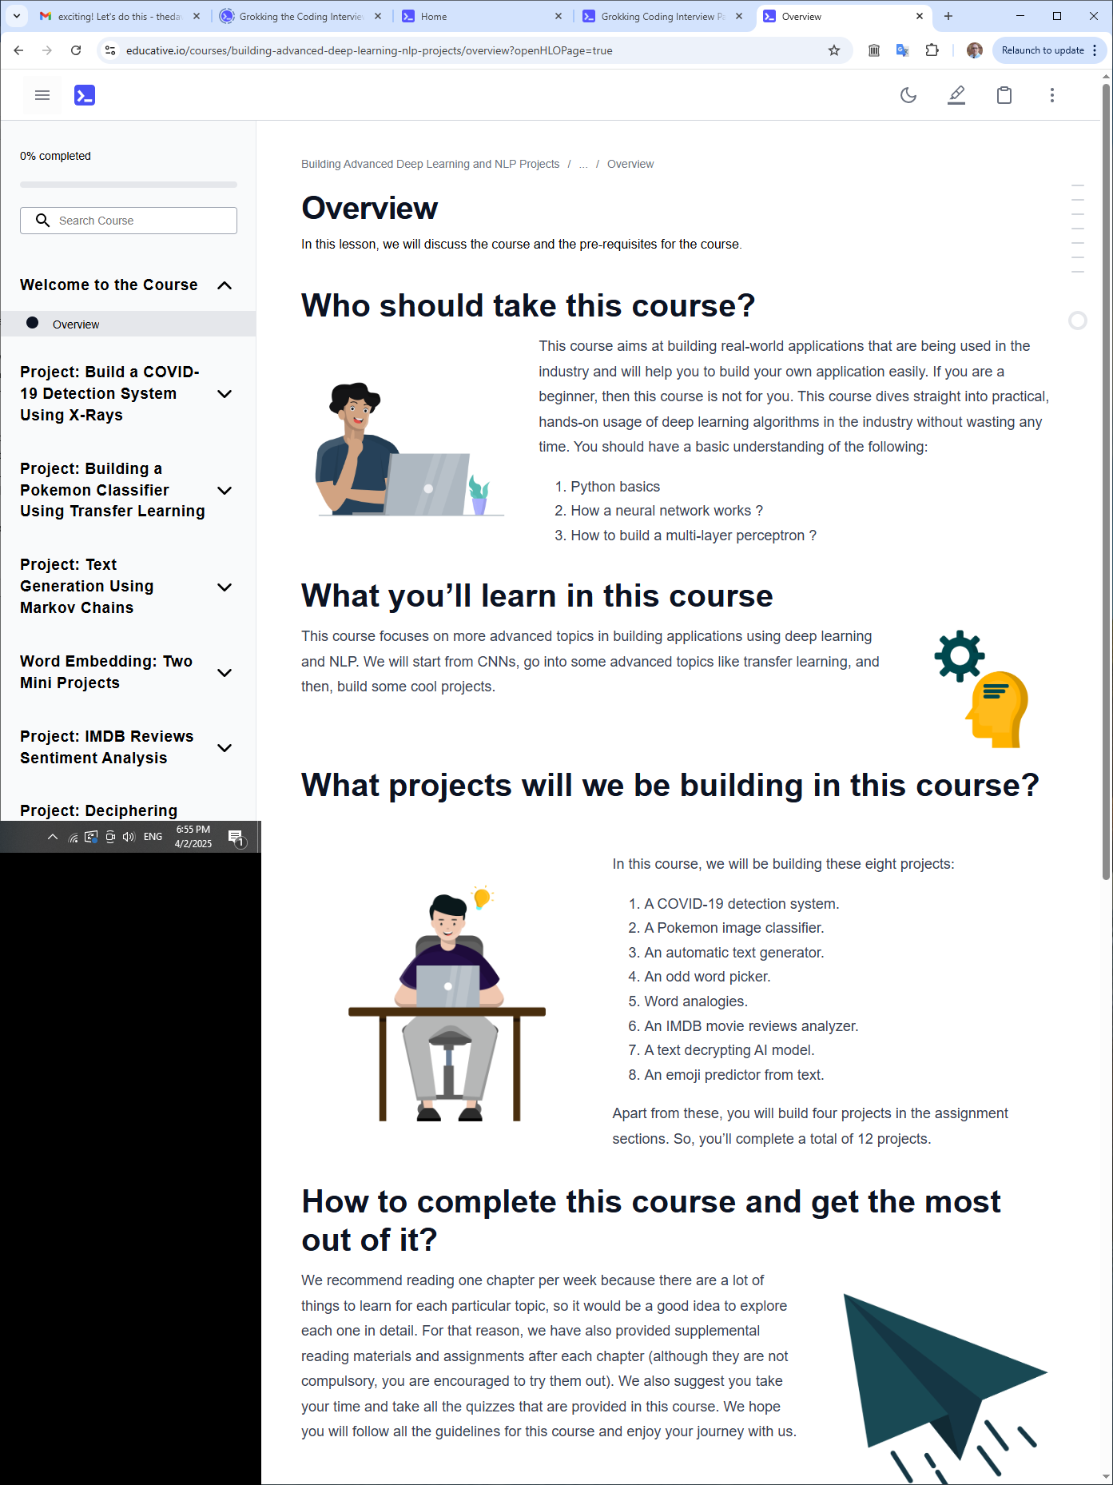

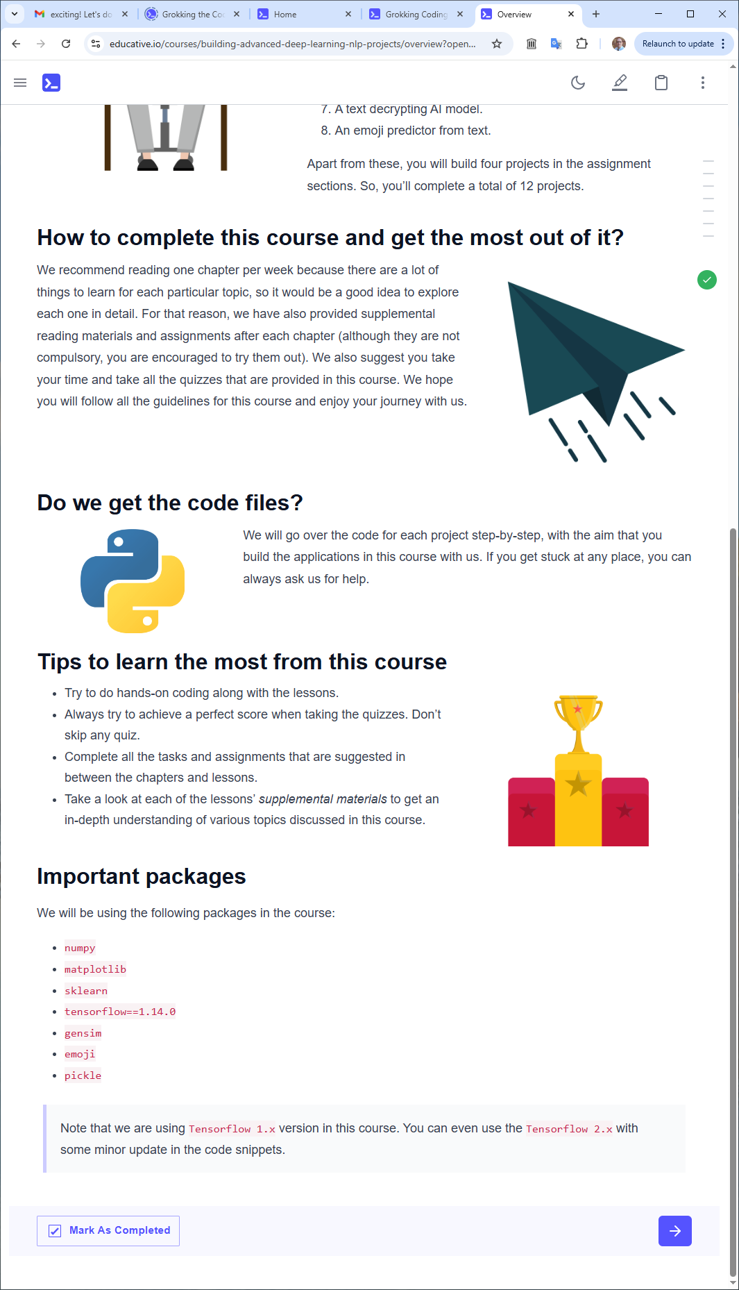

**Introduction to Convolutional Neural Networks**

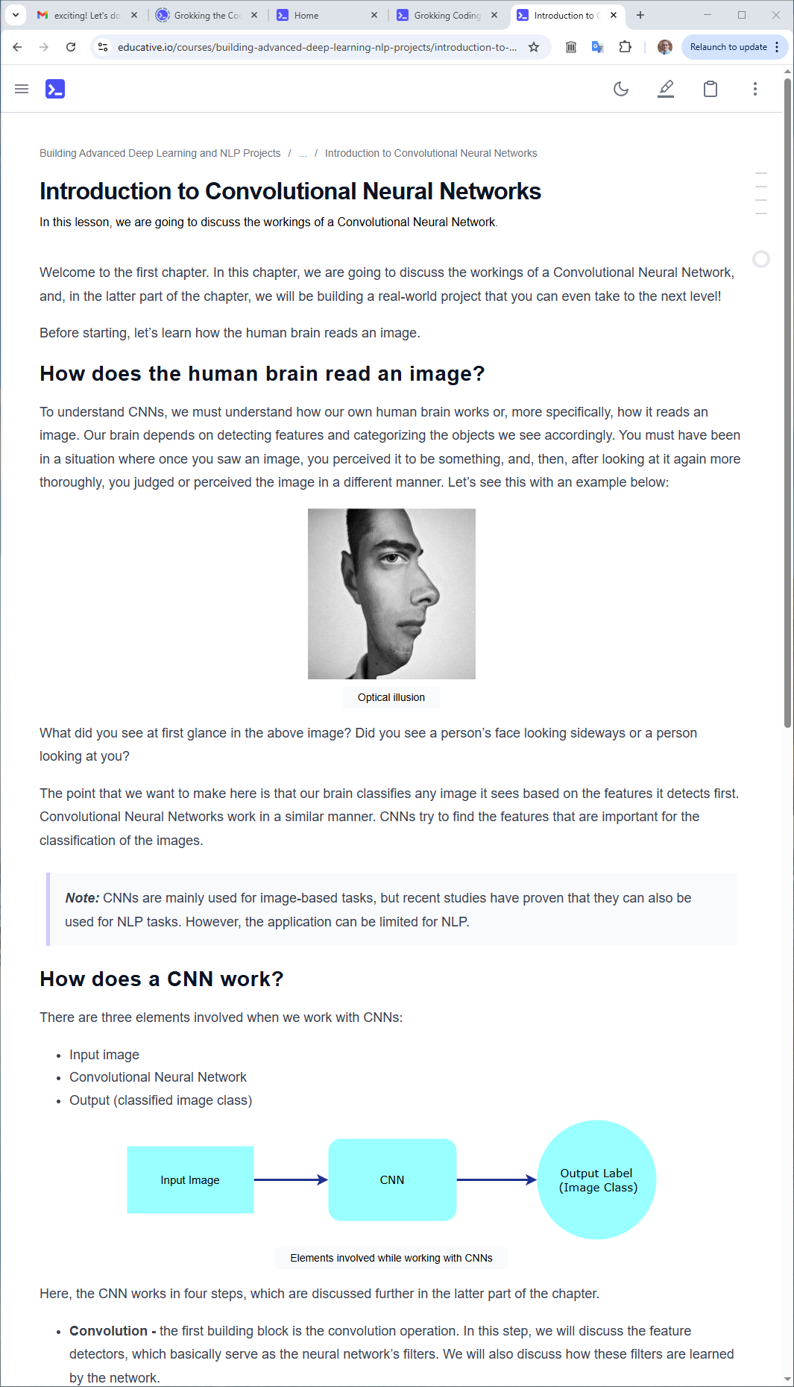

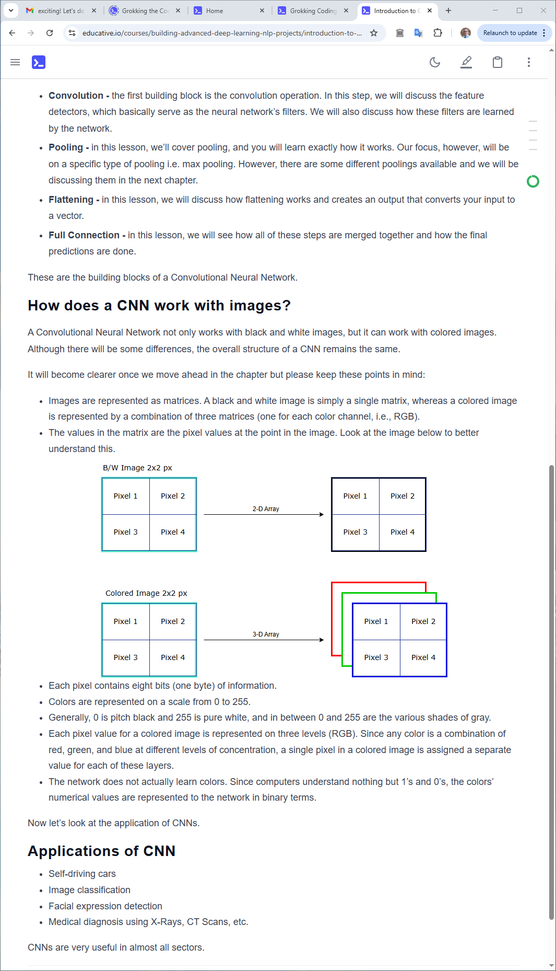

Font

F

f

font

f