BlackJack

Aaron James

Developer

Table of Contents
Vision Statement 4
Sprint #1 7
Design 9
Coding Standards 10

Vision Statement
For anyone wanting to learn to play black jack, BlackJack is a mobile app that allows a user to practice real blackjack at home, without having the risk of losing their hard-earned money at the casino. Unlike most of the other applications, this app will not make the user wait an extended amount of time to get chips after losing them all nor will it require you to buy chips.

Actor | Goal
User | Load the game
 | Play blackjack against a dealer
 | Add computer players to the table
 | Be able to split hand
 | Be able to double down on their bet

Story ID | Story | Story Points | Priority | Status
S1 | Allow user to place bet and hide certain buttons from view when the bet is placed | 2 | 4 | Done
S2 | Deal the player their cards and the dealer but only show one of the dealers cards | 1 | 3 | Done
S3 | Add the total of cards for the dealer or for the person to give a hand total. | 5 | 1 | Done
S4 | Make a refactor to change the total for a hand if the player busts but has an ace. | 5 | 2 | Done

The program shall allow a player to bet chips against a dealer.
The program shall allow a user to add bots to play along with them.
The program shall allow a player to change positions.
The program shall allow player to manipulate their bets based on black jack rules.
The program shall randomly assign bot choices for blackjack to act like an unskilled player.
The program shall always save the players chips when they exit the game.
The program shall display images for the deck and the cards that are dealt.

Sprint #4
Before you can plan a sprint you need a prioritized list of user stories (the product backlog). Factors to consider when prioritizing stories include [Cohn, Agile Estimating and Planning]:
- Business value of feature
- Cost of implementation (story points or ideal days)
- Amount and value of new knowledge gained by developing the feature
- Risks resolved as a consequence of implementing the feature

Another important step in sprint planning is estimating project velocity. Project velocity is a measure of how much work is being completed each iteration (sprint). It is usually expressed using the same unit of measure used to estimate story effort (typically story points). For the first iteration, project velocity must be estimated based on past projects. After the first iteration, project velocity can be predicted based on the completed iterations.

The Sprint Backlog identifies stories planned for the sprint along with tasks necessary to complete each story.

Sprint Backlog
Story ID | Story / Task | Estimated  Hours | Actual  Hours
S1 | Hide buttons from view when the user should not see them | 2 | 2
 | Allow user to see there cards and dealers 1 card and 1 card facedown. And be able to tell what there score is | 2 | 4
 | Create function to change score if an ace is in users hand | 2 | 2

I had problems with the change ace function. The function worked if there was only one ace somewhere in the hand. But if the user was able to have to aces and another card it would always change both aces to 1 point each, even if leaving one ace to 11 would help the users total.

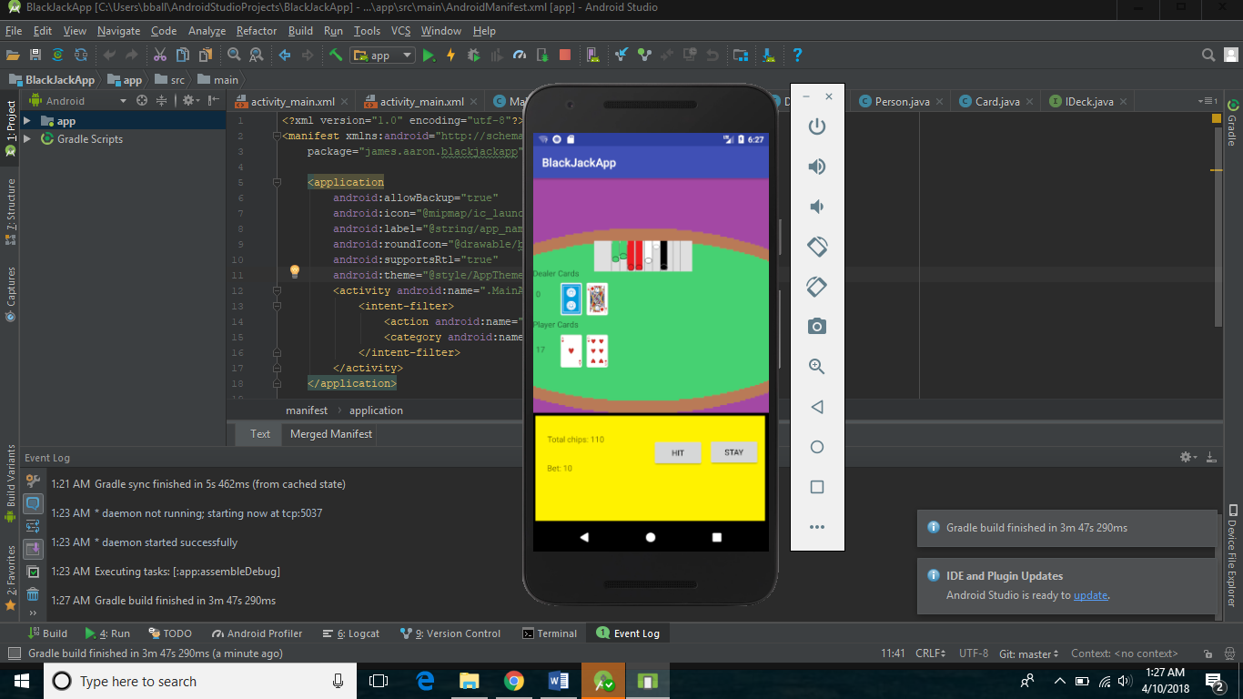

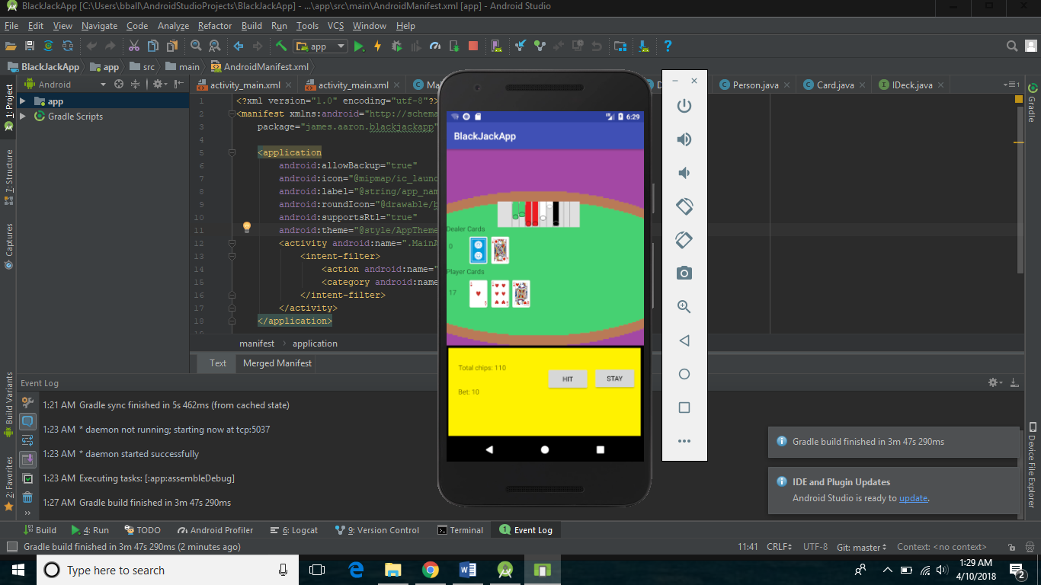
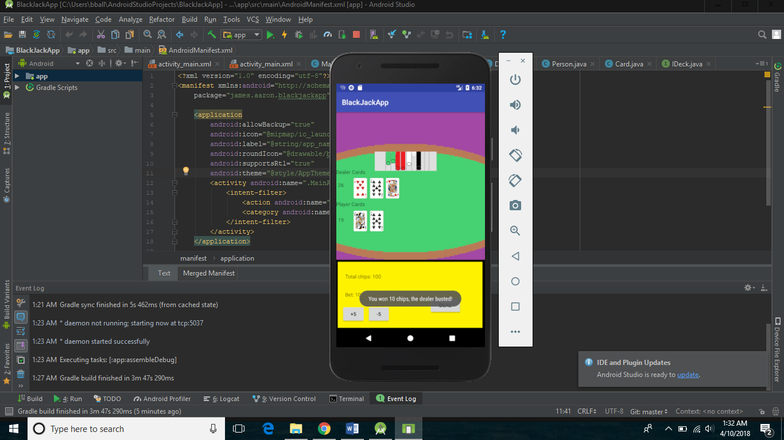

Design
My application shall be a simple design. The screen shall have buttons to place a bet and options to manipulate the bet(double, split). The user will also have the table and the seats displayed to them so they may see their hand and any hands next to them. There will be an actual deck that will be programmed and it will take cards and distribute them like an actual casino would. The graphics of the cards should make them look realistic. A user can add bots to seats around them and the bots will make decisions randomly. They can make poor or good decisions for the actions they take to symbolize poor choices inexperienced black jack players make in real casinos. When the user is done playing they may save the chips they have acquired for the next time they open the app, or they can clear their bank so that they start fresh when they re-open the application.

Coding Standards
Coding standards improve readability. They make it easier to understand code written by others. Good coding standards also improve reliability.

