Attachment 1
STATE OF CALIFORNIA
Department of Fish Wildlife
Specifications for Interpretive Panels and Posts

- Definition
49 panels: dimensions 48"w x 54"h x 1/2"t; high-pressure laminate on phenolic resin compounds OR gel coat laminate; UV, graffiti, and vandalism resistant, with 8 threaded inserts for 1/4" screws, ten year warranty
49 pairs (98 total) posts: 3"x 3" x 108" black powder coated aluminum; four holes in each post, 8 mounting brackets for each pair of posts
The panels will all be reprints of the same preexisting design.

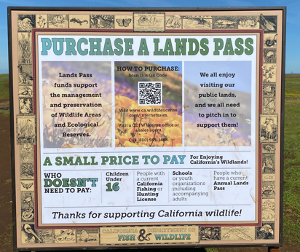

- Delivery

To be shipped to:
Dept. of Fish and Wildlife
ATTN: Shannon Stanfield
1701 Nimbus Road, Suite A
Rancho Cordova, CA 95670

