EMUNE User Manual

Abstract
This EMUNE code is based on the peridynamic theory to solve 2D fracture problem.
This manual is mainly discussed the main solver, how to write the main input file and boundary conditions. The adaptive refinement is not discussed.

Contents
1. The Peridynamic Theory 2
2. Code description 4
2.1 Main input file 4
2.2 Assign nodes 6
2.3 The Structure of Main Solver (Module of Solver) 6
Other procedures 7
3. Build the EMUNE code on Microsoft Visual Studio 2005 7
4. Modules Description 7
4.1 Module of peri_motion (the structure of main solver) 7
4.2 Subroutine get_family 8
4.3 Subroutine cal_interval 9
4.4 Subroutine cal_volume 10
4.5 Subroutine peri_force 10
4.6 Subroutine MicromodF 11
4.7 Subroutine compute_critical_strain 11
4.8 damage computation 12
4.9 Boundary Conditions 13
4.10 External Force Density 13
4.11 Module Precision 14
Bibliography 14
Attachment 15

The Peridynamic Theory

From the peridynamic theory, the equation of motion is

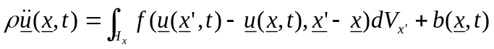 ( )
where H_{x} is the horizon of x, each node horizon can be calculated in the module Horizon.
u is the displacement vector, and f is a force vector that the particle x’ exerts on the particle x.

In the following discussion, by introducing the relative distance ξ in reference configuration and relative displacement η it can help to discretization the equation (1),
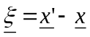 ( ) 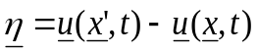 ( )
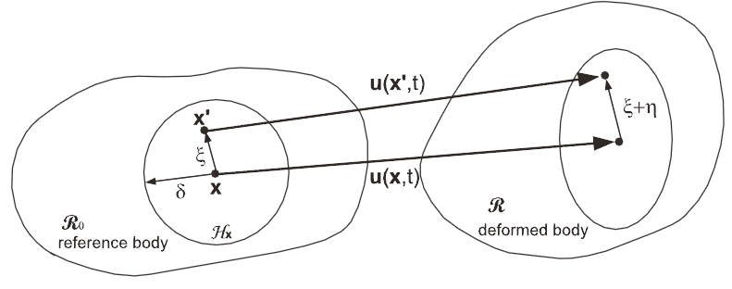
Fig.1 The deformation of a bond (Ha, 2011)

The micropotential is the elastic energy in a single bond. The strain energy density at x is given
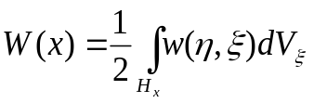 ( )
The pairwise force function of microelastic material is derivable from the scalar micropotential w
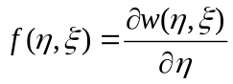 ( )
The linear micro elastic material is defined by
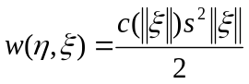 ( )
The function c(||ξ ||) is called micromodulus and it can be considered as the bond elastic modulus. The 2D micromodulus are discussed later from equation (15) to (18).
where s called as relative elongation
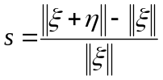 ( )
the pairwise force will be describe as
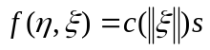 ( )
The pairwise force magnitude for elastic material with damage is
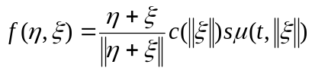 ( )
Where 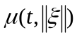is a history-dependent scalar function,
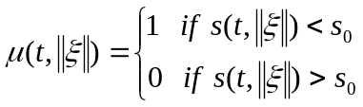 ( )
Here, is the critical relative elongation. The bond will be broken, if the relative elongation s is over the critical value.
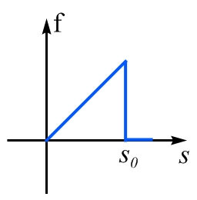
Fig.2 Bond force and bond relative elongation (Wenke, 2012)

For 2D case, required to break all the bonds across the fracture surface, the fracture energy required for separate the body into two parts,

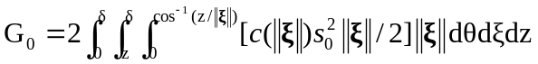 ( )

The critical relative elongation parameter s₀ can be obtained from (12).
The spatial discretization of the equation (1) is given by using mid-point integration
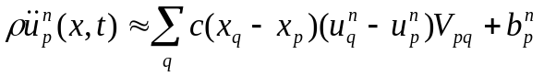 ( )
where 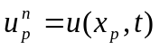, n is the time step number and subscripts denote the node number.
To solve the ordinary differential equation (13), different integral algorithms are used in EMUNE solver. (Such like: Forward Euler, Velocity-Verlet, Runge-Kutta method)

Code description
EMUNE start from read the main input file to record the parameters and flags for the peridynamic calculation in different modules. Module of solver is the main part of peridynamic solver. Also, the geometry of 2D model will be loaded from nodes file (usually the nodes file name as nodes_***by**.txt ) from the current directory.

Main input file
The EMUNE read the input file to record the flags and parameters for calculation, in the subroutine Input_subroutine. The following is an example of EMUNE main input file (main_input_file.txt for 2D model):

****** nodes input file nRamulu_203by82.txt 3202 357*******
nPlate_3721.txt

Note: the elements input file is not needed for the solver without adaptive refinement.
Calling the subroutine assign_nodes and the subroutine assign_elements, the nodes and element information read from nodes***.txt and element***.txt to the memory. Also, the name of output data file can be also defined.
In order to have the right form nodes (and element file with the flag of adaptive refnement) for EMUNE to read, you can use ABAQUS to generate the nodes file (and element file) (See the attachment One about how to use ABAQUS to write the nodes and element files for the EMUNE)

******* output data file *****
Plate_3721_m4force_conical_static_retest5_wide.plt

The output data including the information of ……, the output file can be plot by the Tecplot.

******* Do you wanna perform adaptive refinement in the analysis ( 1 = yes, 0 = no)
0

Note: This manual does not introduce the adaptive refinement. (Note: this part of code is removed from current manual instruction)

******* Dynamic or static analysis? ( 0 = dynamic-relaxation, 1 = dynamic, 2 = static)
1
(currently, we mainly focus on dynamic solver)

******* 2D constant or conical micromodulus ? (0 = constant, 1 = conical)
1

In the chapter of module description, we talk more about 2D constant and conical micromodulus.
**** Number of iterations 4000 3000 1600****
1000

******* Step Size(sec) 0.000000005 *****
0.000000025
This time step is discussed in (Silling, 2005)

******* Number of iterations between snapshots 20 8******
10

******* Young's modulus(Pa) *****
72000000000.0

******* Density( kg m-3)*****
2440.0

For this code is written based on isotropic material, Young’s modulus and density are introduced.

******* Fracture energy 135.0 204.0*****
135.0

Choose fracture energy used in current model based on the equation (12).

******* Horizon's scalar factor: horizon is calculated as the delta_x(distance between nodes) times a scalar(e.g. 3,4,6) *****
4.01

Scalar factor choose as 4.01. The convergence of horizon’s scalar factor is discussed in (Wenke, 2012).

******* introduce a precrack in the body defined below( 1 = yes, 0 = no)
1

******* Initial crack(x0,y0)(x1,y1)-0.05,0.0,0.0,0.00.0,0.02541,0.0,0.02387**
-0.05,0.0,0.0,0.0

Introduce a single precrack to the sample, (x0,y0) and (x1,y1) described the crack location.

******* Velocity(m s-1) ******
0.0

******* External force magnitude (Pa) 1.0e7 ******
0.0e0

Define the boundary conditions (velocity and force) in the subroutine boundary_cond and ExtForceDensity.

******* Damage viscosity ******
0.0, 0.05

The damage viscosity (visco,visdk) help to reduce nonphysical “snapback” if intact bonds if other bonds connected to the same node break. Generally the defaults can be used.

Default: visco=0, visdk=0.05.

******* Damage index criterion ******
0.8

The damage index is defined as the ratio of the number of broken bonds to the number of initially bonds.

******* Damage stretch coefficients (dc1, dc2, dc3) 0.2, 0.2, 1.4******
0.0, 0.0, 1.0

These three coefficients help the material stiffness to be constant everywhere (used in the subroutine peri_motion).

Assign nodes

In the subroutine assign nodes describe how to locate the node information. The tree structure method is used to read the input node file and allocate these nodes to the global array of node.
There is a part of code how the tree structure assigns the nodes information:

allocate(nodes(i)%disp(dim))
nodes(i)%strain_energy = strain_energy
nodes(i)%iflag = .false.
allocate(nodes(i)%old_disp(dim))
allocate(nodes(i)%new_disp(dim))
allocate(nodes(i)%veloc(dim))
allocate(nodes(i)%new_veloc(dim))
allocate(nodes(i)%accel(dim))

The Structure of Main Solver (Module of Solver)

With the data read from the input file, EMUNE start to locate the nodes information. As the main part of EMUNE, it mainly contains the following modules: dynamics and peri_motion, which are the main part of peridynamic solver. And it will call the modules get_famliy, damage, horizon and etc. to calculate the related parameters.

Peridynamic motion calculation outline:

The procedure of peridynamic motion calculates:
- get the family of node mi (within its horizon, mi is the global number of the nodes) (with subroutine get_family, and Horizon);
- loop over the nodes in the family of current node, locate the nodes which bonds are not break yet (brokij=broke(js,mi);
Note: brokij is set to 1, if the bond between mi and mj is already broken. mj is the node in the node mi’s family.
- find the peridynamic interparticle force (with subroutine peri_force);
- sum up the force on current node;
- reduce the volume of node mj, if it is not fully within the horizon (Bobaru, 2010) (mj is the nodes in the horizon of the current node mi); to get the df1 and df2, the relative changing of the load;
- renew the force at the current configuration;
Take the Velocity-Verlet Method for example, in order to use the Velocity-Verlet Method to renew the displacement and velocity; we need to know the intermediate displacement and velocity first with the following equations (13);
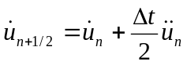
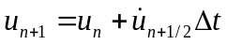
Note: the above step 1 to 6 is used to update the intermediate velocity and displacement
- get the family of node mi (subroutine Get_family) with the renew intermediate velocity and position;
- find the peridynamic interparticle force;
- break the bond if critical stretch exceed (critical stretch as a function of damage);
- Again sum the force on the node mi;
- Reduce the volume of node mj if it is not fully within the horizon;
- Renew the force of the n+1 configuration, update the displacement and velocity for the next circle with the third Velocity-Verlet equation:

We will talk about the key parameters and subroutine used in this solver the section 4.1 for the subroutine of main_solver.

Other procedures
The Forward-Euler scheme and Runge-Kutta scheme are both introduced in the EMUNE. Forward-Euler scheme includes the subroutine peri_motion, shortrange_motion and intergrate_disp. Runge-Kutta scheme includes peri_motion_RK, intergrate_disp_RK.

In the step 12, boundary conditions and external force density will be introduced to the equation.

Build the EMUNE code on Microsoft Visual Studio 2005

The EMUNE can be created on Visual studio 2005 with the following steps:
- Create a new project
- Copy the EMUNE *.f90 files to the current project path, move *.f90 files to the solution explorer window of Visual Studio 2005
- Include the tecio files, if need to link the Tecplot. The tecio header files locate in $TEC_360/include.

Modules Description

In this chapter the module will be discussed

Module of peri_motion (the structure of main solver)

This module is the main part of EMUNE. The main function of this module (peri_motion) integrates the node acceleration, and updates the node velocity and displacement due to peridynamic. And update the bond strain; break the bonds based on critical strain of breakage.

Velocity-Verlet algorithm is introduced (the module of peri_motion), Velocity_Verlet method is a more numerically stable way of central-differences. (Hairer, 2003)
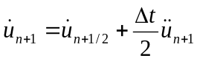
( )
where , and are displacement, velocity, and acceleration of the nodes.

This subroutine is used in Step 6, renew the force at the current configuration (n+1);

f1(mi) = f1(mi)+df1
f2(mi) = f2(mi)+df2

With the Velocity-Verlet Method to renew the displacement and velocity (14);

The fortran code is list below:
1.
nodes(mi)%new_veloc(1) = nodes(mi)%veloc(1) + (ext1(mi)+f1(mi))*fac
nodes(mi)%new_veloc(2) = nodes(mi)%veloc(2) + (ext2(mi)+f2(mi))*fac
nodes(mi)%veloc(1) = nodes(mi)%new_veloc(1)
nodes(mi)%veloc(2) = nodes(mi)%new_veloc(2)
2.
nodes(mi)%new_disp(1) = nodes(mi)%disp(1) + nodes(mi)%veloc(1)*dt
nodes(mi)%new_disp(2) = nodes(mi)%disp(2) + nodes(mi)%veloc(2)*dt

With update the intermediate velocity and position to calculate the new velocity and position for the next step.
(ext(i) links to the subroutine ExtForceDensity to apply the load boundary)

In the step 12 Update the displacement and velocity are updated for the next circle with the third Velocity-Verlet equation:

Subroutine get_family

The subroutine get_family is used in the step 1 and step 7 in the chapter 2.3, which Loop over all the nodes and defines each node family within its horizon size.

In the subroutine get_family, the current node’s number m is the global node number.
Input and output parameters in the subroutine get_family:

delta=nodes(mi)%horizon_size

delta is defined as the horizon size of current node, delta is the input parameter for the subroutine get_family.

xt1_global,...

defined as node positions

ncell1,ncell2,ncell3...

ncell stand for number of cells in each direction for sorting, defined in the subroutine global variables.

maxfam...

Define as dimension of the family array, defined in the global variables;

cell_location_in_bin...

pointer to the element in the bin corresponding to a cell

number_of_nodes_in_cell...

number of nodes whose position in each cell

nodes_in_bin...

node numbers sorted by cell compressed into the bin

x1_lo,x1_hi,x2_lo,x2_hi

Upper and lower coordinates of search region;

family...

Output of the subroutine get_family, array containing the family of node m;

mfam...

Number of nodes in the family of node m;

Subroutine cal_interval

This subroutine is used to find the node’s horizon in step 2; need element information to find the horizon along the x and y direction.

max_interval_x=dmax1(dabs(nodes(kp)%pos(1)-nodes(kn)%pos(1)), max_interval_x)
max_interval_y=dmax1(dabs(nodes(kp)%pos(2)-nodes(kn)%pos(2)), max_interval_y)

interval(i,1)=max_interval_x
interval(i,2)=max_interval_y
nodes(i)%horizon_size= horizon_factor*dmax1(max_interval_x,

This part describes method to calculate the horizon of each node in a uniform grid.
Note: The subroutine Calculate_Horizon can calculate the horizon size for each node of any uniform and non-uniform grid. This subroutine will be used, if the refinement is used.

Subroutine cal_volume

Method to calculate the volume of each node in a uniform grid:

area=area+nodes(k)%pos(1)*nodes(kp)%pos(2)-nodes(kp)%pos(1)*nodes(k)%pos(2)
area=area+nodes(k)%pos(1)*nodes(kp)%pos(2)-nodes(kp)%pos(1)*nodes(k)%pos(2)
nodes(k)%volume=nodes(k)%volume+area*0.125d0

Method to calculate the volume of each node in a uniform grid
Note: In the subroutine Calculate_Volume, general method to calculate the volume of each node in any type of grid (uniform and non-uniform)

Subroutine peri_force

Find the peridynamic interparticle force with the subroutine peri_force, which is used in step 3 and step 8.

subroutine peri_force peri_force(eta1,eta2,xi1,xi2,brokp,expco,df1,df2,dw,spcoef,str,x1i,x1j,x2i,x2j)

xi1,xi2
is the initial position of each node;

eta1,eta2
is the displacement of nodes;

r = dsqrt(xi1**2+xi2**2)
p1 = xi1+eta1
p2 = xi2+eta2

r is the initial distance between the nodes;

p = dsqrt(p1**2+p2**2)

p is the new distance between the nodes;

u = p-r
str = (p-r)/r
df1 = dmicroF*str*p1/p
df2 = dmicroF*str*p2/p
dw = 0.5d0*dmicroF*u
spcoef = dmicroF

in the code u is the displacement between the two nodes, this part procedure is based on the equation (7).
df1 and df2 are the load along the bond according to the bond elongation , dw is the strain energy;
In the subroutine peri_force, need to call the subroutine MicromodF to find the dmicroF. There is flag sw_micro to tell which micromodulus will be selected in the program; two micromodulus described as the above for 2D case: constant micromodulus and conical micromodulus.

Subroutine MicromodF

This subroutine tells which micromodulus will be used in the model, 2D constant or conical micromodulus;
subroutine MicromodF(esi,dmicroF, RadH,young)
if (sw_micro.eq.0) then
dmicroF = 13.5d0*young/(pi*(RadH**3))
if (sw_micro.eq.1) then
dmicroF = 54.0d0*young*(1.0d0-esi/RadH)/(pi*(RadH**3))

Subroutine compute_critical_strain

From the description of EMUNE input file, 2D constant micromodulus and conical micromoduls are introduced;

******* 2D constant or conical micromodulus ? (0 = constant, 1 = conical)
1

The following is about 2D constant and conical micromodulus:
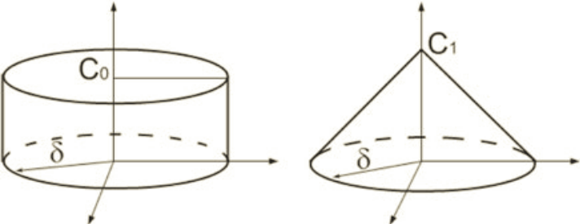
Fig.3 The 2D micromodulus function (Youn Doh & Florin, 2011)
The constant micromodulus is given by:
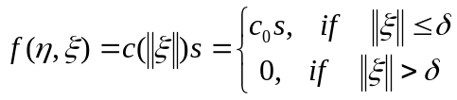 ( )
With the classical elastic energy density theory c₁ equals to:
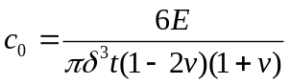 ( )
Similarly, the conical micromodulus function is define as,
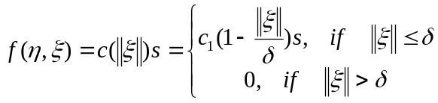 ( )
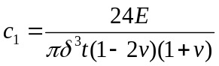 ( )
The EMUNE code described as:
if (sw_micro.eq.0)
critical_strain(mi) = 2.d0/3.d0*dsqrt(2.d0*pi*fracture_energy/3.d0/h)
critical_strain(mi) = critical_strain(mi)/syoung
if (sw_micro.eq.1)
critical_strain(mi) = dsqrt(10.d0*pi*fracture_energy/3.d0/h)/3.d0
critical_strain(mi) = critical_strain(mi)/syoung

damage computation

Damage Index
We choose to strength the material in damaged region by increase the elongation of bond depending on the amount of damage at the current node. (Silling S. , 2005)

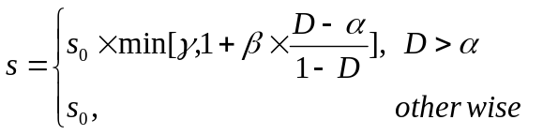 ( )
D is damage index. dc1, dc2, dc3 stand for α, β and γ in the code.
Break the bond if critical stretch exceeds based on damage index (critical stretch as a function of damage);

dmgij = dmax1(damage_index(mi),damage_index(mj))
coef1 = dc1
coef2 = dc2
coef3 = dc3
if(coef2>zero .and. coef3>One) then
if(dmgij<=coef1) then
fac = One
elseif(dmgij<0.9999d0) then
fac = One+coef2*(dmgij-coef1)/(One-dmgij)
fac = dmin1(fac, coef3)
else
fac = coef3
endif
else
fac = One
endif

dmgij is the damage index

Break the bond if critical stretch exceeded;

ecr2 = critical_strain(mi)*fac
if((str>ecr2).and.(.not.brokij)) then
if(nofli==0.and.noflj==0) then
broke(js,mi) = 1
vis(mi) = vis(mi)+One
n_broken_bounds = n_broken_bounds+1
endif
end if

critical_strain(mi) links to the subroutine compute_critical_strain based on the equation (7)

Boundary Conditions

In the subroutine boundary_cond, different boundary conditions are prescribed with the flags nodes(mi)%bc(1) OR nodes(mi)%bc(2).

if nodes(mi)%bc(1)=1 prescribe dispalcement condition;
if nodes(mi)%bc(1)=±2 prescribe velocity condition to positive or negative directions;
Note: velocity loading conditions can be implemented during the time integration.

The following is how the code describes the boundary condition:
! prescribed fixed displacement
if (nodes(mi)%bc(1).eq.1) then
nodes(mi)%new_veloc(dim) = zero
nodes(mi)%veloc(dim) = zero
nodes(mi)%new_disp(dim) = zero
! prescribed velocity along axis direction
if (nodes(mi)%bc(1).eq.-2) then
nodes(mi)%new_veloc(dim) = bc_velocity
nodes(mi)%veloc(dim) = bc_velocity
nodes(mi)%new_disp(dim) = nodes(mi)%disp(dim)+nodes(mi)%veloc(dim)*dt

External Force Density

There are four different external force density defined in the EMUNE code.
The subroutine ExtForceDensity is used to define the nodes on the top and bottom boundary; the subroutine ExtForceDensity2 is used to define the nodes on the left and right boundary;
The subroutine ExtForceDensity_4_point_bending is defined the load for 4 point bending.
Also, all these subroutines about external force include vanishing the thickness affect part.

Module Precision
Define the precision to be used, and other constant values (zero, one and pi)

Bibliography
Bobaru, F., & Duangpanya, M. (2012). A peridynamic formulation for transient heat conduction in bodies with evolving discontinuities. Journal of Computational Physics 231, 2764-2785.
Hairer, E. L. (2003). Geometric numerical integration illustrated by the stromer/verlet method. Acta Numerica 12, 399-450.
Silling, S. &. (2005). A meshfree method based on peridynamic model of solid mechanics. Computers and Structures 83, 1526-1535.
Silling, S. (2005). Fragmentation modeling with EMU. New Mexico, USA: Computational Physics Department, Sandia National Laboratories.
Wenke, H. (2012). Peridynamic Modles for Dynamic Brittle Fracture. University of Nebraska Lincoln: Apartment of Enginerring Mechanics.
Youn Doh, H., & Florin, B. (2011). Characteristics of dynamic brittle fracture captured with peridynamics. Engineering Fracture Mechanics 78, 1156-1168.

Attachment

Instruction of generating the nodes and elements files from ABAQUS.

This instruction described how to use ABAQUS to generate the nodes and elements files for the EMUNE to assign the nodes and elements of the model. Including the ABAQUS, the main_input_file, nodes and elements file for EMUNE.

Processes:
- In the ABAQUS, define the size of geometry in the model_Parts;
- Go to the mesh menu;
In the mesh control, element shape is chosen as Quad;

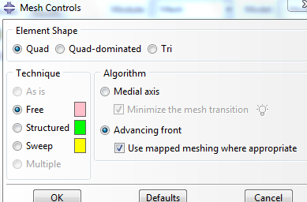

In the seed part button, the number of elements can be selected, or the element size can be changed; then mesh the model
- Go to the job menu, create the current the model as a new job; in the job manager you can write the input file. The whole information of current model can be found in a *.INP file, including the nodes and elements information.
- Copy the nodes position and elements assignment from *.INP (ABAQUS) to the nodes***.txt and elements***.txt which later read by the EMUNE (Fortran)
Example:
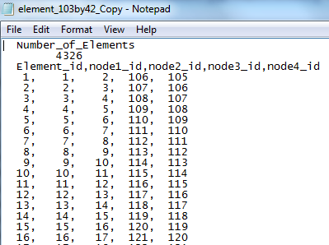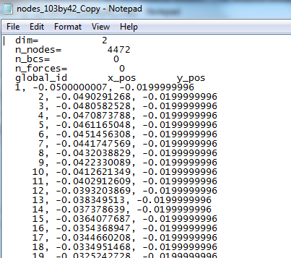

Remark:
It is always need to change number of elements manually in the nodes***.txt and elements***.txt
- Save all the node and element files

