Fully funded ME/PhD Positions:
Fracture Simulation for Visual Effects

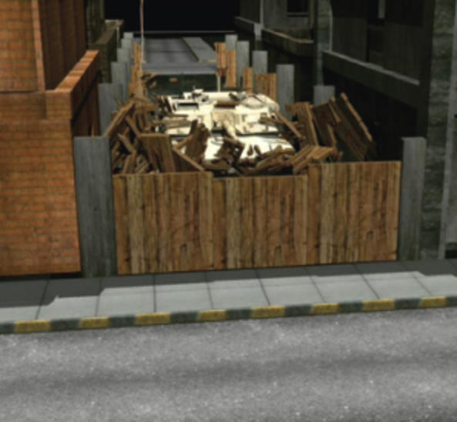
High speed simulations of the fracture of wood, glass, concrete, brick walls, and many other materials are used every day in the visual effects industry. The project team will develop the next generation of fracture effects technology, bringing visual effects fracturing to the next level through novel computational methods in conjunction with realistic material models for deformation and fracture.

We are looking for two Masters students to work on the project. Exceptional students will be considered for a PhD program. Scholarships will be provided to suitable candidates.

(see http://www.fxguide.com/featured/dmm-fea-for-vfx/ for some more background)

Master's/PhD Thesis Project 1: Computational Fracture Algorithms
The project will involve research into algorithms for peridynamics and the material point method (MPM), development of material models, transitioning between peridynamics and MPM, validation and verification . The student will primarily be supervised at Industrial Research Limited (IRL, Auckland) and may have to travel to the University of Nebraska (Lincoln) and interact closely with Weta Digital (Wellington).

Master's/PhD Thesis Project 2: Model-size Reduction Techniques
The project will involve research into techniques for model size reduction in nonlinear dynamics simulations. This will include the development and implementation of homogenisation techniques to reduce the size of the problem both in space (by reducing the number of degrees of freedom) and in time (by eliminating high-frequency vibrational modes). The student will be expected to interact closely with both IRL and Weta Digital.

Requirements and Skills
The students should be able to meet eligibility requirements for a MS/PhD program at the University of Auckland (NZ). We require students with a strong work ethic, knowledge of computational methods and numerical analysis, prior experience in mechanics, basic understanding of computer graphics, strong programming skills and a willingness to learn.

Contact

The students will be co-supervised by Dr. Biswajit Banerjee (b.banerjee@irl.cri.nz), Dr. Bryan Smith (bryan.smith@irl.cri.nz), Dr. Kumar Mithraratne (p.mithraratne@auckland.ac.nz), Dr. Florin Bobaru (U. Nebraska), and Dr. Andreas Soderstrom (Weta Digital). Please contact Dr. Mithraratne for further information on how to apply for the positions.

