# [https://avatars2.githubusercontent.com/u/4156894?v=3&s=100](http://www.calstatela.edu/centers/hipic)CIS4560-01 Term Project Tutorial

#### Authors: Brian Bao, Karen Alvarez, Natalie Sanchez, Shadman Sayef

#### Instructor: [Jongwook Woo](https://www.linkedin.com/in/jongwook-woo-7081a85)

#### Date: 05/18/2025

**Lab Tutorial**

**U.S. Used Cars Dataset Analysis using Hadoop and Hive**

**Objectives**

In this hands-on lab, you will learn how to:

* Transfer and upload a large dataset (10GB) into a distributed file system (HDFS).
* Create external Hive tables with Beeline for full and simple schemas.
* Run HiveQL queries for statistical analysis.
* Export simplified results from HDFS to local machine.
* Use Microsoft Excel/PowerBI to visualize key trends.

**Platform Spec**

* Hadoop Version 3.1.2
* CPU Speed: 2.45 GHz
* # of CPU cores: 6
* # of nodes: 5 (2 Master, 3 Worker)
* Total Memory Size: 31 GB

Step 1: Transfer Dataset from Kaggle to HDFS

This step is to obtain the unzipped .csv file in HDFS.

1. Download zipped dataset from Kaggle.

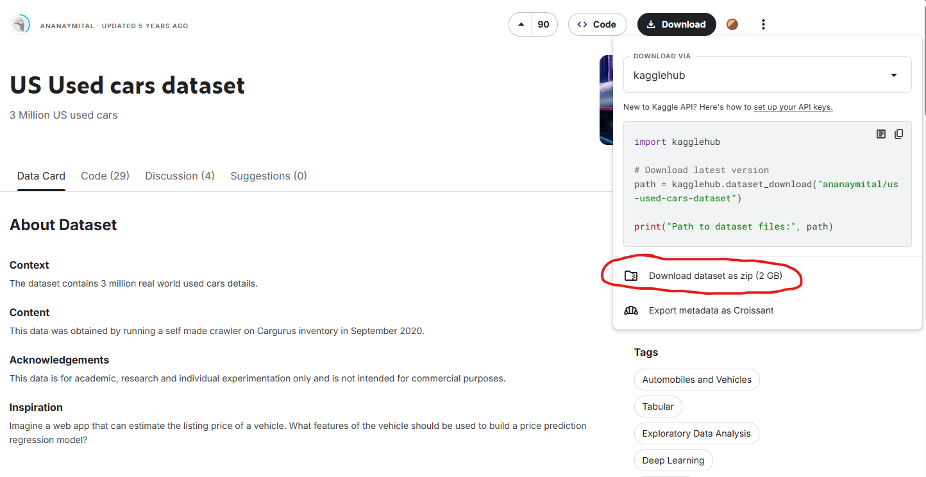

1. Transfer zipped dataset from local machine to Linux file system.

(scp used_car_data.zip your_name@144.24.46.199:~)



1. Enter Linux file system with ssh.

(ssh [your_name@144.24.46.199](mailto:your_name@144.24.46.199))



1. Unzip the dataset into a .csv file.

(unzip used_car_data.zip)



1. Create a directory in HDFS.

(hdfs dfs –mkdir UsedCars)



1. Upload unzipped .csv file to HDFS.

(hdfs dfs –put used_cars_data.csv UsedCars)



1. Verify upload to HDFS.

(hdfs dfs –ls UsedCars)



Step 2: Create Hive Tables

This step is to create Hive table schemas, one full and one simple for query processing and analysis.

1. Enter beeline.

(beeline)



1. Use your database.

(use your_name;)



1. Create full table.

(CREATE EXTERNAL TABLE used_cars_full (

vin STRING,

back_legroom FLOAT,

bed STRING,

bed_height FLOAT,

bed_length FLOAT,

body_type STRING,

cabin STRING,

city STRING,

city_fuel_economy FLOAT,

combine_fuel_economy FLOAT,

daysonmarket INT,

dealer_zip STRING,

description STRING,

engine_cylinders INT,

engine_displacement FLOAT,

engine_type STRING,

exterior_color STRING,

fleet BOOLEAN,

frame_damaged BOOLEAN,

franchise_dealer BOOLEAN,

franchise_make STRING,

front_legroom FLOAT,

fuel_tank_volume FLOAT,

fuel_type STRING,

has_accidents BOOLEAN,

height FLOAT,

highway_fuel_economy FLOAT,

horsepower INT,

interior_color STRING,

isCab BOOLEAN,

is_certified BOOLEAN,

is_cpo BOOLEAN,

is_new BOOLEAN,

is_oemcpo BOOLEAN,

latitude FLOAT,

length FLOAT,

listed_date STRING,

listing_color STRING,

listing_id STRING,

longitude FLOAT,

main_picture_url STRING,

major_options STRING,

make_name STRING,

maximum_seating INT,

mileage INT,

model_name STRING,

owner_count INT,

power FLOAT,

price FLOAT,

salvage BOOLEAN,

savings_amount FLOAT,

seller_rating FLOAT,

sp_id STRING,

sp_name STRING,

theft_title BOOLEAN,

torque STRING,

transmission STRING,

transmission_display STRING,

trimId STRING,

trim_name STRING,

vehicle_damage_category STRING,

wheel_system STRING,

wheel_system_display STRING,

wheelbase FLOAT,

width FLOAT,

year INT

)

ROW FORMAT DELIMITED

FIELDS TERMINATED BY ','

STORED AS TEXTFILE

LOCATION '/user/your-user/UsedCars';)

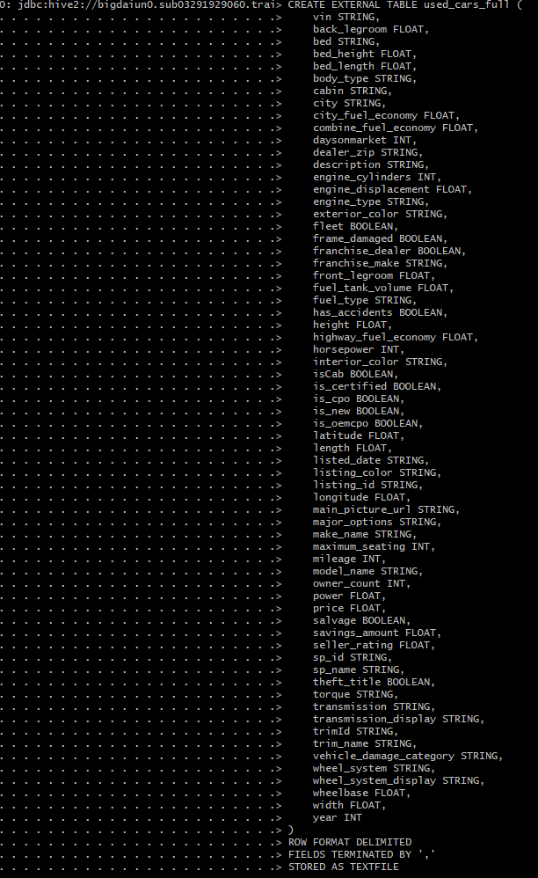

1. Create simple table.

(CREATE EXTERNAL TABLE used_cars_simple (

vin STRING,

make_name STRING,

model_name STRING,

year INT,

price FLOAT,

mileage INT,

city STRING,

fuel_type STRING,

body_type STRING,

transmission STRING

)

ROW FORMAT DELIMITED

FIELDS TERMINATED BY ','

STORED AS TEXTFILE

LOCATION '/user/your-user/UsedCars';)

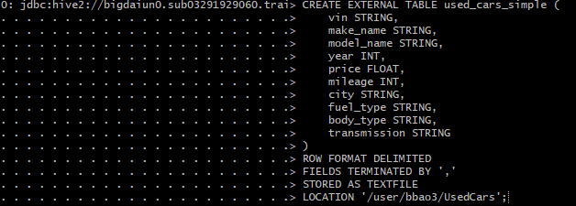

Step 3: Prepare data for export to local machine.

This step is to obtain a cleaned .csv file for analysis and visualization in Excel/PowerBI.

1. Write Hive output to HDFS.

(INSERT OVERWRITE DIRECTORY '/user/your-user/UsedCars'

ROW FORMAT DELIMITED

FIELDS TERMINATED BY ','

SELECT

vin,

make_name,

model_name,

year,

price,

mileage,

city,

fuel_type,

body_type,

transmission

FROM used_cars_full;)

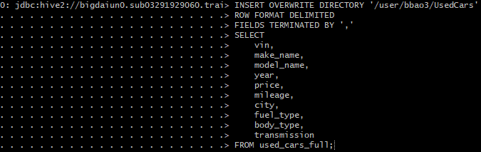

1. Merge created partitions into one cleaned .csv file.

(hdfs dfs -getmerge /user/your-user/UsedCars used_cars_simple.csv)



1. Download .csv file to local machine for analysis and visualization in Excel and PowerBI.

(scp [your_user@your_ip_address:/home/your_name/used_cars_simple.csv](mailto:your_user@your_ip_address:/home/your_local_machine/used_cars_simple.csv) ~)

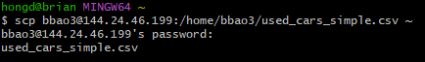

References

* 1. URL of Data Source, <https://www.kaggle.com/datasets/ananaymital/us-used-cars-dataset>
  2. URL of your Github, <https://github.com/bbao3-csula/CIS-4560-Used-Cars>