- False codling moth (Thaumatotibia leucotreta)
Last modified: October 16, 2026

6A. Introduction
Native to sub-Saharan Africa, the false codling moth (FCM), Thaumatotibia leucotreta Meyrick (Lepidoptera: Tortricidae), is a highly polyphagous pest distributed throughout much of Africa and parts of the Middle East, including Israel (Carstens and Moore 2020). Economically important hosts include avocado, Citrus spp., corn, cotton, eggplant, grapes, stone fruits, peppers, and cut roses (EPPO 2025). FCM undergoes five larval instars, during which larvae bore into and feed within plant tissues, particularly fruit, causing direct damage before exiting the host to form cocoons in the soil (NAPPFAST 2003, Gilligan et al. 2011). In 2008, a single adult male was discovered in Ventura County, California, representing the first domestic detection of FCM, extensive subsequent trapping failed to detect additional individuals, and the introduction was successfully eradicated (Gilligan et al. 2011). Although FCM is not established in the United States, it has been repeatedly intercepted at United States ports of entry in both cargo and passenger baggage (Stibick 2006). If established in the United States, FCM could cause substantial economic losses, potentially reaching billions of dollars (Venette et al. 2003, Stibick 2006).
A risk map for FCM based on biome similarities identified the western and southwestern United States, excluding the Pacific Coast, and small areas of Florida as suitable for establishment (Venette et al. 2003). Although Mediterranean climates, including California, were previously considered unsuitable for FCM (EPPO 2013), more recent modeling predicted suitable conditions in California and other areas of the Pacific Coast, as well as portions of the southern United States (Barker and Coop 2019). FCM has limited capacity for rapid cold hardening over short time periods, whereas larvae can tolerate a broader range of temperatures than adults and adults exhibit a heat-hardening response (Stotter and Terblanche 2009, Terblanche et al. 2017). FCM can complete 2–10 generations per year, with the number of generations influenced by temperature, food availability and quality, photoperiod, humidity, and latitude (Venette et al. 2003, Gilligan et al. 2011). In environmentally suitable areas of the contiguous United States (CONUS), FCM is predicted to complete 1–9 generations (Barker and Coop 2019). Drought and associated changes in host-plant availability may contribute to variation in FCM developmental rates and host use (Gilligan et al. 2011), while experimental evidence indicates that moisture stress can also affect FCM development and infestation of tomato (Patrick et al. 2021).
A model for FCM developed for the Degree-Day, establishment Risk, and Phenological event mapping system (DDRP) is operationalized to produce near real-time forecasts for the CONUS at https://uspest.org/DDRP. The phenology model applies a lower developmental threshold of 11.7 °C and upper threshold of 38 °C for all life stages (egg, larva, pupa, and adult) and assumes the adult is the overwintering stage. The climatic suitability model applies a lower cold stress threshold and upper heat stress threshold of −1 °C and 40 °C, respectively. The full set of model parameters for FCM, including degree-day requirements for individual life stages and climate stress limits, are presented in Table 1. Details on model parameterization are available at USPest.org (Barker and Coop 2019).
Table 1. FCM model parameters for DDRP.

Parameter Code Value

Lower developmental thresholds (°C)
Egg eggLDT 11.7
Larvae larvaeLDT 11.7

Pest events (°C degree-days)
Parameter | Code | Value
Pupae | pupaeLDT | 11.7
Adult | adultLDT | 11.7
Upper developmental thresholds (°C)
Egg | eggUDT | 38
Larvae | larvaeUDT | 38
Pupae | pupaeUDT | 38
Adult | adultUDT | 38
Stage durations (°C degree-days)
Egg | eggDD | 71
Larvae | larvaeDD | 155
Pupae | pupDD | 175
Adult | adultDD | 83
J-larval development complete | OWEventDD | 220
Egg hatch | eggEventDD | 71
Developing J-larvae | larvaeEventDD | 77
Adult emergence (pupal development complete) | pupaeEventDD | 145
Egg laying | adultEventDD | 17
Cold stress temperature threshold (°C) | coldstress_threshold | -1
Cold degree-day (°C) limit when most individuals die | coldstress_units_max1 | 25
Cold degree-day (°C) limit when all individuals die | coldstress_units_max2 | 250
Heat stress temperature threshold (°C) | heatstress_threshold | 40
Heat stress degree-day (°C) limit when most individuals die | heatstress_units_max1 | 75
Heat stress degree-day (°C) limit when all individuals die | heatstress_units_max2 | 150
Cohorts
Degree-days (°C) to emergence (average) | distro_mean | 220
Degree-days (°C) to emergence (variation) | distro_var | 500
Minimum degree-days (°C) to emergence | xdist1 | 140
Maximum degree-days (°C) to emergence | xdist2 | 280
Shape of the distribution | distro_shape | normal
Other
Order of stages | stgorder | OP, E, L, P, A
Degree-day calculation method | calctype | average

Cold stress

Heat stress

6B. Results

Phenology
Entire period: 1981–2025
Over 1981–2025, predicted first adult emergence and egg hatch generally occurred earlier across the southern and central United States, while later events were more evident across portions of the northern interior (Figure 1, Figure 2). Significant changes were concentrated in the eastern and southern United States and in scattered western areas.

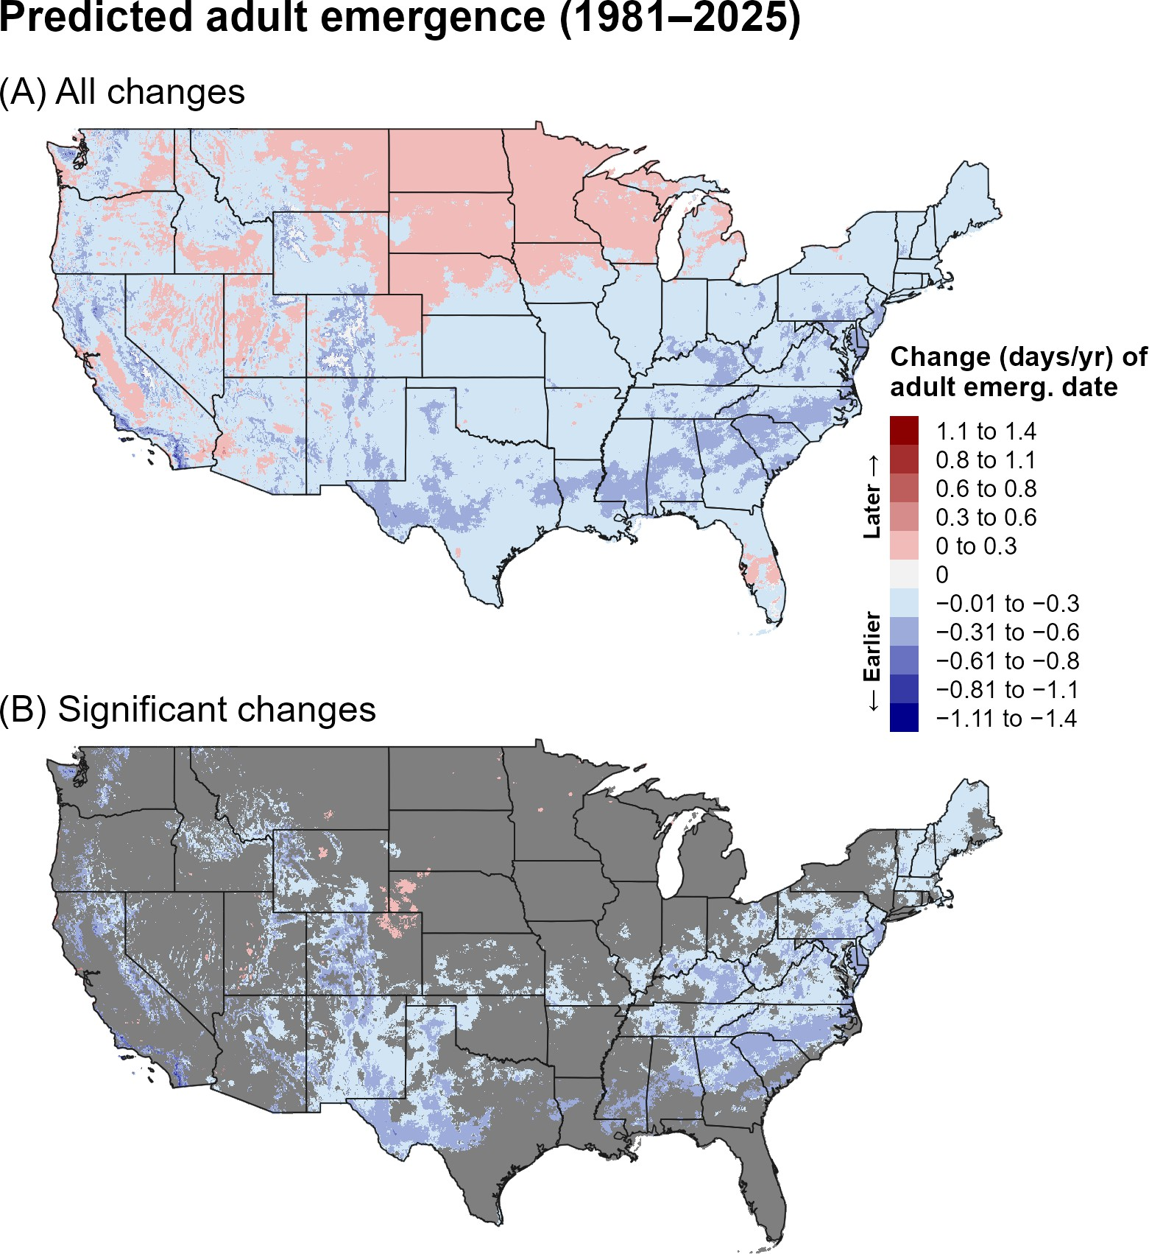

Figure 1. Changes (days/year) in predicted dates of first adult emergence for FCM across the CONUS over the entire 44-year period (1981–2025). Maps show (A) all changes and (B) statistically significant changes (P < 0.1); areas shown in gray are not statistically significant.

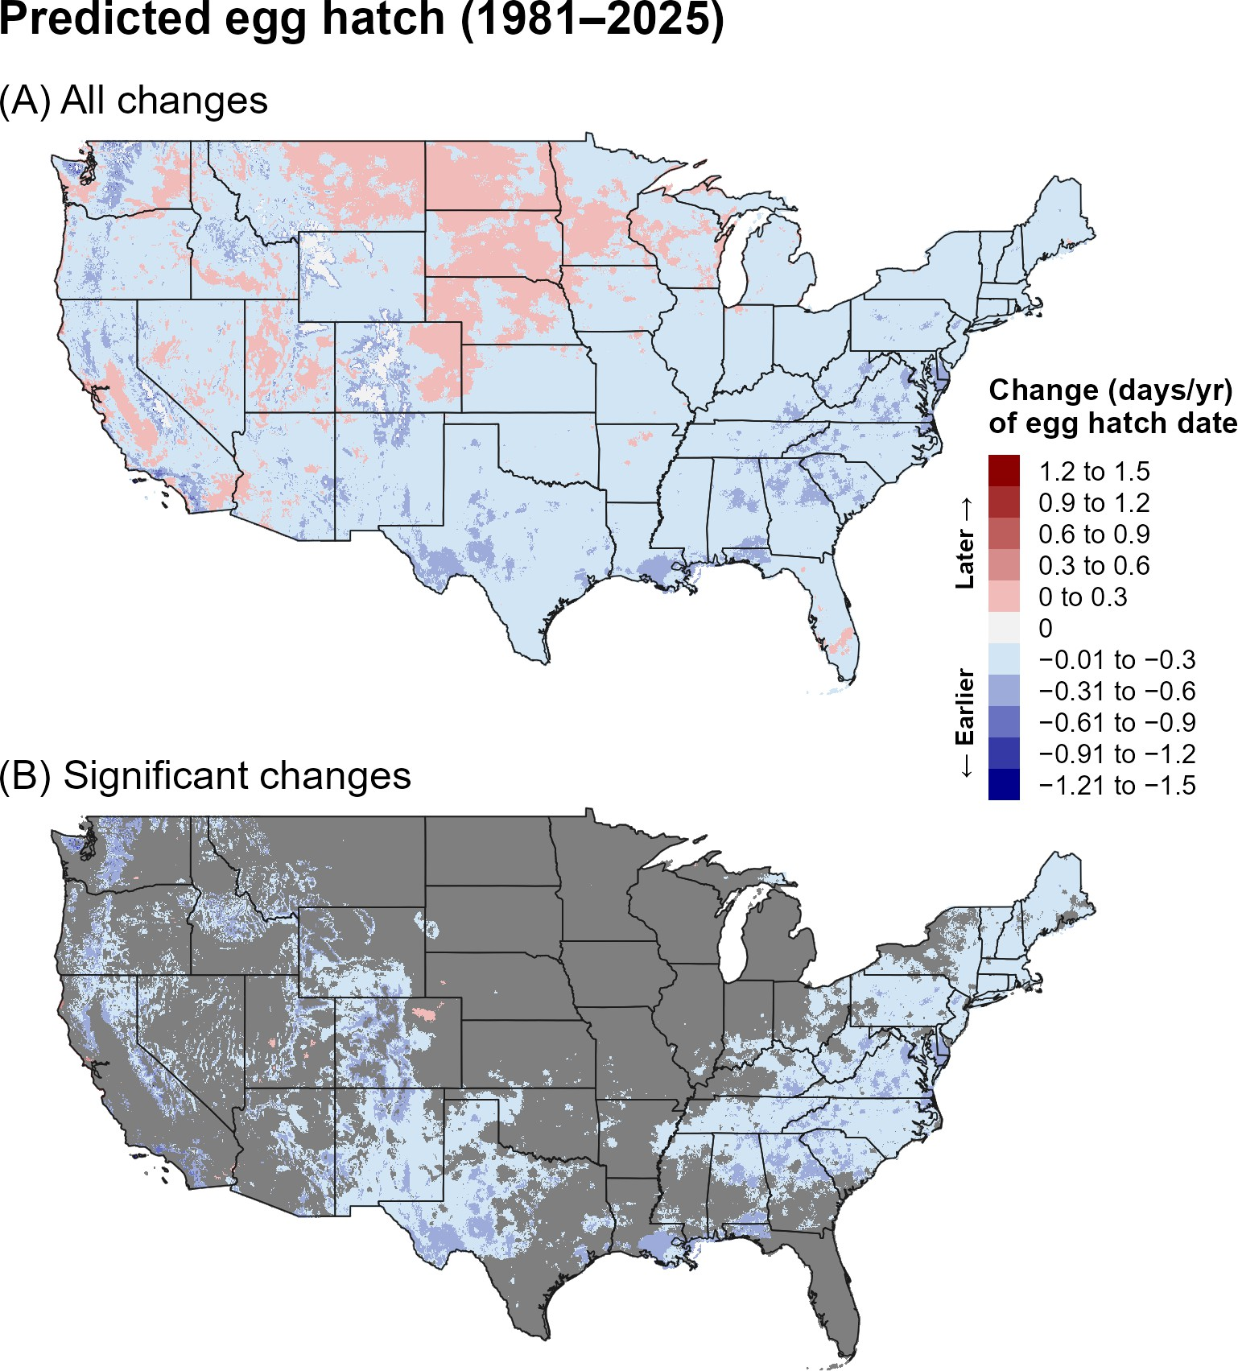
Figure 2. Changes (days/year) in predicted dates of first egg hatch for FCM across the CONUS over the entire 44-year period (1981–2025). Maps show (A) all changes and (B) statistically significant changes (P < 0.1); areas shown in gray are not statistically significant.

Recent period: 2001–2025
During 2001–2025, the pattern became more spatially heterogeneous, with later predicted events across portions of the central and northern United States and earlier events in the Southeast and parts of the West (Figure 3, Figure 4). Significant changes were relatively localized, particularly in the central and eastern United States.

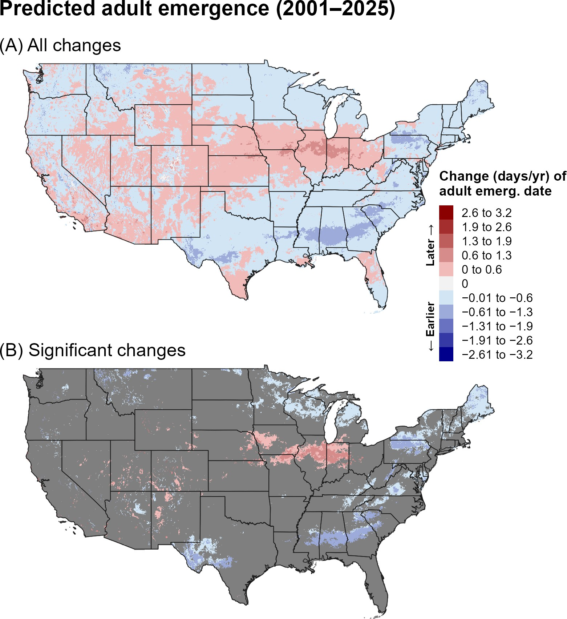

Figure 3. Changes (days/year) in predicted dates of first adult emergence for FCM across the CONUS over the recent 24-year period (2001–2025). Maps show (A) all changes and (B) statistically significant changes (P < 0.1); areas shown in gray are not statistically significant.

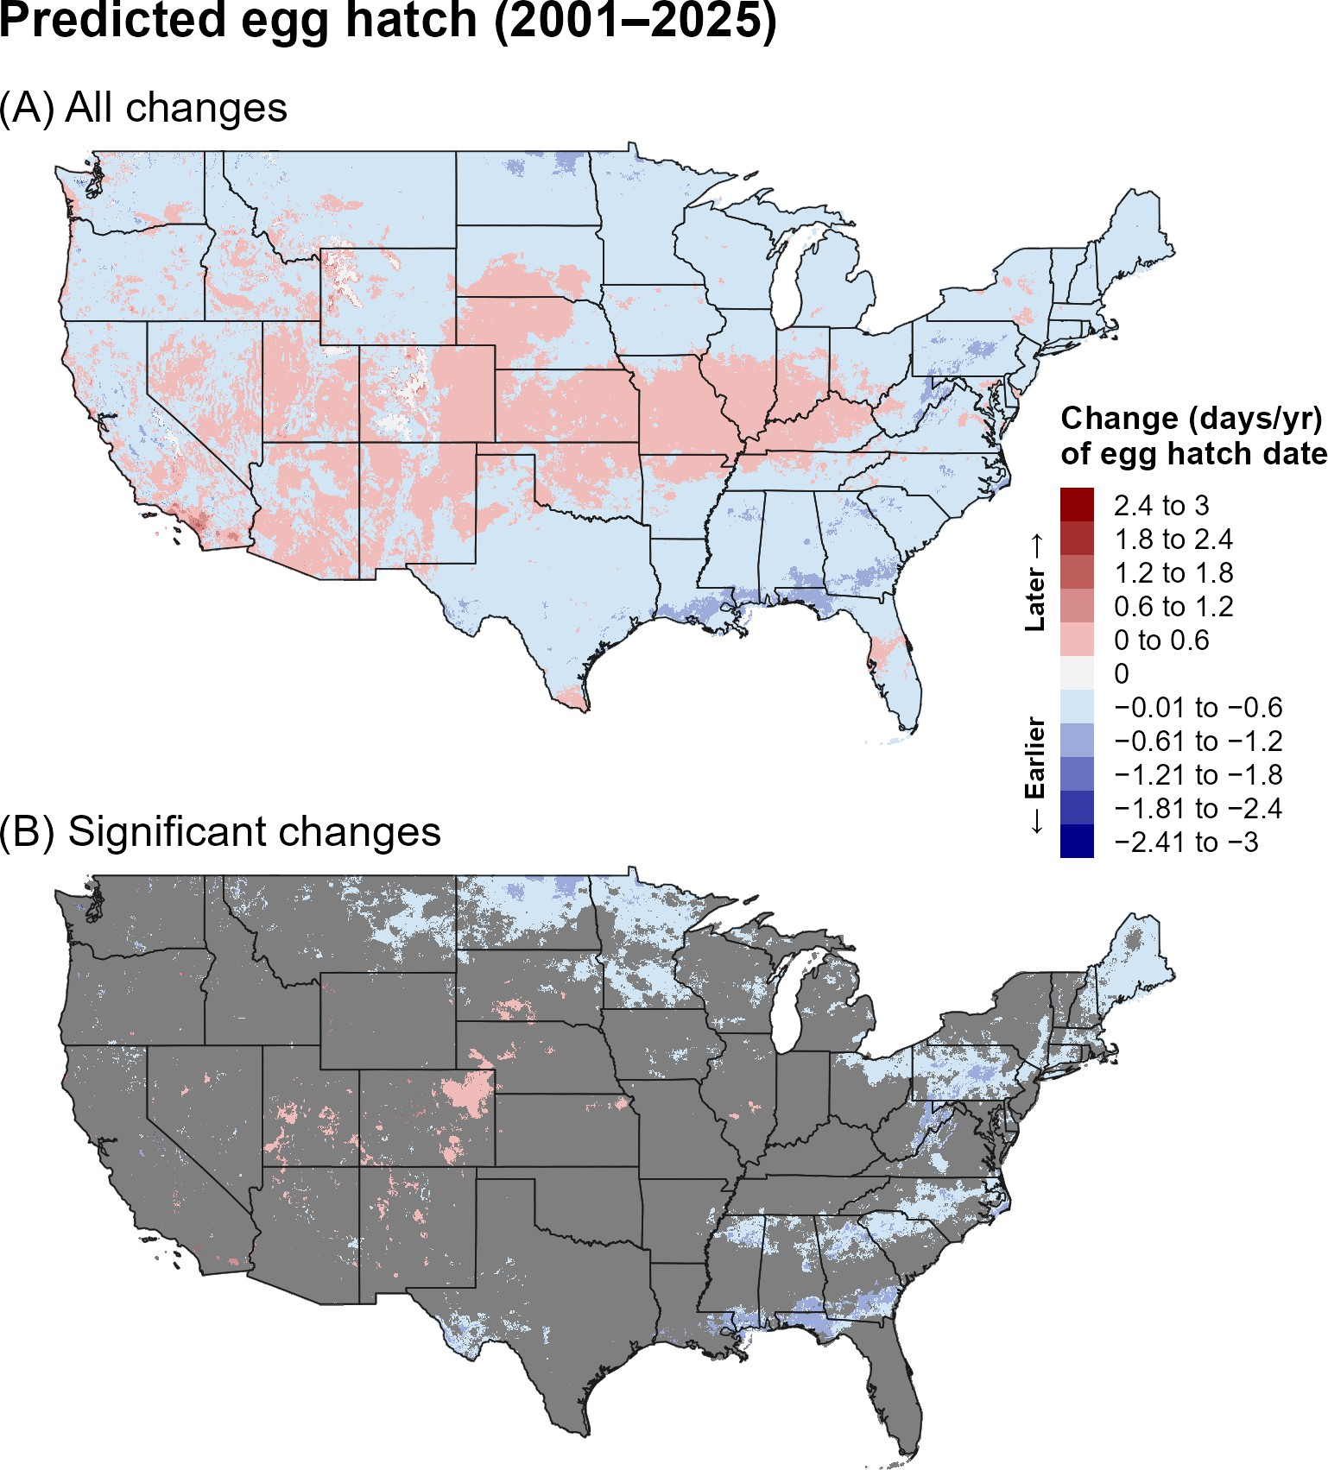
Figure 4. Changes (days/year) in predicted dates of first egg hatch for FCM across the CONUS over the recent 24-year period (2001–2025). Maps show (A) all changes and (B) statistically significant changes (P < 0.1); areas shown in gray are not statistically significant.

Climatic suitability Entire period: 1981–2025
Predicted cold stress decreased across much of the northern and western United States over 1981–2025, with significant decreases especially evident in the northern interior and Northeast (Figure 5). Predicted heat stress increased across the Southwest, southern Great Plains, and parts of the Southeast (Figure 6). Climatic suitability showed significant increases in portions of the southern United States, including parts of the Southeast and Southwest, although the changes were spatially limited (Figure 7).

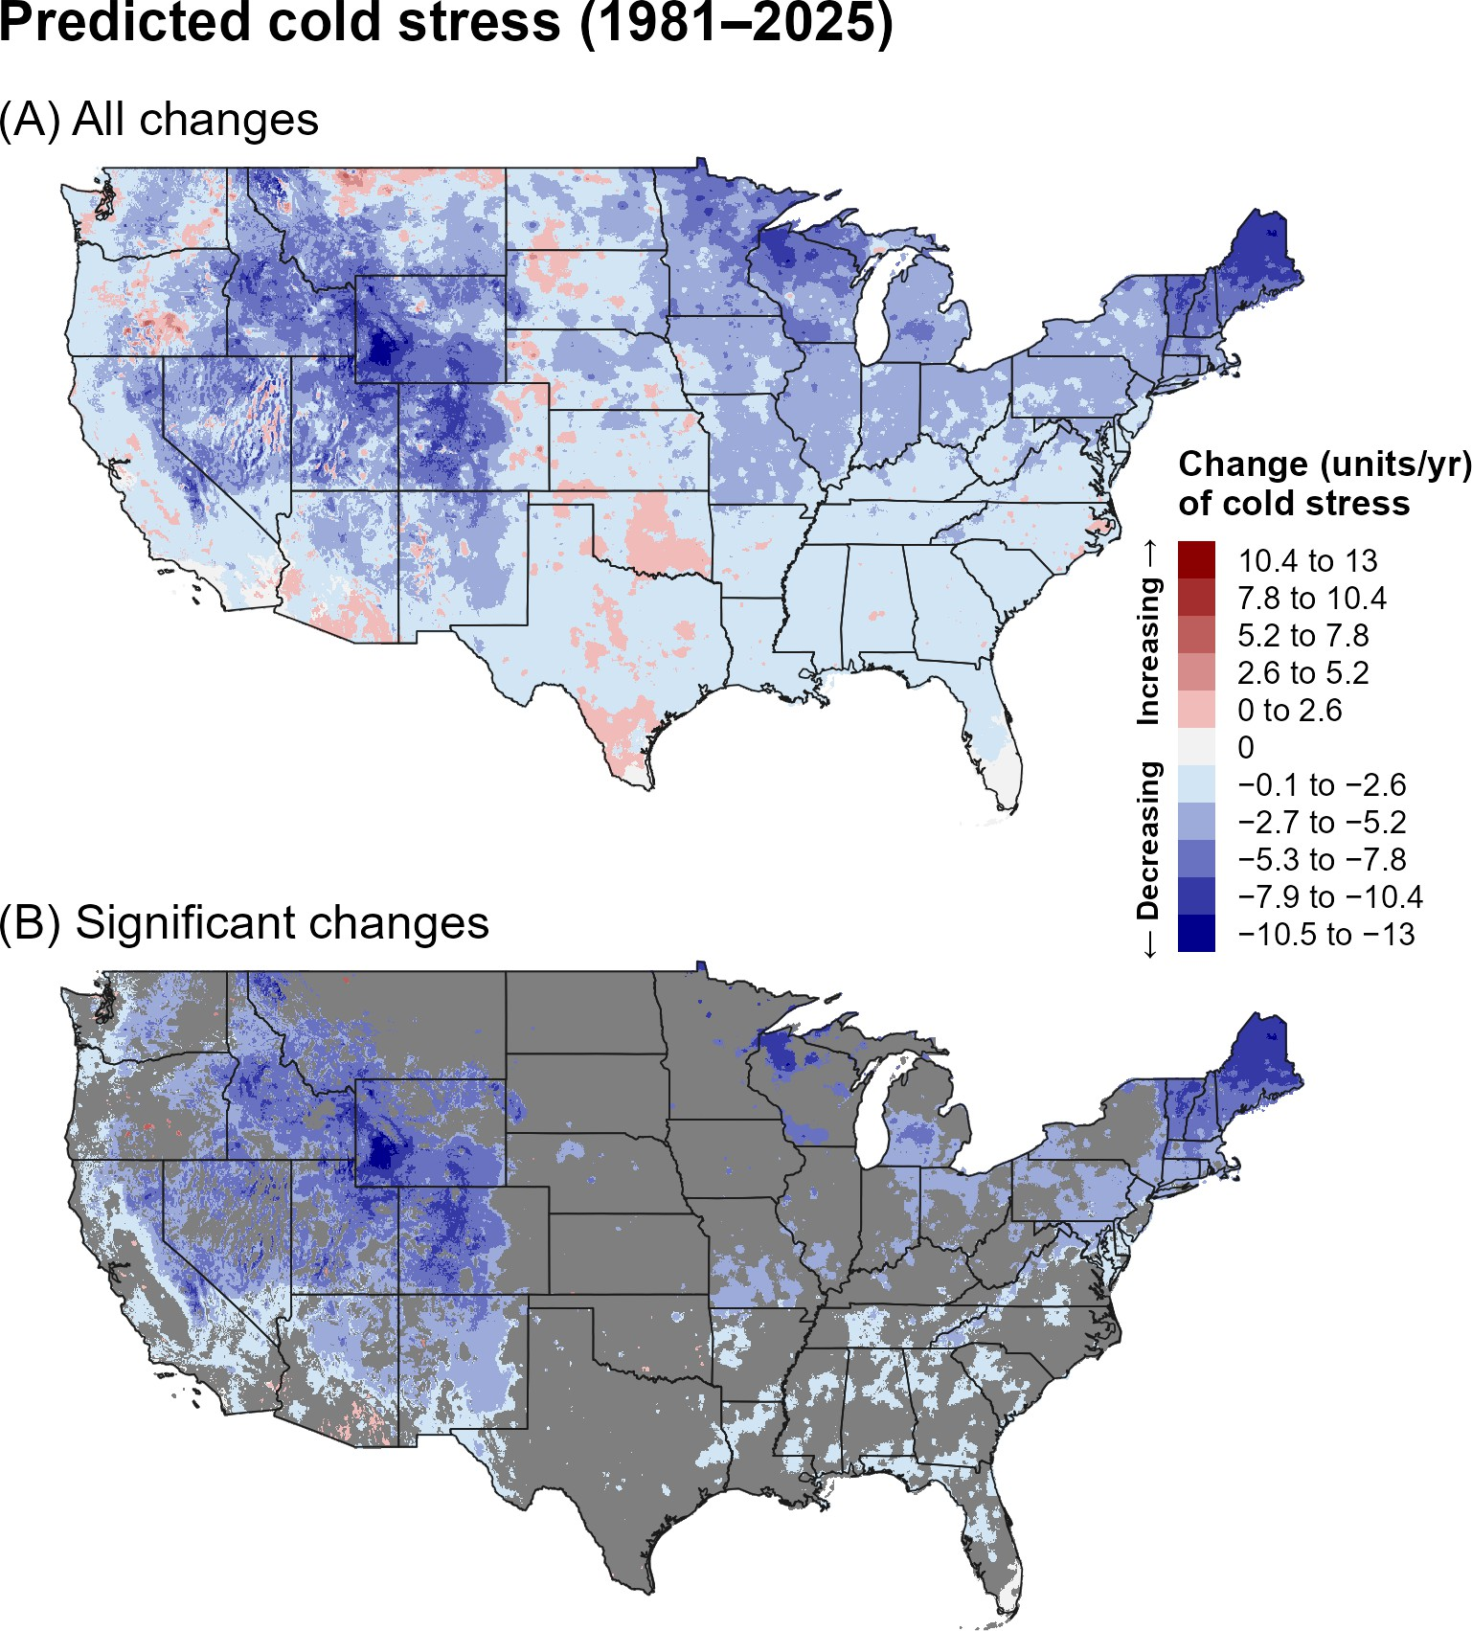
Figure 5. Changes (units/year) in predicted cold stress for FCM across the CONUS over the entire 44-year period (1981–2025). Maps show (A) all changes and (B) statistically significant changes (P < 0.1); areas shown in gray are not statistically significant. Areas shown as 0 in (B) had significant trends but very small changes.

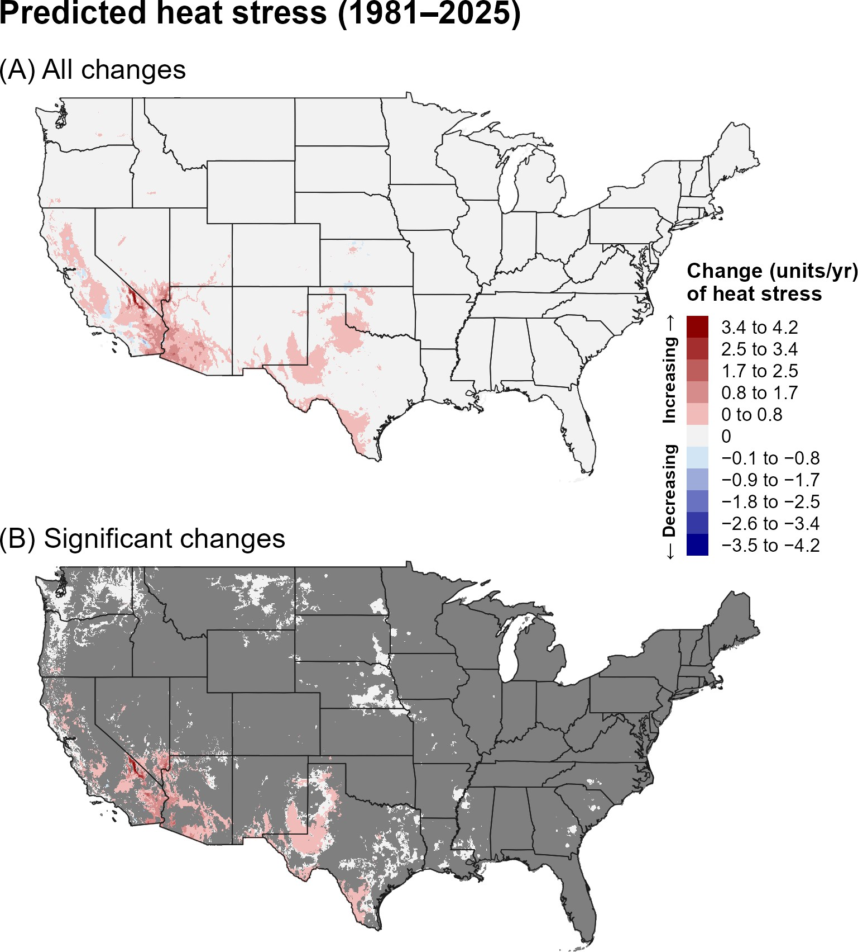
Figure 6. Changes (units/year) in predicted heat stress for FCM across the CONUS over the entire 44-year period (1981–2025). Maps show (A) all changes and (B) statistically significant changes (P < 0.1); areas shown in gray are not statistically significant. Areas shown as 0 in (B) had significant trends but very small changes.

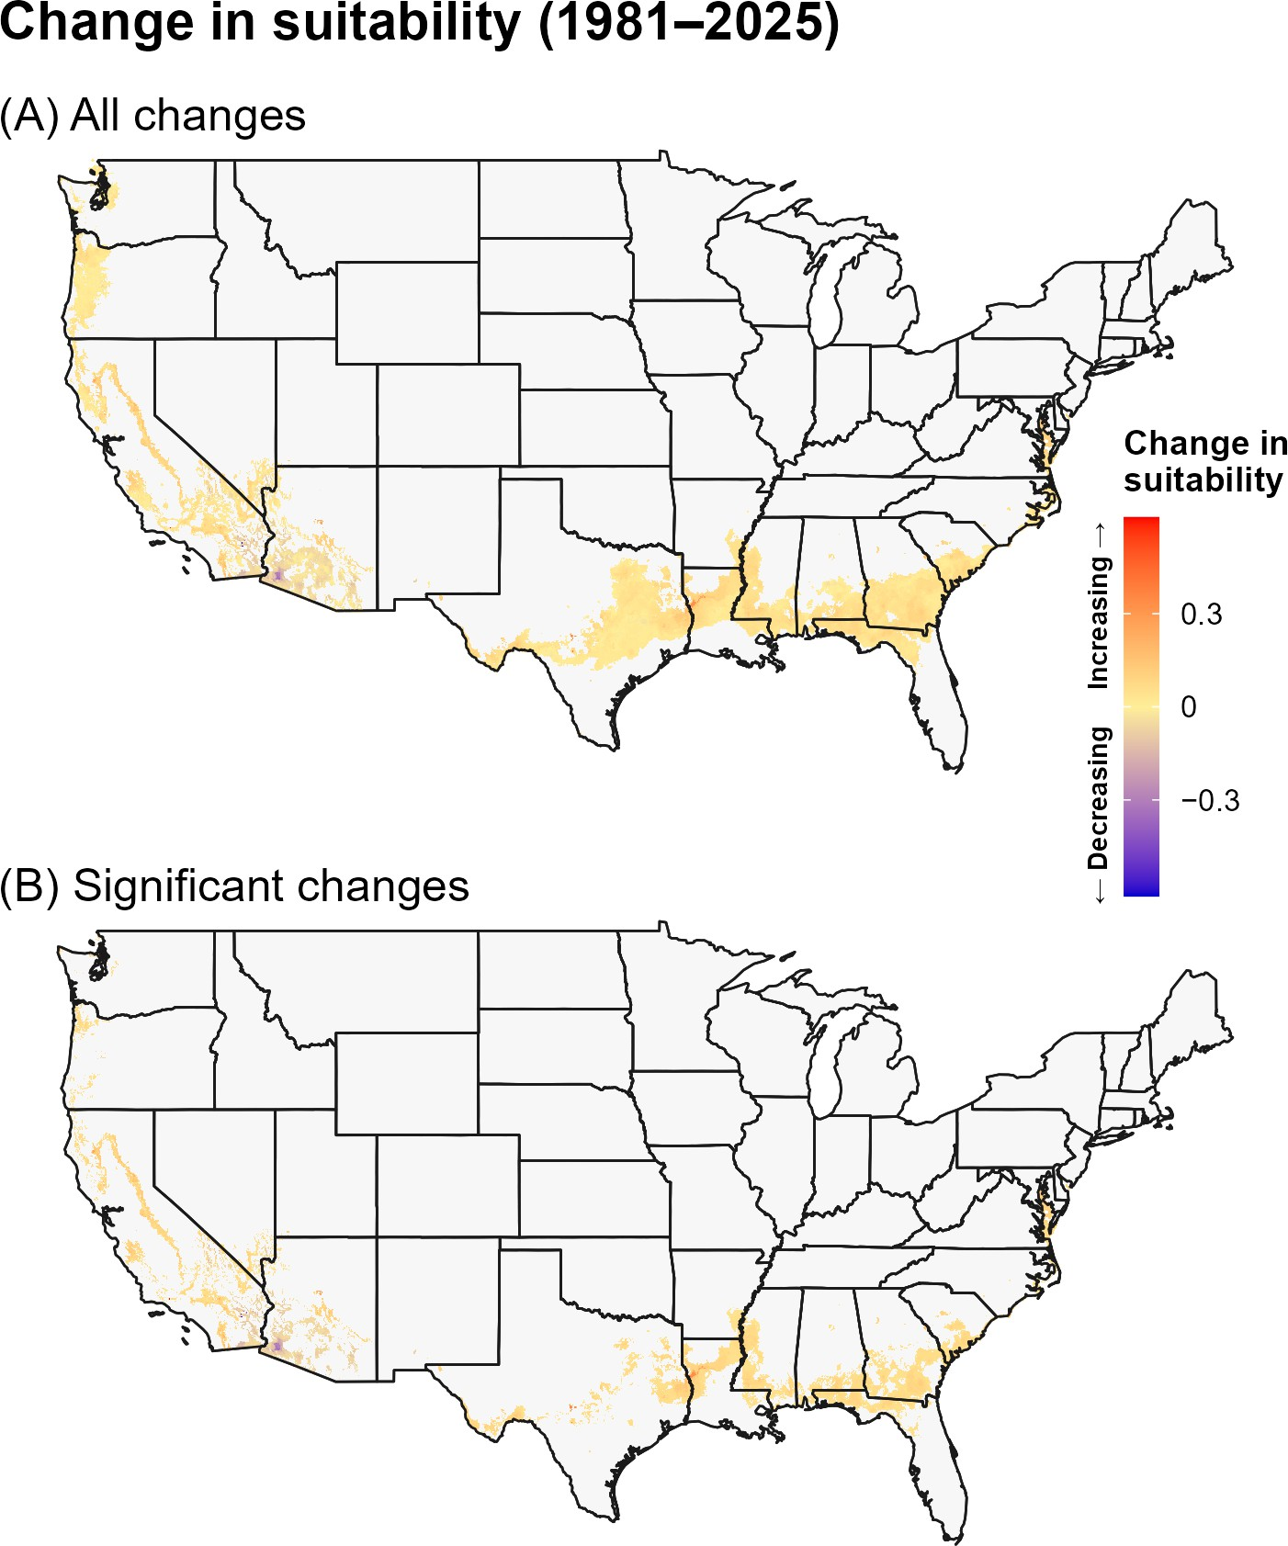
Figure 7. Changes in predicted climatic suitability for FCM across the CONUS over the 44-year period (1981–2025). Suitability is defined as areas not excluded by climate stress. Positive changes (warmer colors) indicate an increased likelihood of establishment, whereas negative changes (cooler colors) indicate a decreased likelihood of establishment.

Recent period: 2001–2025
During 2001–2025, cold-stress trends became more mixed, with increases across portions of the northern interior and decreases in scattered regions (Figure 8). Heat stress continued to increase in the Southwest and southern Great Plains (Figure 9). The climatic-suitability map showed relatively limited significant change, although increases remained evident in portions of the southern United States (Figure 10).

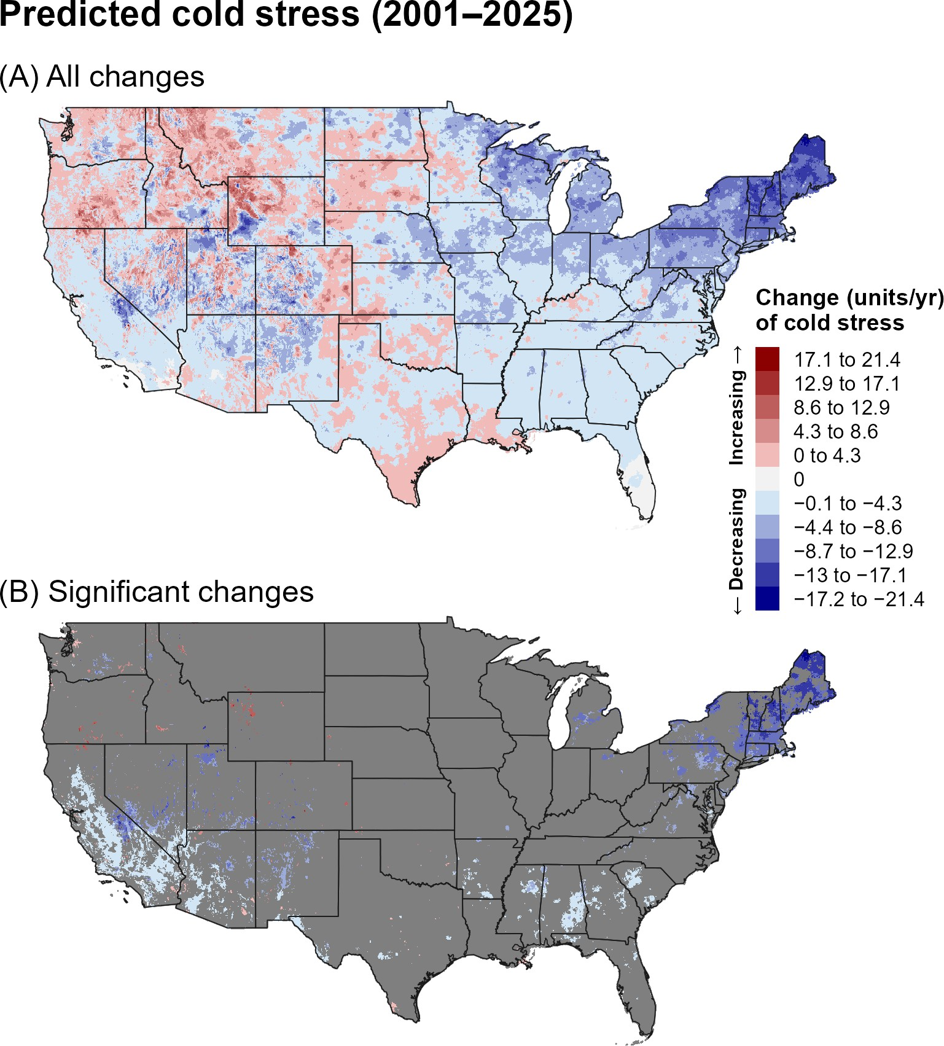
Figure 8. Changes (units/year) in predicted cold stress for FCM across the CONUS over the recent 24-year period (2001–2025). Maps show (A) all changes and (B) statistically significant changes (P < 0.1); areas shown in gray are not statistically significant. Areas shown as 0 in (B) had significant trends but very small changes.

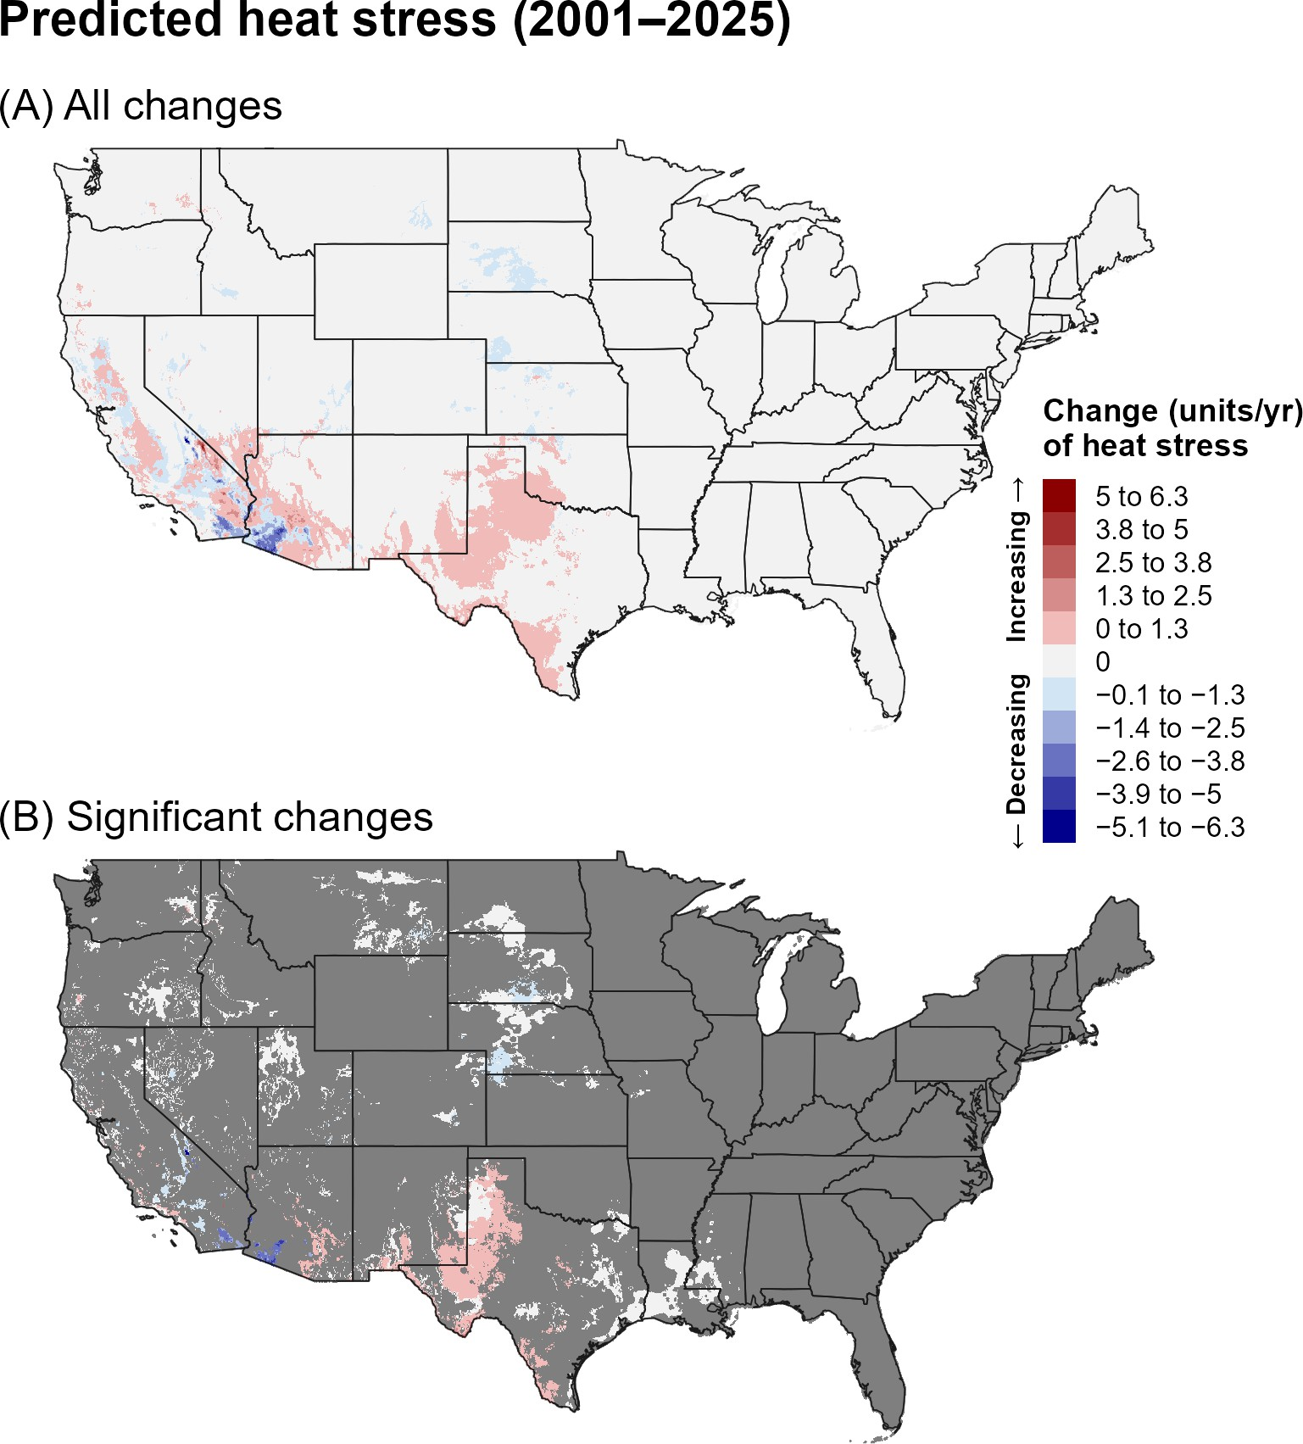
Figure 9. Changes (units/year) in predicted heat stress for FCM across the CONUS over the recent 24-year period (2001–2025). Maps show (A) all changes and (B) statistically significant changes (P < 0.1); areas shown in gray are not statistically significant. Areas shown as 0 in (B) had significant trends but very small changes.

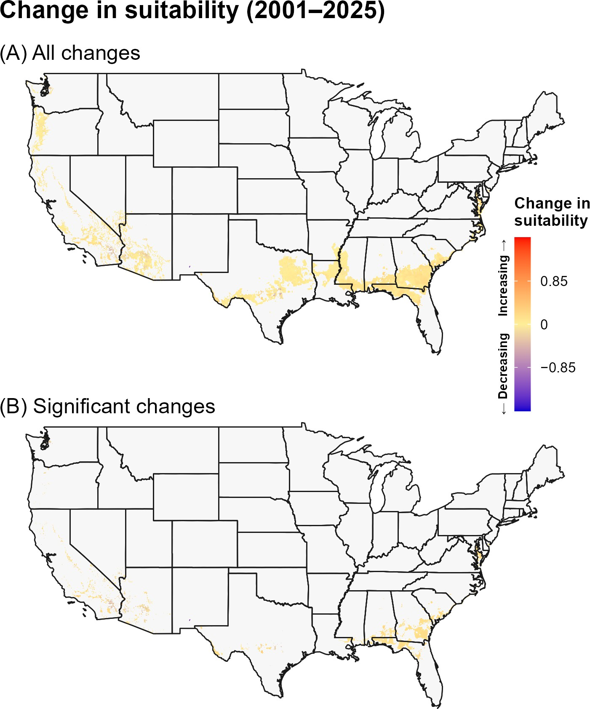
Figure 10. Changes in predicted climatic suitability for FCM across the CONUS over the recent 24-year period (2001–2025). Suitability is defined as areas not excluded by climate stress. Positive changes (warmer colors) indicate an increased likelihood of establishment, whereas negative changes (cooler colors) indicate a decreased likelihood of establishment.

6C. Discussion
Predicted phenology for FCM indicates a tendency toward earlier development in many southern regions over the full period, consistent with the strong temperature dependence of a multivoltine species. The recent-period maps show greater regional heterogeneity, emphasizing that short-term climate variability can modify the longer-term spatial pattern. In environmentally suitable areas, shifts toward earlier activity could affect the timing of monitoring and management.
Decreasing cold stress across portions of the northern United States could expand the areas in which cold conditions are less limiting, while increasing heat stress in the Southwest could offset some of that potential benefit.

The suitability maps suggest that these opposing stress changes may result in localized rather than uniform changes in establishment likelihood. Because FCM is influenced by temperature, food availability, photoperiod, humidity, and latitude, climate-stress trends should be interpreted as one component of establishment risk.
The stronger and more spatially extensive trends in predicted phenology and climate stress over the full 44-year period may reflect both the larger sample size, which can reduce noise and improve detection of directional patterns, and differences in the underlying climate trends between the two time periods. In particular, the recent 24-year period may capture climate variability or regional trends that differ from those observed over the longer 44-year period. Thus, differences between the two periods should be interpreted as reflecting both long-term climate trends and shorter-term regional variability.

6D. References
Barker, B. S., and L. Coop. 2019. False codling moth, Thaumatotibia leucotreta. Phenology/degree-day and climate suitability model analysis for USPEST.ORG. Prepared for United States Department of Agriculture (USDA) – Animal and Plant Health Inspection Service (APHIS) – Plant Protection and Quarantine (PPQ). Vs. 1.0 (12/2/2019). Online at: https://uspest.org/CAPS/Thaumatotibia_ leucotreta_white_paper.pdf (accessed 8 September 2025).
Carstens, E., and S. Moore. 2020. Thaumatotibia leucotreta (false codling moth (FCM)). CABI Compendium.
Available online: https://doi.org/10.1079/cabicompendium.6904 (accessed 25 August 2025).
EPPO. 2013. Pest risk analysis for Thaumatotibia leucotreta. EPPO, Paris.
EPPO. 2025. Thaumatotibia leucotreta. EPPO datasheets on pests recommended for regulation. Online at: https://gd.eppo.int/ (accessed 25 August 2025).
Gilligan, T. M., M. E. Epstein, and K. M. Hoffman. 2011. Discovery of false codling moth, Thaumatotibia leucotreta (Meyrick), in California (Lepidoptera: Tortricidae). Proceedings of the Entomological Society of Washington 113:426–435.
NAPPFAST. 2003. Pest assessment: False codling moth, Cryptophlebia leucotreta (Meyrick), (Lepidoptera: Tortricidae). USDA-APHIS-PPQ-CPHST-PERAL/NCSU.
Patrick, E. M., I. Koomen, S. Ndlela, and J. M. Wesonga. 2021. Effect of moisture stress on the development of false codling moth Thaumatotibia leucotreta (Lepidoptera: Tortricidae) on two tomato varieties. Neotropical Entomology 50:828–834.
Stotter, R. L., and J. S. Terblanche. 2009. Low-temperature tolerance of false codling moth Thaumatotibia leu-cotreta (Meyrick) (Lepidoptera: Tortricidae) in South Africa. Journal of Thermal Biology 34:320–325.
Terblanche, J. S., K. A. Mitchell, W. Uys, C. Short, and L. Boardman. 2017. Thermal limits to survival and activity in two life stages of false codling moth Thaumatotibia leucotreta (Lepidoptera, Tortricidae). Physiological Entomology 42:379–388.
Stibick, J. 2006. New pest response guidelines: false codling moth Thaumatotibia leucotreta. USDA-APHIS-PPQ-Emergency and Domestic Programs, Riverdale, Maryland. Online at: https://www.cdfa.ca.gov/ plant/fcm/pdfs/publications/Stibick_2006-FCM_NPRG.pdf (accessed 3 April 2026).
Venette, R. C., E. E. Davis, M. Dacosta, H. Heisler, and M. Larson. 2003. Mini risk assessment False codling moth, Thaumatotibia (=Cryptophlebia) leucotreta (Meyrick) [Lepidoptera: Tortricidae]. CAPS PRA, St. Paul, Minnesota.

