Lab Assignment 1: Conceptual models
HORT 499/599 (Winter 2024)

Overview
For this lab, everyone gets to practice building a conceptual model. See the slide set from Week 1 for more information on conceptual models including examples.

Instructions
Select a subject that you know well. Think of an ecological process or activity that interests you. Use pencil and paper and don’t worry about neatness. Plan to re-draw and revise at least once! Consider these instructions and tips as you develop your conceptual model:

- Pick your drawing conventions (for example start with those used by cocoa pod borer conceptual model, shown on the next page)

- You could start with major life stages (if relevant). Think about what mortality factors affect life stage transitions, both “natural” and management-based

- Also consider other trophic levels: hosts, predators, diseases, etc.

- Are there environmental inputs? Decision making? Major or minor feed-backs?

- Aim for a simple model with only the most relevant interactions; try to ignore trivial factors.

First draft due Thursday, Jan 11 (write up IS NOT required): Take a photo of your conceptual model diagram with your cell phone or use a scanner if you have one available. Submit it to Canvas (‘Assignments’ -> ‘Assignment 1’) as a PNG or equivalent. Expect suggestions for improvement by the weekend.

Final draft due Thursday, Jan 18 (write up IS required): Submit a Word Document (.doc or .docx) that includes your improved conceptual model diagram as well as a description of the model. You can insert the diagram as a PNG or equivalent. The document should be ca. 1-2 pages long and use 12 pt font.

Evaluation
The rubric for grading the final draft of the assignment is below.

Criteria | Weight
Conceptual model provides a good representation of the system | 20%
Conceptual model includes state variables and major processes linking them | 20%
Written description of model is sufficiently detailed and clear | 40%
Conceptual model was improved upon based on instructors’ feedback | 20%

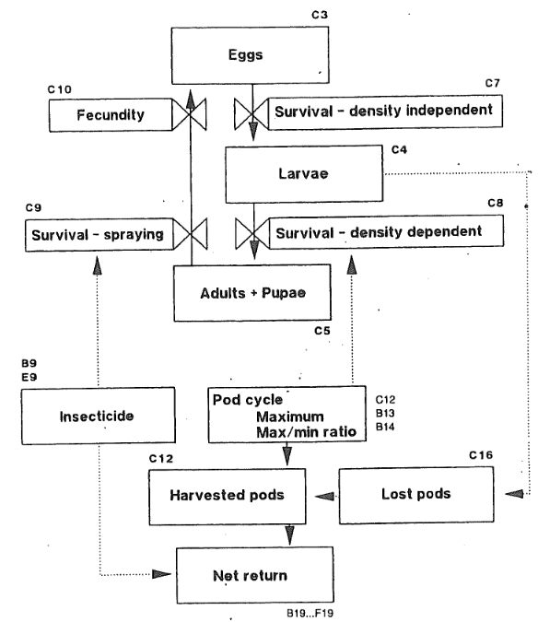

Cocoa Pod Borer Conceptual Model
This model describes major life stages, impacts, and decisions to control the cocoa pod borer (Conopomorpha cramerella), a key pest of cocoa. This happens to be a spreadsheet model, so the cell addresses (e.g. C16) denote where the values are stored in the spreadsheet (note: ignore this feature as we are using R, not spreadsheets). Starting with larvae, the number of cocoa pods available limits the larval survival as a density dependent response, so this is a potential for control (stripping pods by hand at the low point in the cycle of pod production). The number of larvae determine the rate of lost pods, which impacts harvestable pods and net returns. Adults can be sprayed, limiting the next generation of damaging larvae, but spray costs also impact net returns. Other transition rates are constant in this model, but there is always potential to intervene in some way not illustrated here. See Norton and Mumford (1993) pages 159-165 for more details about the model.

