Oregon State University
HORT 599

Lab Assignment
Conceptual Models
Name: Joussy Hidrobo Chávez
Date: 01/10/2025

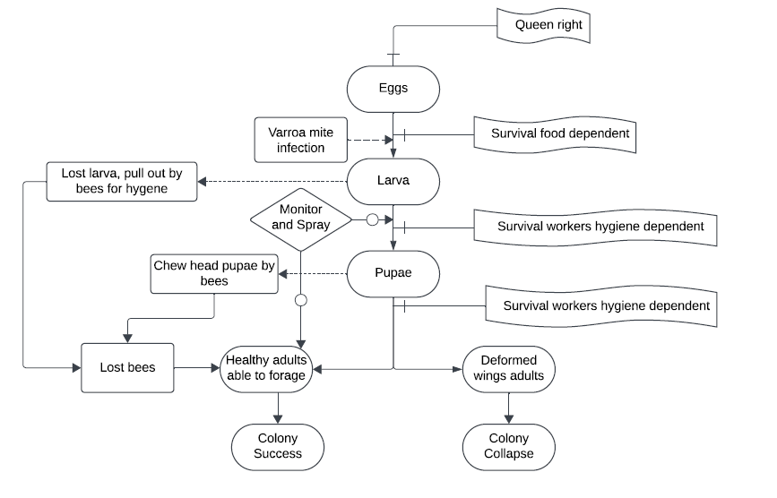
Comments:
- Nice start!
- A title is needed
- How is transition from egg to larva “food dependent” or am I missing something? Should that be for developing larvae not eggs?
- More info on “spray” would be good – sprays to manage varroa mites I assume?
- Maybe add legend, for example what are arrows with the small circles depicting?
- If insufficient healthy foraging adults, does that lead to lack of food where you have “food dependent”, so could add arrow connecting them?

