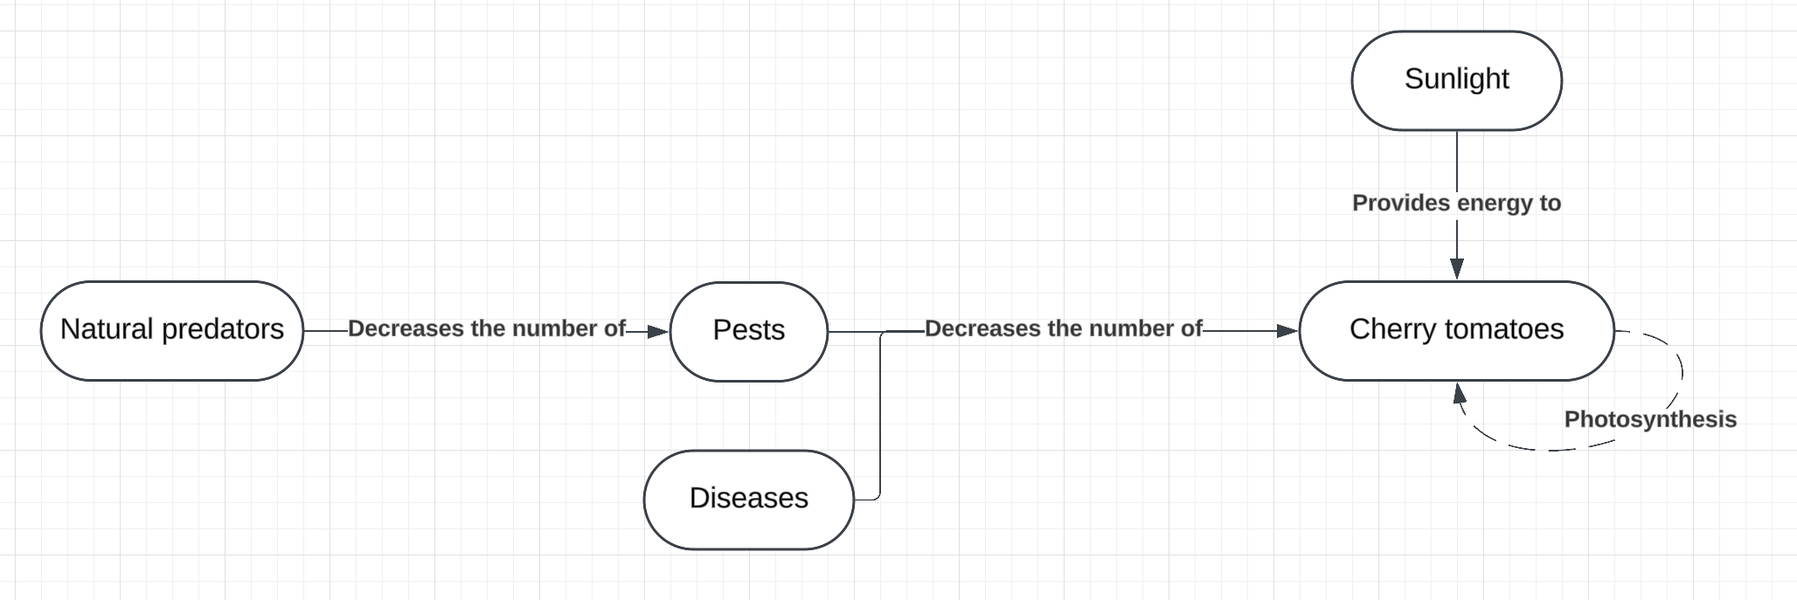
Comments:
- Good start but a bit too basic. Please elaborate more!
- What is the title? What story are you telling?
- Should be more specific. Besides cherry tomatoes I don’t know what specific players are involved in this system.
- “Natural” not needed before “predators” (what about introduced predators?) Perhaps you were thinking “natural enemies”, which would be broader in the inclusion of parasitoids and diseases of the pest.
- “Decreases the number of” is an interesting but wordy and non-specific way to express the process that is happening. Try to use more specific names of processes like “predation” and “herbivory” etc.
- It would seem that sunlight provides energy to drive photosynthesis so it would be better to represent that
- Impacts of pests and diseases should be separate impacts (unless you have a specific example where they work together?)

