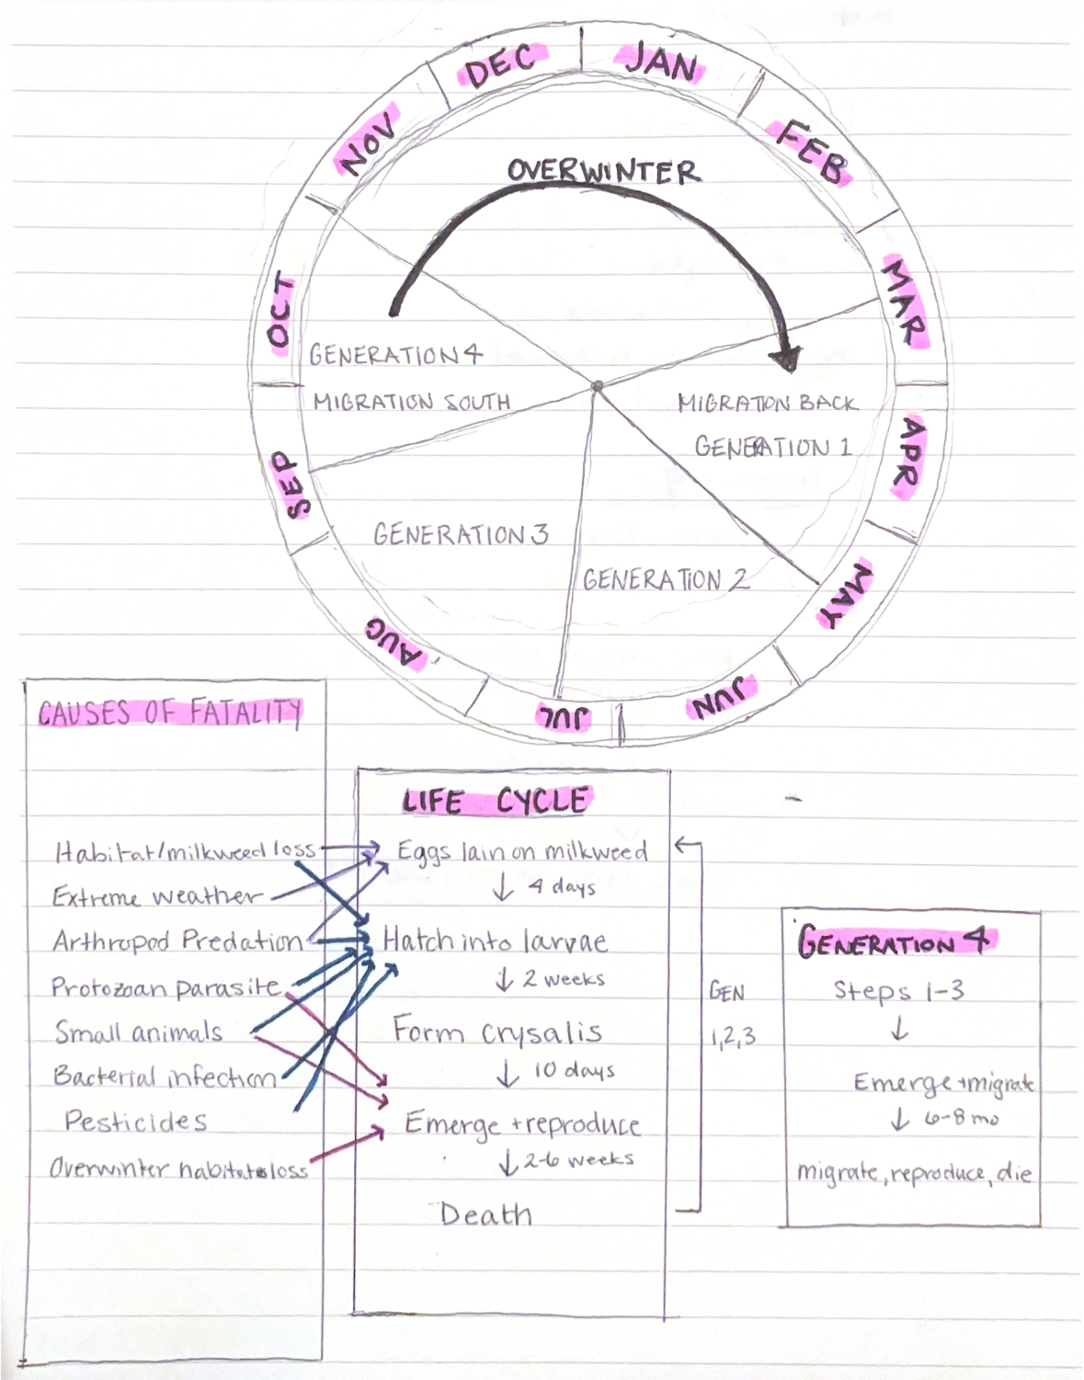

Comments:
- Excellent start!
- Needs a title
- Maybe separate list or extend list of mortality factors for migration phase
- I would try to merge Gen4 with Gens1-3 to make it more of a connected life cycle diagram

