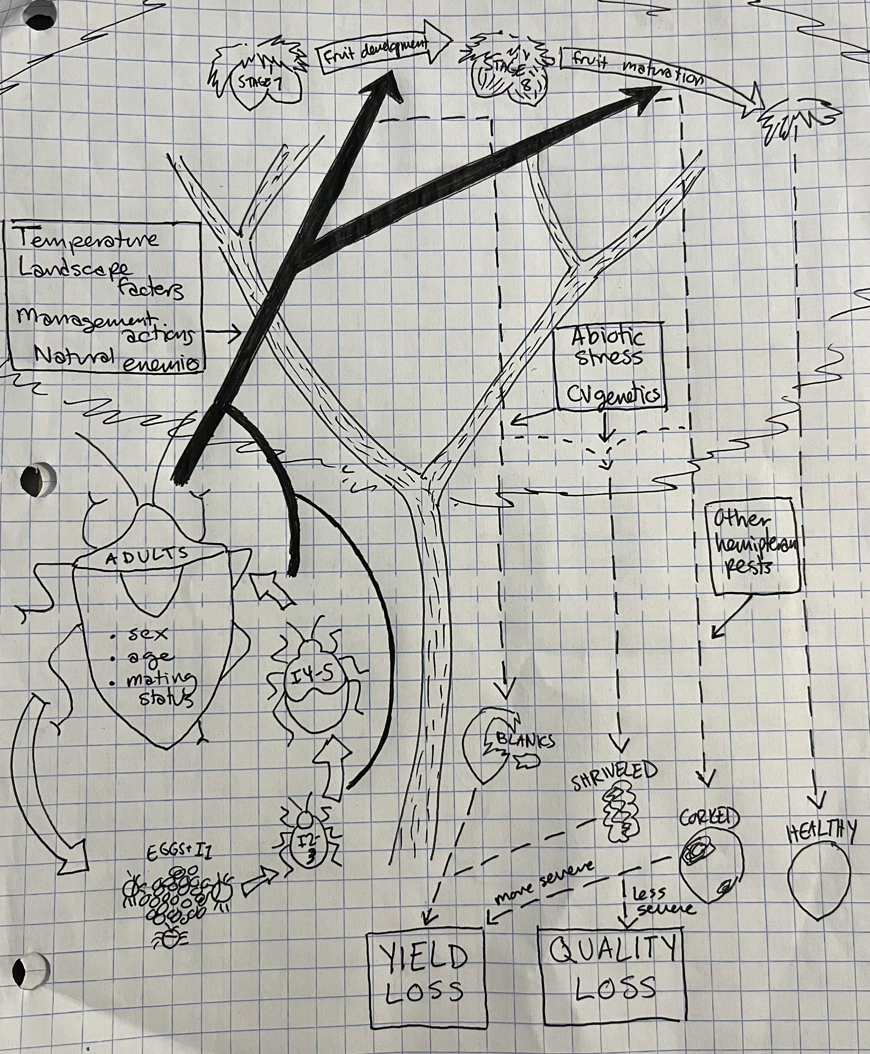
Comments:
- Very good start, good drawings!
- A title is needed, also label stink bug life cycle and host plant sections
- Would like to see the factors on left (Temperature, landscape factors, etc) broken apart and use more specific arrows to state variables/objects that they each impact as much as possible

