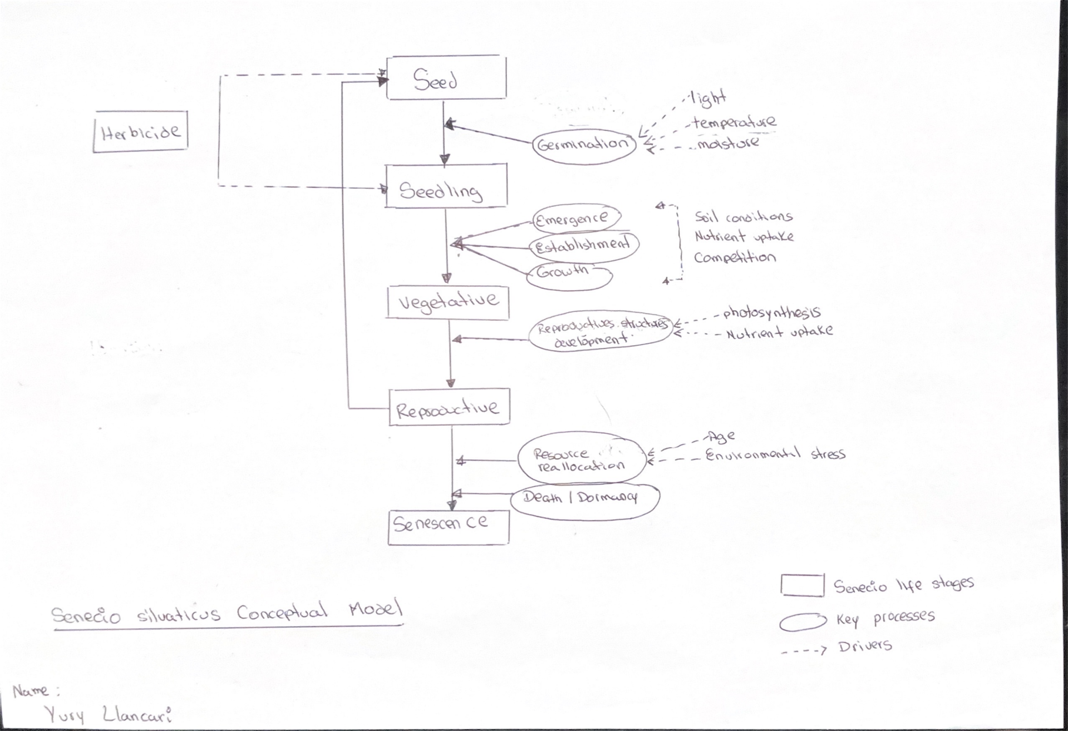
Comments:
- Well done, excellent start!
- Maybe add something like “life cycle and management” to title
- Nutrient uptake and photosynthesis can be listed only once with arrows pointing to all relevant stages
- Any seed dispersal process that might be important
- Also seed bed might be important for weeds
- Maybe use different shape than rectangles for “Herbicide” as it is management and not a life stage
- No other management like cultivation, grazing, etc?

