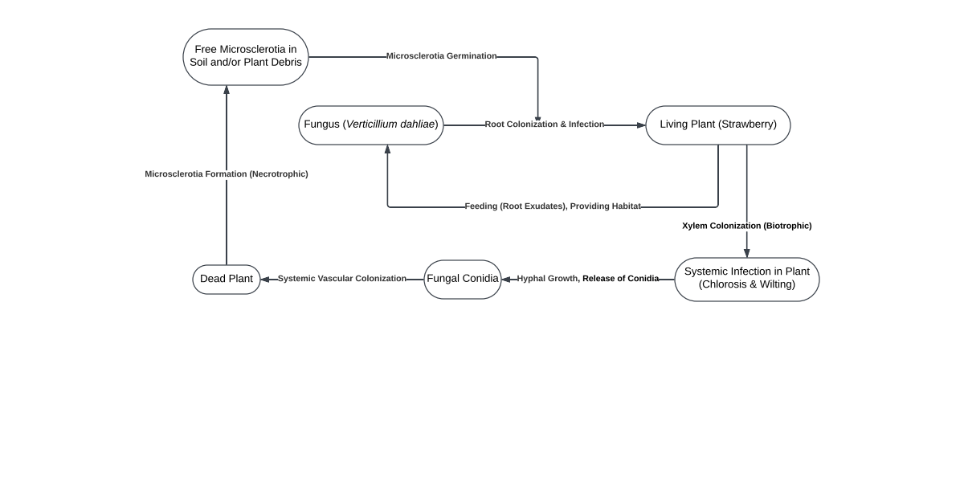
Comments:
- Great start, captures a lot of the story. Needs a title (although your filename implies the title).
- Should there be an arrow from “Fungal Conidia” to “Living Plant” to depict secondary infections?
- Would it make sense to make this two-sectioned, one side for infections, the other for disease expression, like using a dashed line between the two? Or find another way to show both major parts of the story?

