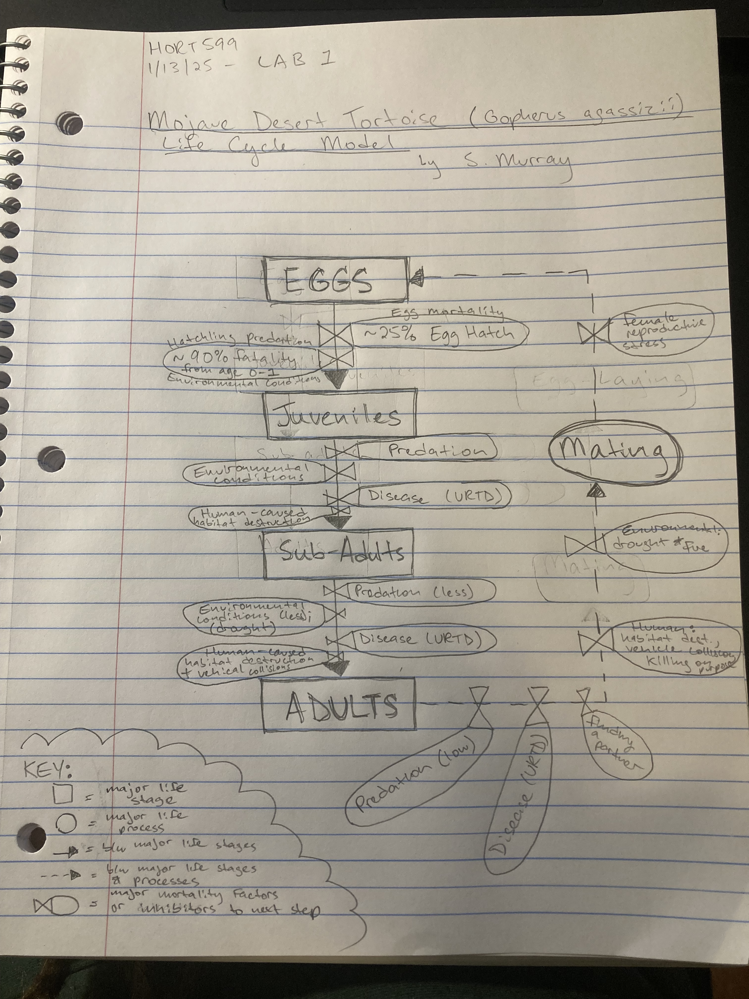

Comments:
- Nice start
- Would it make sense to add the stage “hatchlings” to help separate egg mortality from hatchling predation and other hatchling mortality factors?
- Common mortality factors (common to more than one stage) such as drought could be depicted once and use arrows to show all the points in the life cycle where it is impacting survival.

