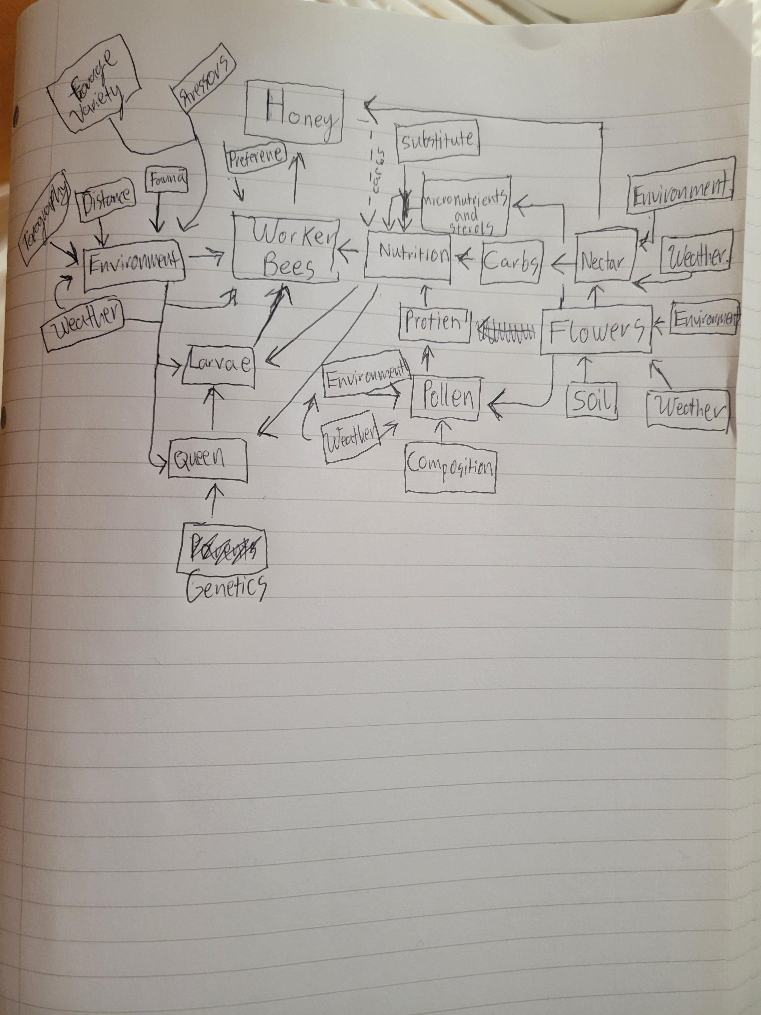
Comments:
- Pretty messy but that is what first drafts are for!
- I would start over by listing your input variables (sunlight, temperature, etc) using one shape (ovals?) and your state variable/objects/players (bees, flowers, soil, honey, etc.) and pick another shape to represent the objects (rectangles?), and draw them each showing how processes (preference, competition, environmental stresses, etc) link them using arrows.
- Try to draw each item only once to keep it less messy. E.g. I see both environment and weather (same thing only weather is more specific) each depicted three times. Environment is too general so avoid using that altogether. Similar for weather – too cold? Heat units for growth? What is the effect of these inputs on the particular state variable?
- Drawing MORE specific inputs (topography, distance, weather, etc) with arrows leading into LESS specific inputs (environment) is confusing. Avoid doing that.
- Also it might be good to start with your major life stages of the bee hive, queen→eggs-→larvae+pupae-→workers etc. Then you can show what players and processes affect each one.

