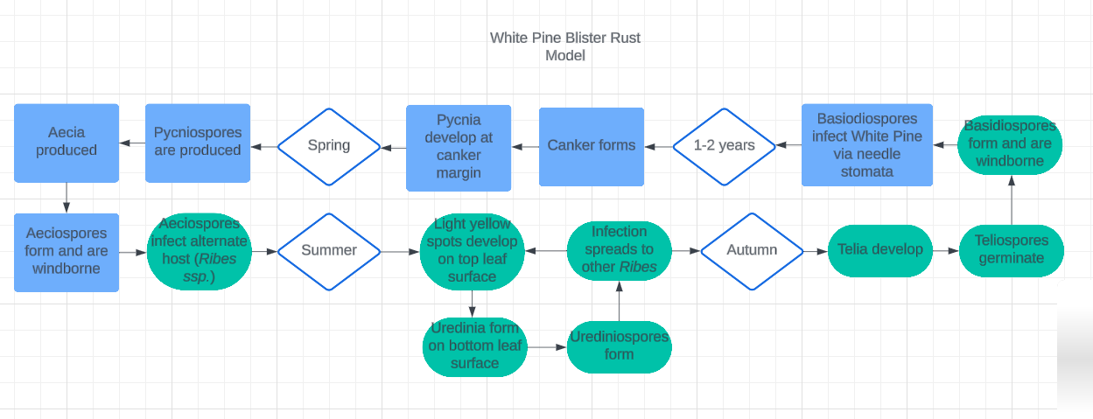
Comments:
- Excellent description of the life cycle!
- Can you draw a line separating sexual vs asexual portions? That might be helpful.
- Any plans to add management/control options?
- Any way to better highlight the hosts? Letting reader start with a focus on hosts might help readability.

