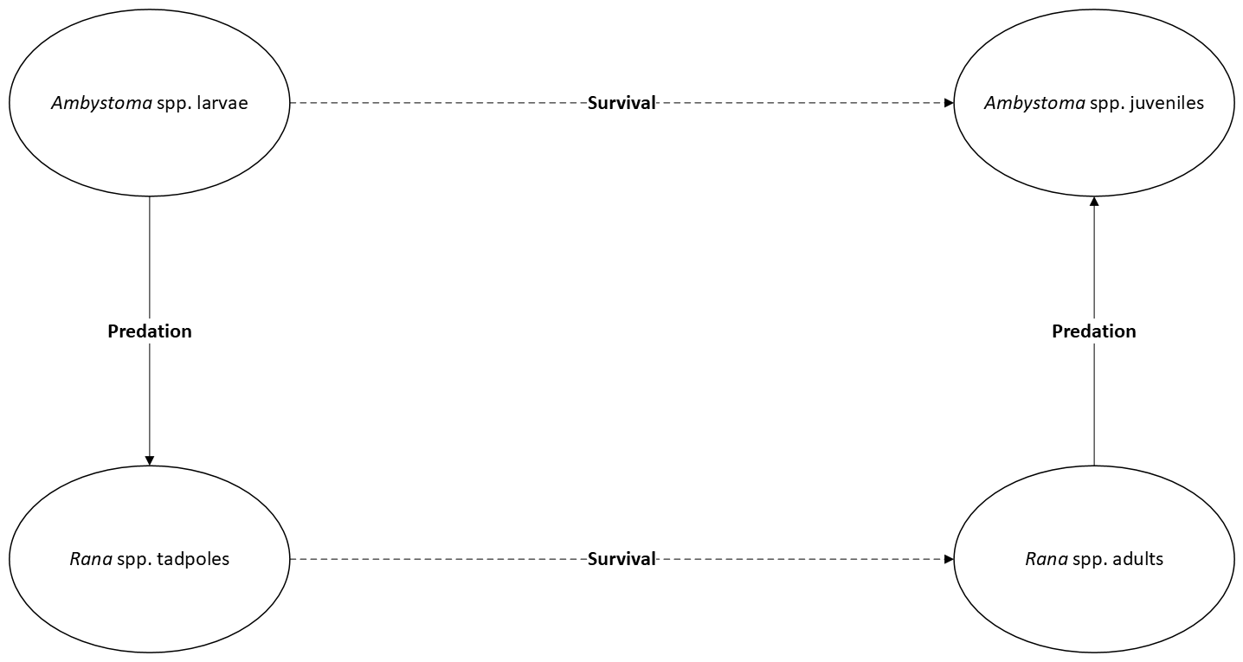

Comments:
- Good start showing how frogs and salamanders each predate upon each others young stages. Title?
- Might be better so show full life cycle of each. Is there a more specific susceptible stage (sizes) for each?
- Does one of these happen on land or are both in the water? It might be good to show more context such as land vs water.
- This makes me wonder if cannibalism is just as likely. If young salamanders are abundant do the adults eat the same species?
- Similarly, can you put this into context of why it might be important. What is the story you are telling us?

