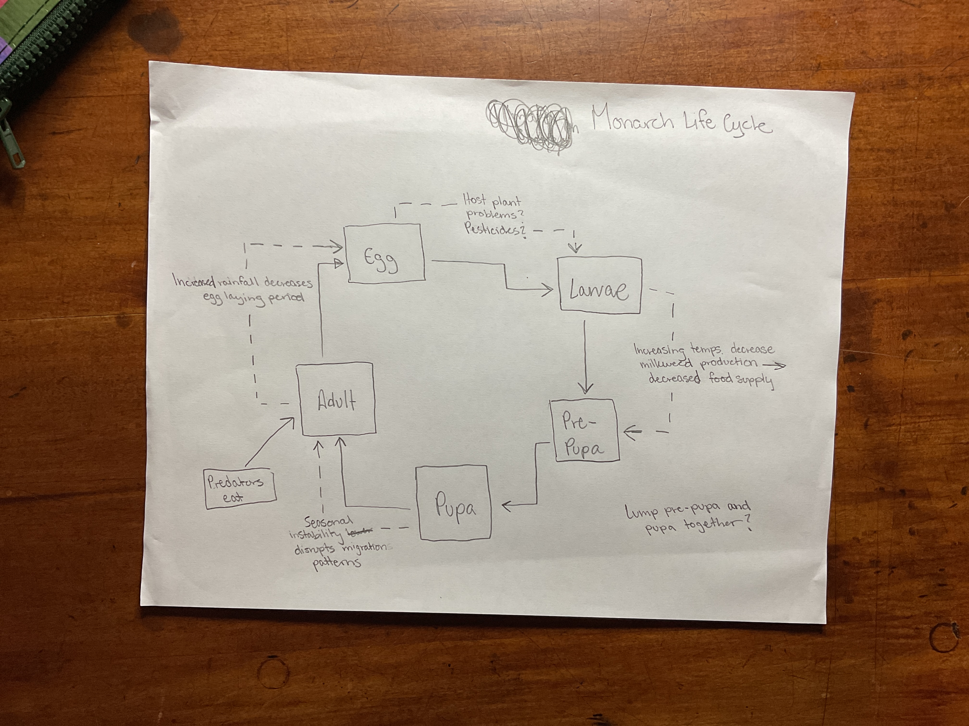

Comments:
- Good topic and you show how population is impacted by weather and other factors. A bit more work researching these factors might be in order.
- Probably a better way to show migration and mortality factors that occur during migration. Add a loop to show that phase at end of season perhaps.
- Best to keep same use of singular/plural for insect life stages: Eggs, Larvae, Pupae, Adults OR Egg, Larva, Pupa, Adult.
- Not sure “predators eat” can be backed up, as the Monarch is well known for alkaloids and aposematic coloration that warns predators that it tastes bad, maybe research that and find citations of predation of (in this case) adult stage.
- Only keep prepupae as separate if you find a factor that affects their survival in that stage.
- Pupae of butterflies also known as chrysalis stage.
- Good start!

