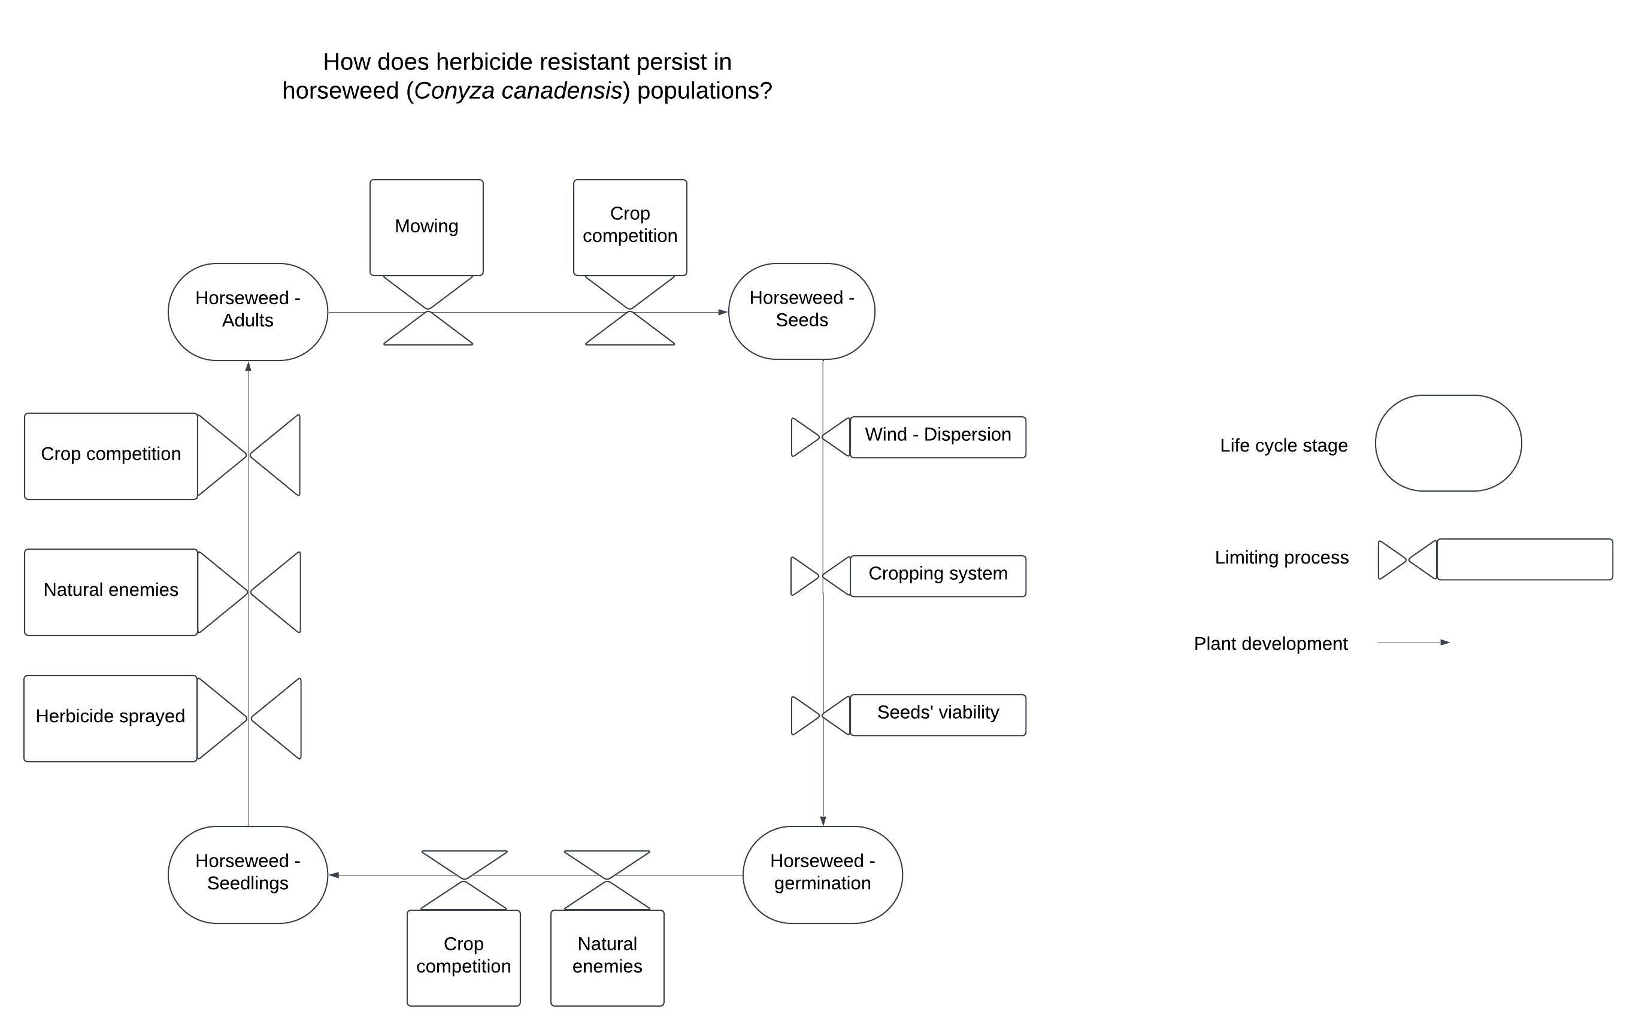
Comments:
- Great start, I like the legend
- Unclear how the limiting processes contribute to persistence of herbicide resistance
- Should reproductive stage be called “adult”? What about “mature” or “reproductive”?
- Perhaps strive to reduce redundancy of limiting processes, so represent “crop competition” only once and use arrows to show which stages are impacted, for example.
- If these are truly limiting processes, perhaps include more detail regarding the mechanisms, if appropriate. E.g. Herbicides cause mortality, natural enemies cause foliar or root damage, etc.

