**25 Google Response Samples – Copy and Paste**

*Upfront Restoration & Roofing Inc.*

*Your BBB Business ID: 1000022112*

*BBB Rating: A+*

**Share this link to promote your BBB Customer Reviews:**[**https://www.bbb.org/southern-colorado/review/1000022112/**](https://www.bbb.org/southern-colorado/review/1000022112/)

**Review Response Directions:** Copy and paste, reword, add words, etc., and submit!

**People are more likely to buy your products or services if they see your positive reviews and respond promptly.** Plus, search engines like Google and Bing really love to see that sort of content for local businesses.

One thing that I think a lot of people struggle with is replying to their positive reviews. You can only say “Thanks!” so many times, right? But your response as the business is vitally important to how your brand is perceived.

You want to make your clients feel appreciated and show that you listen to their feedback. You also want to show search engines that you’re consistently active to achieve higher rankings.

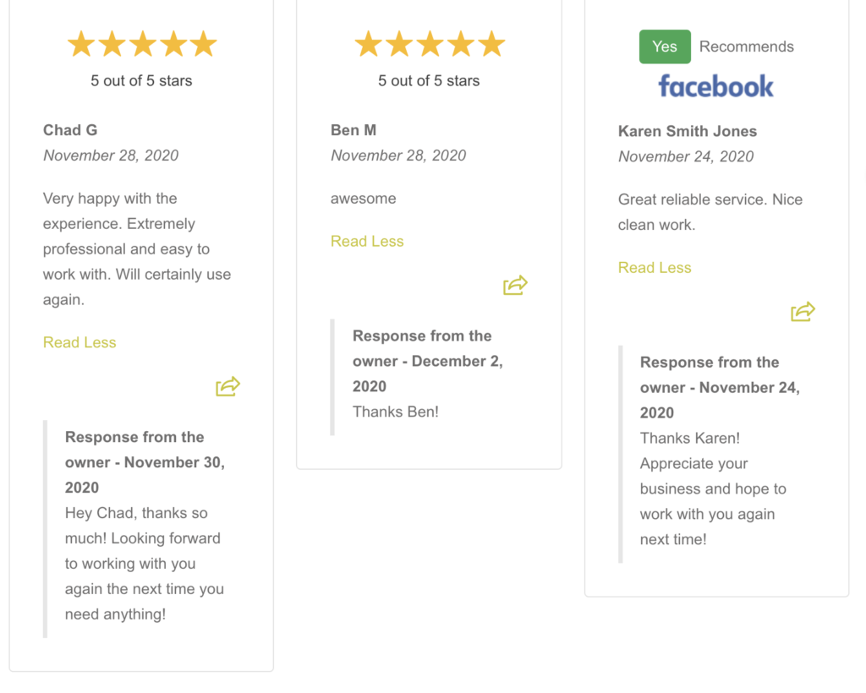

*Simply copy and paste these responses (and update any customer names or info) for your positive reviews:*

*1. Contact Us Again*

Dear (insert customer name), thank you so much for using us for (insert service they received). Please feel free to contact us again soon!

**2. Show Appreciation**

Hey (insert customer name), we appreciate the fantastic review and are glad we could be of service. If you have any further needs or questions, please reach out!

**3. We Value Your Feedback**

(Insert customer name), we appreciate your business and value your feedback. If there is anything else we can do for you, please let us know!

**4. We’re Thrilled!**

Thanks (insert customer name). We’re thrilled that you were satisfied with our services. Your feedback is appreciated, and we hope to be of help again soon!

**5. Need Anything Else?**

Hey (insert customer name), thank you so much for the great review! If you need any other services, please see our list of offers here. (insert a link to other services you provide)

**6. Visit Us Again!**

(Insert customer name), on behalf of (insert company name), I would like to thank you for using us for (insert service they received), and your feedback is appreciated. Please come visit us again soon!

**7. Thanks For Recommending Us**

Dear (insert customer name), thank you for recommending us in your review! We’re glad we made your experience with us a great one and will be happy to help you again soon.

**8. Here’s a Discount!**

Hey (insert customer name), thank you for allowing us to be of help today! We have some great offers right now (insert link for sales/offers/discounts/etc) if there is anything else you need!

**9. Looking Forward to Working Together Again**

Dear (insert customer name), we are so happy that you enjoyed your experience with us! We appreciate the great review and look forward to working with you again soon.

**10. Wow, Thanks!**

Dear (insert customer name), Wow! Thank you so much for the feedback! We appreciate your business and hope to see you again soon!

**11. We Hope to Assist Again Soon**

Thank you for the fantastic review (insert customer name)! We loved being of service to you and hope we can assist you again soon.

**12. Check Out Our Other Offers**

We’re glad to hear you had a great experience with us, (insert customer name)! Did you know we also offer (insert a link to other services)? That might be helpful to you as well.

**13. Tell Your Friends and Family**

Thank you so much for your business and feedback, (insert customer name)! If any of your friends or family need help, please let them know about us!

**14. Customers Like You**

Dear (insert customer name), it is because of customers like you that we continue to improve as a business! Please come see us again soon.

**15. Your Review Made Our Day**

Hey (insert customer name), our staff always enjoys reading reviews such as the one you left us! It lets us know we are making customers happy and doing something right! Please let us know if there is anything else you need.

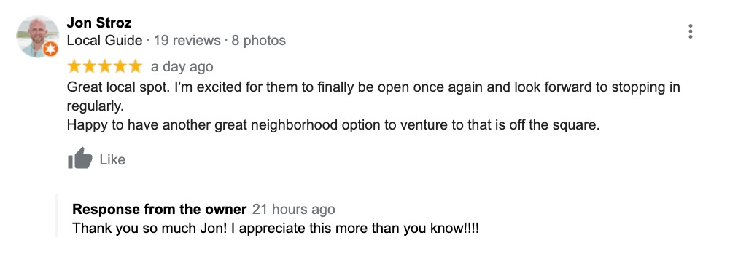

*Here’s a review that I recently left about a bar that recently reopened in my neighborhood. The owner left a review response that same day, which really lets me know that they do care about their business and the neighbors that go there.*

**16. Thanks for Taking the Time**

Dear (insert customer name), we appreciate you taking the time to let us know about your experience! If there’s anything else we can help you with, please let us know.

**17. We Couldn’t Improve Without You**

We would not be able to grow and develop without feedback like yours, (insert customer name). We are thrilled you had a great experience with us and hope to see you again soon.

**18. Anything Else You Need, Let Us Know**

Dear (insert customer name), thank you for sharing your experience with us here at (insert company name)! If there’s anything else you need, please contact us here! (insert contact us page link)

**19. Thanks for Sharing with the Community!**

Dear (insert customer name), thank you for letting us and the community know about your fantastic experience with us! We hope to see you again soon.

**20. A Personal Touch**

(Insert customer name), (insert name or names of employee(s) who provided service) will love to read the kind words you left about their service! Thank you for the feedback and we hope you visit us again!

**21. Top-Notch Service**

Dear (insert customer name), we are glad to hear we provided you with top-notch service! We appreciate the feedback and would love to work with you again.

**22. How Can We Make it Even Better?**

(Insert customer name), we appreciate you sharing your experience with us and would love to get in touch with you about how we can make it even better next time! Please get in touch with us here (insert contact us link page).

**23. Glad to Be of Service!**

We always enjoy hearing what our customers have to say, (insert customer name)! We’re glad we could be of service and appreciate the kind words! Please see us again if there is anything else you need!

**24. We Appreciate Your Loyalty**

Dear (insert customer name), we greatly appreciate your loyalty to us, and thank you for sharing your experience with us! We look forward to working with you again!

**25. Don’t Hesitate to Ask Us Questions!**

Thank you so much (insert customer name) for the great review! If there is any other service we can provide for you or questions we can answer, please get in touch with us!