**Up-811 Positive Ticket Example Cleared for Digging & Codes**

* The **Clearing Code** is located under the date
* Specifies **Cleared** under the **Work Performed** box
* **Positive Response** at the bottom of the ticket indicates a cleared ticket
* See **Codes** sheet on the following page
* **811 emailed** informing us this ticket cleared for digging

Our records indicate you called in dig request **B203901765** at [**3450 WINDJAMMER DR, COLORADO SPRINGS, CO**](https://www.google.com/maps/search/3450+WINDJAMMER+DR,+COLORADO+SPRINGS,+CO?entry=gmail&source=g).

This email is a status update relating to ticket number **B203901765** for code **FLCNBD1**.

|  |  |
| --- | --- |
| Ticket: | **B203901765** |
| Member Code: | **FLCNBD1** |
| Company: | **TRENT SHANE** |
| Done For: | **JARED COLE** |
| Work to begin on: | **2/11/2022 11:59:00 PM** |
| County: | **EL PASO** |
| City: | **COLORADO SPRINGS** |
| Address: | **3450WINDJAMMER DR** |
| Contact: | **TRENT SHANE** |
| Phone: | **(719)466-9912** |
| Completed on: | **2/9/2022 4:57:35 AM** |
| Response: | **002-CLEAR** |

|  |  |  |
| --- | --- | --- |
| Facility | Work Performed | Action Code |
| **FIBER** | **Cleared** |  |
| **STRATUSIQ** | **Cleared** |  |

**Remarks:**

**Notes:**

This is **a positive response** message from Stratus IQ in response to a dig request you submitted with Colorado 811.

If you have any questions, please contact Joseph Sinio at 719-963-4994.

**811 Codes Listed Below**

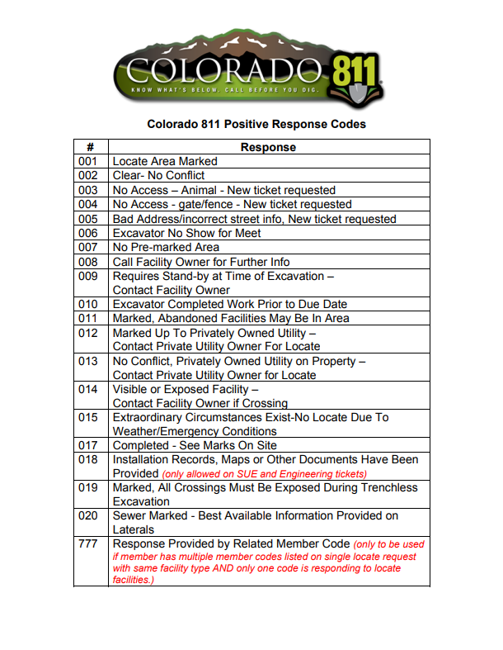

888 - Ticket Has Been Cancelled