# HVAC Diagnostics Report

## Fault Rule Details

Equation:  
fault_flag = 1 if (MAT < min(RAT, OAT) or MAT > max(RAT, OAT)) and (VFDSPD > 0.01) else 0

Description:  
Fault Condition: Mix air temperature (MAT) must be between return air temperature (RAT) and outside air temperature (OAT) when the fan is running.

Required Inputs:  
- Mix air temperature (MAT)  
- Return air temperature (RAT)  
- Outside air temperature (OAT)  
- Supply fan VFD speed (VFDSPD)

## Summary Statistics

Total Data Points: 131635

Fan Running Points: 131635

Fault Count: 33746

Outlier Count: 425

## OpenAI Diagnostics

Explanation: The condition indicates that when the fan is operational, the mixed air temperature (  
MAT) should always be bounded by the return air temperature (RAT) and outside air temperature (OAT).

Output: Analyzing Fault Rule: Mix air temperature (MAT) should be between RAT and OAT when the fan is running.

Explanation: The total number of data points is equal to the times when the fan is running, implying the fan was operational throughout the dataset. Therefore, each data point needs to be verified against the fault condition to determine compliance.

Output: Total data points: 131635  
Fan running data points: 131635  
Fault occurrences: 33746

Explanation: Given 33,746 faults detected over 131,635 instances when the fan was running, approximately 26% of the times a fault was detected. This indicates a significant occurrence rate, suggesting possible systemic issues in the system configuration or sensor inaccuracies.

Output: Fault detection rate: (33746 / 131635) * 100 ≈ 25.64%

Explanation: With 425 outliers noted, consideration should be given to potential sensor malfunctions or erroneous data entries, which might affect the accuracy of fault detection.

Output: Number of detected outliers: 425

Explanation: The mean, standard deviation, and distribution statistics for RAT and OAT can be compared against MAT statistics to check for consistency or anomalies, but specific distributions for these parameters are missing, limiting detailed fault analysis.

Output: Dataset offers sensor statistics but lacks distinct statistics for MAT, RAT, and OAT comparison.

Explanation: Potential root causes for discrepancies include: sensor miscalibration or drift, issues in data logging or processing, or anomalies in system operation.  
  
Verification of sensor calibration and reviewing historical data for consistency checks may assist in identifying false positives.

Output: Consider assessing:  
1. Sensor calibration errors  
2. Data processing issues  
3. System operational anomalies

Explanation: If the mean value of RAT and OAT are both very close, and MAT reflects a similar average, the natural variability might account for some faults being registered. This is assuming reasonable proximity that still generates occasional out-of-bound values.

Output: Cross-reference sensor averages:  
- RAT approximation missing  
- OAT Mean: 52.86°F  
- MAT Mean: 63.50°F

Explanation: Given the number of detected faults, system assessments focusing on sensors' precise reading capabilities, data flow validation, and control accuracy are recommended.

Output: Recommend scrutiny and potential recalibration or diagnostics of RAT, MAT, and OAT sensors.

Final Analysis: The significant fault occurrences likely indicate issues not just with sporadic failures but potentially systemic calibration errors, sensor inaccuracies, or control faults. The future course involves a detailed investigation into sensor performance, ensuring all systems meet operational specifications accurately. False fault triggers might also result from poor temperature sensor alignment or mechanical issues in the air handling unit.

## Visualizations

Cumulative Faults Over Time:

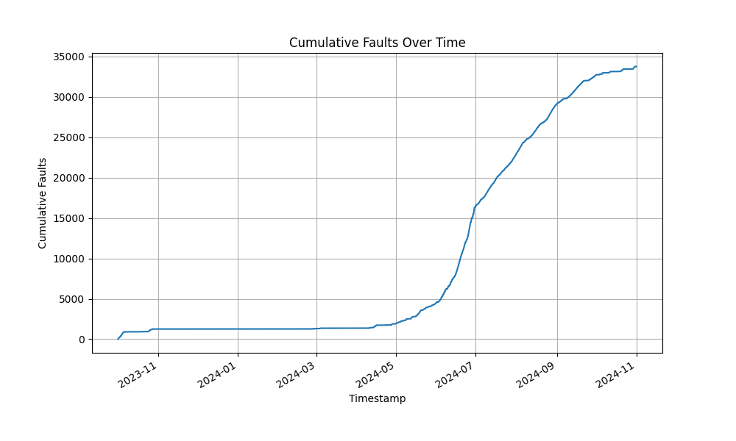

Temperature Ranges (MAT, RAT, OAT):

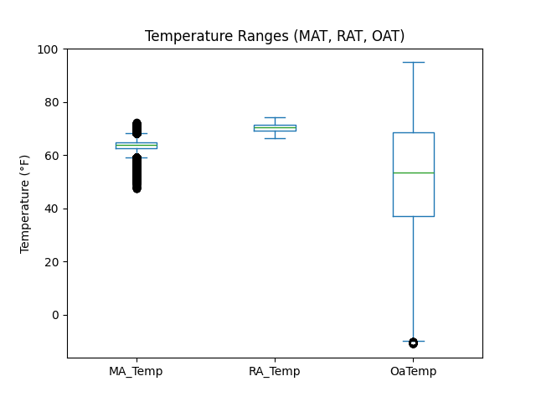

Hourly Fault Occurrences:

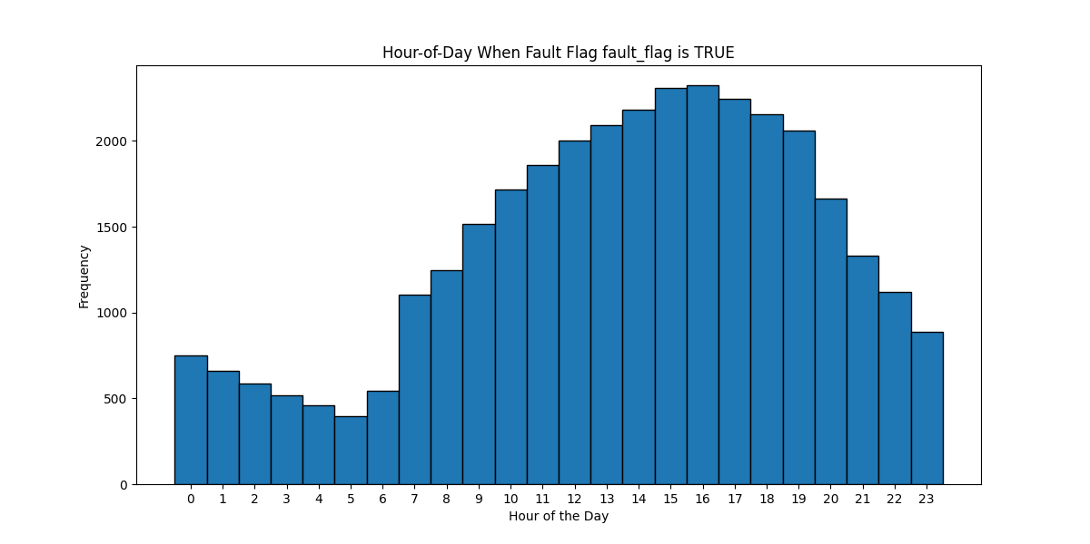

## LLM Decision-Making Steps

Fault detection: 33746 faults identified.

Outlier detection: 425 outliers identified.

Triage decision: Conduct a thorough sensor calibration and diagnose the mixing damper operation.. Explanation: The fault condition indicating the mix air temperature must be between the return air temperature and outside air temperature when the fan is running was triggered in 25.64% of the data points, which is significant. This suggests a potential issue with the mix air temperature control mechanism or sensor accuracy. Considering the sensor statistics, the mix air sensor (MA_Temp) and related return and outside air sensors (RA_Temp and Oa_Temp) should be checked for calibration and functionality. Additionally, the mixing damper operation, which affects how air from different sources is mixed, should be inspected for proper mechanical and control performance to ensure it responds correctly to control signals..