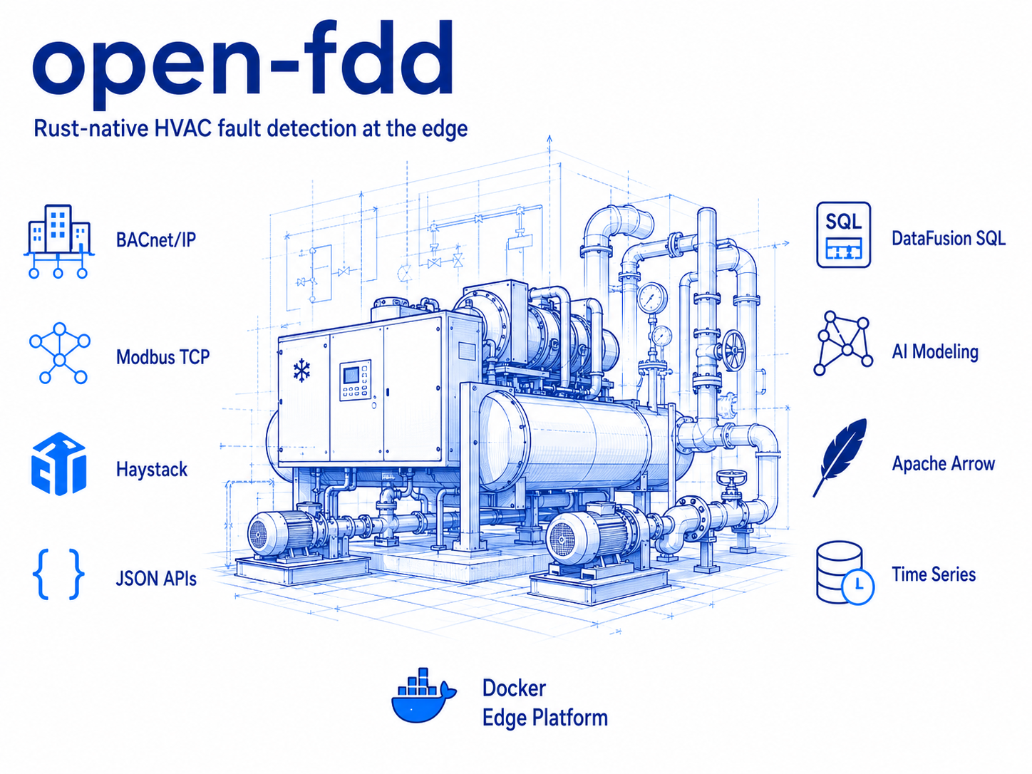
Generic HVAC RCx Report
Short client-ready template for any mechanical system

Client: [CLIENT NAME]
Facility: [FACILITY / SITE]
System(s): [AHU / VAV / BOILER / CHILLER / HEAT PUMP / OTHER]
Analysis period: [START DATE] to [END DATE]
Prepared by: [ENGINEER]
Data source: [CSV / BAS EXPORT / DATABASE]

Purpose
Summarize the most important operating issues, paste supporting Plotly charts from the Streamlit application, and document practical corrective actions. Replace all bracketed text before issuing the report.

Executive summary
- [Overall system condition: normal, needs attention, or significant operational concern.]
- [Most important comfort, energy, or reliability issue identified.]
- [Approximate fault duration, frequency, or affected equipment count.]
- [Recommended immediate action or field verification.]
- [Important data limitation, missing point, or assumption.]

Key conclusions
- [Priority 1 finding and why it matters.]
- [Priority 2 finding and why it matters.]
- [Priority 3 finding and why it matters.]

Analytics and supporting evidence
Paste the strongest Streamlit Plotly charts below. Use readable titles, legends, units, equipment names, and date ranges.

Finding 1: [SHORT FINDING TITLE]
- Rule / analytic: [RULE ID OR ANALYTIC NAME]
- What the chart shows: [ONE OR TWO SENTENCES]
- Operational impact: [COMFORT / ENERGY / RELIABILITY]
PASTE PLOTLY CHART HERE
Copy or download the chart from Streamlit and insert it here.

- Recommended action: [CONTROL CHANGE, SENSOR CHECK, SCHEDULE FIX, BALANCING, OR FIELD TEST]

Finding 2: [SHORT FINDING TITLE]
- Rule / analytic: [RULE ID OR ANALYTIC NAME]
- What the chart shows: [ONE OR TWO SENTENCES]
- Operational impact: [COMFORT / ENERGY / RELIABILITY]
PASTE PLOTLY CHART HERE
Copy or download the chart from Streamlit and insert it here.

- Recommended action: [CONTROL CHANGE, SENSOR CHECK, SCHEDULE FIX, BALANCING, OR FIELD TEST]

Recommended actions
- [High priority] [Action, responsible party, and expected verification.]
- [Medium priority] [Action, responsible party, and expected verification.]
- [Low priority] [Action, responsible party, and expected verification.]

Verification plan
- Trend the affected points after implementation using the same analysis period and operating filters.
- Confirm the equipment is enabled and operating before judging fault clearance.
- Compare before-and-after fault hours, comfort performance, and control stability.
- Document any unresolved issues or changes to the sequence of operation.
OPTIONAL BEFORE / AFTER PLOT
Paste a post-correction Plotly chart using the same points and comparable axes.

Engineering notes and limitations
- Results depend on correct point mapping, engineering units, timestamps, schedules, and operating gates.
- A skipped or unavailable rule is not the same as a passing result.
- Verify recommendations against the approved sequence of operation and field conditions before implementation.
Prepared by: [NAME / SIGNATURE] Date: [DATE]
Reviewed by: [NAME / SIGNATURE] Date: [DATE]

