README
1. Program name and version
AA-Frequency-analyzer-2
Version 1.0

AA-Frequency-Analyzer-2 is a Windows application designed to determine positional amino-acid frequencies in sequence segments surrounding furin cleavage sites.

2. Functionality
Furin is a proteolytic enzyme widely expressed in the tissues of higher animals, where it participates in the proteolytic activation of many precursor proteins. A variety of pathogens, including viruses and bacteria, can also exploit host furin for the processing of their proteins.
The minimal furin recognition motif is generally represented as R-X-X-R, where R represents arginine and X can represent other amino acids. However, residues outside this minimal motif can also influence furin recognition and cleavage.
AA-Frequency-Analyzer-2 was developed to determine the frequency of each amino acid at individual positions surrounding furin cleavage sites. The program is particularly designed for analysis of datasets containing aligned 20-amino-acid (20-AA) segments spanning positions P14 through P6′, with the P1 arginine immediately preceding the cleavage site. This allows positional patterns within large collections of furin substrate sequences to be readily identified.

3. Input
The user interface (UI) of AA-Frequency-Analyzer-2 is shown in Fig. 1.
For the standard analysis, the program accepts datasets of aligned 20-AA sequence segments. The complete dataset can be copied from an Excel column or other text source and pasted into the input field.
For 20-AA datasets, sequences must be aligned with the P1 arginine at position 14, immediately preceding the cleavage site. The program checks the length and amino-acid characters of each sequence and excludes invalid sequences from the analysis. Rejected sequences are reported separately in the lower display field.

4. Validation

A test dataset consisting of 100 20-AA segments containing the PRRAR motif was constructed with a predetermined composition of flanking amino acids. The dataset was analyzed using AA-Frequency-Analyzer-2, and the positional amino-acid frequencies reported by the program agreed with the expected values.5. Installation and requirements

Operating system: Microsoft Windows
Application type: Windows Forms application
Framework: .NET 9.0 for Windows
Installation: Run the supplied installer and follow the installation prompts.

6. How to use
The user interface of the program is shown in Fig. 1.
a. Before beginning the analysis, decide whether duplicate sequences should be retained or removed. Check “PickUniqueIfChecked” if only unique sequences are to be analyzed. Leave it unchecked if duplicate sequences should be retained. This choice should be based on the purpose of the analysis. For example, duplicates should normally be retained when the objective is to determine the proportions of different sequence types within a dataset.
b. Paste the dataset into the first text box. A column of sequences copied directly from Excel can be pasted into this field.
c. Click “PerformAnalysis.” A message will confirm whether PickUnique has been selected. Click “OK.” You will then be asked to enter the sequence length to be analyzed. The default is 20 amino acids.
d. The results are displayed in the output fields. Output 1 reports the frequency of each of the 20 amino acids at each sequence position. For the standard 20-AA analysis, these positions are labelled P14 through P6′. The output can be saved as a CSV file and opened in Microsoft Excel.
To produce a graph in Excel from Output 1:
- Open the saved CSV file in Excel.
- Select the first two columns.
- Choose Insert and create a column or bar chart.
- Expand the selected data range to include the remaining amino-acid columns.
Depending on the version of Excel being used, selecting the first two columns before creating the chart and subsequently expanding the data range may produce the desired graph more reliably than selecting the entire dataset initially.
e. Output 2 reports the frequencies of the hydrophobic, hydrophilic, and charged amino-acid categories at each analyzed position. This output can also be saved as a CSV file and opened in Excel.
f. Sequences rejected because of incorrect length, invalid amino-acid characters, or failure to meet the P1 arginine requirement for a 20-AA dataset are listed in the lower display field.

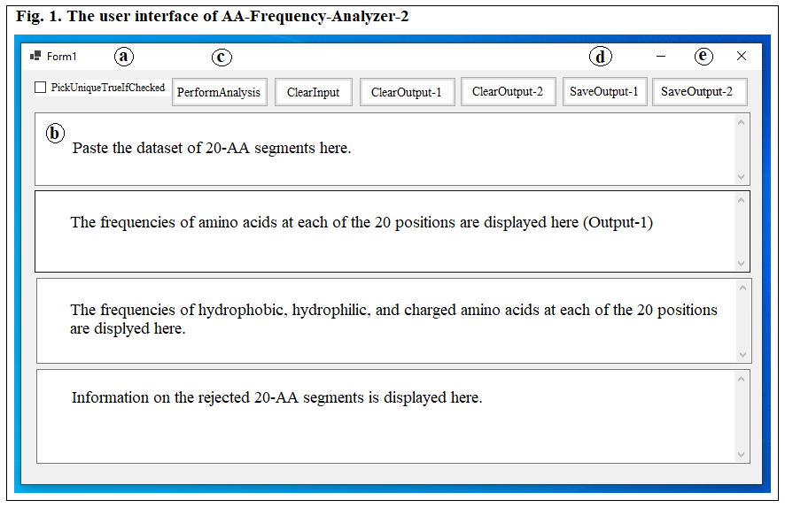

7. Limitations

AA-Frequency-Analyzer-2 was developed primarily for positional analysis of furin cleavage sites. Although sequence motifs shorter on the C-terminal side can also be analyzed, interpretation of analyses involving other types of proteolytic cleavage sites may require modification of the program or consideration of different positional conventions.

