Nicholas J. Tustison

480 Ray C Hunt Drive

Charlottesville, VA 22903

540-383-2719

[ntustison@virginia.edu](mailto:ntustison@virginia.edu)

March 18, 2019

Dear Professor George Perry,

I am pleased to submit an original research article entitled “Longitudinal mapping of cortical thickness measurements: an ADNI-based evaluation study” for consideration for publication in the *Journal of Alzheimer’s Disease*. Cortical morphology has been widely used to investigate both pathological and developmental processes. Members of our team previously published a large-scale evaluation of two well-known frameworks for extracting localized cortical thickness measurements in a cross-sectional human cohort (Tustison, et al., “Large-scale evaluation of ANTs and FreeSurfer cortical thickness measurements,” NeuroImage 2014) which has been well-cited. This work presents a longitudinal specific framework which is also available as open source through the Advanced Normalization Tools software library. Using the well-known ADNI data set, we evaluate the derived thickness measurements in the context of a linear mixed effects modeling which permits a straightforward comparison with comparable investigatory tools, including the established FreeSurfer processing stream.

Cortical morphology is a widespread biomarker for scientific inquiry into Alzheimer’s disease which is why we believe that this manuscript is appropriate for your journal. A cursory topical search yields similar type articles that have been recently published in JAD:

* J. Lee, et al., Sex-Related Reserve Hypothesis in Alzheimer's Disease: Changes in Cortical Thickness with a Five-Year Longitudinal Follow-Up, 2019.
* A. Pink, et al., Cortical Thickness and Depressive Symptoms in Cognitively Normal Individuals: The Mayo Clinic Study of Aging, 2018.
* L. Pasquini, et al., Increased Intrinsic Activity of Medial-Temporal Lobe Subregions is Associated with Decreased Cortical Thickness of Medial-Parietal Areas in Patients with Alzheimer's Disease Dementia, 2016.

This manuscript has not been published and is not under consideration for publication elsewhere. All authors have contributed to the work and agree with the presented findings. We have no conflicts of interest to disclose.

We suggest the following handling editor

* Joon-Kyung Seong ([jkseong@korea.ac.kr](mailto:jkseong@korea.ac.kr))

in addition to the following potential reviewers:

* Babak Ardekani ([babak.ardekani@nki.rfmh.org](mailto:babak.ardekani@nki.rfmh.org))
* Caroline Dallaire-Theroux ([caroline.dallaire-theroux.1@ulaval.ca](mailto:caroline.dallaire-theroux.1@ulaval.ca))
* Dai Wang (statistician) ([dwang39@its.jnj.com](mailto:dwang39@its.jnj.com))
* Francisco J. Martinez-Murcia ([fjm56@cam.ac.uk](mailto:fjm56@cam.ac.uk))
* Iman Beheshti ([Beheshtiiman@gmail.com](mailto:Beheshtiiman@gmail.com))

Thank you for your consideration,

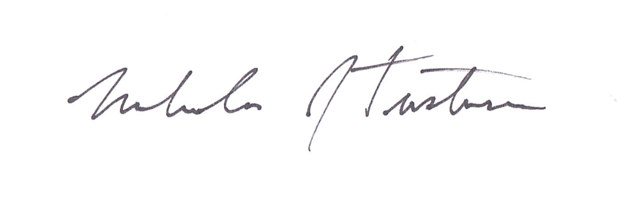

Nicholas J. Tustison, D.Sc.

Associate Professor

Department of Radiology and Medical Imaging

University of Virginia