Nicholas J. Tustison

480 Ray C Hunt Drive

Charlottesville, VA 22903

540-383-2719

[ntustison@virginia.edu](mailto:ntustison@virginia.edu)

May 24, 2019

Dear Professor George Perry,

We very much appreciate the time spent by the editors and reviewers in assessing our original research article entitled “Longitudinal mapping of cortical thickness measurements: an ADNI-based evaluation study” (Manuscript 19-0283). We are pleased that it was well-accepted and submit this revision with a point-by-point response to issues raised by the reviewers.

Thanks again,

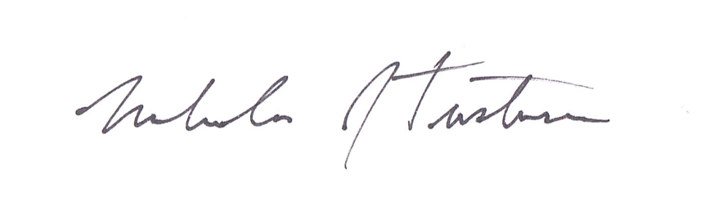

Nicholas J. Tustison, D.Sc.

Associate Professor

Department of Radiology and Medical Imaging

University of Virginia