# Readme for CSCI 6461 Project Part 1

Li, Qinyang / Nguyen, Kathy M. / Wang, Binren / Zhang, Qiuyu

## Requirement

JDK 1.8

## Steps to Run the Program

1. Executable jar file is in *ClassProject/target/classproject-0.0.1-SNAPSHOT.jar*
2. Make sure port 8080 of the computer is not occupied by any programs.
3. Run the classproject-0.0.1-SNAPSHOT.jar file using command like

*java -jar classproject-0.0.1-SNAPSHOT.jar*

1. 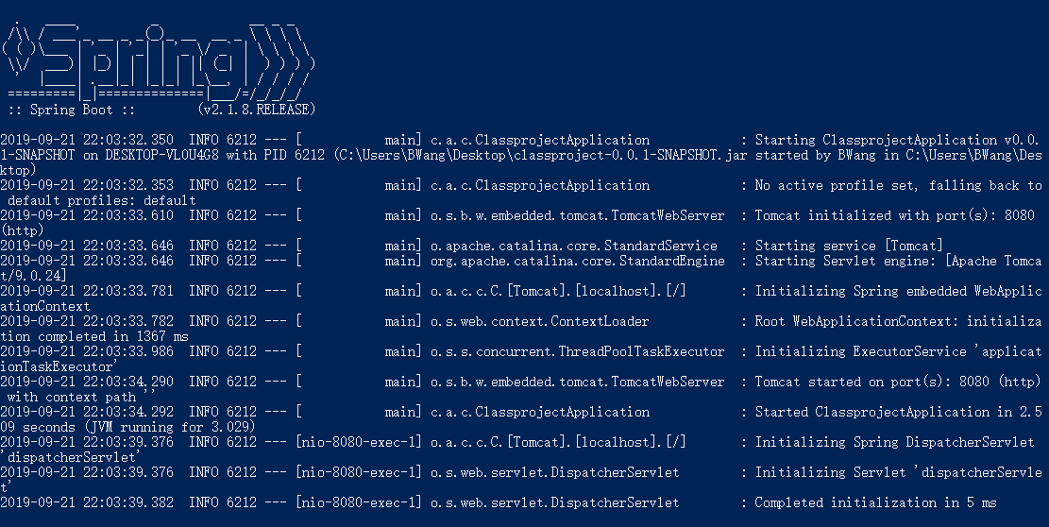If you saw output like this, the jar file is working now. DO NOT close it.
2. Now open a browser (Chrome recommended) and go to <http://localhost:8080/ProjectUI>. If the webpage shows like this, the program is running successfully and you can use the User Interface.

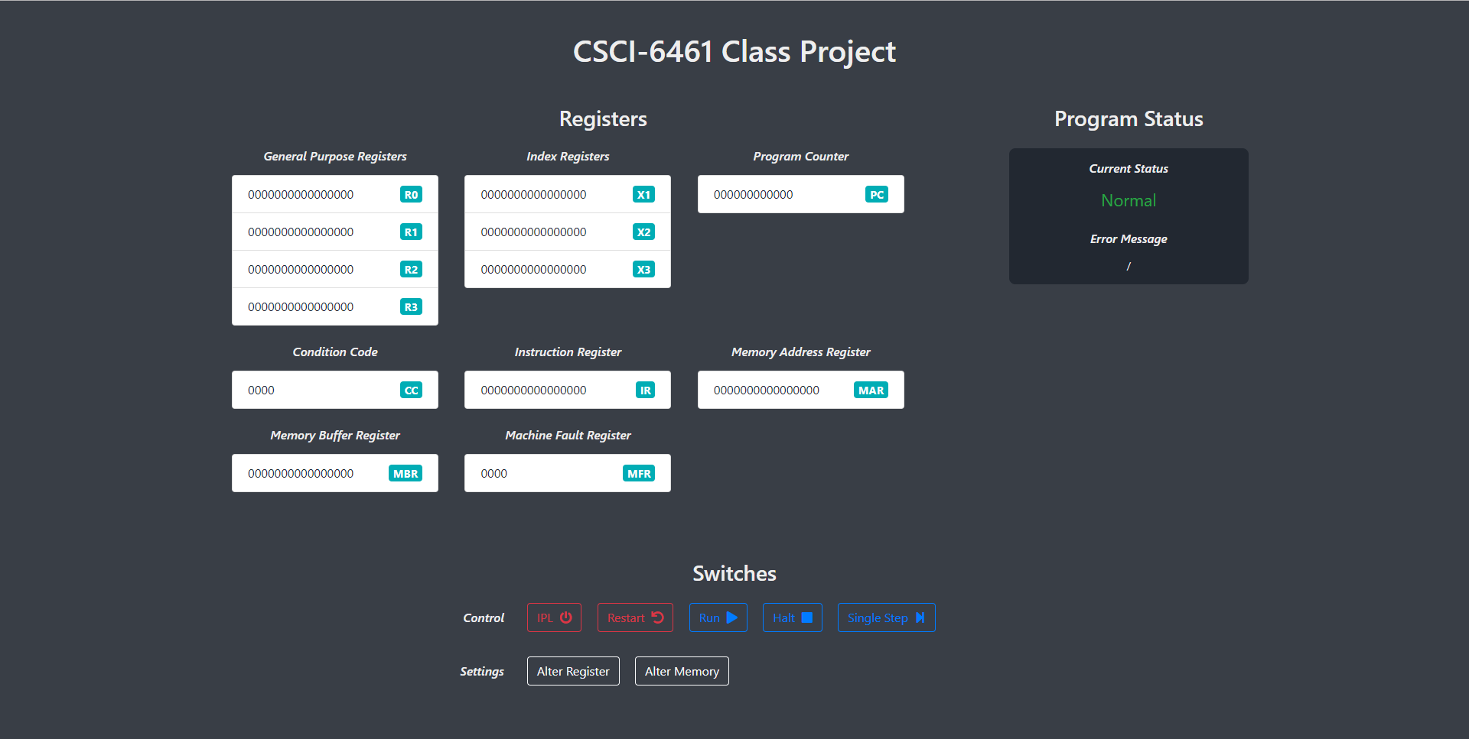

## Actions

* Press the “IPL” button to load the simulation of test program 1, test program 2 and a demonstration of part 4a in sequence. One program ends and another program starts running automatically with an alert “A new program starts.” on printer. It would load the program into the machine and waits for the user to click either "Run" or "Single Step".
* Press the “Restart” button to restart the machine. It would reset all the registers, memory and status. You need to press “IPL” again to reload the program(s).
* Press "Run" to automatically step through the program until all the instructions in the pre-loaded program are executed.
* Press "Single Step" to run execute the instruction at the current address.
* "Halt" is temporarily useless as either “Run” or “Single Step” would finish immediately.
* Click "Alter Register" to alter the value of a register. You need to select a register (mandatory), input a decimal integer (if integer is not given, register would be reset) and press “save”.
* Click "Alter Memory" to alter the value of memory in an address. You need to type in an address in decimal integer from 0 to 2047 (mandatory), input a decimal integer (if integer is not given, the memory at that address would be reset) and press “save”.
* **Warning**: After an required input, the program would stop, you shall manually continue the program by click “Run” or “Single Step”