**TRAIN MODEL**

**INSTALLATION**

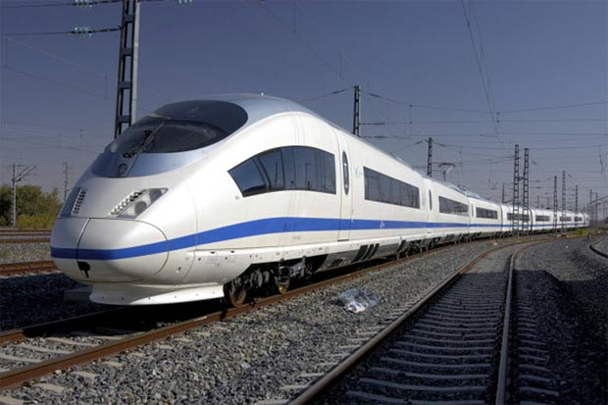**GUIDE**

*This document provides installation instructions for the Train Model Module of the Bits Please Train Control System.

*The module has been tested extensively, but is not guaranteed to be without error.

*The module uses a simplified point mass physics that does not account for friction, and does not represent a ‘real-world’ scenario to the fullest extent.

STEP ONE:

Make sure your system is running Java 6 or any newer version.

If download required, see here: <https://java.com/en/>

STEP TWO:

The module is provided in both a compiled and uncompiled form. The source code can be viewed in the uncompiled form. To compile the uncompiled form, the Train Model module with be expecting both a TrainController class and a TrackModel class, both with appropriate methods.